Interrogating the data

In this exercise we will review the database for IndoTERM. A good understanding of the structure of the initial database is fundamental. The initial database contains information regarding the structure of the Indonesian economy, especially the regional characteristics of the economy. It also forms an initial solution of the IndoTERM model equations.

Getting Started
You will be working in the working directory of …\kepri\D1S1 The aim of this exercise is to have a closer look at the initial data file for IndoTERM. Work through this exercise and write down answers to the questions onto the instruction sheet. The questions are scattered through the instructions.

Viewing the data using ViewHAR
You can view the data either directly in ViewHAR or by typing commands in DOS.

Opening ViewHAR directly
You can open ViewHAR directly by clicking on the ViewHar icon on your desktop. In the toolbar click on File | Open HAR or SL4 file and navigate to the working directory …\kepri\D1S2. This directory contains two *.HAR files (aggmod.har and aggsets.har). Click on aggmod.har.

ViewHAR via DOS commands

Opening a DOS box
If you already know how to open a DOS box, do it now, and jump to the next subsection, Navigating to the work folder.
There are many ways to open a DOS box -- but some only work with some versions of Windows. Here is one method that works with with most versions.
Locate the Windows key near bottom left of your keyboard. It may look like this  or this .
Simultaneously press the Windows key and the "R" key. The Run box should be displayed:
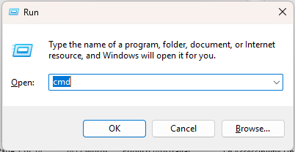
Type in "cmd", then click OK.
You should see a DOS box rather like this:
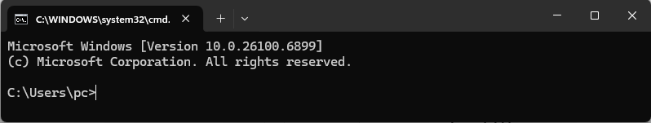

Navigating to the work folder
Type the following line, exactly as shown below, into your DOS box, then press Enter:
cd \DTERMCRS\D1S2
The DOS box should now resemble:
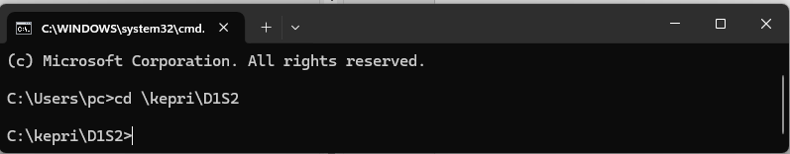

Now type:
dir
to list the files in this folder.
To view the data file type:
viewhar aggmod.har
This is the main data file for IndoTERM -- it contains Indonesian data for the year 2005. Use this file to answer the questions below.

Questions
3.1. Which Header contains the set of industries? IND
How many commodities are there, and how many industries? 30 COM, 30 IND
3.2. How many margins commodities are there? 5
Which commodities are they?
No. String
1 Trade
2 LandRailTr
3 SeaRiverTr
4 AirTransport
5 OthTrans

3.3. What does the Header “TRAD” contain?
TRADE shows the value of inter-regional trade by sources (r in ORG) and destinations (d in DST) for each good (c in COM) whether domestic or imported (s in SRC). The diagonal of this matrix (r=d) shows the value of local usage which is sourced locally. For foreign goods (s="imp")the regional source subscript r (in ORG) denotes the port of entry.
How many dimensions does this Header have? What are they?
4 dimensions, namely COM, SRC, ORG, DST
3.4. What is the name of the set containing the regions of origin? ORG
What are the regions of origin?
No. String
1 KepRi
2 ROS
3 ROI

3.5. In the top right hand corner of the Trade matrix (Header TRAD) there are four drop-down windows. Click on them until you have “Sum COM”, “Sum SRC”, “All ORG” and “All DST”. Describe the matrix that you see in front of you.
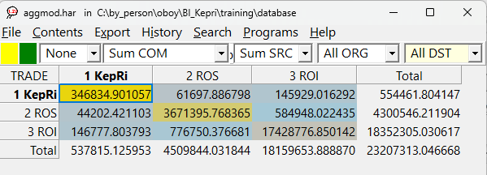
This matrix shows the trade between regions. The diagonal values of the matrix is the largest, implying that most goods are sourced locally.
What is the share of all commodities (domestic and imported) used in KepRi are sourced from KepRi? [Hint: use column shares]
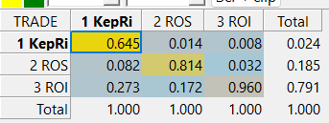
64.5%
Now change the four settings to “FoodProds”, “1 dom”, “All ORG” and “All DST” and explain again what you have in front of you. (Note: ViewHAR can only view two dimensions at a time. See the ViewHAR help under "Options for real matrices" for more details).
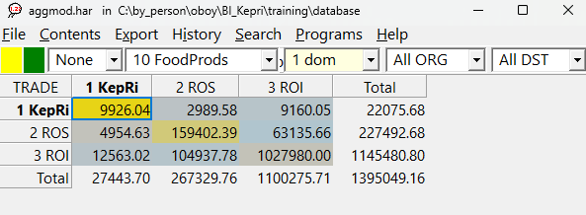
The values show the trade of domestically sourced FoodProds between regions in Indonesia.

Set the data to row shares. What do you see?
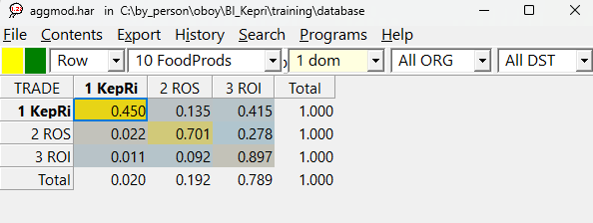
Most of the domestically source FoodProds are sourced from the local region. This matrix is strongly diagonal.
3.6. What is the name of the COEFFICIENT used in TERM.TAB to represent the "Armington elasticities", ie, the elasticities of substitution between imported and Indonesian goods?
ARMSIGMA
From what Header are these values read? P015
What are the values used for these Armington elasticities? What do these parameters represent?
The ease with which we can substitute between domestically and imported commodities due to changes in relative price
P015 ARMSIGMA
1 Rice 5.05
2 FoodCrops 3.70
3 OthAgr 1.96
4 Forestry 2.50
5 OthPlant 2.69
6 Fishery 1.25
7 Coal 3.05
8 NatGas 17.20
9 OthMine 4.62
10 FoodProds 2.50
11 EdibleOils 3.30
12 RiceMilling 2.60
13 PetrolRefin 2.10
14 BasChemicals 3.30
15 Fertilizer 3.30
16 ElectEqp 4.29
17 OthMan 3.49
18 ElecGas 2.80
19 OthUtil 2.80
20 Construction 1.90
21 Trade 1.90
22 LandRailTr 1.90
23 SeaRiverTr 1.90
24 AirTransport 1.90
25 OthTrans 1.90
26 Telecommunic 1.90
27 InformatTech 1.90
28 Banking 1.90
29 RealEstate 1.90
30 OthServices 1.90
Total 93.39
Which products have the highest elasticities?
8 NatGas 17.2
1 Rice 5.05
9 OthMine 4.62
Which have the lowest?
29 RealEstate 1.9
30 OthServices 1.9
6 Fishery 1.25
3.7. What is the value at delivered prices of household consumption for imported "FoodProds" (delivered price = basic + margins) (Header BSMR)? 35,121
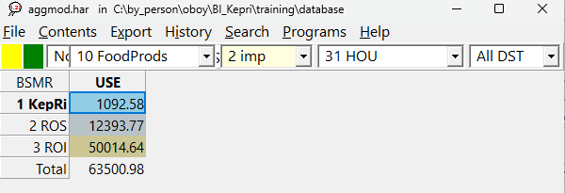
What is the value at delivered prices of household consumption of domestically-produced commodity " FoodProds " (including margins)? 845,046
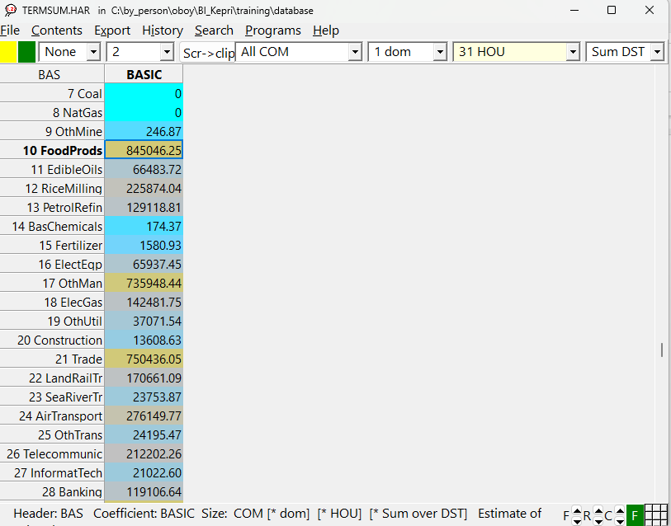
How can we find the basic value [hint: search for "basic" in TERMSUM.HAR]?
3.8. What is the total value of capital rental for industry "Construction" in Indonesia? (Header 1CAP) 538,679
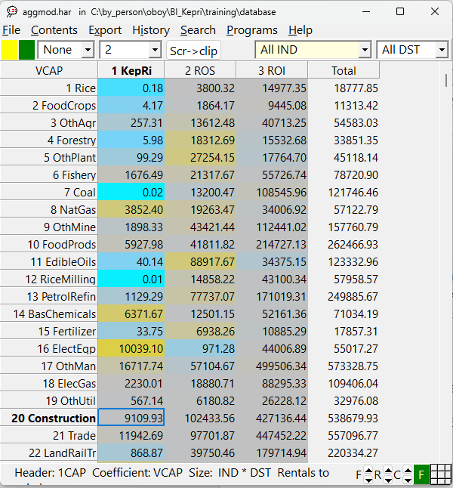
Which region has the largest share of the total value of capital rental for industry "Construction".
ROI (79%)
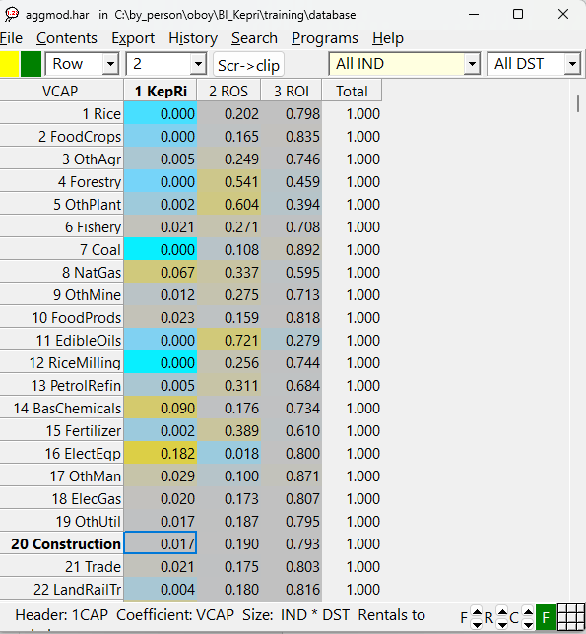
3.9. What is the value of investment demand for commodity "Fishery" by the industry "FoodProds" in Indonesia? (Header 2PUR) 57.72
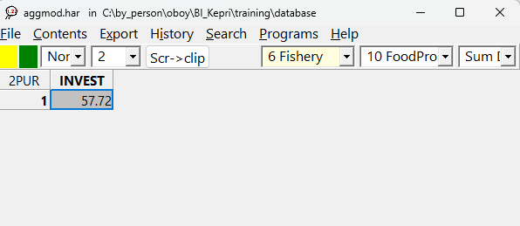
Which region has the highest demand for “Fishery” by their industry “FoodProds”?

ROI(47,42)
2PUR INVEST
1 KepRi 1.14
2 ROS 9.16
3 ROI 47.42
Total 57.72

Consequences of the data
You will also need to look at consequences of the data (for example, totals and shares calculated from the data which is read in).
The main TABLO Input file TERM.TAB can be used for this purpose. As well as solving the model, it writes out various useful data calculated from the original data to a SUMMARY file. You can use GEMSIM to produce this file without actually performing a simulation.
Open TERM.TAB and search for "summary". You will see that some Coefficients are written to a SUMMARY file. To produce the SUMMARY file proceed as follows.
Open and examine the file NoSim.CMF. In the DOS box type the following command:
tabmate nosim.cmf
It is a special CMF file which just processes the model data, without doing a simulation. Hence, no closure or shocks are needed. It will read all the data, calculate all coefficients, and write the summary data. Now type:
tablo –pgs term
To run the command file type:
gemsim –cmf nosim.cmf
The program should complete without error. Once the run has finished, type into the DOS box:
viewhar termsum.har
to examine the SUMMARY file.
If you want to arrange the headers alphabetically, click on
File | Options and activate Sort headers alphabetically.
Most of the following questions can be answered by examining TERMSUM.HAR. Each data item there has a descriptive "long name". As a guide, you might in each case look first in the TAB file to find
- the correct name of the COEFFICIENT.
- how each item was calculated (and whether it is really what you want to find out).
- the Header used in writing this COEFFICIENT to file SUMMARY.
- then look in TERMSUM.HAR in ViewHAR to find the Header and double-click on it to see the values.
ViewHAR options: You can get ViewHAR to show the name of the Coefficient by selecting
File | Options
and then clicking on the box Show coefficient names.
Another good idea is to select
File | Use advanced editing menu rather than
Use simplified, read-only menu.
4.1. The COEFFICIENT used for the total labour bill by industry and province is LAB_O(i,d). What is the total labour costs for the electronic equipment (ElecEqp) industry? 66973
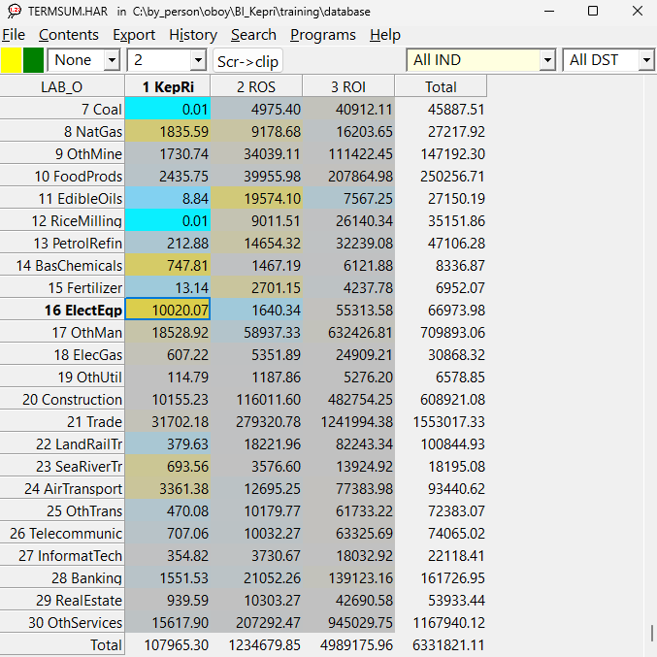
4.2. What COEFFICIENT is used for the total cost in industry "i" (plus tax)? [Hint search in TERM.TAB for “total national industry cost plus tax”]. What is the total value of this coefficient? Under what header does this coefficient appear in TERMSUM.HAR?
NATVTOT, 23536890, NATV
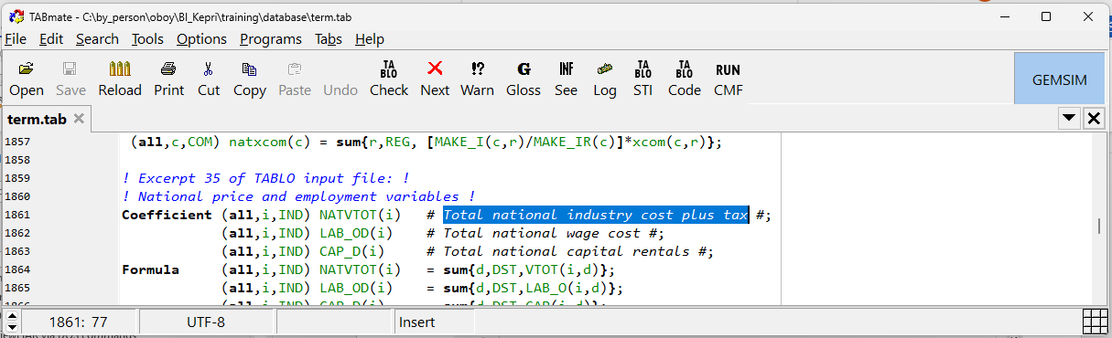
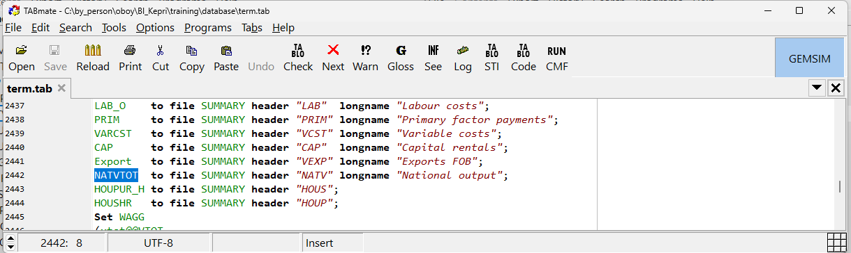
4.3. What COEFFICIENT is used for the total factor input to industry "i"? What is the total primary factor payments for all industries? (PRIM) PRIMCOST, 12359555
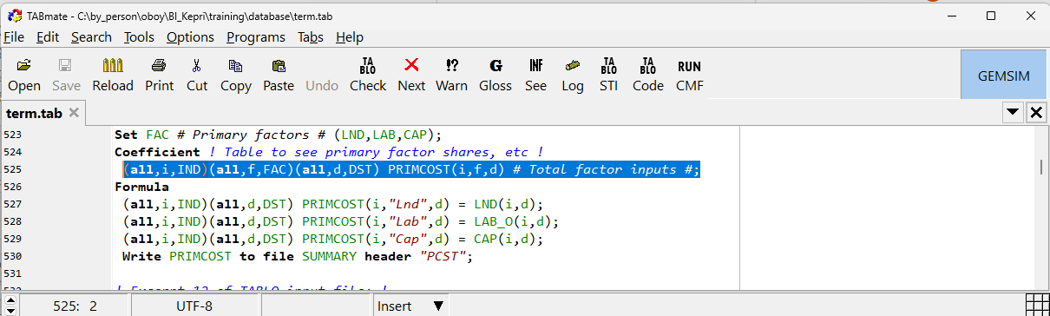
What is the total value of capital rental summed over all industries? 5565891
What is the total payments to labour summed over all industries? (LAB_O) 6331821
What is the total value of factor input to industry "Coal"? 221962
What is the total value of factor input to industry "Fishery"? 285245
What is the share of each of the factor inputs in the total costs of industry "Coal"?
Land = 25%, Labour = 20% and Capital = 55%
What is the share of each of the factor inputs in the total costs of industry "Fishery"?
Land = 18%, Labour = 53% and Capital = 27%
What is the share of labour in total factor cost for all industries? 6331821/12359555 = 51.2%
4.4. What is the total value at purchasers prices of exports of domestically-produced commodities "EdibleOil" and “OilPalm”? [Hint: search for the header VEXP]
Fishery = 8855, EdibleOil = 235770
What COEFFICIENT is this? EXPORT
What set elements do you need to look up? EXPORT(“EdibleOil”) summed over all regions and EXPORT(“Fishery”) summed over all regions.
What header on file SUMMARY VEXP
Which region exports the most “Edibleoil” and “OilPalm”? EXPORT(“EdibleOil”) = ROS=72%
EXPORT(“Fishery”) = ROI = 89%
What commodity has the greatest share nationally? [Hint: use the "column" share" feature in ViewHAR]
VEXP OthMan 38% followed by Coal at 12%
Which province has the highest share of agricultural exports? [Hint: sum the commodity exports of the first five commodities for each region]. ROI 54%
4.5. What is the difference between the Coefficients GDPINCSUM and GDPEXPSUM in TERMSUM.HAR?
GDPEXPSUM summarises GDP from the expenditure side while GDPINCSUM summarises GDP from the income side
What is the value of household expenditure in the provincial domestic product (PDP) of KepRi? 130311
What proportion is it of the PDP? (Use “Row” in the top left drop down box). 56%
What proportion is KepRi PDP of Indonesia’s GDP? (Use “Col” in the top left drop down box) . 2%

GDP questions
4.6. GNSM, GESM, NGSM are 3 headers in TERMSUM.HAR show values of GDP from the income and expenditure sides
4.7. Are the values of Nominal GDP from the income and expenditure sides equal? Yes at 12915061
4.8. Nominal national GDP from the expenditure side is often given by the formula
GDP = C + I + G + X - M
where C is Consumption, I is Investment, G is Government, X is Exports, M is Imports.
What COEFFICIENT contains these values in TERMSUM.Har? NATGDPEXPSUM at header NGSM
Find the values of all these quantities and determine each value’s share in GDP.
(Hint: Textbook definitions of GDP often ignore inventories.)
Fill in the following list of values:
 | Value (in the Summary file) | Share of GDP (“col” share)
C | 7554346.50 | 58%
I | 3635068.00 | 28%
G | 1611679.63 | 12%
X | 2356297.50 | 18%
-M | -2276289.25 | -18%
GDP | 12915059.34 | 100%
4.9. Examine coefficient GDPEXPSUM at header GESM. This shows expenditure side GDP by region. New columns REXPORTS and RIMPORTS are needed to account for trade within Indonesia. [EXP and IMPORTS include only international exports]. Choose the Row shares option to see shares of each category in regional GDP.
What is the share of EXPorts in KepRi GDP? 78%
What is the share of EXPorts in ROS GDP? 18%
4.10. Nominal GDP from the income side is given by the formula
GDPINC = PRIM + TAX
What do PRIM and TAX represent? Primary factors and all the commodity and production taxes.
Go to TERM.TAB and search for “GNSM”. You will find the formula for the calculation of GDP from the income side to see what “PRIM” and “TAX” mean. Fill in the following list of values from TERMSum.har (choose "Sum DST"):
 | Value (in the Summary file) | Share of GDP (“col” share)
LAND | 461843.1 | 3.6%
LABOUR | 6331821 | 49.0%
CAPITAL | 5565891 | 43.1%
PRODTAX | 89886.16 | 0.7%
COMTAX | 465619.6 | 3.6%
GDPINC | 12915061 | 100.0%
Share of PRIM in GDP (PRIM / GDPINC) = 95.7%
Still viewing Nominal GDP from the income side at header, GNSM, choose "All DST" and the Col shares option to see shares of regional GDP within the nation. Look at the total column.
What is KepRi share in national GDP ? 2%

