1.
Take the string 'Flipkart-Sale2024' and use string methods to convert it to lowercase, replace the dash with a space, and print the result.
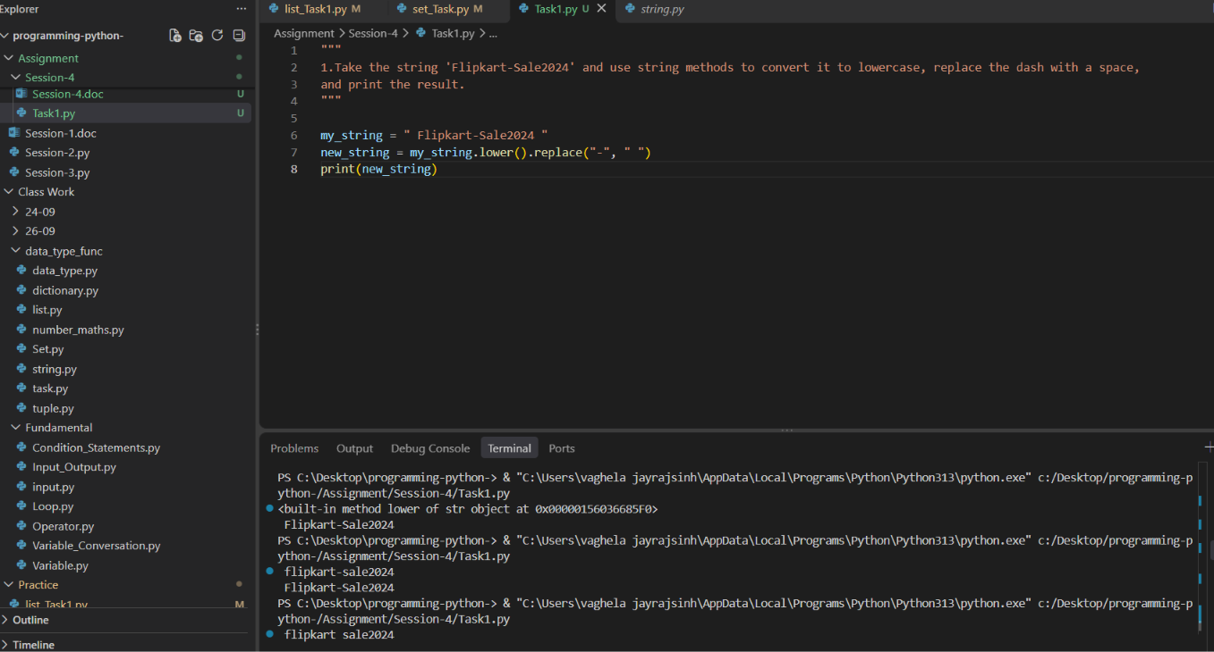

2.
Given the product name ' OnePlus Nord-CE 3 ', write code to clean it by removing extra spaces, converting all letters to uppercase, and replacing the dash with a colon.<br><br><em><strong>Hint:</strong> Use strip(), upper(), and replace() methods in sequence.</em>
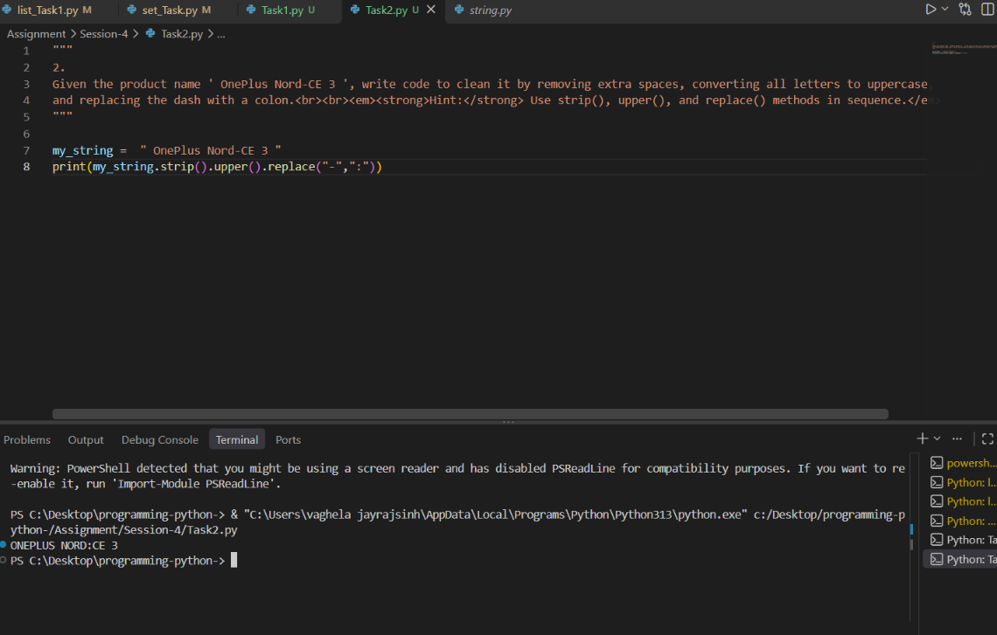

3.
Write a function split_product_code(product_code) that takes a string like 'ZOMATO-FOOD-2024' and returns a list of its parts using the split() method
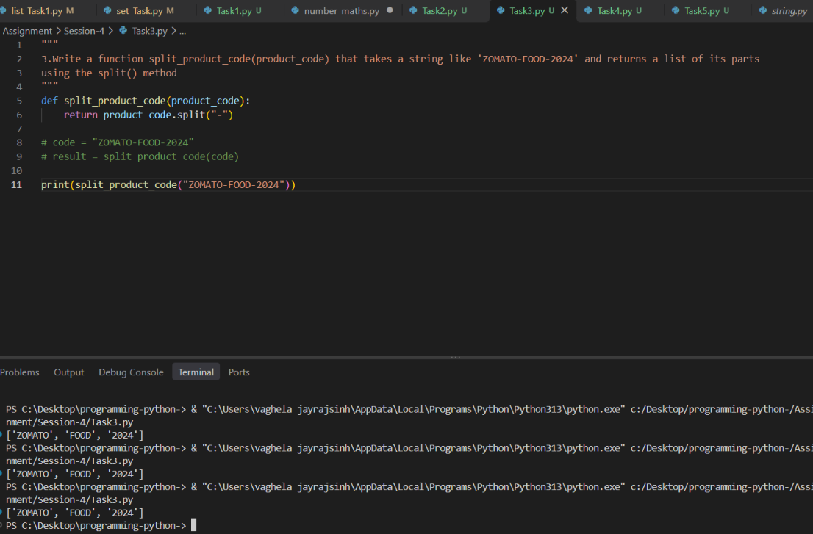

4.Given the string 'Spotify_Premium_Offer', use string slicing to extract and print only the word 'Premium'.
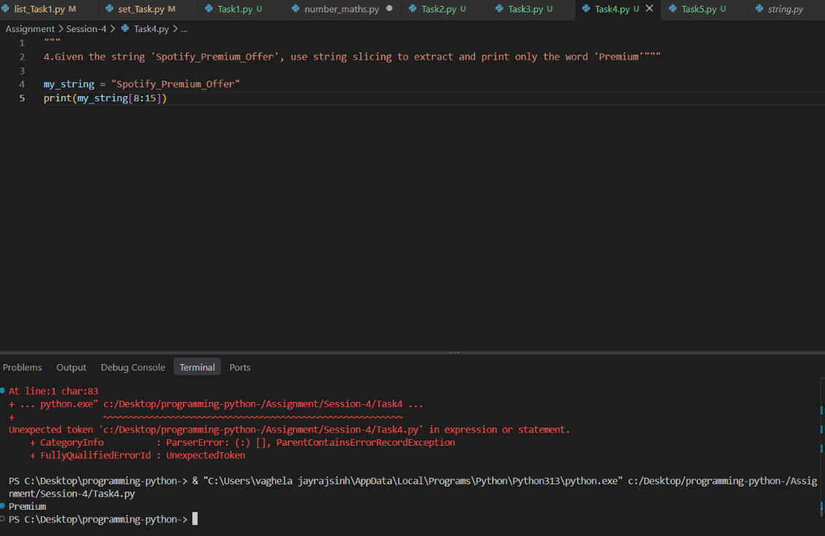

5.Format and print a message using variables: product = 'Myntra Shirt', price = 799.5. The output should be: 'Deal: Myntra Shirt is available at ₹799.50 only!' using string formatting.
