Task 1:Create a list called playlist_ids with 5 song IDs (as integers) that you might see in a Spotify playlist, and print the lista
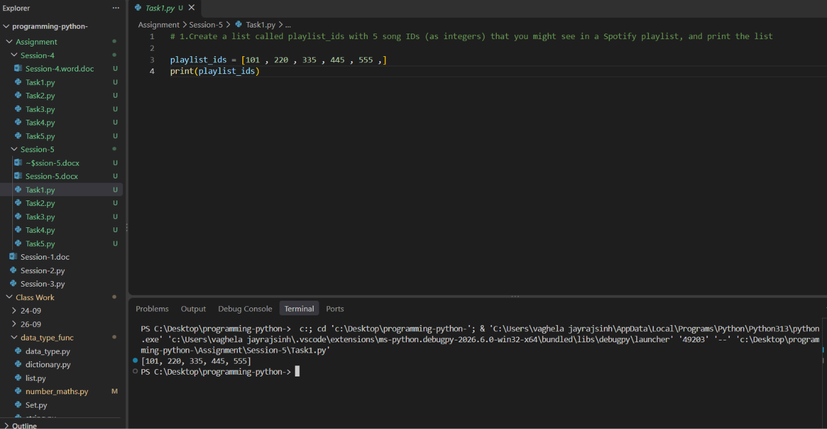

Task 2:Add two more song IDs to your playlist_ids list using both append() and extend(), then print the updated list.<br><br><em><strong>Hint:</strong> Use append() for a single ID and extend() for adding multiple IDs at once.</em>
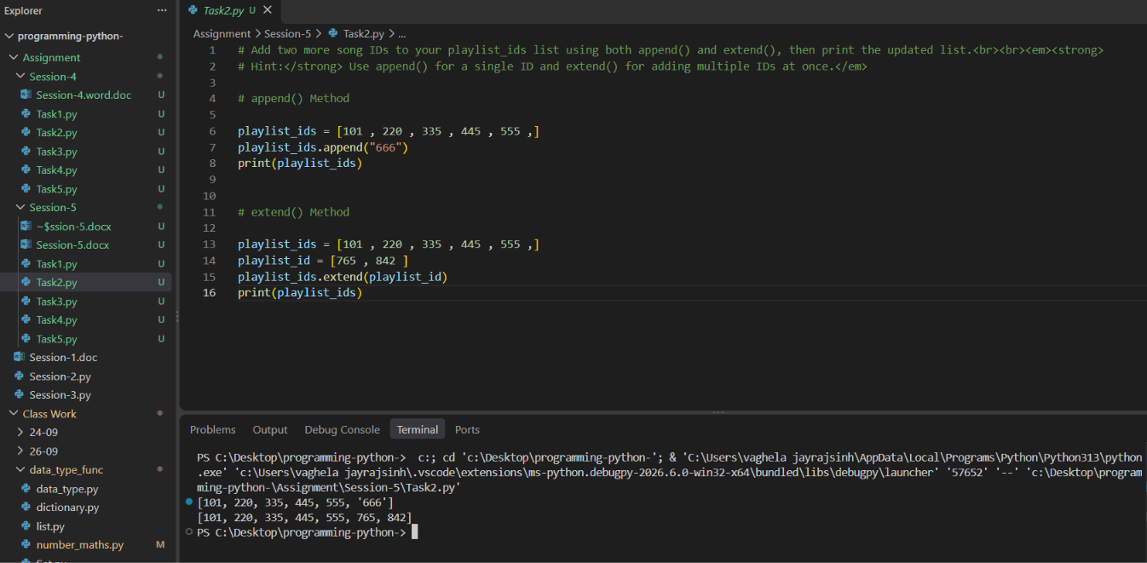

3.Simulate removing the last played song from your playlist_ids list using pop(), and display the removed ID along with the remaining playlist.
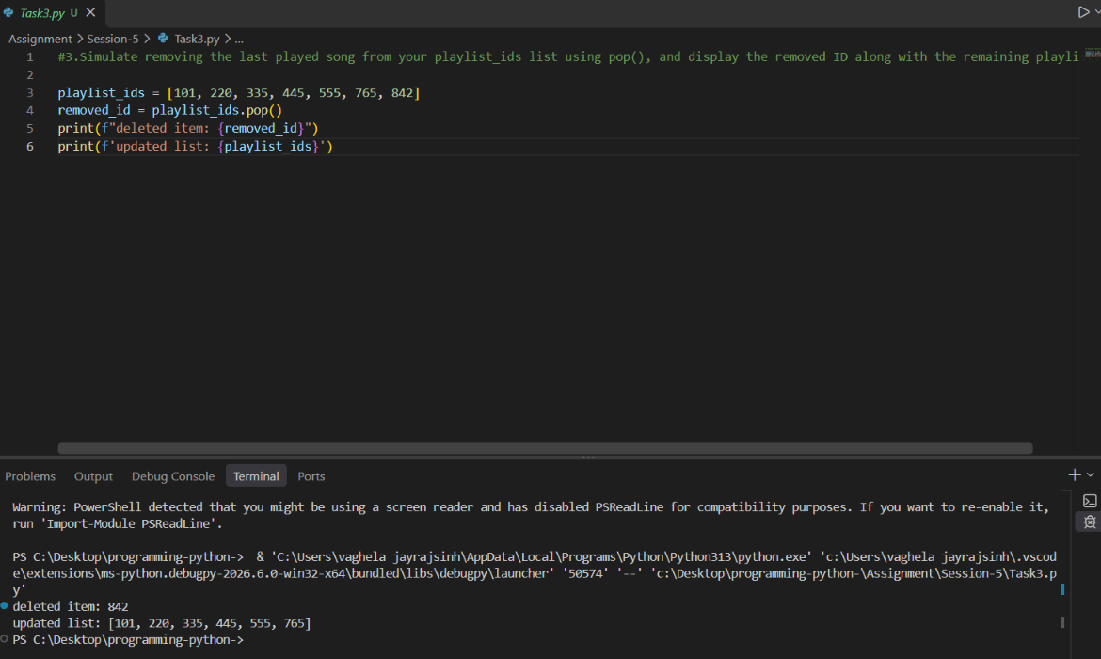

4.Create a tuple called insta_filters with 4 Instagram filter names (as strings). Try to change the first filter name and observe what error you get.<br><br><em><strong>Hint:</strong> Tuples are immutable. Note down the error message.
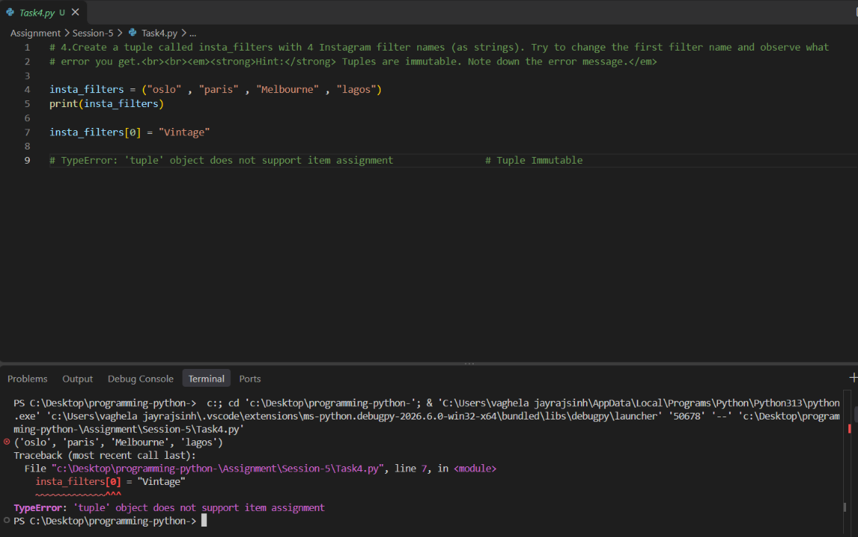

5.Write a short Python script that takes a scenario (like a list of recent Zomato orders vs a tuple of fixed IPL team names) and prints which one should use a list and which should use a tuple, explaining your choice in a comment.
