**Task 5: Creating a Custom Aggregation Function for Pandas groupby**

**Objective:**

The goal of this task was to create a custom aggregation function that can be applied to a groupby operation in Pandas. Instead of using the built-in aggregation functions like sum() or mean(), we implemented a custom function to compute a **weighted average** for each group.

**Approach:**

1. **Data Preparation**:
   * We started by creating a simple DataFrame with three columns: Category, Value, and Weight. The Category column groups the data, and the Value column contains the numbers we want to aggregate. The Weight column provides the weight for each Value, which is important for calculating the weighted average.
2. **Custom Aggregation Function**:
   * Instead of using the default Pandas aggregation functions, we wrote a custom function to compute the **weighted average** for each group. The formula for the weighted average is:

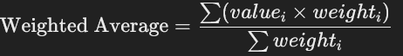

* + This ensures that values with higher weights contribute more to the average.

1. **Applying the Aggregation Function**:
   * We used groupby() to group the data by the Category column, and then applied our custom weighted_average function to the Value column using .apply(). This allowed us to compute the weighted average for each category in the DataFrame.

**Results:**

Using the custom aggregation function, we computed the weighted average for each category in the Category column. Here’s the result:

Input:

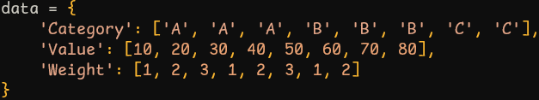

Output:

