***Rogue Blades: Manual***

**To play Rogue Blades, first click the “Start” button in the center of the starting screen.**

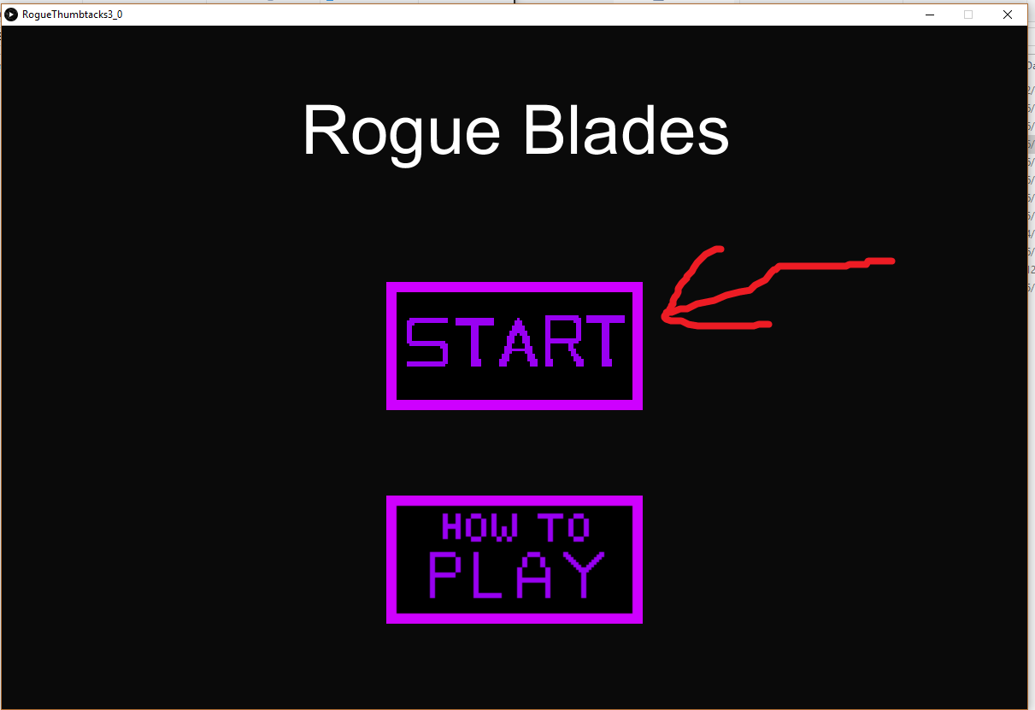

**If you would like in-game instructions, click the “How to play” button.**

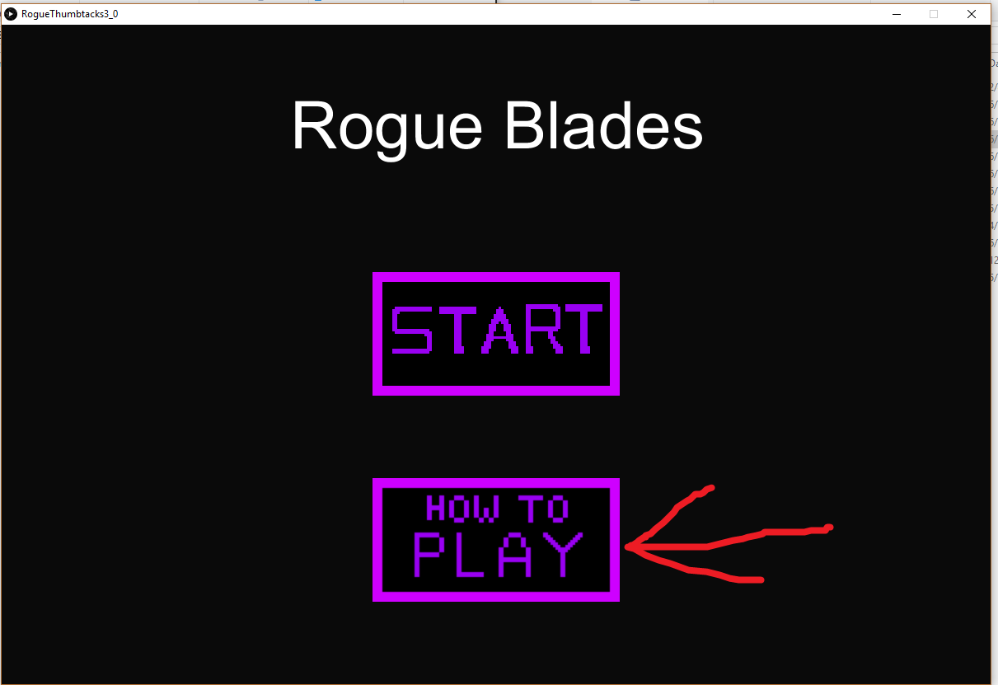

**After reading the in-game instructions on the “How to Play” screen, press the “Back” button to return to the starting screen.**

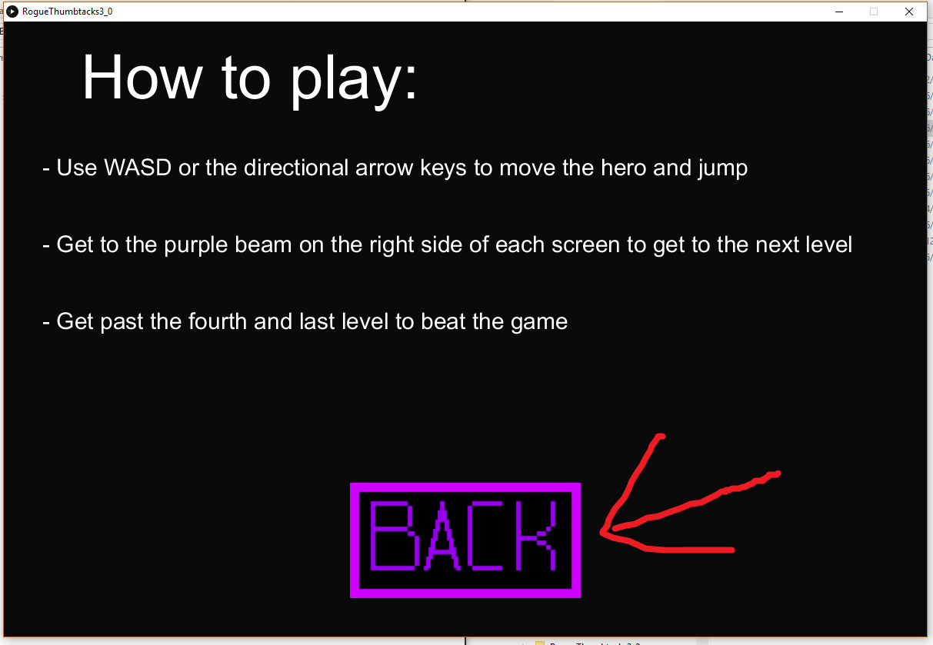

**After pressing the “Start” button, you will be sent to the first level. Here you will control the hero Bill:**

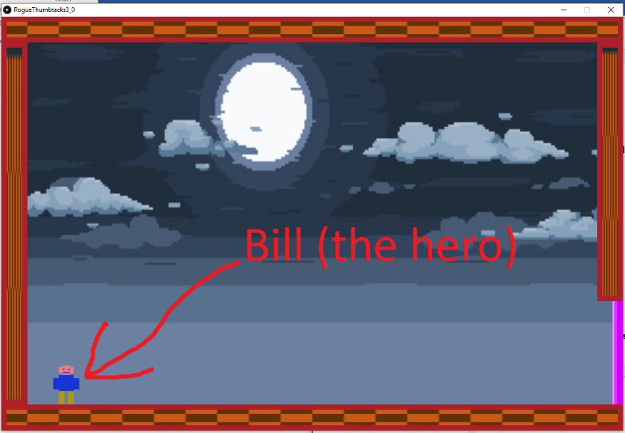

**Then use the WASD keys or alternatively the directional keys to control Bill, your character. (W/up for jump, A/left to move Bill left, D/right to move Bill right, and R to reset Bill to the beginning of the room (in case you fall).**

**Your goal is to get to the purple beam at the right side of the each level that look like this:**

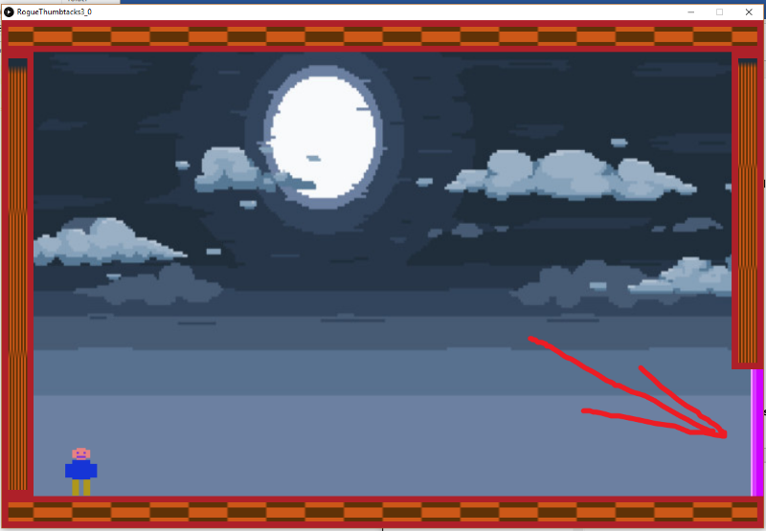

**To traverse rooms, simply jump from platform to platform (the brown rectangles):**

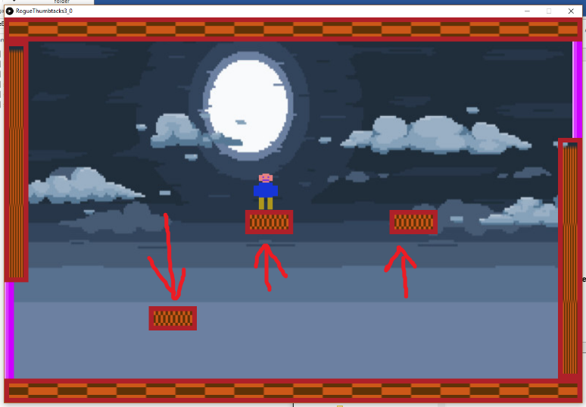

**Once you reach the fourth room, there will a small brown enemy on the floor. His name is Goomster and his main goal is to be annoying:**

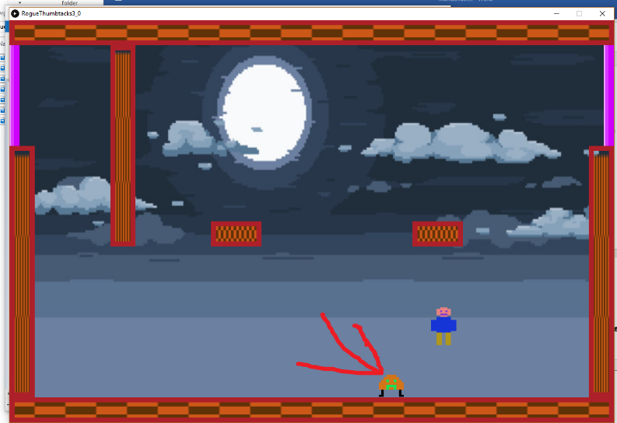

**If Bill gets within 200 pixels either direction of the enemy, he will begin to close in on Bill. Upon contact Bill will be knocked back in the direction Goomster is moving. There is no way to kill the enemy (right now).**

**If you jump on top of the enemy you will be able to jump a second time to reach the platforms above the hero.**

**Upon reaching the final purple beam, you will be taken to the end screen.**

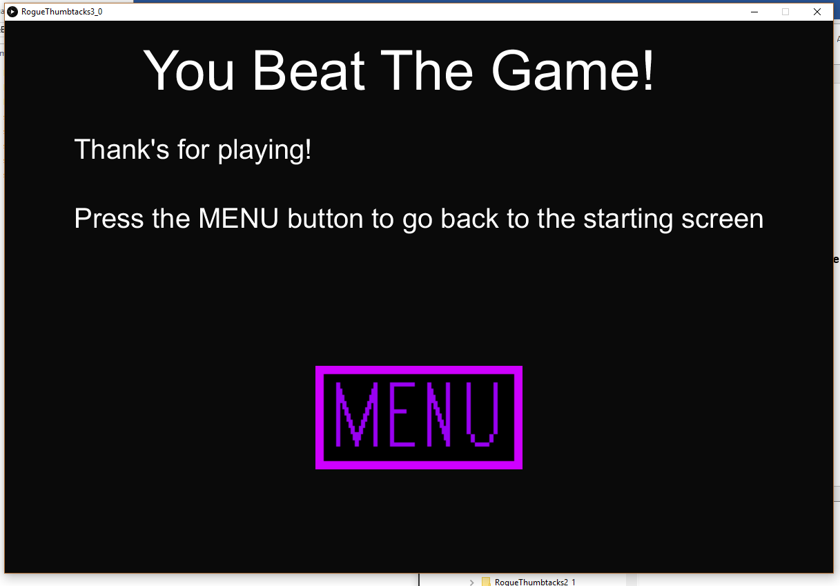

**If you would like to play again, you can press the menu button to return to the starting screen.**

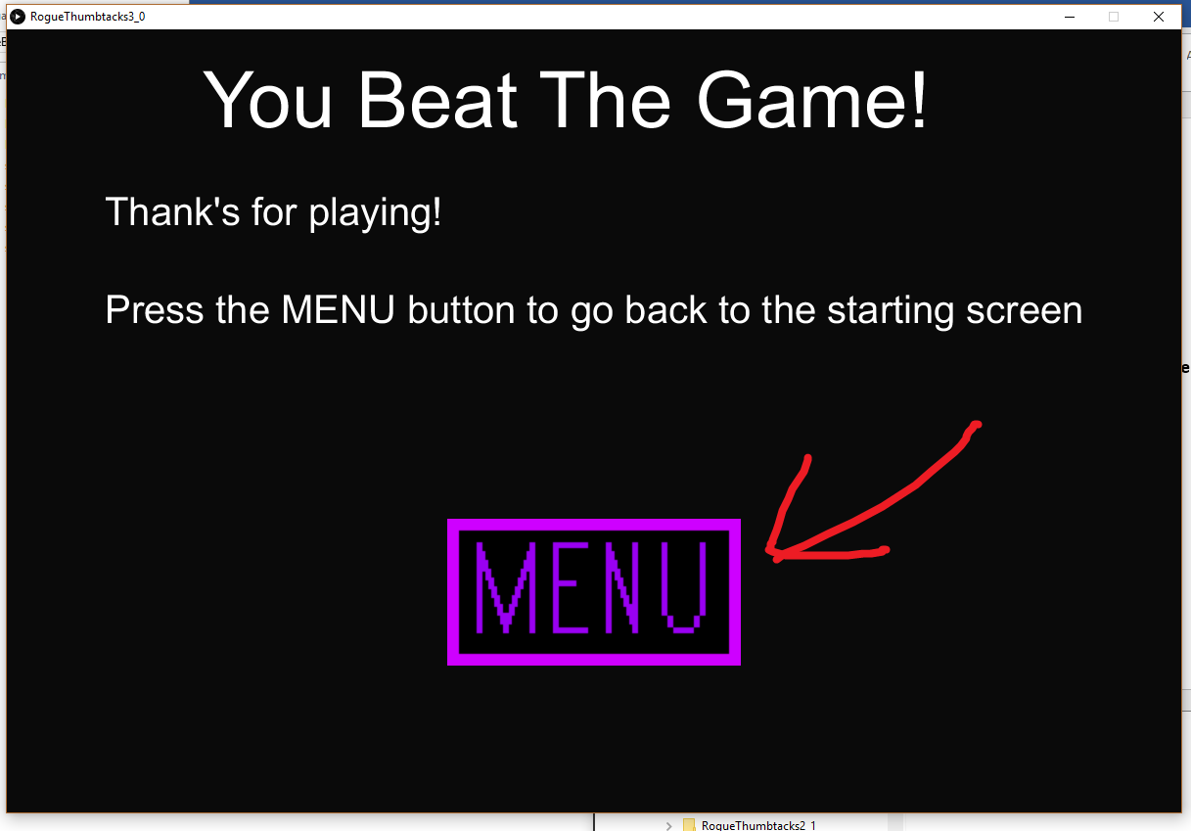

**A bug that you can use to your advantage is to walk off an edge and then press w as it allows you to jump in midair, accessing platforms you can’t jump to normally.**