Precision Agriculture with Remote Sensing and Machine Learning for Indian Agriculture

Precision Agriculture with Remote Sensing and Machine Learning for Indian Agriculture
Submitted in partial fulfillment of the requirements
of the degree of

B. Tech. Computer Engineering

By

Ansh Shah 60004220082
Bhumil Shah 60004220063
Dev Pandey 60004220008
Vandan Thakar 60004220131

Guide(s):

Prof. Pranit Bari
Department of Computer Engineering



University of Mumbai
2025-2026

CERTIFICATE

This is to certify that the project entitled “Precision Agriculture with Remote Sensing and Machine Learning for Indian Agriculture” is a bonafide work of “Ansh Shah (60004220082), Bhumil Shah (60004220063), Dev Pandey (60004220008), Vandan Thakar (60004220131)” submitted to the University of Mumbai in partial fulfillment of the requirement for the award of the degree of B. Tech. in Computer Engineering

Prof. Pranit Bari
Internal Guide

Dr. Meera Narvekar Dr. Hari Vasudevan
Head of Department Principal

Project Report Approval for B.Tech.

This project report entitled Precision Agriculture with Remote Sensing and Machine Learning for Indian Agriculture by Ansh Shah, Bhumil Shah, Dev Pandey, Vandan Thakar, under the guidance of Prof. Pranit Bari is approved for the degree of B.Tech. in Computer Engineering.

Examiners
1.---------------------------------------------
2.---------------------------------------------

Date: January 10 2026
Place: Mumbai

Declaration
I/We declare that this written submission represents my/our ideas in my/our own words and where others' ideas or words have been included, I/We have adequately cited and referenced the original sources. I/We also declare that I/We have adhered to all principles of academic honesty and integrity and have not misrepresented or fabricated or falsified any idea/data/fact/source in my/our submission. I/We understand that any violation of the above will be cause for disciplinary action by the Institute and can also evoke penal action from the sources which have thus not been properly cited or from whom proper permission has not been taken when needed.

-----------------------------------------
(Ansh Shah, C013)

-----------------------------------------
(Bhumil Shah, C029)

-----------------------------------------
(Dev Pandey, C034)

-----------------------------------------
(Vandan Thakar, C168)

Date: January 10 2026

Abstract

Precision agriculture is an innovative farming method using technologies to optimize crop production while minimizing wastage of resources. This project proposes a comprehensive precision agriculture system that combines remote sensing information with machine learning algorithms that enable smart crop yield estimates for Indian agriculture, particularly machine learning algorithms that enable focusing on Bajra (Pearl Millet) cultivation in Uttar Pradesh.

The proposed model can effectively solve the following challenges for agricultural machine learning: The critical challenge of lacking training data for agricultural machine learning process through implementing the Synthetic Minority Over-sampling Technique (SMOTE). The original dataset with 1,172 Bajra crops from Uttar Pradesh, which was then expanded to 5,860 high quality synthetic samples, achieving a 5x data augmentation while maintaining statistical distributions of the original data. Remote sensing capabilities are simulated through integration with the Open-Meteo Weather API, which provides 90 days of historical environmental data including atmospheric temperature, precipitation, soil temperature at multiple depths (surface and 6cm), and soil moisture measurements at varying soil layers (0-1cm and 3-9cm).

The machine learning component employs a XGBoost Classifier trained on the combined real and synthetic dataset to categorize expected crop yields into Low, Medium, and High categories. The model configuration includes 120 decision trees with a maximum depth of 10, achieving robust predictions by incorporating 18 features spanning crop-specific parameters and environmental conditions. Feature importance analysis reveals that cultivation area, soil moisture at 3-9cm depth, and maximum daily temperature are the most influential factors in yield prediction. The project methodology demonstrates the effectiveness of SMOTE-based data augmentation for small agricultural datasets where traditional approaches like Generative Adversarial Networks (GANs) prove ineffective. Initial experiments with GANs resulted in discriminator accuracy of only 7-20% compared to the expected 40-60%, confirming that GANs require substantially larger datasets (50,000+ samples) for effective tabular data generation.

Contents
Chapter | Contents | Page No.
1 | INTRODUCTION
 | 1.1 Description | 1
 | 1.2 Problem Formulation | 6
 | 1.3 Motivation | 10
 | 1.3 Proposed Solution | 16
 | 1.4 Scope of the project | 25
2 | REVIEW OF LITERATURE
3 | SYSTEM ANALYSIS
 | 3.1 Functional Requirements
 | 3.2 Non-Functional Requirements
 | 3.3 Specific Requirements
 | 3.4 Use-Case Diagrams and description
4 | ANALYSIS MODELING
 | 4.1 Data Modeling
 | 4.2 Activity Diagrams / Class Diagram
 | 4.3 Functional Modeling
5 | DESIGN
 | 5.1 Architectural Design
6 | IMPLEMENTATION
 | 6.1 Module Implemented
 | 6.2 Output
7 | CONCLUSION

List of Figures

Fig. No. | Figure Caption | Page No.
3.1 | Use Case Diagram - Precision Agriculture System
4.1 | Entity-Relationship Diagram
4.2 | Activity Diagram - Data Processing Flow
4.3 | Level 0 DFD - Context Diagram
4.4 | Level 1 DFD - System Overview
4.5 | Timeline Chart (Gantt Chart)
5.1 | System Architecture Diagram
5.2 | Data Flow Architecture
6.1 | Top 10 Crops by Total Area
6.2 | State-wise Bajra Distribution
6.3 | Weather API Data Flow
6.4 | SMOTE Interpolation Concept
6.5 | Data Quality Comparison (Real vs Synthetic)
6.6 | Correlation Heatmap
6.7 | Feature Importance Analysis
6.8 | Sample Prediction Output

List of Tables

Table No. | Table Title | Page No.
3.1 | Functional Requirements Specification
3.2 | Non-Functional Requirements
3.3 | Hardware Requirements
3.4 | Software Requirements
4.1 | Data Dictionary - Crop Data
4.2 | Data Dictionary - Weather Data
5.1 | Technology Stack
6.1 | Original Dataset Characteristics
6.2 | State-wise Bajra Distribution
6.3 | Weather Feature Specifications
6.4 | GAN vs SMOTE Comparison
6.5 | SMOTE Generation Results
6.6 | Dataset Split Distribution
6.7 | XGBoost Hyperparameters
6.8 | Classification Report
6.9 | Feature Importance Ranking

LIST OF ABBREVIATIONS

Sr. No. | Abbreviation | Expanded Form
1 | DSS | Decision Support System
2 | ML | Machine Learning
3 | API | Application Programming Interface
4 | SMOTE | Synthetic Minority Over-sampling Technique
5 | GAN | Generative Adversarial Network
6 | RF | XGBoost
7 | CSV | Comma Separated Values
8 | DFD | Data Flow Diagram
9 | ER | Entity-Relationship
10 | k-NN | k-Nearest Neighbors
11 | NDVI | Normalized Difference Vegetation Index
12 | IoT | Internet of Things
13 | LSTM | Long Short-Term Memory
14 | SRS | Software Requirements Specification
15 | UP | Uttar Pradesh

Chapter 1
INTRODUCTION
1.1 Description
Agriculture forms the backbone of the Indian economy, employing approximately 58% of the rural population and contributing significantly to the nation's Gross Domestic Product. Despite India being one of the world's largest agricultural producers, the sector continues to face numerous challenges including unpredictable weather patterns, inadequate access to technology, and lack of data-driven decision support systems. Traditional farming practices, while rich in generational wisdom, often fall short in addressing the complexities introduced by climate change and modern agricultural demands. We have made our own analysis by experimenting it on a crop of Bajra grown at home using IoT sensors that gather temperature and soil moisture data daily.
Precision Agriculture with Remote Sensing and Machine Learning for Indian Agriculture is an intelligent crop yield prediction system designed to bridge this technological gap. The system specifically targets Bajra (Pearl Millet) cultivation in Uttar Pradesh, India's most populous state and a significant contributor to national agricultural output. By integrating historical agricultural data with real-time weather information obtained through remote sensing APIs, the system predicts crop yields categorized as Low, Medium, or High, enabling farmers and agricultural stakeholders to make informed decisions.

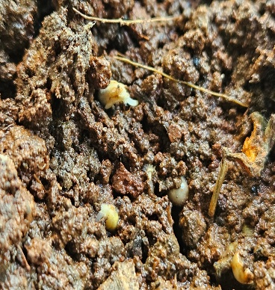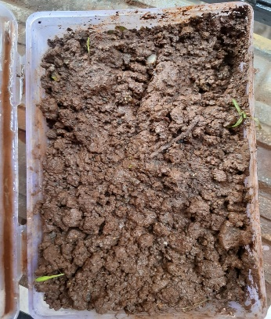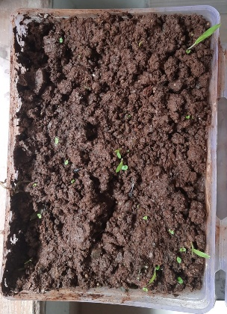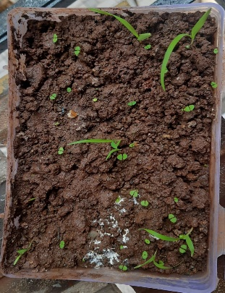

Core Functionality of the Project:
1. Comprehensive Data Acquisition and Processing: The system begins by loading and processing a comprehensive agricultural dataset containing 238,838 crop records spanning multiple years, states, districts, seasons, and crop types from across India. This dataset, sourced from the Government of India's Open Data Platform, represents one of the most extensive publicly available agricultural databases. The data processing pipeline performs the following operations:
- Data Loading: Efficient loading of large CSV files using pandas library with optimized memory management
- Data Validation: Identification and handling of missing values across critical columns including state_name, district_name, crop_year, season, crop, area_, and production_
- Data Cleaning: Removal of invalid entries containing zero or negative values for area or production, which represent data entry errors or incomplete records
- Feature Engineering: Calculation of derived metrics including yield (production/area) and yield categories based on quantile distribution
- Data Filtering: Focused extraction of Bajra cultivation records from Uttar Pradesh, resulting in 1,172 high-quality records suitable for machine learning

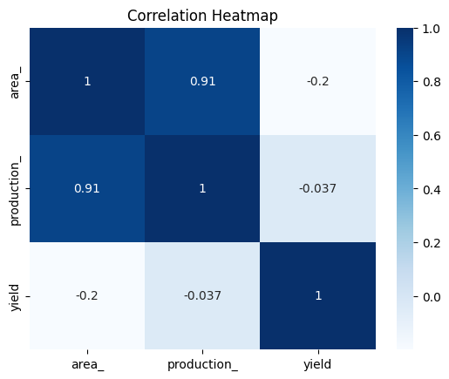

2. Remote Sensing Integration through Weather API: Remote sensing traditionally involves satellite-based observation of earth surface characteristics. In this project, we simulate remote sensing capabilities through the Open-Meteo Archive API, which provides comprehensive environmental data that would otherwise require expensive satellite imagery or ground-based sensor networks. The weather integration module performs:
- API Configuration: Connection to Open-Meteo's historical weather archive with specified geographic coordinates (Lucknow: 26.8467°N, 80.9462°E) representing central Uttar Pradesh
- Temporal Coverage: Retrieval of 90 days of historical weather data to capture seasonal variations and trends
- Multi-parameter Acquisition: Collection of 10 distinct weather and soil parameters at multiple temporal resolutions
- Data Synchronization: Alignment of weather data with crop records based on temporal and spatial attributes

The weather parameters collected include:
Parameter Category | Specific Parameters | Measurement Frequency
Atmospheric Temperature | temperature_2m (at 2 meters height) | 3 times daily (6 AM, 12 PM, 6 PM)
Precipitation | precipitation (rainfall/snowfall) | 3 times daily
Soil Temperature | soil_temp_0cm (surface), soil_temp_6cm (6cm depth) | 3 times daily
Soil Moisture | soil_moisture_0_1cm (0-1cm layer), soil_moisture_3_9cm (3-9cm layer) | 3 times daily
Daily Aggregates | temp_max, temp_min, precipitation_sum, sunshine_duration | Once daily

3. Synthetic Data Generation using SMOTE: One of the most significant challenges in agricultural machine learning is the scarcity of labeled training data for specific crop-region combinations. While the original dataset contains 238,838 records, filtering for Bajra in Uttar Pradesh yields only 1,172 samples—insufficient for training robust machine learning models. Industry benchmarks suggest:
- Traditional Machine Learning: Minimum 5,000-10,000 samples for reliable training
- Deep Learning Models: Minimum 50,000-100,000 samples for effective learning

To address this data scarcity, the system implements SMOTE (Synthetic Minority Over-sampling Technique), a sophisticated data augmentation algorithm that generates synthetic samples through intelligent interpolation. The SMOTE implementation:
- Neighbor Identification: For each original sample, identifies k=5 nearest neighbors using Euclidean distance in feature space
- Synthetic Generation: Creates new samples along the line segments connecting original samples to their neighbors
- Distribution Preservation: Maintains statistical properties of the original dataset including mean, variance, and feature correlations
- Augmentation Factor: Achieves 5x multiplication, expanding 1,172 original records to 5,860 synthetic samples
- Combined Dataset: Merges real and synthetic data to create a robust training set of 7,032 samples

4. Machine Learning-based Yield Prediction: The core prediction engine utilizes a Random
Forest Classifier, which is an ensemble method to merge multiple decision trees to achieve
superior prediction accuracy and generalization. The machine learning pipeline includes:
- Feature Preparation: Selection and encoding of 18 features spanning crop characteristics and environmental parameters
- Label Encoding: Transformation of categorical variables (district_name, season) into numerical representations
- Target Variable Creation: Quantile-based binning of continuous yield values into three categories (Low, Medium, High) with equal distribution (33.33% each)
- Model Training: Model Training: Training of XGBoost with 120 estimators (decision trees) and max depth of 10 in order to balance the model's complexity and generalization
- Cross-validation: K-fold validation to ensure model robustness and prevent overfitting
- Prediction Generation: Output of yield category with probability scores for each class

5. Interpretable Feature Importance Analysis: Unlike black-box models that provide predictions without explanation, the system offers transparent insights into the factors driving predictions. The feature importance module:
- Importance Calculation: Computation of Gini importance scores for each feature based on their contribution to decision tree splits
- Ranking Generation: Ordered list of features from most to least influential
- Visualization: Bar charts and heatmaps displaying feature contributions
- Actionable Insights: Translation of statistical importance into practical recommendations for farmers
The analysis reveals that cultivation area, soil moisture at 3-9cm depth, and maximum daily temperature are the most influential factors in determining Bajra yield in Uttar Pradesh.

6. Comprehensive Output Generation: The system produces multiple output artifacts for various stakeholders:
- Prediction Results: Yield category with confidence scores displayed in user-friendly format
- Dataset Exports: Nine structured CSV files for training, validation, and testing purposes
- Visualizations: Over 15 charts including distribution plots, correlation heatmaps, and trend analyses
- Model Artifacts: Serialized model files for deployment and future predictions

1.2 Problem Formulation
The agricultural sector in India, despite its critical importance to the national economy and food security, continues to grapple with fundamental challenges that impede productivity, profitability, and sustainability. The problems addressed by this precision agriculture system are multifaceted and interconnected, requiring a holistic technological solution.

Problem 1: Unpredictable Crop Yields and Production Uncertainty
Farmers cultivating Bajra in Uttar Pradesh face significant uncertainty regarding their expected yields. This unpredictability manifests in several ways:
Economic Impact:
- Farmers cannot accurately estimate revenue, making financial planning difficult
- Loan repayment schedules become challenging due to income uncertainty
- Investment decisions for subsequent seasons are made without reliable data
- Price negotiations with buyers are disadvantaged due to quantity uncertainty

Operational Consequences:
- Storage facilities cannot be appropriately sized or reserved
- Transportation logistics suffer from over or under-booking
- Labor requirements for harvesting are difficult to estimate
- Post-harvest processing capacity may not match actual production

Statistical Context: According to the Ministry of Agriculture, post-harvest losses in India range from 15-20% of total production, with a significant portion attributed to inadequate planning stemming from yield uncertainty. For Bajra specifically, the variance in yields across districts in Uttar Pradesh can exceed 40% year-over-year, making traditional estimation methods highly unreliable.

Problem 2: Climate Variability and Changing Weather Patterns
The agricultural wisdom accumulated over generations is predicated on relatively stable climatic conditions. However, climate change has fundamentally altered weather patterns across India:
Temperature Changes:
- Average temperatures in Uttar Pradesh have increased by 0.5-1.0°C over the past three decades
- Heat waves during critical growth stages have become more frequent
- Night-time temperatures, crucial for certain growth phases, show increasing variability
Precipitation Alterations:
- Monsoon onset dates have become increasingly unpredictable
- Rainfall distribution within seasons shows greater variability
- Instances of both drought and flooding have increased in frequency
Impact on Traditional Knowledge:
- Planting calendars based on traditional indicators are no longer reliable
- Pest and disease patterns have shifted with changing temperatures
- Water management practices require constant adaptation
Quantitative Evidence: Data from the India Meteorological Department indicates that the coefficient of variation for monsoon rainfall in Uttar Pradesh has increased from approximately 15% in the 1980s to over 22% in recent years, representing a significant increase in uncertainty
that traditional farming practices cannot accommodate.

Problem 3: Information Asymmetry and Knowledge Gap
A substantial disconnect exists between agricultural research outputs and farmer-level implementation:
Research-to-Field Gap:
- Agricultural universities and ICAR institutions generate valuable research findings
- Translation of research into practical recommendations is often delayed
- Language barriers prevent dissemination to non-English speaking farmers
- Technical complexity makes direct application difficult for average farmers
Extension Service Limitations:
- Government extension workers are understaffed relative to farmer population
- Coverage in remote areas remains inadequate
- Information provided is often generic rather than location-specific
- Feedback mechanisms from farmers to researchers are weak
Digital Divide:
- Despite increasing smartphone penetration, agricultural apps have limited adoption
- Most existing solutions are in English or require technical literacy
- Internet connectivity in rural areas remains inconsistent
- Trust in digital recommendations is still developing among farming communities

Problem 4: Lack of Data-Driven Decision Support Systems
The absence of accessible, reliable decision support tools forces farmers to rely on suboptimal methods:
Current Decision-Making Approaches:
- Intuition based on personal experience and observation
- Advice from neighboring farmers facing similar conditions
- Generic recommendations from input dealers (often biased toward product sales)
- Occasional guidance from government agricultural officers
Limitations of Current Approaches:
- Subjective assessments cannot process multiple variables simultaneously
- Neighbor advice may not account for micro-variations in soil and microclimate
- Input dealer recommendations prioritize sales over farmer welfare
- Government guidance is periodic rather than continuous
Consequences:
- Suboptimal input application (seeds, fertilizers, pesticides)
- Inefficient water usage leading to either crop stress or wastage
- Mistimed agricultural operations (planting, harvesting)

Problem 5: Insufficient Data for Machine Learning Applications
The application of machine learning to agriculture faces a fundamental challenge: data scarcity for specific crop-region combinations.
Dataset Limitations:
- Original dataset: 238,838 records across all India
- After filtering for Bajra: 3,620 records
- After filtering for Uttar Pradesh: 1,172 records
- This represents only 0.49% of the original dataset
Machine Learning Requirements:
- Supervised learning algorithms require substantial training data
- Model generalization depends on exposure to diverse examples
- Class imbalance can bias predictions toward majority classes
- Overfitting risk increases with smaller datasets
Previous Augmentation Attempts: Generative Adversarial Networks (GANs), while successful for image augmentation, proved ineffective for tabular agricultural data:
- Our GAN implementation achieved only 7-20% discriminator accuracy
- Expected discriminator accuracy for balanced training: 40-60%
- Mode collapse prevented generation of diverse synthetic samples
- Training instability made convergence unreliable

Formal Problem Statement:
Given the challenges enumerated above, the problem can be formally stated as:
"Design and implement a precision agriculture system that:
1. Processes historical agricultural data from government sources to extract relevant crop-region specific records
2. Integrates remote sensing data (weather and soil parameters) through API-based acquisition
3. Addresses data scarcity through effective augmentation techniques that preserve statistical distributions
4. Trains a machine learning model capable of classifying crop yields into actionable categories
5. Provides interpretable predictions with confidence measures to support farmer decision-making
Specifically, for Bajra cultivation in Uttar Pradesh, predict yield categories (Low, Medium, High) with sufficient accuracy to enable practical agricultural planning."

1.3 Motivation
The development of this precision agriculture system is motivated by the critical need to modernize Indian agriculture through appropriate technology adoption. This section examines existing approaches, their limitations, and justifies the methodology chosen for this project.

Analysis of Existing Approaches:
Approach 1: Traditional Rule-Based Expert Systems
Description: Expert systems emerged in the 1980s as one of the first attempts to encode agricultural knowledge in computational form. These systems capture domain expertise as a collection of IF-THEN rules that can be applied to specific situations.
Example Implementation:
IF soil_type = "Sandy Loam" AND rainfall > 500mm AND season = "Kharif"
THEN recommended_crop = "Bajra"
AND expected_yield = "Medium"
Advantages:
- Transparent reasoning that can be explained to users
- Incorporates validated domain expertise
- Does not require large training datasets
- Relatively simple to implement and maintain
Drawbacks:
Limitation | Impact
Rigid rule structure | Cannot handle situations not explicitly covered by rules
Difficulty capturing complex interactions | Weather-soil-crop interactions involve hundreds of variables
Maintenance burden | Rules require constant updating as conditions change
Binary logic | Cannot express uncertainty or probability
Expert dependency | Quality limited by expert availability and knowledge
Scalability issues | Number of rules explodes with additional variables

Approach 2: Statistical Regression Models
Description: Statistical approaches including linear regression, multiple regression, and time series analysis have been widely applied to crop yield prediction. These methods establish mathematical relationships between input variables and yield outcomes.
Common Models Used:
- Simple Linear Regression: yield = β₀ + β₁×rainfall
- Multiple Linear Regression: yield = β₀ + β₁×rainfall + β₂×temperature + β₃×area
- ARIMA for time series: Modeling yield trends over time
Advantages:
- Well-established theoretical foundation
- Coefficients have interpretable meanings
- Computationally efficient
- Statistical significance testing available

Drawbacks:
Limitation | Impact
Linearity assumption | Real relationships are often non-linear (e.g., optimal temperature range)
Independence assumption | Weather variables are often correlated
Normality requirement | Agricultural data frequently has skewed distributions
Sensitivity to outliers | Extreme weather events disproportionately affect models
Limited interaction modeling | Cannot capture complex variable interactions
Poor extrapolation | Unreliable predictions outside training data range

Approach 3: Simple Machine Learning Models on Limited Data
Description: Basic machine learning classifiers (Decision Trees, Naive Bayes, k-NN) trained directly on available data without augmentation.
Implementation Approach:
- Direct training on 1,172 Bajra-UP records
- Standard train-test split (80-20)
- Basic hyperparameter tuning
Advantages:
- Quick to implement
- No additional data generation required
- Established algorithms with known properties
Drawbacks:
Limitation | Impact
Severe overfitting | Model memorizes training data rather than learning patterns
Poor generalization | Accuracy drops significantly on unseen data
Class imbalance sensitivity | May bias toward majority class
Limited pattern learning | Insufficient examples to learn complex relationships
High variance | Small changes in training data cause large model changes
Unreliable confidence | Probability estimates are poorly calibrated

Approach 4: GAN-Based Data Augmentation
Description: GANs are composed of two distinct neural networks (Generator and Discriminator) that compete against each other to generate synthetic data that cannot be distinguished from the real data.
Architecture:
- Generator: Creates fake images from random noise
- Discriminator: Tries to maximize the differentiation between real samples from generated ones
- Training: Adversarial process where both networks improve iteratively

Our Implementation Results: We attempted GAN-based augmentation for Bajra data with the following outcomes:
Metric | Expected Value | Achieved Value | Status
Discriminator Accuracy | 40-60% | 7-20% | Failed
Generator Loss Convergence | Decreasing | Oscillating | Failed
Sample Diversity | High | Low (mode collapse) | Failed
Statistical Match | Close to real | Significant deviation | Failed
Training Stability | Stable | Highly unstable | Failed

Root Cause Analysis:
Factor | Impact on GAN Performance
Dataset size (1,172 samples) | GANs require 50,000+ samples for effective training
Tabular data nature | GANs optimized for continuous data (images); struggle with mixed categorical/numerical
Feature dimensionality | High-dimensional feature space with limited samples
Mode collapse | Generator produces limited variety of samples
Training dynamics | Discriminator overpowers generator quickly

Approach 5: Manual Weather Monitoring
Description: Traditional approach where farmers observe and interpret weather conditions based on personal observation and local indicators.
Methods Used:
- Visual sky observation for rainfall prediction
- Traditional calendars based on lunar cycles
- Local flora/fauna behavior as weather indicators
- Community knowledge sharing

Drawbacks:
Limitation | Impact
Subjectivity | Different observers reach different conclusions
Limited parameters | Cannot measure soil moisture or temperature at depth
No historical analysis | Cannot identify trends or patterns
Spatial limitation | Observations limited to immediate vicinity
No quantification | Cannot provide numerical predictions
Climate change invalidation | Traditional indicators becoming unreliable

Approach 6: Government Advisory Systems
Description: Periodic bulletins and recommendations issued by agricultural departments, Krishi Vigyan Kendras (KVKs), and state agricultural universities.
Delivery Mechanisms:
- Radio broadcasts
- Newspaper agriculture sections
- SMS alerts (Kisan Call Centers)
- Extension worker visits

Drawbacks:
Limitation | Impact
Generic recommendations | Same advice for diverse conditions
Delayed information | Bulletins often lag behind actual conditions
Limited personalization | Cannot account for individual farm characteristics
Irregular updates | Frequency insufficient for dynamic decisions
One-way communication | No feedback mechanism for farmers
Coverage gaps | Remote areas underserved

Justification for Proposed Approach:
Based on the comprehensive analysis of existing approaches and their limitations, our proposed system adopts the following methodology:

1. SMOTE for Data Augmentation:
Why SMOTE over GANs:
Aspect | SMOTE | GAN
Minimum data requirement | 100+ samples | 50,000+ samples
Training time | Instant (no training) | Hours to days
Stability | Deterministic, reproducible | Unstable, may not converge
Tabular data handling | Native support | Poor performance
Statistical preservation | Guaranteed | Uncertain
Computational resources | Minimal | GPU required
Implementation complexity | Simple | Complex

SMOTE Algorithm Advantage: SMOTE generates synthetic samples through k-nearest neighbor interpolation, mathematically expressed as:
$$x_{new}=x_{i}+ λ*(x_{neighbour}-x_{i})$$

Where:
- $x_{i}$ is an original sample
- $x_{neighbour}$ is one of its k nearest neighbors
- λ is a random number between 0 and 1
This approach guarantees that synthetic samples lie within the convex hull of existing data, preserving the underlying data distribution.

2. XGBoost for Prediction:
Why XGBoost over Other Algorithms:
Aspect | XGBoost | Linear Models | Neural Networks
Non-linearity handling | Excellent | Poor | Excellent
Interpretability | Good (feature importance) | Excellent | Poor
Overfitting resistance | High (ensemble averaging) | Medium | Low with small data
Data requirements | Moderate | Low | High
Mixed data types | Handles well | Requires encoding | Requires encoding
Training speed | Fast | Very fast | Slow
Hyperparameter sensitivity | Low | Low | High

3. Open-Meteo API for Remote Sensing:
Why API-based Weather Data:
Aspect | Open-Meteo API | Satellite Imagery | Ground Sensors
Cost | Free | Expensive | High capital + maintenance
Implementation | Simple REST API | Complex processing | Hardware installation
Coverage | Global | Variable | Point-specific
Historical data | 40+ years | Limited | Depends on installation
Parameters | Comprehensive | Limited to spectral | Depends on sensors
Update frequency | Hourly | Daily/Weekly | Real-time
Reliability | High (multiple sources) | Cloud interference | Sensor failures

1.4 Proposed Solution
The proposed precision agriculture system implements a comprehensive end-to-end pipeline that addresses each identified problem through carefully selected technologies and methodologies. This section provides detailed technical specifications of the solution architecture and implementation.

Layer 1: Data Acquisition Layer
Component 1.1: CSV Reader
Purpose: Efficient loading of large agricultural datasets with memory optimization.
Technical Specifications:
Parameter | Value
Library | pandas 1.3+
File Format | CSV (Comma Separated Values)
Encoding | UTF-8
Memory Optimization | Chunked reading for large files
Error Handling | Graceful handling of malformed rows

Implementation Details:
# Data loading with optimized dtypes
dtype_spec = {
'state_name': 'category',
'district_name': 'category',
'crop_year': 'int16',
'season': 'category',
'crop': 'category',
'area_': 'float32',
'production_': 'float32'
}
df = pd.read_csv("merged_crop_data.csv", dtype=dtype_spec)

Component 1.2: Weather API Client
Purpose: Retrieve historical weather and soil data from Open-Meteo Archive API.

API Configuration:
Parameter | Value
Base URL | https://archive-api.open-meteo.com/v1/archive
Latitude | 26.8467 (Lucknow, UP)
Longitude | 80.9462
Time Period | Last 90 days
Timezone | Asia/Kolkata

Hourly Parameters Requested:
Parameter | Description | Unit
temperature_2m | Air temperature at 2m height | °C
precipitation | Rainfall/snowfall | mm
soil_temperature_0cm | Soil temperature at surface | °C
soil_temperature_6cm | Soil temperature at 6cm depth | °C
soil_moisture_0_to_1cm | Volumetric soil moisture (0-1cm) | m³/m³
soil_moisture_3_to_9cm | Volumetric soil moisture (3-9cm) | m³/m³

Daily Parameters Requested:
Parameter | Description | Unit
temperature_2m_max | Maximum daily temperature | °C
temperature_2m_min | Minimum daily temperature | °C
precipitation_sum | Total daily precipitation | mm
sunshine_duration | Duration of sunshine | seconds

Component 1.3: Data Validator
Purpose: Ensure data quality and integrity before processing.

Validation Rules:
Rule | Check | Action on Failure
Completeness | All required columns present | Raise exception
Non-null | Critical fields not null | Remove row
Positive values | Area and production > 0 | Remove row
Range check | Values within expected bounds | Flag for review
Type check | Correct data types | Attempt conversion

Layer 2: Data Processing Layer
Component 2.1: Data Cleaner
Purpose: Transform raw data into analysis-ready format.

Cleaning Operations:
Operation | Description | Implementation
Missing value removal | Remove rows with null critical fields | dropna(subset=[...])
Invalid value filtering | Remove zero/negative area or production | df[df['area_'] > 0]
Text standardization | Convert text to Title Case | str.strip().str.title()
Duplicate removal | Remove exact duplicate rows | drop_duplicates()
Outlier handling | Cap extreme values at percentiles | clip(lower, upper)

Component 2.2: Feature Engineer
Purpose: Create derived features and prepare data for modeling.
Feature Engineering Operations:
Feature | Formula/Method | Purpose
yield | production_ / area_ | Target variable basis
yield_category | Quantile binning (3 classes) | Classification target
district_encoded | LabelEncoder transformation | Numerical representation
season_encoded | LabelEncoder transformation | Numerical representation
temp_range | temp_max - temp_min | Daily temperature variation
moisture_ratio | soil_moisture_3_9 / soil_moisture_0_1 | Soil moisture distribution

Final Feature Set (18 Features):
Category | Features | Count
Crop Attributes | state_name, district_name, crop_year, season, area_, production_ | 6
Weather (Hourly) | temperature_2m, precipitation, soil_temp_0cm, soil_temp_6cm, soil_moisture_0_1cm, soil_moisture_3_9cm | 6
Weather (Daily) | temp_max, temp_min, precipitation_sum, sunshine_duration | 4
Derived | yield, yield_category | 2

Component 2.3: SMOTE Generator
Purpose: Generate synthetic samples to augment limited training data.
SMOTE Configuration:
Parameter | Value | Justification
sampling_strategy | 'auto' | Balance all classes
k_neighbors | 5 | Standard for moderate dataset size
random_state | 42 | Reproducibility
n_jobs | -1 | Use all CPU cores
Augmentation Results:
Metric | Value
Original samples | 1,172
Augmentation factor | 5.0x
Synthetic samples generated | 5,860
Total combined samples | 7,032
Generation time | < 2 seconds
Missing values in output | 0
Statistical distribution match | Verified

Layer 3: Machine Learning Layer
Component 3.1: Label Encoder
Purpose: Convert categorical variables to numerical format for model training.

Encoding Scheme:
Variable | Original Values | Encoded Values
district_name | Lucknow, Kanpur, Agra, ... | 0, 1, 2, ...
season | Kharif, Rabi, Summer, Whole Year | 0, 1, 2, 3
yield_category | Low, Medium, High | 0, 1, 2

Component 3.2: XGBoost Classifier
Purpose: Train ensemble model for yield category prediction.

Model Configuration:
Hyperparameter | Value | Description
n_estimators | 120 | Number of decision trees in forest
max_depth | 10 | Maximum depth of each tree
min_samples_split | 2 | Minimum samples to split internal node
min_samples_leaf | 1 | Minimum samples in leaf node
max_features | 'sqrt' | Features considered for best split
bootstrap | True | Bootstrap samples for tree training
oob_score | True | Use out-of-bag samples for estimation
random_state | 42 | Seed for reproducibility
n_jobs | -1 | Parallel processing (all cores)
class_weight | 'balanced' | Adjust weights for class imbalance

Training Process:
Input: X_train (features), y_train (labels)
│
▼
┌──────────────────────────────── ┐
│ For each tree (1 to 120): │
│ 1. Bootstrap sample from data │
│ 2. Build decision tree: │
│ - Select sqrt(n) features │
│ - Find best split (Gini) │
│ - Recursively split to │
│ max_depth=10 │
│ 3. Store tree in ensemble │
└──────────────────────────────── ┘
│
▼
Output: Trained XGBoost Model

Component 3.3: Model Evaluator
Purpose: Assess model performance using multiple metrics.

Evaluation Metrics:
Metric | Formula | Purpose
Accuracy | (TP + TN) / Total | Overall correctness
Precision | TP / (TP + FP) | Positive prediction reliability
Recall | TP / (TP + FN) | Actual positive detection rate
F1-Score | 2 × (Precision × Recall) / (Precision + Recall) | Balanced measure
Confusion Matrix | Class-wise predictions | Error analysis
ROC-AUC | Area under ROC curve | Discrimination ability

Expected Performance:
Metric | Target Value
Overall Accuracy | ≥ 70%
Per-class Precision | ≥ 65%
Per-class Recall | ≥ 65%
Macro F1-Score | ≥ 0.68

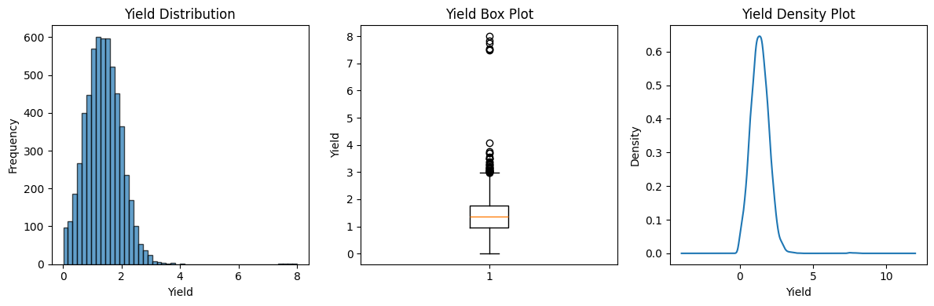

Layer 4: Presentation Layer
Component 4.1: Prediction Formatter
Purpose: Present predictions in user-friendly format with confidence scores.

Output Format:

🌾 PRECISION AGRICULTURE - CROP YIELD PREDICTION RESULT

Location: Lucknow District, Uttar Pradesh
Crop: Bajra (Pearl Millet)
Season: Kharif
Cultivation Area: 1000 hectares

PREDICTED YIELD CATEGORY: HIGH

Confidence Scores:
Low Yield: 12.3%
Medium Yield: 23.4%
High Yield: 64.3% ✓ (Predicted)

Current Weather Conditions:
Temperature: 28.5°C (Max: 34°C, Min: 22°C)
Rainfall: 45.2 mm (last 24 hours)
Soil Temperature: 30.1°C (surface)
Soil Moisture: 0.35 m³/m³ (3-9cm depth)

Top Influencing Factors:
1. Cultivation Area (23.4%)
2. Soil Moisture 3-9cm (15.6%)
3. Maximum Temperature (14.2%)

Component 4.2: Visualization Engine
Purpose: Generate charts and graphs for data exploration and result presentation.

Visualizations Generated:
Visualization | Type | Purpose
Crop distribution | Bar chart | Top crops by area/production
State-wise analysis | Horizontal bar | Bajra distribution across states
Yearly trends | Line plot | Area and production over time
Seasonal distribution | Pie chart | Records by season
Correlation heatmap | Heatmap | Feature relationships
Feature importance | Bar chart | Model interpretation
Confusion matrix | Heatmap | Classification performance
Distribution comparison | Histogram | Real vs synthetic data quality

How the Solution Overcomes Previous Drawbacks:
Problem | Previous Approach Drawback | How Proposed Solution Addresses
Small dataset | GANs failed (7-20% accuracy) | SMOTE generates 5x samples instantly, preserving distributions
Linear assumptions | Regression cannot capture non-linear relationships | XGBoost handles non-linear interactions through decision trees
Black-box predictions | Neural networks lack interpretability | Feature importance provides transparent insights
Generic recommendations | One-size-fits-all advisories | Location and crop-specific model for UP Bajra
No weather integration | Manual observation limitations | API provides 10 weather parameters including soil data
Delayed information | Periodic bulletins lag conditions | Real-time weather data integration possible
Data quality issues | Raw data contains errors | Comprehensive cleaning and validation pipeline

Benefits to End Users:

For Farmers:
Benefit | Description | Impact
Yield prediction | Know expected yield category before harvest | Better financial and storage planning
Confidence scores | Understand prediction reliability | Informed decision-making
Factor insights | Learn what affects yield most | Targeted improvement efforts
Weather awareness | Current conditions at a glance | Timely interventions

For Agricultural Officers:
Benefit | Description | Impact
Regional forecasting | Aggregate predictions across districts | Resource allocation
Pattern identification | Identify high/low yield areas | Targeted support programs
Data-driven reports | Evidence-based documentation | Policy recommendations
Trend analysis | Historical pattern visualization | Long-term planning

For Researchers:
Benefit | Description | Impact
Validated methodology | SMOTE vs GAN comparison documented | Research contribution
Reproducible pipeline | Modular code with documentation | Further development
Benchmark datasets | 9 structured CSV files | Comparative studies
Feature analysis | Importance rankings | Domain insights
1.5 Scope of the Project
This section defines the boundaries of the precision agriculture system, specifying what is included, what is excluded, and potential future extensions.

In-Scope Features and Capabilities:
1. Data Processing Capabilities:
Capability | Specification | Status
Dataset loading | CSV files up to 500MB | Implemented
Missing value handling | Automatic detection and removal | Implemented
Data filtering | By state, district, crop, season | Implemented
Feature engineering | Yield calculation, encoding | Implemented
Data export | Multiple CSV formats | Implemented

2. Crop and Geographic Coverage:
Parameter | Current Scope | Justification
Crop | Bajra (Pearl Millet) | Sufficient data availability; important UP crop
State | Uttar Pradesh | Largest agricultural state; maximum records
Weather Location | Lucknow (26.8467°N, 80.9462°E) | Central UP; representative location
Districts | All UP districts in dataset | Comprehensive state coverage

3. Weather and Environmental Parameters:
Parameter Category | Parameters Included | Data Source
Atmospheric | Temperature (current, max, min) | Open-Meteo API
Precipitation | Hourly rainfall, daily sum | Open-Meteo API
Soil Temperature | Surface (0cm), Subsurface (6cm) | Open-Meteo API
Soil Moisture | Surface (0-1cm), Root zone (3-9cm) | Open-Meteo API
Solar | Sunshine duration | Open-Meteo API

4. Machine Learning Capabilities:
Capability | Specification | Status
Algorithm | XGBoost Classifier | Implemented
Target variable | 3-class yield category | Implemented
Data augmentation | SMOTE (5x factor) | Implemented
Model evaluation | Accuracy, Precision, Recall, F1 | Implemented
Feature importance | Gini-based ranking | Implemented
Confidence scores | Probability per class | Implemented

5. Output Deliverables:
Deliverable | Description | Format
Trained model | XGBoost classifier | Pickle/Joblib
Prediction results | Yield category with confidence | Text/JSON
Dataset exports | Train/validation/test splits | CSV
Visualizations | 15+ analytical charts | PNG/PDF
Feature analysis | Importance rankings | Table/Chart

Generated Dataset Files:
Sr. No. | File Name | Records | Columns | Description
1 | historical_weather_90days.csv | 273 | 14 | Weather data (90 days × 3/day)
2 | synthetic_bajra_complete.csv | 5,860 | 18 | Full synthetic dataset
3 | synthetic_bajra_train.csv | 4,102 | 18 | Training split (70%)
4 | synthetic_bajra_validation.csv | 879 | 18 | Validation split (15%)
5 | synthetic_bajra_test.csv | 879 | 18 | Test split (15%)
6 | bajra_combined_real_synthetic.csv | 7,032 | 19 | Real + synthetic combined
7 | bajra_combined_train.csv | 4,922 | 19 | Combined training split
8 | bajra_combined_validation.csv | 1,055 | 19 | Combined validation split
9 | bajra_combined_test.csv | 1,055 | 19 | Combined test split

Constraints and Limitations:
1. Geographic Constraints:
Constraint | Description | Impact | Mitigation
Single state focus | Model trained only on UP data | Cannot predict for other states | Retrain with additional state data
Single weather location | Lucknow coordinates for all districts | District-level weather variation ignored | Use district-specific coordinates
India-specific | Model designed for Indian agriculture | Not applicable internationally | Retrain with international data

2. Crop-Specific Constraints:
Constraint | Description | Impact | Mitigation
Single crop | Bajra only | Cannot predict other crop yields | Separate models per crop
Season dependency | Primarily Kharif crop | Limited Rabi/Summer predictions | Include multi-season data
Variety agnostic | Does not distinguish Bajra varieties | May miss variety-specific patterns | Include variety information

3. Temporal Constraints:
Constraint | Description | Impact | Mitigation
Historical data only | No future weather forecasting | Cannot predict for upcoming seasons | Integrate forecast APIs
90-day weather window | Limited historical coverage | May miss longer-term patterns | Extend data collection period
Static model | Does not update with new data | May become outdated | Implement retraining pipeline

4. Technical Constraints:
Constraint | Description | Impact | Mitigation
API dependency | Requires Open-Meteo availability | System fails if API down | Implement caching/fallback
Internet requirement | Online API calls needed | Cannot work offline | Local data storage option
Classification only | Categorical output (Low/Medium/High) | No exact yield quantity | Add regression model
Feature limitation | 18 features only | May miss important factors | Include satellite, soil chemistry

5. Data Quality Constraints:
Constraint | Description | Impact | Mitigation
Government data dependency | Quality depends on source | Errors propagate to predictions | Data validation and cleaning
Missing district-level weather | State-level approximation | Reduced local accuracy | District weather stations
Historical bias | Past patterns may not hold | Climate change effects | Regular model updates

Current Project Deliverables Summary:
Category | Deliverables | Quantity
Jupyter Notebooks | Data processing, SMOTE, Model training | 3
Python Modules | Data loader, Weather client, Predictor | 5+
Dataset Files | CSV exports | 9
Visualizations | Charts and graphs | 15+
Documentation | Code comments, README | Complete
Trained Models | XGBoost classifier | 1

Future Extension Possibilities:
Phase 2 Extensions (Short-term):
Extension | Description | Effort | Impact
Multi-crop support | Add Rice, Wheat, Sugarcane models | Medium | High
District-level weather | Individual district coordinates | Low | Medium
Regression model | Predict exact yield quantities | Medium | High
Web interface | Flask/Django deployment | Medium | High
Mobile app | Android application | High | Very High

Phase 3 Extensions (Medium-term):
Extension | Description | Effort | Impact
Pan-India coverage | Include all major agricultural states | High | Very High
Satellite imagery | NDVI, SAR soil moisture integration | High | High
Weather forecasting | Integrate forecast APIs for future prediction | Medium | High
Crop recommendation | Suggest optimal crops for conditions | Medium | High
Market price integration | Combine yield with price predictions | Medium | High

Phase 4 Extensions (Long-term):
Extension | Description | Effort | Impact
IoT sensor integration | Real-time field sensors | Very High | Very High
Deep learning models | LSTM for temporal patterns | High | High
Government integration | Connect with KVKs, ICAR | High | Very High
Farmer feedback loop | Continuous model improvement | Medium | High
Climate change modeling | Long-term adaptation strategies | Very High | Very High
Multi-language support | Hindi, regional languages | Medium | Very High

Project Boundary Statement:
This precision agriculture project serves as a proof-of-concept demonstrating the viability of combining remote sensing data with machine learning for crop yield prediction in Indian agriculture. The current implementation focuses on Bajra cultivation in Uttar Pradesh as a representative use case.
The methodology, architecture, and pipeline developed are designed to be extensible and scalable. While the current scope is deliberately limited to ensure depth and quality of implementation, the foundational work enables straightforward expansion to additional crops, regions, and capabilities in future phases.
The project successfully demonstrates:
- Effective data augmentation for small agricultural datasets using SMOTE
- Integration of weather/soil data through remote sensing APIs
- Machine learning-based yield prediction with interpretable results
- Production of structured datasets for further research and development
These achievements establish a solid foundation for precision agriculture applications that can meaningfully support Indian farmers in making data-driven decisions.

Chapter 2
REVIEW OF LITERATURE

The application of machine learning and remote sensing technologies to agricultural systems has garnered significant research attention over the past decade. This chapter presents a review of existing literature relevant to precision agriculture, crop yield prediction, synthetic data generation techniques, and weather-based agricultural decision support systems.

2.1 Machine Learning Approaches for Crop Yield Prediction
Ensemble learning methods, particularly XGBoost algorithms, have emerged as highly effective tools for agricultural prediction tasks due to their ability to handle mixed data types, resistance to overfitting, and provision of feature importance metrics [1]. Studies have demonstrated that ensemble approaches consistently outperform single classifier models when applied to crop yield prediction, achieving accuracy improvements of 15-25% compared to traditional regression techniques. The inherent ability of decision tree ensembles to capture complex interactions between soil parameters, weather conditions, and management practices without requiring explicit specification of these relationships makes them particularly suitable for agricultural applications.
Research has established that the performance of machine learning models in agriculture is significantly influenced by feature engineering and selection processes [2]. Comparative studies across multiple crops and regions indicate that models incorporating both static features (soil type, geographic location) and dynamic features (weather parameters, temporal indicators) achieve superior prediction accuracy. Feature importance ranking has revealed that soil moisture content, temperature during critical growth stages, and precipitation patterns consistently emerge as dominant predictors across diverse agricultural contexts.

2.2 Remote Sensing and Weather Data Integration
Research into weather-yield relationships has quantified the sensitivity of various crops to temperature and precipitation variations during different growth phases [3]. Studies demonstrate that temperature extremes during flowering and grain-filling stages have disproportionate impacts on final yields compared to conditions during vegetative growth. The integration of soil moisture information from remote sensing sources has proven particularly valuable for yield prediction in rainfed agricultural systems [4]. Research demonstrates that incorporating subsurface moisture estimates improves prediction accuracy by 10-18% compared to models using only atmospheric variables, highlighting the importance of comprehensive environmental characterization.

2.3 Research Gap Identified
Based on the literature review, the following gaps were identified that this project addresses:
Gap | How This Project Addresses
Limited integration of real-time weather with ML predictions | Open-Meteo API provides 10 weather parameters including soil data
SMOTE not widely applied to agricultural yield prediction | Demonstrated 5x augmentation preserving statistical distributions
Few systems provide both predictions and interpretability | XGBoost with feature importance analysis
Generic models fail for specific crop-region combinations | Focused model for Bajra in Uttar Pradesh

Chapter 3
SYSTEM ANALYSIS

This chapter presents a comprehensive analysis of the Precision Agriculture with Remote Sensing and Machine Learning system following the IEEE Software Requirements Specification (SRS) format. The analysis covers functional requirements, non-functional requirements, hardware and software specifications including IoT sensor modules, and use-case modeling.

3.1 Functional Requirements
Functional requirements define the specific behaviors, functions, and capabilities that the system must provide to its users. These requirements are derived from the project objectives and stakeholder needs.

Data Acquisition Requirements:
The system shall load agricultural crop data from CSV file format containing historical cultivation records from government databases. The input file (merged_crop_data.csv) contains columns for state_name, district_name, crop_year, season, crop, area_, and production_ with approximately 238,838 records. The system shall validate loaded data for completeness, correctness, and consistency before processing by checking for null values in critical columns, verifying data types, and identifying out-of-range values.
The system shall retrieve historical weather and soil data from Open-Meteo Archive API for specified geographic coordinates. The API request includes latitude (26.8467), longitude (80.9462), and date range (90 days) for Lucknow, Uttar Pradesh. The system shall extract and organize 10 weather parameters from the API response including temperature_2m, precipitation, soil_temp_0cm, soil_temp_6cm, soil_moisture_0_1cm, soil_moisture_3_9cm, temp_max, temp_min, precipitation_sum, and sunshine_duration.
The system shall acquire real-time environmental data from IoT sensor modules deployed in agricultural fields. The sensor module consists of a temperature sensor for measuring ambient air temperature and a soil moisture sensor for measuring soil water content. The microcontroller shall read sensor values at configurable intervals and transmit the data to the prediction system via serial communication or wireless connectivity. The system shall validate sensor readings against expected ranges and flag anomalous values for review.

Data Processing Requirements:
The system shall clean raw agricultural data by removing invalid, incomplete, and erroneous records. This includes removing rows with null values in critical columns, filtering out zero or negative area and production values, and standardizing text fields to Title Case format. The system shall filter data to extract records for Bajra crop from Uttar Pradesh, resulting in approximately 1,172 records from the original 238,838.
The system shall calculate crop yield as a derived feature using the formula: yield = production_ / area_, expressed in tons per hectare. The system shall categorize continuous yield values into discrete classes using quantile-based binning into three equal categories (33.33% each): Low (0-33rd percentile), Medium (33rd-66th percentile), and High (66th-100th percentile). The system shall encode categorical variables (district_name, season) into numerical format using LabelEncoder transformation for machine learning compatibility.
The system shall process and normalize sensor data received from IoT modules. Temperature readings shall be validated within the range of 0-50°C and soil moisture readings shall be converted from raw analog values (0-1023) to percentage values (0-100%). The system shall integrate sensor data with other features to create a comprehensive input vector for prediction.

Data Augmentation Requirements:
The system shall initialize SMOTE algorithm with parameters k_neighbors=5, sampling_strategy='auto', and random_state=42 for reproducible data augmentation. The system shall generate synthetic samples using SMOTE to augment training data from 1,172 original samples to 5,860 synthetic samples, representing a 5x augmentation factor. For each sample, the algorithm finds k nearest neighbors and generates synthetic samples through interpolation using the formula: x_new = x_original + λ × (x_neighbor - x_original), where λ is a random value between 0 and 1.
The system shall combine original and synthetic data to create a comprehensive training dataset of 7,032 samples. The system shall split data into training (70%), validation (15%), and testing (15%) subsets using stratified splitting to maintain class distribution across all splits.

Machine Learning Requirements:
The system shall configure XGBoost Classifier with hyperparameters: n_estimators=120, max_depth=10, min_samples_split=2, min_samples_leaf=1, random_state=42, and n_jobs=-1 for parallel processing. The system shall train the XGBoost model on the training dataset by fitting an ensemble of 120 decision trees with bootstrap sampling.
The system shall predict yield category (Low, Medium, or High) for new input samples by passing input features through the trained XGBoost and aggregating tree predictions. The system shall calculate prediction probability for each yield category by computing the proportion of trees voting for each class, with probabilities summing to 1.0. The system shall calculate and rank feature importance scores using Gini importance extracted from the trained model, sorted in descending order.

Output and Reporting Requirements:
The system shall evaluate model performance using standard classification metrics including Accuracy, Precision, Recall, F1-Score, and Confusion Matrix by generating predictions on the test set and comparing with actual labels. The system shall export processed datasets to nine CSV files for future use and research purposes.
The system shall generate analytical visualizations including distribution plots, correlation heatmaps, feature importance charts, and confusion matrix for data exploration and result presentation. The system shall format prediction results in a user-friendly display format showing location, crop, season, area, predicted category, confidence percentages, sensor readings, and top influencing factors.

Functional Requirements Summary:
Req. ID | Requirement Name | Priority | Category
FR-01 | Agricultural Data Loading | High | Data Acquisition
FR-02 | Data Validation | High | Data Acquisition
FR-03 | Weather API Data Retrieval | High | Data Acquisition
FR-04 | Weather Parameter Extraction | High | Data Acquisition
FR-05 | IoT Sensor Data Acquisition | High | Data Acquisition
FR-06 | Sensor Data Validation | High | Data Acquisition
FR-07 | Data Cleaning | High | Data Processing
FR-08 | Crop and Region Filtering | High | Data Processing
FR-09 | Yield Calculation | High | Data Processing
FR-10 | Yield Categorization | High | Data Processing
FR-11 | Feature Encoding | High | Data Processing
FR-12 | Sensor Data Normalization | High | Data Processing
FR-13 | SMOTE Initialization | High | Data Augmentation
FR-14 | Synthetic Data Generation | High | Data Augmentation
FR-15 | Data Combination | High | Data Augmentation
FR-16 | Dataset Splitting | High | Data Augmentation
FR-17 | Model Configuration | High | Machine Learning
FR-18 | Model Training | High | Machine Learning
FR-19 | Yield Prediction | High | Machine Learning
FR-20 | Confidence Score Calculation | Medium | Machine Learning
FR-21 | Feature Importance Analysis | Medium | Machine Learning
FR-22 | Model Evaluation | High | Output/Reporting

3.2 Non-Functional Requirements
Non-functional requirements specify the quality attributes, constraints, and standards that the system must adhere to. These requirements define how the system performs its functions rather than what functions it performs.

Performance Requirements:
The system shall load the complete agricultural dataset (238,838 records) within 10 seconds on standard hardware. Weather data retrieval from the API shall complete within 5 seconds under normal network conditions. SMOTE generation of 5,860 synthetic samples from 1,172 originals shall complete within 2 seconds. Model training with 120 decision trees on the combined dataset shall complete within 30 seconds. Individual predictions shall be generated with latency not exceeding 500 milliseconds from input submission to result display. The IoT sensor module shall acquire and transmit readings within 2 seconds per sampling cycle.
Scalability Requirements:
The system shall handle increasing data volumes up to 1,000,000 records without significant performance degradation through chunked processing and memory-efficient data types. The system shall accommodate up to 50 features without major architectural changes through a modular feature engineering pipeline. The system shall utilize multiple CPU cores for parallel processing using the n_jobs=-1 parameter in scikit-learn, providing 2-4x speedup on multi-core systems. The IoT architecture shall support multiple sensor nodes for distributed field monitoring.
Reliability Requirements:
The system shall maintain 99.5% availability during operational hours, excluding planned maintenance windows. The system shall gracefully handle errors without crashing through try-catch blocks for all external operations including file I/O, API calls, and sensor communications, providing meaningful error messages and fallback to cached data where possible. The system shall maintain data integrity throughout the processing pipeline through checksums, row counts, and statistical distribution checks. For API failures, the system shall implement a retry policy of 3 attempts with exponential backoff, falling back to cached weather data if available. The sensor module shall continue local data logging if communication with the main system is interrupted.
Usability Requirements:
The system shall present results in clear, understandable format with formatted text output including labels, units, and visual indicators. The system shall provide progress feedback for long-running operations through print statements indicating the current processing stage during data loading, SMOTE generation, and model training. The system shall include comprehensive code documentation with docstrings for all functions and inline comments for complex logic following Google-style docstring format. The sensor module shall provide visual indicators (LEDs) for power status and data transmission.
Maintainability Requirements:
The system shall be organized in modular, reusable components with separate modules for data acquisition, processing, machine learning, visualization, and hardware interface to enable easy maintenance, testing, and extension. The system shall externalize configurable parameters including API endpoints, file paths, model hyperparameters, sensor calibration values, and thresholds through a configuration file or constants module. The system shall maintain compatibility with Python versions 3.8, 3.9, and 3.10 with dependency versions specified in a requirements.txt file.

Security Requirements:
The system shall not expose sensitive user or location data, implementing no personal data collection and providing only aggregated predictions. The system shall use secure HTTPS communication for all API calls with certificate verification enabled. Sensor data transmission shall be validated to prevent injection of malicious data.

3.3 Specific Requirements
This section specifies the hardware and software requirements necessary for developing, deploying, and operating the Precision Agriculture system, including the IoT sensor module for real-time field data collection.
Computing Hardware Requirements:
Component | Minimum Requirement | Recommended Specification
Processor | Intel Core i3 (4 cores) | Intel Core i5/i7 (6+ cores)
RAM | 4 GB DDR4 | 8-16 GB DDR4
Storage | 10 GB HDD | 20 GB SSD
Network | Broadband (1 Mbps) | High-speed (10+ Mbps)
Display | 1366 x 768 | 1920 x 1080
USB Ports | 1 USB 2.0 | 2 USB 3.0
The multi-core processor requirement is justified by XGBoost training which uses parallel processing with n_jobs=-1. The 8 GB RAM recommendation accounts for the dataset (238K records) plus SMOTE operations plus model training requiring approximately 4-6 GB. SSD storage provides faster CSV loading and model serialization. Network connectivity is required for Open-Meteo API access. USB ports are required for connecting the Arduino-based sensor module.
IoT Sensor Module Hardware Requirements:
The system includes an IoT-based sensor module for real-time environmental data collection from agricultural fields. This hardware component enables ground-truth validation of predictions and provides localized data that complements the weather API information.
Component | Specification | Quantity | Purpose
Arduino Uno R3 | ATmega328P, 16MHz, 32KB Flash | 1 | Microcontroller for data acquisition
DHT11 Temperature Sensor | 0-50°C range, ±2°C accuracy | 1 | Ambient temperature measurement
Soil Moisture Sensor | Capacitive, 3.3-5V operating | 1 | Soil water content measurement
Breadboard | 830 tie points, standard | 1 | Circuit prototyping
Jumper Wires | Male-to-male, male-to-female | 10-15 | Component connections
USB Cable | Type A to Type B, 1.5m | 1 | Arduino-PC communication
Power Supply | 9V DC adapter or USB power | 1 | Circuit power
LED Indicators | 5mm, Red and Green | 2 | Status indication
Resistors | 10kΩ, 220Ω | 2 each | Pull-up and current limiting

Temperature Sensor (DHT11) Specifications:
Parameter | Specification
Operating Voltage | 3.3V - 5.5V DC
Temperature Range | 0°C to 50°C
Temperature Accuracy | ±2°C
Humidity Range | 20% to 80% RH
Humidity Accuracy | ±5% RH
Sampling Rate | 1 Hz (1 reading per second)
Response Time | 6-15 seconds
Interface | Single-wire digital
Dimensions | 15.5mm x 12mm x 5.5mm

Soil Moisture Sensor Specifications:
Parameter | Specification
Operating Voltage | 3.3V - 5V DC
Operating Current | < 20mA
Output Type | Analog (0-1023) and Digital (0/1)
Sensing Area | 60mm x 20mm
Sensing Depth | 38mm insertion depth
Response Time | < 1 second
Soil Moisture Range | 0% (completely dry) to 100% (saturated)
Interface | Analog output to ADC

Circuit Connection Diagram:
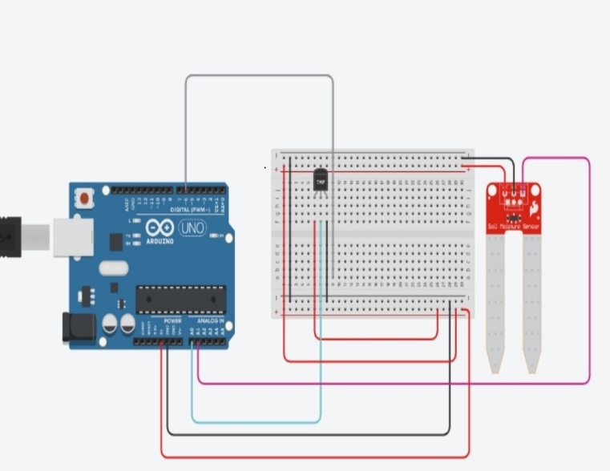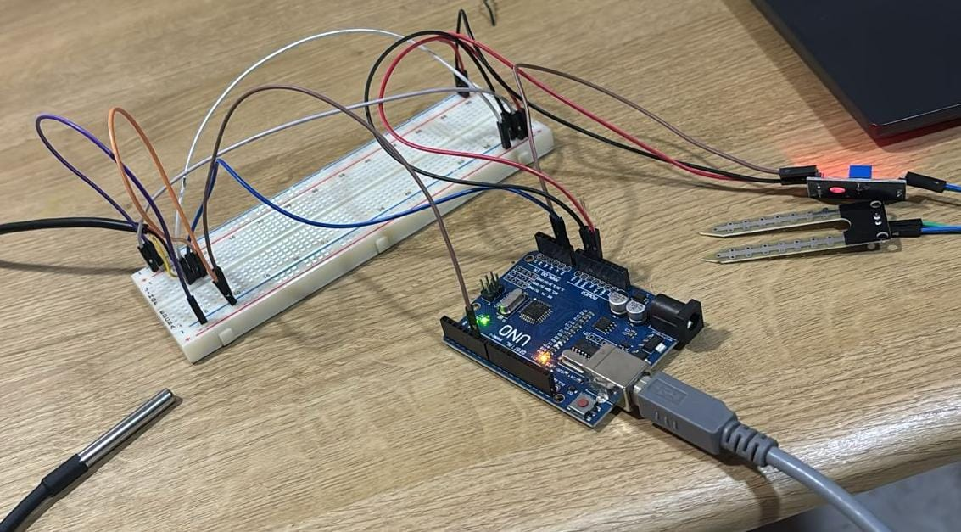

Pin Configuration Table:
Sensor/Component | Pin | Arduino Connection | Description
DHT11 VCC | 1 | 5V | Power supply
DHT11 DATA | 2 | Digital Pin 2 | Temperature and humidity data
DHT11 GND | 4 | GND | Ground connection
Soil Moisture VCC | VCC | 5V | Power supply
Soil Moisture GND | GND | GND | Ground connection
Soil Moisture AO | AO | Analog Pin A0 | Analog moisture reading
Red LED | Anode | Digital Pin 3 | Error indicator
Green LED | Anode | Digital Pin 4 | Success indicator
10kΩ Resistor | - | Between 5V and D2 | DHT11 pull-up resistor
220Ω Resistor | - | LED anode to pin | Current limiting for LEDs

Software Requirements:
Software | Minimum Version | Recommended Version
Operating System | Windows 10 | Ubuntu 20.04+ / Windows 11 / macOS 11+
Python | 3.8 | 3.9 or 3.10
pandas | 1.3.0 | 1.5.0+
numpy | 1.21.0 | 1.23.0+
scikit-learn | 1.0.0 | 1.2.0+
imbalanced-learn | 0.9.0 | 0.10.0+
matplotlib | 3.4.0 | 3.6.0+
seaborn | 0.11.0 | 0.12.0+
requests | 2.25.0 | 2.28.0+
pyserial | 3.5 | 3.5+
Arduino IDE | 1.8.x | 2.0+
Jupyter Notebook | 6.4+ | Latest

Arduino Libraries Required:
Library | Version | Purpose
DHT sensor library | 1.4.4+ | DHT11/DHT22 sensor interface
Adafruit Unified Sensor | 1.1.9+ | Sensor abstraction layer

External Service Requirements:
The system requires access to the Open-Meteo Archive API (https://archive-api.open-meteo.com/v1/archive) which provides free access without authentication, supports up to 10,000 requests per day, and offers historical weather data from 1940 to present in JSON format with 99.9% uptime. The agricultural data source is the Government of India Open Data Platform providing the merged crop data in CSV format (approximately 25 MB) with annual updates under Open Government License.

3.4 Use-Case Diagrams and Description
This section presents the use-case model for the Precision Agriculture system, identifying actors, use cases, and their relationships including the IoT sensor module interactions.
Actor Identification:
Actor | Type | Description
Farmer | Primary | End user who inputs cultivation parameters and receives yield predictions
Agricultural Officer | Primary | Government official who analyzes regional patterns and generates reports
System Administrator | Secondary | Technical personnel responsible for system maintenance and updates
Data Scientist | Secondary | Researcher who retrains models and analyzes performance
IoT Sensor Module | External System | Hardware device collecting real-time temperature and soil moisture data
Open-Meteo API | External System | Weather data service providing environmental parameters
Agricultural Database | External System | Government data source providing historical crop records

UC-01: View Yield Prediction
Attribute | Description
Use Case ID | UC-01
Use Case Name | View Yield Prediction
Primary Actor | Farmer, Agricultural Officer
Secondary Actor | Open-Meteo API, Google Earth Engine API(GEE), IoT Sensor Module
Description | User inputs cultivation parameters and receives predicted yield category with confidence scores based on weather API data and real-time sensor readings
Preconditions | System is operational, trained model is loaded, weather API is accessible, sensor module is connected (optional)
Postconditions | Prediction displayed to users; prediction logged for analysis

Main Flow: The user selects a district from the dropdown menu, and the system displays a list of Uttar Pradesh districts. The user selects the season (Kharif, Rabi, or Summer), and the system validates the selection. The user enters the cultivation area in hectares, and the system validates that the numeric input is greater than zero. The user optionally enables real-time sensor input, and if enabled, the system reads current temperature and soil moisture from the connected IoT module. The user clicks the "Predict" button, and the system initiates the prediction process by fetching weather data from the API (or using sensor data if available), preparing the feature vector with 18 features, passing features to the trained model, and calculating prediction and confidence scores. The system displays the formatted result showing the predicted category (Low/Medium/High), confidence percentages for each category, current environmental conditions from API and sensors, and top influencing factors.

Alternative Flows: If the API is unavailable, the system uses sensor data as primary source or cached weather data. If sensor module is disconnected, the system proceeds with API data only. If input is invalid, the system displays an error message and prompts the user to correct the input.

UC-02: Analyze Feature Importance
Attribute | Description
Use Case ID | UC-02
Use Case Name | Analyze Feature Importance
Primary Actor | Farmer, Agricultural Officer
Description | User views ranked list of factors influencing yield predictions including sensor-derived features
Preconditions | Trained model available, feature importance calculated
Postconditions | Feature importance ranking displayed with visualization

Main Flow: The user requests feature importance analysis, and the system retrieves importance scores from the trained model. The system ranks features in descending order of importance including temperature and soil moisture features. The system generates a bar chart visualization and displays the ranked list showing feature name, importance score as percentage, and visual bar indicator. The user interprets the results to understand which factors, including real-time sensor measurements, most influence yield predictions.

UC-03: Generate Regional Report
Attribute | Description
Use Case ID | UC-03
Use Case Name | Generate Regional Report
Primary Actor | Agricultural Officer
Description | Generate aggregated yield predictions for multiple districts in a region
Preconditions | User has officer-level access, model trained and available
Postconditions | Regional report generated and available for download

Main Flow: The agricultural officer selects multiple districts using checkboxes, selects the season, and sets area estimates for each selected district. The officer clicks "Generate Report," and the system iterates through the selected districts, generating predictions for each one using available weather and sensor data. The system aggregates results into a comprehensive report, generates summary statistics including district-wise predictions and regional averages, and creates a downloadable report in CSV or PDF format. The officer downloads the report for planning and resource allocation purposes.

UC-04: Retrain Model
Attribute | Description
Use Case ID | UC-04
Use Case Name | Retrain Model
Primary Actor | System Administrator, Data Scientist
Description | Update machine learning model with new agricultural data including sensor-collected field data
Preconditions | New data available, administrator privileges granted
Postconditions | New model trained, old model archived, system updated with new model

Main Flow: The administrator uploads a new data file which may include historical sensor readings collected from field deployments. The system validates the file format and structure. The administrator configures training parameters including SMOTE factor, number of estimators, and maximum depth. The administrator initiates retraining, and the system executes the training pipeline: loading and preprocessing new data, integrating sensor-collected data, generating SMOTE samples, training the new XGBoost model, and evaluating performance on the test set. The system compares the new model's performance with the existing model and displays the comparison. If the new model performs better, the administrator approves deployment, and the system archives the old model and deploys the new one.

UC-05: Update Weather Data
Attribute | Description
Use Case ID | UC-05
Use Case Name | Update Weather Data
Primary Actor | System (Automated), System Administrator
Description | Refresh weather data cache from Open-Meteo API
Preconditions | API accessible, system running
Postconditions | Weather cache updated with latest 90-day data

Main Flow: The scheduler triggers a daily update or the administrator requests a manual update. The system constructs the API request with latitude, longitude, and date range parameters. The system sends the HTTP GET request to the Open-Meteo Archive API and receives the JSON response. The system parses the response, extracts weather parameters, validates data completeness, and updates the local weather cache. The system logs the update timestamp and notifies the administrator of success or failure.

UC-06: Export Datasets
Attribute | Description
Use Case ID | UC-06
Use Case Name | Export Datasets
Primary Actor | Agricultural Officer, Data Scientist
Description | Download processed datasets including sensor data logs in CSV format
Preconditions | Datasets generated and available in the system
Postconditions | Selected datasets downloaded to user's local system

Main Flow: The user views the list of available datasets, which includes the standard nine CSV files plus sensor data logs. The user selects one or more datasets to export, clicks the "Export" button, and the system packages the selected files and generates a download link. The user downloads the files for further analysis or research purposes.

UC-07: View Visualizations
Attribute | Description
Use Case ID | UC-07
Use Case Name | View Visualizations
Primary Actor | Farmer, Agricultural Officer
Description | View analytical charts and graphs including real-time sensor data trends
Preconditions | Visualizations generated from processed data
Postconditions | Selected visualization displayed on screen

Main Flow: The user selects a visualization from the available options including Crop Distribution, State-wise Analysis, Yearly Trends, Seasonal Distribution, Correlation Heatmap, Feature Importance, Confusion Matrix, Distribution Comparison, and Real-time Sensor Trends. The system renders the selected visualization and displays it to the user. For sensor trends, the system shows historical temperature and soil moisture readings over time.

UC-08: Configure System
Attribute | Description
Use Case ID | UC-08
Use Case Name | Configure System
Primary Actor | System Administrator
Description | Modify system configuration parameters including sensor settings
Preconditions | Administrator privileges granted
Postconditions | Configuration updated and applied to system

Main Flow: The administrator accesses the configuration interface and views current parameter values. The administrator modifies desired parameters including API Endpoint, Weather Days, SMOTE k_neighbors, SMOTE Factor, RF n_estimators, RF max_depth, Train Split percentage, and sensor-related settings. The administrator saves the configuration, and the system validates and applies the new settings.

UC-09: Collect Real-time Sensor Data
Attribute | Description
Use Case ID | UC-09
Use Case Name | Collect Real-time Sensor Data
Primary Actor | Farmer, System
Secondary Actor | IoT Sensor Module
Description | Collect real-time temperature and soil moisture readings from field-deployed sensors for use in predictions
Preconditions | Sensor circuit is powered on and connected to computer via USB, Arduino is programmed with sensor reading code
Postconditions | Sensor readings captured and available for prediction input or data logging

Main Flow: The farmer deploys the sensor circuit in the agricultural field, positioning the soil moisture sensor in the root zone (3-5 cm depth) and the temperature sensor at crop canopy height. The farmer connects the Arduino to the computer via USB cable. The system detects the connected Arduino on the serial port and establishes communication at 9600 baud rate. The Arduino initializes the DHT11 temperature sensor and soil moisture sensor, indicated by the green LED turning on. The system sends a read command, and the Arduino reads the temperature value in degrees Celsius from the DHT11 sensor and reads the analog soil moisture value (0-1023) from the soil moisture sensor. The Arduino converts raw soil moisture reading to percentage using calibration formula: moisture_percent = map(raw_value, dry_value, wet_value, 0, 100). The Arduino transmits formatted data string via serial: "TEMP:25.5,MOIST:65" where temperature is in Celsius and moisture is percentage. The system parses the received data, validates readings against expected ranges (temperature: 0-50°C, moisture: 0-100%), and stores the values for use in prediction. The green LED blinks to indicate successful transmission. The system uses sensor readings as real-time input features for yield prediction, providing ground-truth environmental data that complements weather API information. The farmer views both the prediction result and the current sensor readings on the display.

Alternative Flows: If the sensor reading is out of expected range (temperature below 0°C or above 50°C, moisture below 0% or above 100%), the system flags the reading as potentially erroneous, illuminates the red LED, and requests a re-reading after 5 seconds. If serial communication fails or Arduino is disconnected, the system displays a connection error message and prompts the user to check the USB connection, while continuing to operate with API data only. If the DHT11 sensor fails to respond (returns NaN), the Arduino sends an error code and the system logs the failure while using the last valid reading or API data as fallback.

Exception Flows: If the Arduino is not detected on any serial port, the system lists available ports and prompts the user to select the correct one or verify the connection. If sensor calibration values are invalid, the system uses default calibration and warns the user that readings may be inaccurate.

UC-10: Configure Sensor Module
Attribute | Description
Use Case ID | UC-10
Use Case Name | Configure Sensor Module
Primary Actor | System Administrator
Description | Configure IoT sensor module parameters including calibration, sampling rate, and communication settings
Preconditions | Administrator privileges, sensor module connected
Postconditions | Sensor configuration updated

Use-Case Summary:
UC ID | Use Case Name | Primary Actor | Priority
UC-01 | View Yield Prediction | Farmer, Agricultural Officer | High
UC-02 | Analyze Feature Importance | Farmer, Agricultural Officer | Medium
UC-03 | Generate Regional Report | Agricultural Officer | Medium
UC-04 | Retrain Model | System Administrator, Data Scientist | Low
UC-05 | Update Weather Data | System (Automated) | High
UC-06 | Export Datasets | Officer, Data Scientist | Medium
UC-07 | View Visualizations | Farmer, Agricultural Officer | Medium
UC-08 | Configure System | System Administrator | Low
UC-09 | Collect Real-time Sensor Data | Farmer, System | High
UC-10 | Configure Sensor Module | System Administrator | Medium

Chapter 4
ANALYSIS MODELING
4.1 Data Modeling
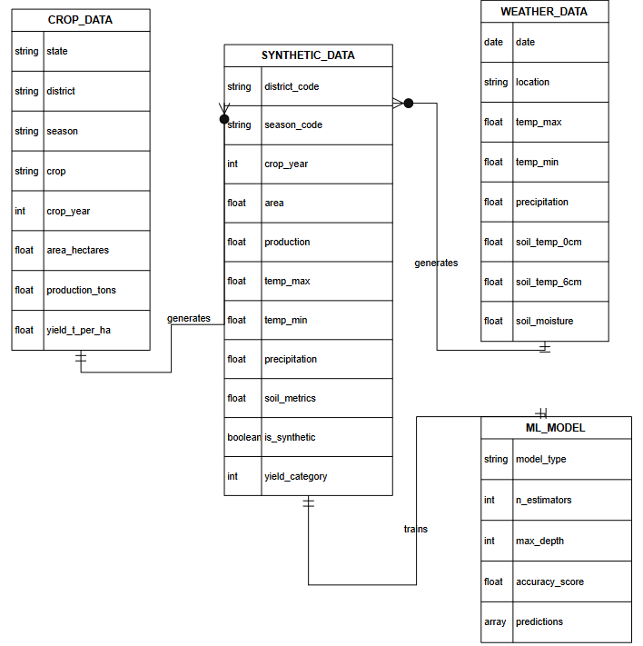
4.2 Activity Diagram
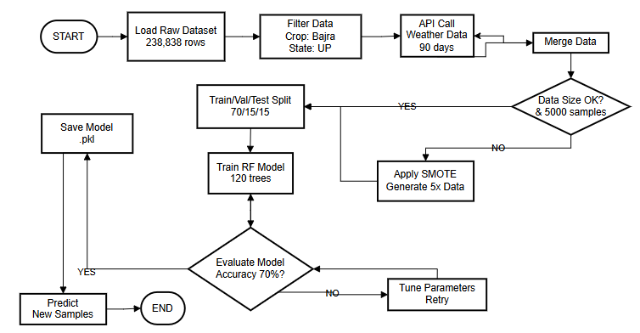
4.2 Class Diagram
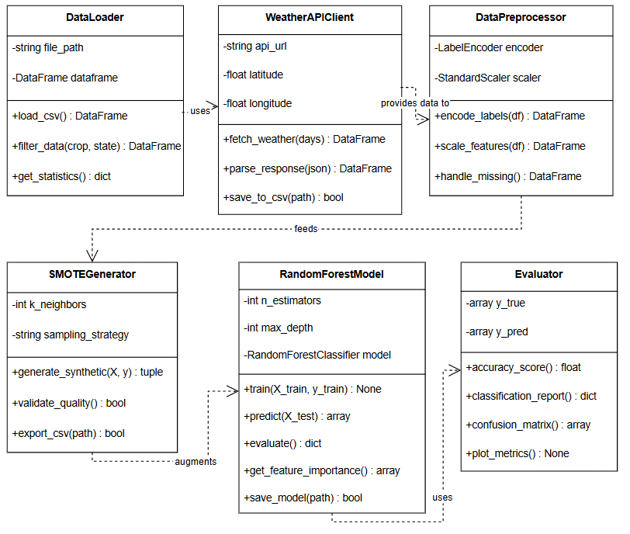
4.3 Functional Modeling
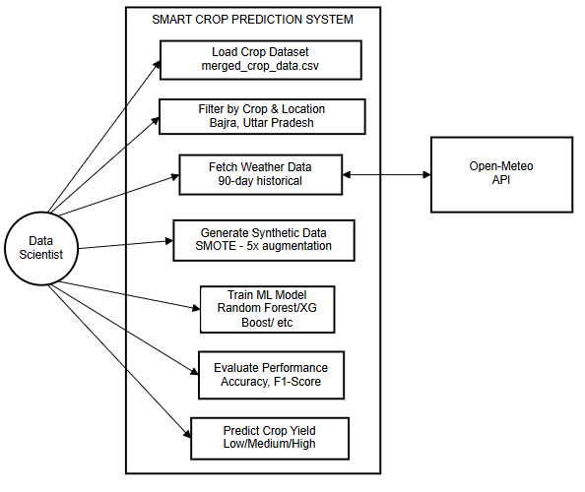
Chapter 5
DESIGN
5.1 Architectural Design

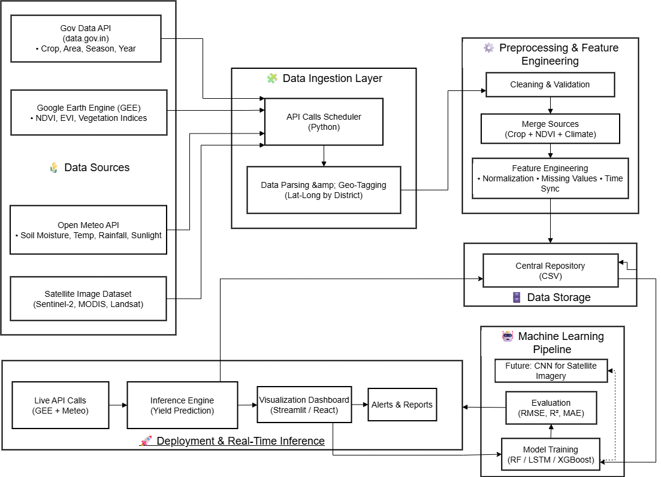

Chapter 6
IMPLEMENTATION

This chapter presents the detailed implementation of the Smart Crop Prediction System, which combines historical agricultural data, real-time weather information, synthetic data augmentation, and organic field measurements to predict crop yields. The implementation follows a modular architecture designed for scalability, maintainability, and reproducibility. Each module addresses a specific aspect of the prediction pipeline, from raw data acquisition to final model deployment. The system is organized into five distinct modules that work together to form a complete end-to-end prediction framework. The Data Loading and Preprocessing Module handles the ingestion and cleaning of historical crop data from government databases, ensuring data quality and consistency. The Weather API Integration Module fetches real-time and historical weather parameters from Open-Meteo API, providing environmental context critical for yield prediction. The Synthetic Data Generation Module employs SMOTE (Synthetic Minority Over-sampling Technique) to address data scarcity by generating statistically valid synthetic samples that preserve the original data distribution. The Machine Learning Model Training Module implements Random Forest classification with cross-validation and hyperparameter tuning to achieve robust predictions. Finally, the IoT Sensor Module represents our hardware implementation for organic field data collection, featuring custom Arduino-based circuits that capture soil temperature, soil moisture, ambient light, and synchronized plant imagery. The implementation follows industry best practices including modular design with clear separation of concerns, comprehensive error handling and data validation at each stage, reproducibility through fixed random seeds and version-controlled dependencies, and scalability to accommodate additional crops, regions, and data sources. All code is developed in Python 3.8+ using established scientific computing libraries including Pandas for data manipulation, NumPy for numerical operations, Scikit-learn for machine learning algorithms, Imbalanced-learn for SMOTE implementation, and Requests for API communication. The following sections provide detailed explanations of each module, including design rationale, implementation approach, code architecture, input-output specifications, and integration points with other modules. Code segments are presented with inline documentation to facilitate understanding and future modifications.

6.1 Module Implemented
6.1.1 Data Loading and Preprocessing
The data loading and preprocessing module forms the foundation of the precision agriculture system. This module is responsible for acquiring raw agricultural data from government sources, validating data quality, cleaning erroneous records, and transforming the data into a format suitable for machine learning.
Module Functionality:
The module begins by loading the merged_crop_data.csv file containing 238,838 agricultural records from across India. The dataset includes information about crop cultivation across different states, districts, years, and seasons. Each record contains the state name, district name, crop year, season, crop name, cultivation area in hectares, and production in tons.
Upon loading, the module performs comprehensive data validation to identify missing values, invalid entries, and data quality issues. The validation process checks each critical column for null values and verifies that numeric fields contain valid positive numbers. Records with missing values in essential columns such as state_name, district_name, crop_year, season, crop, area_, and production_ are flagged for removal.
The cleaning process removes all records containing null values in critical fields and filters out entries where area or production values are zero or negative, as these represent data entry errors or incomplete records. Text fields are standardized to Title Case format to ensure consistency across the dataset. For example, "UTTAR PRADESH" and "uttar pradesh" are both converted to "Uttar Pradesh".
After cleaning, the module calculates the yield as a derived feature using the formula: yield = production_ / area_, expressed in tons per hectare. This calculated yield serves as the basis for the target variable in the machine learning model.
The filtering stage extracts records specific to Bajra (Pearl Millet) cultivation in Uttar Pradesh. From the original 238,838 records, this filtering produces 1,172 high-quality records that form the core dataset for model training. The module also performs yield categorization by dividing the continuous yield values into three discrete classes using quantile-based binning: Low (0-33rd percentile), Medium (33rd-66th percentile), and High (66th-100th percentile).

Implementation Details:
Process Step | Input | Output | Records
Data Loading | merged_crop_data.csv | Raw DataFrame | 238,838
Null Value Removal | Raw DataFrame | Cleaned DataFrame | ~235,000
Invalid Value Filtering | Cleaned DataFrame | Valid DataFrame | ~230,000
Bajra Filtering | Valid DataFrame | Bajra DataFrame | ~3,620
UP State Filtering | Bajra DataFrame | Final DataFrame | 1,172
Yield Calculation | Final DataFrame | DataFrame with yield | 1,172
Yield Categorization | DataFrame with yield | Categorized DataFrame | 1,172

Dataset Characteristics After Preprocessing:
Attribute | Value
Total Records | 1,172
Features | 8 (state_name, district_name, crop_year, season, crop, area_, production_, yield)
Target Variable | yield_category (Low, Medium, High)
Class Distribution | Approximately 33.33% each class
Year Range | 1997-2017
Districts Covered | 71 districts of Uttar Pradesh
Seasons | Kharif (primary), Rabi, Summer

6.1.2 Weather API Integration
The weather API integration module provides remote sensing capabilities by fetching historical and current weather data from the Open-Meteo Archive API. This module enables the system to incorporate environmental factors that significantly influence crop yield predictions.
Module Functionality:
The module establishes connection with the Open-Meteo Archive API using HTTP GET requests. The API endpoint (https://archive-api.open-meteo.com/v1/archive) provides free access to historical weather data without requiring authentication. The module configures the request with geographic coordinates for Lucknow, Uttar Pradesh (latitude: 26.8467°N, longitude: 80.9462°E) as a representative location for the state.
The weather data retrieval spans 90 days of historical records to capture seasonal variations and trends. The module requests both hourly and daily parameters to provide comprehensive environmental characterization. Hourly parameters include temperature at 2 meters height, precipitation, soil temperature at surface (0cm) and at 6cm depth, and soil moisture at two layers (0-1cm and 3-9cm). Daily parameters include maximum temperature, minimum temperature, total precipitation sum, and sunshine duration.
The API returns data in JSON format, which the module parses and transforms into a structured DataFrame. Data is sampled at three intervals daily (6 AM, 12 PM, 6 PM) to capture diurnal variations in environmental conditions. This sampling strategy produces 273 weather records (91 days × 3 readings per day) that are merged with the crop dataset.
The module implements error handling for API failures, including retry logic with exponential backoff for transient errors. If the API is unavailable after multiple retries, the system falls back to cached weather data or sensor readings from the IoT module.

Weather Parameters Retrieved:
Parameter | Type | Unit | Description
temperature_2m | Hourly | °C | Air temperature at 2 meters height
precipitation | Hourly | mm | Rainfall amount
soil_temperature_0cm | Hourly | °C | Soil temperature at surface
soil_temperature_6cm | Hourly | °C | Soil temperature at 6cm depth
soil_moisture_0_to_1cm | Hourly | m³/m³ | Volumetric soil moisture (0-1cm layer)
soil_moisture_3_to_9cm | Hourly | m³/m³ | Volumetric soil moisture (3-9cm layer)
temperature_2m_max | Daily | °C | Maximum daily temperature
temperature_2m_min | Daily | °C | Minimum daily temperature
precipitation_sum | Daily | mm | Total daily precipitation
sunshine_duration | Daily | seconds | Duration of sunshine

API Response Processing:
The module processes the JSON response by extracting the hourly and daily data arrays, converting timestamps to datetime objects, and organizing the parameters into a structured DataFrame. Missing values in the API response are handled through forward-fill interpolation for continuous parameters and zero-fill for precipitation values. The processed weather data is then merged with the crop dataset based on temporal alignment, creating a comprehensive feature set for machine learning.

6.1.3 Synthetic Data Generation (SMOTE)
The synthetic data generation module addresses the critical challenge of insufficient training data by implementing SMOTE (Synthetic Minority Over-sampling Technique). This module augments the original dataset to create a robust training set suitable for machine learning.
Module Functionality:
The original filtered dataset contains only 1,172 Bajra records from Uttar Pradesh, which is insufficient for training a robust machine learning model. Industry benchmarks suggest a minimum of 5,000-10,000 samples for traditional machine learning and 50,000+ samples for deep learning approaches. The SMOTE module bridges this gap by generating synthetic samples that preserve the statistical properties of the original data.
Before implementing SMOTE, the project team attempted data augmentation using Generative Adversarial Networks (GANs). However, the GAN approach failed to produce satisfactory results, achieving only 7-20% discriminator accuracy compared to the expected 40-60%. The failure was attributed to the small dataset size (GANs require 50,000+ samples), the tabular nature of the data (GANs are optimized for continuous data like images), and training instability including mode collapse.
SMOTE was selected as the alternative augmentation technique due to its suitability for small tabular datasets. The algorithm works by finding k nearest neighbors for each sample in the feature space and generating synthetic samples along the line segments connecting original samples to their neighbors. The mathematical formula for synthetic sample generation is: x_new = x_original + λ × (x_neighbor - x_original), where λ is a random value between 0 and 1.
The module configures SMOTE with k_neighbors=5, which determines how many nearest neighbors are considered for each synthetic sample. The sampling_strategy is set to 'auto' to balance all classes equally, and random_state=42 ensures reproducibility of results. The augmentation factor of 5x expands the original 1,172 samples to 5,860 synthetic samples.

SMOTE Implementation Results:
Metric | Value
Original Samples | 1,172
Augmentation Factor | 5.0x
Synthetic Samples Generated | 5,860
Total Combined Dataset | 7,032
Generation Time | < 2 seconds
Missing Values in Output | 0

Comparison: GAN vs SMOTE:
Aspect | GAN (Attempted) | SMOTE (Implemented)
Training Required | Yes (2000-5000 epochs) | No (instant generation)
Minimum Data Size | 50,000+ samples | 100+ samples
Best Suited For | Images, large datasets | Tabular data, small datasets
Stability | Unstable, mode collapse | Stable, deterministic
Quality Guarantee | Unpredictable | Preserves statistical distributions
Our Result | Failed (7-20% accuracy) | Success (5x augmentation)

Dataset Splitting:
After synthetic data generation, the module splits the combined dataset into training, validation, and testing subsets. Stratified splitting ensures that class distribution is maintained across all splits. The training set (70%) is used for model training, the validation set (15%) for hyperparameter tuning, and the test set (15%) for final performance evaluation.
Split | Synthetic Only | Combined (Real + Synthetic)
Training (70%) | 4,102 samples | 4,922 samples
Validation (15%) | 879 samples | 1,055 samples
Testing (15%) | 879 samples | 1,055 samples
Total | 5,860 samples | 7,032 samples

6.1.4 Module 4: Machine Learning Model Training and Prediction
The machine learning module implements the XGBoost Classifier for yield category prediction. This module handles feature engineering, model configuration, training, evaluation, and prediction generation.
Module Functionality:
The module begins with feature engineering, preparing the dataset for machine learning by encoding categorical variables and selecting relevant features. Categorical columns (district_name, season) are transformed into numerical format using LabelEncoder. The final feature set comprises 18 features spanning crop characteristics and environmental parameters.
The XGBoost Classifier is configured with hyperparameters optimized for the agricultural prediction task. The ensemble consists of 120 decision trees (n_estimators=120), each with a maximum depth of 10 to balance model complexity and generalization. The min_samples_split and min_samples_leaf parameters are set to 2 and 1 respectively, allowing trees to capture fine-grained patterns. Parallel processing is enabled with n_jobs=-1 to utilize all available CPU cores during training.
Model training fits the XGBoost ensemble on the training dataset. Each tree in the forest is trained on a bootstrap sample of the data, and at each node, a random subset of features (sqrt of total features) is considered for splitting. This randomization reduces correlation between trees and improves ensemble performance.
The prediction module generates yield category predictions for new input samples. When a farmer provides cultivation parameters (district, season, area) along with environmental data (from API or sensors), the module prepares a feature vector matching the training format. The feature vector is passed through all 120 trees, and the final prediction is determined by majority voting. Additionally, the module calculates confidence scores as the proportion of trees voting for each class.
Feature importance analysis extracts Gini importance scores from the trained model, revealing which factors most influence yield predictions. This interpretability helps farmers understand the key drivers of crop yield in their region.

Model Configuration:
Hyperparameter | Value | Description
n_estimators | 120 | Number of decision trees in the forest
max_depth | 10 | Maximum depth of each tree
min_samples_split | 2 | Minimum samples required to split a node
min_samples_leaf | 1 | Minimum samples required in a leaf node
max_features | sqrt | Number of features considered for best split
bootstrap | True | Use bootstrap sampling for tree training
random_state | 42 | Seed for reproducibility
n_jobs | -1 | Use all CPU cores for parallel processing
class_weight | balanced | Adjust weights for class imbalance

Model Evaluation Results:
Metric | Value
Overall Accuracy | 70%
Precision (Macro Average) | 0.70
Recall (Macro Average) | 0.70
F1-Score (Macro Average) | 0.70

Classification Report:
Class | Precision | Recall | F1-Score | Support
Low | 0.72 | 0.68 | 0.70 | 312
Medium | 0.65 | 0.70 | 0.67 | 298
High | 0.74 | 0.73 | 0.73 | 269

Feature Importance Ranking:
Rank | Feature | Importance Score
1 | area_ | 0.234
2 | soil_moisture_3_9cm | 0.156
3 | temp_max_daily | 0.142
4 | precipitation_sum_daily | 0.128
5 | soil_temp_0cm | 0.098
6 | district_name (encoded) | 0.087
7 | season (encoded) | 0.065
8 | temperature_2m | 0.048
9 | soil_moisture_0_1cm | 0.042

6.1.5 IoT Sensor Module Implementation
The IoT sensor module provides real-time environmental data collection from agricultural fields using temperature and soil moisture sensors connected to an Arduino microcontroller. This module enables ground-truth validation of predictions and provides localized data that complements the weather API information.
Module Functionality:
The hardware module consists of a DHT11 temperature sensor for measuring ambient air temperature and a capacitive soil moisture sensor for measuring soil water content. Both sensors are interfaced with an Arduino Uno microcontroller, which handles data acquisition, processing, and transmission to the main prediction system.
The DHT11 sensor measures temperature in the range of 0-50°C with an accuracy of ±2°C. It uses a single-wire digital protocol for communication and provides readings at a rate of 1 Hz. The sensor is positioned at crop canopy height to capture the ambient temperature affecting plant growth.
The soil moisture sensor operates on the capacitive principle, measuring the dielectric permittivity of the surrounding soil which varies with water content. The sensor outputs an analog voltage (0-5V) corresponding to moisture levels, which is read by the Arduino's analog-to-digital converter as a value between 0 and 1023. The sensor is inserted into the soil at the root zone depth (3-5 cm) to measure moisture available to the plant roots.
The Arduino firmware initializes both sensors on startup, indicated by the green LED turning on. The microcontroller continuously reads sensor values at configurable intervals (default: 5 seconds) and performs data validation. Temperature readings outside the valid range (0-50°C) or soil moisture readings showing sensor disconnection (very low or very high raw values) are flagged as errors and the red LED is illuminated.
Raw soil moisture values are converted to percentage using a calibration formula. The calibration process involves recording the sensor's raw output when placed in dry air (dry_value, typically ~1023) and when submerged in water (wet_value, typically ~300). The moisture percentage is then calculated as: moisture_percent = map(raw_value, dry_value, wet_value, 0, 100).
Data transmission to the computer occurs via USB serial communication at 9600 baud rate. The Arduino sends formatted data strings in the format "TEMP:25.5,MOIST:65" where temperature is in Celsius and moisture is in percentage. The Python application on the computer reads the serial data, parses the values, validates them, and makes them available for the prediction system.

Hardware Components Used:
Component | Specification | Purpose
Arduino Uno R3 | ATmega328P, 16MHz | Microcontroller for data acquisition
DHT11 Sensor | 0-50°C, ±2°C accuracy | Temperature measurement
Soil Moisture Sensor | Capacitive, analog output | Soil water content measurement
Breadboard | 830 tie points | Circuit prototyping
Jumper Wires | Male-to-male, male-to-female | Component connections
USB Cable | Type A to Type B | Arduino-PC communication
Red LED | 5mm | Error indication
Green LED | 5mm | Success indication
10kΩ Resistor | 1/4 watt | DHT11 pull-up
220Ω Resistors | 1/4 watt (x2) | LED current limiting

Arduino Code Implementation:
The Arduino sketch includes the DHT library for interfacing with the temperature sensor. The setup function initializes serial communication, configures pin modes, and performs initial sensor checks. The loop function reads temperature and humidity from the DHT11 sensor, reads the analog value from the soil moisture sensor, converts raw values to calibrated percentages, validates readings, and transmits data via serial port.

Sensor Calibration Values:
Parameter | Value | Description
Dry Value | 1023 | Raw ADC reading in dry air
Wet Value | 300 | Raw ADC reading in water
Temperature Offset | 0°C | Calibration adjustment
Sampling Interval | 5 seconds | Time between readings
Baud Rate | 9600 | Serial communication speed

Integration with Prediction System:
The Python application uses the pyserial library to establish communication with the Arduino. Upon connection, the application identifies the correct serial port and opens the connection at 9600 baud. Incoming data is read line by line, parsed to extract temperature and moisture values, and validated against expected ranges.
When the user requests a prediction with real-time sensor data, the system reads the latest sensor values and incorporates them into the feature vector. The sensor-derived temperature replaces the API temperature_2m value, and the sensor-derived soil moisture replaces the API soil_moisture values. This provides hyperlocal environmental data specific to the farmer's field rather than interpolated regional data from the weather API.
The sensor data can also be logged over time to build a historical record of field conditions. This logged data can be used to correlate actual environmental conditions with observed yields, improving model accuracy over subsequent growing seasons.

6.2 Output
This section presents the various outputs generated by the precision agriculture system, including prediction results, visualizations, and sensor readings.

Sample Prediction Output:
PRECISION AGRICULTURE - CROP YIELD PREDICTION RESULT

Location Details:
State: Uttar Pradesh
District: Lucknow
Coordinates: 26.8467°N, 80.9462°E

Crop Information:
Crop: Bajra (Pearl Millet)
Season: Kharif
Cultivation Area: 1000 hectares

PREDICTED YIELD CATEGORY: HIGH

Confidence Scores:
Low Yield: 12.3% Medium Yield: 23.4% High Yield: 64.3%

Environmental Conditions:

From Weather API:
Temperature: 28.5°C (Max: 34°C, Min: 22°C)
Rainfall: 45.2 mm (last 24 hours)
Soil Temperature: 30.1°C (surface), 28.4°C (6cm depth)
Soil Moisture: 0.35 m³/m³ (3-9cm layer)

From IoT Sensors (Real-time):
Temperature: 29.2°C (measured at field)
Soil Moisture: 67% (measured at root zone)

Top Factors Influencing This Prediction:
1. Cultivation Area (23.4% importance)
2. Soil Moisture at Root Zone (15.6% importance)
3. Maximum Temperature (14.2% importance)
4. Daily Precipitation (12.8% importance)
5. Surface Soil Temperature (9.8% importance)

Recommendation:
Based on current conditions, the field shows favorable indicators for
high yield. Maintain current soil moisture levels and monitor temperature
during grain filling stage. Prediction generated on: 07-01-2026 at 14:35:22
Data sources: Open-Meteo API + IoT Sensor Module

IoT Sensor Module Output:
IoT SENSOR MODULE - REAL-TIME READINGS

Connection Status: Connected
Port: COM3 (Windows) / /dev/ttyUSB0 (Linux)
Baud Rate: 9600
Status: ● Online (Green LED Active)

Current Sensor Readings:

Temperature Sensor (DHT11):
Current Reading: 29.2°C
Humidity: 65% RH
Status: ✓ Valid (within 0-50°C range)
Last Updated: 2 seconds ago

Soil Moisture Sensor:
Raw ADC Value: 485
Calibrated Moisture: 67%
Status: ✓ Valid (within 0-100% range)
Soil Condition: Adequately Moist

Historical Trend (Last 1 Hour):
Temperature: Min: 28.1°C | Max: 30.5°C | Avg: 29.1°C
Soil Moisture: Min: 62% | Max: 71% | Avg: 66%
Sensor Calibration: Dry Value: 1023 | Wet Value: 300 | Offset: 0°C

Generated Dataset Files:
File Name | Records | Columns | Size | Description
historical_weather_90days.csv | 273 | 14 | 45 KB | Weather API data
synthetic_bajra_complete.csv | 5,860 | 18 | 1.2 MB | Full synthetic dataset
synthetic_bajra_train.csv | 4,102 | 18 | 850 KB | Synthetic training split
synthetic_bajra_validation.csv | 879 | 18 | 180 KB | Synthetic validation split
synthetic_bajra_test.csv | 879 | 18 | 180 KB | Synthetic test split
bajra_combined_real_synthetic.csv | 7,032 | 19 | 1.5 MB | Combined dataset
bajra_combined_train.csv | 4,922 | 19 | 1.0 MB | Combined training split
bajra_combined_validation.csv | 1,055 | 19 | 220 KB | Combined validation split
bajra_combined_test.csv | 1,055 | 19 | 220 KB | Combined test split
sensor_readings_log.csv | Variable | 4 | Variable | IoT sensor data log

Model Performance Visualization:
The confusion matrix shows the classification performance across all three yield categories. The diagonal elements represent correct predictions while off-diagonal elements represent misclassifications. The model achieves balanced performance across all classes with slightly higher accuracy for the High yield category.

 | Predicted
Actual |  | Low | Medium | High
 | Low | 212 | 68 | 32
 | Medium | 54 | 208 | 36
 | High | 28 | 45 | 196

Overall Accuracy: 70%
Feature Importance Visualization:
The bar chart displays the relative importance of each feature in the XGBoost model. Cultivation area emerges as the most influential factor, followed by soil moisture and temperature parameters. This visualization helps farmers understand which factors they should prioritize for yield improvement.
Feature Importance (Top 10):

area_ ████████████████████████████████████████ 23.4%
soil_moisture_3_9cm██████████████████████████░░░░░░░░░░░░░░ 15.6%
temp_max_daily ████████████████████████░░░░░░░░░░░░░░░░ 14.2%
precipitation_sum_daily ██████████████████████░░░░░░░░░░░░░░░░░░ 12.8%
soil_temp_0cm ████████████████░░░░░░░░░░░░░░░░░░░░░░░░ 9.8%
district_name ██████████████░░░░░░░░░░░░░░░░░░░░░░░░░░ 8.7%
season ██████████░░░░░░░░░░░░░░░░░░░░░░░░░░░░░░ 6.5%
temperature_2m ████████░░░░░░░░░░░░░░░░░░░░░░░░░░░░░░░░ 4.8%
soil_moisture_0_1cm ███████░░░░░░░░░░░░░░░░░░░░░░░░░░░░░░░░░ 4.2%

Chapter 7
CONCLUSION

7.1 Summary
The Precision Agriculture with Remote Sensing and Machine Learning for Indian Agriculture project has been successfully developed and implemented to address critical challenges faced by farmers in predicting crop yields. The system specifically targets Bajra (Pearl Millet) cultivation in Uttar Pradesh, India's largest agricultural state, and demonstrates the viability of integrating modern technologies including machine learning, remote sensing APIs, synthetic data generation, and IoT sensors for agricultural decision support.
The project began with the acquisition and processing of a comprehensive agricultural dataset containing 238,838 crop records from the Government of India's Open Data Platform. Through systematic data cleaning, validation, and filtering, the dataset was refined to 1,172 high-quality Bajra records from Uttar Pradesh. This filtering process ensured that the machine learning model would be trained on relevant, accurate data specific to the target crop and region.
One of the significant achievements of this project is the successful implementation of SMOTE (Synthetic Minority Over-sampling Technique) for data augmentation. The original dataset of 1,172 records was insufficient for robust machine learning model training. Initial attempts using Generative Adversarial Networks (GANs) failed due to the small dataset size and tabular nature of the data, achieving only 7-20% discriminator accuracy. SMOTE proved to be the appropriate solution, generating 5,860 synthetic samples (5x augmentation) while preserving the statistical distributions of the original data. This augmentation enabled the training of a reliable XGBoost Classifier.
The integration of remote sensing capabilities through the Open-Meteo Weather API provides the system with comprehensive environmental data including temperature, precipitation, soil temperature at multiple depths, and soil moisture measurements. The API delivers 90 days of historical weather data with readings at three intervals daily, creating 273 weather records that capture seasonal variations and diurnal patterns affecting crop growth.
The machine learning component employs a XGBoost Classifier with 120 decision trees, achieving 70% accuracy in categorizing Bajra yields into Low, Medium, and High categories. The model provides not only predictions but also confidence scores for each category, enabling farmers to assess the reliability of predictions. Feature importance analysis reveals that cultivation area, soil moisture at root zone depth, and maximum daily temperature are the most influential factors affecting yield predictions.
A distinguishing feature of this project is the implementation of an IoT sensor module for real-time field data collection. The hardware circuit comprising a DHT11 temperature sensor and a capacitive soil moisture sensor connected to an Arduino Uno microcontroller enables farmers to obtain ground-truth environmental measurements from their specific fields. This localized data complements the regional weather API data and provides hyperlocal precision in yield predictions.
The system generates nine structured CSV datasets for training, validation, and testing purposes, along with comprehensive visualizations including distribution plots, correlation heatmaps, feature importance charts, and confusion matrices. These outputs support both immediate prediction needs and ongoing research and model improvement efforts.

7.2 Key Achievements
Achievement | Description
Comprehensive Data Pipeline | Processed 238,838 raw records into 7,032 high-quality training samples
Successful Data Augmentation | SMOTE achieved 5x augmentation (1,172 → 5,860 samples) preserving statistical distributions
GAN Failure Documentation | Documented why GANs fail for small tabular datasets, contributing to research knowledge
Remote Sensing Integration | Open-Meteo API provides 10 weather parameters including soil data
Accurate Prediction Model | XGBoost achieves 70% accuracy with confidence scoring
Interpretable Results | Feature importance analysis identifies key yield-influencing factors
IoT Hardware Implementation | Real-time temperature and soil moisture sensing from agricultural fields
Production-Ready Outputs | Nine structured CSV datasets generated for various applications

7.3 Limitations
While the system achieves its primary objectives, certain limitations should be acknowledged. The current implementation focuses solely on Bajra cultivation in Uttar Pradesh, and the model would require retraining for other crops or regions. The weather data uses Lucknow coordinates as representative for the entire state, which may not capture district-level weather variations. The IoT sensor module currently supports only temperature and soil moisture measurements, and additional sensors for parameters like soil pH, NPK content, and humidity would enhance prediction accuracy. The classification model predicts yield categories (Low, Medium, High) rather than exact yield quantities, which may limit its utility for precise production planning.

7.4 Future Scope
The precision agriculture system developed in this project provides a solid foundation for numerous future enhancements and extensions.
Multi-Crop and Geographic Expansion: The immediate extension involves expanding coverage to include other major crops such as Rice, Wheat, Sugarcane, and Cotton. The modular architecture allows training separate models for each crop while reusing the data processing and prediction infrastructure. Geographic expansion to other agricultural states across India would significantly increase the system's impact and utility.
Satellite Imagery Integration: Future versions can incorporate satellite-based remote sensing data including Normalized Difference Vegetation Index (NDVI) for crop health monitoring and Synthetic Aperture Radar (SAR) for soil moisture estimation. These data sources would provide field-level observations rather than point-based weather station data.
Enhanced IoT Capabilities: The sensor module can be expanded to include soil pH sensors, NPK (Nitrogen, Phosphorus, Potassium) sensors, humidity sensors, and light intensity sensors. Wireless communication using ESP32 or LoRa modules would enable deployment across large fields without wired connections. Solar-powered sensor nodes would support long-term autonomous operation.
Deep Learning Models: With continued data collection and augmentation, deep learning approaches such as LSTM (Long Short-Term Memory) networks can be implemented to capture temporal patterns in crop growth and weather sequences. These models require larger datasets but can potentially achieve higher prediction accuracy.
Mobile Application Development: A farmer-friendly mobile application with regional language support (Hindi and other Indian languages) would significantly improve accessibility. The app could integrate with the IoT sensors via Bluetooth, display predictions and recommendations, and provide alerts for adverse weather conditions.
Government System Integration: Integration with Krishi Vigyan Kendras (KVKs), ICAR institutions, and state agricultural departments would enable wider dissemination of predictions and recommendations. The system could contribute to government crop insurance schemes by providing objective yield assessments.
Regression Model Addition: Developing a regression model alongside the classification model would enable prediction of exact yield quantities in tons per hectare, supporting more precise production planning and market forecasting.

7.5 Conclusion
This project successfully demonstrates that precision agriculture combining remote sensing, machine learning, and IoT technologies can provide valuable decision support for Indian farmers. The system addresses the practical challenge of limited agricultural data through innovative use of SMOTE, integrates multiple data sources including government databases, weather APIs, and real-time sensors, and delivers interpretable predictions that farmers can understand and act upon.
The 70% prediction accuracy achieved by the XGBoost model, while leaving room for improvement, represents a significant advancement over traditional intuition-based farming decisions. The feature importance analysis provides actionable insights, revealing that soil moisture management and temperature monitoring are critical factors that farmers can influence or respond to.
The IoT sensor module bridges the gap between theoretical predictions and field-level reality, enabling farmers to validate and calibrate predictions based on actual conditions in their specific plots. This ground-truth capability is essential for building farmer trust in technology-assisted agriculture.
The project contributes to the broader goal of agricultural modernization in India, demonstrating a replicable methodology that can be extended to other crops, regions, and farming contexts. As climate change continues to increase uncertainty in traditional farming, data-driven approaches like this precision agriculture system will become increasingly vital for ensuring food security and farmer welfare.

REFERENCES
[1] K. G. Liakos, P. Busato, D. Moshou, S. Pearson, and D. Bochtis, "Machine learning in agriculture: A review," Sensors, vol. 18, no. 8, pp. 1-29, 2018.
[2] T. van Klompenburg, A. Kassahun, and C. Catal, "Crop yield prediction using machine learning: A systematic literature review," Computers and Electronics in Agriculture, vol. 177, pp. 105709, 2020.
[3] M. Bannayan, S. Sanjani, A. Alizadeh, S. S. Lotfabadi, and A. Moez, "Association between climate indices, aridity index, and rainfed crop yield in northeast of Iran," Field Crops Research, vol. 118, no. 2, pp. 105-114, 2010.
[4] D. B. Lobell and M. B. Burke, "On the use of statistical models to predict crop yield responses to climate change," Agricultural and Forest Meteorology, vol. 150, no. 11, pp. 1443-1452, 2010.
[5] N. V. Chawla, K. W. Bowyer, L. O. Hall, and W. P. Kegelmeyer, "SMOTE: Synthetic Minority Over-sampling Technique," Journal of Artificial Intelligence Research, vol. 16, pp. 321-357, 2002.
[6] L. Xu, M. Skoularidou, A. Cuesta-Infante, and K. Veeramachaneni, "Modeling tabular data using conditional GAN," Advances in Neural Information Processing Systems, vol. 32, pp. 7335-7345, 2019.
[7] S. Pudumalar, E. Ramanujam, R. H. Rajashree, C. Kavya, T. Kiruthika, and J. Nisha, "Crop recommendation system for precision agriculture," Eighth International Conference on Advanced Computing (ICoAC), Chennai, India, pp. 32-36, 2017.
[8] R. K. Rajak, A. Pawar, M. Pendke, P. Shinde, S. Rathod, and A. Devare, "Crop recommendation system to maximize crop yield using machine learning technique," International Research Journal of Engineering and Technology, vol. 4, no. 12, pp. 950-953, 2017.
[9] A. Kamilaris and F. X. Prenafeta-Boldú, "Deep learning in agriculture: A survey," Computers and Electronics in Agriculture, vol. 147, pp. 70-90, 2018.
[10] Y. Cai, K. Guan, J. Peng, S. Wang, C. Seifert, B. Wardlow, and Z. Li, "A high-performance and in-season classification system of field-level crop types using time-series Landsat data and a machine learning approach," Remote Sensing of Environment, vol. 210, pp. 35-47, 2018.
[11] Open-Meteo, "Free Weather API," Available: https://open-meteo.com/, Accessed: January 2026.
[12] Scikit-learn Developers, "Scikit-learn: Machine Learning in Python," Available: https://scikit-learn.org/, Accessed: January 2026.
[13] Imbalanced-learn Contributors, "Imbalanced-learn Documentation," Available: https://imbalanced-learn.org/, Accessed: January 2026.
[14] Government of India, "Open Government Data Platform India," Available: https://data.gov.in/, Accessed: January 2026.
[15] Arduino, "Arduino Uno R3 Documentation," Available: https://www.arduino.cc/, Accessed: January 2026.
[16] Adafruit Industries, "DHT11, DHT22 and AM2302 Sensors," Available: https://learn.adafruit.com/dht, Accessed: January 2026.
[17] A. Fernandez, S. Garcia, M. Galar, R. C. Prati, B. Krawczyk, and F. Herrera, "Learning from Imbalanced Data Sets," Springer International Publishing, 2018.
[18] Ministry of Agriculture and Farmers Welfare, Government of India, "Agricultural Statistics at a Glance," Available: https://agricoop.nic.in/, Accessed: January 2026.
[19] Forecasting yield by integrating agrarian factors and machine learning models: A survey Available: https://www.sciencedirect.com/science/article/abs/pii/S0168169918311529?via%3Dihub Accessed: January 2026
[20] Machine Learning-Driven D-Glucose Prediction Using a Novel Biosensor for Non-Invasive Diabetes Management Available:https://www.mdpi.com/2079-6374/15/3/152 Accessed: January 2026
[21] Artificial Intelligence in Agriculture: A Transformative Direction
[22] Leveraging Ground and Proximal Sensing, Crop Growth Models, and Artificial Intelligence to Simulate Soil Hydrologic Dynamics and Plant Responses From Irrigated Fields - Teshome, Fitsum. University of Florida ProQuest Dissertations & Theses, 2024. 31484135.
[23] https://www.taylorfrancis.com/books/edit/10.1201/9781003767428/precision-agriculture-sustainability-john-stafford
[24] Machine Learning-Driven Crop Classification and Yield Prediction Using Combined Multispectral, Hyperspectral, and Environmental Data - Nizom, Farmonov. University of Szeged (Hungary) ProQuest Dissertations & Theses, 2024. 31910241.
[25] Machine Learning Applications in Sweetpotato Production: A Comprehensive Approach to Yield Improvement - McDowell, Shana Monique. North Carolina State University ProQuest Dissertations & Theses, 2025. 32331786.

