## Front End Engineering-II

Project Report

Semester-IV (Batch-2022)

RENTAL HUB WEBSITE

**Supervised By: Submitted By:**

Ms. Preenu Mittal ANSH , ANIRUDH SHARMA,

(FEE Trainer) AYUSH PALAD, ANSH SHUKLA

**Department of Computer Science and Engineering**

## Chitkara University Institute of Engineering & Technology,

## Chitkara University, Punjab

**TABLE OF CONTENT**

|  |  |  |
| --- | --- | --- |
| **S NO.** | **TOPIC** | **PAGES** |
| 1. | INTRODUCTION | 3-9 |
| 2. | PROBLEM DEFINITION AND REQUIREMENTS | 9-12 |
| 3. | METHODOLOGY | 13-15 |
| 4. | FUTURE SCOPE | 16 |
| 5. | RESULTS | 17-20 |

**INTRODUCTION**

* 1. **BACKGROUND**

1. **Market Research:** Conducted thorough market research to understand the needs and pain points of tenants and landlords in the rental market.

3. **Technology Selection**: Chose React JS as the primary technology stack for front-end development due to its flexibility, scalability, and rich ecosystem of libraries and tools.

4**. Feature Identification**: Identified key features and functionalities based on market research and user feedback, including property search, tenant screening, online rental agreements, and 24/7 support.

5. **UI/UX Design**: Collaborated with UI/UX designers to create intuitive and user-friendly interfaces that prioritize ease of use and accessibility for both tenants and landlords.

6. **Backend Development**: Integrated React JS with a backend framework (e.g., Node.js) to handle data storage, authentication, and other server-side functionalities.

7. **API Integration**: Utilized APIs from third-party services for functionalities such as property listings, credit checks, and payment processing, ensuring seamless integration with the Rental Hub platform.

8. **Responsive Design**: Ensured that the website is fully responsive and optimized for various devices and screen sizes, providing a consistent experience across desktops, tablets, and mobile devices.

9. **Testing and Quality Assurance**: Conducted thorough testing, including unit tests, integration tests, and user acceptance testing, to identify and address any bugs or issues before deployment.

10. **Continuous Deployment**: Implemented continuous integration and deployment pipelines to automate the build, test, and deployment processes, enabling rapid iteration and delivery of new features and updates.

12. **Security**: Implemented robust security measures, including encryption, authentication, and authorization, to protect user data and ensure compliance with privacy regulations (e.g., GDPR, CCPA).

By focusing on these key points, the Rental Hub website project using React JS aims to deliver a modern, reliable, and user-friendly platform that meets the needs of tenants and landlords in the rental market.

* 1. **OBJECTIVE**

A rental hub website developed using React.js aims to provide a user-friendly platform for individuals to rent out their belongings or properties and for others to find what they need for temporary use. With React.js as the chosen frontend framework, the objective is to create an interactive, responsive, and efficient user interface that enhances the overall rental experience.

**Key Objectives:**

1. **Dynamic User Interface**: React.js enables the creation of a dynamic and responsive user interface, allowing for seamless interaction and navigation across the website. Users can easily explore rental listings, view property details, and manage bookings with minimal loading times and smooth transitions between pages.
2. **Efficient Data Management**: Leveraging React's state management capabilities, the website efficiently handles and updates rental data, including listings, user profiles, and booking information. This ensures that users have access to accurate and up-to-date information throughout their rental journey.
3. **Enhanced User Experience**: By implementing interactive features such as real-time search and filtering options, instant feedback on user actions, and intuitive user interfaces, the website aims to enhance the overall user experience. React.js facilitates the creation of engaging and interactive components that make the rental process intuitive and enjoyable for users.

**Benefits for Users**:

1. **Convenience:** Users can easily find and book rental items or properties through a user-friendly interface, streamlining the rental process.
2. **Interactivity**: React.js enables the integration of interactive features that enhance user engagement and satisfaction, such as real-time updates and feedback.
3. **Efficiency:** With React's efficient rendering and state management, the website delivers fast performance and smooth navigation, ensuring a seamless user experience.

**Technical Considerations**:

1. **Scalability and Performance**: React.js' virtual DOM and component-based architecture facilitate scalability and optimize performance, even as the website grows in size and complexity. This ensures that the website remains responsive and efficient, even under heavy traffic loads.
2. **Integration with Backend Services**: React.js seamlessly integrates with backend services, such as APIs for user authentication, database management, and payment processing. This enables the website to provide a complete and functional rental hub platform with robust backend functionality.

**Conclusion**:

In conclusion, a rental hub website developed using React.js aims to provide users with a seamless and enjoyable rental experience through a dynamic, responsive, and efficient user interface. By leveraging React.js' capabilities, the website enhances user engagement, streamlines the rental process, and ensures scalability and performance for future growth. Ultimately, the objective is to create a rental hub platform that meets the needs of both renters and owners while delivering a superior user experience.

* 1. **SIGNIFICANCE**

1. **Enhanced User Experience**: React JS allows for the creation of dynamic and interactive user interfaces, providing tenants and landlords with a seamless and engaging experience while browsing listings, managing rental agreements, and accessing support services.

2. **Fast and Responsive Performance**: React's virtual DOM and efficient rendering mechanisms result in faster page load times and smoother interactions, ensuring that users can quickly find the information they need and perform tasks without delay.

3. **Scalability**: React's component-based architecture enables easy scalability, allowing the Rental Hub website to accommodate a growing number of users, listings, and features without sacrificing performance or stability.

4. **Cross-Platform Compatibility**: React JS supports building applications that work seamlessly across various platforms and devices, including desktops, tablets, and mobile phones, ensuring accessibility for users regardless of their preferred device.

5. **Modular Development**: React's modular approach to development facilitates code reuse, maintainability, and collaboration among developers, enabling efficient development and iteration of new features and functionalities for the Rental Hub website.

6. **Rich Ecosystem**: React JS benefits from a vast ecosystem of libraries, tools, and community support, providing developers with access to a wide range of resources for building and maintaining the Rental Hub website efficiently.

7. **Integration Capabilities**: React JS can easily integrate with other technologies and APIs, allowing the Rental Hub website to seamlessly connect with external services for features such as property listings, payment processing, and communication tools.

**PROBLEM DEFINITION**

In the current rental market, finding and renting properties, vehicles, appliances, and other items can be a time-consuming and complex process. Users often have to navigate through multiple platforms, deal with unclear pricing structures, and face a lack of trust and transparency.

The goal of the RentalHub website is to create a user-friendly platform that consolidates various rental services into one place. It aims to provide clear information about the availability, pricing, and features of rental items, and establish a trustworthy environment for users to rent items with ease and confidence.

This platform should also facilitate seamless transactions between renters and owners, provide a robust review and rating system, and offer excellent customer service to resolve any issues promptly. In today's fast-paced world, people often need access to various cars on a temporary basis. Therefore, there's a need for a sophisticated and user-friendly platform that facilitates the rental process for a diverse range of products. RentalHub is an all-encompassing MERN stack application that serves as a centralized platform for renting products, furniture, cars, and various daily items. The platform aims to connect owners who want to rent out their belongings with users who are in need of temporary access to these items.

**REQUIREMENTS**

**1. User Authentication**

• Feature: Allow users to sign up, log in, and manage their profile.

• Implementation: Use JWT (JSON Web Tokens) for secure authentication. You can use crypt for password hashing.

2**. Product Listings**

• Feature: Users can view a list of available products/items for rent.

• Implementation: Create a MongoDB collection for products, and use Express.js to fetch and display the data.

3. **Product Details**

• Feature: Provide detailed information about each product, including images, description, rental terms, etc.

• Implementation: Use React.js to create a dynamic and responsive product details page.

4. **Rental Booking**

• Feature: Allow users to book a product for a specific duration.

• Implementation: Implement a booking system with a start and end date using MongoDB to store booking information.

5. **User Dashboard**

• Feature: Users can manage their bookings, view rental history, and update their profile.

• Implementation: Create a personalized dashboard for users using React.js.

6. **Reviews and Ratings**

• Feature: Allow users to leave reviews and ratings for products.

• Implementation: Create a MongoDB collection for reviews and integrate it into the product details page.

7. **Admin Panel**

• Feature: Provide an admin panel to manage products, users, and bookings.

• Implementation: Create a separate admin interface using React.js and secure it with proper authentication.

8. **Responsive Design**

• Feature: Ensure the application is responsive and works well on various devices.

• Implementation: Use CSS frameworks like Bootstrap or Tailwind CSS for responsive design.

**METHODOLOGY**

1. **Project Setup:**
   * + 1. **Install Node**.js: Ensure you have Node.js installed on your system. Node.js comes with npm, the Node Package Manager, which we'll use to manage dependencies.
       2. **Create React App**: Use the Create React App tool to bootstrap your project. Run npx create-react-app my-website in your terminal to generate a new React project named "my-website".
       3. **Navigate to Project Directory**: Move into your project directory by running cd my-website.
       4. **Start Development Server**: Start the development server by running npm start. This command will launch your website in a development environment, automatically refreshing the page as you make changes.
       5. **Project Structure**: Familiarize yourself with the project structure. Key directories include public (for static assets) and src (for your React components and JavaScript files).
2. **React Structure:**

**App Component:**

* Acts as the root component.
* Manages routing and overall layout.

**Header Component:**

* Contains the navigation bar with links to different sections of the website.

**Footer Component:**

* Contains footer content such as contact information, social media links, and copyright notices.

**Homepage Component:**

* Displays featured rental listings.
* Provides quick access to search functionality or popular rental categories.

**Search Component:**

* Allows users to search for rental properties based on various criteria such as location, price range, number of bedrooms, etc.
* Displays search results.

**Rental Listing Component:**

* Represents an individual rental listing.
* Displays details such as property images, description, price, location, amenities, etc.

**Authentication Components:**

* Login and registration forms for users to create accounts or log in.
* Profile management for authenticated users.

1. **CSS Styling**:
   * Create a CSS file (e.g., styles.css) to style your website.
   * Apply consistent styling across all pages (fonts, colors, spacing, etc.).
   * Use CSS classes to target specific elements (e.g., buttons, headings, images).
2. **Navigation:**
   * Implement a navigation bar that links to different pages.
   * Include links to the home page, service and support, login, appliances page.
3. **Home Page**:
   * The home page should introduce your website and provide a brief overview.
   * Include an enticing image or hero section related to renting ,buying or selling appliances.
4. **Appliances Page**:
   * This is the heart of your website. Display a list of items.
   * Each item should have a title, image, brief description, and a link to buy item.
   * Consider organizing items by categories (e.g. refrigerators, microwave oven, etc.).
5. **Login Page**:

* Provide a form or contact details for users to get in touch.
* Include fields for name, email, password, etc.

1. **Responsive Design**: Ensure your website looks good on various devices (desktop, tablet, mobile). Use media queries to adjust styles based on screen size.
2. **Testing and Debugging**: Regularly test your website in different browsers. debug any issues related to layout, responsiveness, or functionality.

**FUTURE SCOPE**

**1. Multi-Language Support and Localization: Implementing multi-language support to cater to a global audience, allowing users to access the website in their preferred language. Additionally, incorporating localization features such as currency conversion and region-specific offerings enhances user engagement and accessibility.**

1. **Seamless Social Media Integration: Enhancing user engagement by integrating social media features, enabling users to share their rental experiences, reviews, and promotions across various platforms. Social login options can also simplify the registration process and foster community interaction.**

**3.Advanced Search and Filtering Options: Developing advanced search and filtering functionalities using ReactJS components, allowing users to refine their search based on specific criteria such as vehicle type, price range, features, and location. Implementing real-time filtering enhances user experience and facilitates quicker decision-making.**

1. **Service and Support page: Integrating AI-powered chatbots to provide instant customer support, answer FAQs, and assist users in navigating the website. Chatbots can also handle booking inquiries, process reservations, and offer personalized recommendations, enhancing overall user satisfaction and efficiency.**
2. **Enhanced Security Measures: Implementing robust security measures such as HTTPS encryption, data encryption, and secure payments.**

**RESULTS**

**NAVBAR**

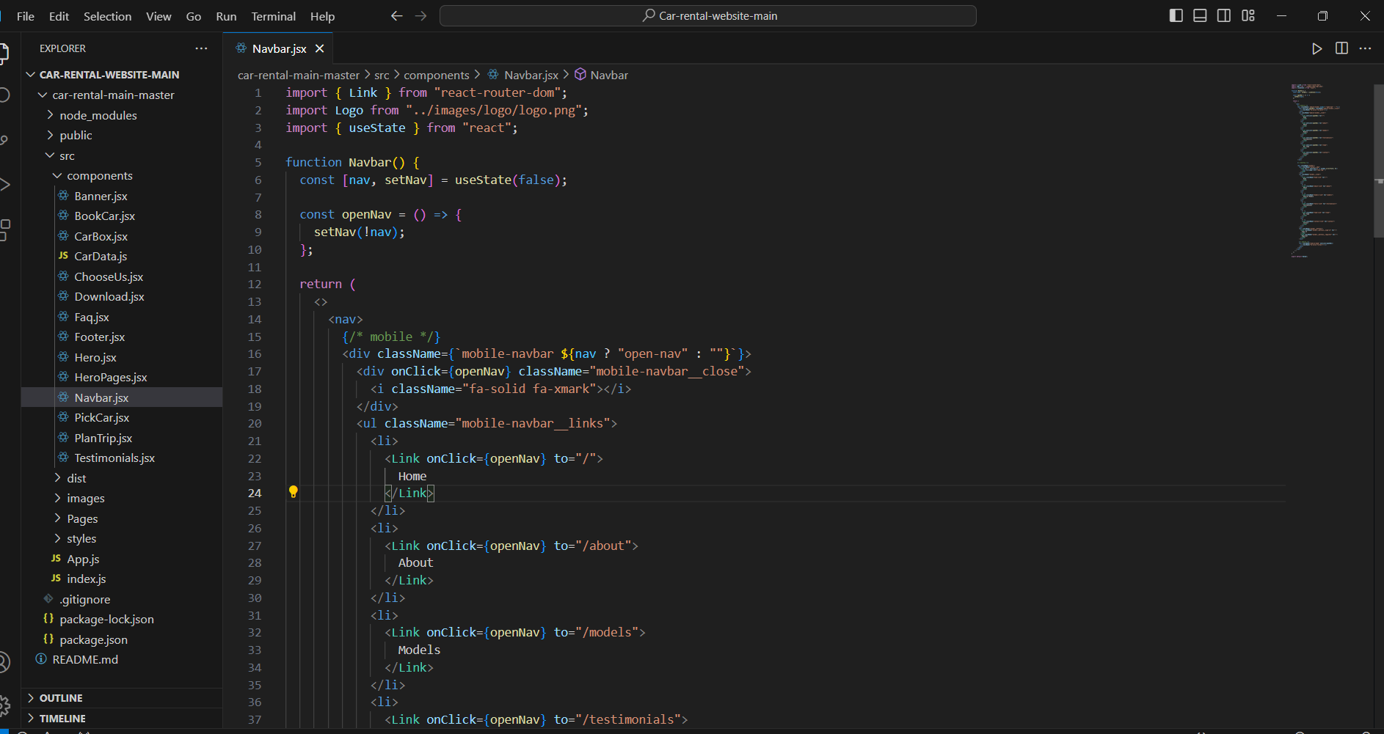

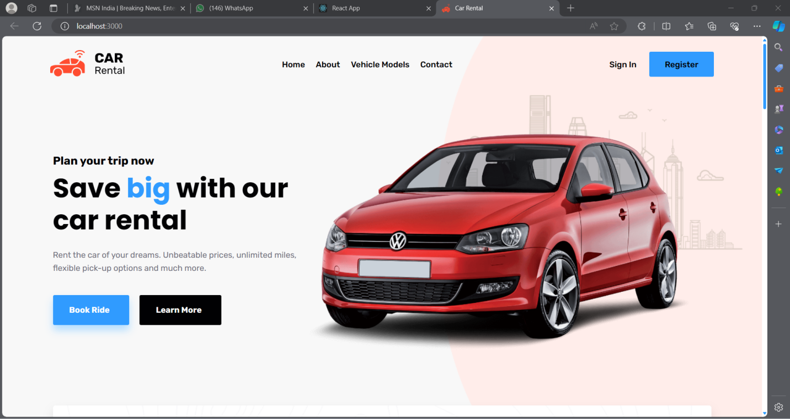

**MAIN PAGE**

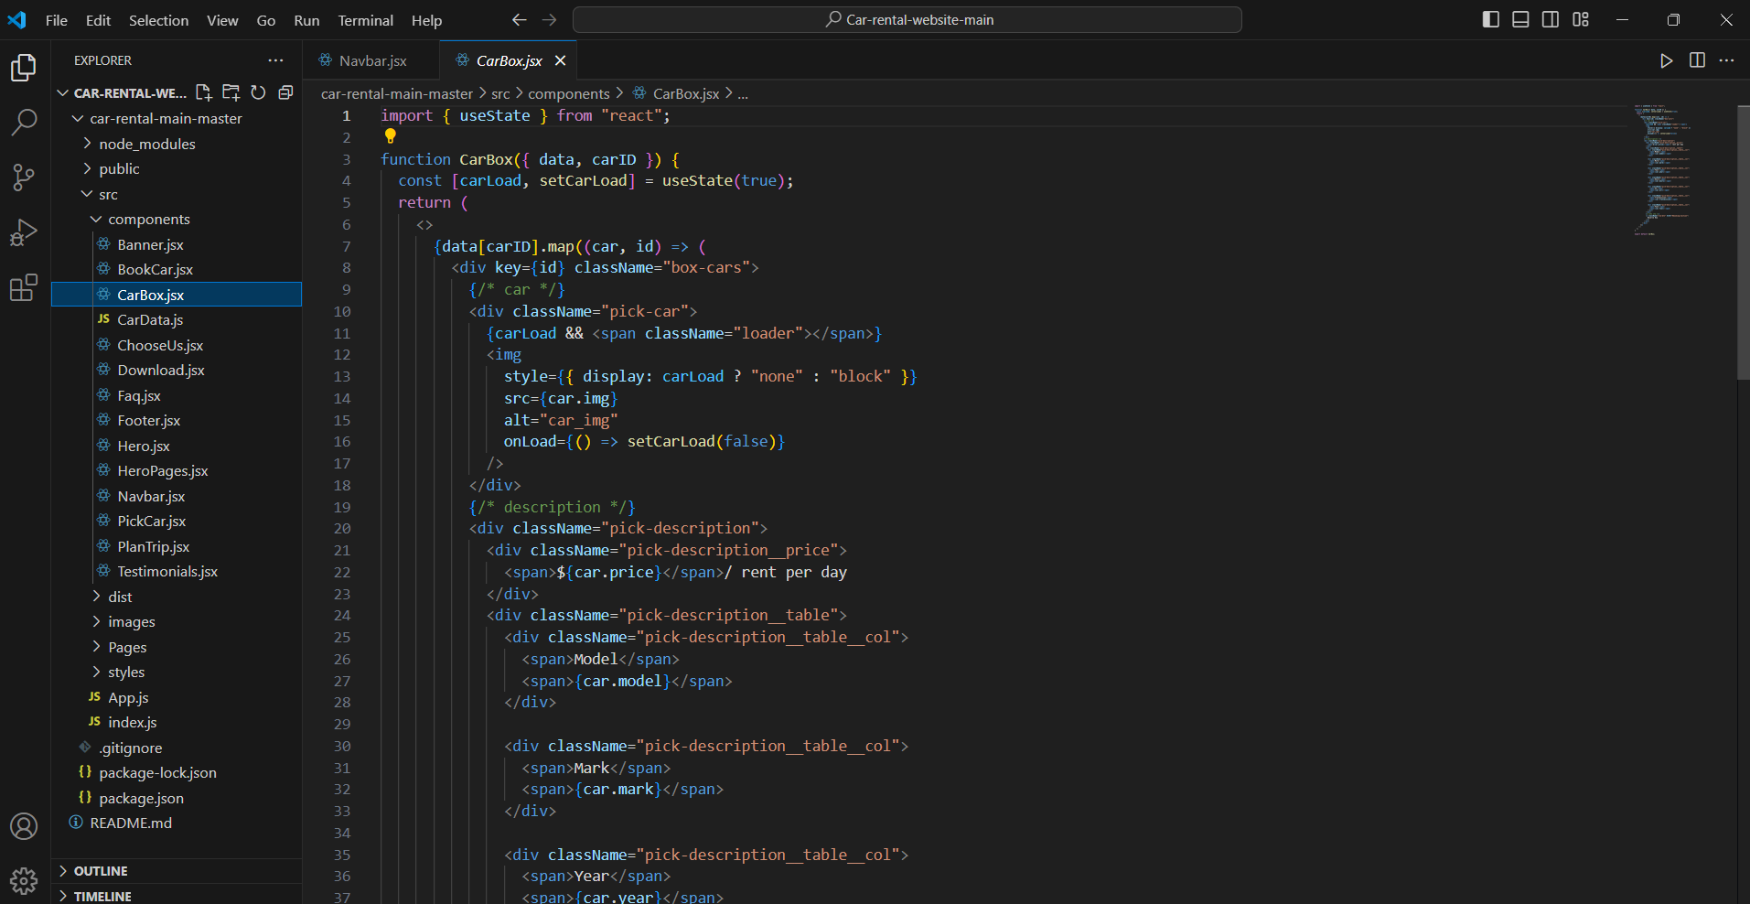

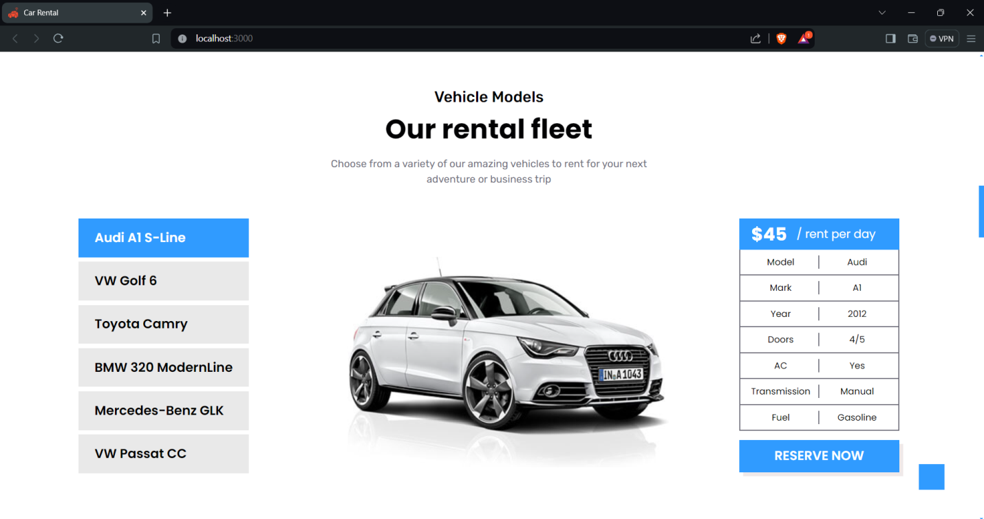

**FOOTER**