# Northwind Traders

# Project Report

## By: Ansh Singla

## Objective

The objective of this Power BI report is to create a visually appealing and user-friendly dashboard that communicates key performance metrics for Northwind Traders effectively. The report aims to generate insights into customer behavior, sales patterns, and employee performance to aid decision-making processes. It will cover sales analysis, customer segmentation, inventory trends, and employee performance, consolidating data from multiple tables for a comprehensive view of the company's operations. The report will empower stakeholders to make data-driven decisions by offering valuable insights and facilitating data exploration through interactive visualizations and dynamic filters. The expected impact is to revolutionize how Northwind Traders interacts with its data, enabling the company to remain competitive and drive its business forward in the wholesale market landscape.

## Significance

* Data Consolidation: Combines multiple data sources for a comprehensive view of business operations.
* Informed Decision-Making**: Provides actionable insights into sales, inventory, customer behavior, and employee performance.
* Proactive Problem-Solving**: Identifies issues early, enabling timely interventions.
* Operational Efficiency**: Optimizes sales, inventory, and employee processes for better resource management.
* Competitive Edge**: Helps anticipate trends, personalize customer interactions, and stay ahead in the market.
* Improved Stakeholder Communication**: Simplifies data through interactive visualizations, aligning all stakeholders with business goals.
* Future Growth Enablement**: Lays the groundwork for predictive analytics and long-term planning.
* Enhanced Customer Engagement**: Drives targeted strategies using customer segmentation insights.
* Performance Optimization**: Tracks key metrics for continuous improvement in employee and business outcomes.

Data

Dataset Description

The Northwind database contains the sales data for a fictitious company called “Northwind Traders,” which imports and exports specialty foods from around the world.

Table Explanations

Customers Table

This table stores information about the company's customers. It includes fields for customer ID, company name, contact name, contact title, address, city, region, postal code, country, phone, and fax.

Employees Table

This table stores information about the company's employees. It includes fields for employee ID, last name, first name, title, title of courtesy, birth date, hire date, address, city, region, postal code, country, home phone, extension, photo, notes, reports to, and photo path.

Orders Table

This table stores information about the company's orders. It includes fields for order ID, customer ID, employee ID, order date, required date, shipped date, ship via, freight, ship name, ship address, ship city, ship region, ship postal code, and ship country.

Order Details Table

This table stores detailed information about the items within each order. It includes fields for order ID, product ID, unit price, quantity, and discount.

Products Table

This table stores information about the company's products. It includes fields for product ID, product name, supplier ID, category ID, quantity per unit, unit price, units in stock, units on order, reorder level, and whether the product is discontinued.

Suppliers Table

This table stores information about the company's suppliers. It includes fields for supplier ID, company name, contact name, contact title, address, city, region, postal code, country, phone, fax, and home page.

## ER Diagram

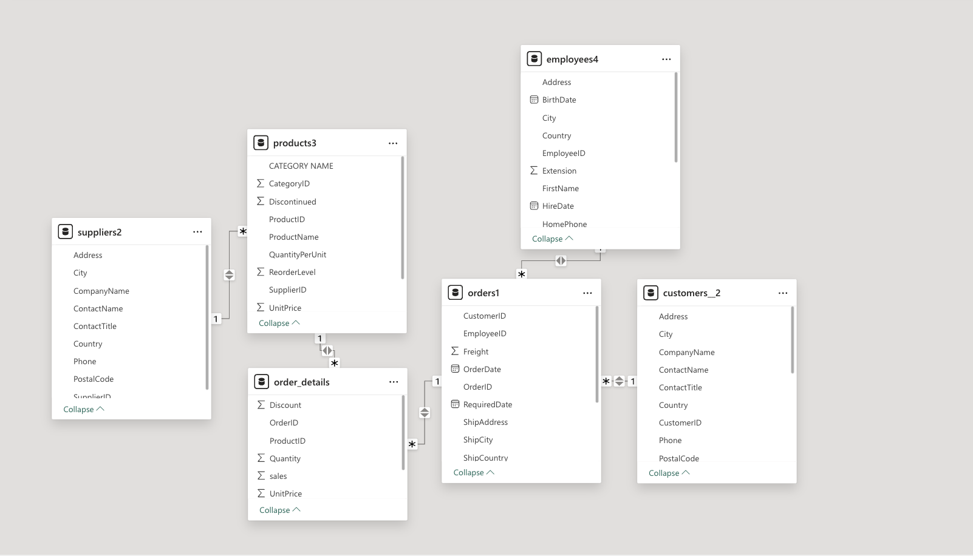

ANALYSIS DONE

**1. Sales Analysis**

• **Revenue Trends**: Highlight monthly/quarterly/yearly sales growth or decline.

• **Top-Selling Regions**: Analyse which regions or countries contribute most to sales.

• **Seasonal Patterns**: Mention any seasonal trends, like sales spikes during holidays or specific months.

**Customer Analysis**

• **Customer Segmentation**: Divide customers into categories like high-value, frequent, or new customers.

• **Retention Rates**: Discuss how many customers are repeat buyers versus new ones.

• **Regional Insights**: Analyze customer distribution across different cities or countries.

**3. Employee Analysis**

• **Sales by Employee**: Highlight the contribution of individual employees to total sales.

• **Order Ful fillment**: Measure the efficiency of employees in processing and fulfilling orders.

• **Performance Metrics**: Use KPIs like orders handled, revenue generated, or customer feedback ratings.

**4. Product Analysis**

• **Best-Selling Products**: List products that perform consistently well in sales.

• **Underperforming Products**: Highlight products with low demand or high inventory levels.

• **Category Insights**: Analyze product categories to identify which ones are most profitable or least performing.

## Conclusion

In conclusion, the analysis highlights significant trends and achievements for Northwind Traders. The **Beverages** and **Dairy Products** categories are the most popular, contributing a combined total of **$1.27M** in sales. The **USA** emerges as the top-performing region, accounting for **$245K** in sales. Among products, **Côte de Blaye** is the best-seller, while **Guylène Nodier** stands out as the top supplier. On the employee front, **Margaret** has been identified as the best performer, achieving the highest sales, particularly in the USA. Overall, the company has demonstrated robust growth, with quarterly sales increasing from **$53K in Q3 1994** to an impressive **$246K in Q2 1996**. These insights showcase the company’s strong performance and upward trajectory, providing a solid foundation for future strategic decisions.