

ReferralMe
Product Overview and Operating Model
Version: v1.0 | Date: 2026-05-16 | Use: Internal

Executive Summary
- ReferralMe is a career-outcomes platform that helps candidates move from confusion to a clear weekly plan, stronger applications, and verified referral support.
- We combine: (1) structured job discovery + referral requests, (2) ATS and application quality tools, (3) AI mentor guidance, and (4) optional paid human mentorship sessions.
- A campus ambassador program creates distribution in colleges through weekly tasks, proof review, and reward ladders.
- Phase 1 monetization: paid mentorship sessions collected by the platform; subscriptions can be added once the guidance loop proves retention.
- North star: increase interview rate and time-to-first-interview for high-intent seekers.

Problem
Most job seekers lack a repeatable system. They send low-signal cold DMs for referrals, apply widely without tailoring, and do not track what works. The result is low response rates and slow progress.
- Referral outreach is noisy and often ignored because it is generic and high volume.
- Candidates struggle to identify the right roles, keywords, and projects to match a target job.
- Interview preparation is unstructured; effort doesn’t compound week to week.

Solution: A Closed-Loop System
- Intake: understand the target role, experience, constraints, and current status.
- Plan: generate a weekly plan (7-day) with tasks, outreach templates, and checkpoints.
- Execute: apply to a curated set of roles; send ethical, high-signal referral requests; track outcomes.
- Improve: ATS fixes, portfolio upgrades, and interview practice based on feedback loops.
- Escalate: when needed, book a paid human mentorship session for mock interviews, resume review, or negotiation.

Core Product Modules

1) Referral Marketplace (Seeker ↔ Referrer)
- Seekers: browse roles, request referrals, attach resume/cover letter, and track status.
- Referrers: post internal opportunities, review requests, and update status (accepted/rejected/sent-to-HR).
- Quality guardrails: discourage “pay-for-referral” language; promote ethical outreach and readiness.

2) Tools: ATS + Application Quality
- ATS score and improvement suggestions based on resume text vs. job description.
- Job detail extraction from referral posts/JDs to reduce manual effort for referrers.
- Reusable templates for faster, higher-quality applications.

3) Mentorship: AI + Human Sessions
- AI Mentor: guided intake wizard, 7-day plan generation, and chat-based support.
- Human mentorship: referrers can enable mentorship, define services (title/duration/price), and confirm sessions with a meeting link.
- Payments (Phase 1): platform collects 100% payment at booking; session request is created only after server-side verification.
- Payouts (Phase 2): pay out mentors after completion (e.g., weekly) and take a platform fee.

4) Campus Ambassador Program
- Landing page + application form + admin review pipeline.
- Ambassador dashboard: tasks, proof submission, activity, points, reward ladder.
- Admin: create tasks, review proof, publish announcements and landing content, manage ambassadors.

Operating Model (How It Works)

Seeker Flow
- Complete profile and set target role.
- Use AI Mentor to generate a weekly plan + outreach scripts.
- Apply to roles and submit referral requests with tailored resume.
- Track responses and improve with ATS insights.
- If stuck, book a mentor session (resume review/mock interview).

Referrer Flow
- Complete profile, post roles, and review incoming requests.
- Optionally enable mentorship and publish services/prices.
- Confirm booked sessions by adding meeting link; mark sessions complete after delivery.

Business Model (Initial)
- Mentorship: paid sessions (platform collects payment).
- Subscription (later): bundled AI guidance + ATS + structured weekly system.
- Campus program: distribution channel; can add sponsor partnerships later.

Roadmap (Next 90 Days)
- Stabilize AI mentor with caching + paid-tier quota or provider fallback; keep offline mode as a safety net.
- Add mentorship payout ledger and admin payout queue (Phase 2).
- Add mentor discovery filters (company, role, rating) and session feedback loop.
- Improve referral quality metrics: readiness checklist before requesting referral.
- Add analytics dashboard for conversion, interview rate, and retention.

Brand Assets (Examples)
Below are example reward assets used in the campus program and marketing pages.
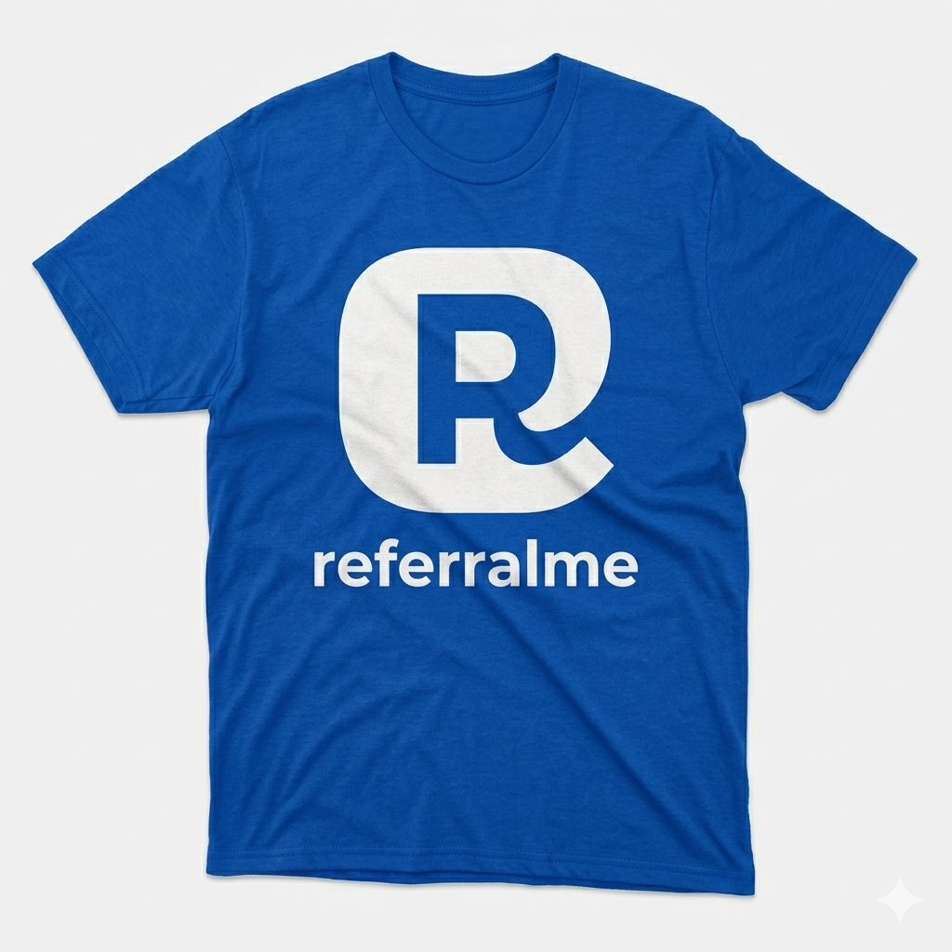
Reward: Ambassador tee (example mock).
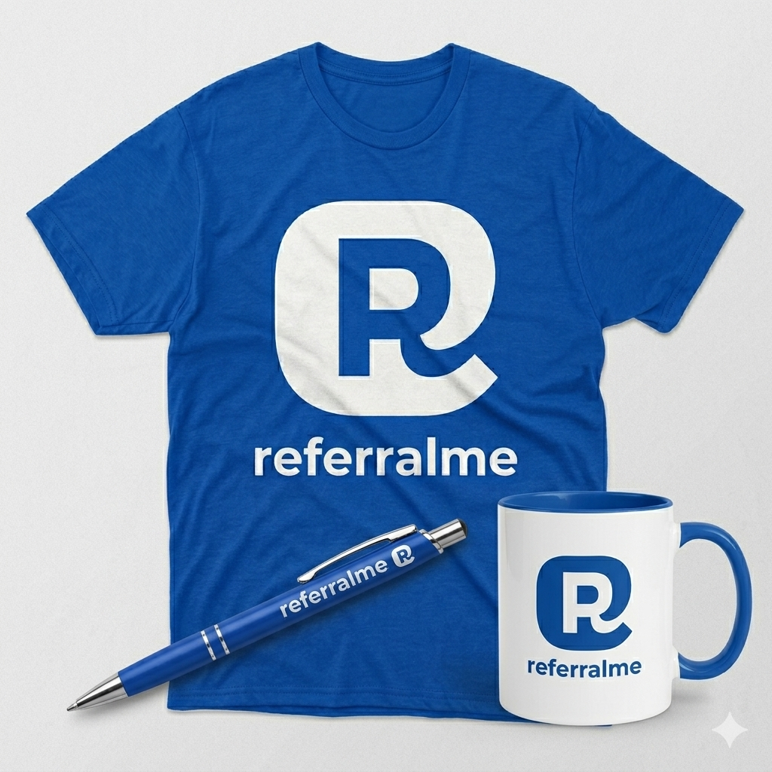
Reward: Brand kit (example mock).
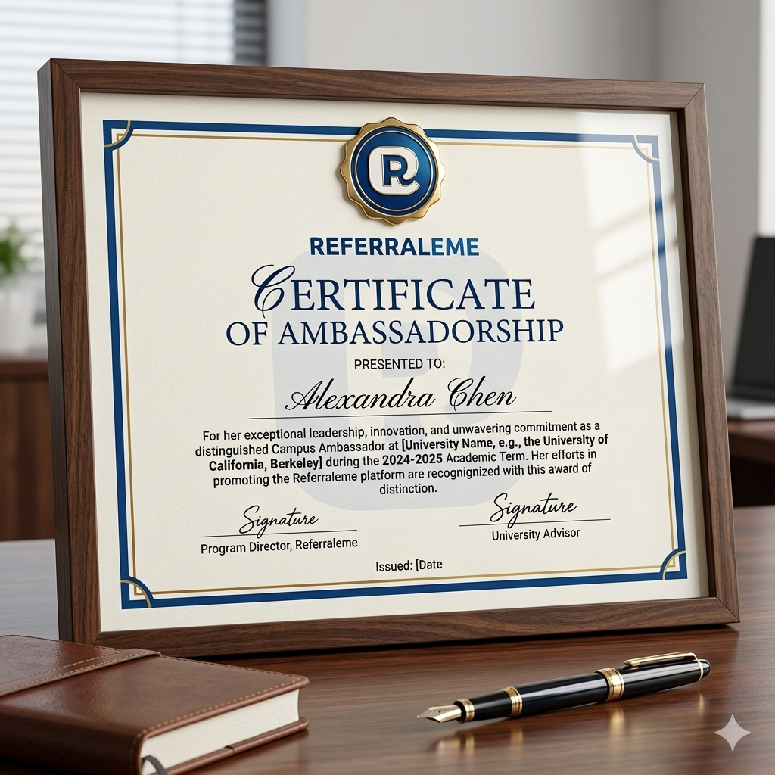
Reward: Recognition certificate (example mock).

