Chapter 1- Raspberry Pi Fundamentals
1.1Introduction to Raspberry Pi

The Raspberry Pi is a credit card-sized single board computers made in the UK by the non-profit Raspberry Pi Foundation for educational purposes. This smart little device enables people to explore the computing world and learn how to program in languages like Scratch and Python. It is capable of doing everything a desktop computer can do, from making spreadsheets, word-processing to playing high-definition videos and games.

Several generations of Raspberry Pi have been released. The first generation (Raspberry Pi 1 Model B) was released in February 2012. It was followed by the simpler and cheaper Model A. In 2014, the Foundation released a board with an improved design in Raspberry Pi 1 Model B+. These boards are approximately credit-card sized and represent the standard mainline form-factor. Improved A+ and B+ models were released a year later. A "Compute Module" was released in April 2014 for embedded applications. The Raspberry Pi 2 which added more RAM was released in February 2015

  - Raspberry Pi 3- Model B
The Raspberry Pi 3 Model B is the third generation Raspberry Pi. This powerful credit-card sized single board computer can be used for many applications and supersedes the original Raspberry Pi Model B+ and Raspberry Pi 2 Model B.
While maintaining the popular board format the Raspberry Pi 3 Model B brings you a more powerful processor, 10x faster than the first generation Raspberry Pi.
Additionally it adds wireless LAN & Bluetooth connectivity making it the ideal solution for powerful connected designs
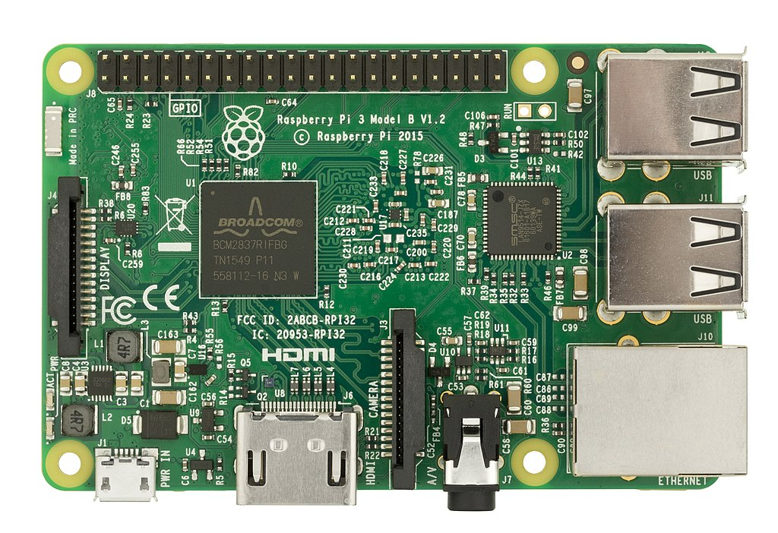
Pic: Raspberry Pi 3B model

1.3 Raspberry Pi 3 - Model B Technical Specification
- Broadcom BCM2387 chipset
- 1.2GHz Quad-Core ARM Cortex-A53
- 802.11 bgn Wireless LAN and Bluetooth 4.1 (Bluetooth Classic and LE)
- 1GB RAM
- 64 Bit CPU
- 4 x USB ports
- 4 pole Stereo output and Composite video port
- Full size HDMI
- 10/100 BaseT Ethernet socketbr
- CSI camera port for connecting the Raspberry Pi camera
- DSI display port for connecting the Raspberry Pi touch screen display
- Micro SD port for loading your operating system and storing data
- Micro USB power source

1.4 Raspberry Pi 3 - Model B Features
  - Now 10x Faster - Broadcom BCM2387 ARM Cortex-A53 Quad Core Processor powered Single Board Computer running at 1.2GHz!
  - 1GB RAM so you can now run bigger and more powerful applications
  - Fully HAT compatible
  - 40pin extended GPIO to enhance your “real world” projects.
  - Connect a Raspberry Pi camera and touch screen display (each sold separately)
  - Stream and watch Hi-definition video output at 1080
  - Micro SD slot for storing information and loading your operating systems.
  - 10/100 BaseT Ethernet socket to quickly connect the Raspberry Pi to the Internet
Chapter 2 - Ebook Fundamentals

2.1 Introduction Of eBook

An electronic book (or e-book) is a book publication made available in digital form, consisting of text, images, or both, readable on the flat-panel display of computers or other elect commercially produced and sold e-books are usually intended to be read on dedicated e-reader devices. However, almost any sophisticated computer device that features a controllable viewing screen can also be used to read e-books, including desktop computers, laptops, tablets and smartphone.

2.2 History Of eBook

In the 2000s, there was a trend of print and e-book sales moving to the Internet, where readers buy traditional paper books and e-books on websites using e-commerce systems. With print books, readers are increasingly browsing through images of the covers of books on publisher or bookstore websites and selecting and ordering titles online; the paper books are then delivered to the reader by mail or another delivery service. With e-books, users can browse through titles online, and then when they select and order titles, the e-book can be sent to them online or the user can download the e-book. At the start of 2012 in the U.S., more e-books were published online than were distributed in hardcover.

Chapter 3 - Benefits of Ebook
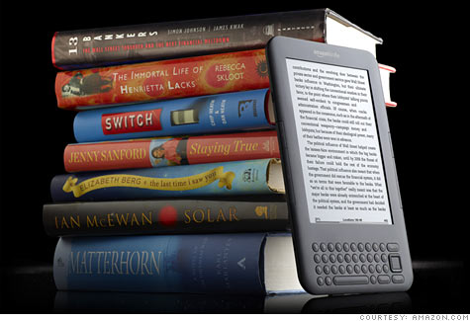

- Mobility
Carry your library in your pocket. With disk space quickly becoming a commodity and the size of portable device hard drives getting bigger and bigger its conceivable to think that you could have your entire library with you.

- Saving Physical space
Our library can grow as big as the disk space we have available and will be relatively small compared to walls and walls of bookshelves.

- Convenience
Keeping a electronic book will take up so little space you are allowed a few mistakes , and hopefully it will allow us to experiment with different types of authors and genres.

- Ease of use
Font size , type and background colure of electronic book can be adjusted easily instead of earmarking pages or marking up paper , electronic copies allow us to add , delete bookmarks and notes easily.

Chapter 4 - eBook Readers

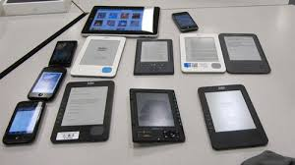

An e-reader , also known as e- book reader is a portable electronic device that is designed primarily for the purpose of reading e-books . E-readers have a similar form factor to a tablet and usually refers to devices that use a electronic paper resulting in better screen readability especially in sunlight and longer battery life when compared top a tablet. An e-readers battery will typically last for multiple weeks.
Any device that can display text on screen act as an e-reader without the advantages of electronic paper.
Electronic paper displays:
1.kindle – kindle oasis, kindle paperwhite
2.Nook- Nook simple touch, nook glowlight
3.Kobo- Kobo aura, kobo touch kobo aura hd
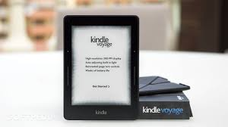

New Generation of Readers
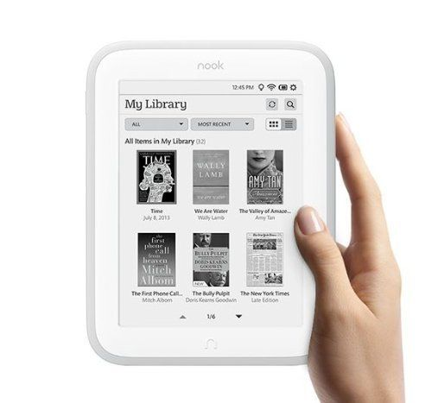
- New fb readers are popular as multi platform ebook reader.

- Supports popular ebook formats:epub,fb2,mobi,plaion text.

- Provides access to popular network libraries that contain a large set of ebooks .

- Hioghly customizable.Choose colors,fonts,page turning animations, dictionaries, bookmarks etc. to make reading as convenient as you want as easy possible can be made

Chapter 5 - Creating an eBook server

5.1 steps followed
Our main purpose was to turn our raspberry pi as a ebook server to achieve this we followed the following steps.

First we bought a raspberry model 3B and a 16 GB sd card which would act as a hard drive for raspberry pi.

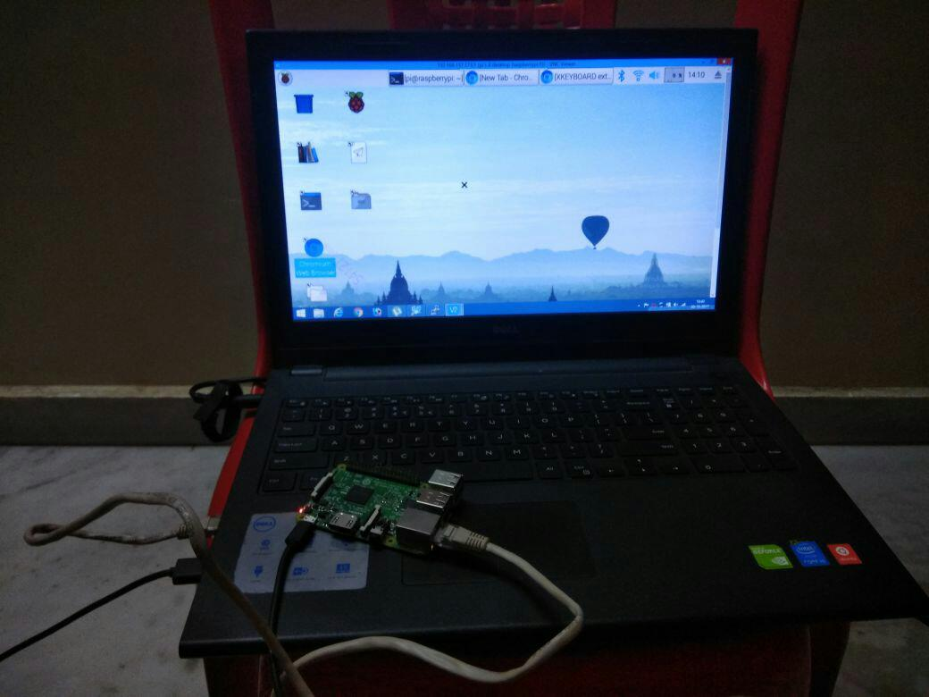
Then to install raspbian operating system software called etcher helped us in transforming the sd card into a 16 GB hard drive for raspberry pi. Then we downloaded three software namely vnc viewer, advance ip scanner and putty. Then connected raspberry pi with laptop using Ethernet cable and finally we were ready to begin.

Now we started our project to turn raspberry pi as a ebook server .

Going to terminal we applied two commands.

Sudo apt-get update;and sudo apt-get install calibre .

It took around 4-5 minutes to install calibre software.

Now our main task was to create a ebook server where we can store our uploaded books and share it with other users.

After creating a server we were all set to share it with other users who can connect to our servers and can access to our files that we have uploaded.

  - Commands used to create server

1.To install calibre
sudo apt-get update && sudo apt-get install calibre
2. To run it as a server
calibre-server –with- library=/home/pi/calibre/myLibrary –daemonize followed by
crontab –e
3. For rebooting the server
reboot caliber-server –with-library=/home/pi/calibre/myLibrary –daemonize
4. Adding some books
calibredb add Raspberry_pi_Education_manual.pdf --with- library=/home/pi/calibre/myLibrary
5. connection from clients
Going to browser and entering URL of content (http://{Local IP}:8080);
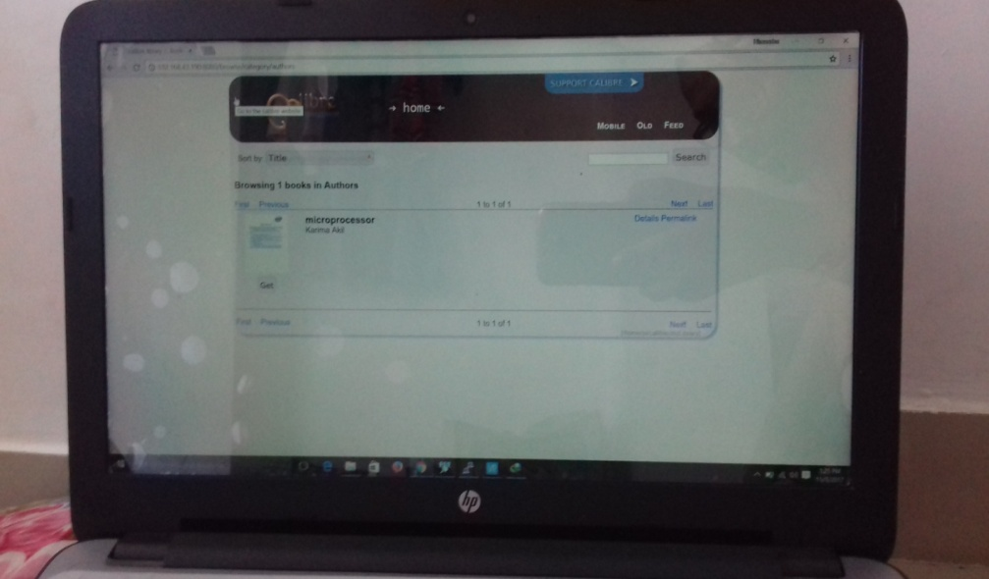
IP address of my server is 192.168.43.190 so users going to URL content 192.168.43.190:8080 can access books from calibreLibrary
Chapter 6 - eBooks in India

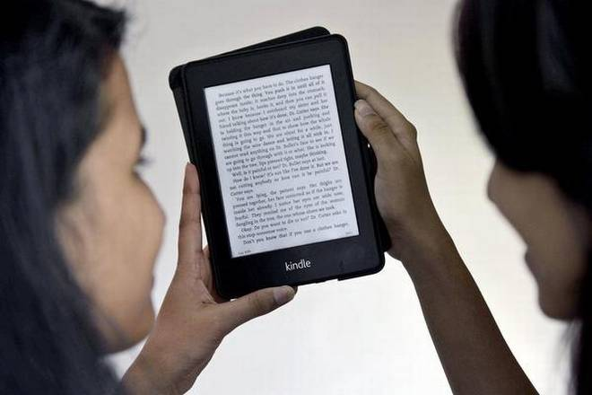
With the launch of Amazon Kindle in India, clearly e-books for the first time are getting attention by publishers as well as readers. there is a lot speculation going on ebook market in india.
  - Present situation of ebooks in India
- Schools colleges are employing this technique for better understanding by connecting through online sources for the students.
- In rural areas it has not been successful because of poor connectivity and inaccessibility of resources.
6.2 Factors which can trigger ebook consumption:
- Price of ebooks
- Push from governments schools and colleges
Ebooks can’t be priced in the same range of printed books.
Many publishers argue that with the growth of ebook sales their printed sales will come down.
Push from institutions is equally important. Readers want some angel to come and tell them-why don’t you buy ebook its cheaper better and reading is more social your experience of reading will be more than reading dead books.Till now publishing industries is totally dependent on distribution. Many good books have not reached to masses because of poor distribution infrastructure in India. eBooks don’t have this issue.
Conclusion

In this project we have made a completely portable,digital ebook library using raspberry pi through which we can acess ebook easily.

During this project we faced many problem while becoming friendly with raspberry pi. We gave our best to this project so that it can run smoothly.

In future we can further improve it, as the future of eBooks are bright enough to give it additional attention. we know that in near future everyone is going to work digitally that time eBook are the future of books everywhere in very field.

We can add up some features in this in future like we can add up scanner so that we can scan up some written file and turn it in eBook. Challenge for us in this is to make is more cheaper and efficient so that everyone can use it in affordable cost. Through raspberry pi we got satisfied result so we decide to work with raspberry pi in future and make our project better.

References

1.Links on youtube
www.youtube.com for raspberry pi os installation

2.links on google for raspberry pi projects
http://www.electronicshub.org/raspberry-pi-pprojects
http://lifehacker.com/top-10-raspberry-pi-projects for beginners
http:///www.makeuseof.com/tag/10-raspberry-pi-projects-beginners
- Video tutorials on youtube
4. completely portable ebook library web links
Portable online library with calibre and raspberry pi
Volkanpaksoy.com>archive>2015/03/07
5. [pdf] Raspberry pi Basics
[pdf] Raspberry pi Projects books
http://raspberrypi.org > magpi-issues

