**DBMS PROJECT**

**By : Dhruv Agarwal 2101CS26**

**Dhruv Choudhari 2101CS25**

**Anshu Nauwala 2101CS10**

**G-DRIVE LINK :**

[**https://drive.google.com/drive/folders/1C7YpjwSsv9nyRiYb3wz4kd43mCVRbSne?usp=share_link**](https://drive.google.com/drive/folders/1C7YpjwSsv9nyRiYb3wz4kd43mCVRbSne?usp=share_link)

**ER DIAGRAM**

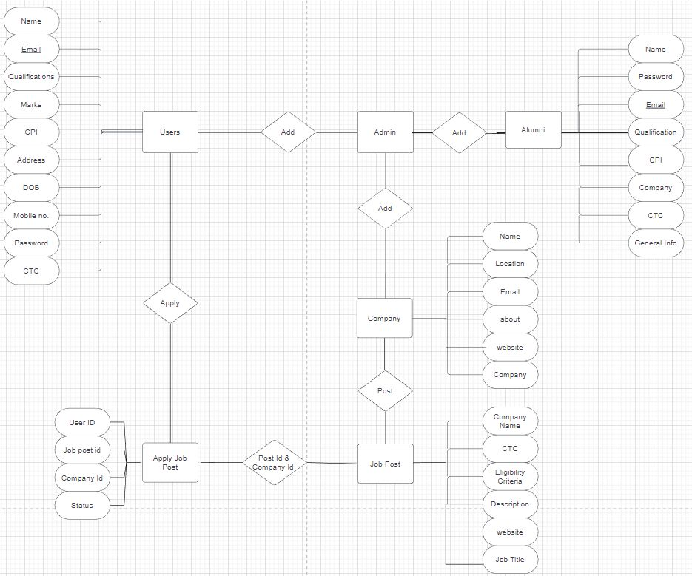

**TABLES**

**Alumni :** Alumni Table is containing details of an Alumni Personal details and most importantly in which company the alumni got placed , his/her ctc , designation , cpi ,stream , passing year.

To see No. of students we can simply run a query on passing year and Count no. of Students.

Also Previous Year data is very useful to understand the ongoing Placement criteria.

**Student / User :** A user table is created containing his/her Personal details and details of Academics.

Details of Academics are further used as every company has some specific criteria for minimum marks/cpi.

**Company** : A Company Table contains details of a company.

**Job Post :** This table contains details of Job Posts available. Contains Name of Company and each company set up criteria for minimum criteria , experience , qualification etc.

**Apply Job Post :** If a match occurs for a student fulfilling the criteria mentioned in Job Post table, his id and company id filled up in apply job-post table. In Active Drive if Student click on a job whose match is already occurred in apply job post table then, the student will get that job. Otherwise it will deny.

**HOME PAGE**

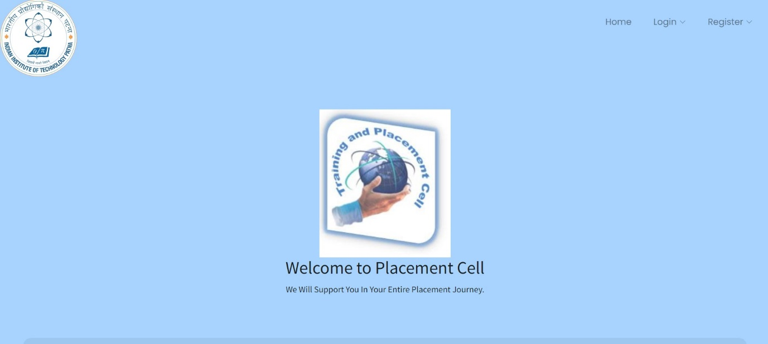

A Home Page containing Login and Registration Buttons of all the Tables we created.

**REGISTRATION PAGES**

**STUDENT REGISTRATION :**

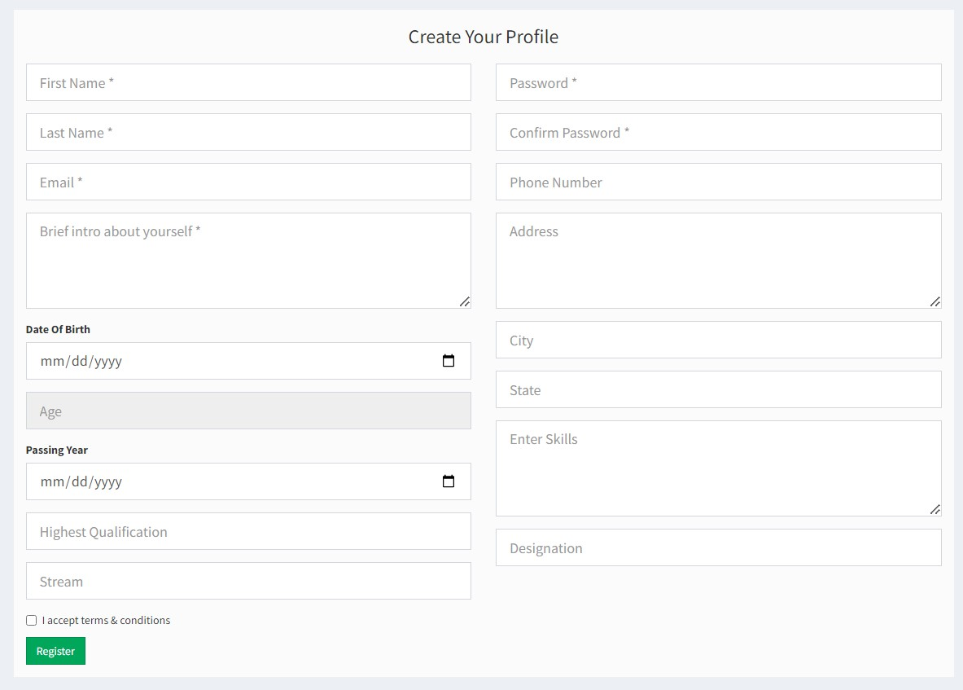

Some Fields can be left NULL in Student Table.

**COMPANY REGISTRATION:**

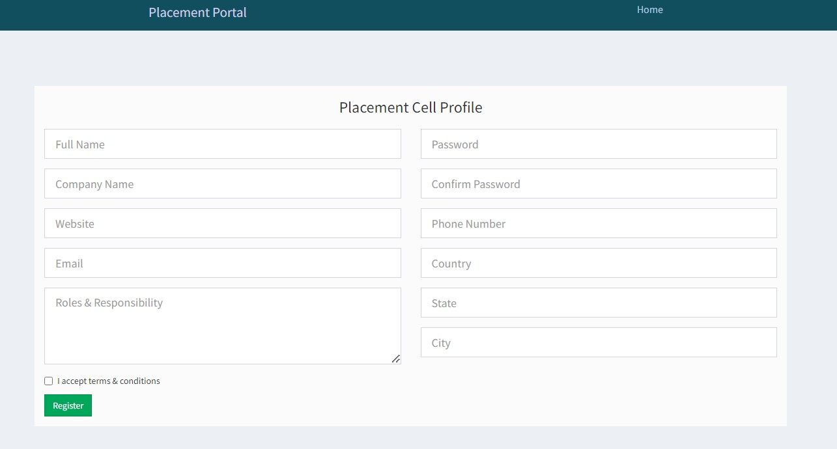

**COMPANY DASHBOARD**

**UPDATE PROFILE :**

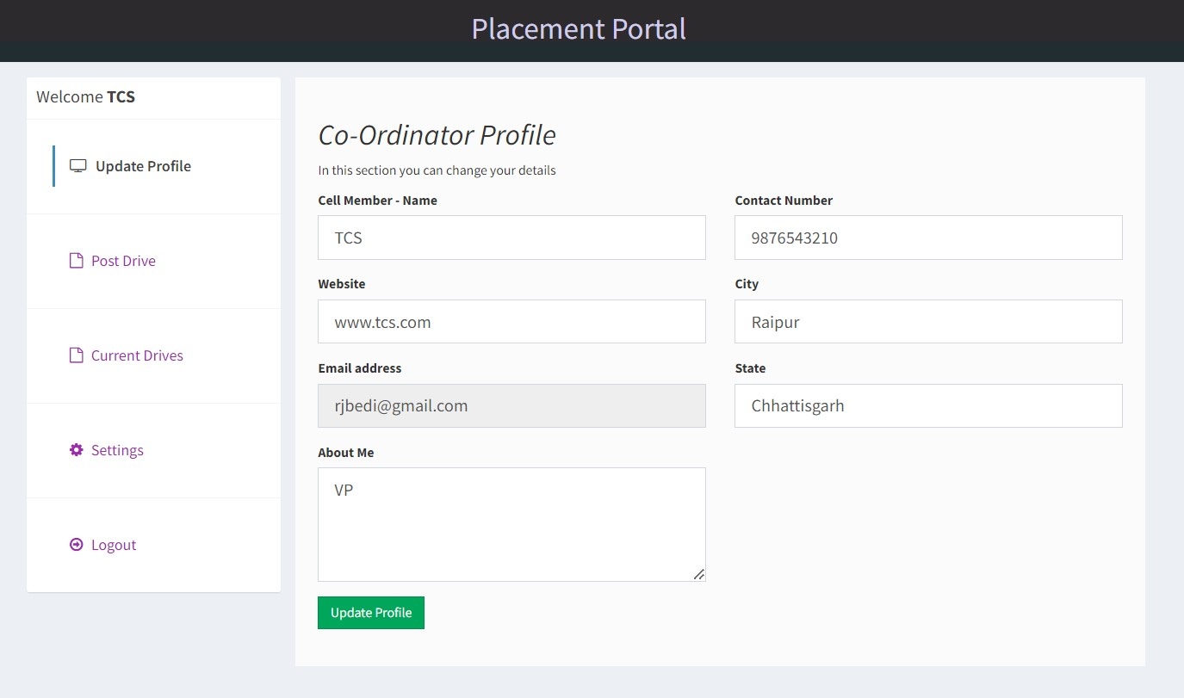

**POST JOB:**

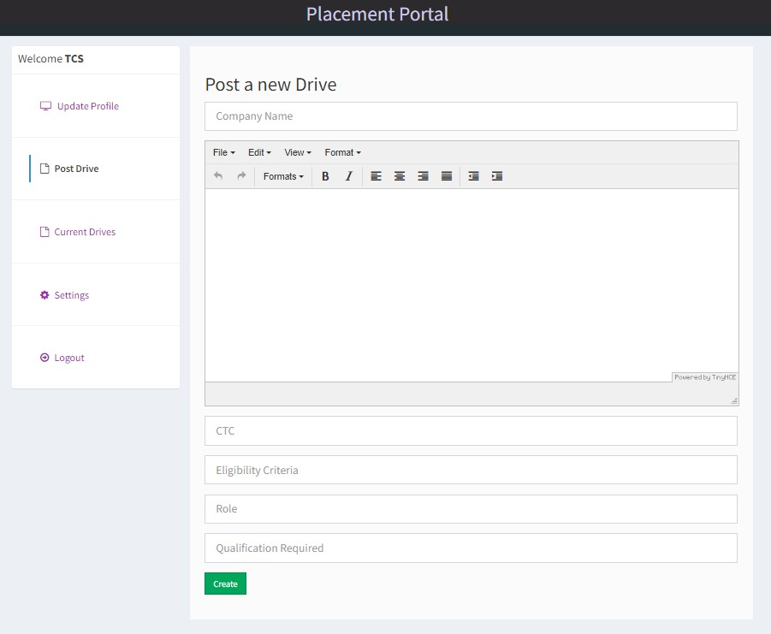

**CURRENT DRIVES :**

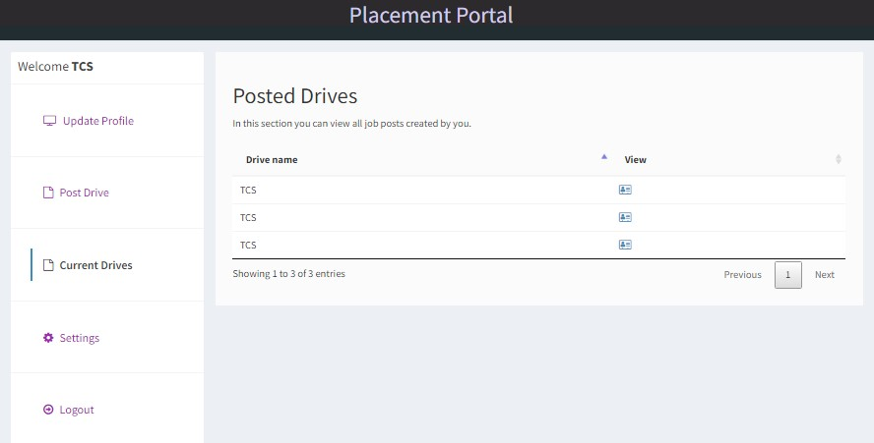

**ACCOUNT SETTINGS:**

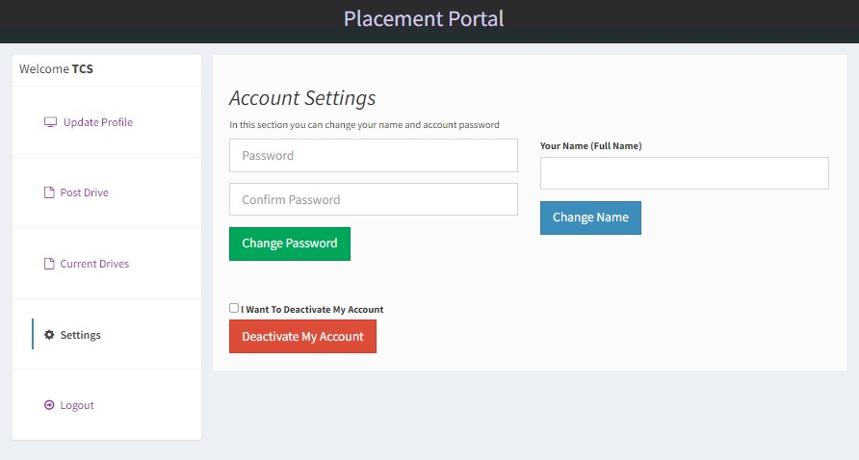

**STUDENT ALUMNI DASHBOARD**

**LOGIN:**

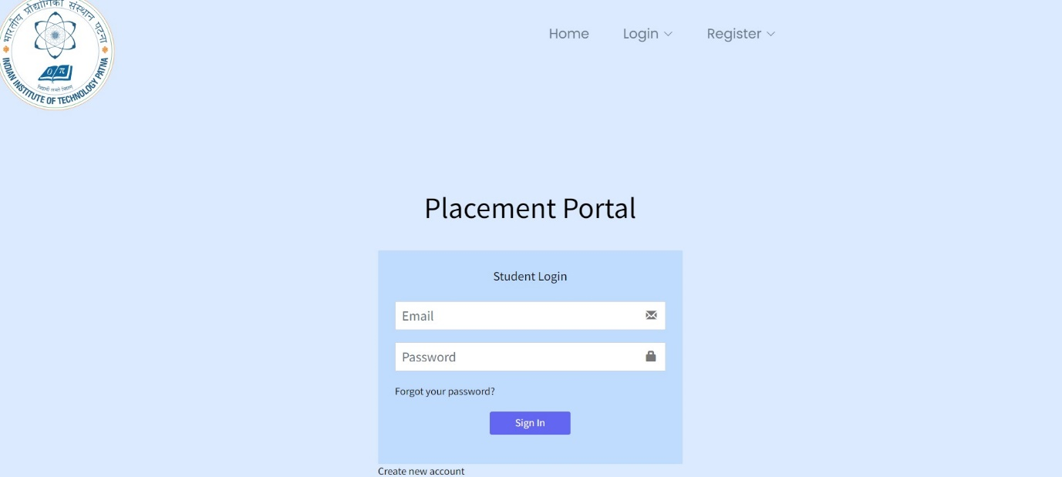

**EDIT PROFILE:**

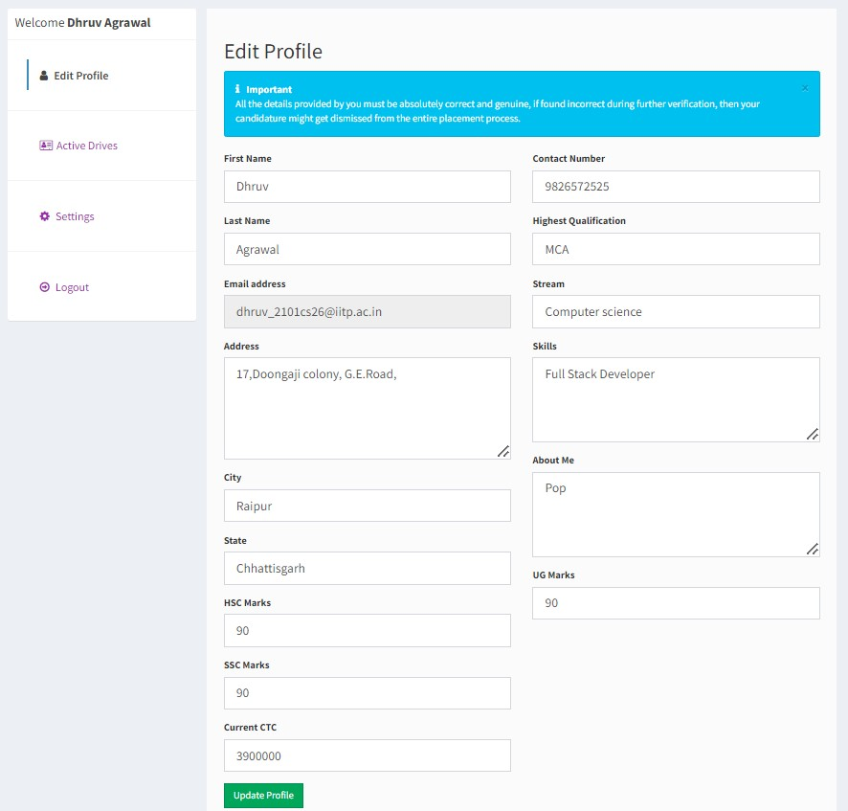

**ACTIVE DRIVES :**

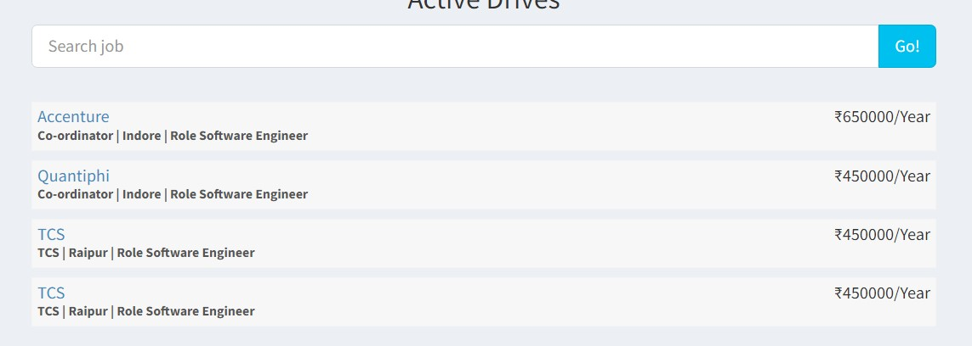

**PASSWORD CHANGE :**

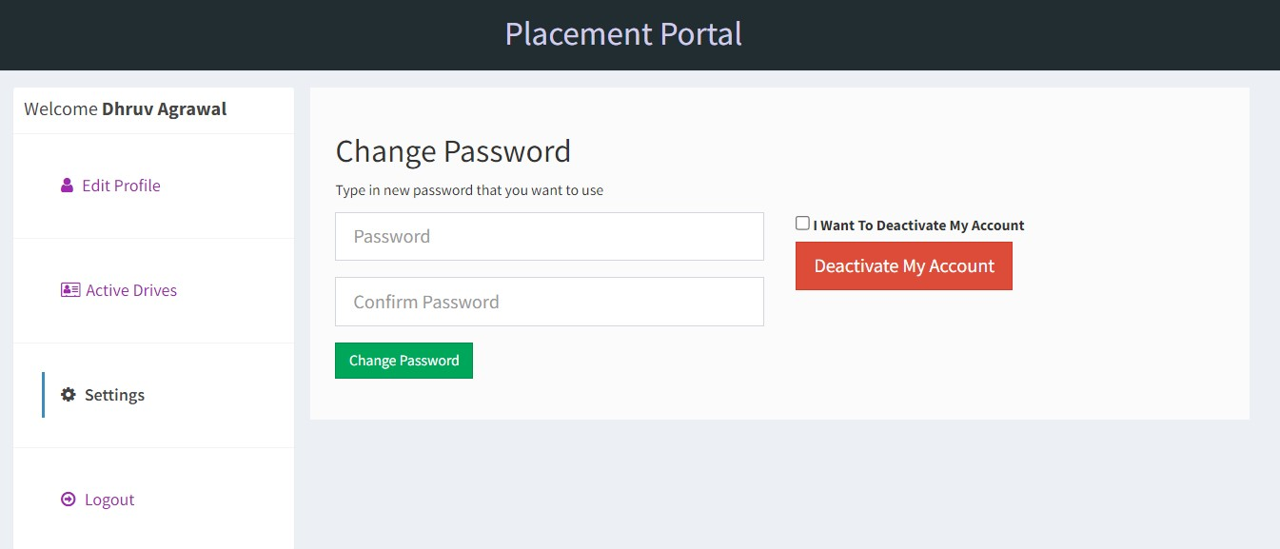

**ADMIN DASHBOARD**

**LOGIN:**

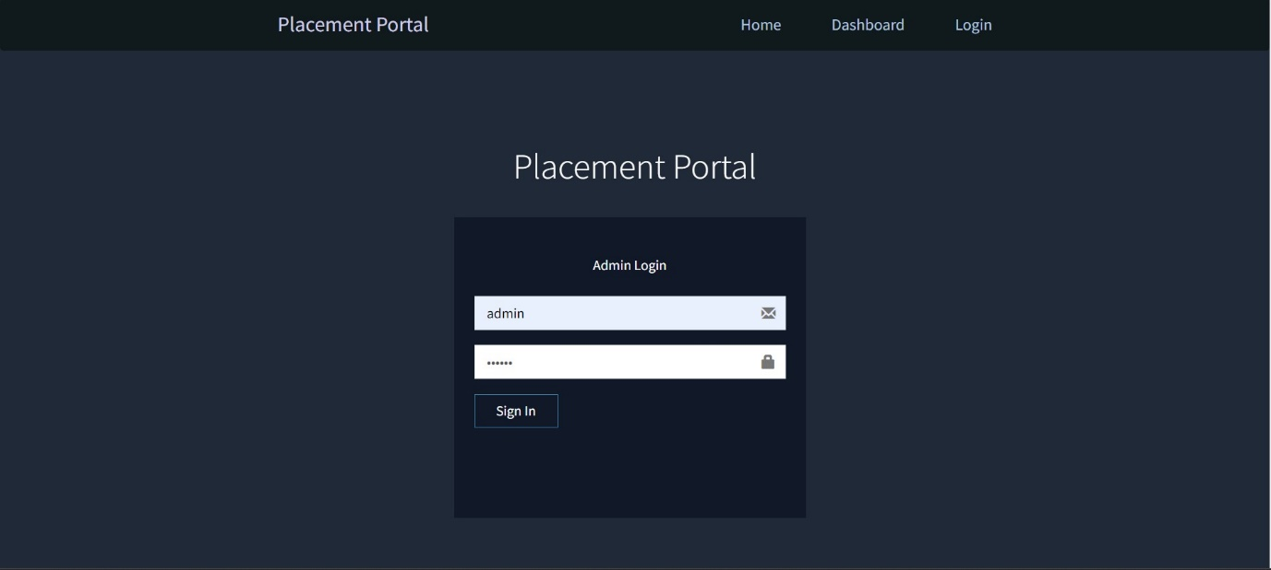

**ACTIVE DRIVES :**

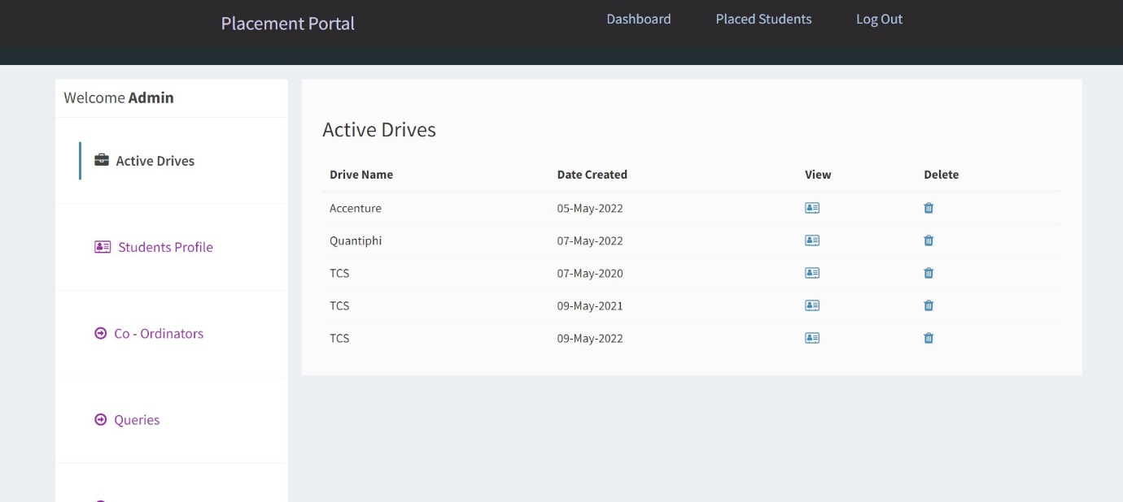

**STUDENT PROFILE:**

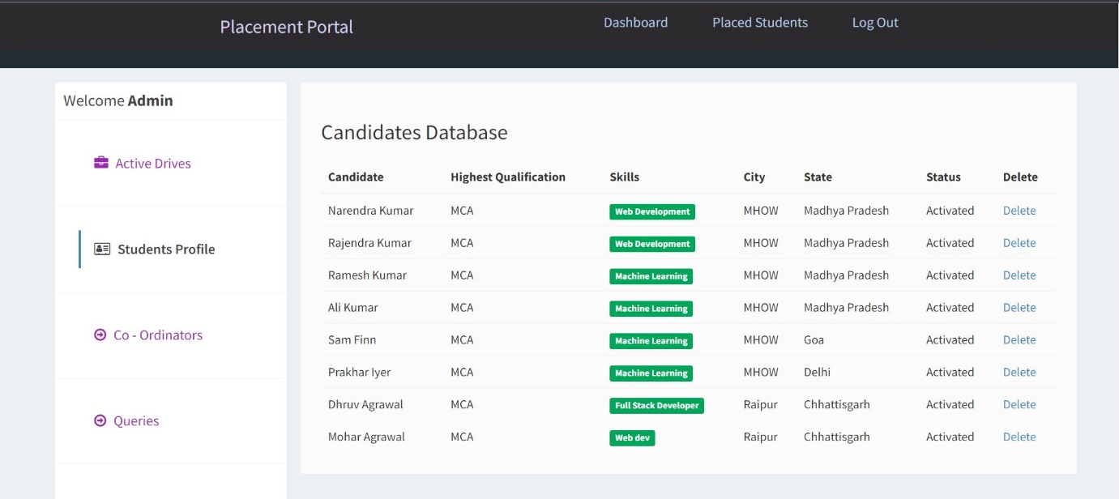

**COMPANY CORDS :**

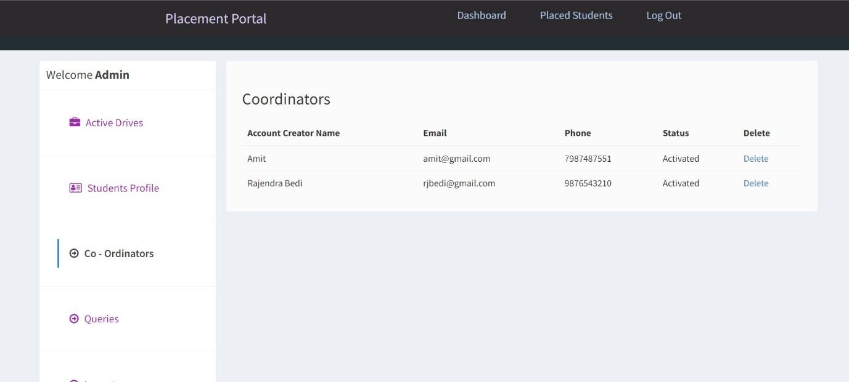

**COMPANY POST REVIEW:**

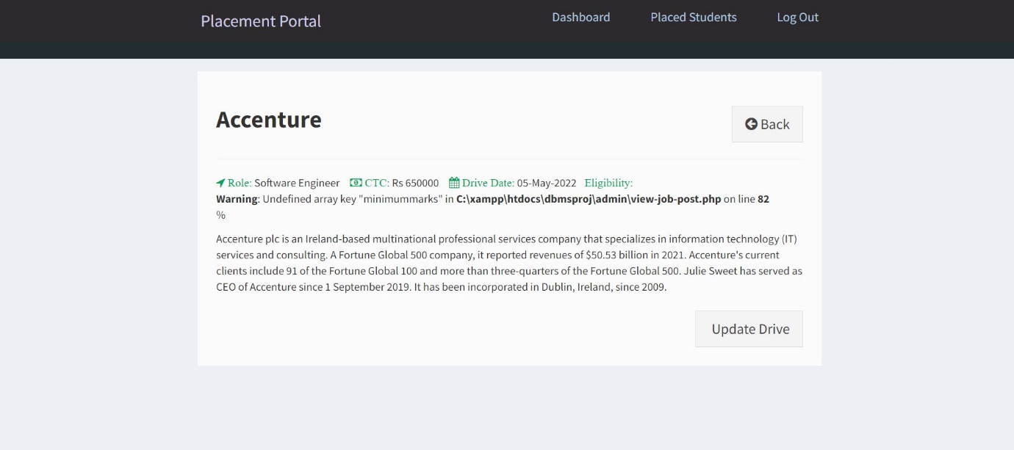

**PLACED STUDENTS:**

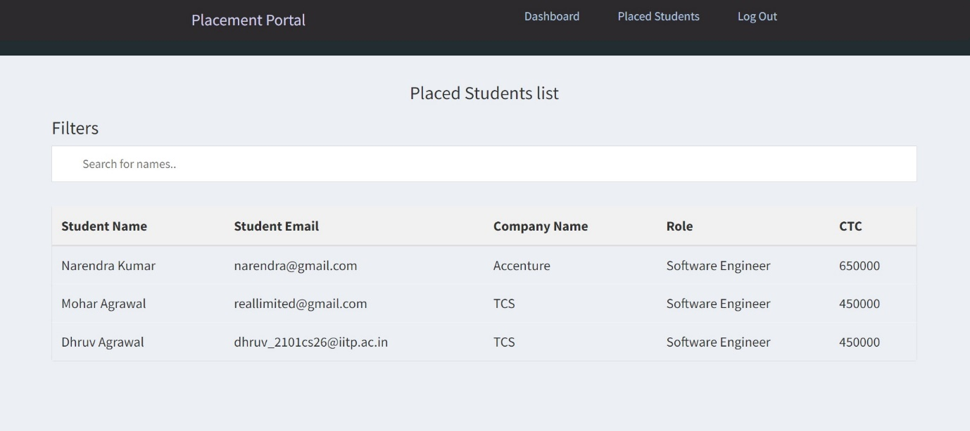

***QUERIES***

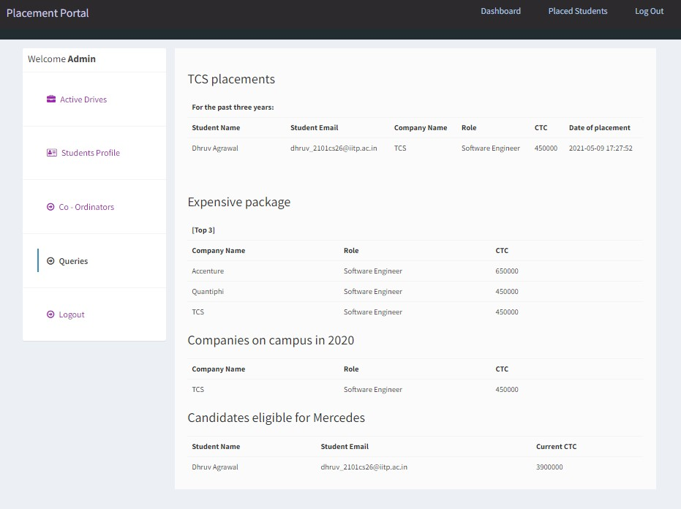

**QUERIES :-**

1.) **TCS Placements for Past Three Years :**

Shows table of Students who are Placed in TCS in and after 2021.

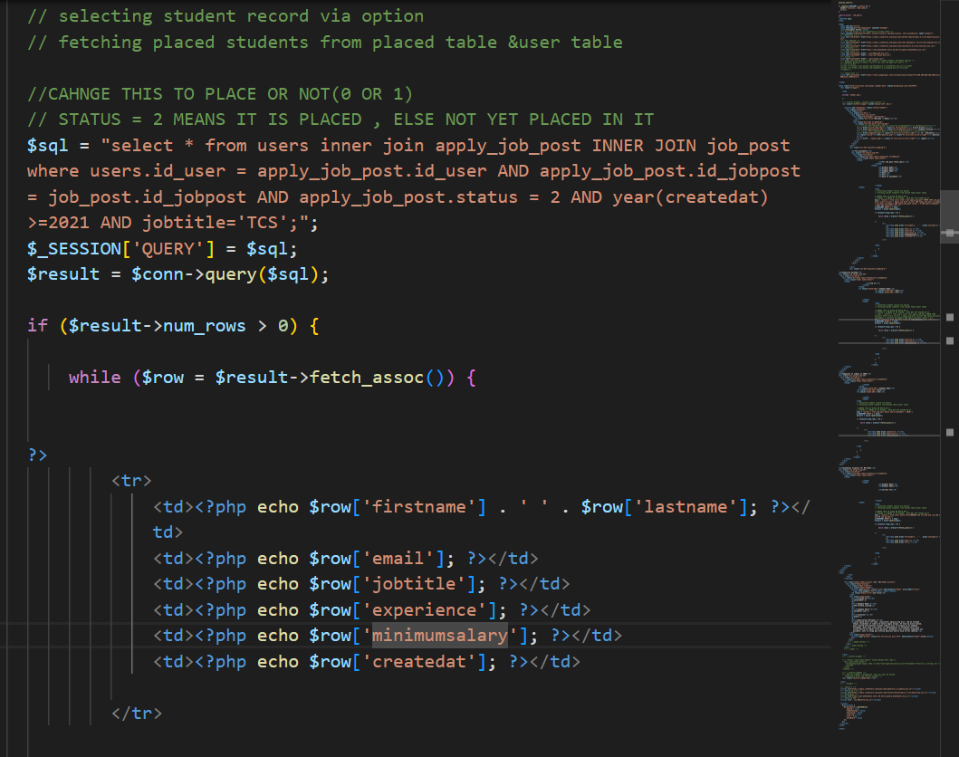

**TOP 3 EXPENSIVE PACKAGES:**

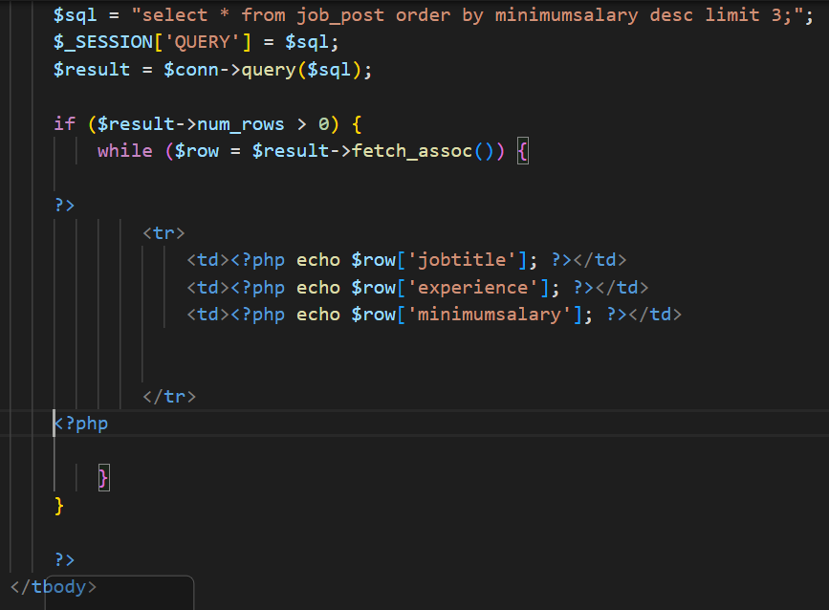

**COMPANIES ON CAMPUS IN 2020:**

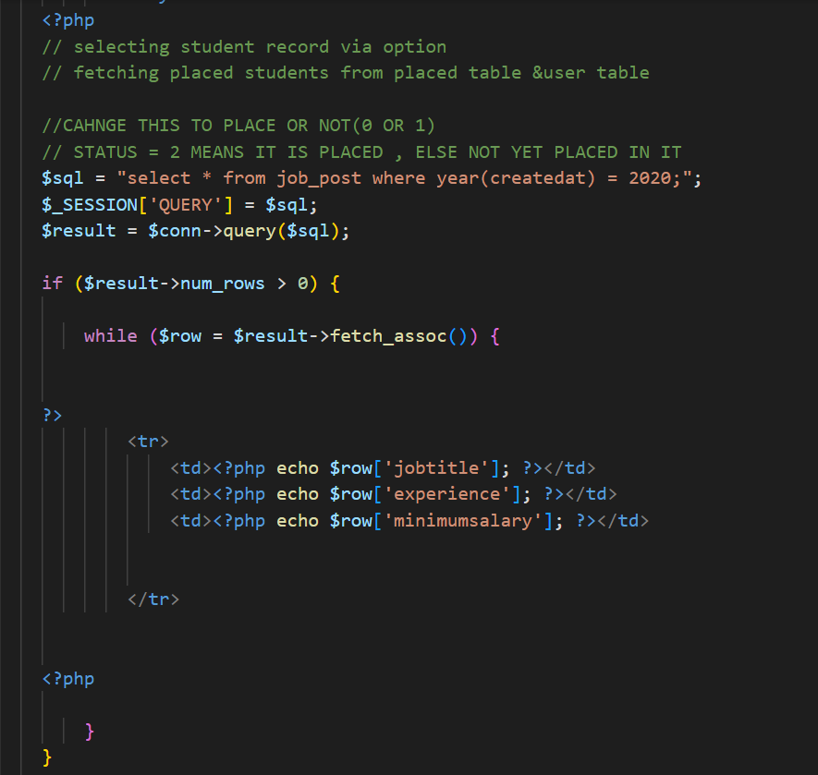

**CANDIDATES ELIGIBLE FOR MERCEDES :**

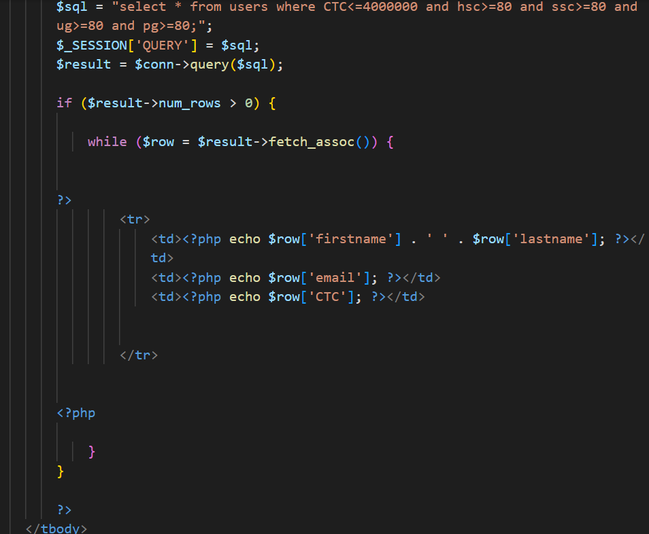

**LOGIN PROCEDURE**

Step 1: Fill the Details.

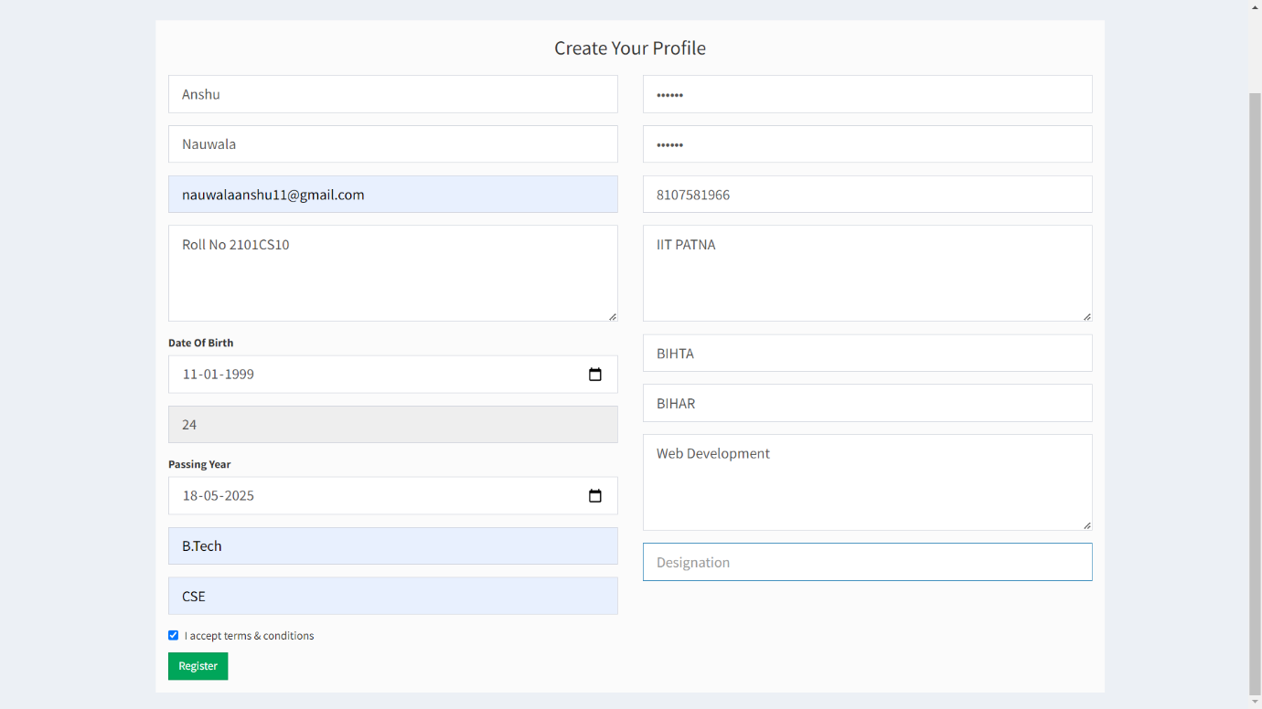

**Step 2: Admin will then Accept your registration request.**

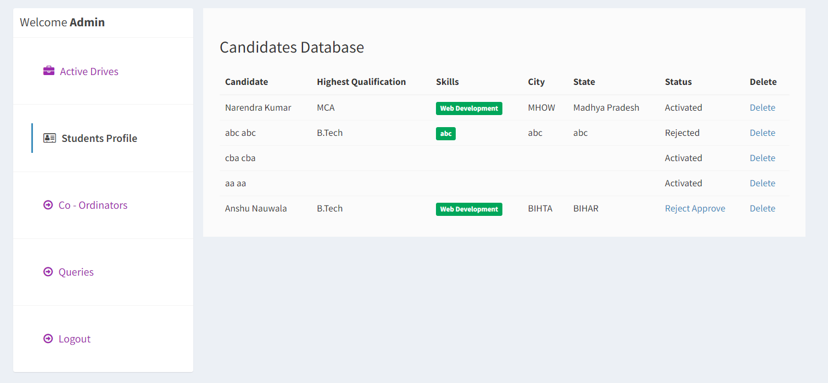

**Step 3: Now you can login.**

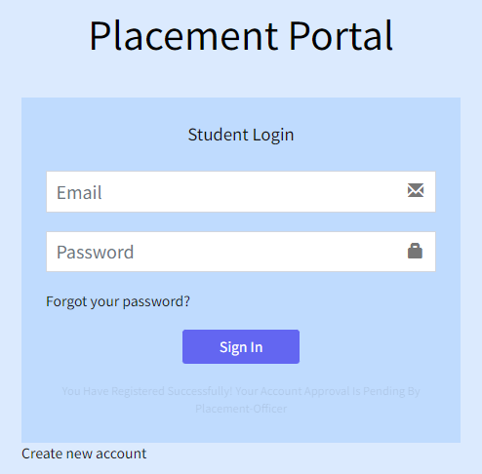

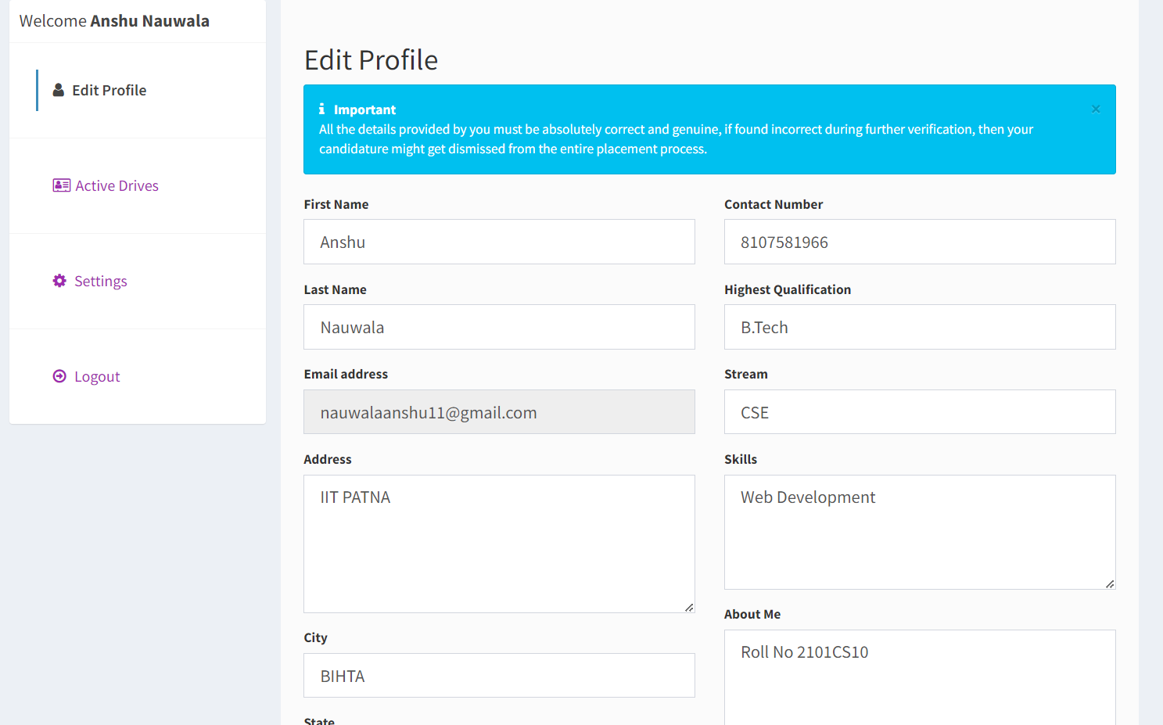

**Applying for Job :** if criteria is fulfilled.

