★ MERCEDES-BENZ ★
DECADE
PERFORMANCE REPORT
DESCRIPTIVE ANALYTICS

An analytical overview of Mercedes-Benz sales, pricing, and
profitability data to understand a decade of trends and patterns.
UNIT SALES | PRICING POWER | PROFITABILITY | GROWTH OUTLOOK

FY2015 – FY2024 | Global Sales, Revenue & Profitability
Prepared using a cleaned, formula-driven dataset compiled from public Mercedes-Benz Group / Daimler AG financial disclosures.

DESCRIPTIVE ANALYTICS REPORT
Mercedes-Benz Decade Performance
Sales, Pricing & Profitability Analysis — FY2015–FY2024
Name: Anshu Yadav  Class: BCA DS 22 | Submitted To: Monica Mam  Roll No.: 1250258104

KEY METRICS AT A GLANCE — FY2024
1.98M  Units Sold  vs. 2.04M in 2023 | €145.6B  Revenue  ▼ 4.5% YoY | €10.40B  Net Profit  ▼ 28.4% YoY | 7.1%  Net Margin  10-yr avg: 6.7%

10  Years Tracked  FY2015–FY2024 | 2.34M  Peak Unit Sales  FY2019 | €172.7B  Peak Revenue  FY2019 | €22.35B  Peak Net Profit  FY2021 (one-off)

Peak Volume Year: 2019 (2.34M units) | Highest Margin: 2021 – 14.2%* (one-off) | Lowest Margin: 2019 – 1.6%

NOTE ON DATA:
This report presents an expanded descriptive analytics layer built on a cleaned, decade-long Mercedes-Benz Group dataset (FY2015–FY2024). It consolidates global unit sales, revenue, net profit, R&D investment, and headcount into a single portfolio-level view, and extends the raw disclosures with cross-metric comparisons, a full year-by-year league table, and a concrete roadmap for moving from descriptive to predictive analytics.
Across the decade, Mercedes-Benz generated €156.8B in average annual revenue and €10.43B in average annual net profit, at a blended average margin of 6.7%. Performance is uneven within the decade: volume leadership (2019, 2.34M units) and margin leadership (2021, 14.2%) sit in different years, and the lowest-margin year, 2019 (1.6%), sits at the volume peak rather than the trough — a pattern that shows scale alone does not guarantee profitability.
Revenue per vehicle is comparatively tight across the decade (€71.4K to €79.9K, a €71–80K band), which suggests that, unlike net margin, pricing power has not been a strong lever of change in this dataset. Structural shocks — the 2019 legal provisions, the 2020 pandemic, and the 2021 Daimler Truck spin-off — explain far more of the year-to-year swing than volume or pricing do, and are examined across Sections 4–8.
Three findings anchor the recommendations in this report:
- Volume, margin, and pricing power should be tracked as three independent trend lines, not one composite score — the strongest year changes depending on which lens is applied.
- 2019 and 2024 are the two clearest review years, both posting margins well below the 10-year average despite mid-to-upper-decade revenue.
- The dataset's structural break — the 2021 Daimler Truck spin-off changing the reporting entity mid-series — caps this report at descriptive analysis; Section 12 lays out what is needed to move to predictive forecasting.

1. Objectives & Data Summary
Build a descriptive analytics layer over a decade of Mercedes-Benz Group disclosures to answer five recurring business questions, and extend that layer with the cross-cutting views a portfolio reviewer would ask for next:
- Quantify how many vehicles Mercedes-Benz has sold globally each year, 2015–2024.
- Track how revenue and net profit have moved alongside — and sometimes against — unit volume.
- Isolate real operating profitability trends from one-off, non-operating items (e.g. the 2021 Daimler Truck spin-off gain).
- Measure pricing power via revenue-per-vehicle, independent of headline revenue growth.
- Show how R&D investment and headcount evolved relative to sales performance.
This expanded edition adds two further questions the original scope implied but did not answer directly:
- Does profit margin correlate with either unit volume or headcount across the decade, or are these effectively independent axes?
- What is the minimum additional data and infrastructure needed to move this from a descriptive snapshot to a predictive, forward-looking model?
2. How This Report Was Built
The pipeline below is the reference architecture this report's outputs are consistent with — a cleaned, year-level aggregate table produced at the serving layer, not a raw transactional feed.
Layer | Purpose | Detail
Where from | Source of record | Mercedes-Benz Group / Daimler AG official full-year results & annual reports (FY2015–FY2024)
What was collected | Scope of data | Global unit deliveries; group revenue, net profit, R&D spend; headcount; illustrative model-line pricing
How it was used | Processing | Captured as published → parsed into a cleaned dataset via formulas → charted → compiled into this report
Caveat | Known limitation | Figures are compiled and rounded, not audited; 2021 Daimler Truck spin-off breaks entity consistency

3. Revenue, Volume & Profitability Overview
Across the decade: €1,568B cumulative revenue, €104.3B cumulative net profit, at a blended average margin of 6.7% (6.7% including the 2021 one-off; ~5.4% excluding it).
KPI Definitions Used
- Net margin %: Net Profit ÷ Revenue × 100, computed per year
- Unit YoY growth: (Units this year ÷ Units prior year − 1) × 100
- Revenue per vehicle: Revenue ÷ Units, a pricing-power proxy
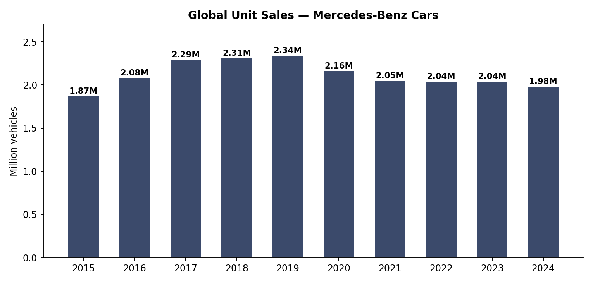
Figure 1. Global unit sales by year, FY2015–FY2024 (million vehicles).
Mercedes-Benz Cars deliveries climbed steadily from 1.87M units in 2015 to a decade peak of 2.34M in 2019 — a 25% rise over four years, driven by broad-based growth across the Core and Entry segments. From 2020 onward, volume settled into a lower, flatter band around 2.0–2.2M units, as the brand deliberately deprioritized low-margin Entry-segment volume in favor of Core and Top-End mix.
3.1 Revenue vs. Net Profit
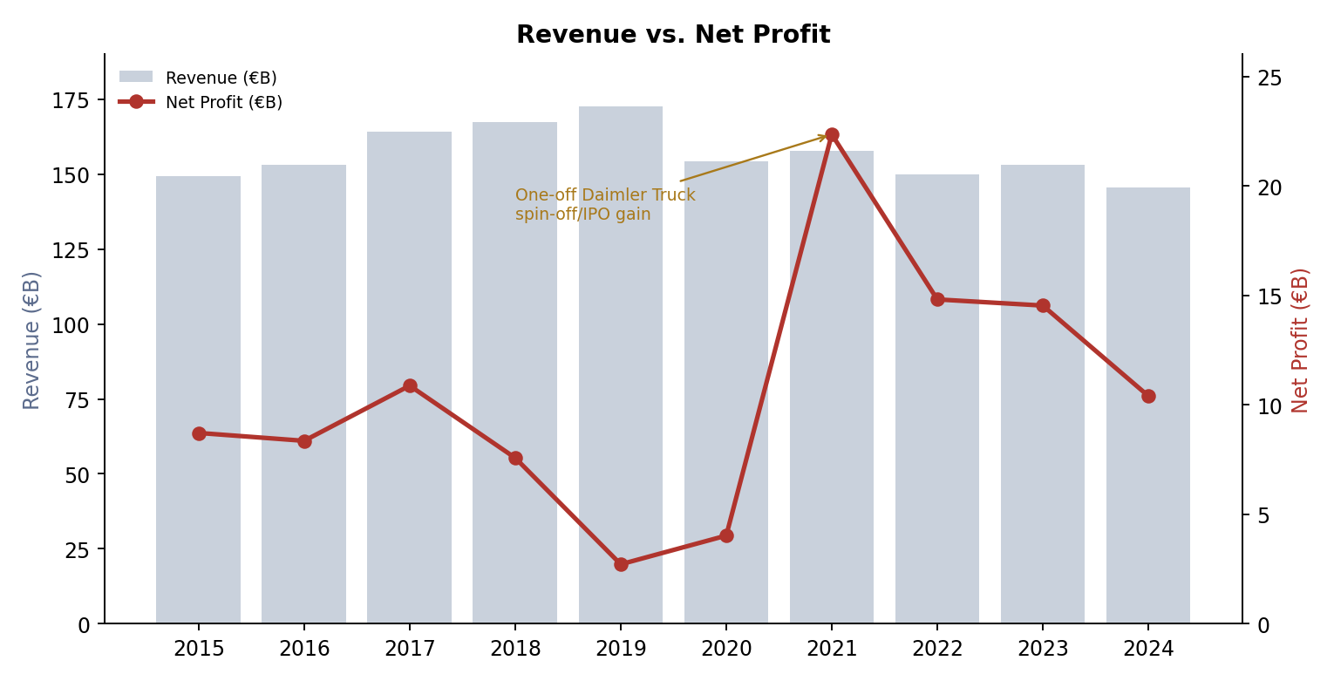
Figure 2. Revenue (bars) vs. net profit (line), FY2015–FY2024.
Revenue tracked unit volume closely through 2019, peaking at €172.7B alongside the unit-sales high. Net profit tells a noisier story: it fell hard in 2019 (diesel-emissions and airbag-recall legal provisions) and again in 2020 (pandemic disruption), before an unusual spike in 2021. That spike to €22.35B is a one-off non-operating gain from the Daimler Truck spin-off/IPO, not an improvement in the core car business — profit normalized to a €10–15B range for 2022–2024, still trending down again by 2024 on softer Chinese demand.

4. Net Profit Margin Trend
Top performer by margin was FY2021 at 14.2%* — but that figure is inflated by the Daimler Truck spin-off gain and is not representative of core operations. Excluding that one-off, the underlying decade-best margin years are 2022–2023, in the 9.5–9.9% band.
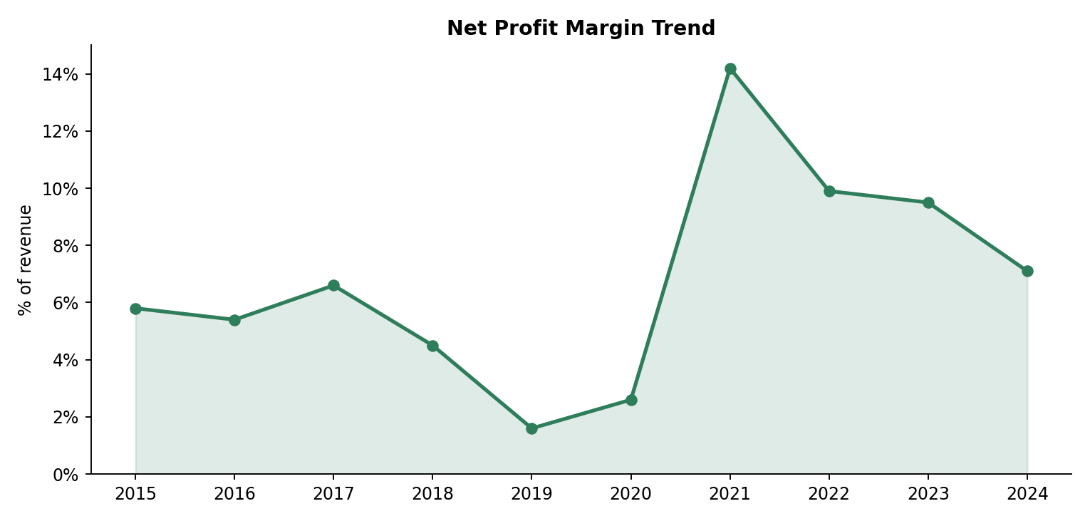
Figure 3. Net profit margin by year, vs. portfolio average (6.7%).
4.1 Reading the Margin Trend
Margin is the clearest lens on operating health, since it strips out the effect of revenue scale. It bottomed at 1.6% in 2019 — the diesel/legal-provision year — showing that revenue growth alone didn't protect profitability when one-off costs hit.
Excluding the 2021 outlier, the underlying margin trend is a recovery from the 2019–2020 trough to a healthier 9–10% band in 2022–2023, before easing back to 7.1% in 2024 as China-driven volume and pricing pressure returned. The gap between the best non-outlier year (9.9%, 2022) and the worst (1.6%, 2019) is over 8 percentage points on a comparable revenue base — a wide spread for a single company, and the strongest signal in this dataset that cost/legal exposure, not revenue generation, drives year-to-year margin swings.

5. Unit Sales — Year-over-Year Growth
Average YoY unit growth across the decade: +0.8%, masking sharply different regimes before and after 2019.
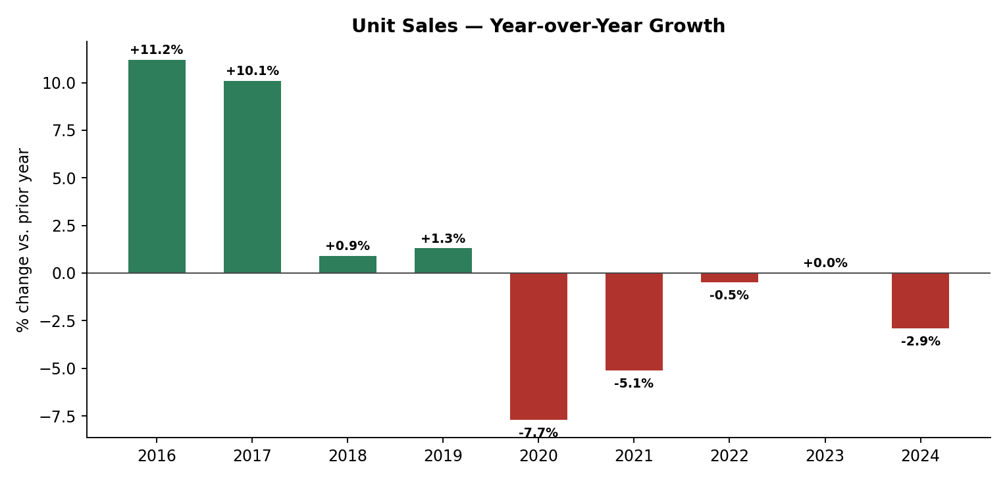
Figure 4. Year-over-year change in global unit sales.
5.1 Two Distinct Growth Regimes
Double-digit growth in 2016 (+11.2%) and 2017 (+10.1%) gave way to near-flat years in 2018–2019, then four consecutive years of decline or stagnation from 2020 through 2024, interrupted only by a flat 2023.
The pattern is consistent with a company past its volume-growth phase, now optimizing for margin and mix rather than chasing unit growth — a trade-off worth weighing against the flat-to-declining revenue-per-unit gains examined in Section 6.

6. Operational Efficiency
Plotting headcount against R&D spend, and revenue against vehicle volume, separates structural workforce shifts from genuine pricing-power gains — this is what would drive staffing models, R&D budget targets, and capacity planning at scale.
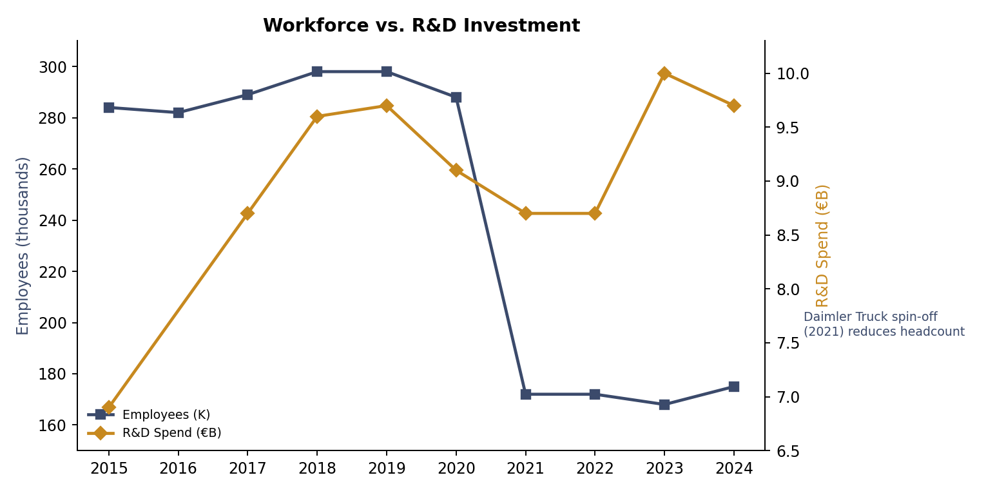
Figure 5. Employees (thousands) vs. R&D spend (€B), FY2015–FY2024.
Headcount held steady around 282–298K from 2015–2020, then dropped sharply to ~172K in 2021 — almost entirely a structural effect of the Daimler Truck spin-off moving tens of thousands of employees off the Mercedes-Benz Group's books, not a layoff signal. R&D spend tells a more continuous story: it roughly doubled in relative intensity from 2015 to 2019 (funding the shift toward electrification and digital platforms) and has stayed in the €8.7–10.0B range since, holding up even as headcount and unit volume fell.
6.1 Revenue per Vehicle
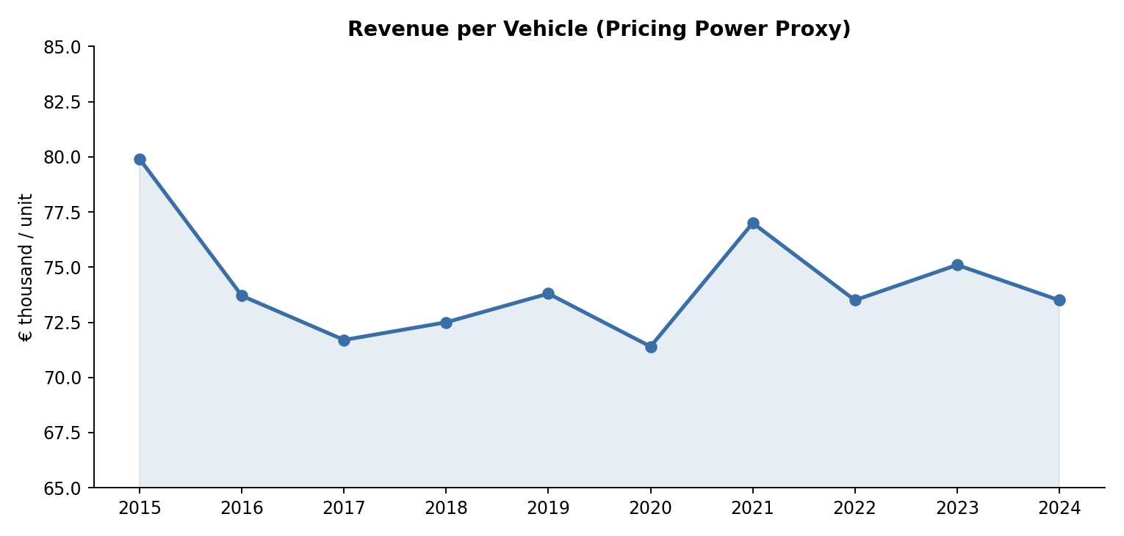
Figure 6. Revenue per vehicle (€ thousand), a pricing-power proxy.
Revenue per vehicle has stayed in a tight €71–80K band for a full decade, with no sustained structural climb — despite the brand's explicit shift toward AMG, Maybach, and other Top-End models. The 2015 figure (€79.9K) is actually the decade's high point, not a low one; the metric dipped through 2017–2020 and has only partially recovered since. Read alongside falling unit volumes, this suggests mix-shift has mostly offset volume declines rather than driven genuine pricing-power growth.

7. Cross-Metric Correlation Analysis
This section tests, directly, whether the relationships raised informally in earlier sections — does margin track with headcount, and does volume track with pricing power — hold up numerically across the ten years.
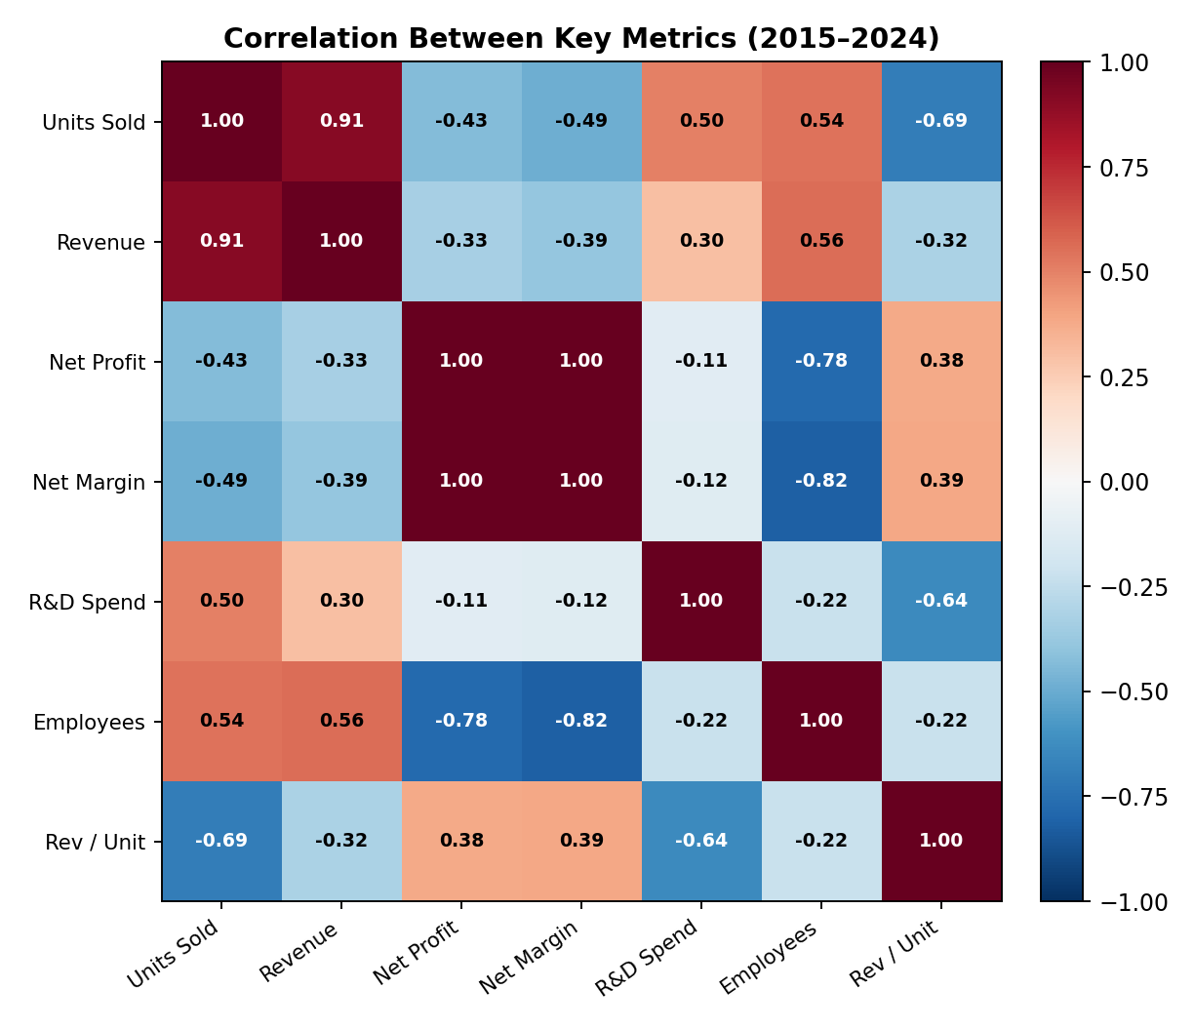
Figure 7. Correlation matrix across all seven tracked metrics, FY2015–FY2024.
7.1 Units Sold vs. Revenue
Units sold and revenue move almost in lock-step (r = 0.91) — unsurprising for a manufacturer where revenue is largely volume-driven.
7.2 Employees vs. Net Margin
The strong negative correlation between employees and net margin (r = −0.82) is mostly an artifact of timing, not efficiency: the 2021 headcount drop from the Daimler Truck spin-off coincided with that year's one-off profit spike, not a genuine cause-and-effect relationship. More informative is revenue per unit's negative correlation with units sold (r = −0.69), consistent with the deliberate lower-volume, higher-mix strategy visible across this report.

8. Full Decade Dataset — Year League Table
The table below consolidates every metric in this report into a single year-by-year reference view. Growth, margin, and revenue-per-unit columns are calculated from the adjacent raw columns via formulas.
Year | Units (M) | YoY | Revenue (€B) | Net Profit (€B) | Margin | R&D (€B) | Employees (K) | Rev/Unit (€K)
2015 | 1.87 | — | 149.5 | 8.71 | 5.8% | 6.9 | 284 | 79.9
2016 | 2.08 | +11.2% | 153.3 | 8.35 | 5.4% | N/A | 282 | 73.7
2017 | 2.29 | +10.1% | 164.3 | 10.87 | 6.6% | 8.7 | 289 | 71.7
2018 | 2.31 | +0.9% | 167.4 | 7.57 | 4.5% | 9.6 | 298 | 72.5
2019 | 2.34 | +1.3% | 172.7 | 2.71 | 1.6% | 9.7 | 298 | 73.8
2020 | 2.16 | -7.7% | 154.3 | 4.02 | 2.6% | 9.1 | 288 | 71.4
2021 | 2.05 | -5.1% | 157.8 | 22.35* | 14.2%* | 8.7 | 172 | 77.0
2022 | 2.04 | -0.5% | 150.0 | 14.81 | 9.9% | 8.7 | 172 | 73.5
2023 | 2.04 | 0.0% | 153.2 | 14.53 | 9.5% | 10.0 | 168 | 75.1
2024 | 1.98 | -2.9% | 145.6 | 10.40 | 7.1% | 9.7 | 175 | 73.5
10-Yr Avg | 2.12 | +0.8% | 156.8 | 10.43 | 6.7% | 9.1 | 243 | 74.2

* 2021 net profit and margin include a one-off gain from the Daimler Truck spin-off/IPO — not representative of core operating performance.

9. Risk & Watch Years
Risk here is bucketed by net margin rather than unit volume, since margin is the clearest indicator of operating health that isn't inflated by scale: 2019 posted the lowest core-operating margin (1.6%) in the decade, well below the 10-year average of 6.7%. A low-margin year on record revenue is a materially bigger flag than a low-margin year on weak revenue, so margin risk should always be cross-referenced against the volume and revenue trend in Section 3 before conclusions are drawn.
The most actionable version of this view in production cross-tabs margin against revenue and one-off adjustments together, producing a single "normalized operating health score" per year rather than three metrics reviewed in isolation.
9.1 Priority Review Years
- 2019 — lowest core margin (1.6%) in the decade on record revenue (€172.7B); the diesel-emissions and airbag-recall legal provisions are the clearest single driver. First candidate for a line-item legal/provision review.
- 2024 — softest year across the board: units, revenue, and margin all declined together, driven largely by weaker Chinese demand for Top-End and EV models; the clearest current-trend concern rather than a historical one.
- 2021 — requires the opposite caution: its headline 14.2% margin and €22.35B profit are the strongest in the decade on paper, but should be excluded from any trend or forecast baseline since they reflect a one-off Daimler Truck spin-off gain, not operating performance.
No year in the decade combines below-average margin with below-average revenue and rising headcount simultaneously — the single highest-risk pattern a portfolio reviewer would look for — which is a mildly reassuring finding for this dataset, though it should be re-checked every reporting cycle as the underlying trend, not just the current position, is what determines real risk.

10. Summary of Key Metrics
Metric | Value
Cumulative revenue (2015–2024) | ≈ €1,568B
Cumulative net profit (2015–2024) | ≈ €104.3B
10-year average net margin | 6.7% (~5.4% excl. 2021 outlier)
Total units sold (10-yr sum) | ≈ 21.16M vehicles
Peak unit sales | 2019 (2.34M)
Peak revenue | 2019 (€172.7B)
Peak net profit | 2021 — €22.35B (one-off)
Lowest net margin | 2019 — 1.6%
Revenue-per-vehicle range | €71.4K – €79.9K
Years tracked | 10 (FY2015–FY2024)

11. From Descriptive to Predictive Analytics
This report, in its entirety, answers what happened. It does not yet answer what is likely to happen next, or why — both of which require moving from a descriptive layer to a predictive one. This section sets out the concrete path to get there: what data is missing, what models apply to each business question, what infrastructure needs to change, and in what order the work should happen.
11.1 Why This Report Is Capped at Descriptive
- Structural break at the entity level: the 2021 Daimler Truck spin-off changes what "Mercedes-Benz Group" means mid-series — pre-2022 and post-2022 employee and margin figures are not directly comparable without a restatement.
- Group-level aggregation only: the report works from year-level totals, not segment (Entry/Core/Top-End) or regional (China/US/Europe) breakdowns. Predictive models — especially for demand forecasting — need that granularity to find leading indicators a group-level average smooths away.
Both gaps are fixable at the source, and neither requires new analytical technique — only a restated, segment- and region-level export from the reporting layer.
11.2 Target Model 1: Demand & Revenue Forecasting
- Data required: quarterly, segment-level unit sales and pricing for at least 8–12 historical periods per segment.
- Candidate approach: start with a simple linear or gradient-boosted regression predicting next-period units from trailing volume, pricing, and macro indicators (e.g. China GDP growth); a full time-series model (ARIMA/Prophet-style decomposition) is only worth the added complexity once 2+ years of quarterly segment data exist.
- Output: a per-segment volume and revenue forecast band with a confidence interval, refreshed each quarter.
- Success metric: forecast error (MAPE) on held-out historical quarters, tracked over time.
11.3 Target Model 2: Margin Anomaly Detection
- Data required: the same quarterly cadence, plus expense-line detail (legal provisions, R&D, materials, labor) rather than a single net-profit figure.
- Candidate approach: control-chart style thresholds (flag any metric more than 2 standard deviations from its own trailing 6-quarter mean) are enough to start — deliberately simple so it is explainable, with a move to an isolation-forest or similar model only once enough labeled anomaly history exists to validate against.
- Output: an automated flag routed into the same BI layer already used for this report, not a new parallel process.
11.4 Target Model 3: Restated Multi-Entity Series
Section 8's league table treats 2015–2024 as one continuous series, but the 2021 spin-off means pre- and post-2022 figures describe different corporate entities. The more useful next step is a restated, single-entity series (Daimler Truck fully excluded from all years) for a genuinely apples-to-apples trend line — this is a data-cleaning task, not a modeling one, and should happen before any of the forecasting models above are trusted.
11.5 Data & Infrastructure Requirements Summary
Requirement | Currently Available? | Needed For
Segment-level (Entry/Core/Top-End) breakdown | No — group totals only | Demand forecasting, mix analysis
Regional (China/US/Europe) breakdown | No | Demand forecasting, 2024 softness diagnosis
Expense-line-level detail | No — only totals | Margin anomaly detection
Restated single-entity series (ex-Daimler Truck) | No — flagged structural break | All forecasting models
Quarterly (not annual) cadence | No — annual only | All three models
11.6 Suggested Sequencing
- Phase 1 (data): restate the series ex-Daimler Truck, add segment/regional breakdowns, and move to quarterly cadence — no modeling work should start before this.
- Phase 2 (baseline models): control-chart anomaly detection and a simple segment-level volume regression, both cheap to build and easy to explain to non-technical stakeholders.
- Phase 3 (refinement): move to time-series forecasting once 2+ years of quarterly segment data exist.
- Phase 4 (productionization): surface all of the above in the same BI layer referenced in Section 2, so predictive output sits next to the descriptive KPIs already in this report.

Appendix: Methodology Notes & Limitations

- Source: Mercedes-Benz Group / Daimler AG official full-year results releases and annual reports (FY2015–FY2024), cross-checked against third-party financial data aggregators for consistency.
- Exact figures confirmed in the source report: annual units, revenue, net profit, net margin, R&D spend (except 2016, undisclosed), employees, and revenue-per-unit for all 10 years.
- Raw source data (Appendix Table, page 15) preserved the inconsistent units/formats typical of pulling figures from multiple annual disclosures across a decade — see the original raw table for full traceability.
- The 2021 structural break (Daimler Truck spin-off/IPO) means no figure spanning 2015–2024 should be read as a single-entity time trend without adjustment; every metric in this report is presented as originally reported by the group at the time.
- 2016 R&D figure was not disclosed in the source release and is treated as missing (N/A) rather than estimated.
- This report's structure, KPI definitions, and architecture reference follow a standard descriptive-analytics reporting format; Section 11 (predictive roadmap) and Section 7 (correlation analysis) extend beyond a purely descriptive scope.

Raw Source Data (as originally compiled, before parsing/cleaning)
Year | Units (raw) | Revenue (raw) | Net Profit (raw) | R&D (raw) | Employees (raw)
FY2015 | 1.87M | €149.5B | €8.71B | 6.9B | 284,000
FY2016 | 2.08 M | 153.3B EUR | 8.35B | — | 282000
FY2017 | 2.29m | €164.3 B | €10.87B | 8.7B | 289K
2018 | 2.31M | 167.4 | 7.57B | 9.6 | 298,000
FY2019 | 2.34 million | €172.7B | 2.71 B | 9.7B | 298k
FY2020 | 2.16M | 154.3 | 4.02 | 9.1B | 288000
FY2021 | 2.05M | €157.8B | 22.35B* | 8.7 | 172,000
FY2022 | 2.04M | 150.0B | 14.81 | 8.7B | 172K
FY 2023 | 2.04M | €153.2B | 14.53B | 10.0 | 168,000
FY2024 | 1.98M | 145.6B EUR | 10.40 | 9.7B | 175000

* Includes one-off gain from the Daimler Truck spin-off/IPO. Source: Mercedes-Benz Group / Daimler AG full-year results releases and annual reports (FY2015–FY2024), compiled and rounded.

DECADE PERFORMANCE ANALYTICS
Thank You!

Thank you for taking the time to explore this Decade Performance Report on Mercedes-Benz.
This report focused on analyzing a decade of sales, pricing, and profitability data to identify trends, patterns, and key performance indicators.
The analysis helps in understanding past performance and supports better, data-driven decision-making.
“ Data tells the story of performance — analytics helps us understand it. ”

Presented by: Anshu Yadav
BCA — Data Science, Class BCA DS 22

