CAMPUSMART
NAME:ANSHU SINGH
ENROLLMENT NO:24162121002
BATCH:41
CSE(BDA)
TECH:MERN STACK

- Introduction
CampusMart is a full-stack web application that allows users to browse, search, and manage products with an interactive user interface.

- Tech Stack
- React.js (Frontend – main focus)
- Node.js & Express (Backend – basic mention)
- MongoDB Atlas (Database)

- FRONTEND CODE
- App.js (Routing)
Handles navigation between different pages using React Router.
import React from 'react';
import { BrowserRouter as Router, Routes, Route } from 'react-router-dom';
import Navbar from './components/Navbar';
import Footer from './components/Footer';
import Home from './pages/Home';
import Login from './pages/Login';
import Register from './pages/Register';
import Dashboard from './pages/Dashboard';
import ProductForm from './pages/ProductForm';
import Sell from './pages/Sell';
import ProductDetails from './pages/ProductDetails';
import Wishlist from './pages/Wishlist';
import Cart from './pages/Cart';

function App() {
const [isAuthenticated, setIsAuthenticated] = React.useState(false);
const [wishlist, setWishlist] = React.useState([]);

React.useEffect(() => {
const storedAuth = localStorage.getItem('campusmart_auth') === 'true';
setIsAuthenticated(storedAuth);
const storedWishlist = JSON.parse(localStorage.getItem('campusmart_wishlist') || '[]');
setWishlist(storedWishlist);
}, []);

const handleAuth = (value) => {
setIsAuthenticated(value);
localStorage.setItem('campusmart_auth', value ? 'true' : 'false');
};

const addToWishlist = (product) => {
setWishlist((prev) => {
const exists = prev.find((p) => p.id === product.id);
if (exists) return prev;
const updated = [...prev, product];
localStorage.setItem('campusmart_wishlist', JSON.stringify(updated));
return updated;
});
};

const removeFromWishlist = (productId) => {
setWishlist((prev) => {
const updated = prev.filter((p) => p.id !== productId);
localStorage.setItem('campusmart_wishlist', JSON.stringify(updated));
return updated;
});
};

return (
<Router>
<Navbar
isAuthenticated={isAuthenticated}
onSignOut={() => handleAuth(false)}
wishlistCount={wishlist.length}
/>
<div className="app-container">
<Routes>
<Route path="/" element={
<Home
wishlist={wishlist}
onAddToWishlist={addToWishlist}
onRemoveFromWishlist={removeFromWishlist}
/>
} />
<Route path="/wishlist" element={
<Wishlist wishlist={wishlist} onRemove={removeFromWishlist} />
} />
<Route path="/post-item" element={<ProductForm />} />
<Route path="/dashboard" element={<Dashboard />} />
<Route path="/login" element={<Login setAuth={handleAuth} />} />
<Route path="/register" element={<Register setAuth={handleAuth} />} />
<Route path="/sell" element={<Sell />} />
<Route path="/add-product" element={<ProductForm />} />
<Route path="/product/:id" element={<ProductDetails />} />
<Route path="/cart" element={<Cart />} />
</Routes>
</div>
<Footer />
</Router>
);
}

export default App;

- Login.js / Signup.js
Manages user authentication through login and registration forms.

import React, { useState } from 'react';
import { useNavigate, Link } from 'react-router-dom';

const Login = () => {
const navigate = useNavigate();
const [email, setEmail] = useState('');
const [password, setPassword] = useState('');
const [error, setError] = useState('');

const handleLogin = (e) => {
e.preventDefault();
setError('');

// localStorage se registered users lo
const users = JSON.parse(localStorage.getItem('campusUsers') || '[]');
const found = users.find(u => u.email === email && u.password === password);

if (found) {
localStorage.setItem('campusmart_auth', 'true');
localStorage.setItem('campusUser', JSON.stringify(found));
navigate('/');
} else {
setError('❌ Email ya password galat hai. Pehle Register karo!');
}
};

return (
<main className="page-shell" style={{ display: 'flex', justifyContent: 'center', alignItems: 'center', minHeight: '80vh' }}>
<div style={{ background: 'white', borderRadius: '24px', padding: '40px', width: '100%', maxWidth: '400px', boxShadow: '0 20px 60px rgba(15,23,42,0.12)' }}>
<h2 style={{ fontSize: '28px', fontWeight: '800', color: '#0f172a', marginBottom: '6px' }}>Welcome Back 👋</h2>
<p style={{ color: '#64748b', marginBottom: '28px' }}>Login to your CampusMart account</p>

{error && (
<div style={{ background: '#fef2f2', border: '1px solid #fecaca', color: '#dc2626', padding: '12px 16px', borderRadius: '10px', marginBottom: '20px', fontSize: '14px' }}>
✕ {error}
</div>
)}

<form onSubmit={handleLogin}>
<div style={{ marginBottom: '16px' }}>
<label style={{ fontSize: '14px', fontWeight: '600', color: '#0f172a', display: 'block', marginBottom: '6px' }}>Email</label>
<input
type="email"
value={email}
onChange={e => setEmail(e.target.value)}
placeholder="tumhara@email.com"
required
style={{ width: '100%', padding: '12px 16px', border: '2px solid #e2e8f0', borderRadius: '10px', fontSize: '15px', outline: 'none', boxSizing: 'border-box' }}
/>
</div>

<div style={{ marginBottom: '24px' }}>
<label style={{ fontSize: '14px', fontWeight: '600', color: '#0f172a', display: 'block', marginBottom: '6px' }}>Password</label>
<input
type="password"
value={password}
onChange={e => setPassword(e.target.value)}
placeholder="••••••••"
required
style={{ width: '100%', padding: '12px 16px', border: '2px solid #e2e8f0', borderRadius: '10px', fontSize: '15px', outline: 'none', boxSizing: 'border-box' }}
/>
</div>

<button type="submit" style={{
width: '100%', padding: '14px',
background: 'linear-gradient(135deg, #ec4899, #f43f5e)',
color: 'white', border: 'none', borderRadius: '12px',
fontSize: '16px', fontWeight: '800', cursor: 'pointer',
boxShadow: '0 6px 20px rgba(236,72,153,0.4)'
}}>🔑 Login</button>
</form>

<p style={{ textAlign: 'center', marginTop: '20px', fontSize: '14px', color: '#64748b' }}>
Don't have an account?{' '}
<Link to="/register" style={{ color: '#ec4899', fontWeight: '700', textDecoration: 'none' }}>Register here</Link>
</p>
</div>
</main>
);
};

export default Login;

- productService.js

This file handles API calls between frontend and backend.

/**
* Product API Integration Examples
* Usage examples for frontend integration with the product API
*/

import axios from 'axios';

export const addProduct = async (product) => {
const res = await fetch("http://localhost:5001/api/products/add", {
method: "POST",
headers: {
"Content-Type": "application/json"
},
body: JSON.stringify(product)
});

return res.json();
};

const API_BASE_URL = 'http://localhost:5001/api/products';

// Configure axios instance
const productAPI = axios.create({
baseURL: API_BASE_URL,
timeout: 10000, // Increased timeout
headers: {
'Content-Type': 'application/json'
}
});

// Add response interceptor for better error handling
productAPI.interceptors.response.use(
(response) => response,
(error) => {
if (error.code === 'ECONNABORTED') {
throw new Error('Request timeout. Please check your connection and try again.');
}
if (!error.response) {
throw new Error('Network error. Please check your internet connection and ensure the server is running.');
}
// Re-throw the error with the response data
throw error;
}
);

// ============================================
// 1. GET ALL PRODUCTS
// ============================================
export const getAllProducts = async (filters = {}) => {
try {
const { category, minPrice, maxPrice, search, sort } = filters;

const params = new URLSearchParams();
if (category) params.append('category', category);
if (minPrice) params.append('minPrice', minPrice);
if (maxPrice) params.append('maxPrice', maxPrice);
if (search) params.append('search', search);
if (sort) params.append('sort', sort);

const response = await productAPI.get(`/?${params}`);
return response.data;
} catch (error) {
console.error('Error fetching products:', error);
throw error;
}
};

// ============================================
// 2. ADD NEW PRODUCT
// ============================================
export const addProduct = async (productData) => {
try {
const response = await productAPI.post('/', {
title: productData.title,
price: parseFloat(productData.price),
description: productData.description,
imageUrl: productData.imageUrl,
category: productData.category || 'Other',
stock: productData.stock || 0
});
return response.data;
} catch (error) {
console.error('Error adding product:', error);
throw error;
}
};

// ============================================
// 3. GET PRODUCT BY ID
// ============================================
export const getProductById = async (productId) => {
try {
const response = await productAPI.get(`/${productId}`);
return response.data;
} catch (error) {
console.error(`Error fetching product ${productId}:`, error);
throw error;
}
};

// ============================================
// 4. UPDATE PRODUCT
// ============================================
export const updateProduct = async (productId, updateData) => {
try {
const response = await productAPI.put(`/${productId}`, updateData);
return response.data;
} catch (error) {
console.error(`Error updating product ${productId}:`, error);
throw error;
}
};

// ============================================
// 5. DELETE PRODUCT
// ============================================
export const deleteProduct = async (productId) => {
try {
const response = await productAPI.delete(`/${productId}`);
return response.data;
} catch (error) {
console.error(`Error deleting product ${productId}:`, error);
throw error;
}
};

// ============================================
// 6. SEARCH PRODUCTS
// ============================================
export const searchProducts = async (query) => {
try {
const response = await productAPI.get(`/search?query=${encodeURIComponent(query)}`);
return response.data;
} catch (error) {
console.error('Error searching products:', error);
throw error;
}
};

// ============================================
// 7. GET PRODUCTS BY CATEGORY
// ============================================
export const getProductsByCategory = async (category) => {
try {
const response = await productAPI.get(`/category/${category}`);
return response.data;
} catch (error) {
console.error(`Error fetching ${category} products:`, error);
throw error;
}
};

// ============================================
// USAGE EXAMPLES
// ============================================

/**
* Example 1: Fetch all products on component mount
*
* useEffect(() => {
* const fetchProducts = async () => {
* try {
* const data = await getAllProducts();
* setProducts(data.products);
* } catch (error) {
* setError('Failed to fetch products');
* }
* };
* fetchProducts();
* }, []);
*/

/**
* Example 2: Fetch products with filters
*
* const handleFilter = async (category, minPrice, maxPrice) => {
* try {
* const data = await getAllProducts({
* category,
* minPrice,
* maxPrice,
* sort: 'price-asc'
* });
* setProducts(data.products);
* } catch (error) {
* console.error('Filter failed');
* }
* };
*/

/**
* Example 3: Add new product
*
* const handleAddProduct = async (formData) => {
* try {
* const result = await addProduct({
* title: formData.title,
* price: formData.price,
* description: formData.description,
* imageUrl: formData.imageUrl,
* category: formData.category,
* stock: formData.stock
* });
* if (result.success) {
* setProducts([...products, result.product]);
* alert('Product added successfully!');
* }
* } catch (error) {
* alert('Failed to add product');
* }
* };
*/

/**
* Example 4: Search products
*
* const handleSearch = async (searchQuery) => {
* try {
* const data = await searchProducts(searchQuery);
* setProducts(data.products);
* } catch (error) {
* console.error('Search failed');
* }
* };
*/

/**
* Example 5: Get products by category
*
* const handleCategoryClick = async (category) => {
* try {
* const data = await getProductsByCategory(category);
* setProducts(data.products);
* } catch (error) {
* console.error('Category fetch failed');
* }
* };
*/

export default {
getAllProducts,
addProduct,
getProductById,
updateProduct,
deleteProduct,
searchProducts,
getProductsByCategory
};

- BACKEND
Backend handles API requests and connects the application to MongoDB database.

  - Db.js

import mongoose from "mongoose";

const connectDB = async () => {
try {
const conn = await mongoose.connect(process.env.MONGO_URI, {
serverSelectionTimeoutMS: 30000,
socketTimeoutMS: 45000,
});
console.log(`✅ MongoDB Connected: ${conn.connection.host}`);
} catch (error) {
console.error(`❌ DB Error: ${error.message}`);
process.exit(1);
}
};

export default connectDB;

  - productRoute.js

const express = require("express");
const router = express.Router();
const Product = require("../models/Product");

// SAVE DATA TO MONGODB
router.post("/add", async (req, res) => {
const product = new Product(req.body);
const saved = await product.save();
res.json(saved);
});

module.exports = router;

Output Screenshots:
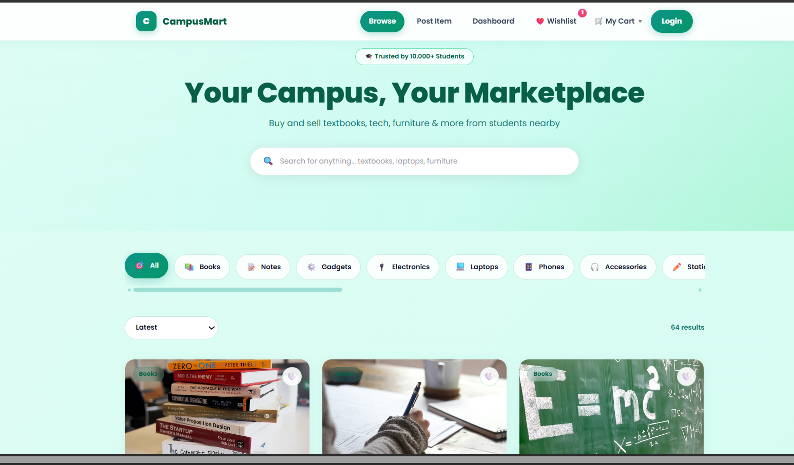

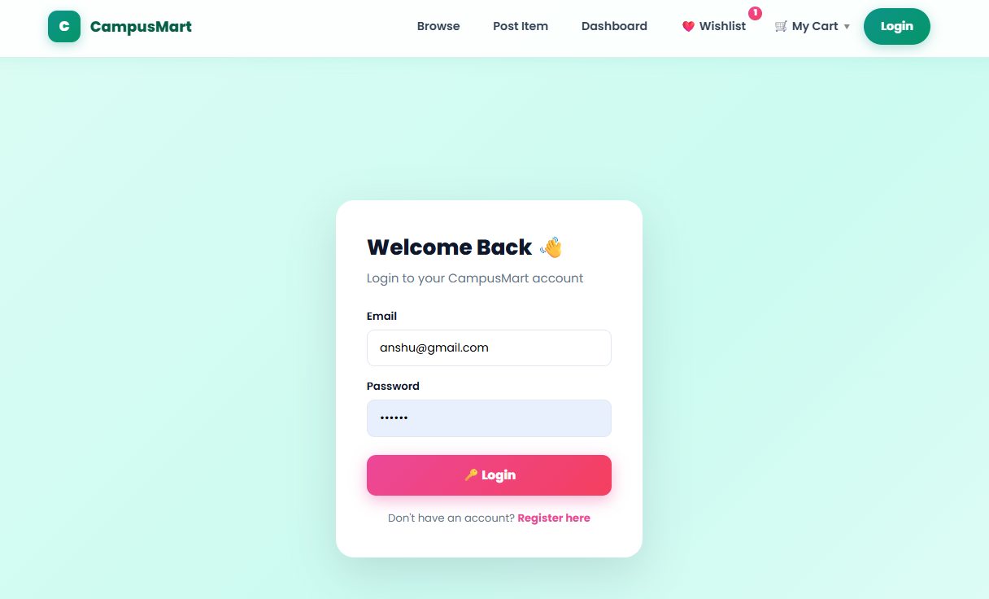
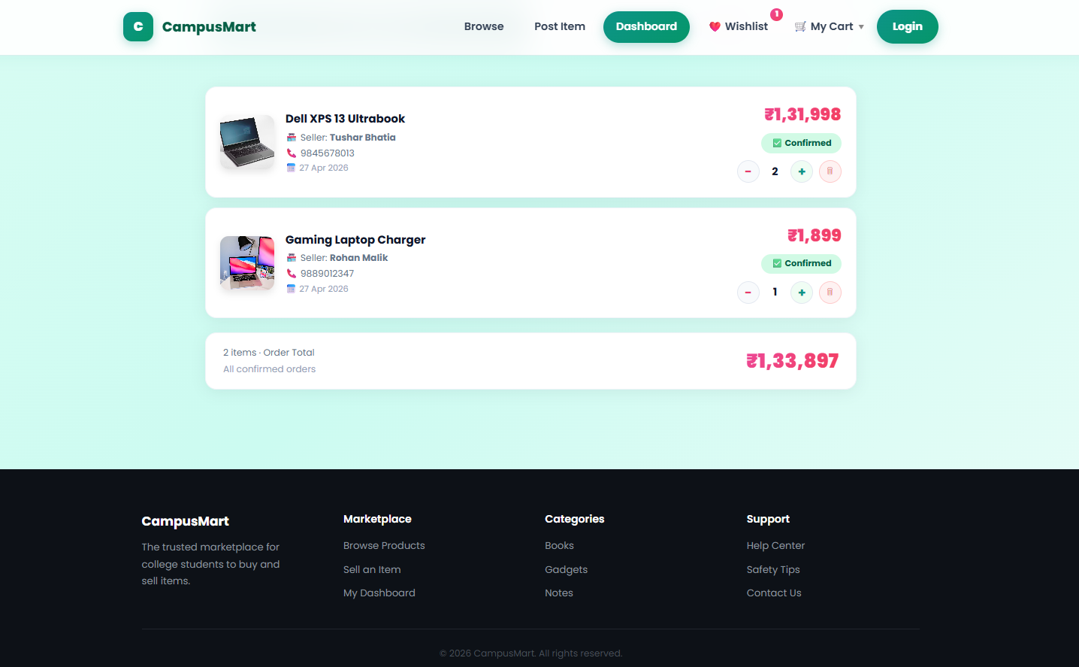
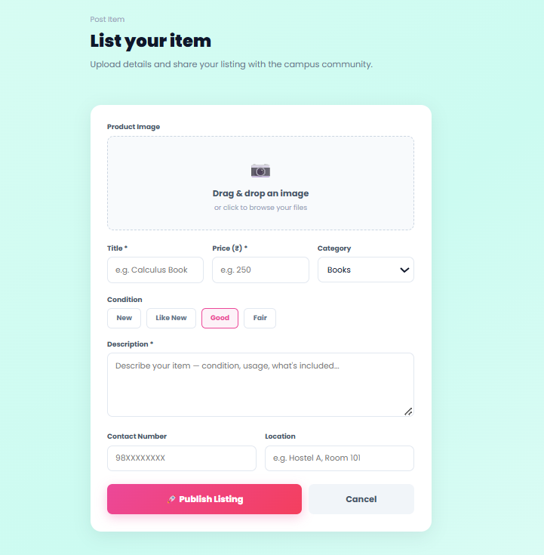
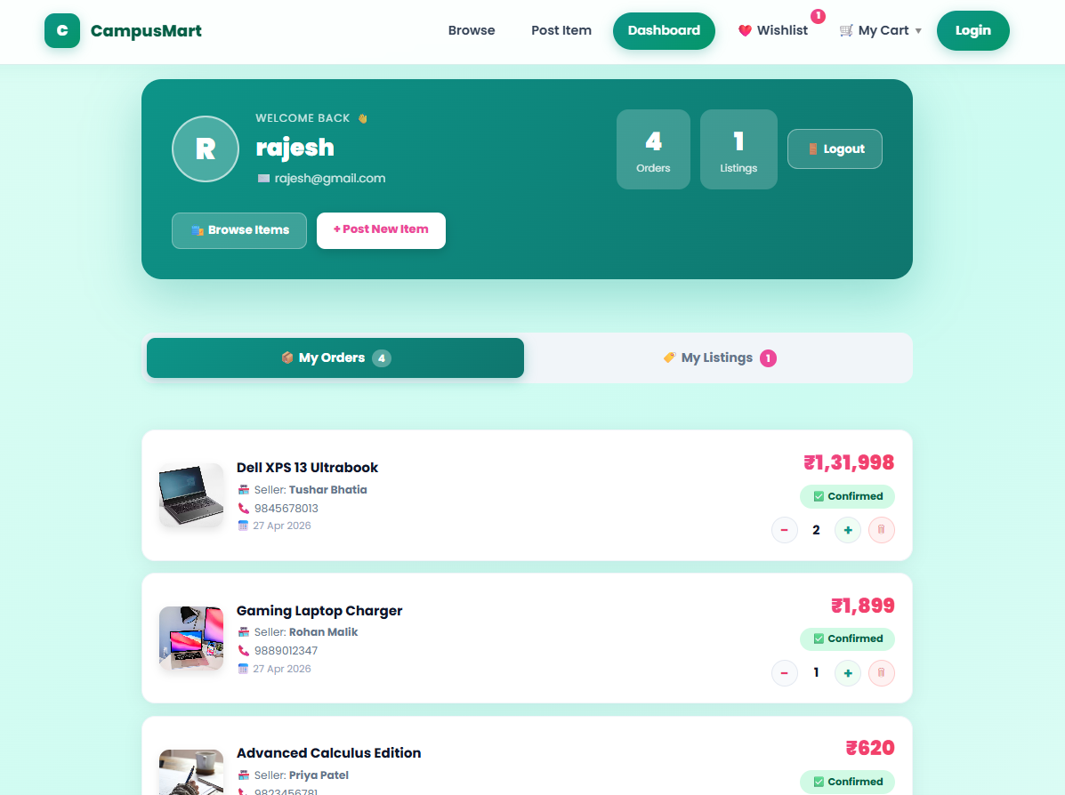
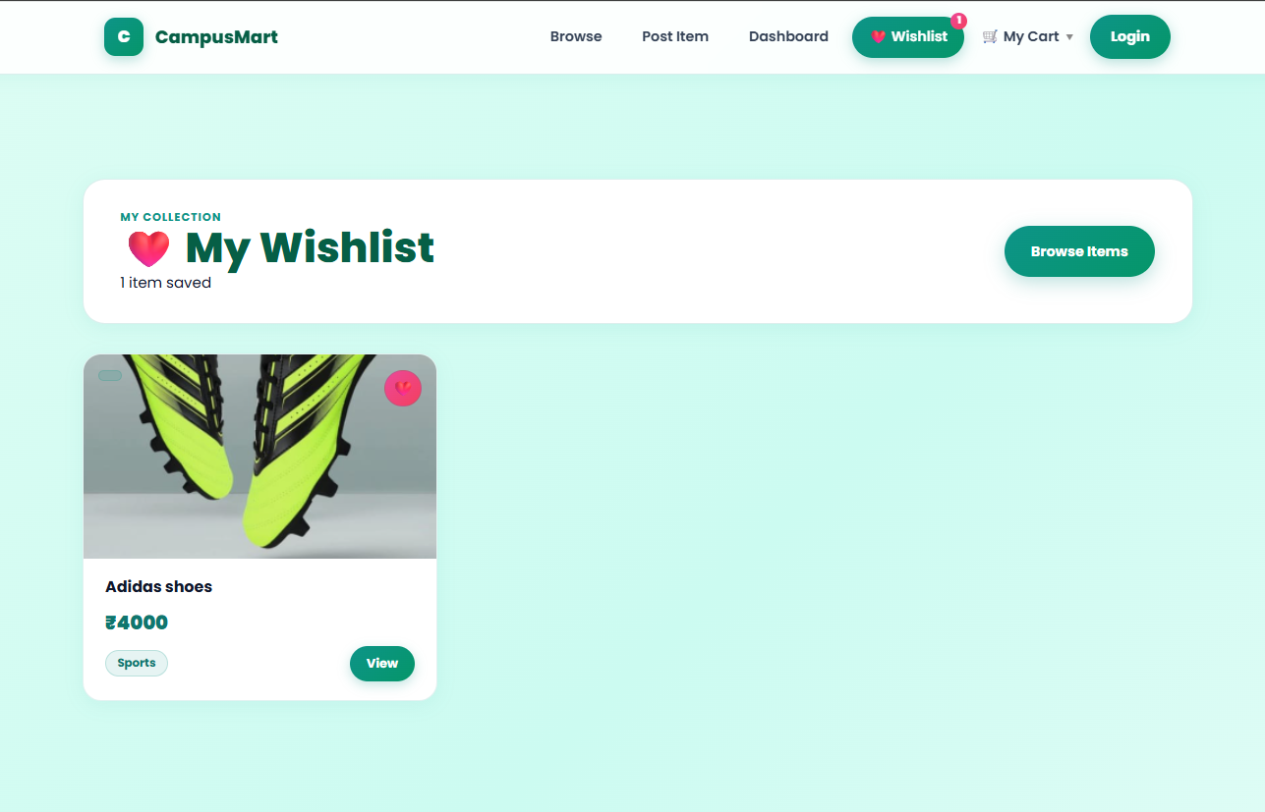
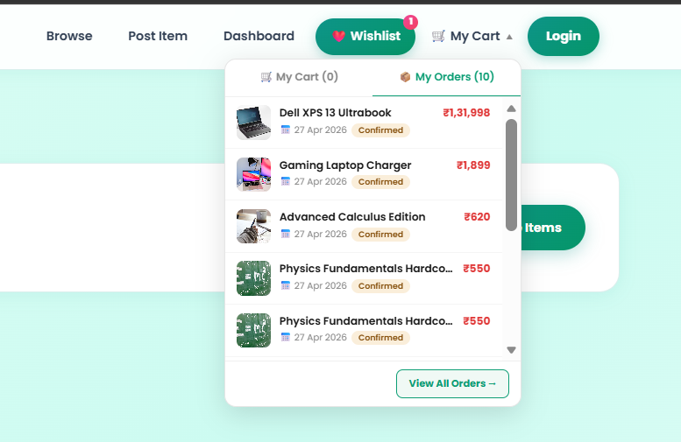

Conclusion:
This project demonstrates a responsive frontend with dynamic data handling using React and API integration.

