IntelliJ IDEA Common Code Navigation short cuts

1. GOTO Line

Short cut :- ctrl G

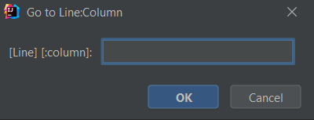

1. GOTO Class

Shortcut :- ctrl N



1. Class hierarchy

Ctrl H



1. Find all

Shift – shift

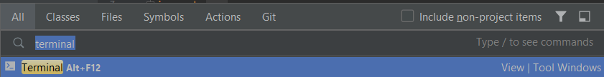

1. Definition

Ctrl **B**

1. Recent history

Ctrl E