Trader Performance vs. Bitcoin Market Sentiment
Hyperliquid Historical Trades x Fear & Greed Index

Executive Summary
This analysis joins 211,224 Hyperliquid trade records from 32 accounts (May 2023 - May 2025) with the daily Bitcoin Fear & Greed Index, to see if broad market sentiment says anything useful about how traders in this dataset actually perform. Short version: it does, to a point. Win rate and average PnL are both noticeably better during Fear regimes than during Greed. A big part of that comes down to positioning - traders in this sample lean long when the market is fearful and lean short when it's greedy, and that contrarian bet works out more often than not.

1. Data & Methodology
- Trader data: 211,224 fills across 32 accounts and 246 symbols - execution price, size, side, direction, closed PnL, fees, timestamps.
- Sentiment data: daily Fear & Greed Index classification (Extreme Fear through Extreme Greed) plus the numeric score, Feb 2018 - May 2025.
- Joined on calendar date (IST). Only 6 of 211,224 trade rows had no matching sentiment date, so those got dropped.
- "Closing trades" (Closed PnL != 0) are what's used for win-rate/PnL analysis, since opening fills have zero realized PnL by definition - that's 104,402 of the 211,224 rows.
- 5-class sentiment (Extreme Fear, Fear, Neutral, Greed, Extreme Greed) is used for the granular charts. A simpler 3-bucket grouping (Fear / Neutral / Greed) is used where a higher-level view is more useful.

2. Win Rate & Profitability by Sentiment
Win rate and average PnL per trade both track sentiment, but not in a straight line. Extreme Greed and Fear come out as the strongest regimes, while plain Greed is actually the weakest one.
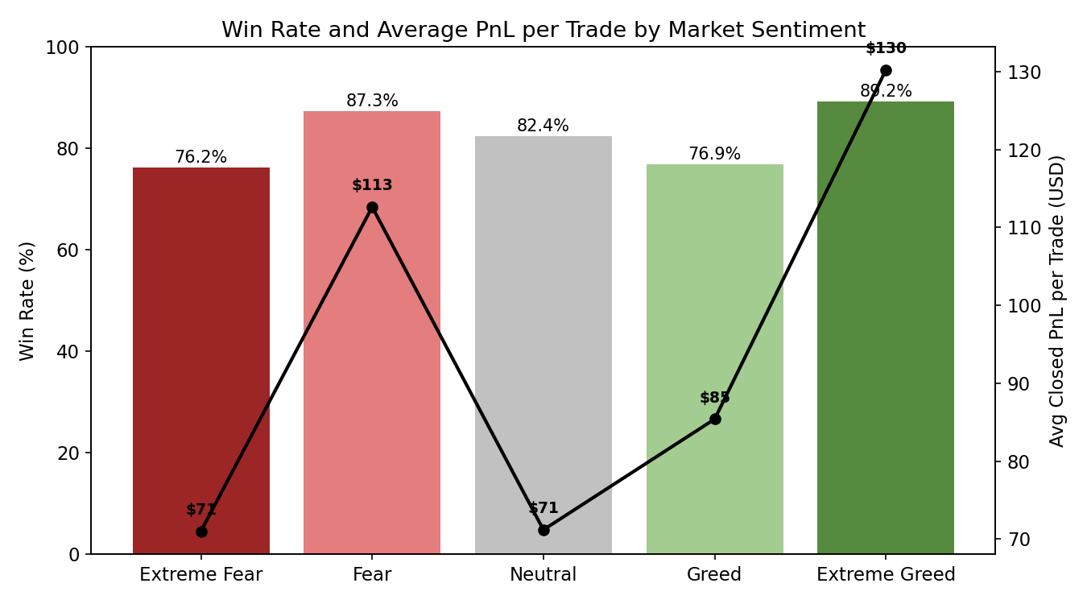
Figure 1 - Win rate (bars, left axis) and average realized PnL per trade (line, right axis) by sentiment class.
Sentiment | Closing Trades | Win Rate | Avg PnL/Trade | Total PnL
Extreme Fear | 10,406 | 76.2% | $71.03 | $739,110
Fear | 29,808 | 87.3% | $112.63 | $3,357,155
Neutral | 18,159 | 82.4% | $71.20 | $1,292,921
Greed | 25,176 | 76.9% | $85.40 | $2,150,129
Extreme Greed | 20,853 | 89.2% | $130.21 | $2,715,171

Fear (87.3% win rate) and Extreme Greed (89.2%) are the two strongest regimes here, both well above the ~82% baseline you'd see in Neutral markets. Plain Greed is actually the weakest of the five on win rate, at 76.9% - about on par with Extreme Fear (76.2%). So it's not just "fear good, greed bad" - the edge seems concentrated at the emotional extremes and in Fear specifically, while the middle-to-moderate-greed zone is where things get shakier for traders.
Grouped into three buckets instead, Fear (84.4% win rate, $101.86 avg) and Greed (82.5%, $105.70) look fairly close on average - but that hides the split above, since Greed's number is basically being carried by Extreme Greed alone.

3. Positioning Bias: Traders Go Contrarian
The clearest behavioral signal in the data is directional bias. Traders open long positions a lot more often during Fear, and open short a lot more often during Greed - pretty classic contrarian behavior.
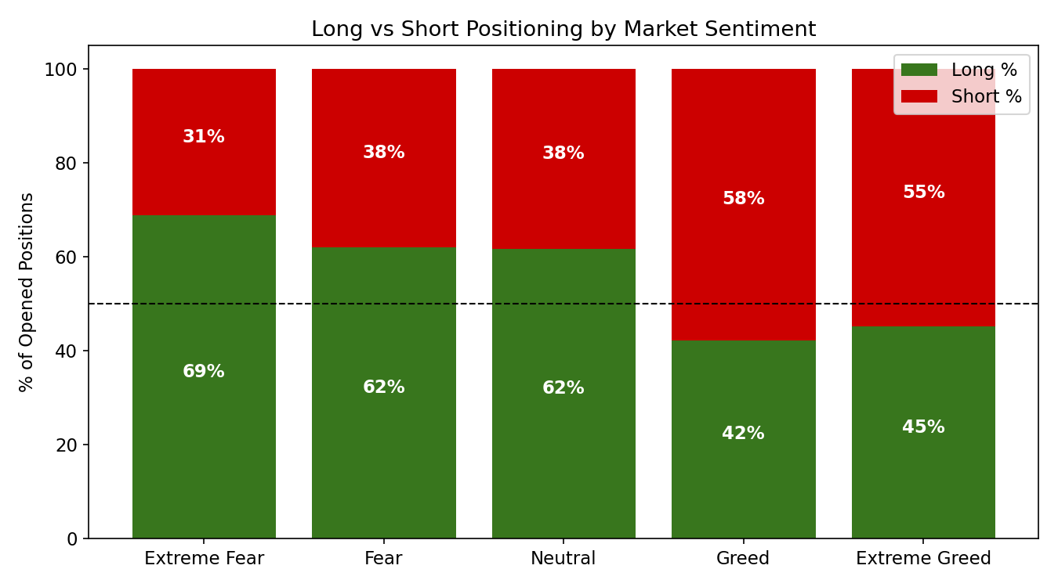
Figure 2 - Share of new long vs. short positions opened, by sentiment.
- Extreme Fear: 68.8% of new positions are long
- Fear: 62.1% long
- Neutral: 61.7% long
- Greed: 42.3% long (57.7% short)
- Extreme Greed: 45.1% long (54.9% short)
Since Fear regimes also have the highest win rates, this contrarian long bias in Fear looks like it's genuinely paying off, not just a quirk. Basically a "buy when others are panicking" pattern that's actually working in this sample.

4. Trade Sizing & Risk-Taking
Average trade size also shifts with sentiment, and not in the direction you'd expect - traders size up the most during Fear, not during Greed.
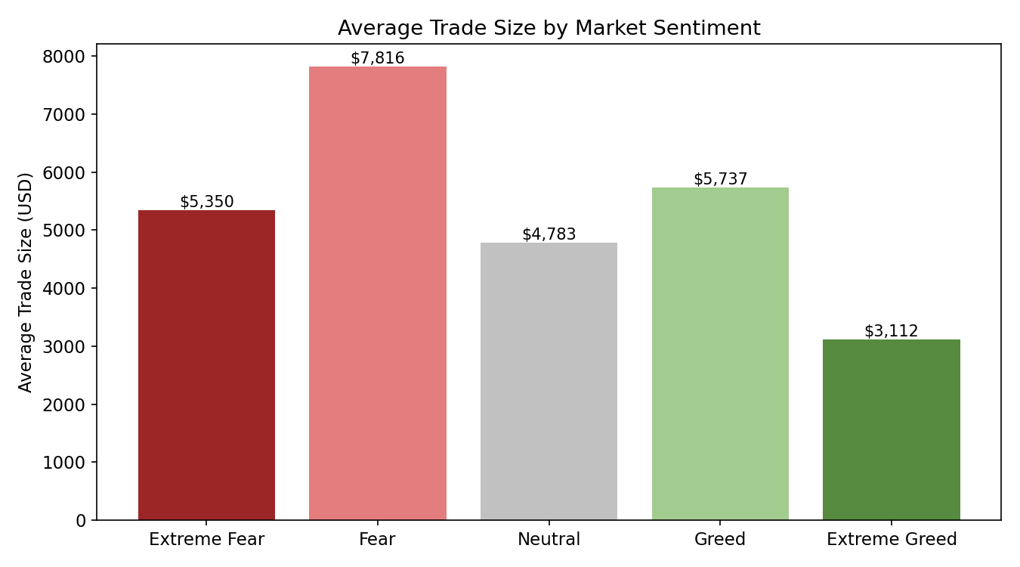
Figure 3 - Average trade notional (USD) by sentiment.
Average trade size peaks in Fear at $7,816 and is smallest in Extreme Greed at $3,112. Traders are putting more capital to work when the market feels scary, and combined with Fear's high win rate, that turns into the single largest profit bucket in the whole dataset ($3.36M). That's a meaningfully different risk profile from Extreme Greed, where trades are smaller but still very accurate (89.2% win rate) - traders seem more cautious sizing-wise even when things are going their way in euphoric markets.

5. PnL Spread and Tail Risk
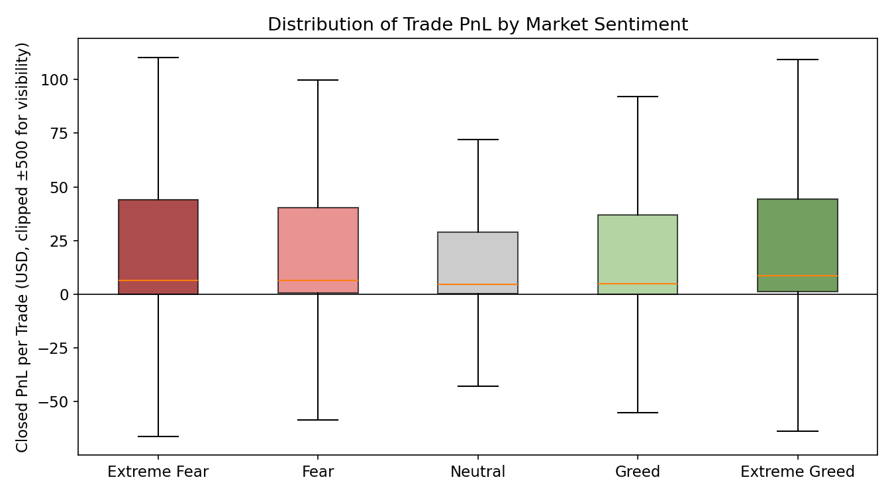
Figure 4 - Distribution of per-trade PnL by sentiment (clipped to +/-$500 for readability, outliers excluded).
Fear-regime trades show a visibly higher median and a fatter upper tail than Greed-regime trades. That reinforces the earlier point - the profitability edge in Fear isn't just a handful of lucky outlier trades, it's a broad shift across the whole distribution.

6. Cumulative PnL Over Time
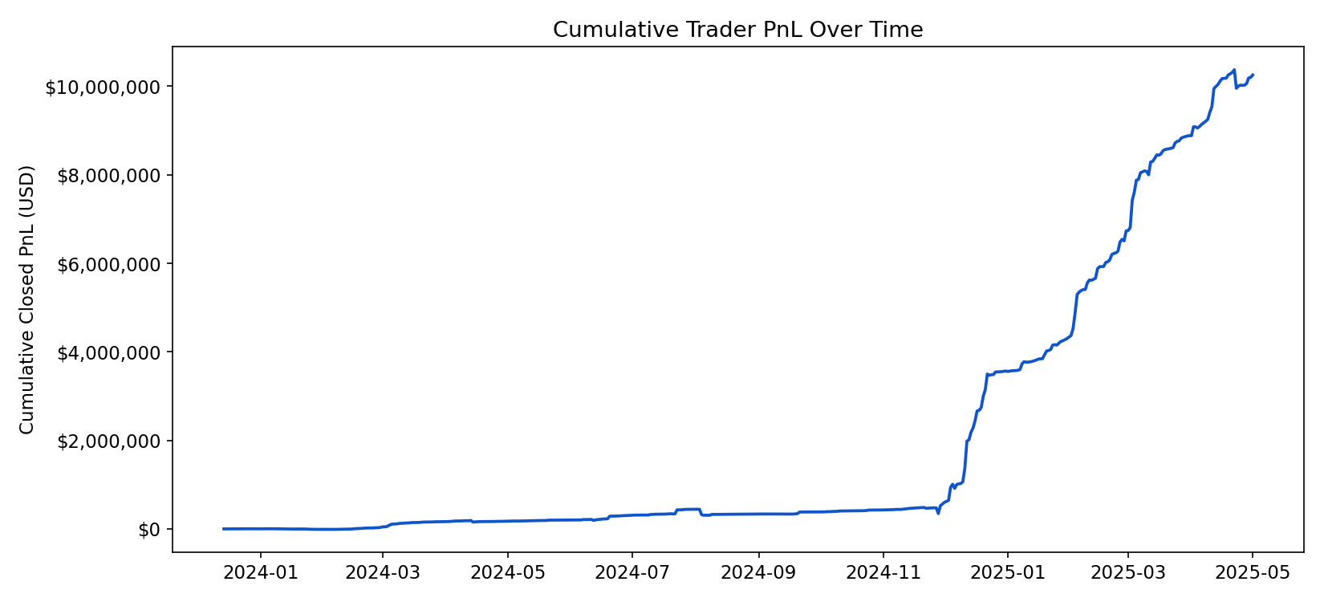
Figure 5 - Cumulative realized PnL across all accounts, May 2023 - May 2025.
Cumulative PnL trends upward across the sample period, with a few visible acceleration phases. Mapping those acceleration windows against the sentiment timeline in more detail would be a good next step (see Limitations).

7. Account-Level Concentration
Performance here is pretty concentrated - the top-earning account alone accounts for over $2.1M of realized PnL, and the top 10 of 32 accounts drive most of the total profit. So these aggregate sentiment findings are partly a story about a small group of large, skilled (or just well-capitalized) traders, rather than something uniform across every participant. Worth keeping in mind before building a strategy on top of this.

8. Sentiment-PnL Correlation Check
As a sanity check, the Pearson correlation between the raw daily Fear & Greed numeric score and daily aggregate realized PnL comes out weak and slightly negative (r ~ -0.10). That basically confirms this isn't a simple linear relationship - it's driven more by regime/category effects, especially the extremes and Fear specifically, which lines up with the U-shaped pattern from Section 2.

9. Key Insights
- Fear is the single most profitable regime by total PnL ($3.36M) and the second-highest by win rate (87.3%), driven by both larger position sizing and a contrarian long bias that's working out.
- Extreme Greed has the highest win rate (89.2%) but smaller average size - traders are accurate but noticeably more cautious in euphoric markets.
- Plain "Greed" (not extreme) is actually the weakest regime on win rate - the effect isn't linear with sentiment intensity.
- Traders are structurally contrarian - long-biased in Fear, short-biased in Greed - and this bias correlates with better outcomes at least in the Fear case.
- Results are concentrated in a handful of high-volume accounts, so any strategy derived from this should be checked per-account, not just in aggregate.

10. Strategy Implications
- Consider scaling position size up (within reason) during Fear/Extreme Fear regimes, where both win rate and average PnL are elevated.
- Treat plain "Greed" days more cautiously than Extreme Greed days - the data shows this is the softest regime, not the most euphoric one.
- A regime-aware sizing or long/short-bias overlay (long-tilt in Fear, short-tilt in Greed) is directly supported by what's in the data and could be backtested as a systematic rule.
- Since PnL is concentrated in a few accounts, any sentiment-based rule should be validated against the median/smaller accounts separately before generalizing it.

11. Limitations & Next Steps
- Correlation, not causation - sentiment and trader behavior might share a common driver (realized volatility, for example) rather than sentiment directly causing the outcomes.
- No leverage column was available in this extract - a follow-up with margin/leverage data would sharpen the risk-adjusted comparison, not just raw PnL.
- Fees were excluded from the PnL figures above - net-of-fee profitability by sentiment would be a good refinement.
- A lagged-sentiment analysis (yesterday's sentiment vs. today's PnL) would help separate predictive value from same-day co-movement.

