Travel Website
ANSHUL SINGH
CSIT-A
202501100500045

Source Code –

Code of index html file
<!-- This is latest boilerplate -->
<!-- Tells browser we are using HTML5 -->
<!DOCTYPE html>
<html lang="en">
<!-- This is head part(non visible part on browser) -->
<head>
<meta charset="UTF-8">
<meta name="viewport" content="width=device-width, initial-scale=1.0">
<title>ABC Travels Co.</title>
</head>
<!-- Body part of html, visible part (style attribute is used to align and change font)-->
<body style="text-align: center; font-family:Verdana, Geneva, Tahoma, sans-serif">
<!-- Header section, it includes the name of the company -->
<header>
<!-- Main Heading of Webpage -->
<hr><h1>ABC Travels Co.</h1><hr>
</header>
<!-- This is introduction para of the company, with proper text formatting, and alignment. -->
<h2 style="text-align: left;">Who are we?</h2>
<p style="text-align: left;">Welcome to <strong>ABC Travel Co.</strong>, your dedicated companion for exploring the breathtaking hill stations of India. <br><br>We are a <u>specialized travel company</u> committed to crafting unique and unforgettable journeys into the country's most serene and majestic mountainous regions.<br><br>From the snow-capped peaks of the Himalayas to the lush green landscapes of the Western Ghats, our mission is to connect travelers with the natural beauty and rich cultural heritage of India's highlands. <br><br><b>ABC Travel Co.</b> offers carefully curated packages that promise not just a trip, but an immersive

experience, ensuring every escape to the mountains is seamless, memorable, and filled
with wonder.</p><hr>
<!-- Image section to give users a overview of destination and activities we offer -->
<h2>Take a Glimpse!</h2>
<img src="destination.jpg" alt="Travel Destination (Leh Ladakh)" width="40%" height="auto" style="border: solid;">
<p><b>Most popular destination - <u><i>Leh Ladakh</i></u></b></p>
<img src="activity.jpg" alt="Travel Activity (Leh Ladakh)" width="40%" height="auto" style="border: solid;">
<p><b>Most popular activity - <u><i>Bike Trip</i></u></b></p>
<hr>
<!-- Ǫuick Guide section for extra information, Uses ordered, unordered, and
defination list to organise content -->
<h2>Ǫuick Guide</h2>
<!-- Ordered List -->
<ol style="text-align: left;"><h3>Top 5 Travel Destinations</h3>
<li>Leh, Ladakh</li>
<li>Spiti Valley, Himachal Pradesh</li>
<li>Doodhpathari, Kashmir</li>
<li>Abbott Mount, Uttarakhand</li>
<li>Tinkitam, Sikkim</li>
</ol>
<!-- Unordered List -->
<ul style="text-align: left;">
<h3>Travel Essentials to Pack</h3>
<li>Warm Clothing</li>
<li>Basic Medicines</li>
<li>Proper Gear</li>
<li>Sturdy Shoes</li>
<li>Skin Protection</li>
</ul>
<!-- Description List -->
<dl style="text-align: left;">
<h3>Some useful Travel Terminologies</h3>
<dt>Round Trip:</dt>
<dd>A journey to a destination and its subsequent return journey.</dd>
<dt>Stopover:</dt>
<dd>A longer stay(usually more than 24 hours) in a city during a journey.</dd>
<dt>ETA:</dt>
<dd>Short abbreviation for <i>Estimated Time of Arrival.</i></dd>
</dl><hr>

<!-- Section to show packages we offer, Uses Table formatting for displaying -->
<h2>Special Offer Packs <i>(For Limited Time only)</i></h2>
<!-- Style for table bordering and alignment -->
<style>table,td,th{border: solid; margin: auto; border-collapse:collapse; width: 50%;}</style>
<table>
<tr>
<th>Destination</th>
<th>Price</th>
<th>Duration</th>
</tr>
<tr>
<td>Leh-Ladakh</td>
<td><del>₹42,000</del><br>₹39,900</td>
<td>5-7 Days</td>
</tr>
<tr>
<td>Spiti Valley</td>
<td><del>₹55,000</del><br>₹49,900</td>
<td>7-9 Days</td>
</tr>
<tr>
<td>Doodhpathari</td>
<td><del>₹27,000</del><br>₹24,900</td>
<td>4-5 Days</td>
</tr>
<tr>
<td>Abbott Mount</td>
<td><del>₹27,000</del><br>₹24,900</td>
<td>5-6 Days</td>
</tr>
<tr>
<td>Tinkitam-Gangtok</td>
<td><del>₹21,000</del><br>₹19,900</td>
<td>3-4 Days</td>
</tr>
</table><br><hr>
<!-- Footer Section, to show hyperlinks for navigation and show company rights -->
<footer>
<h2>Useful Links</h2>
<a href="contact.html">Contact Us</a><br>

<a href="https://tourism.gov.in/" target="_blank">Visit Ministry of Tourism</a><br>
<a href="index.html">Return to Homepage</a><br>
<hr>
<p>Copyright © 2025 ABC Travel Co. All Rights Reserved. </p>
</footer>
</body>
</html>

Code of contact us html file
<!-- This is Contact us webpage -->
<!-- Tells we are using HTML5 -->
<!DOCTYPE html>
<html lang="en">
<!-- Head part of Contact us Page -->
<head>
<meta charset="UTF-8">
<meta name="viewport" content="width=device-width, initial-scale=1.0">
<title>Contact Us | ABC Travels Co.</title>
</head>
<!-- The Main Visible Part of Webpage -->
<body style="text-align: center; font-family:Verdana, Geneva, Tahoma, sans-serif">
<!-- Header part displaying Company Name -->
<header>
<hr><h1>ABC Travels Co.</h1><hr>
</header>
<!-- Contact Information Para -->
<h2>Feel free to reach out to us!</h2>
<p style="text-align: left;"> Phone: +91 1234567890<br>
Email: abctravels@example.com<br> Website: www.example.com
Address: 123, Example Street, India<br><br>
<!-- Hyperlink to return to main page(index.html) -->
<a href="index.html"><i>Return to Homepage</i></a><br>
</p><br><hr>
<!-- Footer Section for showing company rights -->
<footer>
<p>Copyright © 2025 ABC Travel Co. All Rights Reserved.</p>
</footer><hr>
</body>
</html>

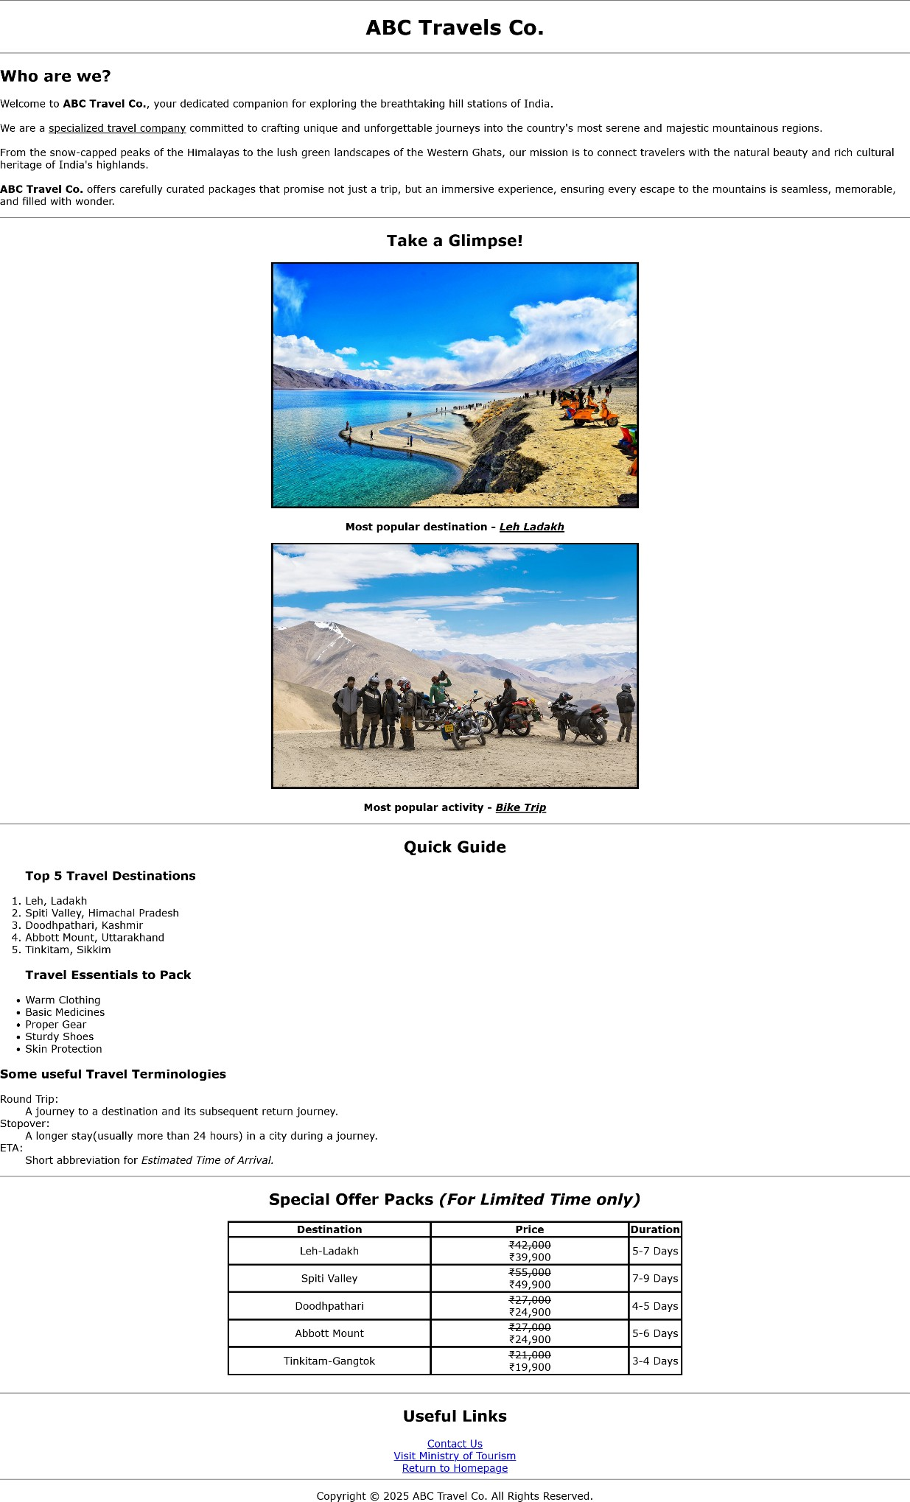
Preview of Webpages –

Main Webpage Index.html

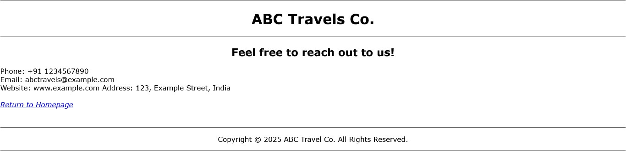
Contact Us Webpage
contact.html

