**4 Modeling the neuron components**

The aim of this chapter is to present the modeling components that would constitute a model of a whole neuron. We have described the anatomy of a neuron in chapter 2. We have discussed the electrophysiological basis of electrical signaling that occurs in a neuron in chapter 3. In this chapter we combine the biological background presented in the two fore-mentioned chapters and present modeling equations.

To begin with let us quickly recall the four components of neural signaling or, rather, the four stages of a neural signal in its passage from the “input” (apical dendrite) of a neuron to its “output” (axon terminal).

1. signal propagation along the dendrite towards the soma
2. spatial and temporal summation in the soma
3. signal propagation along the axon
4. neurotransmission across the synapse

We had also noted earlier that signal propagation along dendrites is mostly passive, as along an electrical cable; that summation occurs in the axon hillock; that an intact action potential propagates down the axon without losing amplitude because it is charged all along the way by voltage-sensitive channels; that neurotransmission occurs across a synapse – as though there is a “hotline” from axon terminal A to apical dendrite B – via chemical means; and, finally, that this whole sequence of events occurs in a neat unidirectional fashion from the apical dendrites to axon terminals.

**4.1 Dendrite**

We introduce three electrical parameters of a dendritic cable. The parameters are defined per unit length of the cable.

1. Axial resistance: Resistance offered by the intracellular compartment per unit length of the cable of diameter, d. The resistivity of the intracellular medium is Ri.

We now relate the resistivity, Ri, which is an intrinsic property of the intracellular medium, to axial resistance, ra, which is resistance per unit length of the cable.

In general the resistance, R, and resistivity, ρ, of a pipe of area of cross-section, A, and length, L, are related as:

R = ρ L/A, and

Resistance per unit length of the pipe is:

= ρ/A

A similar relation for our cable is:

 (Ω/cm) (4.1.1)

1. Membrane resistance: The membrane offers resistance for flow current between the intracellular compartment and the extracellular space. This resistance is inversely proportional to the surface area of the membrane.

Therefore, if Rm is the resistance of a membrane patch of unit area, a quantity referred to as specific resistance, the total resistance offered by a cylinder of diameter, d, and unit length, is given as:

 (Ω-cm) (4.1.2)

1. Membrane capacitance: The plasma membrane has a specific capacitance, Cm, of about 10-6 F/cm2. Therefore, capacitance of the cable of unit length, cm, is,

 (F/cm) (4.1.3)

Using the electrical parameters defined above, we can now represent the cable as an electric circuit. In this circuit, the continuous cable is represented as a series of discrete circuit elements, in which each element approximates a short length of the cable, say, of length, Δx.

**4.1.1 Infinite Cable**

Applying Ohm’s law to one of the horizontal resistances, ra Δx,



 (4.1.1.1)

Applying the law of continuity of current at a given node in the circuit of fig. 4.1.1,

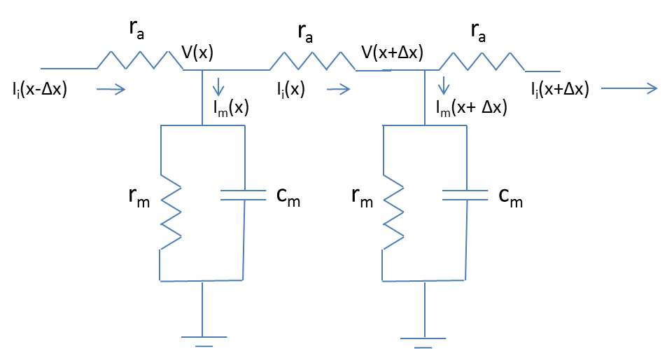

**Figure 4.1.1:** Circuit equivalent for a dendrite



 (4.1.1.2)

Combining (4.1.1.1) and (4.1.1.2),

 (4.1.1.3)

Now, the membrane current, Im, can be resolved into three components 1) current through membrane capacitance, 2) current through membrane resistance, and 3) externally injected current, Iext, if any. Thus,

 (4.1.1.4)

Combining (4.1.1.3) and (4.1.1.4),

 (4.1.1.5)

where

 known as the space constant, and,

 known as the time constant, of the cable.

Equation 4.1.1.5 is known as the Linear Cable Equation. Eqn. 4.1.1.5 can be further simplified if the membrane voltage, , is defined with reference to the resting potential. Assuming that the resting potential is the same everywhere along the cable, it only offsets the membrane potential and does not affect the derivative terms in eqn. (4.1.1.5). Thus, from now on, if we designate Vm to represent the deviation of membrane potential from the resting potential, Vrest, the (Vm - Vrest) term in eqn. (4.1.1.5) can be replaced by, Vm, and we have the following simpler form.

 (4.1.1.6)

**Steady State Analysis:**

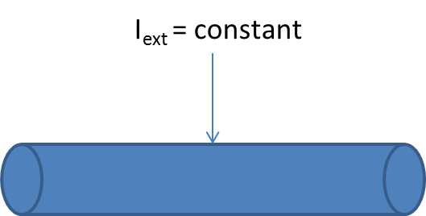

**Figure 4.1.2:** Infinite cable

Though our ultimate objective is to be able to describe signal transmission along the cables with complex geometries, we begin with a simple situation.

We consider an infinite cable in which a constant current is injected at a point. The goal is to determine membrane voltage distribution under steady state conditions.

External Current:

Iext = I0 δ(x) u(t), (4.1.1.7)

spatially it is a point source; and temporally it is a step function.

Boundary conditions:

 (4.1.1.8.a)

Initial condition:

 (4.1.1.8.b)

Under steady state conditions,



Therefore, eqn. (4.1.1.6) becomes,

 (4.1.1.9)

Solution to eqn. (4.1.1.9) will be of the form:

 (4.1.1.10)

Since we are concerned with only steady state behavior, time is omitted, and membrane voltage is represented as, Vm(x).

Now let us apply the boundary conditions eqn. (4.1.1.8), to the solution eqn. (4.1.1.10). Since Vm(x) tends to 0 at +, A=0, and since Vm(x)=0 at –, B = 0. This difficulty can be overcome if we let the form of the solution be,

 (4.1.1.11)

where V0 is the steady state voltage at x=0.

Let us try to verify that Vm(x) of eqn. (4.1.1.11) satisfies eqn. (4.1.1.9).







Comparing the last equation with eqn. (4.1.1.9), we have



Or,

 (4.1.1.12)

Therefore, the final form of steady state membrane voltage of an infinite cylinder is,

 (4.1.1.13)

where,



Electrotonic Distance:

Any length, l, can be expressed as electrotonic distance, L, as,

 (4.1.1.14)

**Input resistance**:

Input resistance, Rin, is defined as the ratio of voltage at the point of current injection to the magnitude of current injected.

 (4.1.1.15)

Example:

Consider a infinite cable with the static current I0= 10 mA injected at point x=2. Plot the static solution for such a cable.

Solution:

The static solution for the infinite cable is given by: .

Since current I0=10 mA is injected at x=2,

Iext = I0 δ(x);

The plot of vs x/λ would be:

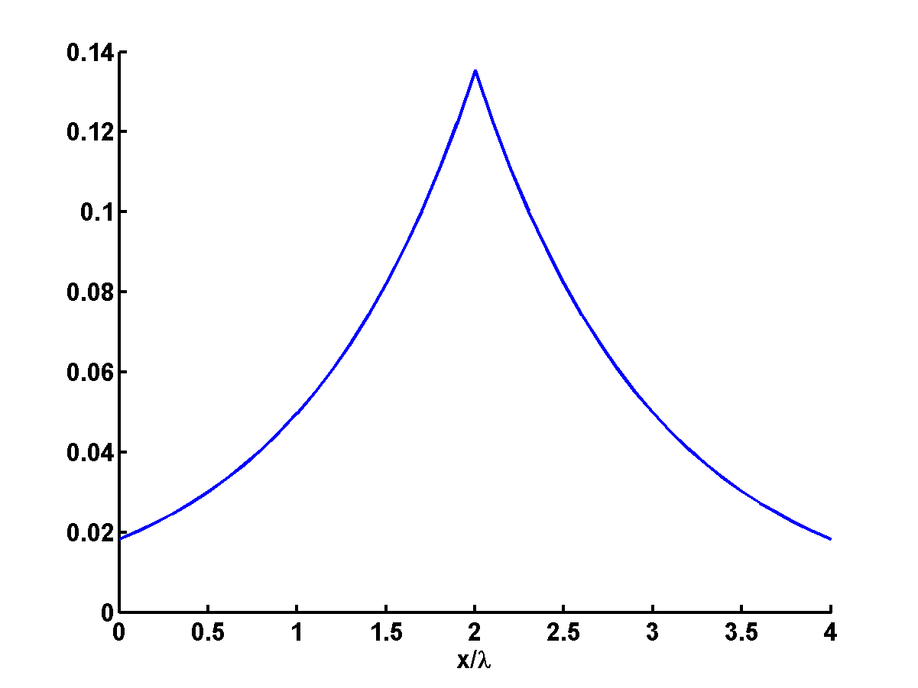

**4.1.2 Semi-infinite Cable:**

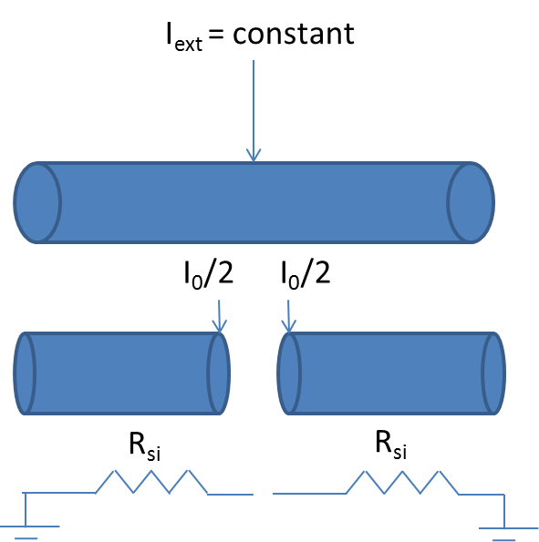

**Figure 4.1.2.1:**: Semi-nfinite cable

Let us consider the case of a semi-infinite cable where current of magnitude, I0, is injected into one end of the cylinder. Since an infinite cable can be viewed as two semi-infinite cables in parallel, steady state membrane voltage of a semi-infinite cable is twice that of the infinite cable, and is given as,

 (4.1.2.1)

Similarly, the input resistance, which is naturally twice that of an infinite cable, is,

 (4.1.2.2)

is called the input resistance of a semi-infinite cable.

**4.1.3 Finite Cable:**

Consider a finite cable of electrotonic length L. Let X denote the electrotonic distance along the cable,

 (4.1.3.1)

A general expression for steady state membrane voltage, as a function of X, is given as,

 (4.1.3.2)

where,





Now we consider three different boundary conditions under which we solve the steady state voltage distribution of a finite length cable.

**4.1.3.1 Sealed-end Boundary Condition:**

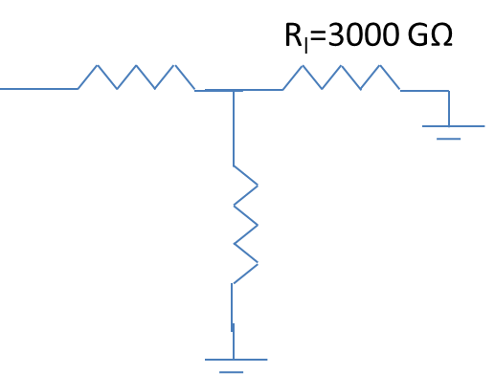

Fig .3

**Figure 4.1.3.1:** Sealed end boundary condition

Physically this refers to the situation when the dendrite is sealed/closed with a membrane patch. Electrically this is equivalent to loading the circuit of fig. 4.1.1 at the far end with a resistance equal to that of membrane patch that sealed the dendritic cable. For dendritic cable of diameter, d of 2μm , and Rm of 105 Ωcm2, the loading resistance RL is,

RL = 3000 G Ω



Since the sealed end has high resistance we can approximate it with an open circuit, implying that axial current, Ii =0 at the sealed end (X=L).

Therefore, from eqn. (4.1.1.1),



Substituting the above boundary condition in the solution of eqn. (4.1.3.2), we have,



or,

B=0.

Therefore,



Assuming, V0, is the voltage at the near-end (x=0=X) of the cable at steady state, the solution can be written as,

 (4.1.3.1.1)



At X=0, Ii is,

 (4.1.3.1.2)

 (4.1.3.1.3)

**4.1.3.2 Killed End Boundary Condition**

The previous case of ‘sealed-end boundary condition’ refers to the situation when the far end is an open circuit. The present case of ‘killed end boundary condition’ the end of the terminal is ‘shorted’ so that the voltage at the far end is zero. Physically this situation can be created by cutting (“killing”) the far end so that the interior of the dendrite is directly in contact with the extracellular space.

The form of the solution for this case is again,



Boundary conditions:









Input resistance: V(X)/Ii(X) at X = 0.

Input current is,









**Arbitrary Boundary Condition:**

Let load resistance be = RL.

Load voltage = VL.



Boundary conditions:









Substituting…







(Using, sinh(X)=sinh(L – (L-X)) = sinh(L)cosh(L-X) - sinh(L-X)cosh(L))

 (4.1.3.2.1)

Axial current is,



Current flowing into the load is, Ii(X) at X = L, which is,



Since load current is also equal to, VL/ RL, we have

,

or,





Substituting the above in eqn. 4.1.3.2.1,











On further reduction we obtain,



Applying the formula for the input current,

 (4.1.3.2.2)

We can obtain the expression for Rin as,

 (4.1.3.2.3)

**4.1.4 Time-dependent solution:**



Let,

; 



 (current density)

**Infinite cable:**

**Impulse response**

Boundary condition: 

If,  (an infinitely brief pulse)



For long times, decay pattern is the same throughout the cable.

Since the system is linear, response to arbitrary current injection is given as,



 (4.1.4.1)

Voltage response to current step:





 (4.1.4.2)

Example:

Plot the time dependant solutions for different distances from the point of injection for a semi-infinite cable with respect to time. Current is injected at X=0;

Solution:

The required plots can be generated using the formula:



Approximating it as:



We plot the X's(distance's) at intervals of 0.5.

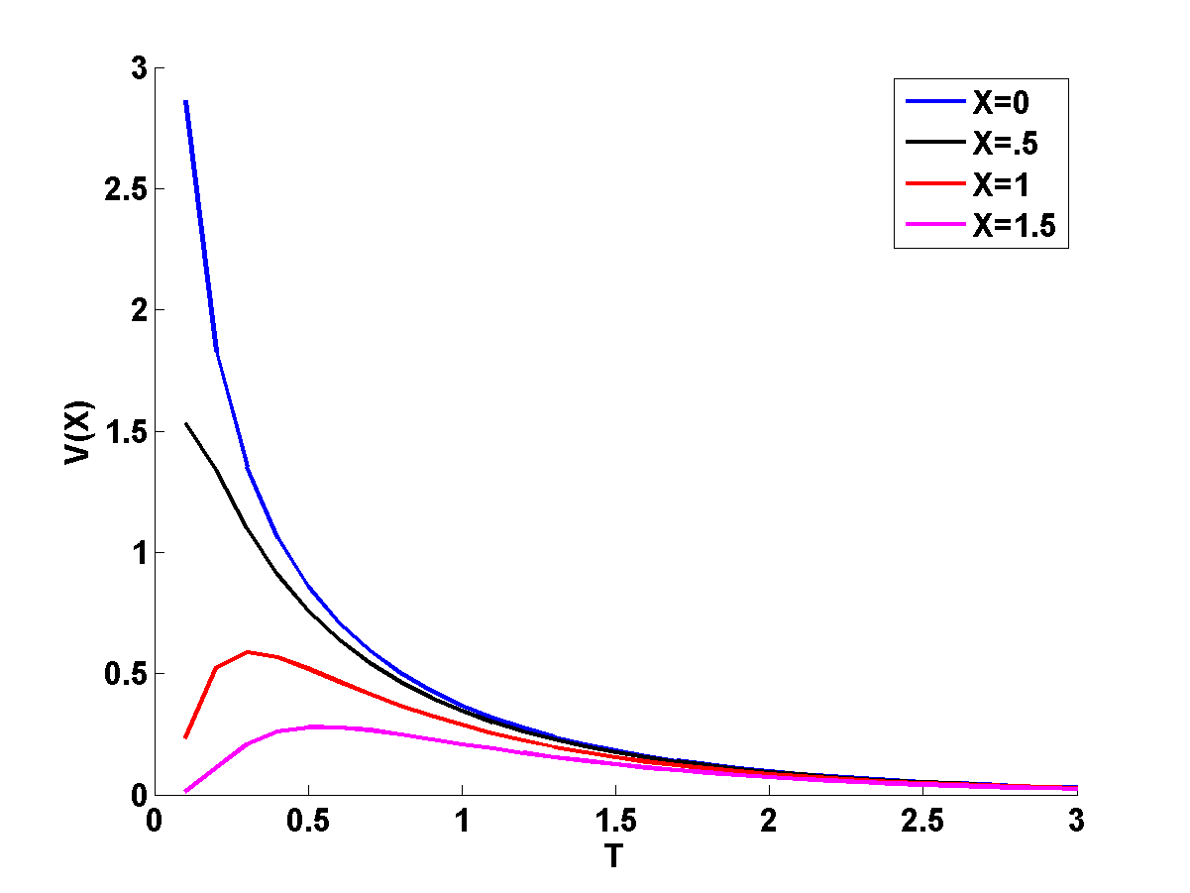

**Propagation Delay:**

Linear cable equation does not admit any wave equation, due to dissipation of energy through the passive membrane. If voltage-sensitive, nonlinear elements are sensitive, then we can have traveling waves as it happens in the axons.

One way of defining velocity is by tracking motion of the peak.

But a centroid gives uniform propagation velocity.

 (4.1.4.3)

**Transfer delay:**

Transfer delay is the difference in centroid of induced voltage at y, and the centroid of injected current at ‘x’.

 (4.1.4.4)

Input or local delay:



* Dxy is always positive and is independent of the shape of the transient input current.
* It is the property of the cable and not of the input waveform

No matter what the electrical structure of the cable, the transfer delay is symmetric.



It does not depend on the direction of travel.

Isopotential neuron – membrane patch:



Infinite or semi-infinite cable:



If the current is injected at x and the voltage is recorded at y, the two centroids are displaced by,



Propagation delay in difference between centroids of voltage at x and y:



For an infinite cable,



 “pseudo-velocity”

**4.1.5 Branched cables:**

Assume that the 2 rightmost branches terminate with sealed end (open) boundary conditions.

Input resistance of the branches,

 (4.1.5.1)

 (4.1.5.2)

Terminal resistance of main cable, RL,0 is given as,

 (4.1.5.3)

Given the terminal resistance, the input resistance is calculated as,

 (4.1.5.4)

Moving from outermost dendritic tips, one moves towards the soma. Finally at X=0, in the parent cable,



Given V0, we can use, voltage distribution along the main branch is,

 (4.1.5.5)

From the above, we can calculate V12, the voltage at the bifurcation point as,



Voltage distribution along the two terminal branches is,





Upward pass (terminals to the root) – compute Rin’s::

Compute Rin,1 and R n,2 using eqns. (4.1.5.1, 4.1.5.2). Using Rin,1 and R n,2compute RL,0 using,

Eqn. (4.1.5.3). Using all the 3 results compute, R­in,0 using eqn. (4.1.5.4).

Downward pass (Root to terminals – compute V(x)):

**4.1.6 Rall’s condition:**

When the diameters of the two terminal branches are related to the diameter of the main branch in a special way.

 (4.1.6.1)

Lengths of the two terminal branches must be the same i.e., L1 = L2 = L (say).



Therefore,

,  and 

Note that, thanks to the way the diameters of the 3 cables are related, we have a special relation among the ’s also,



Input resistance of the terminal branches are,

 and 

Thus, terminal resistance of the main cable is given as,







Or,

 (4.1.6.2)

From, eqn. (4.1.5.5) we may write down the voltage distribution of the main cable as,



Inserting the expression for RL,o from eqn. (4.1.5.3) here,







Rall’s conditions:

1. Rm, Ri are the same in all branches
2. All terminals end in the same boundary condition
3. All terminal branches end at the same electrotonic distance from the origin of the main branch
4. At every branch point, infinite input resistances must be matched, i.e.,



Where, di are the diameters of the branch cables and d0 is the diameter of the root cable at the branch cable.

1. Identical synaptic inputs must be delivered to all corresponding dendritic locations.

X = L0 + X1

**4.2 Axon:**

From the Hodgkin-Huxley model (eqns. (3.4.2-3.4.10)), we know the mechanisms underlying membrane excitation. We know how currents that exceed a threshold value can produce action potentials. But the Hodgkin-Huxley model is an isopotential model. It applies to a patch of membrane with homogenous distribution of ion channels and a uniform membrane voltage. Therefore, it does not describe signal propagation. With a slight modification, the Hodgkin-Huxley model can be transformed into a model of voltage wave propagation in an axon.

Eqn. (4.1.1.3) depicts the relationship between the membrane current, Im, and second spatial derivative of membrane voltage.

 (4.2.1)

This relationship can use used to develop a model of action potential propagation in the axon.

Reproducing eqn. (3.4.2) here with a slight rearrangement of terms,



Iext in the above equation represents Im in eqn. (4.2.1) expressed per unit length.

Currents in eqn. (3.4.2) are expressed as per unit area, whereas current in eqn. (4.2.1) is expressed in per unit length. To describe propagation along a cable, we need to express all membrane currents as per unit length.

From eqn. (4.1.1.) we know that,



For a cable of diameter, d, the membrane current per unit length of the axon is expressed by dividing the currents in eqn. (4.2.1) by *d*1,



Or,



Substituting the last equation in eqn. (3.4.2),

 (4.2.2)

Eqn. (4.2.2) along with eqns. (3.4.3-3.4.10) constitute the complete set of equations that describe signal propagation along an axon.

Eqn. (4.2.2) can be written as,

 (4.2.3.)

We need to seek propagating wave solutions for the above equation. Assuming the existence of a voltage wave, V(x – ut), propagating with a uniform velocity, u, along the axon, the wave must also satisfy the wave equation,

 (4.2.4)

Substitution (4.2.4), we may write eqn. (4.2.3) as,



Where Iionic is the sum of all the ionic currents in eqn. (4.2.3) and,



Note that the currents are expressed in terms of per unit area, therefore they are independent of the axon diameter, *d*. Similarly the voltage Vm must also be independent of *d*. Therefore K must also be independent of *d*. Since Ri and Cm are independent of *d* by definition, it implies that u2/d is independent of *d*. In other words,

 (4.2.5)

Thus we have a relationship between cable diameter and conduction velocity. This rule is roughly followed in real, unmyelinated axons.

Note that the result of eqn. (4.2.5) is identical to that of eqn. (4.1.4.5), the derivation is quite different in the two cases.

Just as the Hodgkin-Huxley model, which is an isopotential model, exhibits threshold effect, the model of wave propagation also exhibits a threshold effect. When suprathreshold external current is injected in at a point in an axon, Na+ ions rush in thereby increasing local membrane voltage rapidly. Voltage increase in neighboring regions activate the local Na+ channels further amplifying the voltage buildup. The fraction of membrane current that depolarizes neighboring membrane segments is called ‘local circuit current.’ As this process continues, the action potential spreads along the axon. When a subthreshold current is injected, the local Na+ channels are not activated, and therefore, due to inadequate amplification, there is no local spread of action potential.

When the current is close to the threshold (within 1% of threshold current), there may not be a propagating wave, but a decaying wave that dies down to resting potential with increasing distance from the point of injection.

Another feature that controls action potential propagation consists of the values of channel conductances. Since the action potential generation and propagation is dependent crucially on voltage-sensitive Na+ and K+ channels, the conductances of these two channels must be sufficiently high for signal propagation. In a simulation study of signal propagation in axon, Cooley and Dodge (1966) reduced gNa and gK by a scaling factor . They found that for  <= 0.26, action potential was generated but did no propagate as a stable wave. Only a decaying wave was observed.

**4.2.1 Voltage-sensitive ion channels**

In the previous chapter, we have seen how we can express channel models in terms of gating variables. Specifically we considered voltage-sensitive Na+ and K+ channels used in the Hodgkin-Huxley model. Both of these models had a common mathematical structure. Channel current, Ix, is expressed as a function of gating variables, an activation variable, m, and an inactivation variable, h, as follows:

 (4.2.1.1)

In the HH model, p=3 and q = 1 for the Na+ channel, and p=4, q=0 (for the activation variable) for K+ channel. Separate α and β functions were associated with each channel. The form of the conductance variation is given in eqn. (4.2.1), and the α and β functions determine the dynamics of the channel.

We now present models of a greater variety of channels. While the above modeling structure applies to most cases, there will be some deviations. Broadly 4 classes of channels will be considered:

1. Sodium channels
2. Potassium Channels
3. Chloride Channels
4. Calcium channels
   1. Calcium gated potassium channels

**4.2.1.1 Sodium channels:**

Sodium channels are broadly classified into “transient” and “persistent” type.

The sodium channels of HH model are fast channels in which the conductance rises fast, due to fast activation dynamics, and drops rapidly, due to fast inactivation dynamics. Such currents are usually called “transient” since the channel opens briefly and shuts again, even though the membrane is depolarized. A transient sodium current, like the one in HH model, can be expressed as,

 (4.2.1.1.1)

But there are sodium channels which do not have inactivation gates ie., h variable is absent. Such channels open on depolarization and remain open as long as the membrane remains depolarized. Such sodium channels are said to be “persistent” (INa,p) or “noninactivating” (referring to the absence of inactivation dynamics). INa,p currents are found for example in the thalamocortical neurons in rats (Parri and Crunelli 1999). A persistent sodium current may be expressed as,

 (4.2.1.1.2)

**4.2.1.2 Potassium channels**

Voltage-sensitive potassium channels are broadly classified in terms of 1) the speed of their inactivation dynamics, and 2) the direction of the currents. Potassium currents with slow inactivation dynamics are said to be “delayed” while those with fast inactivation dynamics are said to carry “A type” currents.

Channels that allow currents in only one direction are said to be rectifying. “Outward rectifying” channels are those that allow current in the outward direction, while “inward rectifying” channels are that allow currents in inward direction. Thus there are three important classes of voltage-sensitive potassium currents:

1. Delayed rectifier currents: These currents have slow inactivation dynamics and allow currents in the outward direction. (The ‘rectifier’ implicitly means outward rectifying). The potassium currents in HH model are of this type.
2. A currents: These currents have fast inactivation dynamics.
3. Inward rectifying currents: Those most potassium channels are outward rectifying, there are a special class of potassium channels (sometimes referred to as the “exceptional”) that are inward rectifying. These are denoted by KIR channels. These channels open under conditions of hyperpolarization.

**4.2.1.3 Calcium currents**

Like the voltage-sensitive sodium and potassium currents visited above, calcium currents are also described in terms of activation, m, and inactivation, h, variables. But the calcium current cannot be calculated using the simple expression of eqn. (4.2.1.1.1) since the calcium concentration inside the neuron is very low (O(nM)) and varies rapidly due to calcium flux. Therefore, the Nernst potential formula which depends on assumptions of equilibrium conditions is not valid. The correct formula for calcium current is given as,

 (4.2.1.3.1)

Where,

 - extracellular calcium concentration (usually about 2 mM).

 - intracellular calcium concentration (varies but low)

 - max. permeability to calcium

Faraday’s constant, F = 9.648 X 104 C mol-1

Ideal gas constant, R = 8.314 V C K-1 mol-1

Though the above description is valid for general calcium currents, there are two subcategories of calcium currents which depend on the threshold voltage at which the channels get activated. These are:

1. Low-threshold calcium current (IT):

The low threshold calcium channels open at a threshold voltage of about -40 mV. That is, these channels open under conditions of hyperpolarization. Hence IT current is responsible for an interesting phenomenon called *post-inhibitory rebound*. When an inhibitory, hyperpolarizing input is suddenly switched off, a neuron can show a rebound response whereby, the cell might fire a few action potentials, a phenomenon called post-inhibitory rebound. The role of low threshold calcium channels in post-inhibitory rebound may be explained as follows.

For the low threshold calcium channels under conditions of hyperpolarization (created by inhibitory input), the inactivation variable, h, is positive. But the channel is in closed state since the activation variable, m, is 0. But when the hyperpolarizing current is stopped, membrane voltage gradually increases. Therefore, m gradually increases while h decreases. There will be a critical stage at which both m and h are sufficiently positive, when the channels are briefly open, allowing a transient calcium pulse. Such pulses are known as low-threshold calcium spikes. The resulting calcium influx transiently increase membrane voltage which in turn triggers a couple of sodium spikes.

1. High-threshold calcium current (IL):

The IL current differs from its low-threshold counterpart only in the threshold voltage at which the channel gets activated. The High-threshold calcium channels, as the name indicates, open only at high levels of membrane depolarization. They are activated even during the action potentials and contribute to changes in membrane voltage. In addition this class of calcium channels have a role in controlling a class of potassium channels.

2a) Calcium-controlled potassium channels:

Intracellular calcium ions are important players in many forms of second-messenger signaling. An instance of such signaling is the role of intracellular calcium in dynamics of a special class of potassium channels, the calcium-controlled potassium channels. Current through these channels is given as,

 (4.2.1.3.2)

Dynamics of the activation variable, m, is given in the usual form, as:



In the channels of HH model, the α and β functions only depend on membrane voltage, Vm. But in the present case, α depends on intracellular calcium, , as follows:





where A, B and k are constants. We know that steady-state value of m may be expressed in terms of α and β functions as,



Thus increasing  can be seen to increase m, and therefore IC (up to a point of saturation).

**4.3 Synapse**

We have already seen that synaptic transmission converts a presynaptic electrical event viz., action potential, into a postsynaptic electrical event – the PSP. This change is produced by the action of the neurotransmitter on a postsynaptic receptor which leads to opening of an ion channel on the postsynaptic side. Therefore the simplest form modeling a synapse would be to consider a membrane model of the postsynaptic side and describe the transient change in the conductance of the ion channel involved in the transmission event.

**4.3.1 Circuit model of synapse**

Accordingly consider a simple circuit model of the postsynaptic membrane in the figure below.

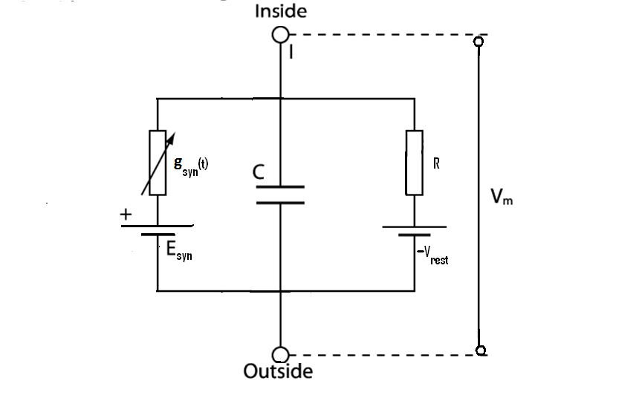

**Figure 4.3.1** Simple circuit diagram of Post synaptic membrane

gsyn(t) – is the time-varying synaptic conductance (of the ion channel involved in synaptic transmission)

Esyn – is the Nernst potential corresponding to the ion channel (involved in synaptic transmission) and the ionic species to which it is permeable

C – membrane capacitance

Vrest – resting membrane potential of the postsynaptic membrane

R – membrane resistance

The central and right branches consisting of C, R and Vrest together model the passive membrane properties in the absence of synaptic transmission. The left branch becomes active only when there is synaptic transmission, i.e., when gsyn(t) > 0.

Applying Kirchoff’s current law to the above circuit, we have,

 (4.3.1.1)

Note that normal resting conditions of the postsynaptic membrane occur by setting gsyn(t) =0 and Vm = Vrest in the above equation.

The transient increase and return to zero of synaptic conductance gsyn(t) is usually expressed in the following form,

 (4.3.1.2)

Where A is a constant, and tpeak is the time at which gsyn(t) peaks. Note that the above expression represents variation of synaptic conductance in response to a single action potential.

Since Post Synaptic Potential (PSP) is defined as the deviation from the resting potential, we define a new voltage variable, *v*, as,

*v* = Vm – Vrest

Accordingly eqn. (4.3.1.1) may be rewritten as,



Or,

 (4.3.1.3)

Therefore, during the neurotransmission, when gsyn(t) begins to rise, the sign of (Esyn- Vrest) determines the direction of change in *v*. We have three cases in order.

**Case 1: Esyn > Vrest**

This amounts to having a positive injected current in eqn. (4.3.1.3). Therefore *v* transiently increases. This corresponds to an Excitatory Post Synaptic Potential (EPSP).

A common example of synapses that produce such EPSPs is the fast, excitatory synapses with AMPA receptors (or non-NMDA type) and glutamate as neurotransmitter.

**Case 2: Esyn < Vrest**

Since the current injected is negative, we have a negative deviation in v, which is an Inhibitory Post Synaptic Potential (IPSP).

A common example is the inhibitory synapse with GABA as the neurotransmitter and GABAB as the receptor. The channel involved is a potassium channel with Esyn that is 10-30 mV below the resting potential.

**Case 3:** 

There is no current in the synaptic conductance in this case. So it does not seem to have any apparent effect on the postsynaptic potential.

An example of such a synapse is the GABA synapse with GABA_A receptor and chloride as the associated channels. The reversal potential of these channels is close to the resting potential of many cells in which these synapses are found.

Although these synapses do not seem to have any effect in isolation, when used in conjunction with excitatory synapses they show an interesting effect. Let us rewrite eqn (4.3.1.3), so as to include a synapse in which , and an excitatory synapse.

 (4.3.1.4)

Where

- conductance and reversal potential of the synapse where 

- conductance and reversal potential of the excitatory synapse

The second term on the RHS is small since . But due to the presence of , the conductance term in the first term on RHS is greater (than what it would be when only the excitatory synapse is present). Therefore, under these conditions the EPSP produced is smaller than what it would be when the excitatory synapse alone is present. In that sense, the synapse corresponding to  is inhibiting the excitatory synapse. Therefore it is known as a silent or a shunting inhibition.

**4.3.2 Excitatory synapses:**

AMPA type synapses: The form of conductance variation of eqn. (4.3.1.2) is applicable for a general synapse. More accurate models have been proposed for specific synapses. A model of synaptic conductance with a double exponential term has been proposed for AMPA synapses (Gabbiani et al 1994):

 (4.3.2.1)

: maximum value of the synaptic conductance

A : normalizing constant that ensures that the highest value of the bracketed expression is unity

t_decay, t_rise : decay and rise time constants

H(t): the step function or the Heaviside function

Numerical values of the above parameters used in (Gabbiani 1994) are as follows:

=750 pS; A = 1.273; t_decay = 1.5 ms, t_rise = 0.09 ms.

NMDA type synapses: This type of synapses have more complex dynamics than AMPA type synapses, since they are dual-gated: they can be gated by both the neurotransmitter and the membrane voltage. Modeling the conductance change due to the neurotransmitter is similar to the cases seen above. Under conditions of normal membrane polarity, extracellular Mg2+ blocks the NMDA associated channels. This block is removed when the membrane potential is depolarized beyond -50 mV. However the time-scales of opening of this channel is longer (10-100 ms) compared to that of AMPA channels (about 1 ms). The form of synaptic conductance for NMDA type synapses is given as follows (Gabbiani et al 1994):

 (4.3.2.2)

Values of various parameters in the last equation are given as (Gabbiani et al 1994),

=1.2 nS; A = 1.358; tdecay = 40 ms, trise = 3 ms; α = 0.062 mV-1; β = 3.57 mM;

=1.2 mM.

**4.3.3 Inhibitory synapses:**

Even for inhibitory synapses, there are more complex models of synaptic conductance variation than that given by eqn. (4.3.1.2). For example, in the GABAergic synapses of cerebellar granule cells, postsynaptic current is found to have a fast and a slow component. Synaptic conductance in such a case may be expressed as,

 (4.3.3.1)

**References:**

C. Koch, Biophysics of Computation, Oxford University Press, 1999.

GABBIANI, F., MIDTGAARD, J. & KNOPFEL, T. (1994). Synaptic integration in a model of cerebellar granule cells. Journal of Neurophysiology 72, 999-1009.