 | INTERNATIONAL TELECOMMUNICATION UNION  TELECOMMUNICATION  STANDARDIZATION SECTOR  STUDY PERIOD 2025-2028 |  | Focus Group on AI Native for Telecommunication Networks  (FG-AINN)
 |  |  | FG-AINN-I-xxx
 |  |  | Original: English
Question(s): |  | N/A | New Delhi, 09th October, 2025
INPUT DOCUMENT
Source: |  | Manipal Institute of Technology, Bengaluru
Title: |  | Build-a-thon 3.0 2025: Autonomous Energy Aware Self Optimizing Radio Access Network (Auto EA-SORAN)
Contact: |  | Anirudh Nishtala  Dept. of ECE, 4th Year  Manipal Institute of Technology, Bengaluru |  | E-mail: anirudh2.mitblr2022@learner.manipal.edu
Contact: |  | Rishiraj Rakesh Kumar  Dept. of ECE, 4th Year  Manipal Institute of Technology,  Bengaluru |  | E-mail: rishiraj.mitblr2022@learner.manipal.edu
Contact: |  | Tarunika D  Dept. of ECE, 4th Year  Manipal Institute of Technology, Bengaluru |  | E-mail: tarunika.mitblr2022@learner.manipal.edu
Contact: |  | Sreelakshmi Anil  Dept. of ECE, 4th Year  Manipal Institute of Technology,  Bengaluru |  | E-mail: sreelakshmi.mitblr2022@learner.manipal.edu
Contact: |  | Dr. Shweta Singh  Asst. Prof., Dept of ECE  Manipal Institute of Technology |  | E-mail:  shweta.s@manipal.edu
Contact: |  | Mr. Rajat Duggal  Senior System Specification Engineer  MN RAN R&D, Nokia Bengaluru |  | E-mail:  rajat.duggal@nokia.com
Contact: |  | Mr. K. Kanagasundaram  Principal Technical Specialist  NI IPN NW A NSP R&D India 7 (L06), Nokia Bengaluru |  | E-mail:  kanagasundaram.k@nokia.com

Abstract: | This document describes a submission towards Build-a-thon 3.0, 2025 conducted in New Delhi on October 9th, 2025.

- Introduction

Background to the Topic: The Energy Consumption Imperative
While the 5G New Radio (NR) standard is significantly more energy-efficient per bit than 4G LTE, the total energy consumption of 5G networks is projected to rise dramatically. This paradox is driven by network densification, massive Multiple-Input Multiple-Output (MIMO) antenna arrays, and exponential growth in data traffic required to meet 5G's performance goals.
These factors create significant operational and environmental challenges. The Radio Access Network (RAN) accounts for 75-85% of a mobile network's energy use, making it a major operational expenditure (OPEX) that impacts financial sustainability. Operators also face pressure to meet sustainability goals like the UN's Sustainable Development Goal (SDG)-13. A key inefficiency is the "always-on" nature of base stations, which consume high power even during low traffic periods, indicating a mismatch between static resource provisioning and dynamic demand.
1.b) Need for AI-Native Network Automation
The complexity of 5G RANs makes traditional, rule-based Network Management Systems (NMS) obsolete, as they are too static, manual, and reactive for 5G's dynamic environment. The necessary shift is towards AI-native networks that embed intelligence into the network fabric, enabling autonomous, proactive control through distributed, agent-based architectures. This creates a fully automated closed loop of observation, prediction, decision, and actuation.
AI-native automation is also essential for 5G's core business case of network slicing, which supports diverse services like enhanced Mobile Broadband (eMBB), Ultra-Reliable Low-Latency Communications (URLLC), and massive Machine-Type Communications (mMTC) on a single infrastructure. These services have conflicting energy and performance needs. A static energy-saving policy would either violate Service Level Agreements (SLAs) or miss optimization opportunities. Therefore, an intelligent system that dynamically manages the energy-QoS trade-off on a per-service basis is a foundational requirement.
- State of the Art in 5G Energy Management

2.a) Commercial AI-Powered Platforms
Major telecom vendors have integrated AI-driven energy management into their 5G RAN portfolios, moving from static configurations to dynamic, data-driven optimization.
- One vendor uses an ML-based engine to set dynamic thresholds for cell sleep modes, reporting energy reductions of 10-12%.
- Another uses MantaRay Self-Organizing Network (SON) platform enables closed-loop automation, claiming up to 30% additional power reduction.
- A third uses AI-based traffic prediction to automate features like power amplifier control and multi-level radio sleep modes.
While these platforms show a trend towards intelligent automation, they are often proprietary systems that may lack the transparency of more advanced frameworks.

2.b) Academic Research Contributions
Academic research has applied machine learning to 5G energy efficiency across several key areas. Foundational work includes traffic prediction and load forecasting using models like LSTMs to enable proactive control. Building on this, a dominant theme is dynamic base station (BS) on/off switching, using techniques from heuristics to Reinforcement Learning (RL) to manage sleep modes. Other significant areas include the use of Multi-Agent Systems (MAS) for robust, distributed control ; ML-based optimization of resource allocation ; and Federated Learning (FL) for privacy-preserving model training.

2.c) Standardisation Efforts in Energy Efficiency
Standardization work by 3GPP's Working Group 5 (SA5) provides the foundation for scalable network automation, defining standards for Energy Efficiency (EE) and Energy Saving (ES) across the entire 5G system. A key contribution is the formal definition of the EE KPI:

$EE=\frac{Performace}{Energy Consupmtion \left(EC\right)}$
This ratio connects energy use to network output, with "Performance" defined differently based on service type (e.g., data volume for eMBB, reliability for URLLC). 3GPP also specifies standardized methods for data collection via OA&M interfaces. This creates a vendor-neutral language for EE, providing a credible and interoperable target for AI optimization algorithms and making the use of 3GPP-defined KPIs a critical design choice.
- Research Gaps and System Limitations
Analysis of the state of the art reveals key gaps that the Auto EA-SORAN project addresses.
- Holistic vs. Siloed Designs: Many solutions optimize single parameters in isolation, such as cell sleep modes. This ignores interdependencies between control levers. The proposed multi-agent architecture enables holistic optimization by coordinating multiple actions simultaneously, such as transmit power and sleep schedules, to find superior solutions.
- The High-Fidelity Validation Gap: Much academic research uses simplified simulators that miss complex, real-world protocol stack effects, like how power reduction can increase MAC layer retransmissions. This project uses Simu5G as a high-fidelity digital twin that models the full 5G stack, ensuring control policies are robust. This also solves the "data gap" by generating realistic synthetic data for model training.
- The Explainability Deficit: The "black box" nature of many AI models creates a trust deficit for operators. This project builds in architectural explainability. The Feedback Agent is not a complex model but a clear logic gate that validates every action against understandable, 3GPP-compliant performance thresholds, making the system's behaviour transparent by design.
- Static Management of the QoS-Energy Trade-off: Current systems often use static, network-wide thresholds to manage the trade-off between energy savings and QoS. This is ill-suited for 5G's diverse services. The proposed system manages this trade-off dynamically with service-level granularity, using the Feedback Agent to apply different validation policies for different traffic types, thus maximizing savings without violating SLAs.
- Technological Foundations and Proposed Architecture (Auto EA-SORAN)

4.a) A Closed-Loop Multi-Agent Control System

The Auto EA-SORAN system is a closed-loop control architecture composed of four cooperative agents executing a continuous cycle of monitoring, prediction, optimization, and actuation.

- Prediction Agent: Ingests real-time network state data and uses an ML model to forecast future energy consumption.
- Optimization Agent: Receives the forecast and formulates a multi-faceted energy conservation plan (e.g., adjust power, enter sleep mode).
- Feedback Agent: Validates the proposed plan against predefined policies and 3GPP-compliant performance thresholds to prevent QoS degradation.
- Orchestration Agent: Executes the final, validated plan within the simulation environment.

4.b) Simu5G as a High-Fidelity Digital Twin

The system is developed and validated within the Simu5G network simulator, which acts as a high-fidelity digital twin of the 5G RAN, modeling the complete NR protocol stack. A key innovation is a custom, state-based gNB energy model built by extending INET's Energy Framework. It defines discrete power states (e.g., active, micro-sleep, deep sleep) and models active power consumption as a dynamic, linear function of real-time Physical Resource Block (PRB) utilization:

$$Ptotal=Pbase+Ptraffic × \left(\frac{num_allocated_PRBs}{total_available_PRBs}\right)$$

This ensures the model is realistically coupled with data plane activity. To maintain a responsive control loop, the architecture uses a low-latency, socket-based Inter-Process Communication (IPC) mechanism (ZeroMQ), between the Python agents and the C++ simulation.

4.c) Proposed Architecture mapped to 3GPP:

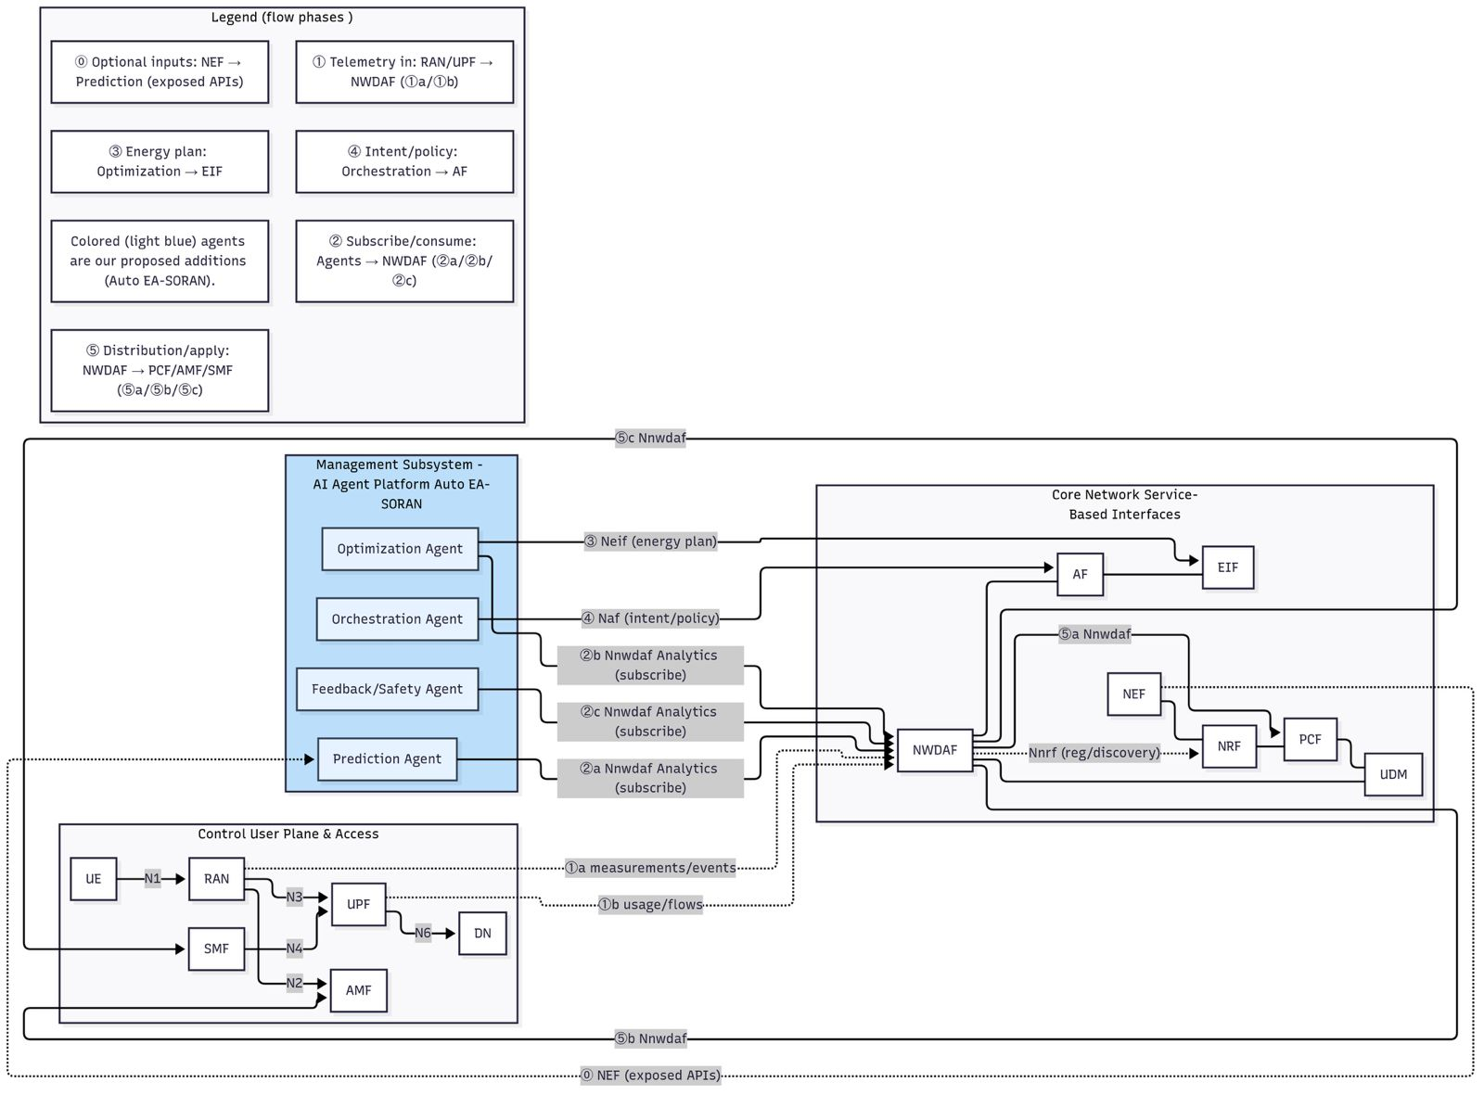
- Current Status & Demo Proposal
Our project, “Autonomous Energy Aware Self Optimizing RAN,” will culminate in a demonstration of a complete, closed-loop optimization cycle within the simulated 5G network. The demonstration will visualize the following sequence:
- The system observes the network state in Simu5G (e.g., PRB utilization, active user count).
- The Prediction Agent forecasts future traffic and energy consumption.
- The Optimization Agent proposes a specific energy-saving action (e.g., "transition gNB-3 into state_micro_sleep").
- The Feedback Agent validates that this action will not violate the predefined QoS policies for active users.
- The Orchestration Agent successfully transmits and executes the command within the Simu5G environment.
- The results will be shown via the simulation's output vectors and scalars, illustrating a measurable decrease in the target gNB's power draw while maintaining stable user throughput. A comparative analysis against a baseline (unoptimized) simulation run will be presented to quantitatively demonstrate the percentage of energy saved.

Submission Id | FG-AINN-PoC-xxx  (Id number is to be assigned by the secretariat)
PoC Objective | In this Build-a-thon proposal, we aim to study AI-native, closed-loop energy optimization for 5G base stations using a prediction → optimization → feedback→ actuation cycle inside Simu5G.  Specifically, we will demonstrate:  - a Prediction Agent that forecasts short-horizon traffic and energy,  - an Optimization Agent that selects an energy-saving action (e.g., TX-power trim, carrier off, micro/deep sleep) under QoS guard-rails,  - a Feedback/Safety Agent that validates and can roll back actions, and  - an Orchestration Agent that executes the command in Simu5G via a low-latency socket.  At this point, we hypothesize that this closed loop will deliver ≥15–25% energy reduction on targeted gNBs without violating QoS (≤3% p95 throughput degradation; latency/loss within policy).
PoC Setup | In this proposal we use the Farzi project’s three CSV datasets (static, offline) plus real-time telemetry from Simu5G. The three CSV files train the energy-prediction model; Simu5G feeds the trained model with live network metrics (e.g., PRB utilization, active UEs, throughput/latency) during the demo.  Model training is done using Python (scikit-learn/Keras) with engineered temporal features; SHAP provides model-level explainability.  The agents communicate with an in-simulation Orchestration Agent over ZeroMQ/TCP; energy is measured via a state-based gNB consumer (active / micro-sleep / deep-sleep) that depends on PRB utilization.
PoC demo and Success Criteria | The following scenarios would be demonstrated:  - Closed-loop saving: the system predicts a low-load window and executes an action (e.g., “gNB-3 → micro_sleep” or “ΔP = −2 dB”); vectors/scalars show lower power while UE throughput remains within policy.  - Intent-to-policy orchestration: an operator intent such as “minimize energy with p95 UE throughput ≥ X and latency ≤ Y” is translated to policies; when conditions are met, an energy action is applied and logged with an explanation trace.  - Safety & rollback: if post-actuation KPIs breach guard-rails, the Feedback Agent auto-reverts to the last safe configuration and records the event.
PoC Plan and Report | Stage-1: Demo proposal by September 07, 2025  Stage-2: Implementation proposal and test cases by September 15, 2025  Stage-3: Initial implementation by September 30, 2025  Stage-4: Final demo and report in FG AINN template by October 9, 2025
Created by | Team: NoWiresAttached  Team lead: Ms. Tarunika D.  Team members:  1.Mr. Anirudh Nishtala  2.Mr. Rishiraj Rakesh Kumar  3.Ms. Sreelakshmi Anil  Internal guide: Asst. Prof. Dr. Shweta Singh
Creation date | 05 September 2025
Open problems and future study | While our current proof-of-concept demonstrates prediction and autonomous self-optimization through explainable AI and lightweight agents, several open challenges remain for further research and deployment at scale:  - Multi-cell coordination: energy savings with HO/load-balancing awareness across clusters.  - Real-time constraints: tighter inference/optimization deadlines and jitter control on commodity edge hardware.  - Policy richness: extend guard-rails to include SLA tiers, slice-specific constraints, and time-of-day pricing signals.  - Model drift & continual learning: handle seasonality and traffic shifts; evaluate federated/online learning.  - Wider actuator set: PA bias control, beam/PRB budgeting, scheduler knobs; safety proofs for each.  - Standards alignment: map to O-RAN E2 control (near-RT RIC xApps) for field portability.  - Adversarial robustness: spoofed telemetry/conflicting intents; formal verification of rollback logic.  These open problems provide an opportunity for iterative enhancement of our framework toward a production-ready, standard-compliant AI-Native self-optimizing system suitable for the energy conservation of 5G Base Stations.
References | [1] “A Calibrated and Automated Simulator for Innovations in 5G,” arXiv, 2024.  https://arxiv.org/html/2404.10643v1  [2] “Scalable Real-Time Emulation of 5G Networks With Simu5G,” ResearchGate, n.d.  https://www.researchgate.net/publication/355690617  [3] “Detailed Explanation on 5G Simulation: Parameters • Model • Indicators,” OMNeT++ Tutorial, n.d.  https://omnet-tutorial.com/5g-simulation/  [4] “Scalable Real-Time Emulation of 5G Networks With Simu5G,” SciSpace (PDF), n.d.  https://scispace.com/pdf/scalable-real-time-emulation-of-5g-networks-with-simu5g-2mv2rbff4t.pdf  [5] “5G-Energy-Consumption-Modelling-Solution — Team Farzi Data Scientists,” GitHub (ITU AI/ML in 5G Challenge), n.d.  https://github.com/ITU-AI-ML-in-5G-Challenge/5G-Energy-Consumption-Modelling-Solution-Team-Farzi-Data-Scientists  [6] “How to Implement 5G Network Simulator Projects (Guide),” Network Simulation Tools, n.d.  https://networksimulationtools.com/5g-network-simulator/  [7] “A Survey on Green Enablers: A Study on the Energy Efficiency of AI-Based 5G Networks,” MDPI (Sensors), 2024.  https://www.mdpi.com/1424-8220/24/14/4609  [8] “Overview — Simu5G: Simulator for 5G New Radio Networks,” Simu5G Users’ Guide, n.d.  https://simu5g.org/users-guide/overview  [9] “Running Simu5G as a Real-Time Network Emulator,” Simu5G Users’ Guide, n.d.  https://simu5g.org/users-guide/emulation  [10] “Simu5G: A System-level Simulator for 5G Networks,” SciTePress (PDF), 2020.  https://www.scitepress.org/Papers/2020/98264/98264.pdf  [11] “Simu5G: Simulator for 5G New Radio Networks,” Project site, n.d.  https://simu5g.org/  [12] “Modeling Power Consumption,” INET 4.5.4 Documentation, n.d.  https://inet.omnetpp.org/docs/users-guide/ch-power.html  [13] L. M. Feeney, “An Extensible Framework for Simulating Battery Consumption in Wireless Networks,” n.d.  https://sonri.org/publications/Files/omnet10energy.pdf  [14] “How to Calculate Network Energy Utilization in OMNeT++,” OMNeT++ Manual (community), n.d.  https://omnet-manual.com/how-to-calculate-network-energy-utilization-in-omnet/  [15] “AI-based Energy Consumption Modeling of 5G Base Stations: An Energy-Efficient Approach,” figshare (conference contribution), n.d.  https://sussex.figshare.com/articles/conference_contribution/AI-based_energy_consumption_modeling_of_5G_base_stations_an_energy_efficient_approach/26394829  [16] “Modeling of IoT Devices Energy Consumption in 5G Networks,” mediaTUM (PDF), n.d.  https://mediatum.ub.tum.de/doc/1705687/55ahjo0udp2jr6z1159ilkwbr.Modelling_energy_consumption_of_IoT_devices_in_5G_network.pdf  [17] “Energy Efficiency for 5G and Beyond 5G: Potential, Limitations, and Future Directions,” MDPI (Sensors), 2024.  https://www.mdpi.com/1424-8220/24/22/7402  [18] “Energy Consumption Modelling for 5G Radio Base Stations with Machine Learning,” Lund University Publications (PDF), n.d.  https://lup.lub.lu.se/student-papers/record/9133984/file/9133985.pdf  [19] “BaseStationStatsCollector,” Simu5G NED Documentation, n.d.  https://simu5g.org/neddoc/simu5g.corenetwork.statsCollector.BaseStationStatsCollector.html  [20] “Packages — Simu5G,” Simu5G NED Documentation, n.d.  https://simu5g.org/neddoc/packages.html  [21] “OMNeT++ 5G Thesis Ideas,” PHD Services, n.d.  https://phdservices.org/omnet-5g/  [22] “New Radio Tutorial — Simu5G,” Tutorial docs, n.d.  https://simu5g.org/tutorials/NR/doc/index  [23] “BackgroundScheduler,” Simu5G NED Documentation, n.d.  https://simu5g.org/neddoc/simu5g.nodes.backgroundCell.BackgroundScheduler.html  [24] “Simu5G — 5G NR and LTE/LTE-A User-Plane Simulation Model for OMNeT++ & INET,” GitHub, n.d.  https://github.com/Unipisa/Simu5G  [25] “A Network Simulator-based Method of Dynamic Traffic Generation for 5G Network Slicing,” Concordia University — Spectrum, n.d.  https://spectrum.library.concordia.ca/id/eprint/990258/1/Ding_MCompSc_df  [26] “Parameter Studies,” OMNeT++ Technical Articles — TicToc Tutorial, n.d.  https://docs.omnetpp.org/tutorials/tictoc/part7/  [27] “gNodeB,” Simu5G NED Documentation, n.d.  https://simu5g.org/neddoc/simu5g.nodes.NR.gNodeB.html  [28] “OMNeT++ — Simulation Manual,” Omnetpp.org, 2025.  https://doc.omnetpp.org/omnetpp5/manual/  [29] “OMNeT++ Simulation Library: cSimpleModule Class Reference,” Omnetpp.org (API v4), n.d.  https://doc.omnetpp.org/omnetpp4/api/classcSimpleModule.html  [30] “Simu5G: A System-level Simulator for 5G Networks,” ARPI (PDF),  https://arpi.unipi.it/retrieve/handle/11568/1039566/609208/SIMULTECH_2020.pdf  [31] “Simu5G – An OMNeT++ Library for End-to-End Performance Evaluation of 5G Networks,” ARPI (PDF), 2020.  https://arpi.unipi.it/bitstream/11568/1053174/2/2020%20Access.pdf  [32] “Steps to Implement Network Energy Management in OMNeT++,” OMNeT++ Manual (community), n.d.  https://omnet-manual.com/how-to-implement-network-energy-management-in-omnet/  [33] “Energy Efficiency (EE) SA5 Work and Results,” 3GPP, n.d.  https://www.3gpp.org/technologies/energy-efficiency-ee-sa5-work-and-results  [34] “5G and Energy Efficiency,” 5G-PPP Standards Tracker (booklet), n.d.  https://standards-tracker.5g-ppp.eu/sites/default/files/BookletA4_EnergyEfficiency.pdf  [35] “A Comparison Analysis of 5G Key Performance Indicators Based on Entropy,” ResearchGate (PDF), n.d.  https://www.researchgate.net/publication/386292921  [36] “Main Modules of the Simu5G Model Library (figure),” ResearchGate — Scientific Diagram, n.d.  https://www.researchgate.net/figure/Main-modules-of-the-Simu5G-model-library_fig3344434106  [37] “SDAP-based QoS Flow Multiplexing Support in Simu5G for 5G NR Simulation,” arXiv, 2025.  https://arxiv.org/html/2508.12785v1

6. Implementation proposal (Build-a-thon Stage-2 proposal)

This clause describes the implementation proposal for the submission above. Implementation is done in the following phases. Phase-1 includes preparation and demo of the test setup. Phase-2 includes a demo of (opensource) base code in as-is-where-is condition. Phase-3 includes modification of the base code and test setup to suit the requirements of the demo mentioned in clause-1. Phase-4 includes a documentation of results corresponding to the test cases executed.

6.a) Description of the test setup
The demo instantiates an AI-native, closed-loop control system integrated with Simu5G. Four agents—Prediction, Optimization, Feedback, and Orchestration—exchange messages over a ZeroMQ socket with an in-simulation orchestration proxy to apply actions on the gNB at runtime. Simu5G serves as a high-fidelity digital twin of the 5G RAN; energy is modelled via discrete states (active / micro-sleep / deep-sleep) with active power tied to PRB utilization.
The test setup involves the following:
- Code generation model from:
OpenAI API (LLM). The Optimization Agent uses an LLM to draft structured plan objects (e.g., ΔP = −2 dB on gNB-k, enter micro_sleep, deactivate one CC), which are then checked against policy guard-rails by the Feedback Agent before actuation.
- Service orchestrator from:
In-simulation Orchestration Agent (C++ in Simu5G) with a thin Python client over ZeroMQ.
The Python side sends validated actions; the C++ Orchestration Agent receives, parses, and applies them by updating gNB parameters or triggering state transitions during the run (e.g., txPower, sleep-mode entry, carrier on/off).
- Agent framework from:
Lightweight Python services (Prediction → Optimization → Feedback → Orchestration) communicating via ZeroMQ/TCP.
A brokerless, asynchronous IPC ensures low-latency state→decision→actuation, avoiding stale decisions typical with file-based exchange.
- Simulator from:
Simu5G (OMNeT++/INET).
Simu5G acts as the controllable digital twin. We couple a state-based gNB energy model to real-time PRB activity so that power reflects load; vectors/scalars are recorded for post-run analysis.
- Datasets from:
Farzi project CSVs (offline training) + live telemetry from Simu5G (runtime).
Three CSV files train the Prediction Agent; at demo time, Simu5G streams PRB utilization, active UEs, and throughput/latency as features to the agents. Model training uses Python with engineered temporal features; SHAP provides explainability.

The following figure shows the pipeline of control in the test setup:-

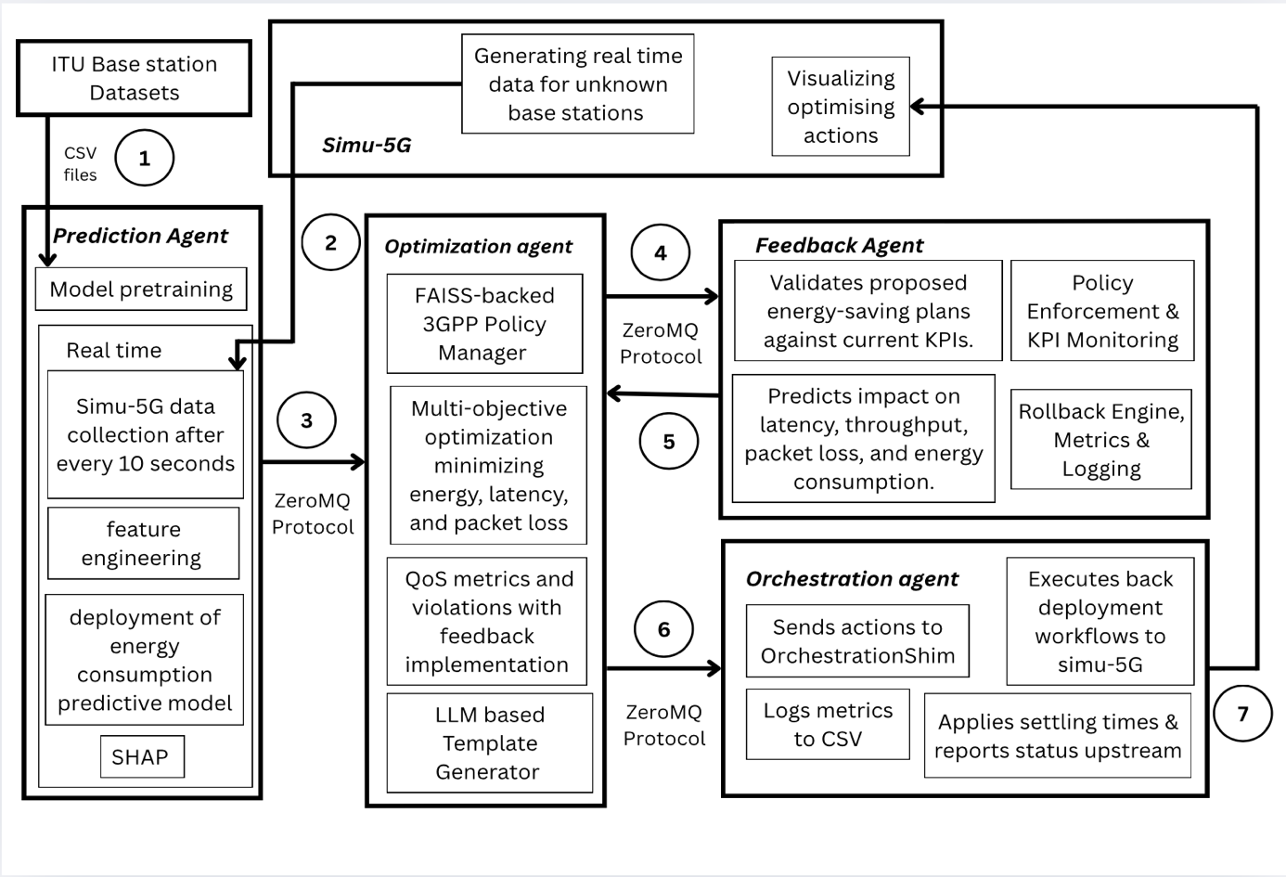

The sequence diagram for the above pipeline is as follows:-

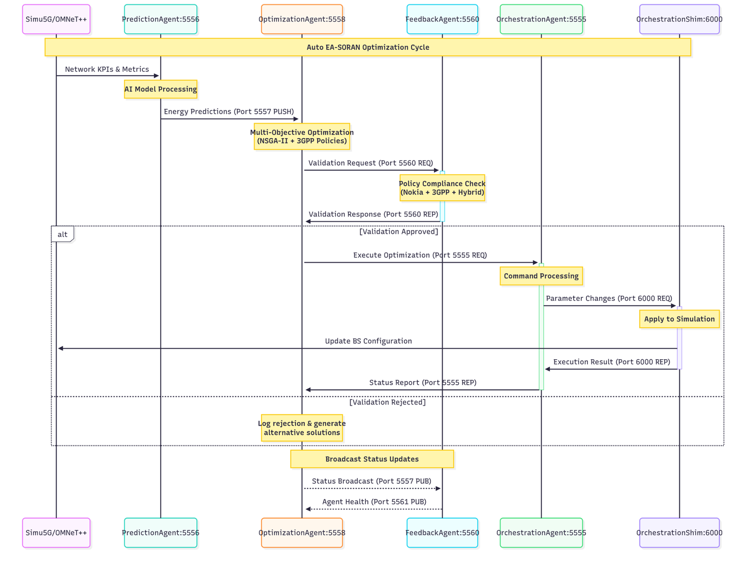

6.b) Description & reference to base code
The base code is used from:
GitHub (Team Farzi): ITU-AI-ML-in-5G-Challenge / 5G-Energy-Consumption-Modelling-Solution-Team-Farzi-Data-Scientists — final Keras ANN with feature engineering, CV strategy, and SHAP analysis.
The complete code for Autonomous Energy Aware Self Optimizing RAN, built on top of their work can be found on our GitHub (link)
It has the following components:
- Keras ANN final model (tabular regression) with embeddings for categorical features and dense layers for continuous features; SiLU/Swish activation; trained with MAE/MAPE/WMAPE focus.
- Feature engineering pipeline: time-stamp features (day/weekday/hour + periodic spline basis), lagged features (T-1/T-2/T-3 for load/ESModes/Energy), binned load, and signal-processed load (Savitzky–Golay and SOS Butterworth filters) — strictly no future data.
- Cross-validation: GroupKFold over base-station IDs to enforce generalization to unseen BS/products/configs.
- Explainability: SHAP analyses for existing vs new base stations.
- Reproducible training environment (Kaggle GPU; pinned libs/versions; notebooks and submission artefacts).
Of these, the following are important for the demo:
- The Keras ANN predictor (selected as final in Farzi’s solution due to best cross-val and leaderboard performance) to estimate gNB energy from live features.
- The feature set definition (hourly temporal features, lags, load transforms) that we map to Simu5G telemetry for real-time inference.
- The no-future-values discipline to keep the closed loop causal.
- SHAP for quick sanity checks on actionability during dry-runs.
The following are used as is:
- Model architecture & loss/metrics: Keras ANN with embedding + dense stacks; MAE/MAPE tracking; WMAPE context retained for comparability.
- Core feature engineering logic: hour/weekday/periodic splines; lagged features; binned load; SG/SOS filters (implemented exactly as in the base write-up).
- GroupKFold generalization approach for any offline re-training runs.
The following are changed as below:
- I/O & runtime integration: Replaced file/CSV exchange from the notebooks with ZeroMQ message passing between Prediction → Optimization → Feedback → Orchestration agents and Simu5G; the predictor now runs as a long-lived Python service. (Reason: low-latency, brokerless IPC for closed-loop control.)
- Feature availability mapping: Limited the online feature set to those emitted by Simu5G at 1-hour/short-horizon cadence (e.g., PRB utilization, active UEs, ES mode counters, config params). Engineered features (splines, lags, filters) are computed on the fly inside the Prediction Agent from these inputs. (Reason: align with simulator telemetry; preserve “no future values”.)
- Model packaging: Exported the trained Keras weights and standardization/encoding artefacts for deterministic inference; added a small wrapper to load artefacts at agent start and to expose a predict(features_json) endpoint over ZMQ. (Reason: productionize for the demo run.)
- Explainability scope: Kept SHAP offline (optional) for debugging, not in the real-time loop. (Reason: compute cost at runtime; Farzi notes SHAP for ANN is heavy.)
- Environment: We retained Farzi’s pinned library versions for any re-training, but inference runs in our project’s Python env (no Kaggle dependency). (Reason: portability to the agent stack.)

The justification for the change are as below:
- Latency & causality: A control loop needs fresh state → decision → actuation; ZMQ sockets eliminate file-polling delays inherent to CSV pipelines.
- Telemetry-driven features: Computing lags/splines/filters in-agent ensures strict “no future data” while matching Simu5G’s live signals.
- Operational robustness: Packaging the model + scalers avoids training-time environment coupling (Kaggle) while keeping Farzi’s reproducibility for offline runs.
- Clarity & safety: Keeping SHAP offline preserves demo performance while still enabling traceability during pre-runs.
6.c Mapping to the demo proposal
This section maps the demo’s functional/performance requirements, datasets, toolsets, and test cases to the proposal’s clauses:
- Architectural baseline: Closed-loop four-agent system (Prediction → Optimization → Feedback → Orchestration) with Simu5G as a high-fidelity digital twin; ZeroMQ is the IPC between Python agents and the C++ simulation.
- Energy model: Custom state-based gNB energy model (active / micro-sleep / deep-sleep) with active power coupled to PRB utilization.
- Demo flow & success signal: Observe state → predict → optimize → validate → actuate; show lower gNB power with QoS within policy and compare to a baseline run.

Functional requirements (mapped)
Req-1 (critical): Low-latency simulator–agent integration.
A socketed interface (ZeroMQ/TCP) must be integrated between Simu5G and the agents, so decisions are based on fresh state (file polling is not acceptable). Rationale: predictive closed loop requires tight latency/jitter bounds.
Req-2 (expected): Policy-guarded actions.
The Feedback Agent must validate every proposed plan against 3GPP-aligned throughput/latency guard-rails before actuation; unsafe plans are revised or rejected.
Req-3 (added value): Non-disruptive orchestration.
In-simulation Orchestration Agent applies TX-power trims, sleep-state transitions, or carrier on/off without destabilizing UE KPIs, with automatic rollback if guard-rails are breached.

Performance requirements:
- Demonstrate ≥15–25% energy reduction on targeted gNBs with QoS within policy (≤3% p95 throughput degradation; latency/loss within limits), compared against an unoptimized baseline.
- Log vectors/scalars to evidence power draw decrease and stable throughput and present a baseline vs. optimized comparison.

Datasets used:
- Training (offline): The three Farzi CSV datasets — BS info, Cell-level (hourly), Energy consumption.
- Runtime (online): Live Simu5G telemetry (PRB utilization, active UEs, throughput/latency) streamed to the Prediction Agent.

Toolsets:
- Simu5G (OMNeT++/INET) as the digital twin with extended INET Energy Framework for the gNB power model.
- ZeroMQ libraries for C++ (simulation) and Python (agents) to ensure brokerless, asynchronous IPC.
- Python (Keras) for the ANN predictor adopted from Team Farzi; SHAP for offline explainability.

Test cases corresponding to the requirements:
TST-1 — Closed-loop energy saving
Trigger: Configure a low-load window; agents run the loop.
Expected result: Action (e.g., “gNB-k → micro_sleep” or “ΔP = −2 dB”) is executed; power vectors decrease while UE throughput remains within policy. Evidence via Simu5G vectors/scalars and before/after comparison.
TST-2 — Intent-to-policy orchestration
Trigger: Operator intent: “minimize energy with p95 throughput ≥ X and latency ≤ Y.”
Expected result: Intent is translated to policies; when conditions are satisfied, an energy action is applied; an explanation trace and policy checks are logged.
TST-3 — Safety & rollback
Trigger: After an action, KPIs breach guard-rails.
Expected result: Feedback Agent auto-reverts to last safe configuration; event is recorded; KPIs stabilize.
TST-4 — IPC robustness
Trigger: Increase agent–sim exchange rate; introduce jitter.
Expected result: ZeroMQ channel sustains low-latency exchanges without stale state; closed-loop remains stable (no oscillations).
TST-5 — Policy conformance under stress
Trigger: Spike traffic to push PRB%; propose aggressive power trim.
Expected result: Feedback rejects or down-scales action; QoS guard-rails maintained.
TST-6 — Baseline vs. optimized report
Trigger: Run baseline (no control) and optimized (closed loop) with identical seeds.
Expected result: Report shows ≥15–25% energy reduction with QoS within limits; include vectors/scalars and KPI tables.

