**Data Used in this exploration:**

The dataset is a zip file located at:

<https://grouplens.org/datasets/movielens/20m/>

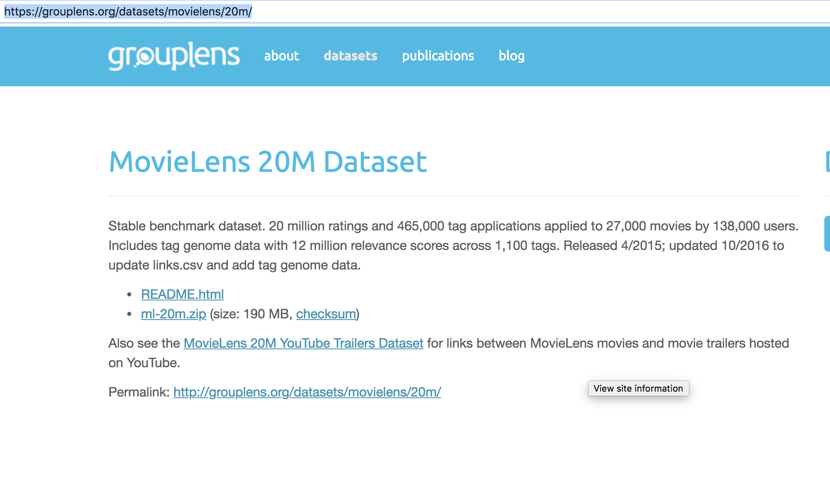

Once downloaded and opened, the files look like below:

