Project Report

1. Executive Summary
This report documents a comprehensive, end-to-end data analytics project conducted on a retail Superstore dataset. The objective was to transform raw transactional data into actionable business intelligence by executing a full-stack data pipeline.
The workflow involved data ingestion and cleaning using Python, structured data storage and complex analytical querying using MySQL Server, and the design of an interactive executive dashboard in Power BI. The final deliverables identify critical revenue drivers, highlight severe profitability leaks, and offer data-driven recommendations to optimize operational efficiency.

2. Project Architecture & Methodology
The project was executed across three distinct phases to ensure data integrity and scalable analysis:

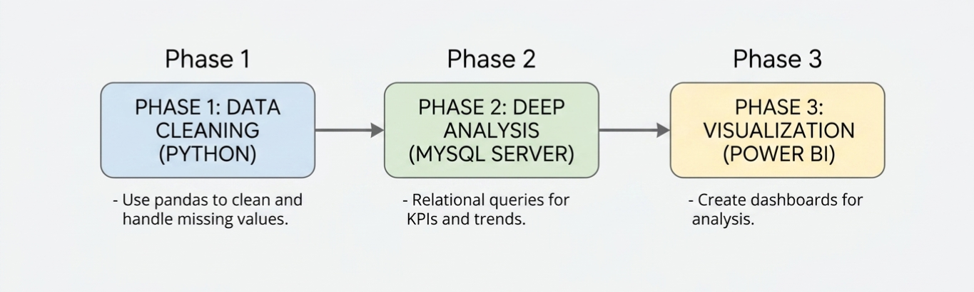

- Data Cleaning (Python): Raw data was ingested using pandas. Missing values were handled, data types (specifically dates and numerical figures) were standardized, and anomalies were filtered to create a verified baseline dataset named clean_superstore.
- Database Engineering (MySQL): The cleaned dataset was programmatically injected into a local MySQL instance using sqlalchemy and pymysql. A unified script (business_analysis.sql) was developed containing comprehensive relational queries to extract key performance indicators (KPIs), time-series trends, and segment breakdowns.
- Business Intelligence (Power BI): Explicit DAX measures were constructed to optimize computational performance. A unified, single-page executive dashboard was engineered using an analytical grid layout, enabling stakeholder data exploration through dynamic slicing.

3. Exploratory Data Analysis & SQL Insights
A script of targeted SQL queries was executed against the database to isolate core operational behaviors. Below are the structural definitions and business findings derived from this analysis:
A. High-Level Core Metrics
The baseline health of the Superstore was calculated using explicit aggregations:
- Total Revenue: $2,300,000 ($2.30M), indicating a highly robust market footprint.
- Total Net Profit: $286,400 ($286.40K), yielding an overall net profit margin of approximately 12.4%.
- Total Order Volume: 5,000 (5K) discrete transactions processed across the historical timeline.
B. Profitability Leaks by Product Sub-Category
While high-level revenue figures are strong, a granular breakdown by product sub-category revealed severe structural inefficiencies:
- Top Performers: Copiers and Phones emerged as the primary profit engines for the organization, driving the highest net margins and volume.
- The Profitability Leak: The Tables sub-category was identified as a critical deficit area. Despite generating substantial sales volume, it consistently yielded negative net profit margins, revealing that production, shipping, or heavy discounting strategies are actively destroying value.
C. Time-Series & Temporal Trends
An analysis of monthly and annual sales performance identified strong cyclical demand patterns:
- Sales and profits exhibit a clear upward trajectory year-over-year.
- A deeper look into monthly rolling totals highlighted recurring seasonal spikes, heavily concentrated in the third and fourth quarters (Q3 and Q4), aligning with corporate purchasing cycles and holiday retail surges.
D. Customer & Market Segmentation
Evaluating performance across consumer archetypes and geographic regions established clear targeting profiles:
- Segment Performance: The Consumer segment stands as the absolute anchor of the business, generating over 46% of total profitability ($134.12K). The Corporate segment follows second (~32%), while the Home Office segment contributes the least (~21%).
- Geographic Density: State-level aggregation showed that California and New York represent the highest revenue-generating territories, while states like Texas and Ohio show significant volume but compressed margins due to aggressive regional pricing structures.

4. Power BI Dashboard Design & Implementation
To bridge the gap between technical data structures and executive decision-making, an interactive dashboard was deployed on a single page using a strict hierarchical user-interface strategy.
A. Visual Layout Hierarchy
As documented in Screenshot (628).jpg, the canvas utilizes a strategic four-tier grid architecture:
- Top Navigation Banner: A prominent header clearly orienting the user (Superstore Executive Performance Dashboard).
- Left-Hand Control Sidebar: Consolidates all interactive filters to maximize real estate. Features an Order Date timeline slider, a Category dropdown, a Ship Mode dropdown, and an advanced Vertical Tile Slicer for the Region field, which utilizes clean button states to eliminate empty margin space.
- Upper Summary Cards: Three high-impact card visuals exposing the core DAX measures (Total Orders, Total Profit, and Total Sales) with automated unit scaling.
- Analytical Body Grid: Divided into two thematic rows mirroring performance dimensions:
  - Row 1 (Strategic Overview): A Donut Chart illustrating profit distribution by customer segment, a horizontal Clustered Bar Chart stack-ranking profit by sub-category, and a Line and Stacked Column Chart visualizing temporal sales and profit growth over time.
  - Row 2 (Operational Deep-Dive): A detailed Customer Matrix Grid displaying top buyers by volume, a Scatter Plot mapping the negative correlation between average discount rates and total profit, and a horizontal Bar Chart mapping total sales across top states.
B. DAX Formulation
To enforce professional development standards, data fields were decoupled from visuals, and processing was driven by explicit Data Analysis Expressions (DAX) stored within a dedicated calculations directory:
Total_sales=SUM(clean_superstore[Sales])
Total_profit=SUM(clean_superstore[profit])
Total_orders=DISTINCTCOUNT(clean_superstore[order_id])

5. Strategic Recommendations
Based on the quantitative insights uncovered throughout the Python, SQL, and Power BI pipeline phases, the following data-driven strategies are recommended for corporate implementation:
- Restructure the Tables Portfolio: Immediately review the pricing structure, supplier agreements, and fulfillment models for the Tables sub-category. Implement a strict discount ceiling on these items, as data shows high discount rates plunge this category deep into negative margins.
- Optimize Q3/Q4 Supply Chains: Reallocate inventory, warehousing capacity, and logistics resources ahead of the predictable Q3/Q4 holiday demand surges to minimize fulfillment delays and capitalize on high-volume periods.
- Deploy Targeted Consumer Campaigns: Capitalize on the high-margin nature of the Consumer segment. Allocate marketing spend toward high-value customer acquisition within California and New York, while introducing loyalty frameworks for the top 10 whale buyers identified in the customer matrix.
- Implement Automated Discount Guardrails: Use the scatter plot insights to establish strict system-level guardrails within the order management system. Cap promotional discounts at levels that maintain a positive net margin across low-performing product lines.

