Specialized Event Management System – Final Project Documentation

# Phase-1

**Project Overview**

The Specialized Event Management System is a Salesforce-based application that simplifies event organization. It manages Events → Sessions → Venues → Attendees → Payments and includes automation for RSVP confirmation, waitlist handling, payment reminders, and dashboards. The system is extended to Experience Cloud so external attendees can log in and register

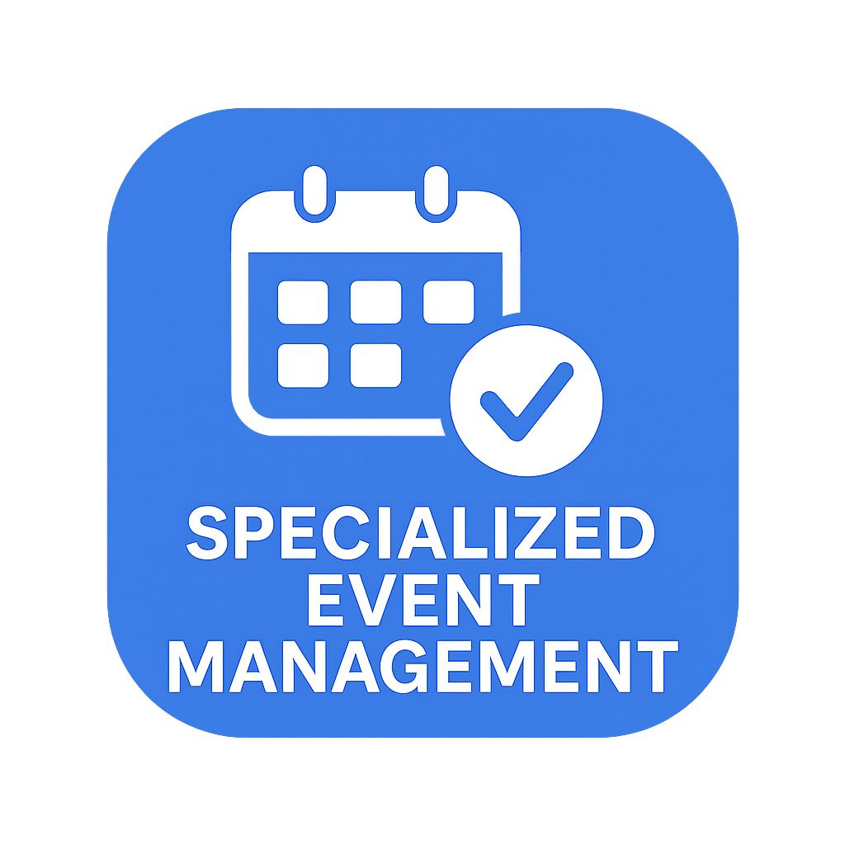

# Phase-2

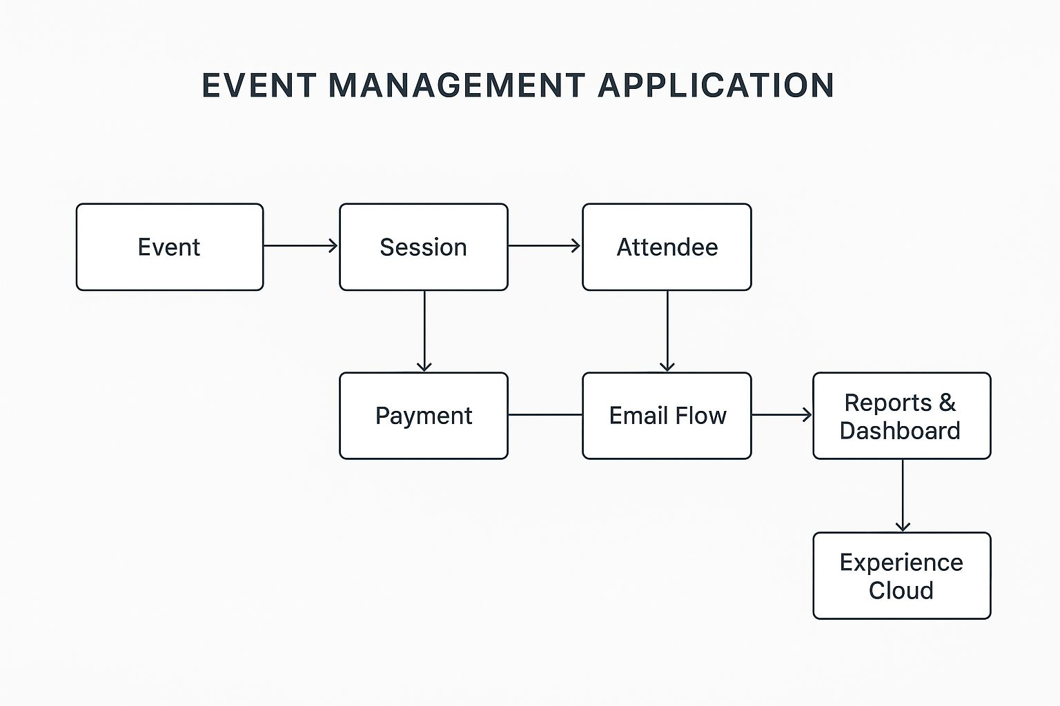

**Objectives**

- Automate event registration and attendee management.  
- Track payments and send reminders automatically.  
- Manage venue capacity and handle waitlisted attendees.  
- Provide real-time insights through reports and dashboards.  
- Offer an external portal for attendees.

**Modules Implemented**

1. Event Management – Create and track events.  
2. Session & Venue Management – Sessions linked to venues, capacity check automation.  
3. Attendee Management – RSVP flows, waitlist handling, auto-promotion.  
4. Payment Management – Track payments with reminders.  
5. Reports & Dashboards – Event summary, session attendance, payments.  
6. Experience Cloud Portal – External attendees can RSVP online.

**Automation Implemented (Flows)**

1. RSVP Confirmation Flow → Sends confirmation email.  
2. Waitlist Flow → Adds attendees to waitlist if full.  
3. Auto-Promotion Flow → Promotes waitlisted attendees when cancellations occur.  
4. Payment Reminder Flow → Sends reminder emails before due date.

**Technical Design**

- Objects Used: Event__c, Session__c, Venue__c, Attendee__c, Payment__c, Vendor__c.  
- Relationships:  
 • Event → Session (Lookup)  
 • Session → Attendee (Lookup)  
 • Session → Payment (Lookup)  
 • Session → Venue (Lookup)  
- Automation: Record-Triggered Flows, Scheduled-Triggered Flows.

**Reports & Dashboard**

- Reports Created:  
 • Attendee Count per Session.  
 • Payment Pending vs Collected.  
 • Event-Wise Attendance.  
- Dashboard:  
 • Revenue Collected vs Pending.  
 • Top Sessions by Attendance.  
 • Upcoming Payments Due.

**Security & Sharing**

- Profiles: Event Planner, Finance, Attendee Manager.  
- Permission sets for external attendees (Experience Cloud).  
- Sharing settings adjusted for Attendee & Payment objects.

**Screenshots (Demo Proof)**

📸 Add here:  
- Event Page Layout.  
- Session with Attendee list.  
- Payment Reminder Email.  
- Dashboard charts.  
- Experience Cloud RSVP page.

**Conclusion**

This Event Management System demonstrates how Salesforce can be used to digitize and automate end-to-end event workflows. It improves efficiency, ensures timely payment follow-ups, and provides clear insights for decision-making.

# Key Features

* • Event, Session, Attendee & Payment Management
* • Automated Payment Reminder Flow
* • Experience Cloud External Portal
* • Reports & Dashboards for revenue insights
* Less-code implementation with Salesforce Flow

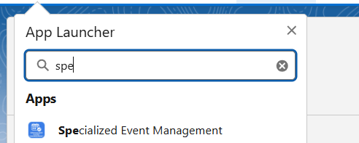p

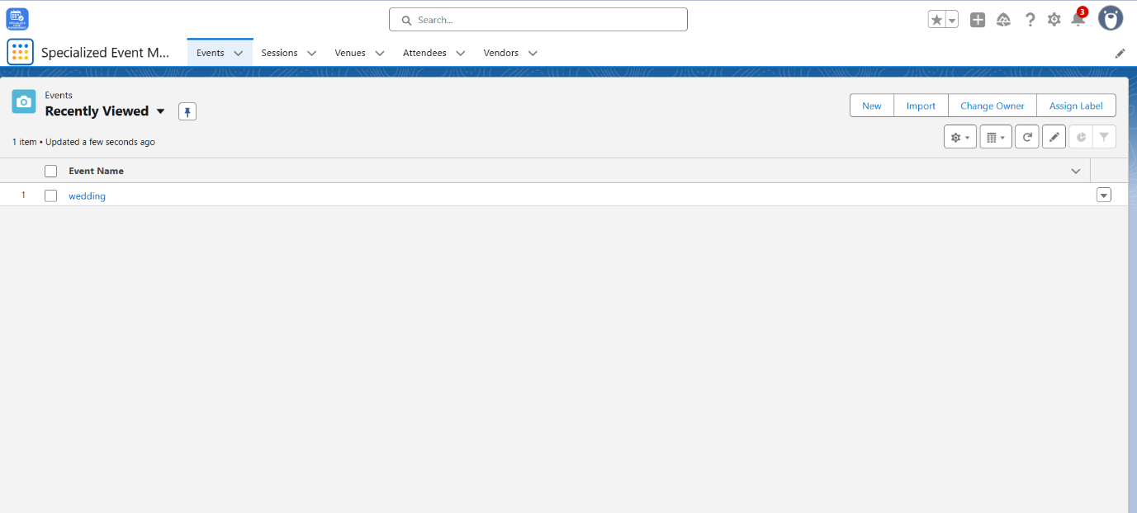

# Flow & Architecture

* • Event, Session, Attendee & Payment Management
* • Automated Payment Reminder Flow
* • Experience Cloud External Portal
* • Reports & Dashboards for revenue insights
* • No-code implementation with Salesforce Flow

# Phase-3

Custom object and dashboard

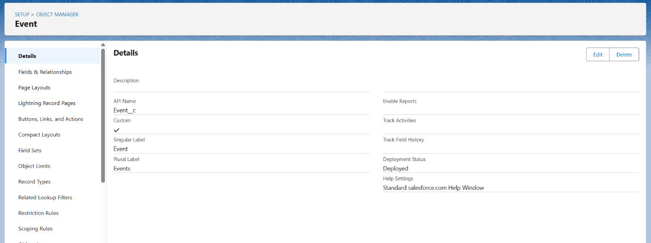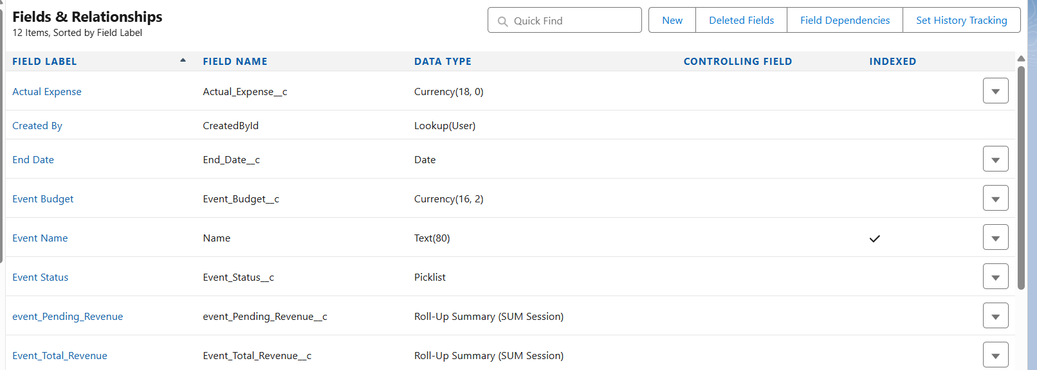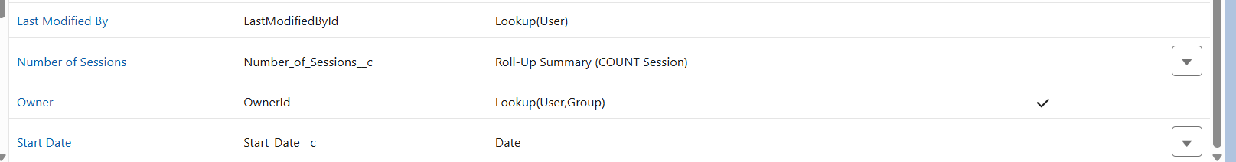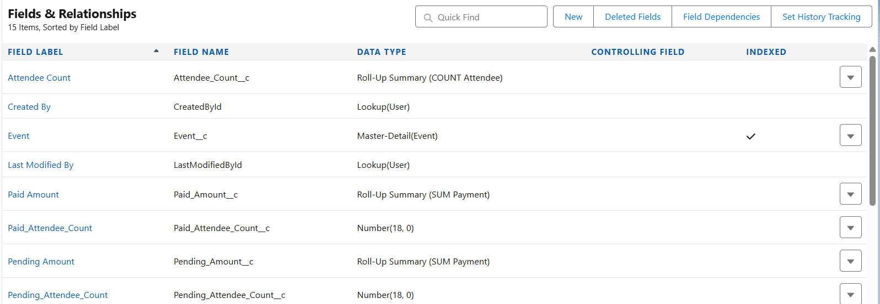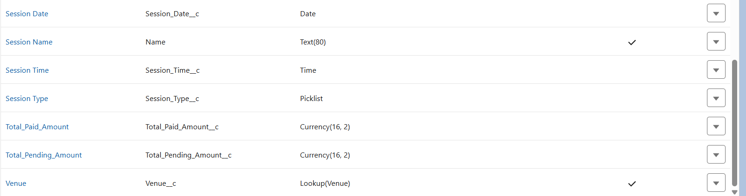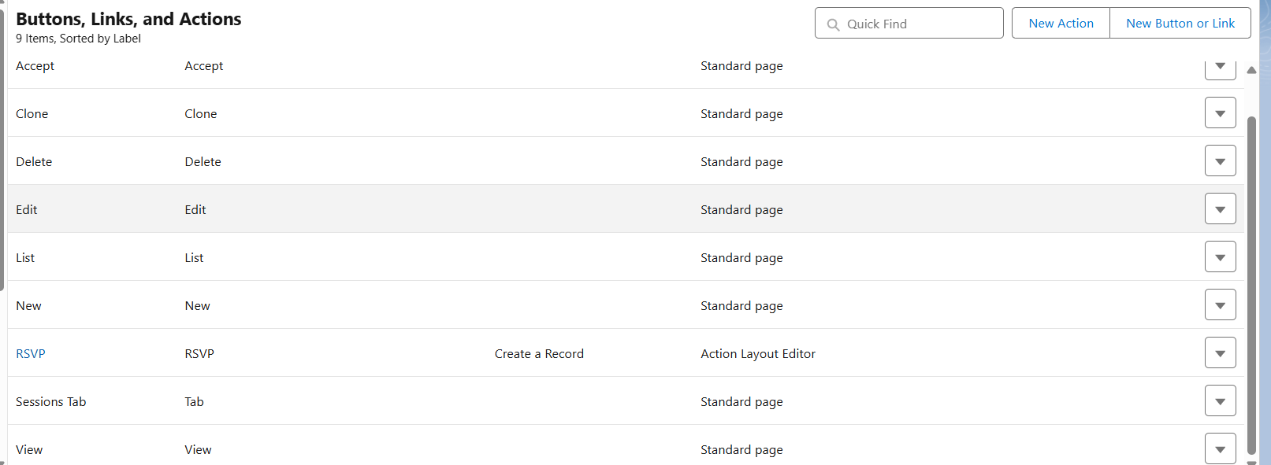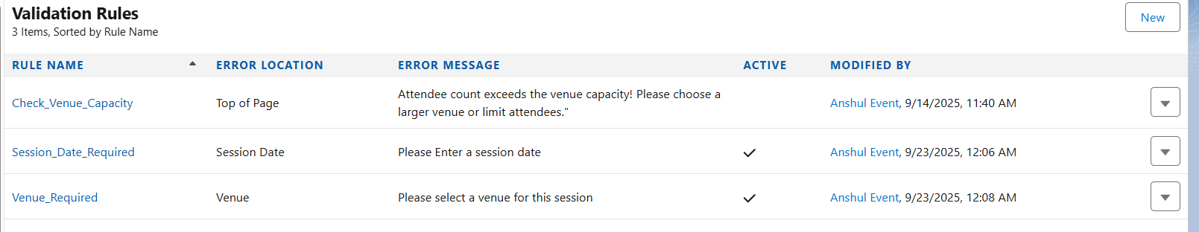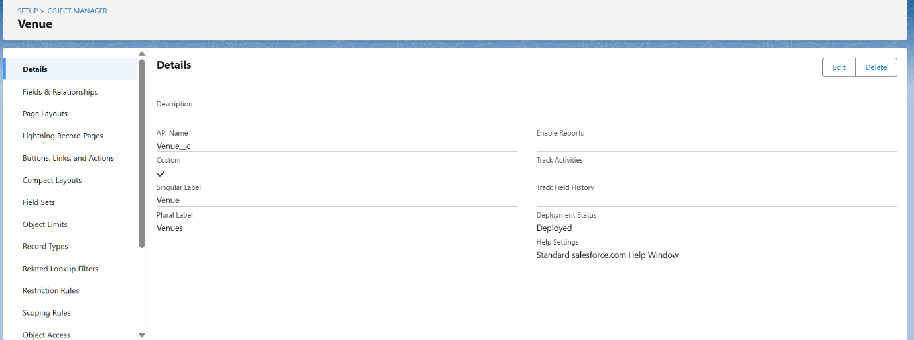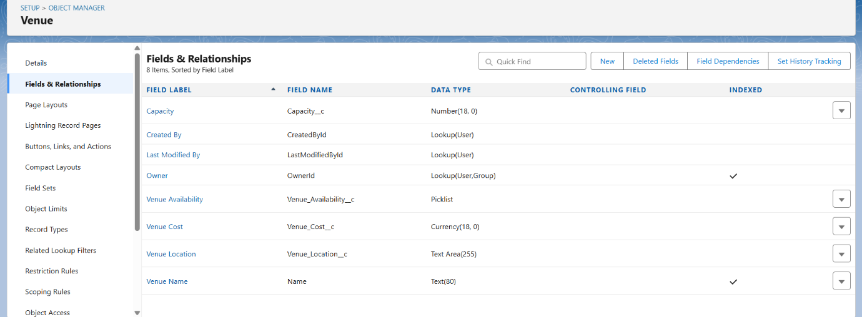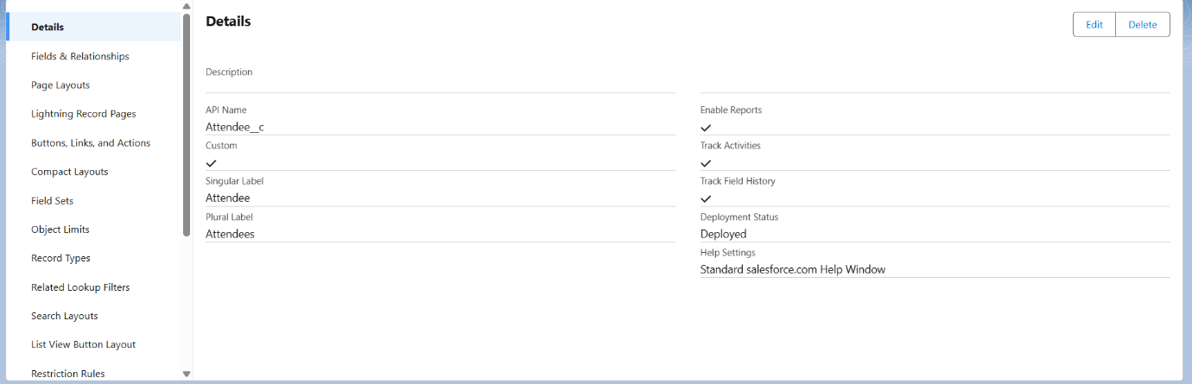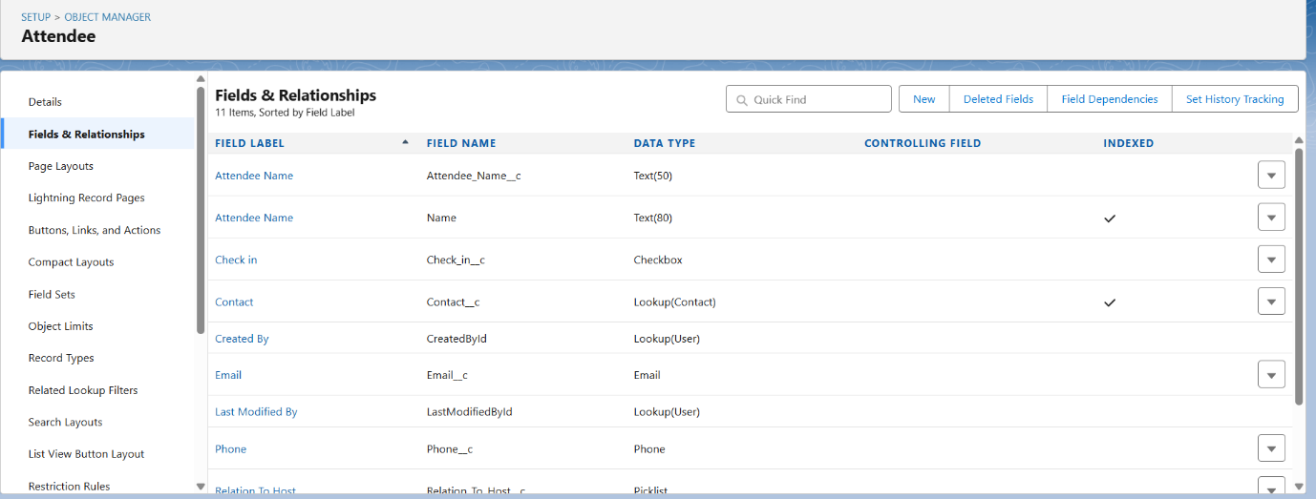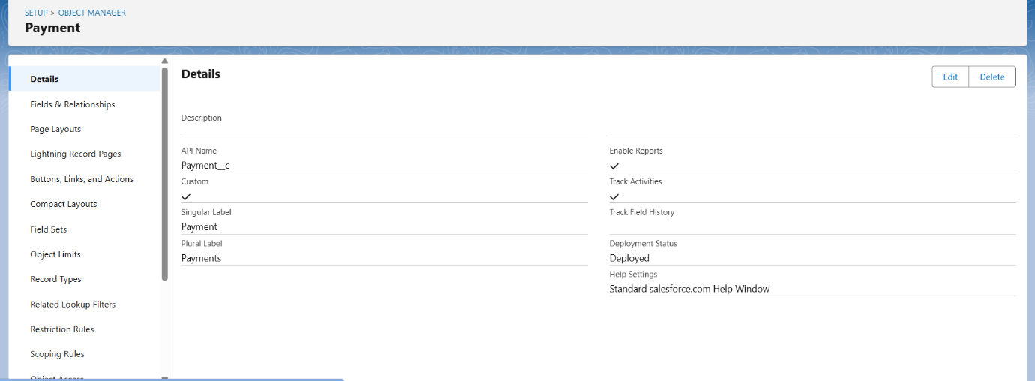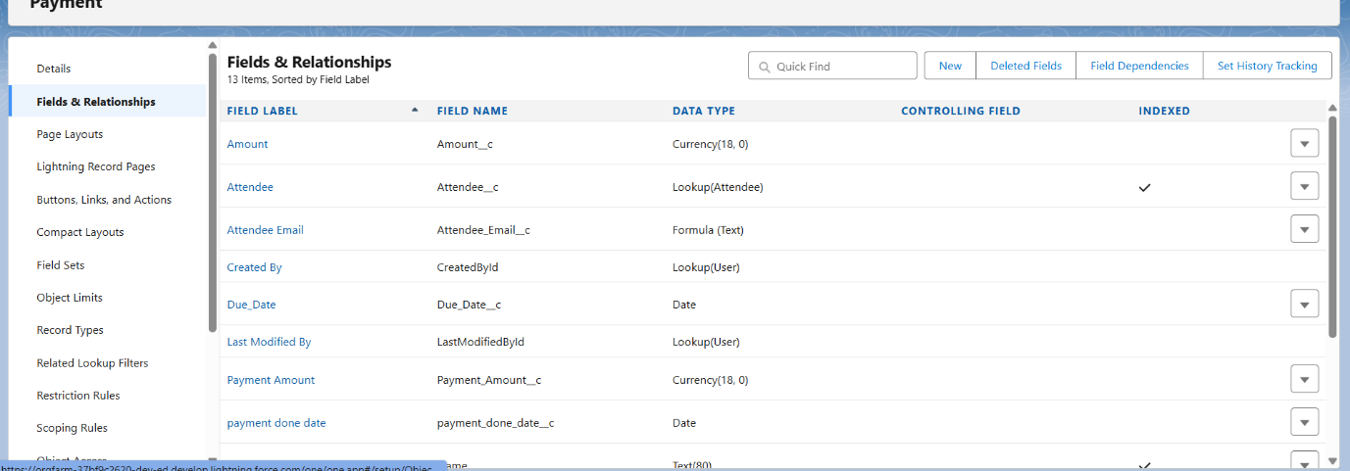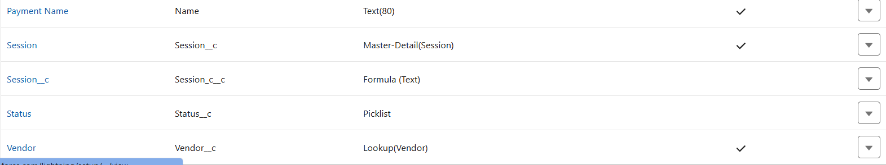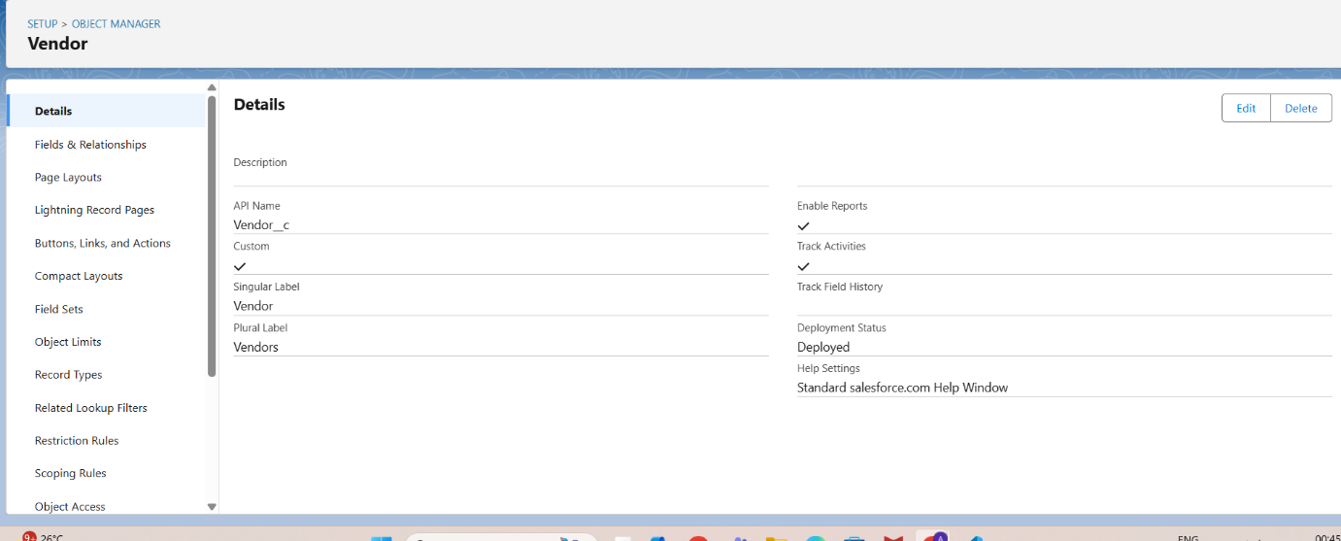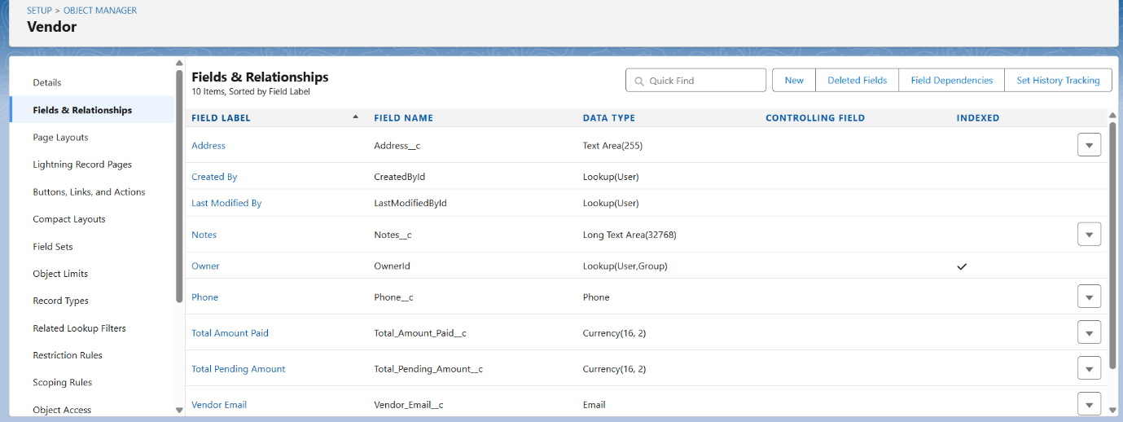



# Phase-4

Flows…

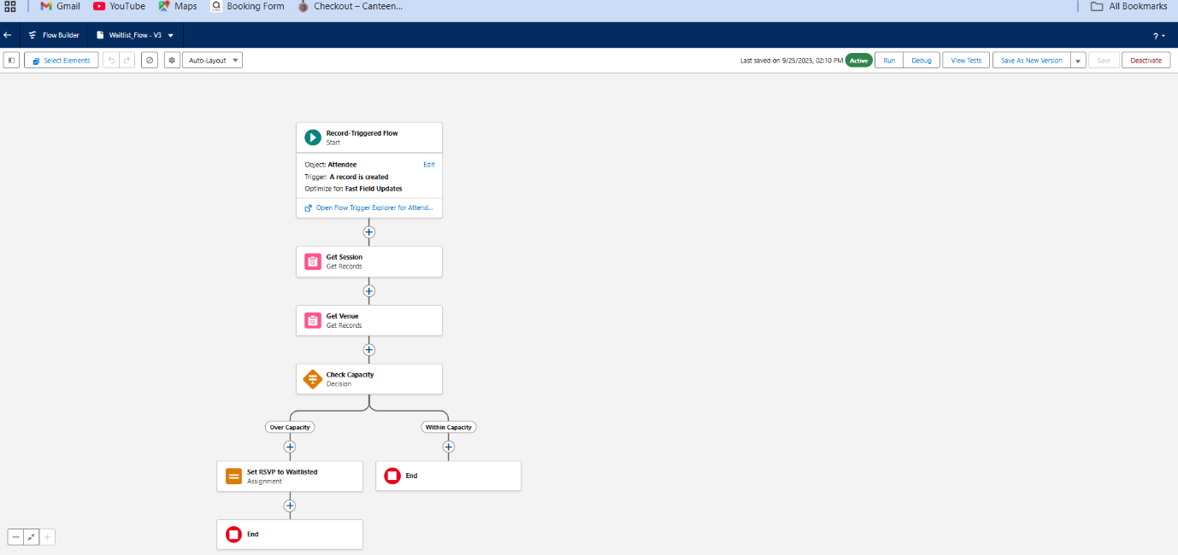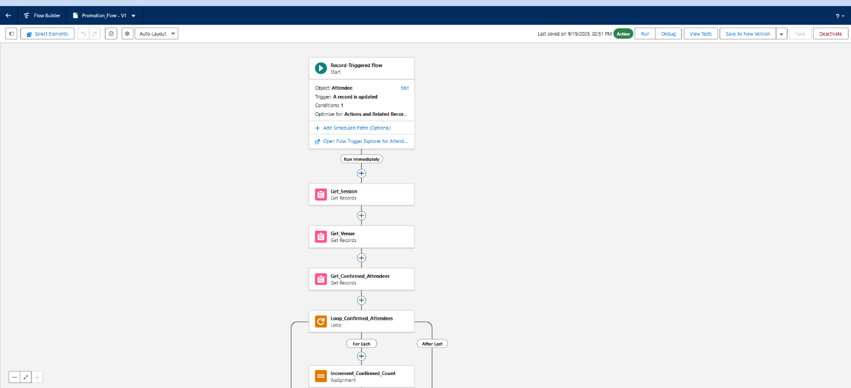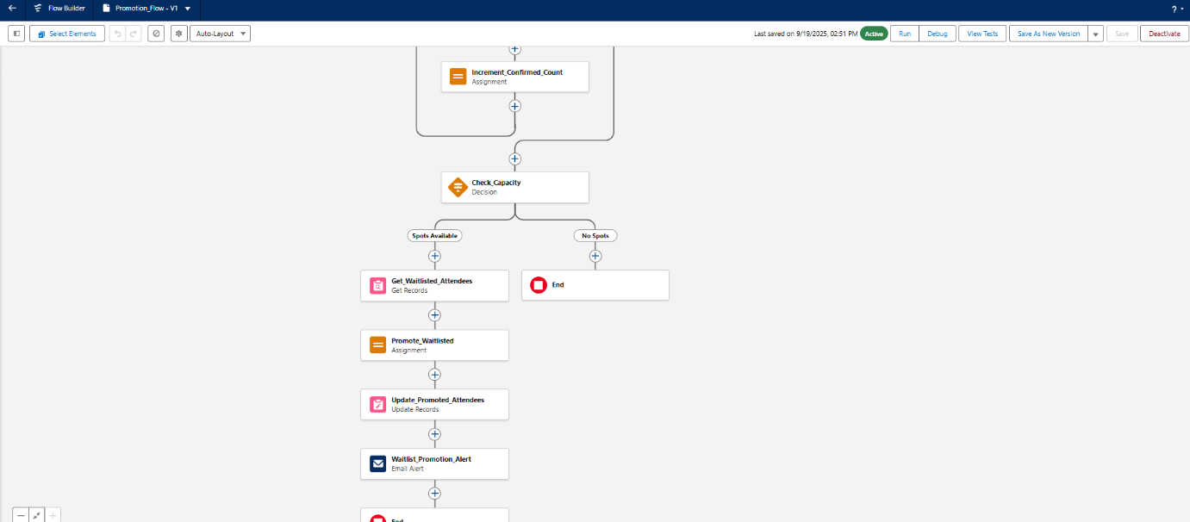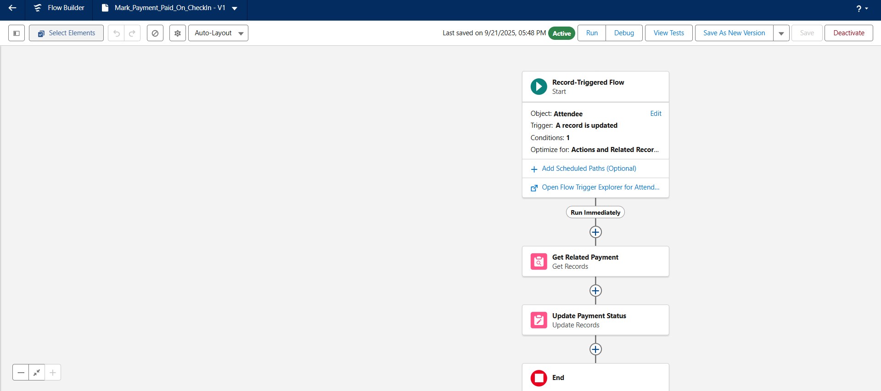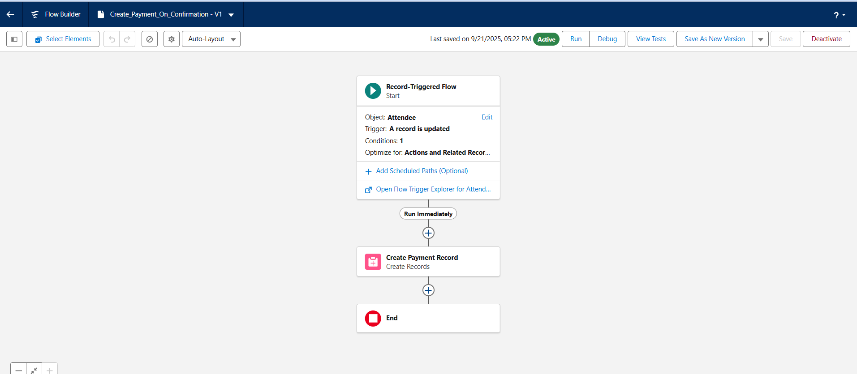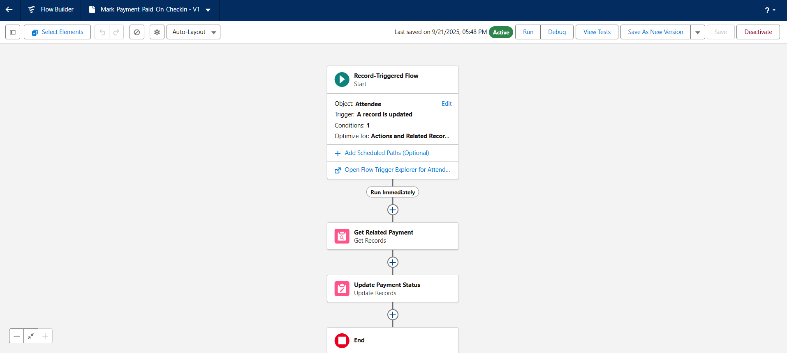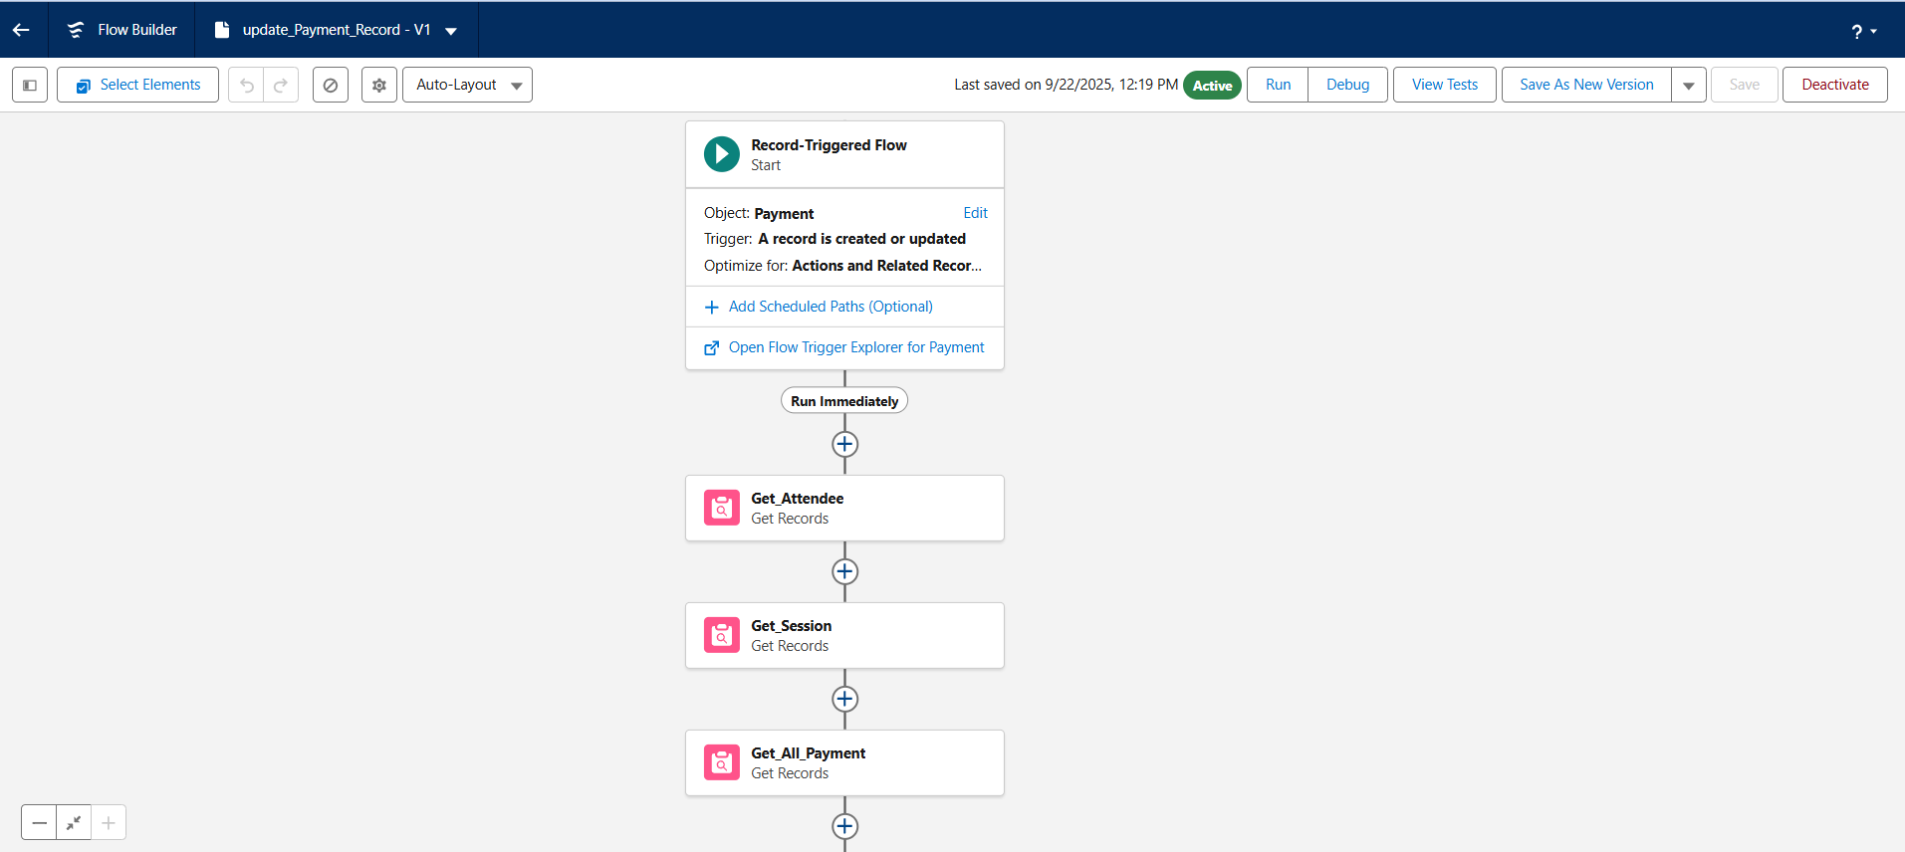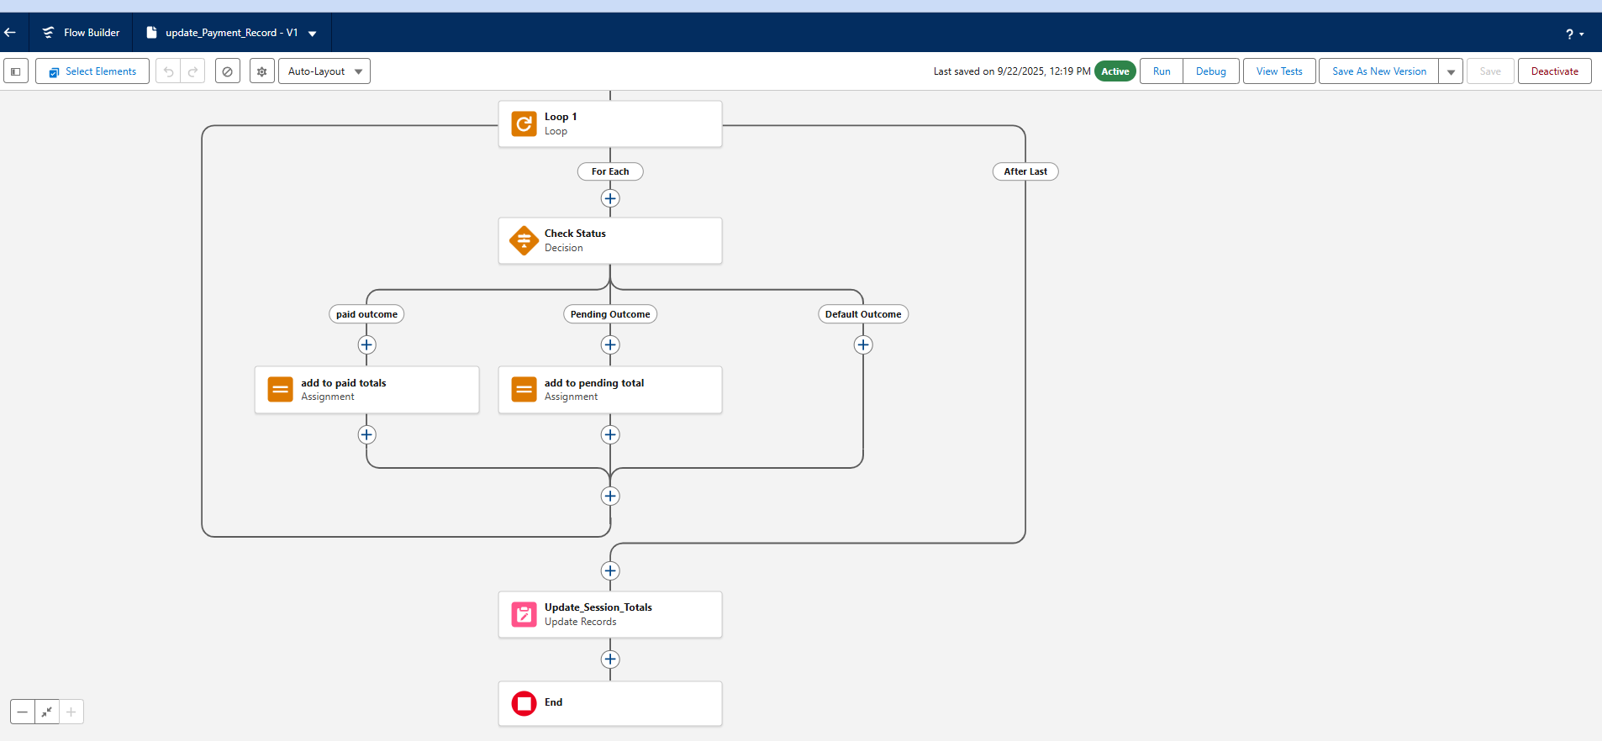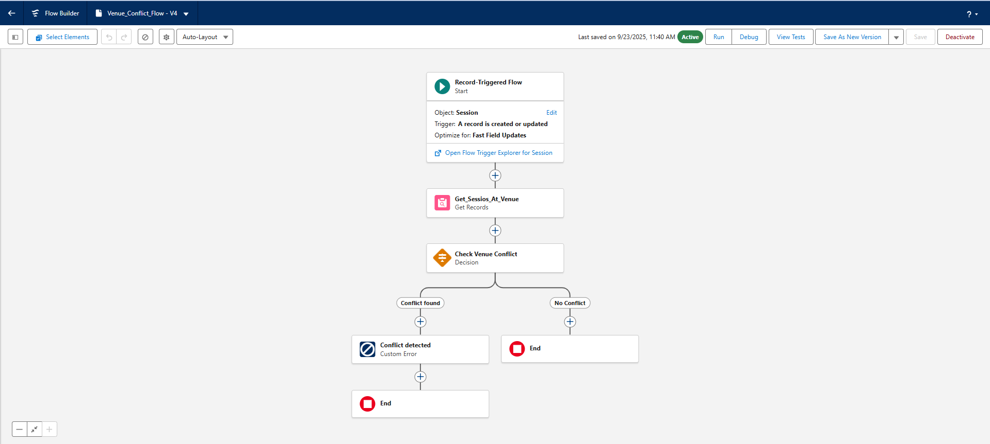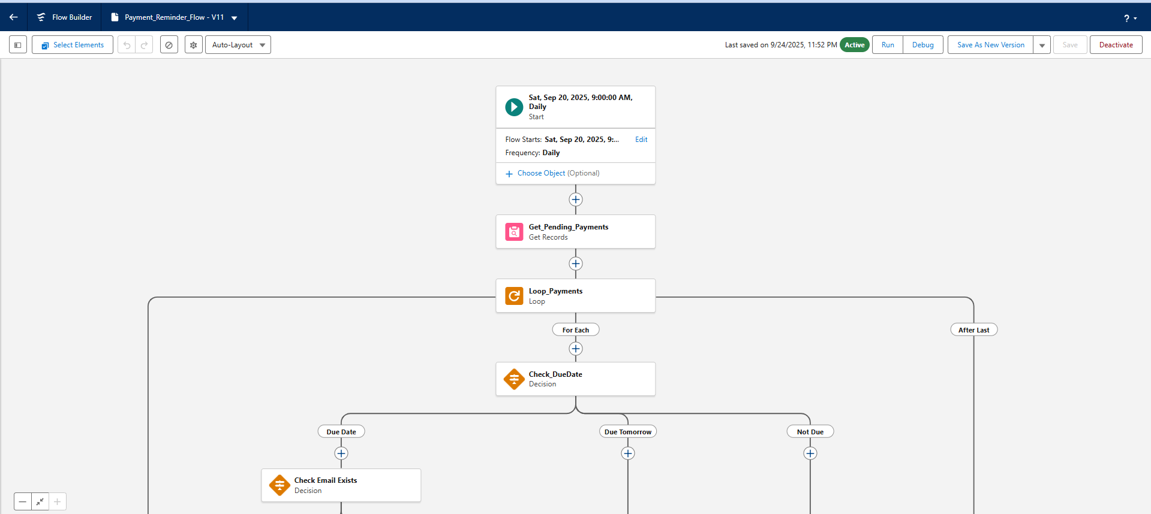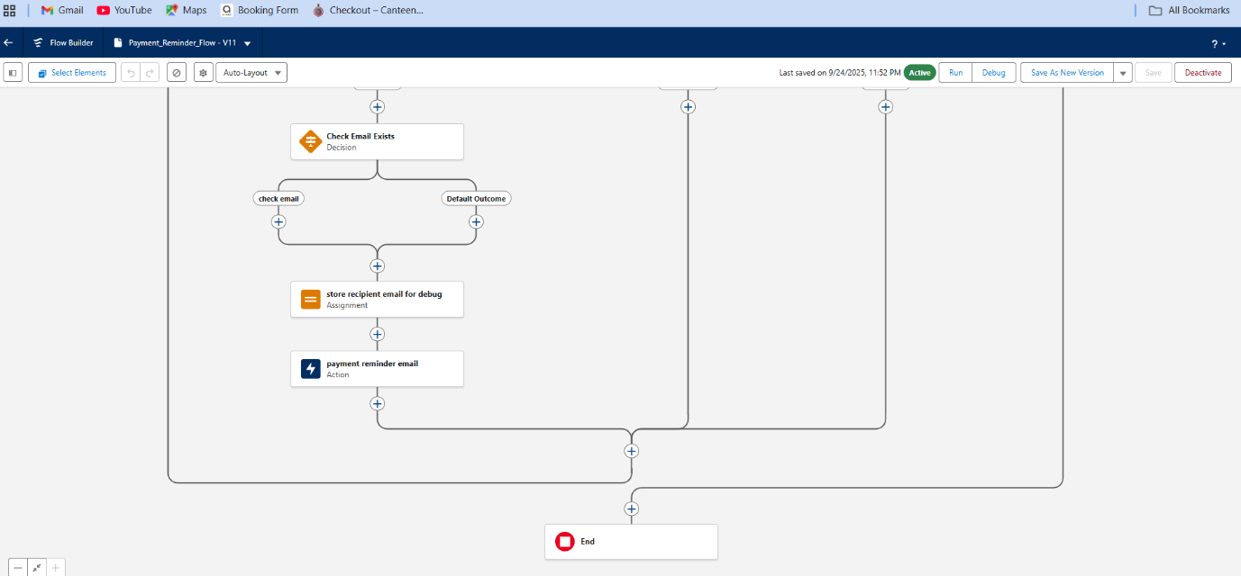

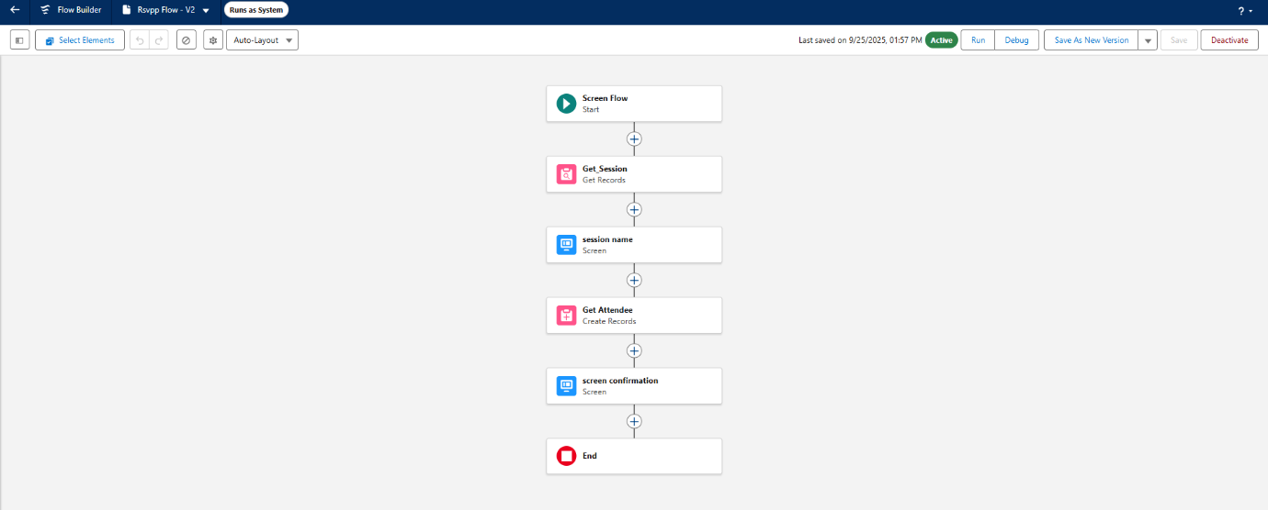

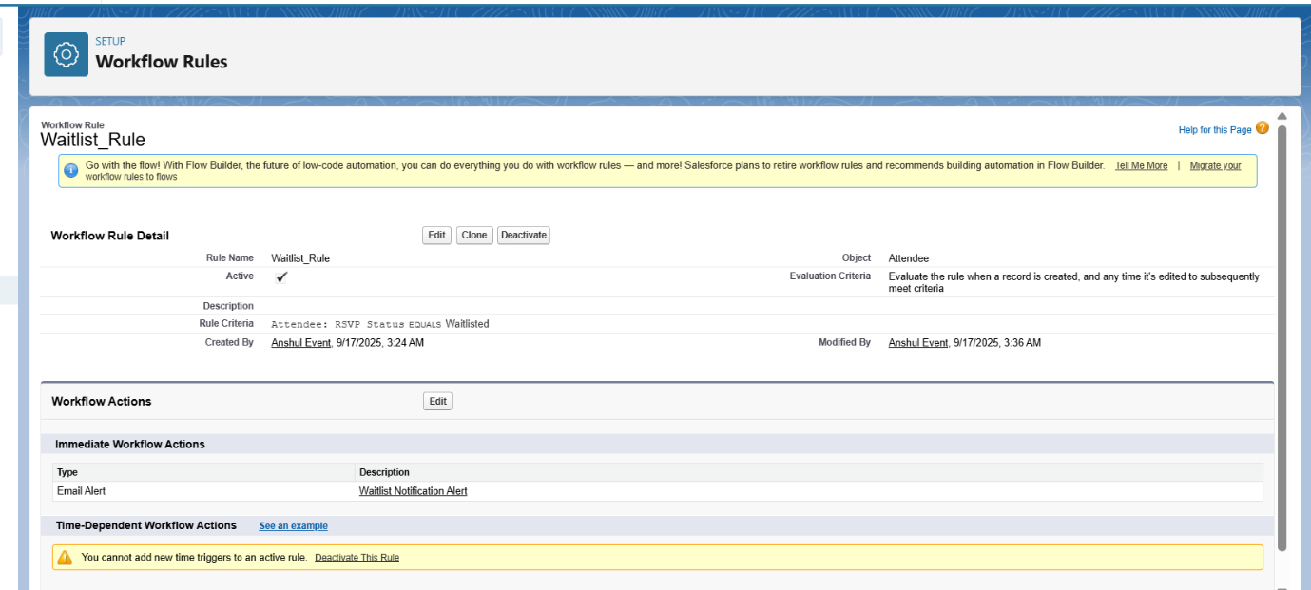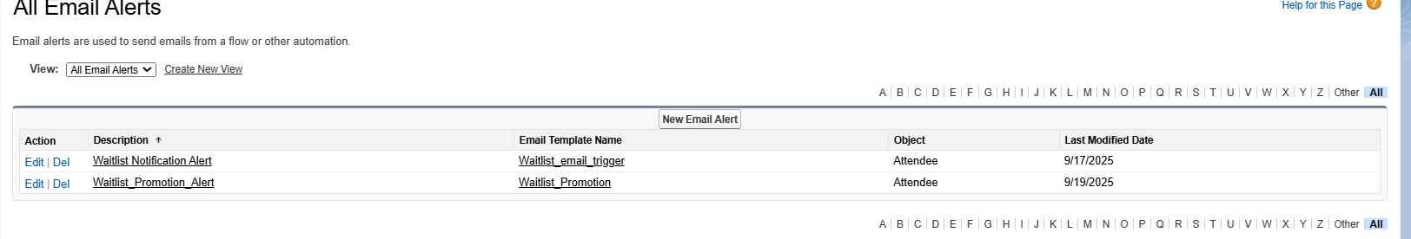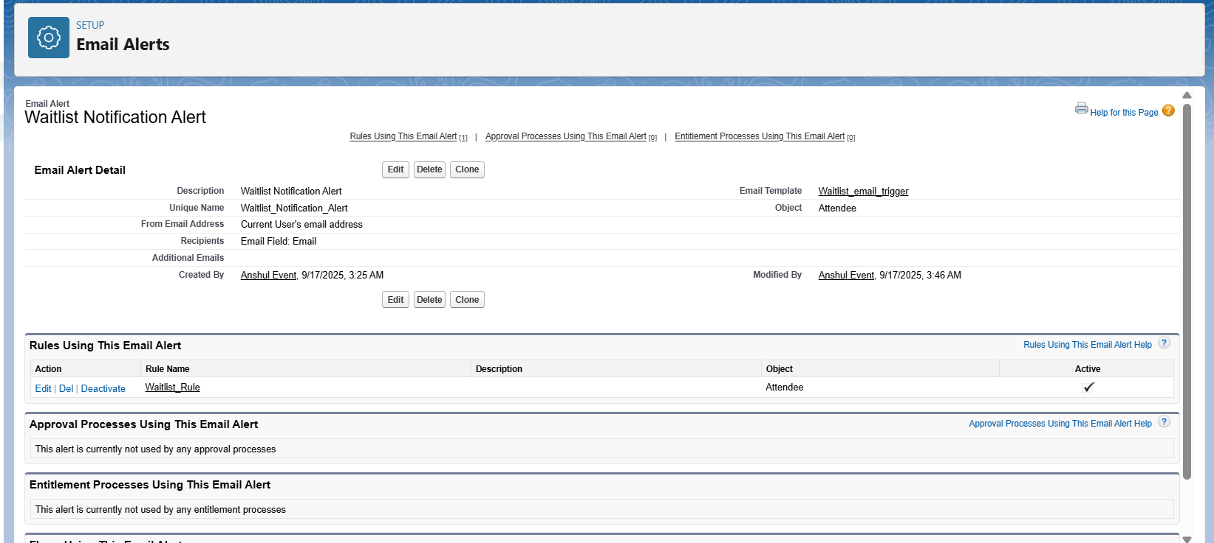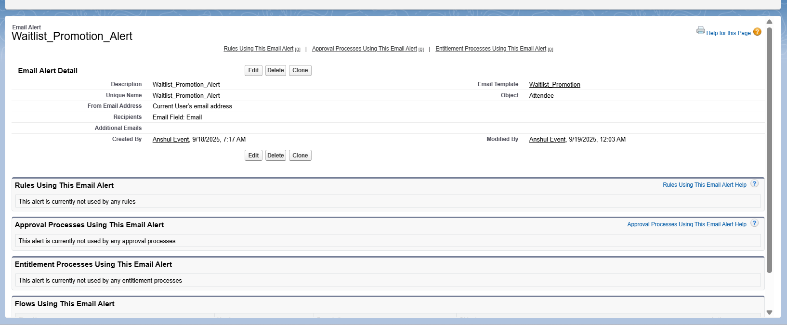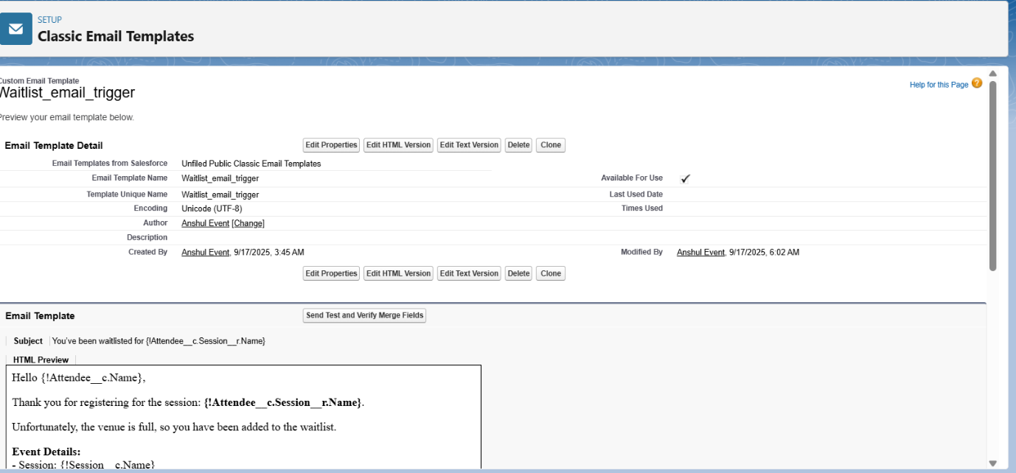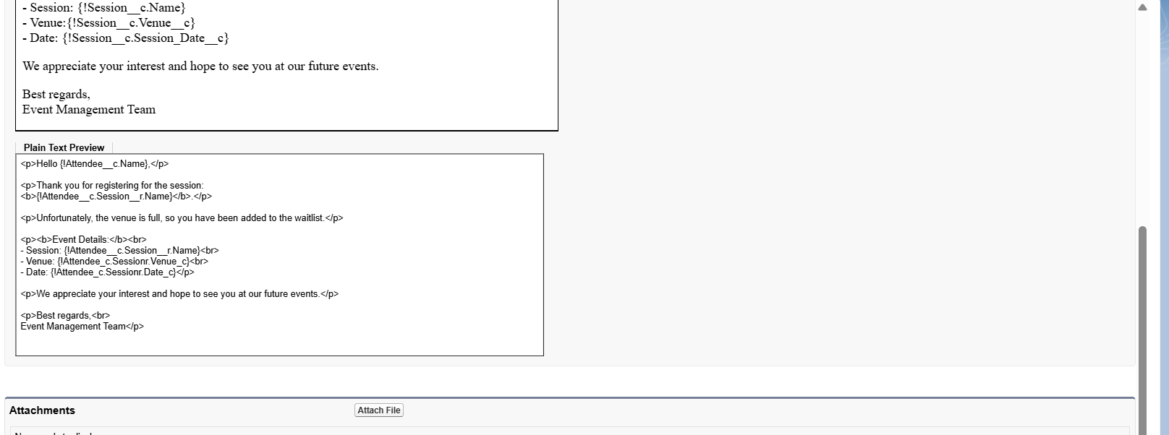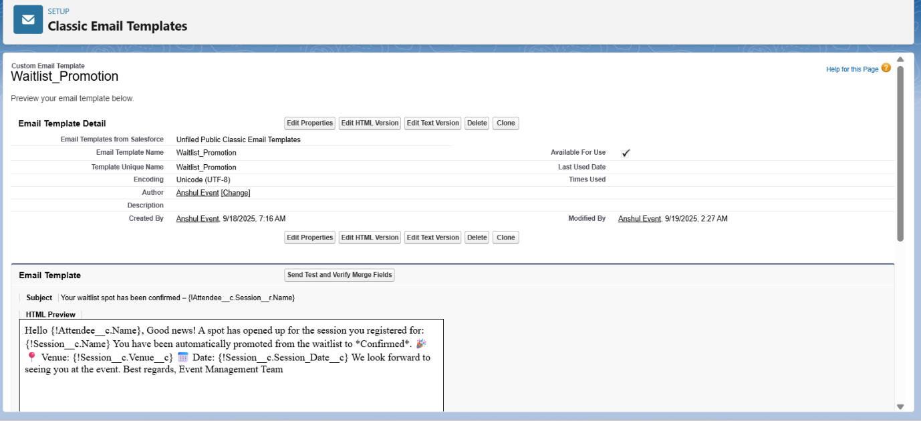

# Phase-5----Apex coding

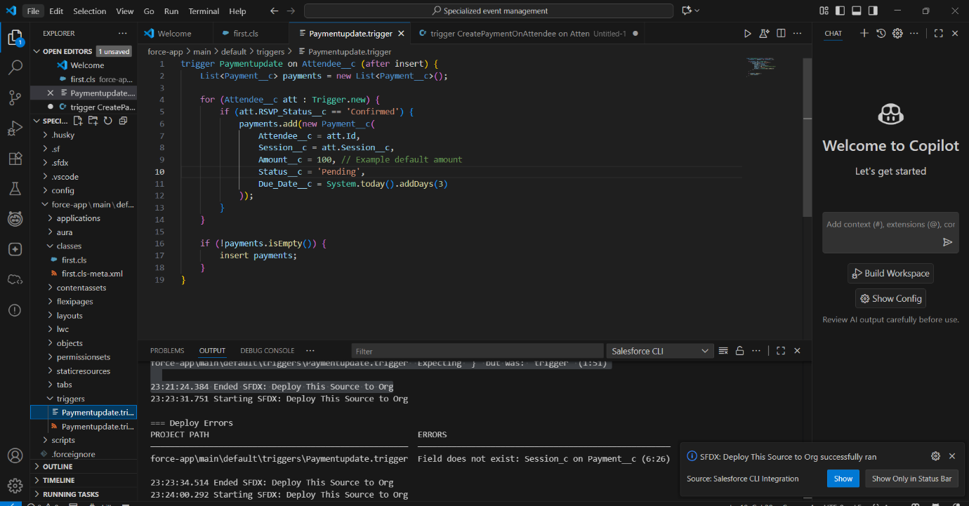

# Phase-6

Lwc component and external portal access

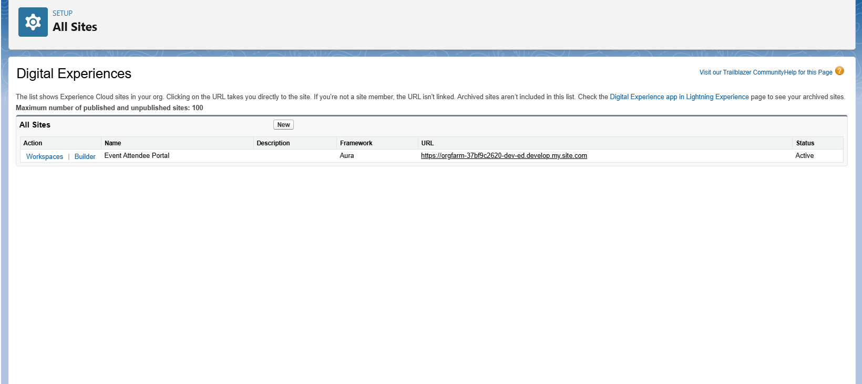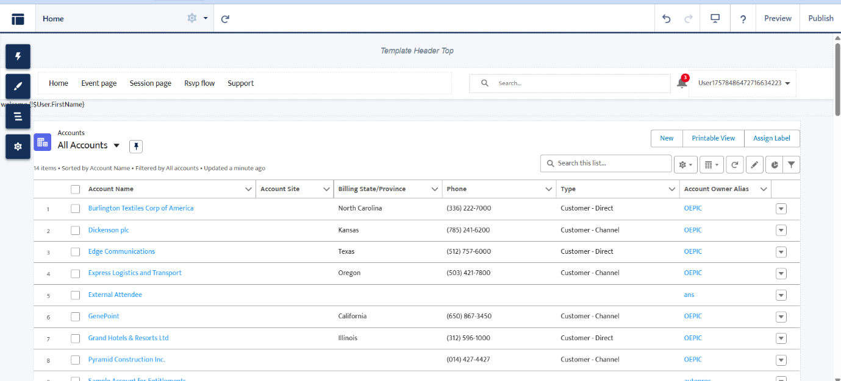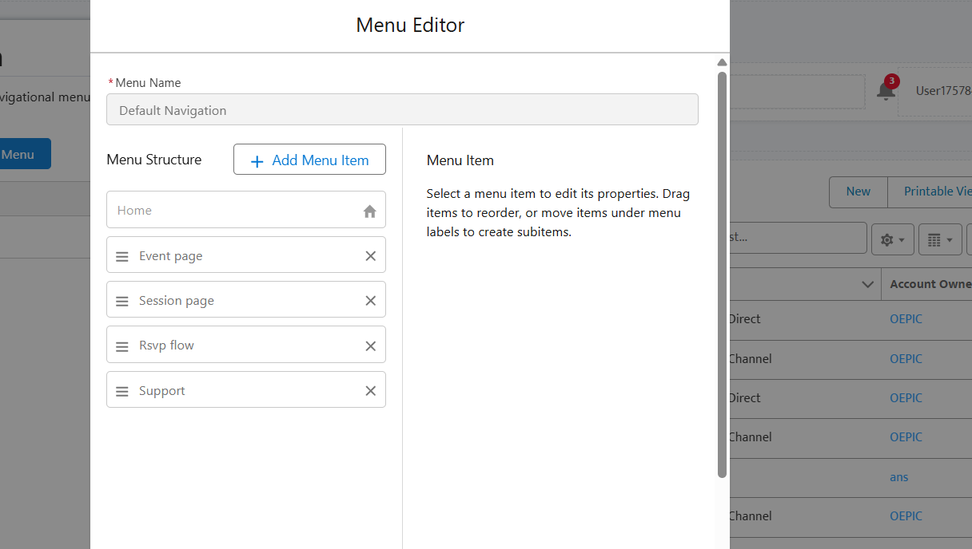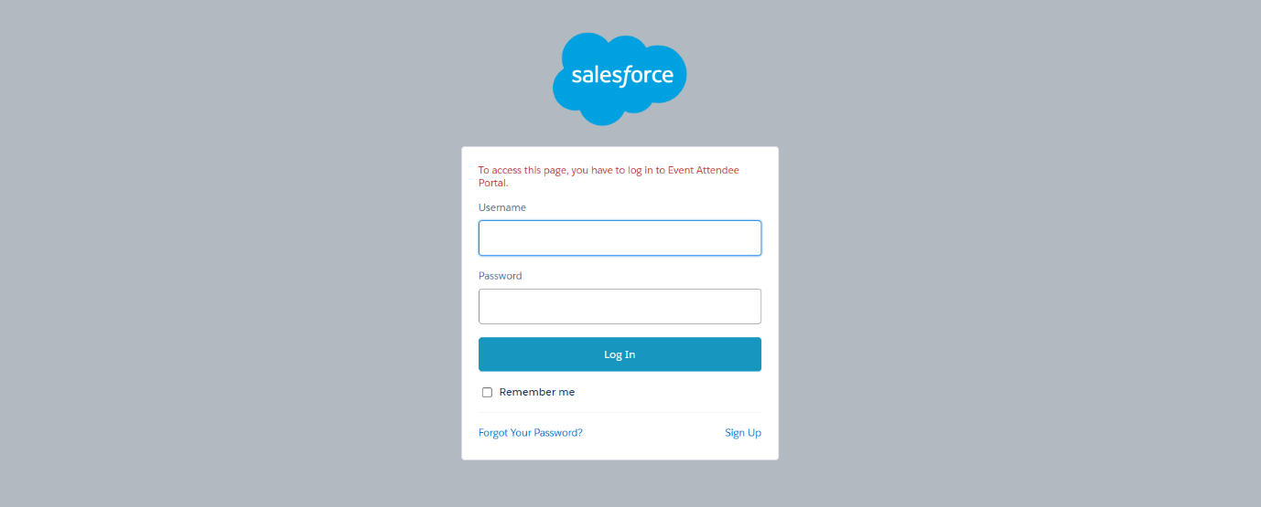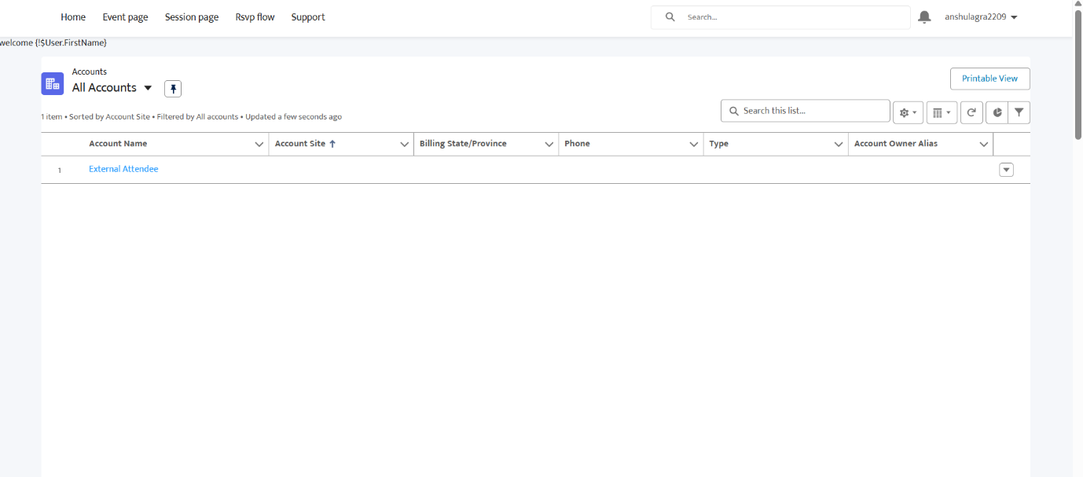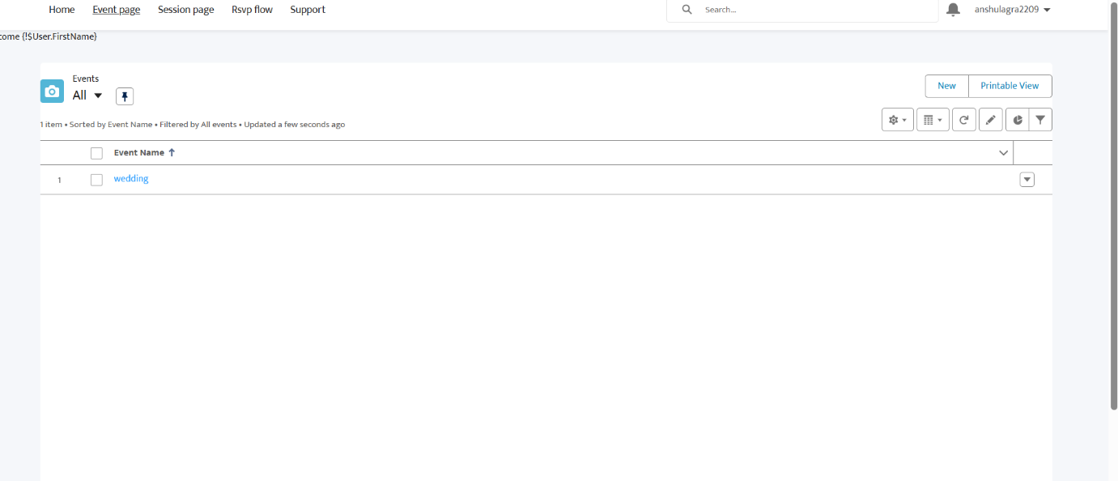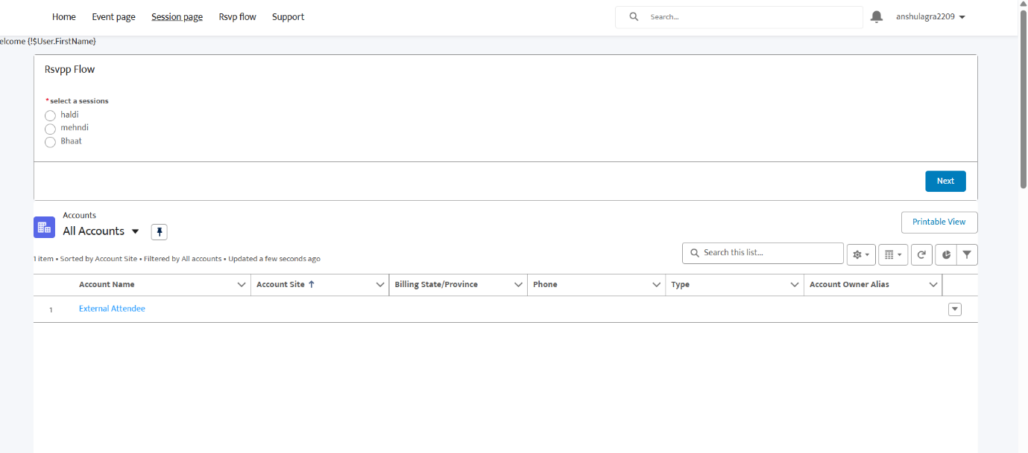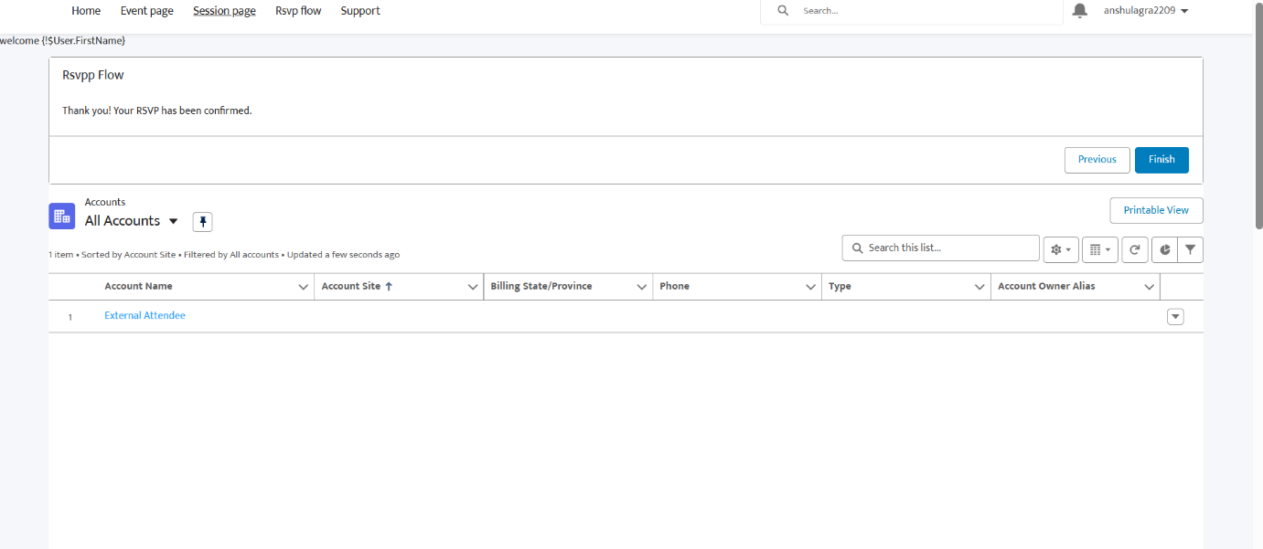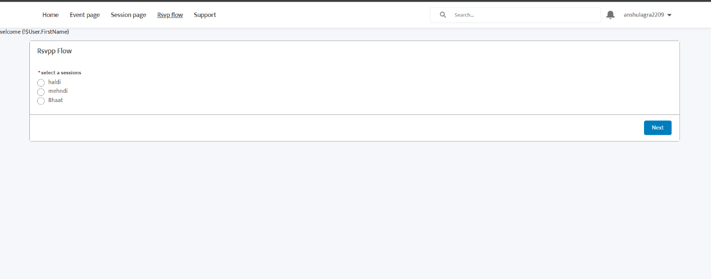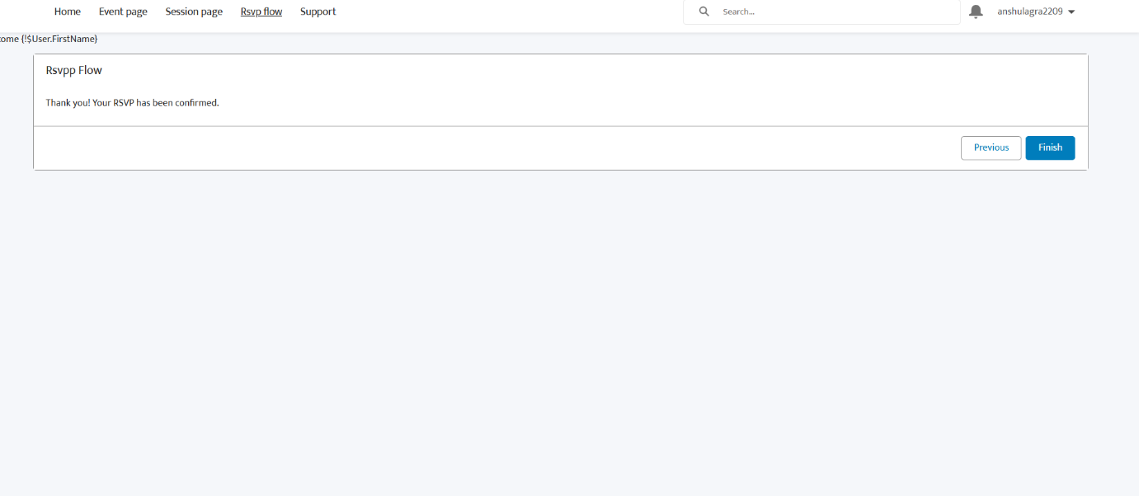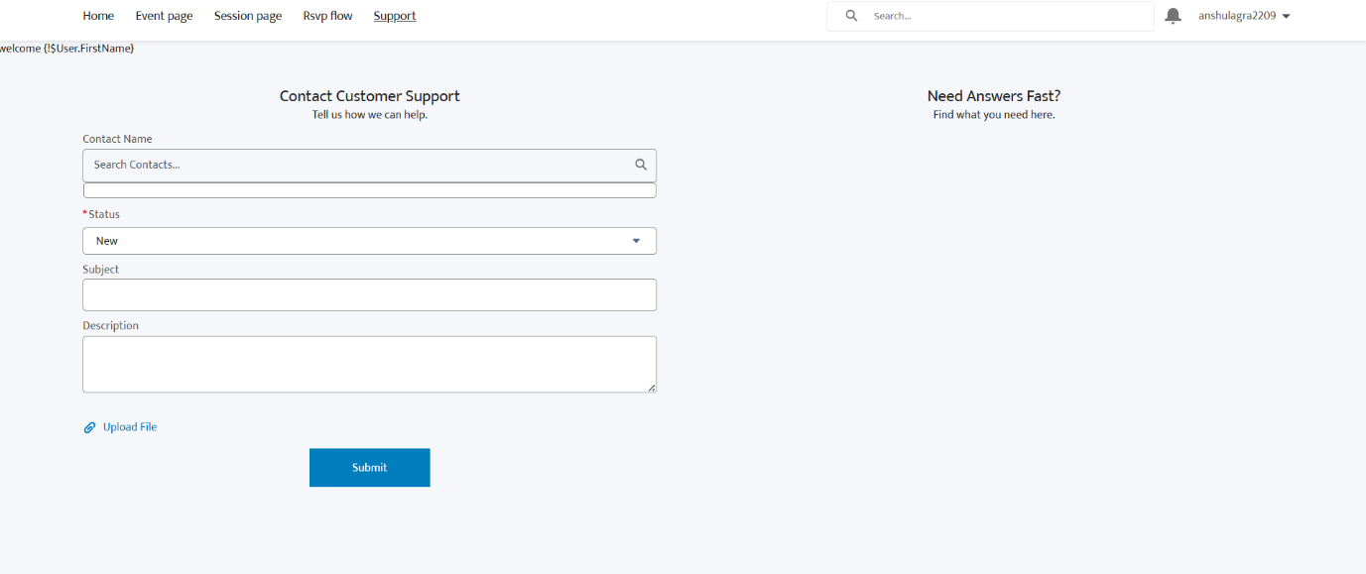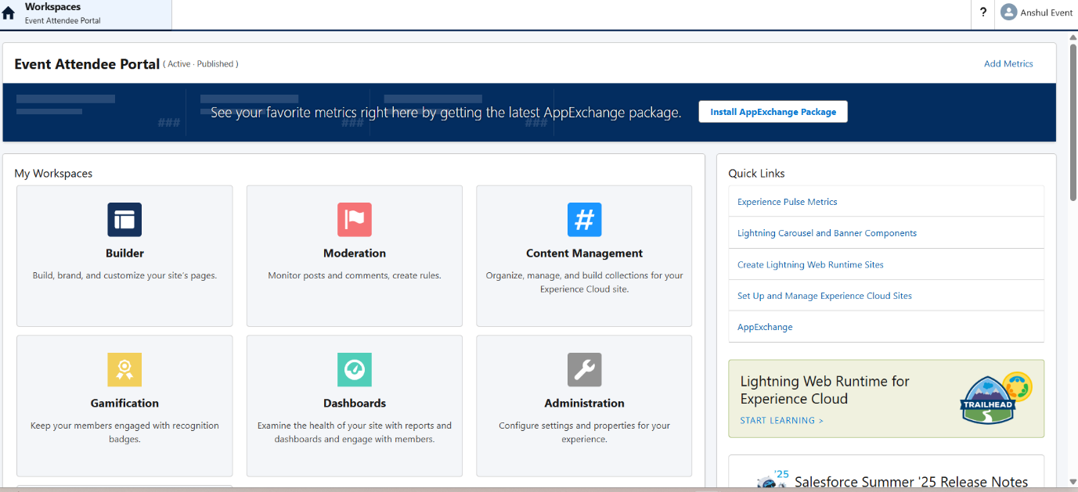

# Phase-7

Attendee portal access

---https://orgfarm-37bf9c2620-dev-ed.develop.my.site.com

# Phase-8

Duplicate and Matching rule…

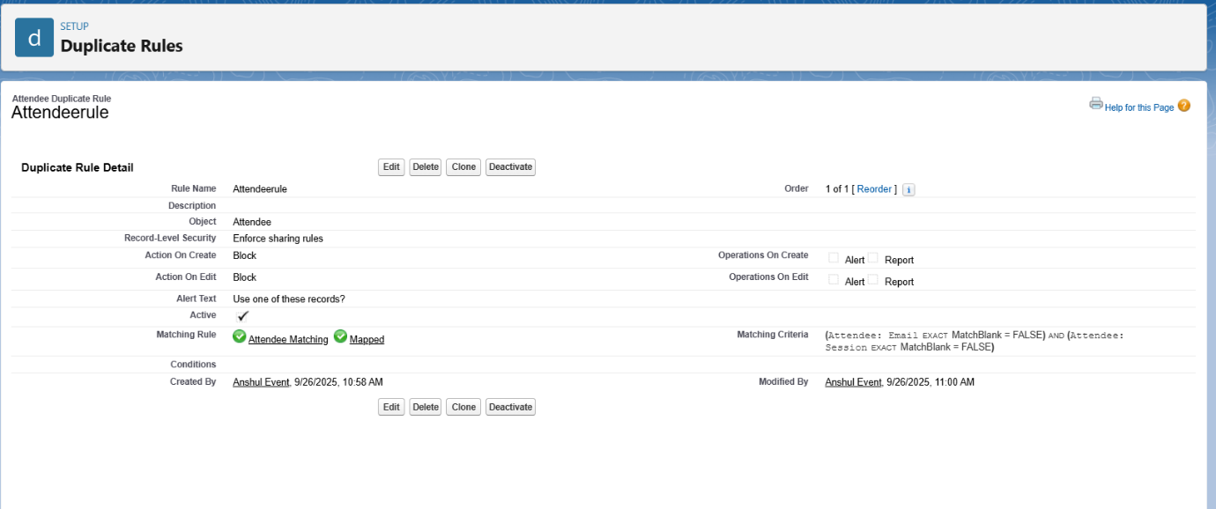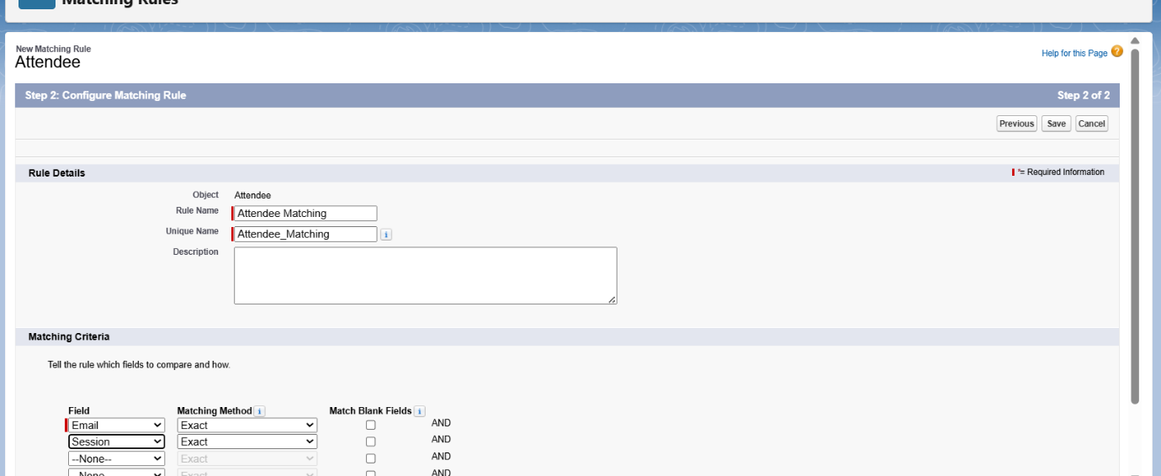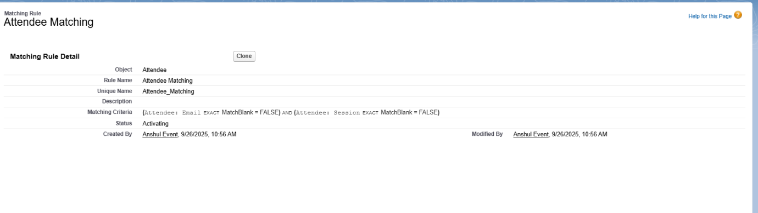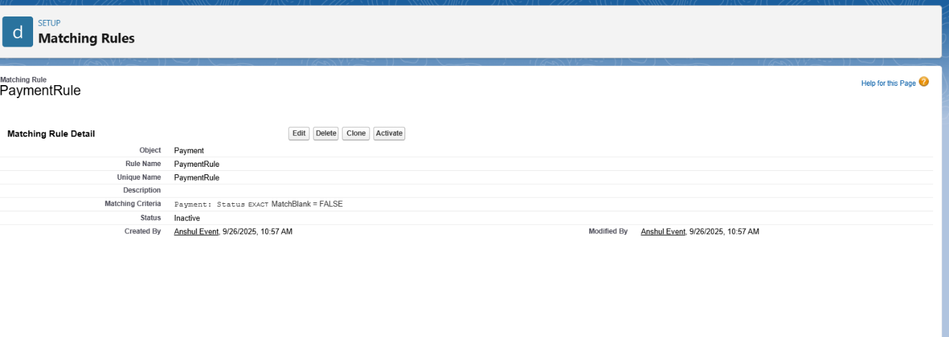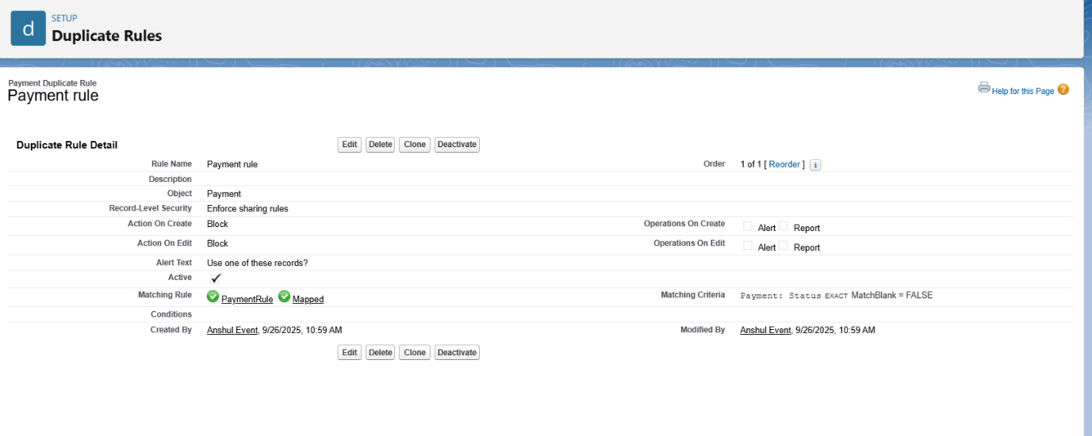

# Phase-9

Reports and Dashboards…..

* • Revenue Collected vs Pending
* • Session-wise Payments
* • Attendee Participation
* • Pending Payment Alerts

