I had a few ideas/ doubts whihc could help simplify the problem at hand-
1) should we just use pixels for all of our calculations instead of meters and finally convert to meters
2) I think we should get the pixel to meter ratio in the begining and just hold on to it, instead of recalculating every time
3) I thnk we should keep the tetha in memory rather than calculating it every time from the image.

Joint Axis
1 Z
2 X
3 Y
4 X

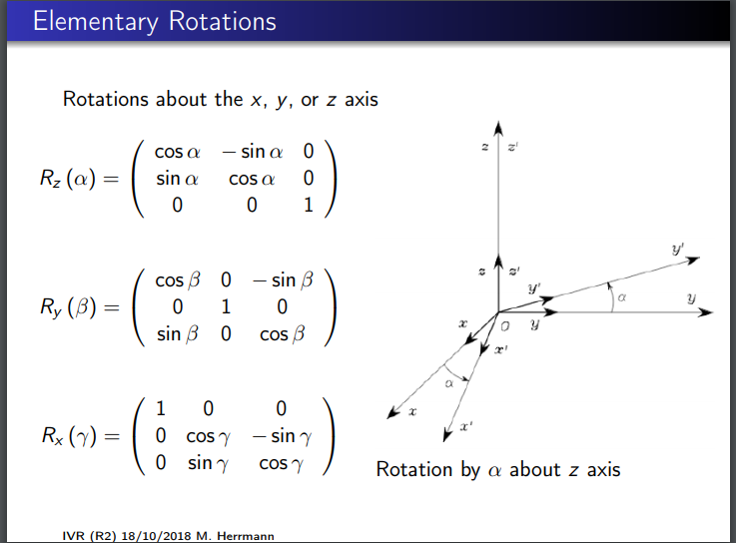
A = Aspect, T = Target
A2 = Rz (A1) + [0,0,3] (blue)
A3 = Rx (A2) + [0,0,0] (blue)
A4 = Ry (A2) + [0,0,2] (green)
T = Rx (A4) + [0,0,3] (red)

I think that is an over simplified version of forward kinematics. I am rotating the orientation and adding the length of the joint.

I think we can forget about joint 1 since the joints 2 & 3 can move in all directions anyway. This will make out task a lot simpler.

If we have to move in a certain dimension, we have to choose an axis that does not rotate along that dimension.

