Task - Write a program which converts currency (dollars) from numbers into word presentation.

**Solution** – I have added the solution to my GitHub repo - can be downloaded from below links.

WCF Service - <https://github.com/anshul3583/CurrencyNumbersToWordsWCFSvc>

WPF UI - <https://github.com/anshul3583/CurrencyNumbersToWordsMVVMPattern>

To run the Application – please download WCF Service and WPF client code and run both solutions, once the service is running locally – please make sure app config file has correct refence as shown below – (update endpoints accordingly).

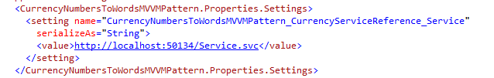

WPF UI - When the WPF application is launched, UI screen shown below will be displayed.

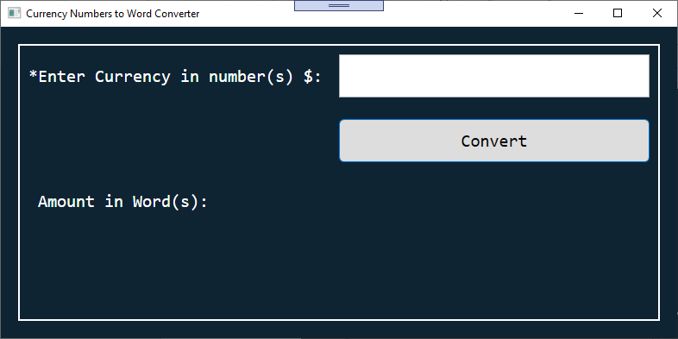

Screen below shows the working example of the application -

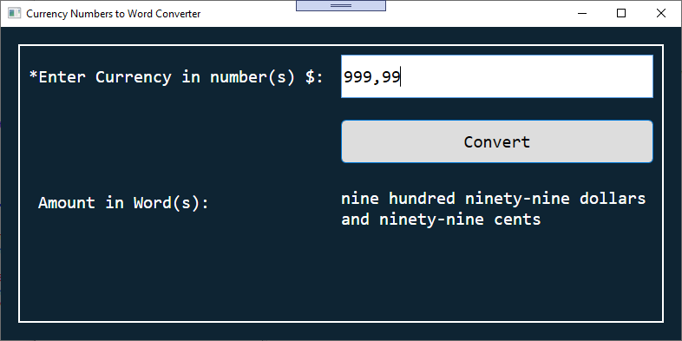

Client side of the application has been created with WPF (.net frame work 4.6). I have implemented MVVM (ModelViewViewModel) pattern with PrismUnity version 7.2.0.1422.

Server Side – **WCF service** contains the parsing and conversion logic. MS unit test project has been added to the solution, with couple unit tests for the main conversion method.

WCF Service url – <http://localhost:50134/Service.svc?singleWsdl>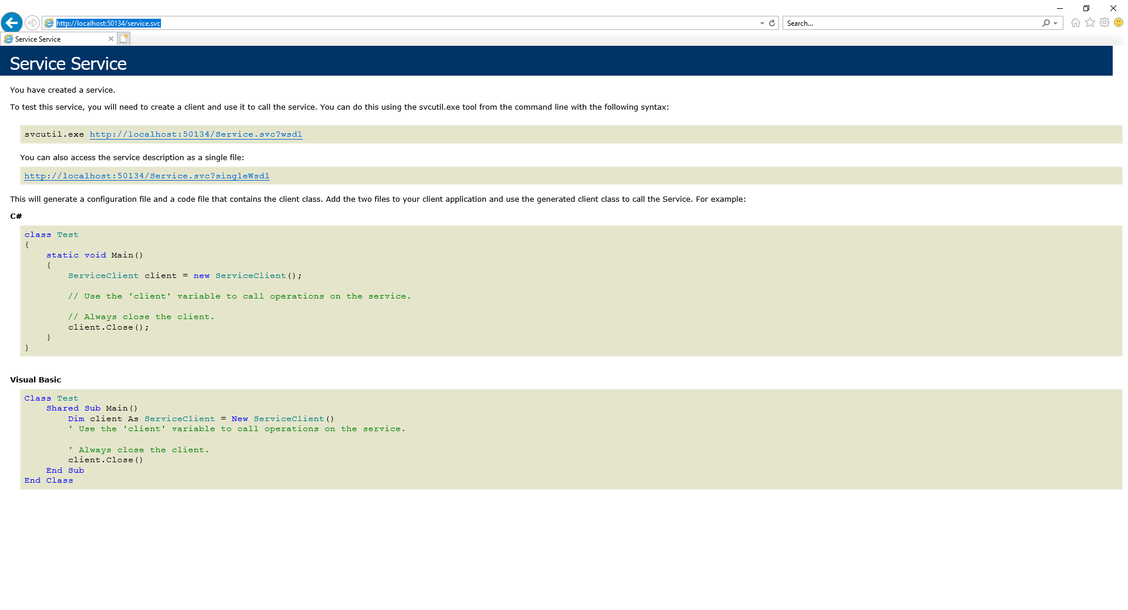

Successful test using WCF Test Client –

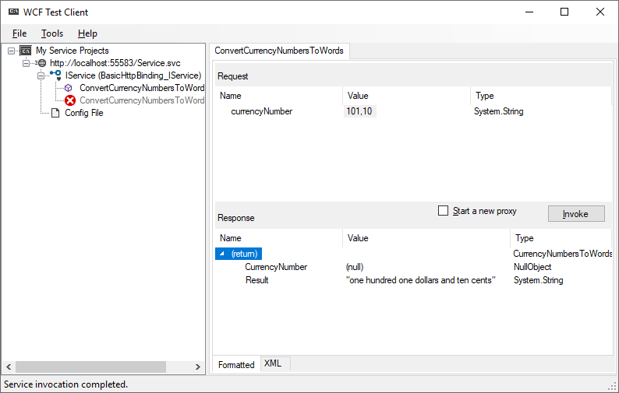

I have used regex101.com to make sure, **regex** for validation is working which can also be accessed via -

<https://regex101.com/r/uSsKNg/2>

screenshot shows valid and invalid inputs.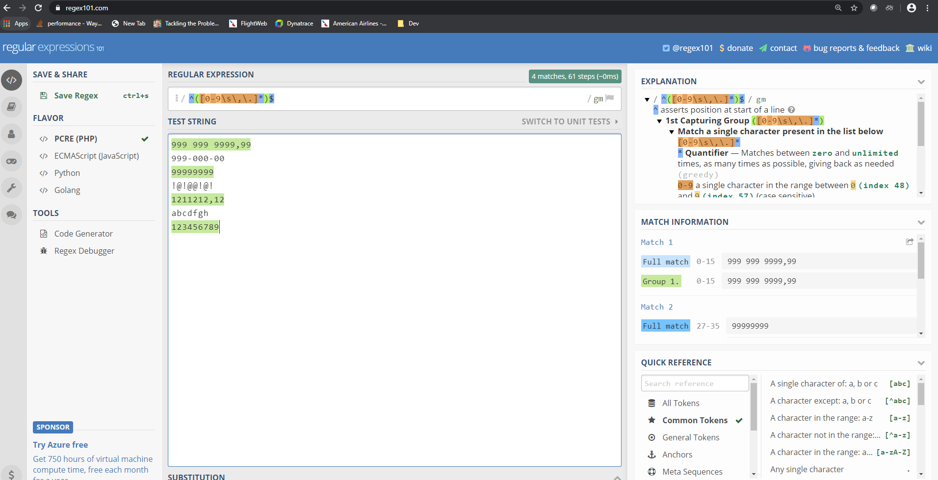

Screenshot below shows – **Unit test output** in Visual Studio –

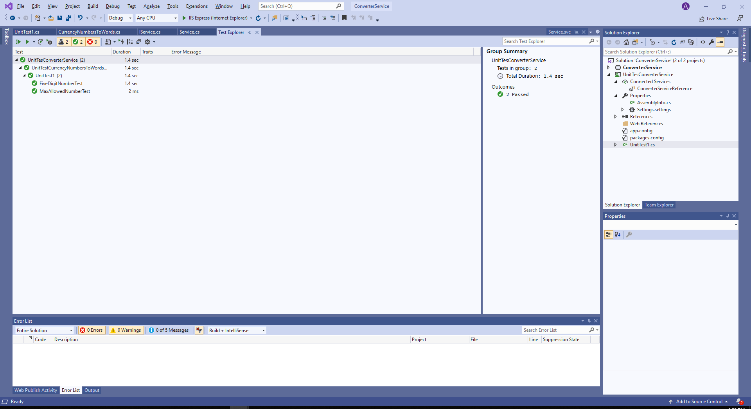

Service hosted on Azure cloud – I have a Sandbox in azure, so I have hosted the service on azure for easy access. The WPF project in git hub doesn’t not use cloud URL but uses localhost.

Azure url - <https://converterwcfservice.azurewebsites.net/service.svc>

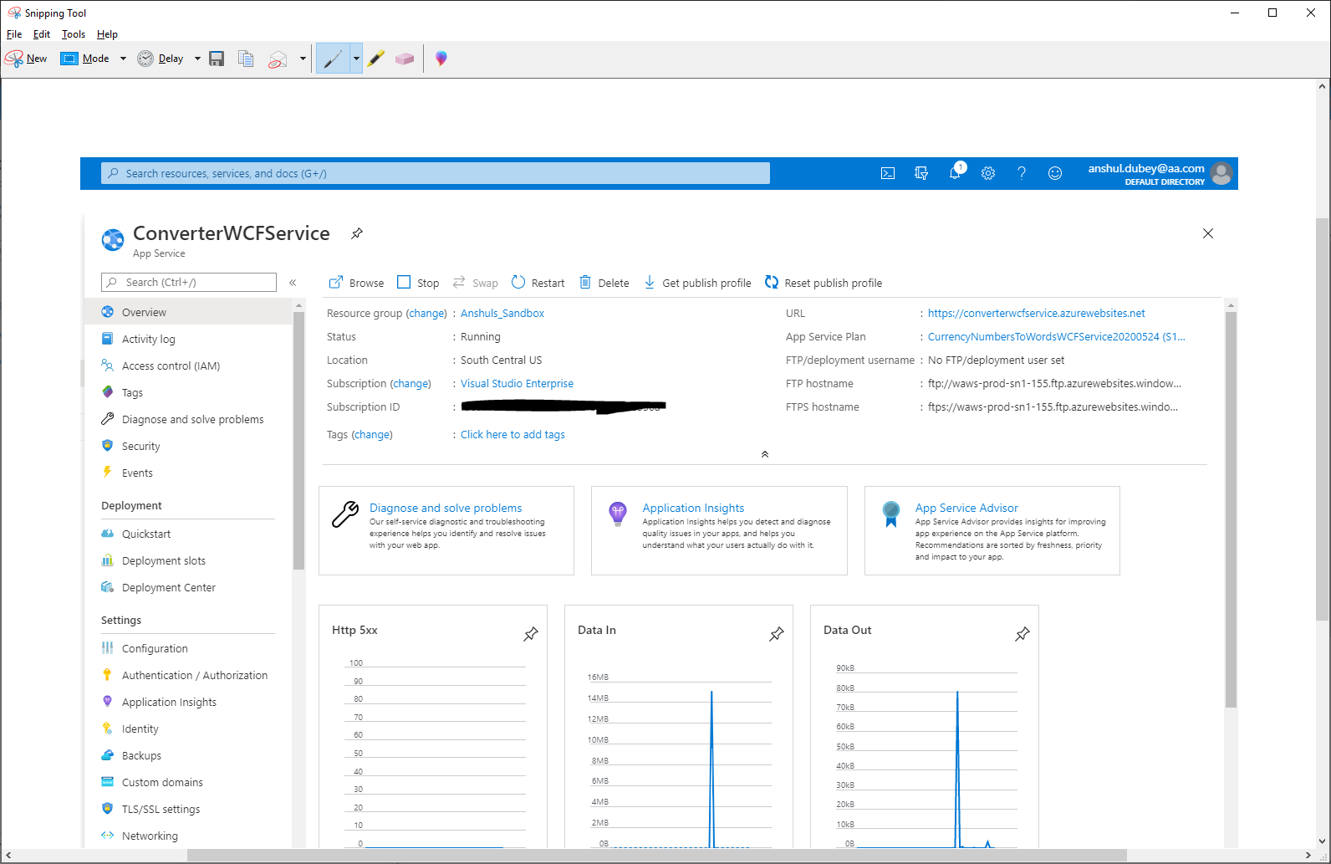

If you want to consume – azure url from client application, update the app config in client with below values -

<CurrencyNumbersToWordsMVVMPattern.Properties.Settings>

<setting name="CurrencyNumbersToWordsMVVMPattern_ConverterServiceReference_Service"

serializeAs="String">

<value>https://converterwcfservice.azurewebsites.net/service.svc</value>

</setting>

</CurrencyNumbersToWordsMVVMPattern.Properties.Settings>

I have tested the cloud deployed service using **Ready-Api tool (SOAP UI client)** – screenshot below –

