Software Requirements Specification

Table of Contents
1. Introduction 1
1.1 Purpose 1
1.2 Scope 1
1.3 References 1
1.4 Overview 1
2. General Description 2
2.1 Product Functions 2
2.2 User Characteristics 2
2.3 General Constraints 2
3. Specific Requirements 3
3.1 Functional Requirements 3
3.1.1 <Functional Requirement or Feature #1> 3
3.1.2 <Functional Requirement or Feature #2> 3
3.2 NON-FUNCTIONAL REQUIREMENTS
3.5.1 Performance 4
3.5.2 Reliability 4
3.5.3 Availability 4
3.5.4 Security 4
3.5.5 Maintainability 4
3.5.6 Portability 4
4. SDLC Models 4
4.1 Model used 4
4.2 Timeline chart 4

1. INTRODUCTION
Crop cultivation plays an essential role in the agricultural field. Presently, the loss of food is mainly due to infected crops, which reflexively reduces the production rate. To identify the plant diseases at an untimely phase is not yet explored. The main challenge is to reduce the usage of pesticides in the agricultural field and to increase the quality and quantity of the production rate. Our project is used to explore the leaf disease prediction at an untimely action.
Basically, the project deals with the identification of disease in soybean plant. In the early stages so as to prevent the spread of the disease at extreme levels.
As an introduction to the project we are using image processing to scan the leaf image and using Machine Learning, will be training the dataset.

1.1 PURPOSE
Agriculture plays an important role in the economy of several countries, contributing from the production of food and income to the generation of jobs. To improve productivity in agriculture, proper crop management should be accomplished through pest control. One approach is to monitor the defoliation level, that is, the percentage of leaf damaged by insects.

1.2 SCOPE

The scopes of this project are:
- For the farmers to detect the diseases more efficiently
- A source of income.
- People working in the plants, to provide them with more accurate results.
- In the research fields, to obtain more accurate results with less efforts and time.

1.3 REFRENCES
References for the information gathered are hereby followed:
[1]https://www.researchgate.net/publication/311501638_Food_Recognition_A_New_Dataset_Experiments_and_Results

[2] https://scholarcommons.scu.edu/cgi/viewcontent.cgi?article=1120&context=cseng_senior

1.4 OVERVIEW
Basically, the project deals with the identification of disease in soybean plant. In the early stages so as to prevent the spread of the disease at extreme levels. As an introduction to the project we are using image processing to scan the leaf image and using Machine Learning, will be training the dataset.

2. GENERAL DESCRIPTION

The project focuses on the use of machine learning to process an image.And then to test it for any disease.
Accordingly a dataset will be trained, for drawing conclusions.
In this section, we describe the proposed method for estimating defoliation in soybean leaves using convolutional neural networks (CNN). Basically, the proposed method can be described in three steps: (i) image preprocessing, (ii) generation of synthetic defoliation, (iii) CNN modeling and training. First the input image is resized to a fixed size of 256 × 256 pixels that corresponds to the CNN input size. This resizing aids in the image standardization, besides contributing to the computational cost. The colored image is then binarized by applying the Otsu thresholding (Bangare et al., 2015) so that the image contains only two regions corresponding to the leaf and the background. Finally, the image is rotated at a random angle in order to make our method invariant to rotation.
CNN modeling and training: Given a set of images generated by the synthetic defoliation methods, we trained a convolutional neural network. Due to the recent results, three architectures have been evaluated: AlexNet (Krizhevsky et al., 2012), VGGNet (Simonyan and Zisserman, 2014) and ResNet (He et al., 2016). These architectures were proposed for classification problems, that is, given an input image the objective is to classify it into one of the known classes. To adapt an architecture to a regression problem, we have removed the softmax layer that returns the class probabilities and added a fully-connected layer with one neuron and a sigmoid activation function to estimate the defoliation level. Also, we have trained the architectures using Root Mean Square Error (RMSE) loss function instead of cross-entropy.

PRODUCT FUNCTION
- To train a CNN Model
- Early detection of diseases
- Analysis of plant diseases
- Study the Deep Learning Models
- Connecting Technology to serve it for a better future

USER CHARCTERSTICS
- Freedom to use the system for recognizing the plant diseases.
- Can help the needy to know about the same.

2.3 GENERAL CONSTRAINS
- To system need to be connected to the internet for use.
- The application uses the mail service for verifying and authenticates the writer if review so the one who wish to write the review need to have a mail ID.
- Implement the database at least using a centralized database management system.

3. SPECIFIC REQURIMENTS

The Specific requirements of this project are:

From user point of view
1. Internet Connection
2. Basic General knowledge of internet.

From Developer end
- Knowledge of datasets in Deep learning and coding in python.
- A PC to work on for developing the Application.

3.1 FUNCTIONAL REQURIMENTS
1. The system will make use of its datasets for analysis.
2. The system will allow users to make accounts and securely sign in.

3.2 NON-FUNCTIONAL REQURIMENTS

3.2.1 RECOGNITION
The system will be accurate in its recognition.

3.2.2 FRIENDLY AND EASY
The system will be easy to use and also user friendly.

3.2.3 EFFICIENT
The system will be efficient and lightweight.

3.2.4 FAST RESULTS
The system will return the results within a reasonable time-frame.

4.1 MODEL USED

The spiral model is a risk-driven process model generator for software projects. Based on the unique risk patterns of a given project, the spiral model guides a team to adopt elements of one or more process models, such as incremental, waterfall, or evolutionary prototyping. The spiral model combines the idea of iterative development with the systematic, controlled aspects of the waterfall model. This Spiral model is a combination of iterative development process model and sequential linear development model i.e. the waterfall model with a very high emphasis on risk analysis. It allows incremental releases of the product or incremental refinement through each iteration around the spiral.
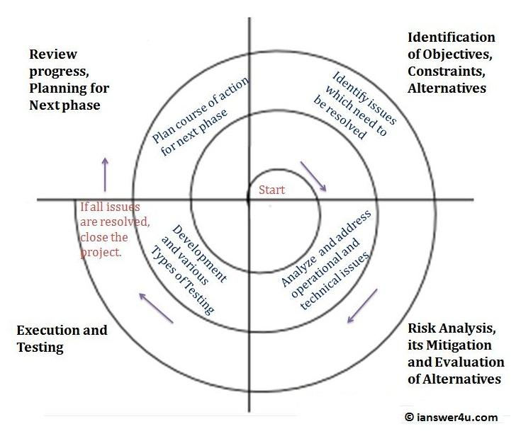

Reason for use
The development team in Spiral-SDLC model starts with a small set of requirement and goes through each development phase for those set of requirements. The development team adds functionality for the additional requirement in every increasing spiral until the application is ready for the productions phase. The reasons for using spiral model are:
- Additional functionality or changes can be done at a later stage
- Cost estimation becomes easy as the prototype building is done in small fragments
- Continuous or repeated development helps in risk management
- Development is fast and features are added in a systematic way.

4.2 TIMELINE CHART

