Institute of Technology
Nirma University



Innovative Assignment

Subject: Machine Learning (ML)
Div: D
Batch: D2

Name & Roll No. :
Patel Anshul, Patel Jainil
23BCE220, 23BCE229

Topic: Machine Learning-Based Estimation of Remaining Useful Life (RUL) in Turbofan Engines Using NASA C-MAPSS Data

Introduction

- Predictive maintenance techniques are designed to help determine the condition of in-service equipment in order to estimate when maintenance should be performed. This approach promises cost savings over routine or time-based preventive maintenance, because here tasks are performed only when warranted.

- In this project, It’s an attempt has been made to predict RUL( Remaining Useful Life of NASA Turbofan Engine) by applying various ML Models. Dataset considered is FD001 dataset which can also be accessed from link
https://www.kaggle.com/datasets/behrad3d/nasa-cmaps/data

About Dataset

- Data Set FD001 is the first in the series and the least complex.
Train trjectories: 100 engines. Test trajectories: 100 engines. Fault Modes: ONE. Datasets include simulations of multiple turbofan engines over time, each row contains the following information:

- Engine unit number

- Time, in cycles

- Three operational settings

- 21 sensor readings. No information regarding sensors have been given. If there has been some information regarding sensor type i.e. pressure sensor, temperature sensor, vibration sensor etc. then we could have fetch some more information about degradation of engine using domain knowledge.

Methodology Followed:

- Data Loading
- Data Analysis
- Data Preprocessing
- Data Visualizations
- Model Building
- Model Evaluation

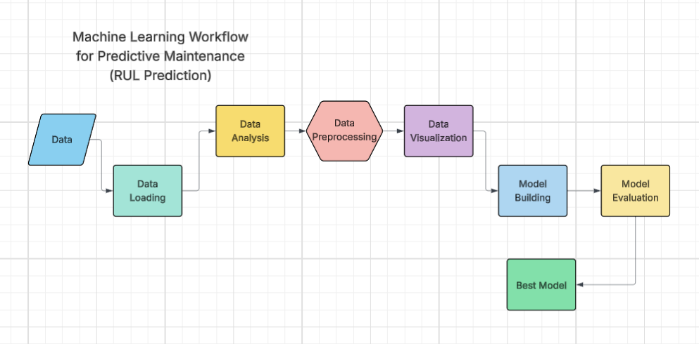

Workflow Link:
https://lucid.app/lucidchart/dc07b56a-53f4-4235-84a8-78b28b26c033/edit?viewport_loc=13%2C-626%2C2629%2C1161%2C0_0&invitationId=inv_b6474bfe-acad-41a5-9385-0b3a312eae5e
Models Used:

- Linear Regression (LR)
- Support Vector Machine (SVM-Regressor)
- Decision Tree (DT)
- Random Forest Regressor (RFR)
- Random Forest Regressor with Hyperparameter Tuning
- Ridge Regression (Regularization)
- XGBoost

Model Evaluation:

