**Skip list** is a [data structure](http://en.wikipedia.org/wiki/Data_structure) that allows fast search within an [ordered sequence](http://en.wikipedia.org/wiki/Ordered_sequence) of elements.

**In RocksDB, the default memtable implementation is SkipList.**

* Fast search is made possible by maintaining a [linked](http://en.wikipedia.org/wiki/Linked_list) hierarchy of subsequence’s, each skipping over fewer elements.
* Searching starts in the sparsest subsequence until two consecutive elements have been found, one smaller and one larger than the element searched for. Via the linked hierarchy these two elements link to elements of the next sparsest subsequence where searching is continued until finally we are searching in the full sequence.
* The elements that are skipped over may be chosen probabilistically.

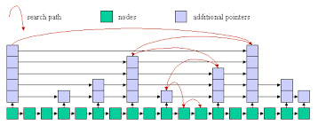

NOTE: Sample program is given in file skiplist_test_main