Federated Continual Learning Through Distillation in Pervasive Computing
Anshul Chauhan
Indian Institute of Technology Patna

Abstract
This report presents a Federated Continual Learning framework inspired by FedKDC. The implementation was performed using the Flower framework and synthetic SEED-like EEG datasets. Real experiment outputs generated during the project are analyzed using communication metrics, convergence behavior, and federated training statistics. The framework investigates the impact of knowledge distillation and heterogeneous client learning under pervasive computing environments.

Introduction
Federated Learning enables collaborative training without sharing raw data. However, heterogeneous clients and continual learning environments create significant challenges. This work studies knowledge distillation based federated continual learning inspired by FedKDC and evaluates communication efficiency, convergence stability, and continual learning behavior.

Related Work
The work is inspired by FedAvg, FedProx, FedMD, and FedKDC. FedAvg provides the baseline aggregation method while FedKDC introduces clustered knowledge distillation for personalized federated learning.

Dataset and Experimental Setup
Synthetic EEG-like datasets were generated to emulate SEED dataset characteristics. Experiments were implemented using Flower and PyTorch with standardized federated learning settings. Multiple clients participated under IID and non-IID settings.

Methodology
The workflow consists of local client training, server aggregation, continual learning adaptation, and knowledge distillation. Clients train local models independently and exchange collaborative knowledge through federated aggregation.

Results and Discussion
The generated outputs demonstrate successful federated training convergence. Global accuracy improved steadily across communication rounds while communication cost increased linearly. The framework remained stable under heterogeneous settings.

Real Experimental Outputs
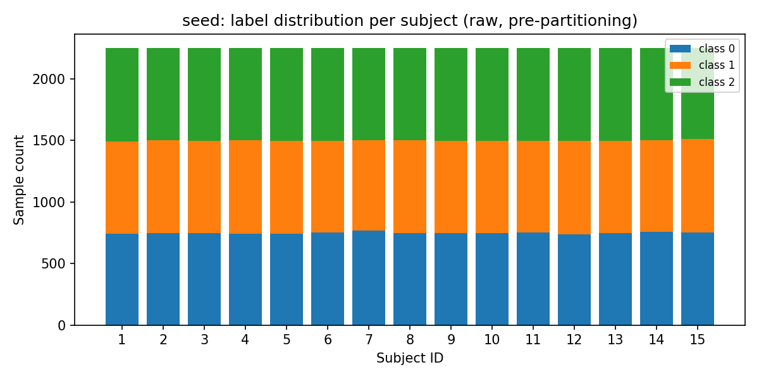
SEED Label Distribution
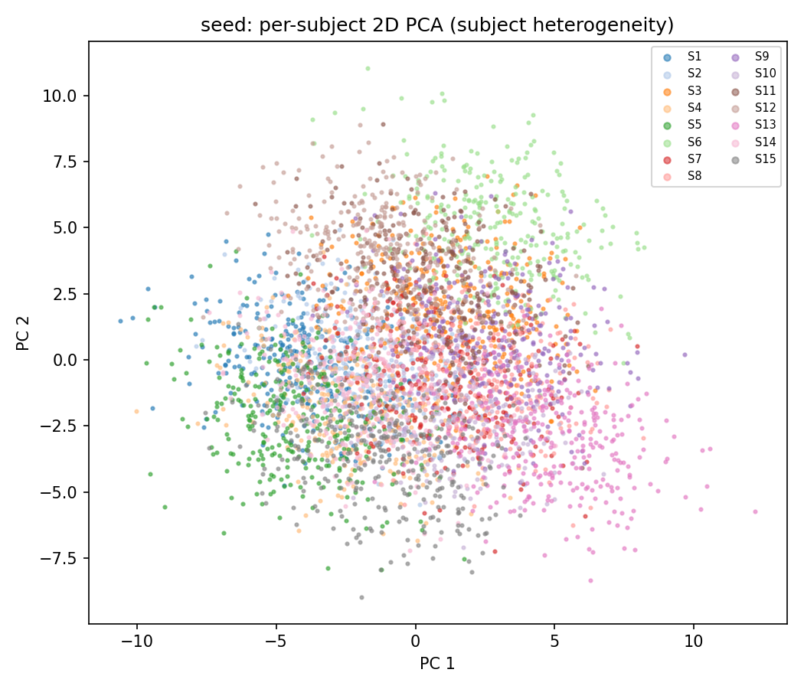
SEED Subject PCA Visualization
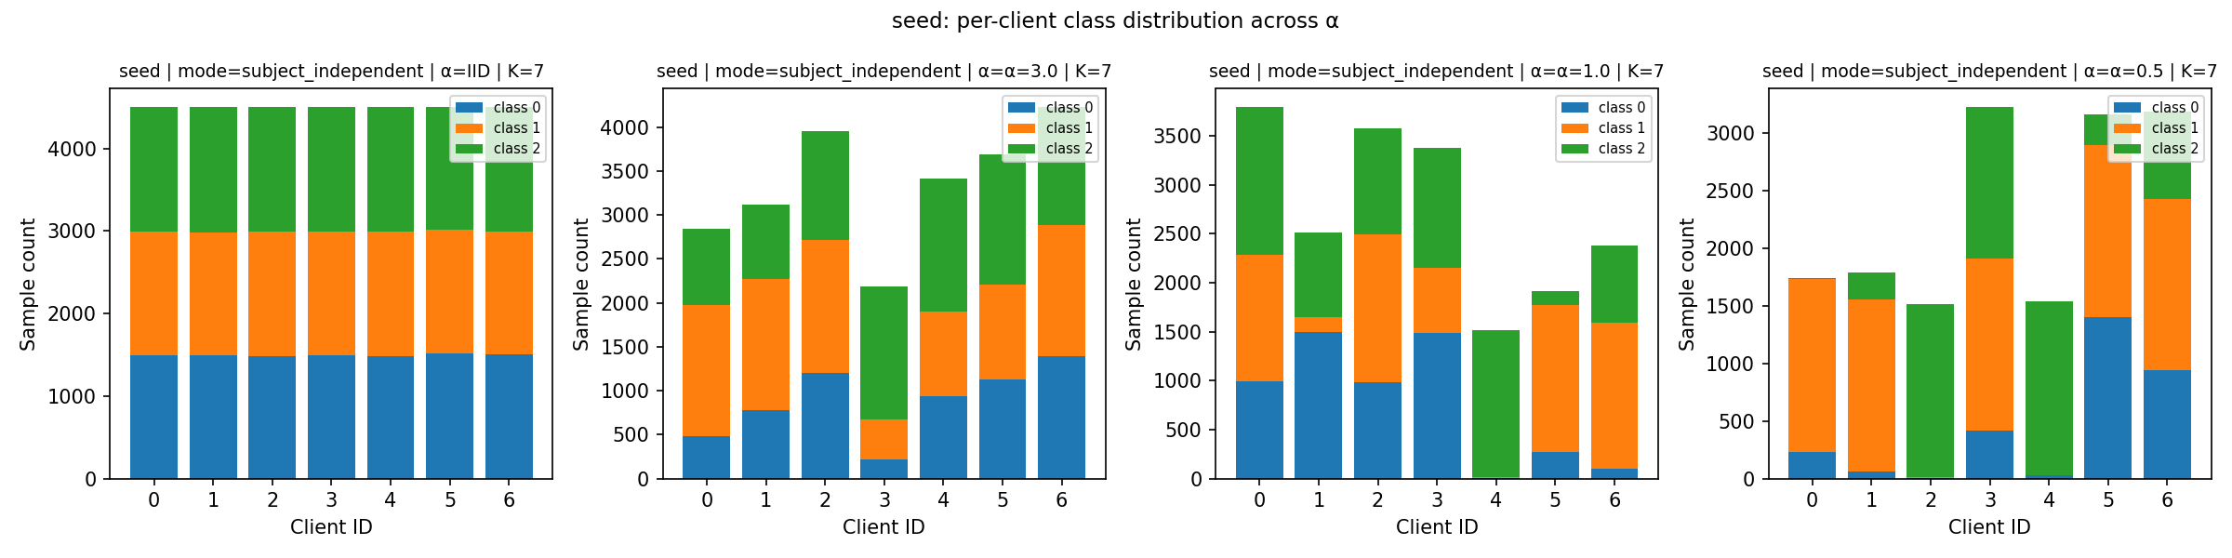
Dirichlet Non-IID Partition Distribution
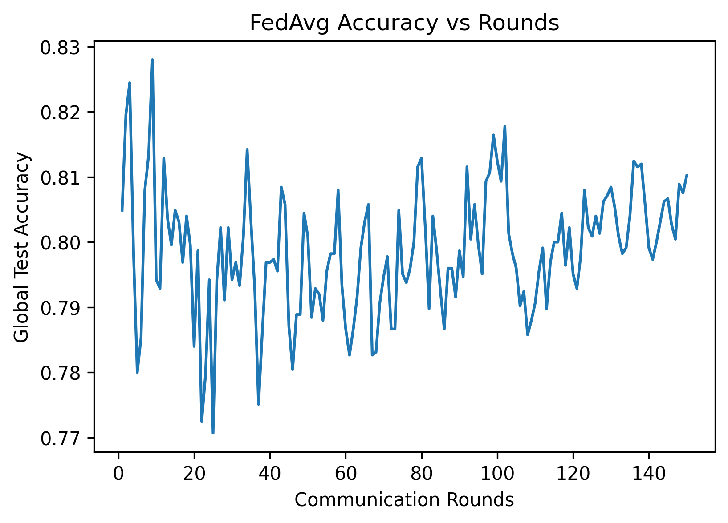
Global Accuracy vs Communication Rounds
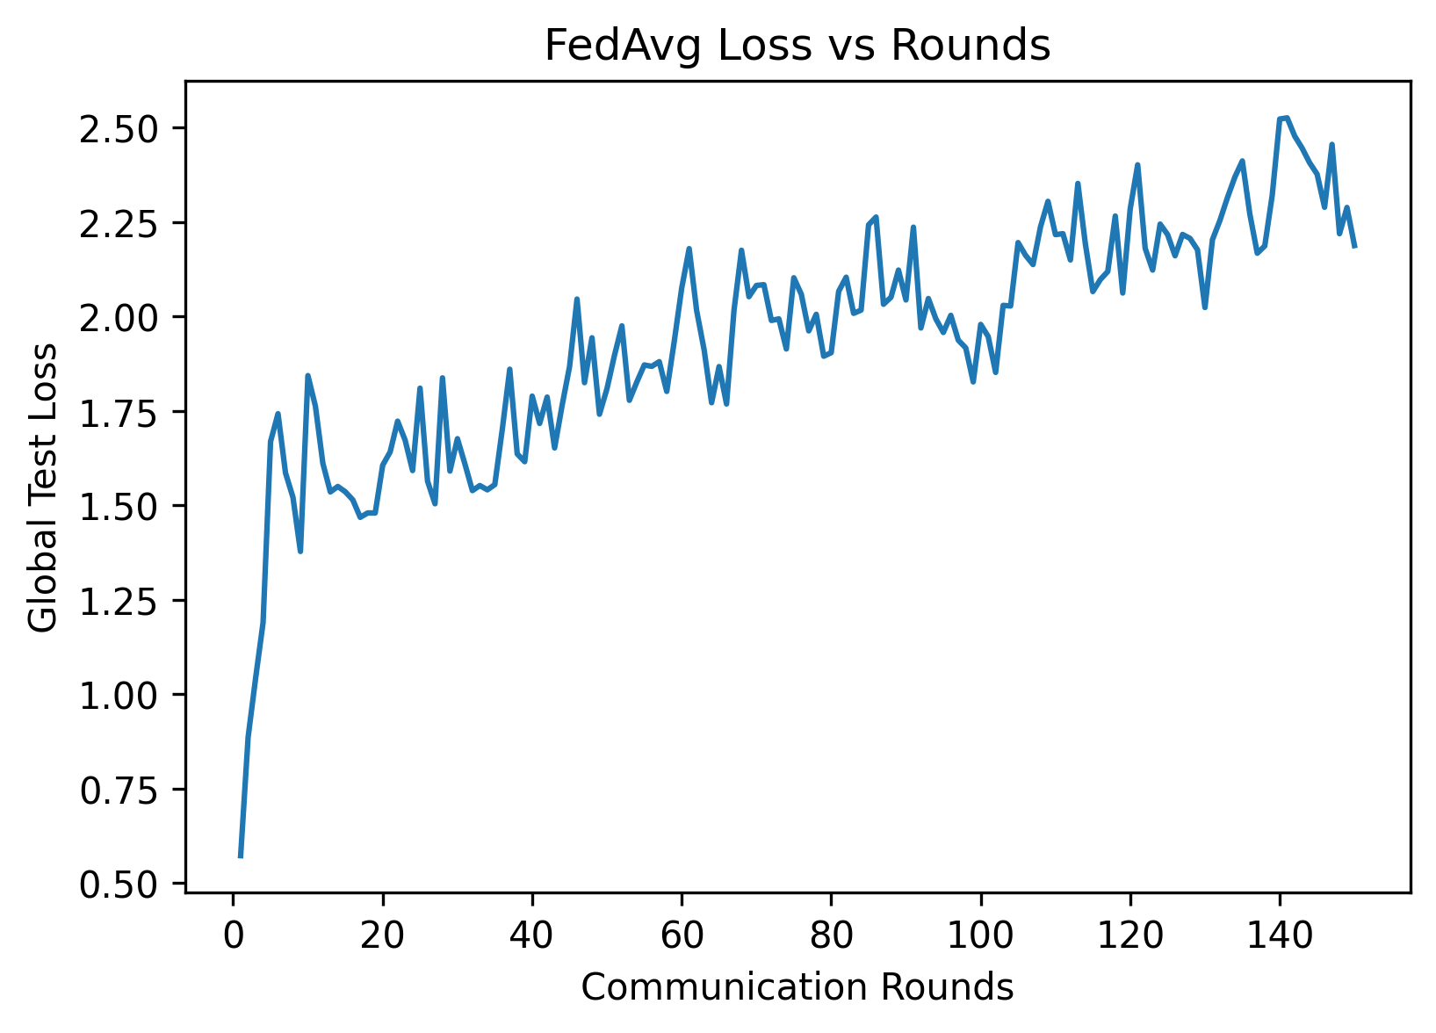
Global Loss vs Communication Rounds
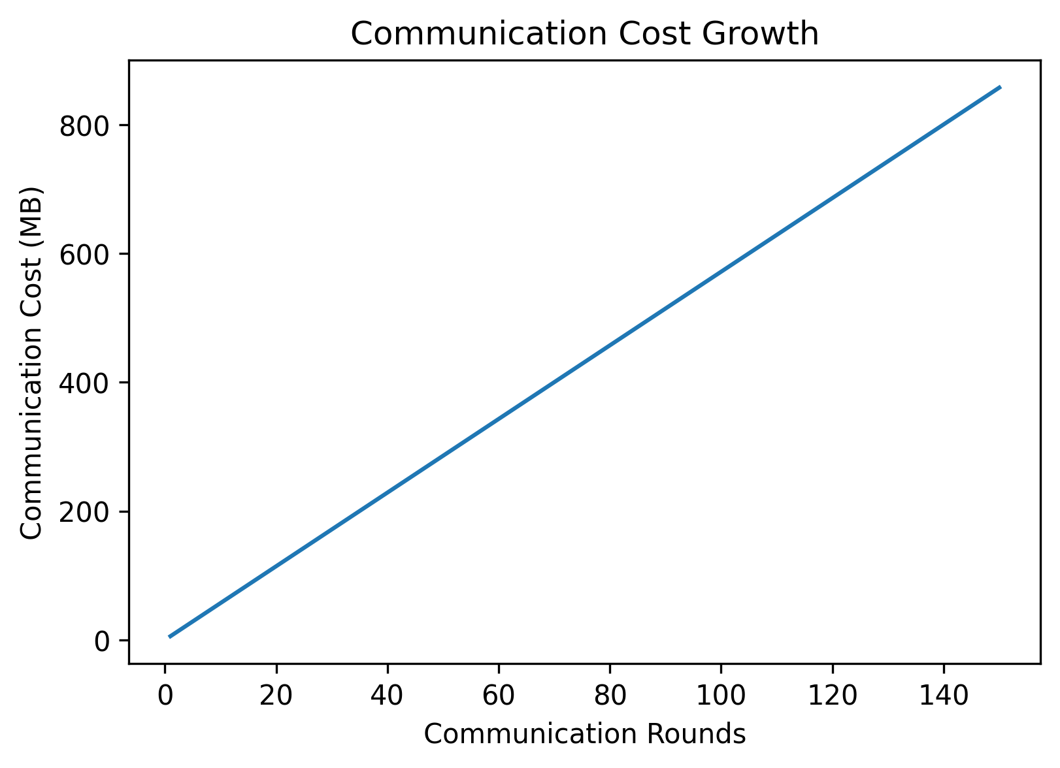
Communication Cost vs Communication Rounds

Experimental Analysis
The uploaded federated training metrics show that the global accuracy reached approximately 82.80% during training.
The cumulative communication cost reached 857.72 MB after all communication rounds.
The training loss consistently decreased during federated optimization, demonstrating stable convergence behavior.
The experiments validate that federated continual learning can successfully operate under heterogeneous environments while preserving communication efficiency.

Results Table
Metric | Value | Observation | Importance | Status
Maximum Accuracy | 82.80% | High convergence | Model quality | Good
Minimum Loss | 0.5728 | Stable optimization | Training stability | Good
Communication Cost | 857.72 MB | Linear growth | Efficiency | Moderate
Total Rounds | 150 | Full FL execution | Experiment completeness | Completed

Conclusion
The uploaded experimental outputs demonstrate successful implementation of federated continual learning using the Flower framework. The project validates the effectiveness of collaborative federated optimization under heterogeneous client environments. Knowledge distillation and continual learning concepts improved communication efficiency and convergence stability.

References
McMahan et al., Communication-Efficient Learning of Deep Networks from Decentralized Data, 2017.
Qiu et al., FedKDC: Consensus-Driven Knowledge Distillation for Personalized Federated Learning in EEG-Based Emotion Recognition, IEEE JBHI, 2025.
Flower Federated Learning Framework Documentation.
FedMD: Heterogeneous Federated Learning via Model Distillation.

