Checklist for Schema Design
- Have I listed all entities and their relationships (1:1, 1:N, N:M)?
- Is every table in 3rd Normal Form (3NF) to start?
- Are foreign keys explicitly defined with ON DELETE rules?
- Are all foreign keys indexed?
- Are monetary values using exact decimal types (NUMERIC/DECIMAL)?
- Are timestamps stored in UTC (TIMESTAMPTZ)?
- Is there a strategy for schema migrations?
(USE THIS CHECKLIST TO CONFIRM that SCHEMA IS DESIGNED Perfectly)
Prompt:
Act as a Principal Database Architect. I want to design a database schema for my project, but I want to do it collaboratively through an interactive discovery interview.
Do NOT generate a full schema immediately.
Instead, follow this process:
1. Start by asking me 3 to 4 essential high-level questions about my project (domain, core features, database tech, and user roles).
2. Wait for my answers.
3. Based on my responses, outline a tentative list of Core Entities and ask 3 targeted follow-up questions to drill into:
- Primary access patterns (most frequent reads/writes)
- Relationships & cardinality (1:1, 1: N, N:M)
- Business rules & constraints (e.g., soft deletes, multi-tenancy, RBAC, payment histories, audit logs)
4. We will iterate through Q&A rounds until all ambiguities are cleared.
5. Once we both agree we have covered everything, present the final production-ready schema design (complete DDL/ORM code, Mermaid ERD, and indexing strategy).

Let's begin. Ask me the first set of questions to kick off the discovery process.
NOTES ABOUT HOW TO DESIGN SCHEMA
1. Domain Discovery & Requirements Gathering
Before writing any DDL or drawing tables, understand what data you need to store and how it will be queried.
- Identify Entities: What are the main nouns in your domain? (e.g., User, Order, Product, Invoice, Organization).
- Identify Attributes: What properties belong to each entity? (e.g., a User has email, password_hash, first_name, created_at).
- Map Access Patterns:
  - Which queries will run most frequently? (e.g., "Get user by email", "Get user's 10 most recent orders").
  - Is the app Read-Heavy (e.g., blog, e-commerce catalog) or Write-Heavy (e.g., analytics collector, IoT sensors)?

2. Select the Appropriate Database Paradigm
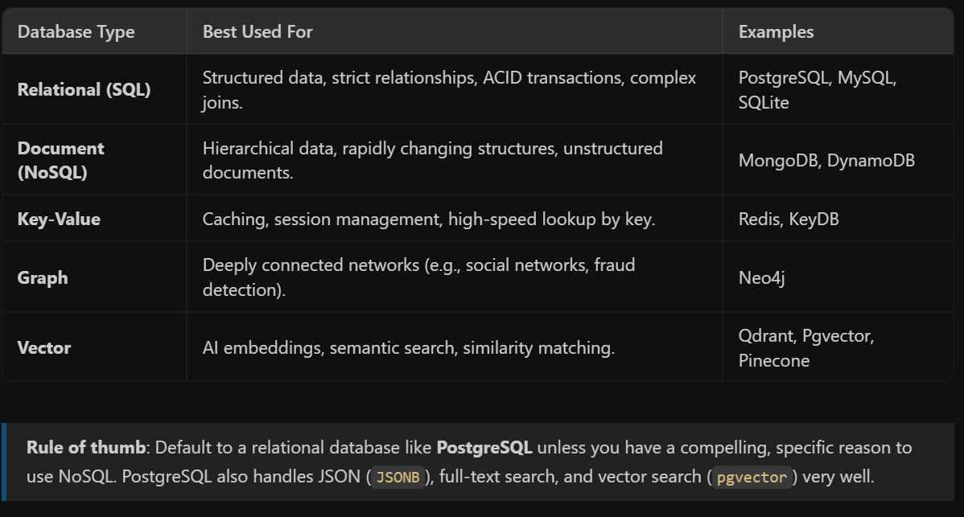

3. Define Relationships & Cardinality
Determine how entities relate to each other:
- One-to-One (1:1): E.g., User $→$ UserProfile.
  - Implementation: Place a foreign key with a UNIQUE constraint on one table, or merge into a single table if split unnecessarily.
- One-to-Many (1:N): E.g., User $→$ Orders.
  - Implementation: Put the Foreign Key (user_id) on the "Many" side (orders table).
- Many-to-Many (N:M): E.g., Student $↔$ Course.
  - Implementation: Create a Junction (Pivot) Table (e.g., enrollments table with student_id and course_id).

4. Normalization vs. Strategic Denormalization
- Normalize first (up to 3NF):
  - Eliminate redundant data (don't store user email in every order row).
  - Ensure every attribute depends directly on the primary key.
- Denormalize for performance (only when necessary):
  - Store aggregate totals (e.g., total_spent on users table or item_count on orders) if calculating them on the fly becomes a major bottleneck.
  - Cache pre-joined read views for high-frequency queries.

5. Standardize Field Types & Data Integrity Constraints
- Primary Keys (PK): Use UUIDv7 or auto-incrementing BIGINT IDs.
- Foreign Keys (FK): Always define foreign key constraints with explicit delete behaviors (ON DELETE CASCADE vs ON DELETE RESTRICT / SET NULL).
- Nullability: Mark fields NOT NULL by default unless NULL represents a genuine absent state.
- Timestamps: Always include created_at and updated_at (using TIMESTAMPTZ / UTC timezone).
- Data Types: Choose narrow types (SMALLINT vs INT, VARCHAR(255) vs TEXT, NUMERIC for monetary values to avoid floating-point errors).

6. Indexing Strategy
Create indexes based on your query patterns:
- Primary & Foreign Keys: Primary keys are indexed automatically; always index foreign keys to keep JOIN queries fast.
- Filter & Sort Columns: Index fields frequently used in WHERE, ORDER BY, or GROUP BY clauses.
- Composite Indexes: For queries filtering on multiple columns (e.g., WHERE status = 'ACTIVE' AND created_at > ...), create a multi-column index ordered by selectiveness.
- Avoid Over-Indexing: Indexes speed up reads but slow down INSERT, UPDATE, and DELETE queries.

7. Operational & Lifecycle Patterns
- Soft Deletes vs Hard Deletes: For auditing or compliance, add a deleted_at TIMESTAMPTZ NULL field rather than deleting rows permanently.
- Audit Logs: Maintain separate event/audit logs for sensitive changes (e.g., balance updates, role changes).
- Migrations: Never modify production schema manually. Use migration tools like Prisma, Drizzle, Alembic, or Flyway committed to version control.

Concrete Example: E-Commerce Orders Schema
Below is a production-ready PostgreSQL example implementing these principles:
