**URL for project assignment:**

<https://www.springboard.com/workshops/data-science-career-track/learn#/curriculum/448>

***Solution for question1:***

import pandas as pd

import json

import operator

from pandas.io.json import json_normalize

sample_json_df = pd.read_json(r'C:\Users\anshu\Documents\assign\data_wrangling_json\data\world_bank_projects.json')

# Initialize an empty dictionary: counts_dict

counts_cntry = {}

#looping through dataframe

for column in sample_json_df['countryshortname']:

if column in counts_cntry.keys():

counts_cntry[column] += 1

else:

counts_cntry[column] = 1

#getting 10 countries with most projects

sorted(counts_cntry.items(), key=operator.itemgetter(1), reverse=True)[:10]

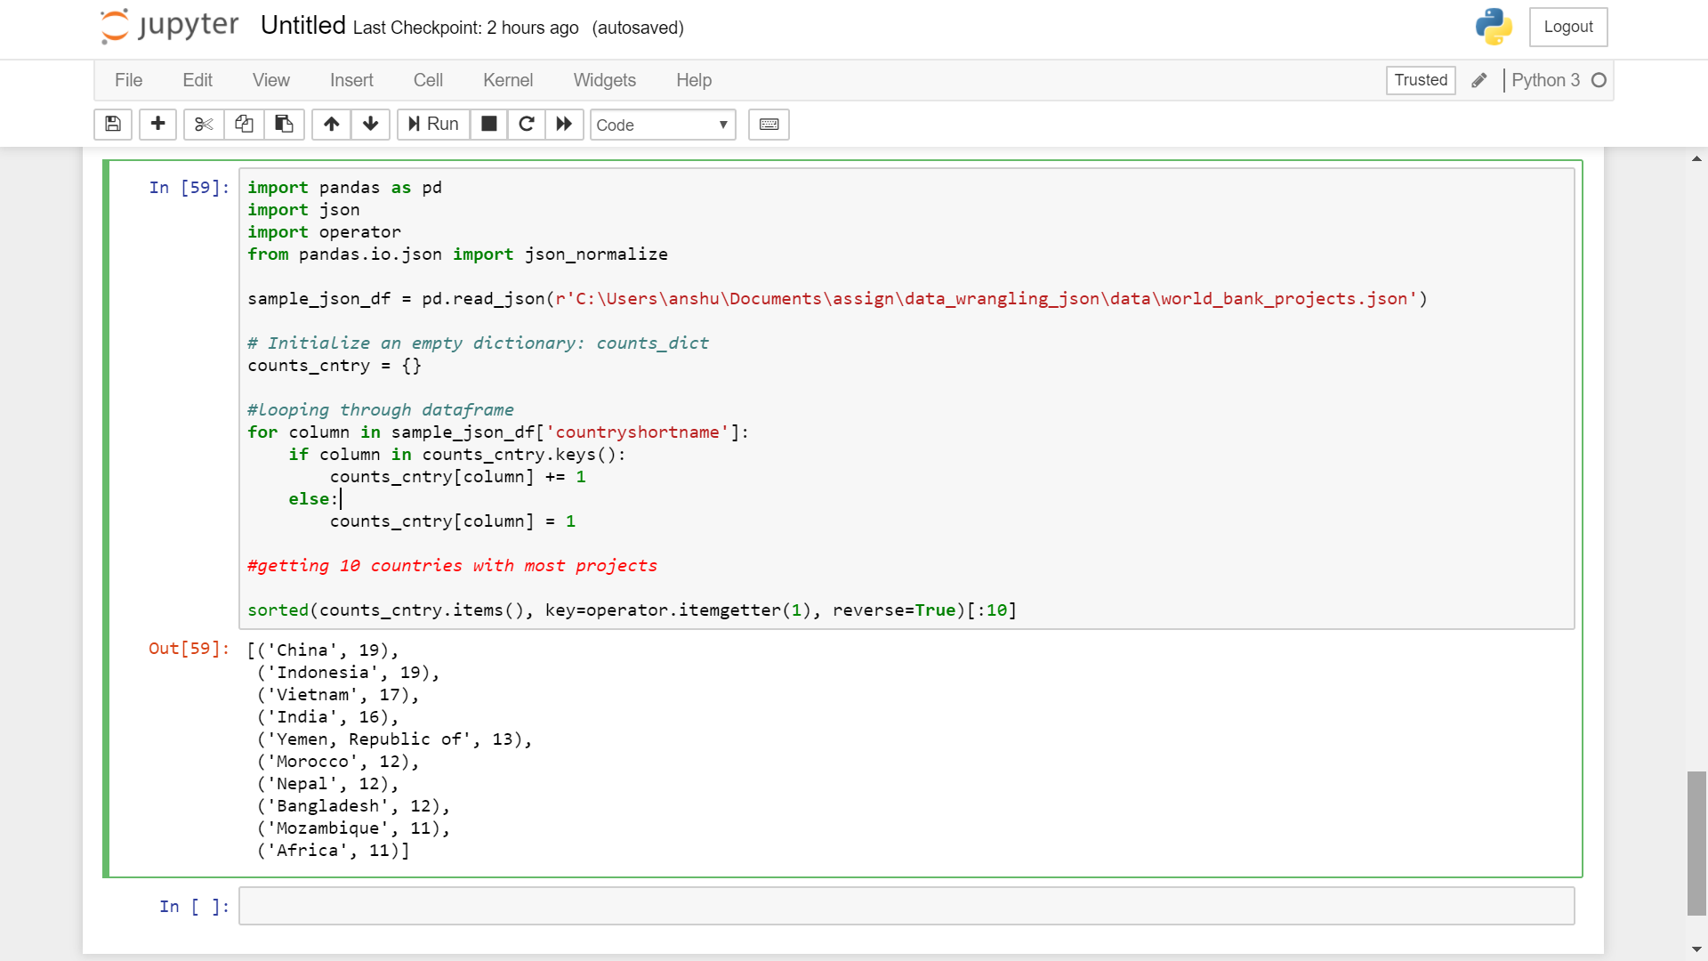

***Solution for question2:***

import pandas as pd

import json

import operator

from pandas.io.json import json_normalize

df = pd.read_json(r'C:\Users\anshu\Documents\assign\data_wrangling_json\data\world_bank_projects.json')

# also load in the raw json to wrangle the nested fields later

with open(r'C:\Users\anshu\Documents\assign\data_wrangling_json\data\world_bank_projects.json') as f:

raw = json.load(f)

df_themes = json_normalize(raw, 'mjtheme_namecode', ['id'])

# some projects seem to have multiple theme code's

#df_themes.groupby('id').code.nunique().sort_values(ascending=False).head(10)

# so to find top themes we will account for this one to many relationship

#print('Top 10 Major World Bank Project Themes:')

df_themes.name.value_counts().head(10)

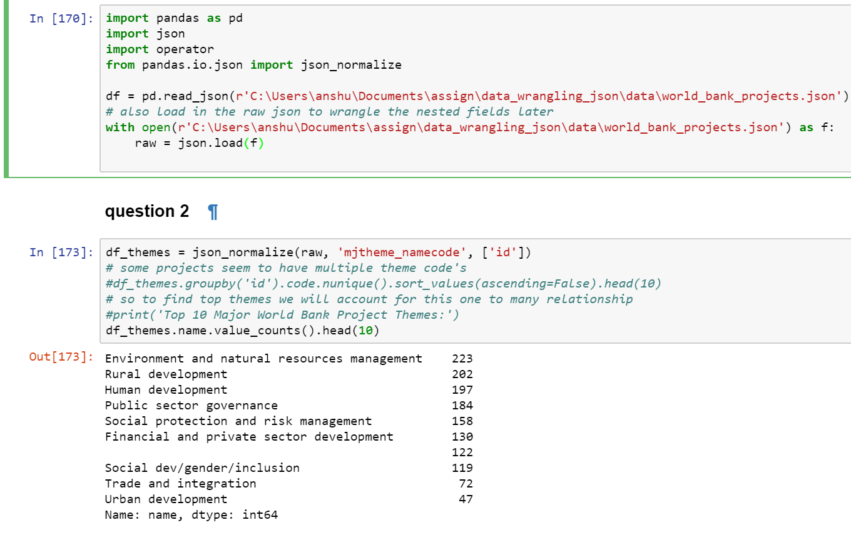

***Solution for question3:***

df_themes_name_to_code = df_themes.groupby('name').code.max().sort_values(ascending=False)

df_themes_name_to_code = df_themes_name_to_code[df_themes_name_to_code.index != '']

df_themes_name_to_code = pd.DataFrame(df_themes_name_to_code,columns=['code'])

df_themes_name_to_code['name_clean'] = df_themes_name_to_code.index

df_themes_code_to_name = df_themes_name_to_code.set_index(['code'])

df_themes_clean = df_themes.merge(df_themes_code_to_name,how='outer',left_on=['code'],right_index=True)

df_themes_clean

