Department of Electrical Engineering
Indian Institute of Technology, Roorkee
Roorkee
EE – 101: Electrical Science
Tutorial Sheet – 02

1. | Find the equivalent resistance between terminals X-Y in the resistive network shown in Fig. 1.  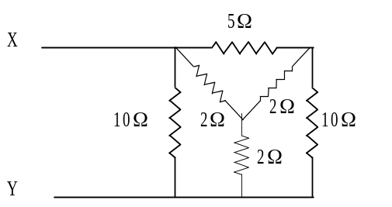  Fig. 1 | (Ans.: R=2.375 Ω)
2. | Find the source current in the following circuit. (Fig. 2)  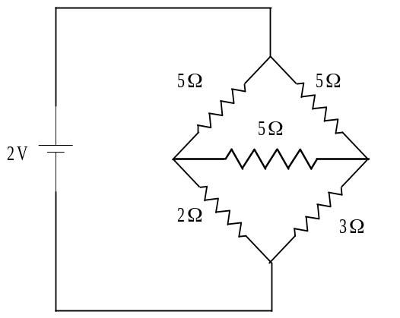  Fig. 2 | (Ans.: I=0.5369 A)
3. | Find the Thevenin’s equivalent circuit of Fig. 3 and find the current in 3 Ω resistor.  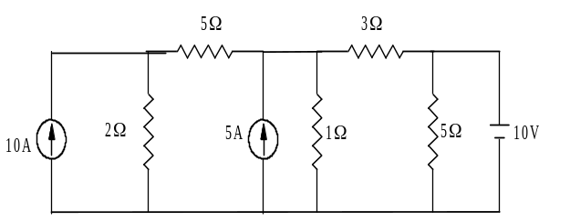  Fig. 3 | (Ans.: v_{th}=3.125 V,  r_{th}=7/8 A,  I=0.806A)
4. | Find the Norton equivalent to right of a-b terminal in Fig. 4.  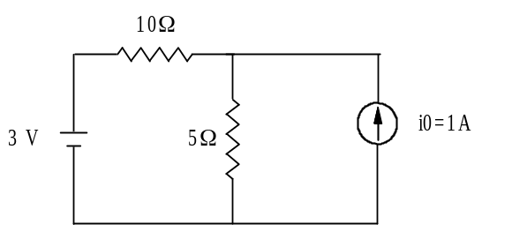  Fig. 4 | (Ans.: I=0.333 A,  R_{n=}15 Ω)

5. | Find the current ‘I’ in the given circuit (Fig. 5) using superposition theorem.  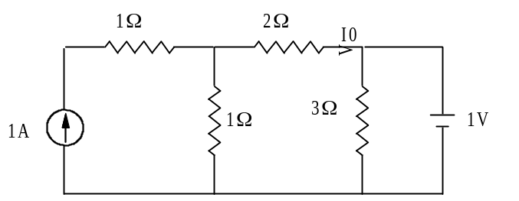  Fig. 5 | (Ans.: I=0 A)
6. | Find the equivalent resistance between terminals A-B in Fig. 6.  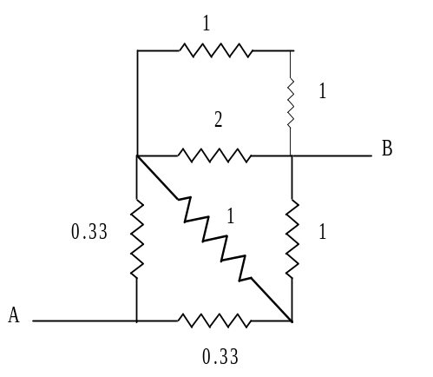  Fig. 6 | (Ans.: 0.666 Ω)
7. | Use superposition theorem to find current ‘I’ in the given circuit. (Fig. 7)  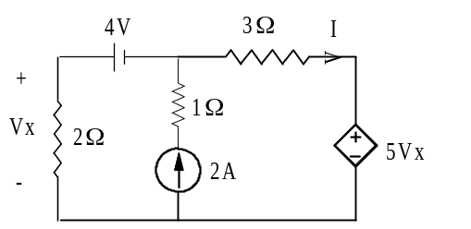  Fig. 7 | (Ans.: I=4 A)
8. | Find the current through 10Ω resistor using Thevenin’s theorem (use star delta transformation also). (Fig. 8)  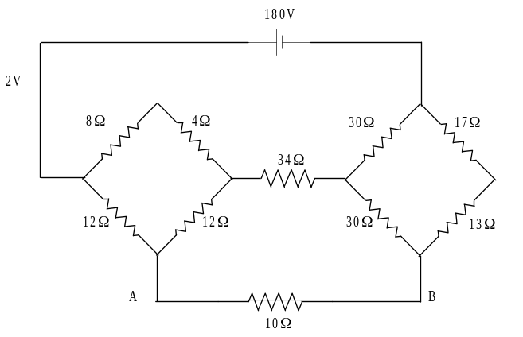  Fig. 8 | (Ans.: V_{th}=139.354 V,  Z_{th}=24.8 Ω,  I=4 A)

9. | Evaluate current through 10 Ω resistor by Thevenin’s theorem and confirm it by Norton’s theorem. (Fig. 9)  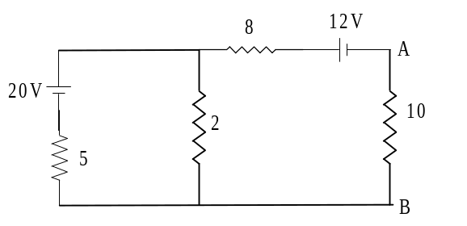  Fig. 9 | (Ans.:  V_{th}=-6.286 V,  Z_{th}=9.42 Ω,  I_{l}=0.3236 A)
10. | Find the currents through all the resistances using superposition theorem. (Fig. 10)  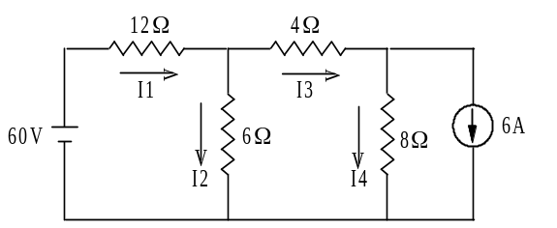  Fig. 10 | (Ans.: I₁₌4.75A, I₂₌0.5A, I₃₌4.25A, I₄=1.75A)
11. | Find the equivalent pie circuit of the following network and find R_{a-b} (all resistances being 1Ω). (Fig. 11)  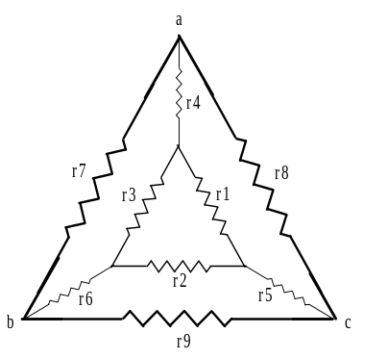  Fig. 11 | (Ans.:  r_{ab}||(r_{ab}+r_{bc}))
12. | Find the Thevenin’s equivalent circuit about a-b of the given circuit. (Fig. 12)  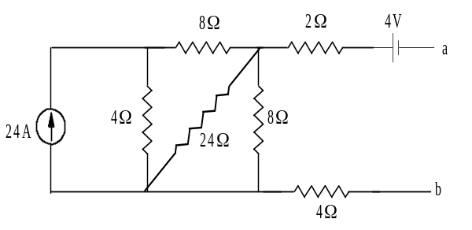  Fig. 12 | (Ans.:  V_{th}= 2 V,  R_{th}=10 Ω)

