PRACTICAL NO 2

Submitted by:- Submitted to:-

Mandeep Choudhary Dr. R.B. Patel

AIM:- Problem 2: Case Study of Simply Linked List: Write a modular program using Simple Linked List for managing record of employees of a Company (e.g. CCET Chandigarh may be considered). The attributes of a record are as follows-

Employee Id (As a primary key) {Consider 6 Digit Number}

Employee Name {Alphabets a-z(only) and .}

Employee Father’s Name {Alphabets a-z(only) and .}

Employee Mother’s Name {Alphabets a-z(only) and .}

Rank/Position {Alphabets a-z(only) and .}

Department of Work Place {Alphabets a-z(only) and .}

Date of Joining the Company {Only Numeric Value dates and months should not be more than 2 digits and year should not be less or more than 4 digits.

Employee Address

Home/House No

Street Name

City

State

Country

Pin

The program must contain the following modules.

Insert a record into the database.

Delete a record from the database

Find a Record into the database

Update a Record {Employee Id cannot be changed}

Display the records of all the Employee belong to particular city/State/Country/Pin

Generate report as per requirements {e.g., List the Employee City wise}

Note: Database should not maintain duplication records.

**DISCUSSION and MODELLING:-**

The block diagram for the given problem is:-

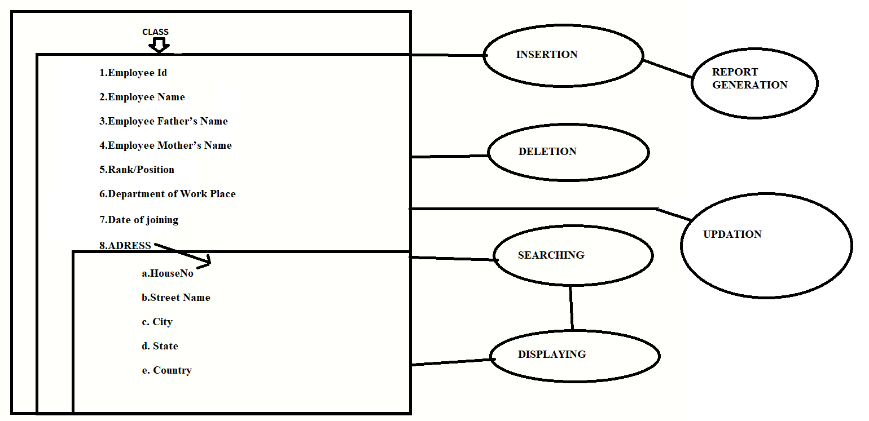

**FLOWCHART for insertion:-**

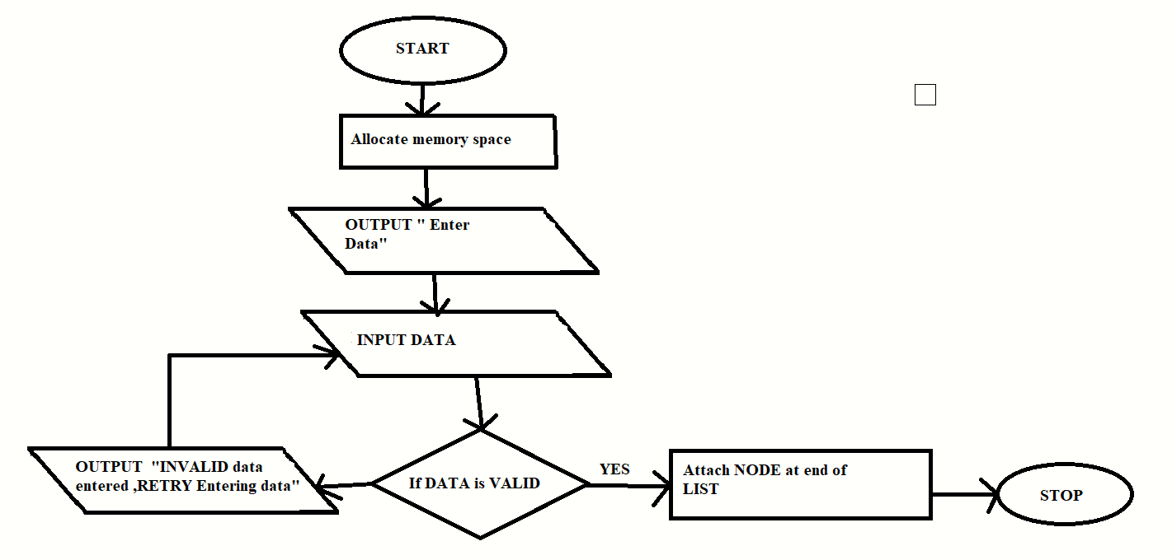

**FLOWCHART for DELETION:-**

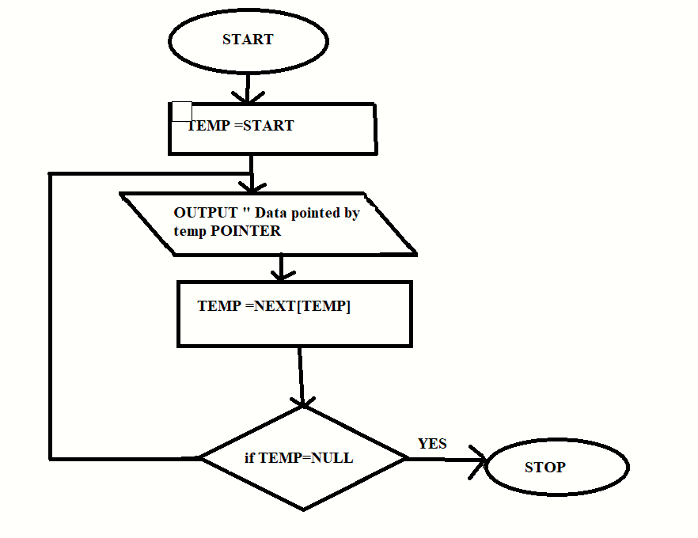

**FLOWCHART for SEARCHING:-**

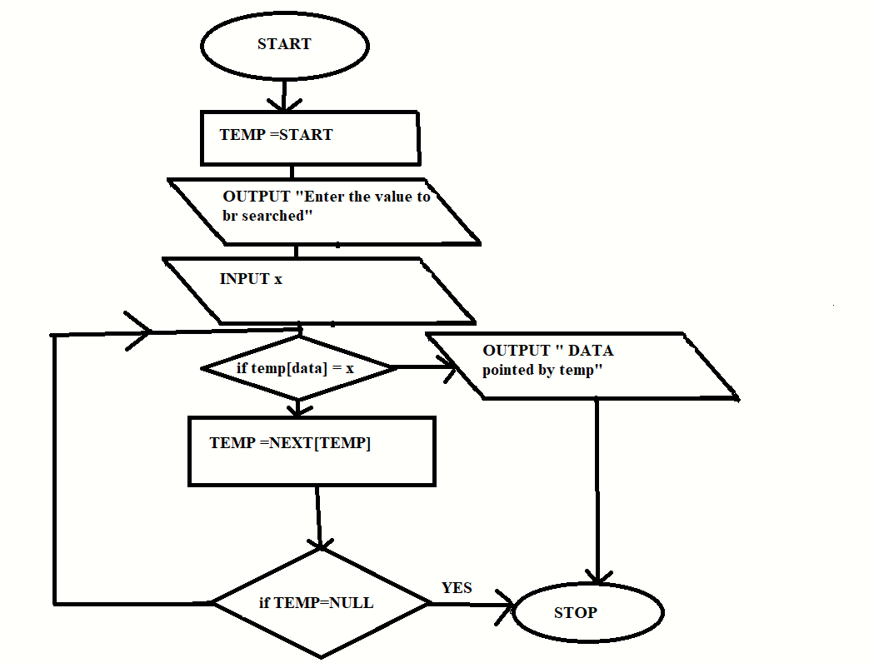

**IMPLEMENTATION:-**

The Source code file is attached with this file.

**OBSERVATIONS:-**

The Screenshots of insertion,deletion,updation,displaying and searching are:-

INSERTION:-

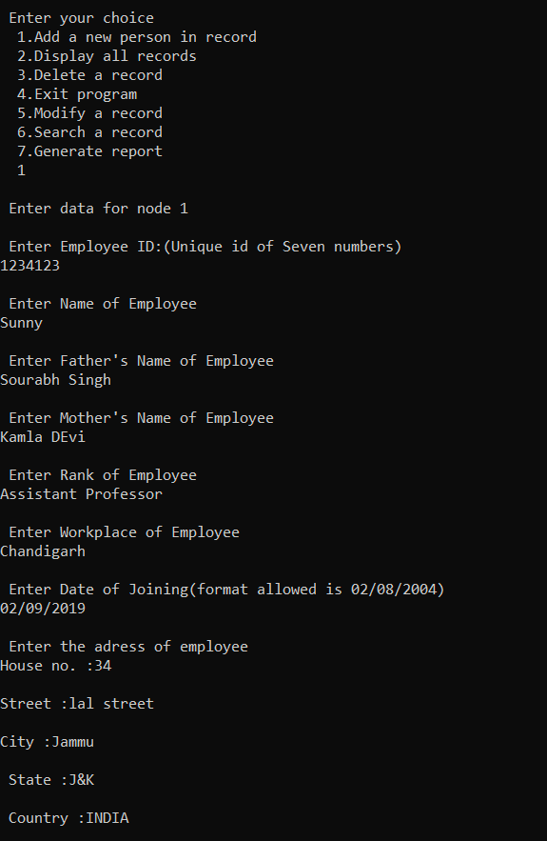

**DISPLAYING:-**

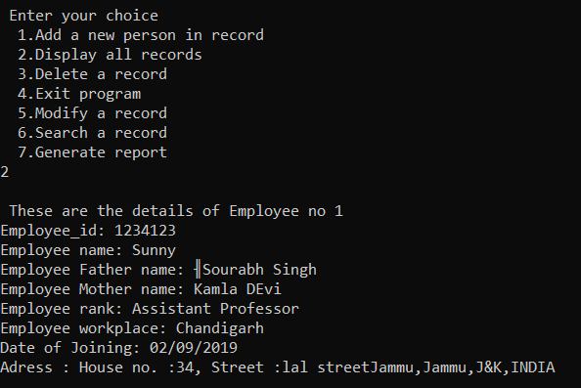

**SEARCHING:-**

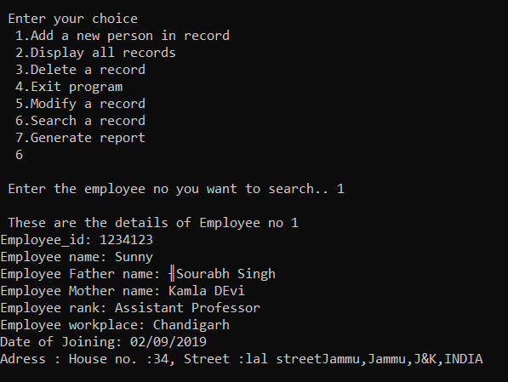

**DELETION:-**

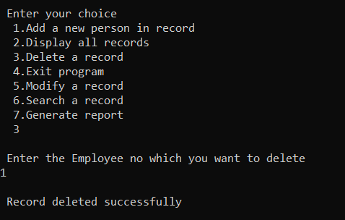

**LESSONS LEARNED:-**

By performing this experiment, I came to learn about a lot of things related to linked list data structure.This experiment is really helpful for more practical understanding of linked list.

Thank You