PROJECT REPORT | N8N + AI

German Property Investment Evaluator
A concise report on the ingestion, evaluation, chat, and user interface workflows.

1 Project overview
Reviewing a property for investment requires collecting listing details, assessing risks, and understanding the asking price in its market context. This project brings those steps into an initial AI-assisted screening workflow.
A user uploads a property PDF, receives an investment report, and can ask follow-up questions about the same property. Reference documents are prepared separately to support the evaluation.

The solution at a glance
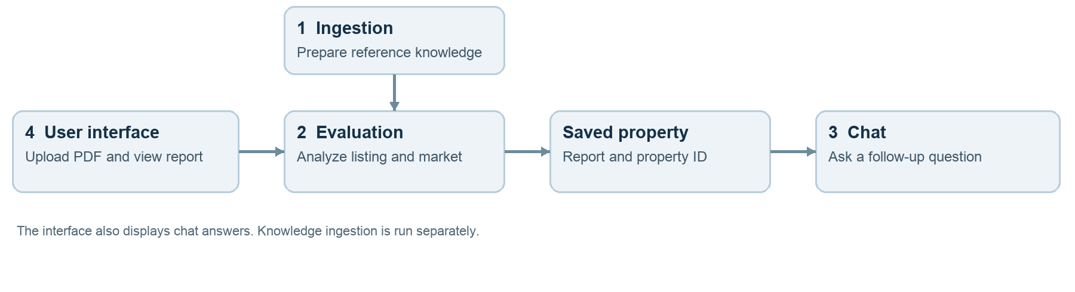
Scope: The output is a starting point for research, not a certified valuation or a substitute for financial, legal, or technical due diligence.

Reading guide
1 Overview • 2 The workflows • 3 Design and testing • 4 Lessons and next steps

2 The four workflows
Each workflow has a distinct role. Together they move information from reference documents and a property listing to a report and a property-specific conversation.

1 Knowledge ingestion
Input: reference PDFs or spreadsheets. The workflow extracts content, divides it into chunks, creates embeddings with Nebius, and stores vectors and metadata in Pinecone. This prepares background knowledge for retrieval during evaluation. Ingestion is separate from each property upload.

2 Property evaluation
Input: a property listing PDF. The workflow extracts the listing, retrieves background context, and uses a language model to create a structured investment analysis. It searches for market evidence, assembles an HTML report, saves the property record in an n8n data table, and returns a property ID.
Market evidence is treated carefully. If fewer than three eligible comparable listings are found, the report may show a sourced location benchmark. A broad house or apartment benchmark is labelled as such; unsupported adjustments for property subtype or condition are not assumed.

3 Property-specific chat
Input: a question, property ID, and session ID. The workflow loads the saved property record and conversation history, then generates a concise answer in English. The IDs keep follow-up questions linked to the selected property and session.
The exported chat workflow contains embedding and Pinecone retrieval nodes, but they are not connected to the active chat path. Current chat answers use the saved property context and conversation history; live vector retrieval is a future improvement.

4 Unified interface
The n8n-hosted interface provides PDF upload, report viewing, and chat on one page. The report is displayed in a restricted frame. Property and session IDs are visible and can be entered again to resume a conversation; the report itself is not restored by that action.

3 Design and testing

Approach and inspiration
The project applies ideas illustrated in the provided solution kits: separate ingestion and question-answering workflows, grounded document analysis, clear system diagrams, and practical testing. These examples informed the report structure; the implementation reflects the project’s own workflows and constraints.
Decision | Purpose and trade-off
n8n workflows | Separate the major tasks and make the process visible; the workflows still depend on reliable handoffs and external services.
Pinecone + embeddings | Make reference material searchable by meaning; index configuration and document quality affect retrieval.
Tavily market search | Bring current search observations into the report; snippets and listing details require verification.
n8n data tables | Retain property records and conversation history; the tables require access controls and ongoing management.
Webhook-based UI | Provide a quick unified interface; sandbox, origin, and deployment settings must be configured carefully.

What was tested
The live flow was tested with a property PDF: the evaluation returned a property ID and report, and a follow-up question returned an answer linked to that property and session. A German-language chat question was also tested after adding an English-response instruction.
These examples demonstrate the flow, but they are not a comprehensive quality evaluation. More properties and questions are needed to test extraction accuracy, source grounding, and isolation between properties.

Observed performance
Four complete evaluations before optimization took approximately 31, 39, 43, and 65 seconds. Two later tests took 20 and 103 seconds. The slower test spent most of its time in external model calls. These small samples show substantial variability and do not establish a guaranteed improvement.

4 Lessons and next steps

Challenges and lessons
- Workflow handoffs: retaining the property and session IDs was essential for linking a follow-up conversation to the right report.
- Incomplete market evidence: listing candidates and location benchmarks need to be separated, sourced, and qualified; neither automatically establishes property value.
- Web interface restrictions: n8n-hosted HTML requires careful handling of sandboxing and cross-origin requests.
- Variable response times: external model and search services can dominate the total duration, even when workflow processing is fast.

Priority improvements
Priority | Next step
High | Connect and test property-filtered vector retrieval in the active chat path.
High | Add webhook authentication and restrict network access; the current webhooks are unauthenticated.
High | Create a repeatable test set for PDF extraction, factual grounding, market evidence, and property isolation.
Medium | Improve progress messages, error handling, report recovery, and measurement of latency and cost.
Medium | Strengthen source verification and clarify how location, property type, condition, and date affect benchmarks.

Conclusion
The project demonstrates a working path from property PDF to report and follow-up chat using four connected n8n workflows. Its main value is organizing an initial review in one place. Further testing, stronger security, and more reliable evidence handling are needed before broader use.

Reference materials
The report draws on the project’s workflow exports and test observations, together with the supplied Customer Support, GraphRAG, Financial Document Analysis, and Enterprise Policy Q&A solution kits.

