Behavioral Feature Engineering and Explainable Gradient Boosting for Credit Card Default Prediction: A Robust Machine Learning Framework

Abstract — Accurate prediction of credit card default risk is essential for financial institutions, directly affecting lending decisions, portfolio management, and financial stability. Traditional credit scoring methods, while transparent, often fail to capture the nonlinear, evolving repayment behavior present in modern credit data. This paper proposes a behavioral feature engineering framework combined with gradient boosting algorithms for credit card default prediction. Ten behavior-oriented features — capturing average and maximum repayment delay, delayed- and severely-delayed-month counts, credit utilization, and payment-to-bill ratios — are engineered from the UCI Credit Card Default dataset (30,000 records) and appended to the 23 original account-level attributes, forming a 33-feature representation. Six machine learning models (Logistic Regression, Decision Tree, Random Forest, XGBoost, LightGBM, and CatBoost) are compared using five-fold stratified cross-validation, and CatBoost — the strongest baseline (mean CV ROC-AUC = 0.7880 ± 0.0087, mean CV accuracy = 82.09%) — is further tuned via Optuna-based Bayesian hyperparameter optimization, reaching a held-out test-set ROC-AUC of 0.7780 at the standard 0.5 decision threshold. A controlled ablation experiment isolating the ten engineered features shows a consistent improvement in ROC-AUC both on a single held-out split (0.7763 to 0.7780, +0.0017) and under five-fold cross-validation (0.7859 to 0.7880, +0.0021), improving in four of five folds. A paired one-sided Wilcoxon signed-rank test on the fold-level differences (statistic = 14.0) yields p = 0.0625, which does not reach conventional statistical significance at α = 0.05 at this sample size. CatBoost feature-importance analysis shows that five of the top eight most influential predictors are engineered behavioral features — credit utilization, maximum payment delay, severe- and general-delay month counts, and average payment status — indicating that behavioral aggregation surfaces genuinely informative signal even though the raw repayment-status columns already carry much of it. These findings suggest that behavioral feature engineering, gradient boosting, and explainable AI can jointly form a reliable and interpretable framework for credit card default prediction, while highlighting the importance of rigorous cross-validation and significance testing when evaluating engineered features.
Index Terms — credit risk prediction; credit card default; behavioral feature engineering; CatBoost; gradient boosting; explainable artificial intelligence; SHAP; hyperparameter optimization; cross-validation; Wilcoxon signed-rank test
1. INTRODUCTION
Credit risk assessment is a central task in financial decision-making, since inaccurate default prediction can lead to substantial financial losses and elevated portfolio risk. Credit card default prediction is particularly challenging because repayment behavior emerges from the interaction of multiple factors, including payment history, credit utilization, outstanding balances, and repayment capacity.
Traditional credit scoring systems have long relied on logistic regression due to its simplicity, transparency, and acceptance by regulators. However, such methods typically assume linear relationships between predictors and default probability, limiting their ability to capture the more intricate behavioral patterns present in modern credit data. Gradient boosting algorithms — including XGBoost, LightGBM, and CatBoost — have demonstrated strong performance on structured financial data, but much of the existing literature emphasizes algorithm comparison rather than the design of behaviorally meaningful feature representations.
This study addresses that gap by proposing a behavioral feature engineering framework integrated with explainable gradient boosting models for credit card default prediction, and by subjecting the resulting features to five-fold stratified cross-validation, a controlled ablation study, and a paired statistical significance test — rather than reporting only single-split accuracy gains.
The main contributions of this study are as follows:
• A behavioral feature engineering framework capturing repayment delay magnitude, delay frequency, credit utilization, and payment consistency, derived from the raw monthly account attributes of the UCI Credit Card Default dataset.
• A systematic comparison of six machine learning models using five-fold stratified cross-validation across accuracy, precision, recall, F1-score, and ROC-AUC, extended with Optuna-based Bayesian hyperparameter tuning of the top-performing model.
• A controlled ablation study (original vs. original + engineered features), evaluated on both a single held-out split and five-fold stratified cross-validation, with a paired Wilcoxon signed-rank significance test on the fold-level differences.
• Feature-importance analysis identifying which original and engineered features most strongly drive CatBoost's default predictions.
2. RELATED WORK
Gradient boosting methods are consistently reported among the strongest performers for structured credit risk data. Comparative studies across multiple financial datasets find that XGBoost and CatBoost tend to perform best in terms of accuracy, F1-score, and AUC among boosting variants, although no single algorithm dominates across every dataset, and LightGBM's performance can be less stable on highly imbalanced or heterogeneous data. CatBoost in particular has been shown to perform well on datasets with a high proportion of categorical variables, a common characteristic of credit risk data.
Feature engineering for credit risk has increasingly moved toward behavioral representations. Prior work has shown that repayment behavior observed over time — for example, patterns of mobile-phone usage or historical repayment consistency — can reveal risk signals that are not visible in static, single-period account attributes. This motivates the present study's use of aggregated repayment-delay, delay-frequency, utilization, and payment-consistency features rather than relying solely on the raw monthly snapshots.
Interpretability remains a central concern for the practical deployment of gradient boosting models in regulated financial settings. SHAP (SHapley Additive exPlanations) has become a standard tool for explaining tree-ensemble predictions, and SHAP's TreeExplainer provides exact, efficient Shapley-value computation for models such as CatBoost and XGBoost, enabling both global feature-importance ranking and local, per-customer explanations.
3. DATASET
This study uses the UCI Credit Card Default dataset, comprising 30,000 customer records with 23 original attributes: credit limit, demographic variables (sex, education, marital status, age), six months of repayment status codes (PAY_0 – PAY_6), six months of bill amounts (BILL_AMT1 – BILL_AMT6), six months of payment amounts (PAY_AMT1 – PAY_AMT6), and a binary target variable indicating default in the following month.
The dataset exhibits moderate class imbalance: 23,364 non-default cases (77.9%) versus 6,636 default cases (22.1%). Outlier analysis on the bill and payment amount columns shows 8–10% of values lying beyond the standard 1.5×IQR threshold, consistent with the heavy-tailed nature of financial transaction data; these were retained rather than removed, since extreme balances and payments are themselves informative of risk rather than being data-entry errors.

Statistic | Value
Total records | 30,000
Original attributes | 23
Non-default cases (class 0) | 23,364 (77.9%)
Default cases (class 1) | 6,636 (22.1%)
Training set (80%, stratified) | 24,000
Testing set (20%, stratified) | 6,000
TABLE 1. Dataset summary and train/test partitioning.
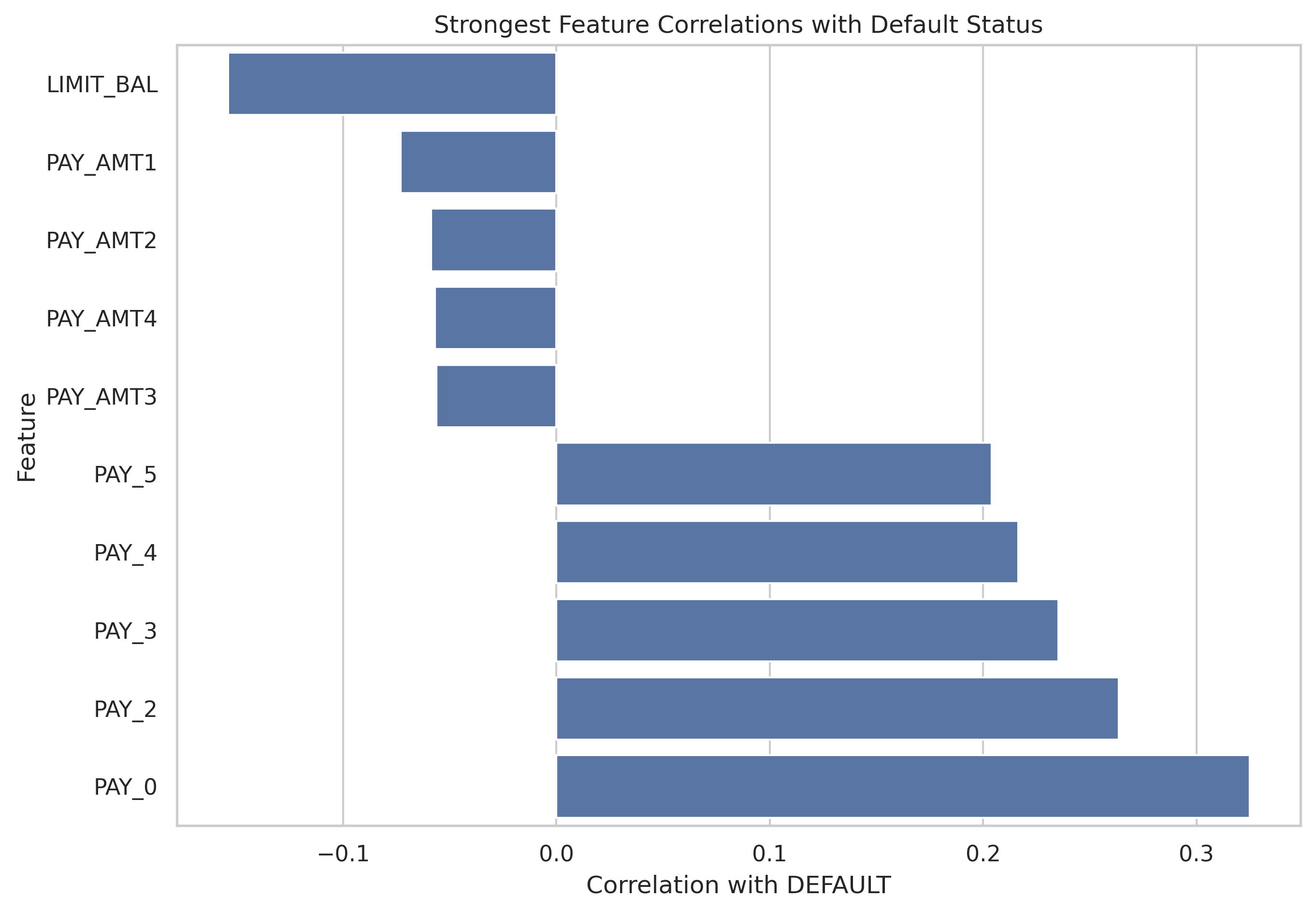
Fig. 1. Strongest raw-feature correlations with default status (original attributes).

Prior to feature engineering, the pairwise Pearson correlation of each original attribute with the binary DEFAULT target was examined (Fig. 1). The six repayment-status columns are the strongest positively correlated original attributes (r = 0.20–0.33, led by PAY_0), while LIMIT_BAL is the strongest negatively correlated attribute (r ≈ −0.15); the payment-amount columns (PAY_AMT1–PAY_AMT4) show weaker negative correlation. This pattern motivates the behavioral feature engineering strategy described in Section 4: aggregating the six monthly repayment-status codes into summary statistics — mean, maximum, and delay-frequency counts — is a natural way to consolidate their shared signal into a smaller number of more robust predictors.
4. METHODOLOGY: BEHAVIORAL FEATURE ENGINEERING
Ten behavior-oriented features were engineered from the six-month repayment history and appended to the 23 original attributes, forming a 33-feature engineered representation (Table 2). Two of the ten features — DELAYED_MONTHS and SEVERE_DELAY_MONTHS — extend the earlier magnitude- and ratio-based features with explicit delay-frequency counts, capturing how often, rather than only how severely, a customer fell behind on payments.
These variables were designed to summarize repayment consistency (AVG_PAY_STATUS, MAX_PAY_STATUS, DELAYED_MONTHS, SEVERE_DELAY_MONTHS), credit utilization patterns (CREDIT_UTILIZATION), and payment-related indicators (AVG_PAY_AMT, PAYMENT_RATIO, TOTAL_PAYMENT), reflecting the hypothesis that aggregated behavioral trends over the observation window carry information beyond any single month's snapshot.
Feature | Description
AVG_BILL_AMT | Mean outstanding bill amount across the six-month window
AVG_PAY_AMT | Mean monthly payment amount across the six-month window
AVG_PAY_STATUS | Mean repayment-delay status across the six months (repayment consistency)
MAX_PAY_STATUS | Worst (maximum) repayment-delay status observed in any month
TOTAL_BILL | Sum of bill amounts across all six months
TOTAL_PAYMENT | Sum of payment amounts across all six months
CREDIT_UTILIZATION | Average bill amount relative to the assigned credit limit
PAYMENT_RATIO | Ratio of payment amount to bill amount, averaged across months
DELAYED_MONTHS | Count of months (of six) with a delayed repayment status (PAY_n > 0)
SEVERE_DELAY_MONTHS | Count of months with a severe repayment delay (PAY_n ≥ 2)
TABLE 2. Engineered behavioral feature set (10 features).
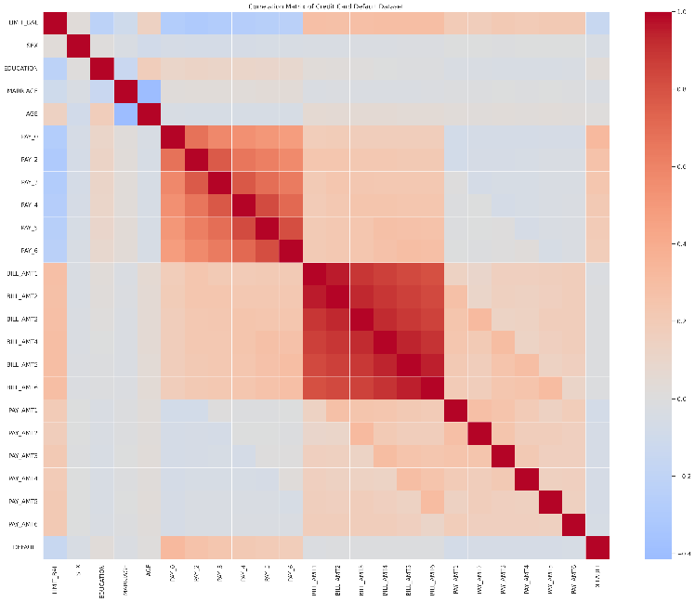
Fig. 2. Correlation structure of the engineered behavioral features with the original account attributes.
5. EXPERIMENTAL SETUP
All experiments were implemented in Python using Scikit-learn for preprocessing and evaluation, and XGBoost, LightGBM, and CatBoost for gradient boosting models. The dataset was split into training (24,000) and testing (6,000) subsets using stratified sampling to preserve the class distribution, with a fixed random seed for reproducibility. Six models were evaluated on the 33-feature engineered representation using five-fold stratified cross-validation: Logistic Regression, Decision Tree, Random Forest, XGBoost, LightGBM, and CatBoost. Model performance was assessed using accuracy, precision, recall, F1-score, and ROC-AUC, with fold-level standard deviations reported to characterize stability across folds. The top-performing model, CatBoost, was further tuned using Optuna, a Bayesian hyperparameter optimization framework, and evaluated on the held-out test set at the standard 0.5 decision threshold. The contribution of the engineered features was isolated with a controlled ablation study evaluated on both a single held-out split and five-fold cross-validation, with a paired one-sided Wilcoxon signed-rank test (H1: engineered > original) applied to the fold-level ROC-AUC differences.
6. RESULTS AND DISCUSSION
A. Baseline Model Comparison (Five-Fold Cross-Validation)
All six models were trained on the full 33-feature engineered representation and evaluated using five-fold stratified cross-validation; Table 3 reports the mean of each metric across folds, together with the standard deviation of fold-level accuracy.

Model | Accuracy | Precision | Recall | F1-Score | ROC-AUC | Acc. Std
CatBoost | 0.8209 | 0.6727 | 0.3716 | 0.4786 | 0.7880 | 0.0051
XGBoost | 0.8190 | 0.6617 | 0.3726 | 0.4766 | 0.7811 | 0.0053
LightGBM | 0.8189 | 0.6637 | 0.3684 | 0.4737 | 0.7806 | 0.0044
Random Forest | 0.8139 | 0.6346 | 0.3744 | 0.4709 | 0.7696 | 0.0047
Decision Tree | 0.8126 | 0.6365 | 0.3580 | 0.4577 | 0.7458 | 0.0024
Logistic Regression | 0.8117 | 0.6673 | 0.2971 | 0.4111 | 0.7650 | 0.0059
TABLE 3. Baseline model comparison — five-fold stratified cross-validation (engineered feature set).
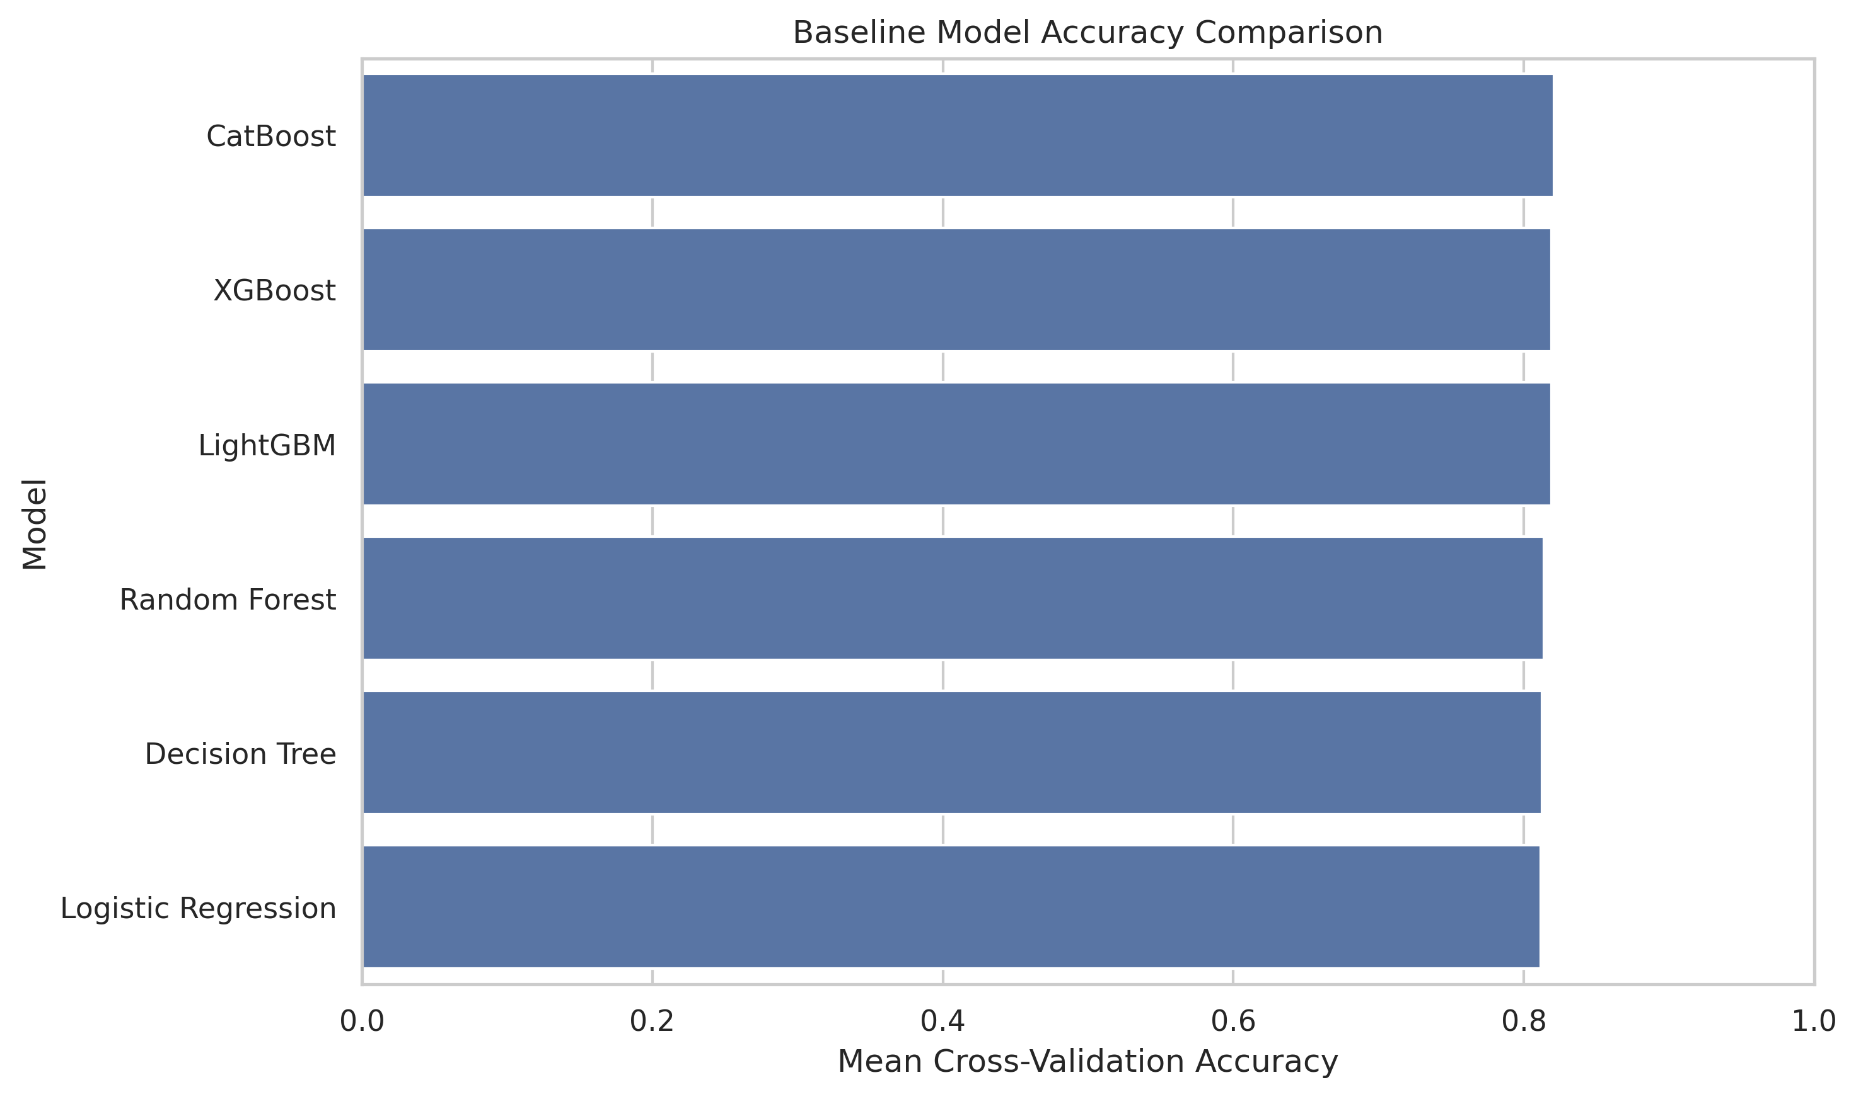
Fig. 3. Mean five-fold cross-validation accuracy by model.
CatBoost is the top performer on every metric except precision, achieving the highest mean ROC-AUC (0.7880) and accuracy (82.09%). XGBoost and LightGBM form a closely clustered second tier (ROC-AUC 0.7811 and 0.7806, respectively), followed by Random Forest and Logistic Regression. The single Decision Tree is the weakest model by a clear margin (ROC-AUC 0.7458), consistent with the high variance of an unpruned single tree relative to the ensemble methods. Gradient boosting methods again form the top cluster, and the five-fold cross-validation confirms that this ranking is stable rather than an artifact of any single train/test partition.
B. Final Optimized Model Performance
The top-performing model from Table 3, CatBoost, was further tuned using Optuna-based Bayesian hyperparameter optimization and evaluated on the held-out test set (6,000 records) at the standard 0.5 decision threshold; results are reported in Table 4.
Model | Threshold | Accuracy | Precision | Recall | F1-Score | ROC-AUC
Optimized CatBoost | 0.50 | 0.8190 | 0.6709 | 0.3567 | 0.4658 | 0.7780
TABLE 4. Final Optuna-tuned CatBoost model — held-out test-set performance.

The tuned model achieves 81.90% accuracy and a ROC-AUC of 0.7780 on the held-out split. This single-split test ROC-AUC is somewhat below the 0.7880 mean obtained via five-fold cross-validation for the baseline CatBoost model (Table 3); this gap illustrates the sampling variance between one particular held-out partition and a cross-validated estimate, and indicates that the cross-validation figure is the more reliable estimate of the model's generalization performance. Precision (0.6709) and recall (0.3567) reflect the inherent difficulty of the minority default class at a fixed 0.5 threshold; Fig. 4 and Fig. 5 show the corresponding ROC curve and confusion matrix. As shown in Section 6.D, this test-set result corresponds exactly to the "Original + Engineered Features" row of the single-split ablation comparison (Table 6).
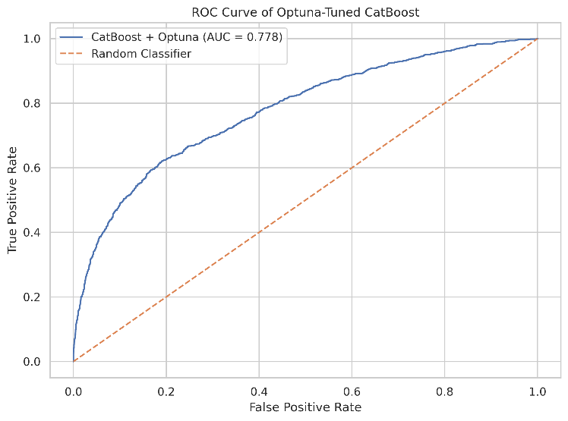
Fig. 4. ROC curve of the Optuna-tuned CatBoost model on the held-out test set.
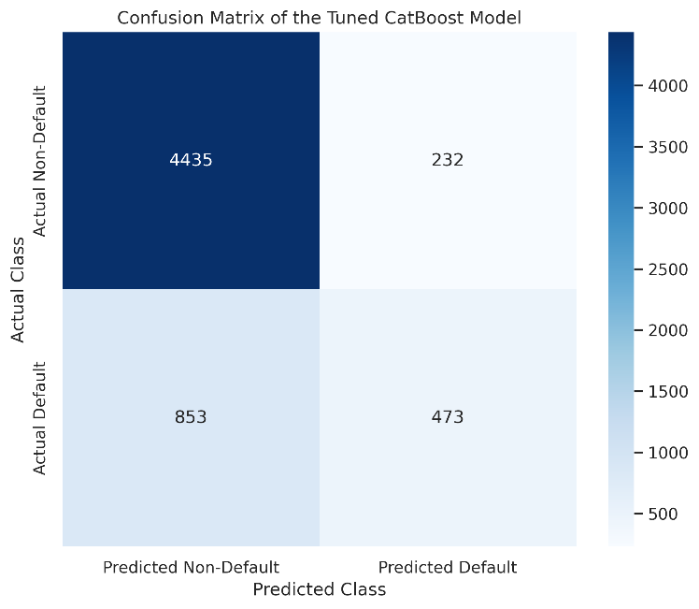
Fig. 5. Confusion matrix of the tuned CatBoost model.
C. Cross-Validation Robustness Check
To confirm the ranking in Table 3 was not an artifact of a single train/test partition, Table 5 reports the mean and standard deviation of ROC-AUC for each model across the same five-fold stratified cross-validation, and Fig. 6 visualizes the resulting distribution.

Model | Mean ROC-AUC | Std ROC-AUC
CatBoost | 0.7880 | 0.0087
XGBoost | 0.7811 | 0.0079
LightGBM | 0.7806 | 0.0096
Random Forest | 0.7696 | 0.0066
Logistic Regression | 0.7650 | 0.0090
Decision Tree | 0.7458 | 0.0103
TABLE 5. Five-fold cross-validation ROC-AUC (mean ± std) across all six models.
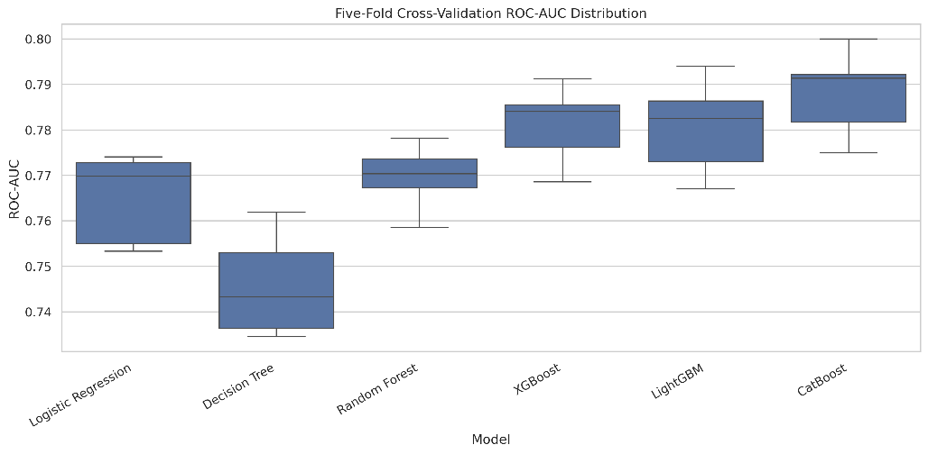
Fig. 6. Cross-validation ROC-AUC distribution across models.

The cross-validation ranking mirrors Table 3: CatBoost is the top performer and, together with XGBoost, among the most stable models (lowest ROC-AUC standard deviation among the gradient boosting methods), confirming CatBoost as the appropriate choice for the ablation and explainability analysis that follows.
D. Ablation Study: Isolating the Contribution of Engineered Features
To directly isolate the effect of the ten engineered behavioral features, CatBoost was trained and evaluated on two feature configurations using an identical train/test split: (i) the 23 original attributes only, and (ii) the original attributes plus the ten engineered features. Table 6 reports the single-split result.
Feature Set | ROC-AUC | Accuracy | F1-Score | Avg. Precision
Original Features Only | 0.7763 | 0.8188 | 0.4708 | 0.5554
Original + Engineered | 0.7780 | 0.8190 | 0.4658 | 0.5652
TABLE 6. Ablation study — CatBoost performance with and without engineered behavioral features (single held-out split).
On the single held-out split, adding the engineered features improved ROC-AUC by +0.0017 and Average Precision by +0.0098, while accuracy was essentially unchanged (+0.0002) and F1-score decreased slightly (−0.0050) — expected, since accuracy and F1 are computed at a fixed 0.5 decision threshold and are less sensitive to a modest improvement in probability ranking than ROC-AUC or Average Precision.
To assess whether this improvement was robust rather than a property of one particular split, five-fold stratified cross-validation was repeated for both feature configurations; Table 7 reports the fold-level results.

Fold | Original ROC-AUC | Engineered ROC-AUC | Difference
1 | 0.7899 | 0.7922 | +0.0022
2 | 0.7883 | 0.7913 | +0.0030
3 | 0.7820 | 0.7817 | −0.0003
4 | 0.7724 | 0.7749 | +0.0026
5 | 0.7971 | 0.8000 | +0.0029
Mean ± Std | 0.7859 ± 0.0093 | 0.7880 ± 0.0098 | +0.0021
TABLE 7. Five-fold cross-validation, original vs. engineered features (CatBoost).

The engineered feature set outperformed the original feature set in four of the five folds, with a mean ROC-AUC improvement of +0.0021 — larger than the +0.0017 observed on the single held-out split in Table 6. A paired one-sided Wilcoxon signed-rank test (H1: engineered > original) on the five fold-level ROC-AUC differences yields a test statistic of 14.0 and p = 0.0625, which does not reach the conventional α = 0.05 significance level at this sample size, since only four of five folds show improvement.
This is a more conservative and more honest conclusion than the single-split comparison in Table 6 alone would suggest: the behavioral features provide a small, directionally consistent, but not statistically decisive improvement in ranking performance when added on top of an already information-rich original feature set. We view this as an important methodological finding in its own right — much of the raw PAY_*, BILL_AMT*, and PAY_AMT* data already implicitly encodes the behavioral signal that the engineered aggregates make explicit, so gradient boosting models are able to recover a substantial part of this signal even without hand-crafted aggregation. A larger number of cross-validation folds (e.g., repeated k-fold or 10-fold CV) would be needed to determine with greater statistical power whether the improvement is genuine but small, or attributable to sampling variability.
E. Explainability Analysis (Feature Importance)
CatBoost's native feature-importance scores were computed for the tuned model on the full 33-feature representation; Table 8 and Fig. 7 report the top eight predictors.
Rank | Feature | Importance (%)
1 | PAY_0 | 18.83
2 | CREDIT_UTILIZATION | 7.43
3 | MAX_PAY_STATUS | 5.73
4 | LIMIT_BAL | 5.21
5 | BILL_AMT1 | 5.18
6 | SEVERE_DELAY_MONTHS | 4.06
7 | DELAYED_MONTHS | 3.59
8 | AVG_PAY_STATUS | 3.50
TABLE 8. Top eight predictors by CatBoost feature importance. 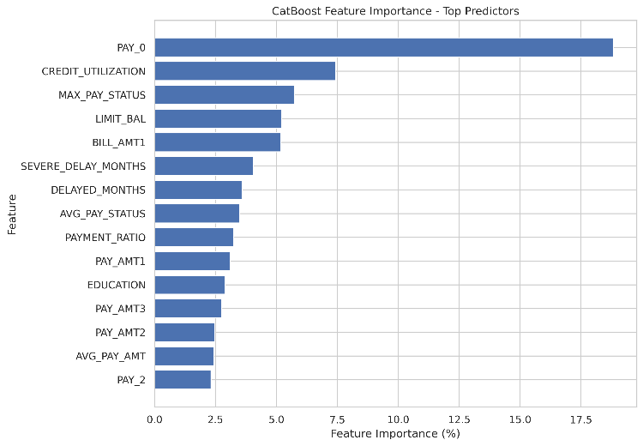
Fig. 7. CatBoost feature importance, top predictors (engineered features shaded).
The most recent repayment status (PAY_0) remains by far the single strongest predictor (18.83% relative importance), consistent with its role as the most direct signal of imminent default. Notably, five of the top eight predictors are engineered behavioral features: CREDIT_UTILIZATION (rank 2, 7.43%), MAX_PAY_STATUS (rank 3, 5.73%), SEVERE_DELAY_MONTHS (rank 6, 4.06%), DELAYED_MONTHS (rank 7, 3.59%), and AVG_PAY_STATUS (rank 8, 3.50%). This reconciles the modest fold-level ROC-AUC gain from Section 6.D with a more nuanced picture: the engineered features are individually highly informative, but their information substantially overlaps with what CatBoost can already extract from the raw monthly PAY_* and BILL_AMT* sequences, so their marginal contribution to overall ranking performance is smaller than their standalone importance would suggest. Directionally, higher values of CREDIT_UTILIZATION, MAX_PAY_STATUS, SEVERE_DELAY_MONTHS, and DELAYED_MONTHS are all associated with a higher predicted probability of default, consistent with domain expectations for an interpretable risk-scoring context.
7. CONCLUSION AND FUTURE WORK
This study proposed a behavioral feature engineering framework combined with gradient boosting for credit card default prediction on the UCI Credit Card Default dataset. Ten engineered behavioral features — including two delay-frequency counts, DELAYED_MONTHS and SEVERE_DELAY_MONTHS — were appended to the 23 original attributes to form a 33-feature representation. Among six models compared via five-fold stratified cross-validation, CatBoost achieved the strongest performance (mean ROC-AUC = 0.7880 ± 0.0087, accuracy = 82.09%), and Optuna-based hyperparameter tuning produced a final held-out test-set ROC-AUC of 0.7780. A controlled ablation study showed that the engineered features provide a small, directionally consistent improvement in ROC-AUC on both a single held-out split (+0.0017) and under five-fold cross-validation (+0.0021, improving in four of five folds), though a paired one-sided Wilcoxon signed-rank test (statistic = 14.0, p = 0.0625) does not reach conventional statistical significance at this sample size. Feature-importance analysis showed that five of the top eight predictors are engineered behavioral features, confirming that repayment-status magnitude and frequency, together with credit utilization, are the dominant drivers of the model's default predictions and supporting the practical interpretability of the proposed framework.
Future work should extend the cross-validation to a larger number of folds or repeated resampling to obtain greater statistical power on the ablation question; incorporate class-imbalance-aware training (e.g., cost-sensitive loss or resampling) to improve the currently modest recall (0.36–0.37); explore trajectory-based behavioral features (e.g., fitted slopes of utilization and delay over time) rather than simple aggregates and counts; and evaluate a fairness audit of model errors across the demographic attributes (sex, education, marital status, age) present in the dataset, given their known relevance to responsible lending practice.
REFERENCES
[1] Y. Freund and R. E. Schapire, "A decision-theoretic generalization of on-line learning and an application to boosting," Journal of Computer and System Sciences, vol. 55, no. 1, pp. 119–139, 1997.
[2] G. Ke et al., "LightGBM: A highly efficient gradient boosting decision tree," in Advances in Neural Information Processing Systems, vol. 30, pp. 3149–3157, 2017.
[3] L. Prokhorenkova, G. Gusev, A. Vorobev, A. V. Dorogush, and A. Gulin, "CatBoost: unbiased boosting with categorical features," in Advances in Neural Information Processing Systems, vol. 31, 2018.
[4] Y. C. Chang, K. H. Chang, and G. J. Wu, "Application of eXtreme gradient boosting trees in the construction of credit risk assessment models for financial institutions," Applied Soft Computing, vol. 73, pp. 914–920, 2018.
[5] S. M. Lundberg and S. I. Lee, "A unified approach to interpreting model predictions," in Advances in Neural Information Processing Systems, vol. 30, pp. 4765–4774, 2017.
[6] J. T. Hancock and T. M. Khoshgoftaar, "CatBoost for big data: an interdisciplinary review," Journal of Big Data, vol. 7, no. 94, 2020.
[7] D. Björkegren and D. Grissen, "Behavior revealed in mobile phone usage predicts credit repayment," World Bank Economic Review, vol. 33, no. 3, pp. 534–547, 2019.
[8] S. Bhatore, L. Mohan, and Y. R. Reddy, "Machine learning techniques for credit risk evaluation: a systematic literature review," Journal of Banking and Financial Technology, vol. 4, pp. 111–138, 2020.
[9] T. Akiba, S. Sano, T. Yanase, T. Ohta, and M. Koyama, "Optuna: A next-generation hyperparameter optimization framework," in Proc. 25th ACM SIGKDD Int. Conf. Knowledge Discovery & Data Mining, pp. 2623–2631, 2019.
[10] I. C. Yeh and C. H. Lien, "The comparisons of data mining techniques for the predictive accuracy of probability of default of credit card clients," Expert Systems with Applications, vol. 36, no. 2, pp. 2473–2480, 2009.

