COOKIES
Field | Type | Null | Key | Default | Extra
CID | Varchar(5) | No | Primary key | NULL
Type | Varchar(30) | Yes |  | NULL
PRICE_PER_PIECE | Integer | Yes |  | NULL

MySQL Command:

Create table Cookie (CID Varchar(5) Primary key, TYPE Varchar(40), PRICE_PER_PIECE INT);

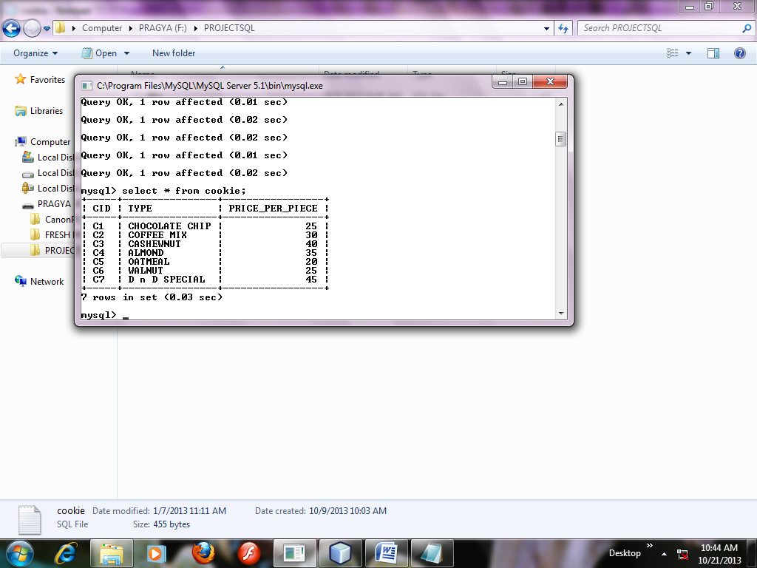
DOUGHNUTS
Field | Type | Null | Key | Default | Extra
CID | Varchar(5) | No | Primary key | NULL
FLAVOURS | Varchar(30) | Yes |  | NULL
PRICE_PER_PIECE | Integer | Yes |  | NULL

MySQL Command:

Create table Doughnut (CID Varchar(5) Primary key, FLAVOURS Varchar(40), PRICE_PER_PIECE INT );

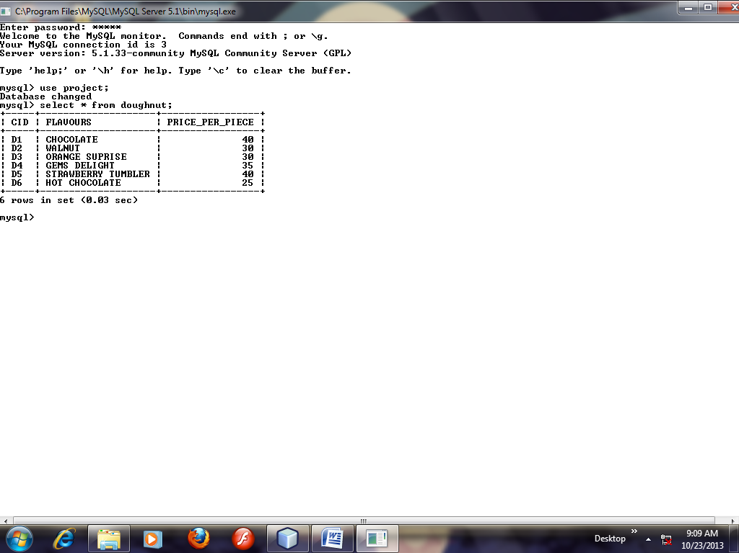

CUPCAKE
Field | Type | Null | Key | Default | Extra
CID | Varchar(5) | No | Primary key | NULL
FLAVOURS | Varchar(30) | Yes |  | NULL
PRICE_PER_PIECE | Integer | Yes |  | NULL

MySQL Command:

create table cupcake (CID varchar(5) primary key, FLAVOURS VARCHAR(40), PRICE_PER_PIECE INT );

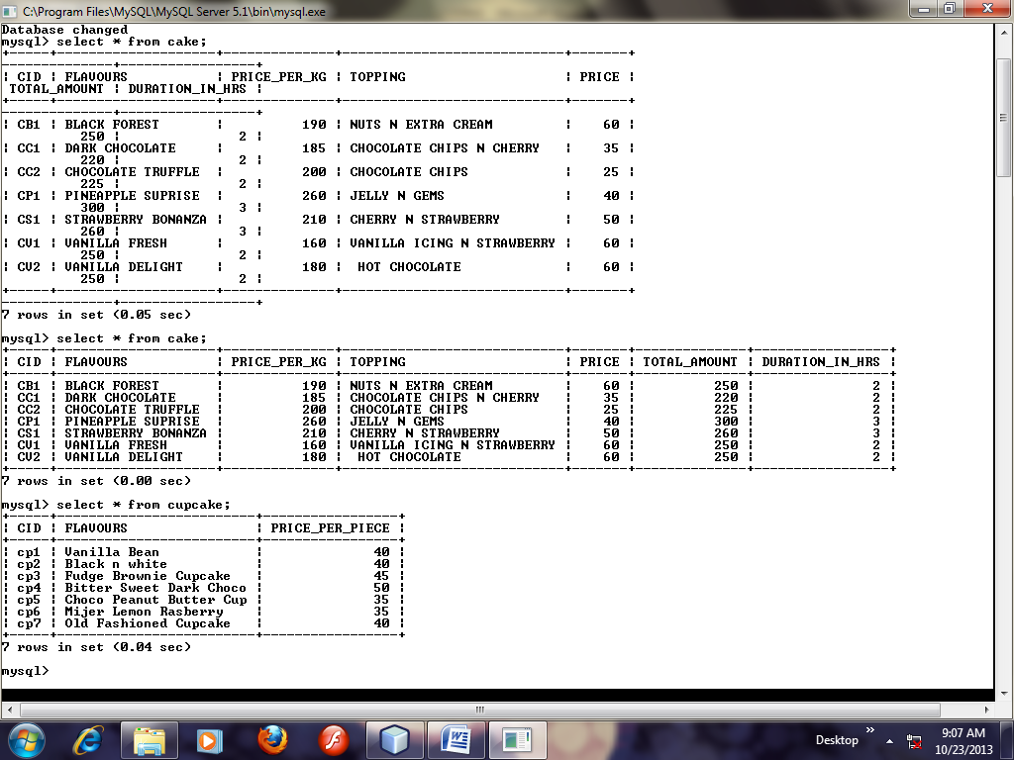
CAKES
Field | Type | Null | Key | Default | Extra
CID | Varchar(5) | No | Primary Key | Null
FLAVOURS | Varchar(30) | Yes |  | Null
PRICE_PER_KG | Integer | Yes |  | Null
TOPPING | Varchar(30) | Yes |  | Null
PRICE | Integer | Yes |  | Null
TOTAL_AMOUNT | Integer | Yes |  | Null
DURATION_IN_HRS | Integer | Yes |  | Null

MySQL Command
Create table Cake (CID Varchar(5) Primary key, FLAVOURS VARCHAR(30), PRICE_PER_KG Integer ,TOPPING VARCHAR(30),PRICE INT ,TOTAL_AMOUNT INT, DURATION_IN_HRS INT);

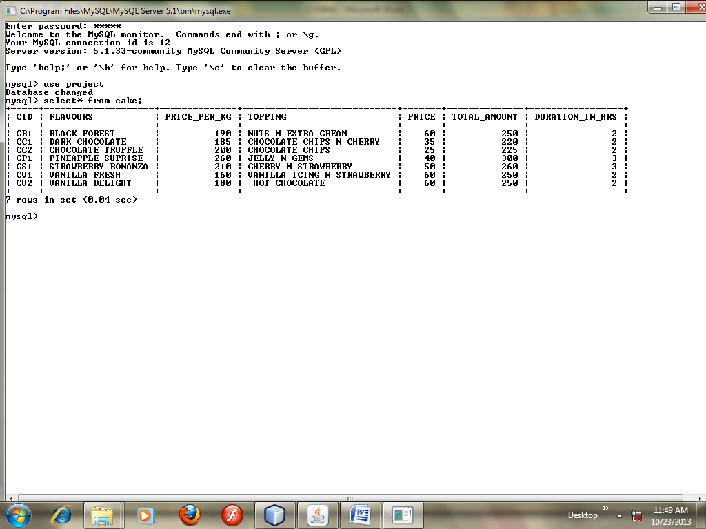

PASTRY
Field | Type | Null | Key | Default | Extra
CID | Varchar(5) | No | Primary key | NULL
FLAVOURS | Varchar(30) | Yes |  | NULL
PRICE_PER_PIECE | Integer | Yes |  | NULL

MySQL Command:
create table pastry (CID varchar(5) primary key, FLAVOURS VARCHAR(40), PRICE_PER_PIECE INT );

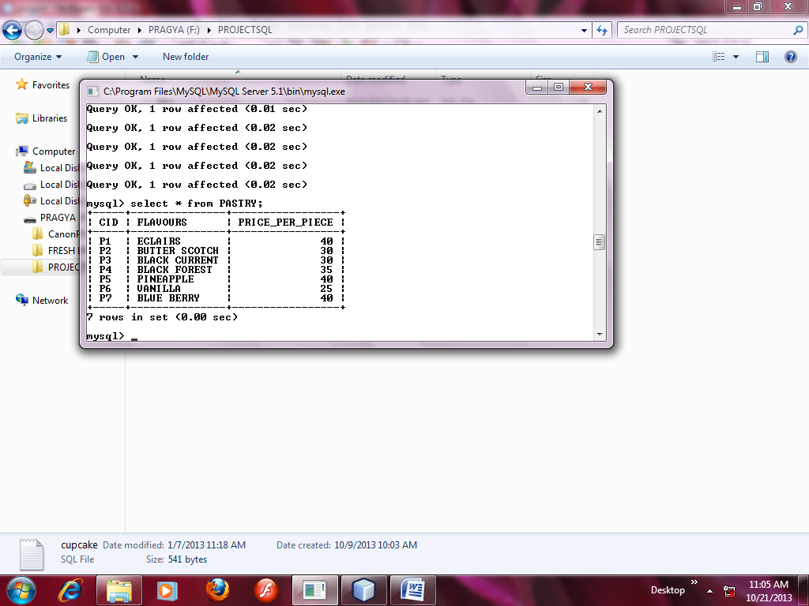

BILL
Field | Type | Null | Key | Default | Extra
CNAME | Varchar(30) | YES |  | NULL
CNO | Varchar(30) | YES |  | NULL
DDELIVERY | Date | YES |  | NULL
DTIME | Varchar(30) | YES |  | NULL
INAME | Varchar(30) | YES |  | NULL
PRICE | Integer | YES |  | NULL
QUANTITY | Integer | YES |  | NULL
MESSAGE_ON_CAKE | Varchar(50) | YES |  | NULL
TAMOUNT | Integer | YES |  | NULL

MySQL Command:
CREATE TABLE BILL(CNAME VARCHAR(30), CNO VARCHAR(30), DELIVERY DATE, DTIME VARCHAR(10),INAME VARCHAR(30), PRICE INT, QUANTITY INT, MESSAGE_ON_CAKE VARCHAR(50),TAMUNT INT);

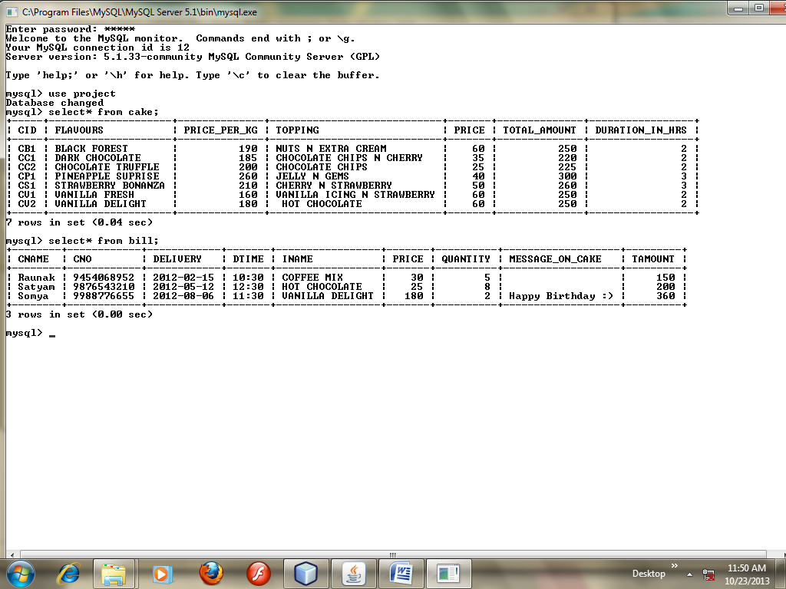
PROJECT EXPLORER
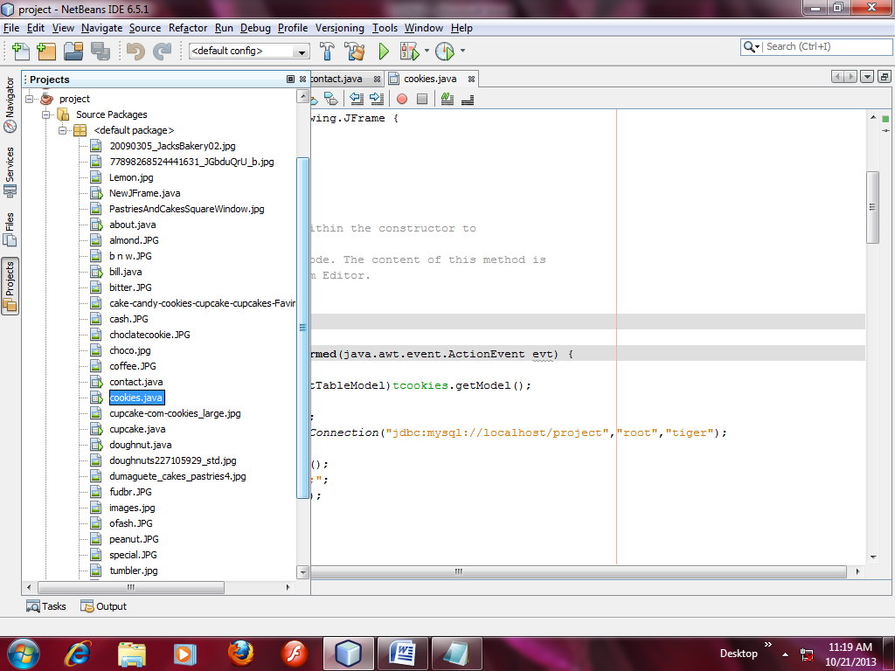

OUTPUT SCREENS

MENU
HOME ORDER CONTACT

ORDER COOKIES

DOUGHNUTS

CUPCAKES

CAKES

PASTRIES
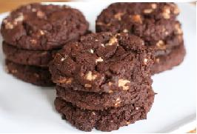

DARK N DELICIOUS BAKERS

MAIN PAGE

ABOUT US

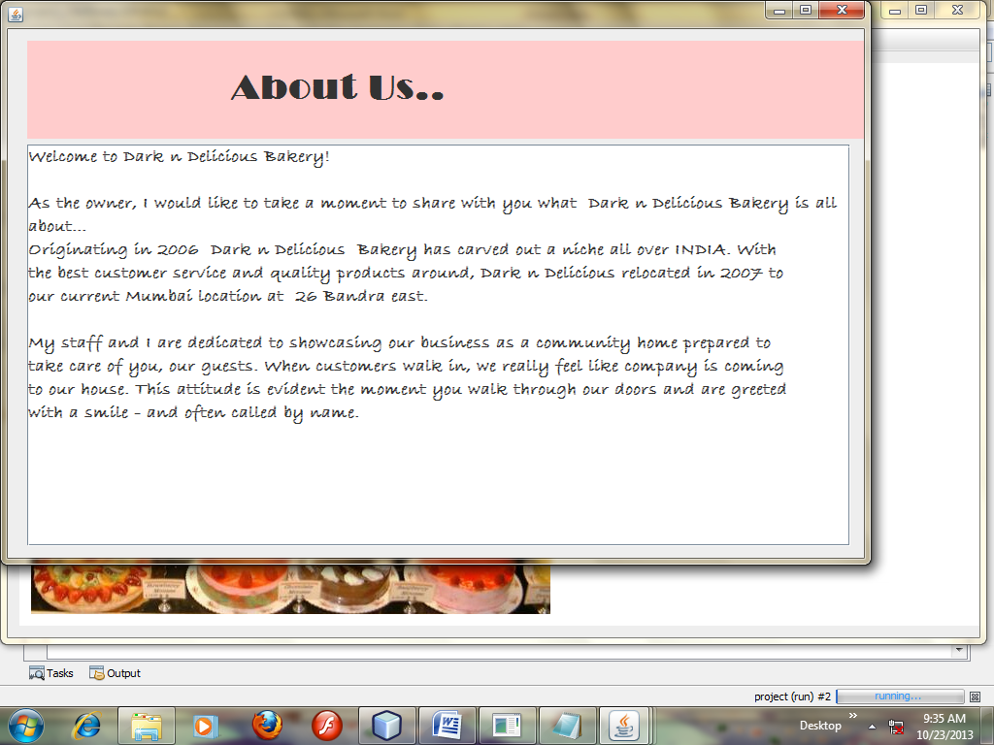
OWNER’S PAGE
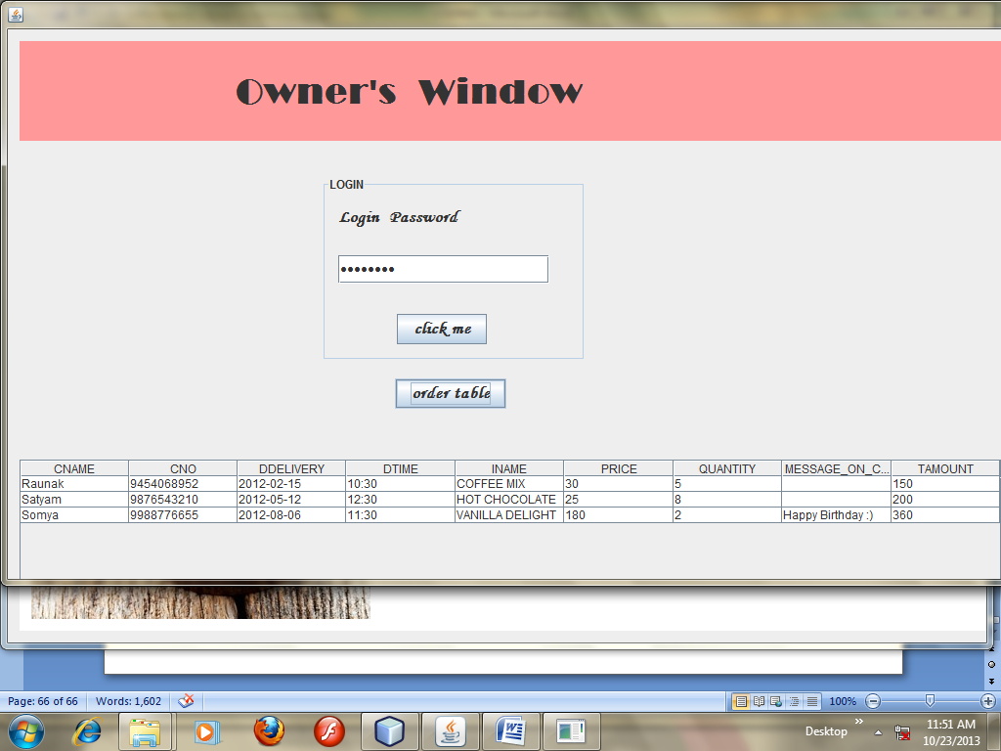
SOURCE CODE
Coding of main page(NewjFrame.java)
import java.awt.event.*;
import javax.swing.Timer;
import javax.swing.ImageIcon;
import java.sql.*;
import java.sql.ResultSet;

import javax.swing.table.DefaultTableModel;

/*
* To change this template, choose Tools | Templates
* and open the template in the editor.
*/

/*
* NewJFrame.java
*
* Created on Oct 30, 2012, 9:15:37 AM
*/

/**
*
* @author optional
*/
public class NewJFrame extends javax.swing.JFrame {
int p=1;
Timer t1=new Timer(1000,new ActionListener(){
public void actionPerformed(ActionEvent e)
{
switch(p)
{
case 1:jLabel2.setIcon(new ImageIcon(getClass().getResource("/20090305_JacksBakery02.jpg")));break;
case 2:jLabel2.setIcon(new ImageIcon(getClass().getResource("/tumblr_lg01ddS4j51qbmwxno1_500.jpg")));break;
case 3:jLabel2.setIcon(new ImageIcon(getClass().getResource("/cupcake-com-cookies_large.jpg")));break;
case 4:jLabel2.setIcon(new ImageIcon(getClass().getResource("/PastriesAndCakesSquareWindow.jpg")));break;
case 5:jLabel2.setIcon(new ImageIcon(getClass().getResource("/doughnuts227105929_std.jpg")));break;
case 6:jLabel2.setIcon(new ImageIcon(getClass().getResource("/dumaguete_cakes_pastries4.jpg")));break;

}
if(p==6)
{ p=1;
}

else
p++;
}
});

/** Creates new form NewJFrame */
public NewJFrame() {
initComponents();
}

/** This method is called from within the constructor to
* initialize the form.
* WARNING: Do NOT modify this code. The content of this method is
* always regenerated by the Form Editor.
*/
@SuppressWarnings("unchecked")
// <editor-fold defaultstate="collapsed" desc="Generated Code">
private void initComponents() {

jDialog1 = new javax.swing.JDialog();
jButton3 = new javax.swing.JButton();
jScrollPane5 = new javax.swing.JScrollPane();
jTable5 = new javax.swing.JTable();
jPanel2 = new javax.swing.JPanel();
jLabel3 = new javax.swing.JLabel();
jPanel3 = new javax.swing.JPanel();
jLabel4 = new javax.swing.JLabel();
jPasswordField1 = new javax.swing.JPasswordField();
jButton1 = new javax.swing.JButton();
jScrollPane1 = new javax.swing.JScrollPane();
jTable1 = new javax.swing.JTable();
jScrollPane2 = new javax.swing.JScrollPane();
jTable2 = new javax.swing.JTable();
jScrollPane3 = new javax.swing.JScrollPane();
jTable3 = new javax.swing.JTable();
jScrollPane4 = new javax.swing.JScrollPane();
jTable4 = new javax.swing.JTable();
jPanel1 = new javax.swing.JPanel();
jLabel1 = new javax.swing.JLabel();
jLabel2 = new javax.swing.JLabel();
jButton2 = new javax.swing.JButton();
jMenuBar1 = new javax.swing.JMenuBar();
jMenu1 = new javax.swing.JMenu();
jMenuItem7 = new javax.swing.JMenuItem();
jMenu3 = new javax.swing.JMenu();
jMenuItem2 = new javax.swing.JMenuItem();
jMenuItem5 = new javax.swing.JMenuItem();
jMenuItem4 = new javax.swing.JMenuItem();
jMenuItem1 = new javax.swing.JMenuItem();
jMenuItem6 = new javax.swing.JMenuItem();
jMenuItem3 = new javax.swing.JMenuItem();
jMenu4 = new javax.swing.JMenu();

jDialog1.setBounds(new java.awt.Rectangle(0, 0, 1300, 600));
jDialog1.addWindowListener(new java.awt.event.WindowAdapter() {
public void windowOpened(java.awt.event.WindowEvent evt) {
jDialog1WindowOpened(evt);
}
});

jButton3.setFont(new java.awt.Font("Monotype Corsiva", 1, 18)); // NOI18N
jButton3.setText("order table");
jButton3.addActionListener(new java.awt.event.ActionListener() {
public void actionPerformed(java.awt.event.ActionEvent evt) {
jButton3ActionPerformed(evt);
}
});

jTable5.setModel(new javax.swing.table.DefaultTableModel(
new Object [][] {

},
new String [] {
"CNAME", "CNO", "DDELIVERY", "DTIME", "INAME", "PRICE", "QUANTITY", "MESSAGE_ON_CAKE", "TAMOUNT"
}
));
jScrollPane5.setViewportView(jTable5);

jPanel2.setBackground(new java.awt.Color(255, 153, 153));

jLabel3.setFont(new java.awt.Font("Broadway", 1, 36)); // NOI18N
jLabel3.setText(" Owner's Window");

javax.swing.GroupLayout jPanel2Layout = new javax.swing.GroupLayout(jPanel2);
jPanel2.setLayout(jPanel2Layout);
jPanel2Layout.setHorizontalGroup(
jPanel2Layout.createParallelGroup(javax.swing.GroupLayout.Alignment.LEADING)
.addGroup(jPanel2Layout.createSequentialGroup()
.addContainerGap()
.addComponent(jLabel3, javax.swing.GroupLayout.PREFERRED_SIZE, 970, javax.swing.GroupLayout.PREFERRED_SIZE)
.addContainerGap(37, Short.MAX_VALUE))
);
jPanel2Layout.setVerticalGroup(
jPanel2Layout.createParallelGroup(javax.swing.GroupLayout.Alignment.LEADING)
.addGroup(jPanel2Layout.createSequentialGroup()
.addContainerGap()
.addComponent(jLabel3, javax.swing.GroupLayout.DEFAULT_SIZE, 78, Short.MAX_VALUE)
.addContainerGap())
);

jPanel3.setBorder(javax.swing.BorderFactory.createTitledBorder("LOGIN"));

jLabel4.setFont(new java.awt.Font("Monotype Corsiva", 1, 18)); // NOI18N
jLabel4.setText("Login Password");

jButton1.setFont(new java.awt.Font("Monotype Corsiva", 1, 18)); // NOI18N
jButton1.setText("click me");
jButton1.addActionListener(new java.awt.event.ActionListener() {
public void actionPerformed(java.awt.event.ActionEvent evt) {
jButton1ActionPerformed(evt);
}
});

javax.swing.GroupLayout jPanel3Layout = new javax.swing.GroupLayout(jPanel3);
jPanel3.setLayout(jPanel3Layout);
jPanel3Layout.setHorizontalGroup(
jPanel3Layout.createParallelGroup(javax.swing.GroupLayout.Alignment.LEADING)
.addGroup(jPanel3Layout.createSequentialGroup()
.addGroup(jPanel3Layout.createParallelGroup(javax.swing.GroupLayout.Alignment.LEADING)
.addGroup(jPanel3Layout.createSequentialGroup()
.addGap(72, 72, 72)
.addComponent(jButton1))
.addGroup(jPanel3Layout.createSequentialGroup()
.addContainerGap()
.addComponent(jPasswordField1, javax.swing.GroupLayout.PREFERRED_SIZE, 216, javax.swing.GroupLayout.PREFERRED_SIZE))
.addGroup(javax.swing.GroupLayout.Alignment.TRAILING, jPanel3Layout.createSequentialGroup()
.addContainerGap()
.addComponent(jLabel4, javax.swing.GroupLayout.DEFAULT_SIZE, 236, Short.MAX_VALUE)))
.addContainerGap())
);
jPanel3Layout.setVerticalGroup(
jPanel3Layout.createParallelGroup(javax.swing.GroupLayout.Alignment.LEADING)
.addGroup(jPanel3Layout.createSequentialGroup()
.addComponent(jLabel4, javax.swing.GroupLayout.PREFERRED_SIZE, 42, javax.swing.GroupLayout.PREFERRED_SIZE)
.addGap(18, 18, 18)
.addComponent(jPasswordField1, javax.swing.GroupLayout.PREFERRED_SIZE, 29, javax.swing.GroupLayout.PREFERRED_SIZE)
.addPreferredGap(javax.swing.LayoutStyle.ComponentPlacement.RELATED, 31, Short.MAX_VALUE)
.addComponent(jButton1)
.addContainerGap())
);

javax.swing.GroupLayout jDialog1Layout = new javax.swing.GroupLayout(jDialog1.getContentPane());
jDialog1.getContentPane().setLayout(jDialog1Layout);
jDialog1Layout.setHorizontalGroup(
jDialog1Layout.createParallelGroup(javax.swing.GroupLayout.Alignment.LEADING)
.addGroup(jDialog1Layout.createSequentialGroup()
.addGroup(jDialog1Layout.createParallelGroup(javax.swing.GroupLayout.Alignment.LEADING)
.addGroup(jDialog1Layout.createSequentialGroup()
.addContainerGap()
.addComponent(jPanel2, javax.swing.GroupLayout.PREFERRED_SIZE, javax.swing.GroupLayout.DEFAULT_SIZE, javax.swing.GroupLayout.PREFERRED_SIZE))
.addGroup(jDialog1Layout.createSequentialGroup()
.addContainerGap()
.addComponent(jScrollPane5, javax.swing.GroupLayout.PREFERRED_SIZE, 1005, javax.swing.GroupLayout.PREFERRED_SIZE))
.addGroup(jDialog1Layout.createSequentialGroup()
.addGap(396, 396, 396)
.addComponent(jButton3))
.addGroup(jDialog1Layout.createSequentialGroup()
.addGap(321, 321, 321)
.addComponent(jPanel3, javax.swing.GroupLayout.PREFERRED_SIZE, javax.swing.GroupLayout.DEFAULT_SIZE, javax.swing.GroupLayout.PREFERRED_SIZE)))
.addContainerGap(218, Short.MAX_VALUE))
);
jDialog1Layout.setVerticalGroup(
jDialog1Layout.createParallelGroup(javax.swing.GroupLayout.Alignment.LEADING)
.addGroup(jDialog1Layout.createSequentialGroup()
.addContainerGap()
.addComponent(jPanel2, javax.swing.GroupLayout.PREFERRED_SIZE, javax.swing.GroupLayout.DEFAULT_SIZE, javax.swing.GroupLayout.PREFERRED_SIZE)
.addGap(36, 36, 36)
.addComponent(jPanel3, javax.swing.GroupLayout.PREFERRED_SIZE, javax.swing.GroupLayout.DEFAULT_SIZE, javax.swing.GroupLayout.PREFERRED_SIZE)
.addGap(18, 18, 18)
.addComponent(jButton3)
.addGap(52, 52, 52)
.addComponent(jScrollPane5, javax.swing.GroupLayout.PREFERRED_SIZE, 137, javax.swing.GroupLayout.PREFERRED_SIZE)
.addGap(190, 190, 190))
);

jTable1.setModel(new javax.swing.table.DefaultTableModel(
new Object [][] {
{null, null, null, null},
{null, null, null, null},
{null, null, null, null},
{null, null, null, null}
},
new String [] {
"Title 1", "Title 2", "Title 3", "Title 4"
}
));
jScrollPane1.setViewportView(jTable1);

jTable2.setModel(new javax.swing.table.DefaultTableModel(
new Object [][] {
{null, null, null, null},
{null, null, null, null},
{null, null, null, null},
{null, null, null, null}
},
new String [] {
"Title 1", "Title 2", "Title 3", "Title 4"
}
));
jScrollPane2.setViewportView(jTable2);

jTable3.setModel(new javax.swing.table.DefaultTableModel(
new Object [][] {
{null, null, null, null},
{null, null, null, null},
{null, null, null, null},
{null, null, null, null}
},
new String [] {
"Title 1", "Title 2", "Title 3", "Title 4"
}
));
jScrollPane3.setViewportView(jTable3);

jTable4.setModel(new javax.swing.table.DefaultTableModel(
new Object [][] {
{null, null, null, null},
{null, null, null, null},
{null, null, null, null},
{null, null, null, null}
},
new String [] {
"Title 1", "Title 2", "Title 3", "Title 4"
}
));
jScrollPane4.setViewportView(jTable4);

setDefaultCloseOperation(javax.swing.WindowConstants.EXIT_ON_CLOSE);
setBackground(new java.awt.Color(153, 153, 153));
addWindowListener(new java.awt.event.WindowAdapter() {
public void windowOpened(java.awt.event.WindowEvent evt) {
formWindowOpened(evt);
}
});

jPanel1.setBackground(new java.awt.Color(255, 255, 255));

jLabel1.setBackground(new java.awt.Color(102, 51, 0));
jLabel1.setFont(new java.awt.Font("Jokerman", 1, 48)); // NOI18N
jLabel1.setForeground(new java.awt.Color(255, 0, 102));
jLabel1.setText(" DARK N DELICIOUS BAKERS");
jLabel1.setOpaque(true);

jLabel2.setIcon(new javax.swing.ImageIcon(getClass().getResource("/dumaguete_cakes_pastries4.jpg"))); // NOI18N

jButton2.setFont(new java.awt.Font("Broadway", 1, 14));
jButton2.setText("ABOUT US ");
jButton2.addActionListener(new java.awt.event.ActionListener() {
public void actionPerformed(java.awt.event.ActionEvent evt) {
jButton2ActionPerformed(evt);
}
});

javax.swing.GroupLayout jPanel1Layout = new javax.swing.GroupLayout(jPanel1);
jPanel1.setLayout(jPanel1Layout);
jPanel1Layout.setHorizontalGroup(
jPanel1Layout.createParallelGroup(javax.swing.GroupLayout.Alignment.LEADING)
.addGroup(jPanel1Layout.createSequentialGroup()
.addContainerGap()
.addGroup(jPanel1Layout.createParallelGroup(javax.swing.GroupLayout.Alignment.LEADING)
.addGroup(javax.swing.GroupLayout.Alignment.TRAILING, jPanel1Layout.createSequentialGroup()
.addComponent(jLabel2, javax.swing.GroupLayout.DEFAULT_SIZE, 716, Short.MAX_VALUE)
.addPreferredGap(javax.swing.LayoutStyle.ComponentPlacement.RELATED)
.addComponent(jButton2)
.addGap(126, 126, 126))
.addComponent(jLabel1, javax.swing.GroupLayout.PREFERRED_SIZE, 771, javax.swing.GroupLayout.PREFERRED_SIZE))
.addContainerGap())
);
jPanel1Layout.setVerticalGroup(
jPanel1Layout.createParallelGroup(javax.swing.GroupLayout.Alignment.LEADING)
.addGroup(javax.swing.GroupLayout.Alignment.TRAILING, jPanel1Layout.createSequentialGroup()
.addContainerGap()
.addComponent(jLabel1, javax.swing.GroupLayout.PREFERRED_SIZE, 138, javax.swing.GroupLayout.PREFERRED_SIZE)
.addGroup(jPanel1Layout.createParallelGroup(javax.swing.GroupLayout.Alignment.LEADING, false)
.addGroup(jPanel1Layout.createSequentialGroup()
.addGap(17, 17, 17)
.addComponent(jLabel2, javax.swing.GroupLayout.PREFERRED_SIZE, 401, javax.swing.GroupLayout.PREFERRED_SIZE)
.addContainerGap())
.addGroup(javax.swing.GroupLayout.Alignment.TRAILING, jPanel1Layout.createSequentialGroup()
.addPreferredGap(javax.swing.LayoutStyle.ComponentPlacement.RELATED, javax.swing.GroupLayout.DEFAULT_SIZE, Short.MAX_VALUE)
.addComponent(jButton2)
.addGap(187, 187, 187))))
);

jMenu1.setText("HOME");

jMenuItem7.setText("Order Table");
jMenuItem7.addActionListener(new java.awt.event.ActionListener() {
public void actionPerformed(java.awt.event.ActionEvent evt) {
jMenuItem7ActionPerformed(evt);
}
});
jMenu1.add(jMenuItem7);

jMenuBar1.add(jMenu1);

jMenu3.setText("ORDER");
jMenu3.addActionListener(new java.awt.event.ActionListener() {
public void actionPerformed(java.awt.event.ActionEvent evt) {
jMenu3ActionPerformed(evt);
}
});

jMenuItem2.setAccelerator(javax.swing.KeyStroke.getKeyStroke(java.awt.event.KeyEvent.VK_F1, java.awt.event.InputEvent.CTRL_MASK));
jMenuItem2.setText("Cookies");
jMenuItem2.addActionListener(new java.awt.event.ActionListener() {
public void actionPerformed(java.awt.event.ActionEvent evt) {
jMenuItem2ActionPerformed(evt);
}
});
jMenu3.add(jMenuItem2);

jMenuItem5.setAccelerator(javax.swing.KeyStroke.getKeyStroke(java.awt.event.KeyEvent.VK_F2, java.awt.event.InputEvent.CTRL_MASK));
jMenuItem5.setText("Doughnuts");
jMenuItem5.addActionListener(new java.awt.event.ActionListener() {
public void actionPerformed(java.awt.event.ActionEvent evt) {
jMenuItem5ActionPerformed(evt);
}
});
jMenu3.add(jMenuItem5);

jMenuItem4.setAccelerator(javax.swing.KeyStroke.getKeyStroke(java.awt.event.KeyEvent.VK_F3, java.awt.event.InputEvent.CTRL_MASK));
jMenuItem4.setText("Cupcakes");
jMenuItem4.addActionListener(new java.awt.event.ActionListener() {
public void actionPerformed(java.awt.event.ActionEvent evt) {
jMenuItem4ActionPerformed(evt);
}
});
jMenuItem4.addMenuKeyListener(new javax.swing.event.MenuKeyListener() {
public void menuKeyPressed(javax.swing.event.MenuKeyEvent evt) {
jMenuItem4MenuKeyPressed(evt);
}
public void menuKeyReleased(javax.swing.event.MenuKeyEvent evt) {
}
public void menuKeyTyped(javax.swing.event.MenuKeyEvent evt) {
}
});
jMenu3.add(jMenuItem4);

jMenuItem1.setAccelerator(javax.swing.KeyStroke.getKeyStroke(java.awt.event.KeyEvent.VK_F4, java.awt.event.InputEvent.CTRL_MASK));
jMenuItem1.setText("Cakes ");
jMenu3.add(jMenuItem1);

jMenuItem6.setAccelerator(javax.swing.KeyStroke.getKeyStroke(java.awt.event.KeyEvent.VK_F4, java.awt.event.InputEvent.CTRL_MASK));
jMenuItem6.setText("Pastries");
jMenu3.add(jMenuItem6);

jMenuItem3.setAccelerator(javax.swing.KeyStroke.getKeyStroke(java.awt.event.KeyEvent.VK_F5, java.awt.event.InputEvent.CTRL_MASK));
jMenuItem3.setText("Special Occasion");
jMenu3.add(jMenuItem3);

jMenuBar1.add(jMenu3);

jMenu4.setText("CONTACT");
jMenu4.addMouseListener(new java.awt.event.MouseAdapter() {
public void mouseClicked(java.awt.event.MouseEvent evt) {
jMenu4MouseClicked(evt);
}
});
jMenuBar1.add(jMenu4);

setJMenuBar(jMenuBar1);

javax.swing.GroupLayout layout = new javax.swing.GroupLayout(getContentPane());
getContentPane().setLayout(layout);
layout.setHorizontalGroup(
layout.createParallelGroup(javax.swing.GroupLayout.Alignment.LEADING)
.addGroup(layout.createSequentialGroup()
.addContainerGap(javax.swing.GroupLayout.DEFAULT_SIZE, Short.MAX_VALUE)
.addComponent(jPanel1, javax.swing.GroupLayout.PREFERRED_SIZE, javax.swing.GroupLayout.DEFAULT_SIZE, javax.swing.GroupLayout.PREFERRED_SIZE))
);
layout.setVerticalGroup(
layout.createParallelGroup(javax.swing.GroupLayout.Alignment.LEADING)
.addGroup(layout.createSequentialGroup()
.addContainerGap()
.addComponent(jPanel1, javax.swing.GroupLayout.DEFAULT_SIZE, javax.swing.GroupLayout.DEFAULT_SIZE, Short.MAX_VALUE)
.addContainerGap())
);

pack();
}// </editor-fold>

private void jButton2ActionPerformed(java.awt.event.ActionEvent evt) {
new about().setVisible(true); // TODO add your handling code here:
}

private void formWindowOpened(java.awt.event.WindowEvent evt) {
t1.start(); // TODO add your handling code here:
}

private void jMenu3ActionPerformed(java.awt.event.ActionEvent evt) {
//new order().setVisible(true); // TODO add your handling code here:
}

private void jMenuItem2ActionPerformed(java.awt.event.ActionEvent evt) {
new cookies().setVisible(true); // TODO add your handling code here:
}

private void jMenu4MouseClicked(java.awt.event.MouseEvent evt) {
new contact().setVisible(true); // TODO add your handling code here:
}

private void jMenuItem4MenuKeyPressed(javax.swing.event.MenuKeyEvent evt) {
// TODO add your handling code here:
}

private void jMenuItem4ActionPerformed(java.awt.event.ActionEvent evt) {
new cupcake().setVisible(true); // TODO add your handling code here:
}

private void jMenuItem7ActionPerformed(java.awt.event.ActionEvent evt) {
jDialog1.setVisible(true); // TODO add your handling code here:
}

private void jButton1ActionPerformed(java.awt.event.ActionEvent evt) {
String psw=new String (jPasswordField1.getPassword());
if(psw.equals("cupncake"))
{
jButton3.setEnabled(true);
jTable5.setEnabled(true);
}

// TODO add your handling code here:
}

private void jDialog1WindowOpened(java.awt.event.WindowEvent evt) {
jButton3.setEnabled(false);
jTable5.setEnabled(false);// TODO add your handling code here:
}

private void jButton3ActionPerformed(java.awt.event.ActionEvent evt) {
DefaultTableModel dm=(DefaultTableModel)jTable5.getModel();
try{
Class.forName("java.sql.Driver");
Connection con=DriverManager.getConnection("jdbc:mysql://localhost/project","root","tiger");
System.out.println("connected");
Statement s1=con.createStatement();
String sql="Select * from bill;";
ResultSet r1=s1.executeQuery(sql);
String cname=null,cno=null,ddel=null,dtime=null,iname=null,msg=null;

int price=0,qnt=0,amnt=0;
while(r1.next())
{
cname=r1.getString(1);
cno =r1.getString(2);
ddel =r1.getString(3);
dtime=r1.getString(4);
iname=r1.getString(5);
msg=r1.getString(8);
price=r1.getInt(6);
qnt=r1.getInt(7);
amnt=r1.getInt(9);
dm.addRow(new Object[]{cname,cno,ddel,dtime,iname,price,qnt,msg,amnt});
}
}
catch(Exception ex)
{
System.out.println(ex);
}
}

private void jMenuItem5ActionPerformed(java.awt.event.ActionEvent evt) {
new doughnut().setVisible(true); // TODO add your handling code here:
}

/**
* @param args the command line arguments
*/
public static void main(String args[]) {
java.awt.EventQueue.invokeLater(new Runnable() {
public void run() {
new NewJFrame().setVisible(true);
}
});
}

// Variables declaration - do not modify
private javax.swing.JButton jButton1;
private javax.swing.JButton jButton2;
private javax.swing.JButton jButton3;
private javax.swing.JDialog jDialog1;
private javax.swing.JLabel jLabel1;
private javax.swing.JLabel jLabel2;
private javax.swing.JLabel jLabel3;
private javax.swing.JLabel jLabel4;
private javax.swing.JMenu jMenu1;
private javax.swing.JMenu jMenu3;
private javax.swing.JMenu jMenu4;
private javax.swing.JMenuBar jMenuBar1;
private javax.swing.JMenuItem jMenuItem1;
private javax.swing.JMenuItem jMenuItem2;
private javax.swing.JMenuItem jMenuItem3;
private javax.swing.JMenuItem jMenuItem4;
private javax.swing.JMenuItem jMenuItem5;
private javax.swing.JMenuItem jMenuItem6;
private javax.swing.JMenuItem jMenuItem7;
private javax.swing.JPanel jPanel1;
private javax.swing.JPanel jPanel2;
private javax.swing.JPanel jPanel3;
private javax.swing.JPasswordField jPasswordField1;
private javax.swing.JScrollPane jScrollPane1;
private javax.swing.JScrollPane jScrollPane2;
private javax.swing.JScrollPane jScrollPane3;
private javax.swing.JScrollPane jScrollPane4;
private javax.swing.JScrollPane jScrollPane5;
private javax.swing.JTable jTable1;
private javax.swing.JTable jTable2;
private javax.swing.JTable jTable3;
private javax.swing.JTable jTable4;
private javax.swing.JTable jTable5;
// End of variables declaration

}
COOKIE PAGE

DETAIL PAGE
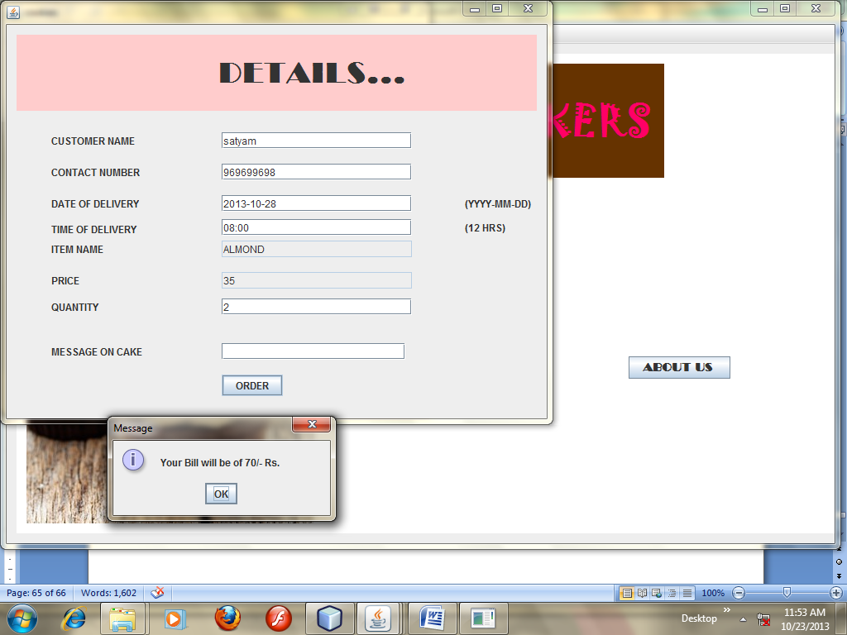
Coding of cookie page(cookies.java)

import java.sql.*;
import javax.swing.ImageIcon;
import javax.swing.table.DefaultTableModel;
/*
* To change this template, choose Tools | Templates
* and open the template in the editor.
*/

/*
* cookies.java
*
* Created on Nov 20, 2012, 10:05:30 AM
*/

/**
*
* @author optional
*/
public class cookies extends javax.swing.JFrame {

/** Creates new form cookies */
public cookies() {
initComponents();
}

/** This method is called from within the constructor to
* initialize the form.
* WARNING: Do NOT modify this code. The content of this method is
* always regenerated by the Form Editor.
*/
@SuppressWarnings("unchecked")
// <editor-fold defaultstate="collapsed" desc="Generated Code">
private void initComponents() {

jLabel1 = new javax.swing.JLabel();
jScrollPane1 = new javax.swing.JScrollPane();
tcookies = new javax.swing.JTable();
bcookies = new javax.swing.JButton();
jPanel1 = new javax.swing.JPanel();
ccrange = new javax.swing.JComboBox();
tcvalue = new javax.swing.JTextField();
bselcookies = new javax.swing.JButton();
bcclear = new javax.swing.JButton();
lcpic = new javax.swing.JLabel();
jButton1 = new javax.swing.JButton();
jButton2 = new javax.swing.JButton();

setTitle("cookies");

jLabel1.setFont(new java.awt.Font("Tahoma", 1, 16)); // NOI18N
jLabel1.setText("cookie selection");

tcookies.setModel(new javax.swing.table.DefaultTableModel(
new Object [][] {

},
new String [] {
"CID", "TYPE", "PRICE PER PIECE"
}
) {
boolean[] canEdit = new boolean [] {
false, false, false
};

public boolean isCellEditable(int rowIndex, int columnIndex) {
return canEdit [columnIndex];
}
});
jScrollPane1.setViewportView(tcookies);

bcookies.setText("SHOW ALL COOKIES");
bcookies.addActionListener(new java.awt.event.ActionListener() {
public void actionPerformed(java.awt.event.ActionEvent evt) {
bcookiesActionPerformed(evt);
}
});

jPanel1.setBorder(javax.swing.BorderFactory.createTitledBorder("PRICE RANGE"));

ccrange.setModel(new javax.swing.DefaultComboBoxModel(new String[] { "<", ">", "<=", ">=", "=" }));

bselcookies.setText("SELECTION");
bselcookies.addActionListener(new java.awt.event.ActionListener() {
public void actionPerformed(java.awt.event.ActionEvent evt) {
bselcookiesActionPerformed(evt);
}
});

javax.swing.GroupLayout jPanel1Layout = new javax.swing.GroupLayout(jPanel1);
jPanel1.setLayout(jPanel1Layout);
jPanel1Layout.setHorizontalGroup(
jPanel1Layout.createParallelGroup(javax.swing.GroupLayout.Alignment.LEADING)
.addGroup(javax.swing.GroupLayout.Alignment.TRAILING, jPanel1Layout.createSequentialGroup()
.addGroup(jPanel1Layout.createParallelGroup(javax.swing.GroupLayout.Alignment.TRAILING)
.addGroup(jPanel1Layout.createSequentialGroup()
.addContainerGap()
.addComponent(bselcookies))
.addGroup(jPanel1Layout.createSequentialGroup()
.addComponent(ccrange, javax.swing.GroupLayout.PREFERRED_SIZE, javax.swing.GroupLayout.DEFAULT_SIZE, javax.swing.GroupLayout.PREFERRED_SIZE)
.addPreferredGap(javax.swing.LayoutStyle.ComponentPlacement.RELATED, 30, Short.MAX_VALUE)
.addComponent(tcvalue, javax.swing.GroupLayout.PREFERRED_SIZE, 69, javax.swing.GroupLayout.PREFERRED_SIZE)))
.addGap(43, 43, 43))
);
jPanel1Layout.setVerticalGroup(
jPanel1Layout.createParallelGroup(javax.swing.GroupLayout.Alignment.LEADING)
.addGroup(jPanel1Layout.createSequentialGroup()
.addGroup(jPanel1Layout.createParallelGroup(javax.swing.GroupLayout.Alignment.BASELINE)
.addComponent(ccrange, javax.swing.GroupLayout.PREFERRED_SIZE, javax.swing.GroupLayout.DEFAULT_SIZE, javax.swing.GroupLayout.PREFERRED_SIZE)
.addComponent(tcvalue, javax.swing.GroupLayout.PREFERRED_SIZE, javax.swing.GroupLayout.DEFAULT_SIZE, javax.swing.GroupLayout.PREFERRED_SIZE))
.addPreferredGap(javax.swing.LayoutStyle.ComponentPlacement.RELATED, 18, Short.MAX_VALUE)
.addComponent(bselcookies)
.addContainerGap())
);

bcclear.setText("CLear");
bcclear.addActionListener(new java.awt.event.ActionListener() {
public void actionPerformed(java.awt.event.ActionEvent evt) {
bcclearActionPerformed(evt);
}
});

jButton1.setText("show pic");
jButton1.addActionListener(new java.awt.event.ActionListener() {
public void actionPerformed(java.awt.event.ActionEvent evt) {
jButton1ActionPerformed(evt);
}
});

jButton2.setText("ORDER");
jButton2.addActionListener(new java.awt.event.ActionListener() {
public void actionPerformed(java.awt.event.ActionEvent evt) {
jButton2ActionPerformed(evt);
}
});

javax.swing.GroupLayout layout = new javax.swing.GroupLayout(getContentPane());
getContentPane().setLayout(layout);
layout.setHorizontalGroup(
layout.createParallelGroup(javax.swing.GroupLayout.Alignment.LEADING)
.addGroup(layout.createSequentialGroup()
.addContainerGap()
.addGroup(layout.createParallelGroup(javax.swing.GroupLayout.Alignment.LEADING)
.addGroup(layout.createSequentialGroup()
.addGroup(layout.createParallelGroup(javax.swing.GroupLayout.Alignment.LEADING)
.addComponent(bcookies)
.addComponent(bcclear)
.addComponent(jButton1)
.addComponent(lcpic, javax.swing.GroupLayout.PREFERRED_SIZE, 272, javax.swing.GroupLayout.PREFERRED_SIZE))
.addGroup(layout.createParallelGroup(javax.swing.GroupLayout.Alignment.LEADING)
.addGroup(layout.createSequentialGroup()
.addGap(77, 77, 77)
.addComponent(jButton2))
.addGroup(layout.createSequentialGroup()
.addGap(11, 11, 11)
.addComponent(jPanel1, javax.swing.GroupLayout.PREFERRED_SIZE, javax.swing.GroupLayout.DEFAULT_SIZE, javax.swing.GroupLayout.PREFERRED_SIZE)))
.addContainerGap())
.addGroup(layout.createSequentialGroup()
.addComponent(jScrollPane1, javax.swing.GroupLayout.PREFERRED_SIZE, 375, javax.swing.GroupLayout.PREFERRED_SIZE)
.addContainerGap(117, Short.MAX_VALUE))
.addGroup(javax.swing.GroupLayout.Alignment.TRAILING, layout.createSequentialGroup()
.addComponent(jLabel1, javax.swing.GroupLayout.PREFERRED_SIZE, 177, javax.swing.GroupLayout.PREFERRED_SIZE)
.addGap(210, 210, 210))))
);
layout.setVerticalGroup(
layout.createParallelGroup(javax.swing.GroupLayout.Alignment.LEADING)
.addGroup(layout.createSequentialGroup()
.addComponent(jLabel1)
.addGap(13, 13, 13)
.addComponent(jScrollPane1, javax.swing.GroupLayout.PREFERRED_SIZE, 77, javax.swing.GroupLayout.PREFERRED_SIZE)
.addPreferredGap(javax.swing.LayoutStyle.ComponentPlacement.UNRELATED)
.addGroup(layout.createParallelGroup(javax.swing.GroupLayout.Alignment.LEADING)
.addGroup(layout.createSequentialGroup()
.addComponent(bcookies)
.addPreferredGap(javax.swing.LayoutStyle.ComponentPlacement.UNRELATED)
.addComponent(bcclear)
.addGap(18, 18, 18)
.addComponent(jButton1))
.addComponent(jPanel1, javax.swing.GroupLayout.PREFERRED_SIZE, javax.swing.GroupLayout.DEFAULT_SIZE, javax.swing.GroupLayout.PREFERRED_SIZE))
.addPreferredGap(javax.swing.LayoutStyle.ComponentPlacement.RELATED)
.addGroup(layout.createParallelGroup(javax.swing.GroupLayout.Alignment.LEADING)
.addGroup(layout.createSequentialGroup()
.addGap(53, 53, 53)
.addComponent(jButton2))
.addGroup(layout.createSequentialGroup()
.addGap(23, 23, 23)
.addComponent(lcpic, javax.swing.GroupLayout.PREFERRED_SIZE, 191, javax.swing.GroupLayout.PREFERRED_SIZE)))
.addGap(20, 20, 20))
);

pack();
}// </editor-fold>

private void bcookiesActionPerformed(java.awt.event.ActionEvent evt) {
bcclear.doClick();
DefaultTableModel dm=(DefaultTableModel)tcookies.getModel();
try{
Class.forName("java.sql.Driver");
Connection con=DriverManager.getConnection("jdbc:mysql://localhost/project","root","tiger");
System.out.println("connected");
Statement s1=con.createStatement();
String sql="Select * from Cookie;";
ResultSet r1=s1.executeQuery(sql);
String id=null,name=null;
int price=0;
while(r1.next())
{
id=r1.getString(1);
name =r1.getString(2);
price=r1.getInt(3);
dm.addRow(new Object[]{id,name,price});
}

}
catch(Exception ex)
{
System.out.println(ex);
}
// TODO add your handling code here:
}

private void bselcookiesActionPerformed(java.awt.event.ActionEvent evt) {
bcclear.doClick();
DefaultTableModel dm=(DefaultTableModel)tcookies.getModel();
try{
Class.forName("java.sql.Driver");
Connection con=DriverManager.getConnection("jdbc:mysql://localhost/project","root","tiger");
System.out.println("connected");
Statement s1=con.createStatement();
String sym=(String)ccrange.getSelectedItem();

int Val=Integer.parseInt(tcvalue.getText());
String sql="Select * from Cookie where price_per_piece"+sym+Val+";";
ResultSet r1=s1.executeQuery(sql);
String id=null,name=null;
int price=0;
while(r1.next())
{
id=r1.getString(1);
name =r1.getString(2);
price=r1.getInt(3);
dm.addRow(new Object[]{id,name,price});
}

}
catch(Exception ex)
{
System.out.println(ex);
} // TODO add your handling code here:
}

private void bcclearActionPerformed(java.awt.event.ActionEvent evt) {
//tcvalue.setText("");
DefaultTableModel dm=(DefaultTableModel)tcookies.getModel();
int rc=dm.getRowCount();
for(int i=rc-1;i>=0;i--)
dm.removeRow(i);

// TODO add your handling code here:
}

private void jButton1ActionPerformed(java.awt.event.ActionEvent evt) {
DefaultTableModel dm1= (DefaultTableModel)tcookies.getModel();
int j=tcookies.getSelectedRow();
System.out.print(" "+j);
String pic=(String) dm1.getValueAt(j, 0);
if(pic.equals("C7"))
lcpic.setIcon(new ImageIcon(getClass().getResource("/special.jpg")));
if(pic.equals("C5"))
lcpic.setIcon(new ImageIcon(getClass().getResource("/choclatecookie.jpg")));
if(pic.equals("C1"))
lcpic.setIcon(new ImageIcon(getClass().getResource("/choco.jpg")));
if(pic.equals("C3"))
lcpic.setIcon(new ImageIcon(getClass().getResource("/coffee.jpg")));
if(pic.equals("C6"))
lcpic.setIcon(new ImageIcon(getClass().getResource("/tumbler.jpg")));
if(pic.equals("C4"))
lcpic.setIcon(new ImageIcon(getClass().getResource("/almond.jpg")));
if(pic.equals("C6"))
lcpic.setIcon(new ImageIcon(getClass().getResource("/walnut.jpg")));
if(pic.equals("C2"))
lcpic.setIcon(new ImageIcon(getClass().getResource("/cash.jpg")));

}

private void jButton2ActionPerformed(java.awt.event.ActionEvent evt) {
DefaultTableModel dm1= (DefaultTableModel)tcookies.getModel();
int i=tcookies.getSelectedRow();
System.out.print(" "+i);
String name=(String) dm1.getValueAt(i, 1);
Object pr=dm1.getValueAt(i,2);
new bill(name,pr).setVisible(true);

}

/**
* @param args the command line arguments
*/
public static void main(String args[]) {
java.awt.EventQueue.invokeLater(new Runnable() {
public void run() {
new cookies().setVisible(true);
}
});
}

// Variables declaration - do not modify
private javax.swing.JButton bcclear;
private javax.swing.JButton bcookies;
private javax.swing.JButton bselcookies;
private javax.swing.JComboBox ccrange;
private javax.swing.JButton jButton1;
private javax.swing.JButton jButton2;
private javax.swing.JLabel jLabel1;
private javax.swing.JPanel jPanel1;
private javax.swing.JScrollPane jScrollPane1;
private javax.swing.JLabel lcpic;
private javax.swing.JTable tcookies;
private javax.swing.JTextField tcvalue;
// End of variables declaration

}

DOUGHNUT PAGE

Coding of Doughnut(doughnut.java)

import java.sql.*;
import javax.swing.ImageIcon;
import javax.swing.table.DefaultTableModel;
/*
* To change this template, choose Tools | Templates
* and open the template in the editor.
*/

/*
* doughnut.java
*
* Created on Jan 30, 2013, 11:16:28 AM
*/

/**
*
* @author LAB1
*/
public class doughnut extends javax.swing.JFrame {

/** Creates new form doughnut */
public doughnut() {
initComponents();
}

/** This method is called from within the constructor to
* initialize the form.
* WARNING: Do NOT modify this code. The content of this method is
* always regenerated by the Form Editor.
*/
@SuppressWarnings("unchecked")
// <editor-fold defaultstate="collapsed" desc="Generated Code">
private void initComponents() {

jLabel1 = new javax.swing.JLabel();
jScrollPane1 = new javax.swing.JScrollPane();
tdoughnut = new javax.swing.JTable();
stab = new javax.swing.JButton();
cle = new javax.swing.JButton();
spics = new javax.swing.JButton();
jPanel1 = new javax.swing.JPanel();
drange = new javax.swing.JComboBox();
dvalue = new javax.swing.JTextField();
jButton4 = new javax.swing.JButton();
jButton5 = new javax.swing.JButton();
dlab = new javax.swing.JLabel();

setDefaultCloseOperation(javax.swing.WindowConstants.EXIT_ON_CLOSE);

jLabel1.setFont(new java.awt.Font("Tahoma", 1, 16));
jLabel1.setText("Doughnut Menu...");

tdoughnut.setModel(new javax.swing.table.DefaultTableModel(
new Object [][] {

},
new String [] {
"CID", "Flavours", "Price_per_piece"
}
) {
boolean[] canEdit = new boolean [] {
false, false, false
};

public boolean isCellEditable(int rowIndex, int columnIndex) {
return canEdit [columnIndex];
}
});
jScrollPane1.setViewportView(tdoughnut);

stab.setText("Show All Tables");
stab.addActionListener(new java.awt.event.ActionListener() {
public void actionPerformed(java.awt.event.ActionEvent evt) {
stabActionPerformed(evt);
}
});

cle.setText("Clear");
cle.addActionListener(new java.awt.event.ActionListener() {
public void actionPerformed(java.awt.event.ActionEvent evt) {
cleActionPerformed(evt);
}
});

spics.setText("Show Pics");
spics.addActionListener(new java.awt.event.ActionListener() {
public void actionPerformed(java.awt.event.ActionEvent evt) {
spicsActionPerformed(evt);
}
});

jPanel1.setBorder(javax.swing.BorderFactory.createTitledBorder("Price Range"));

drange.setModel(new javax.swing.DefaultComboBoxModel(new String[] { "<", ">", "<=", ">=", "=" }));

jButton4.setText("SELECTION");
jButton4.addActionListener(new java.awt.event.ActionListener() {
public void actionPerformed(java.awt.event.ActionEvent evt) {
jButton4ActionPerformed(evt);
}
});

javax.swing.GroupLayout jPanel1Layout = new javax.swing.GroupLayout(jPanel1);
jPanel1.setLayout(jPanel1Layout);
jPanel1Layout.setHorizontalGroup(
jPanel1Layout.createParallelGroup(javax.swing.GroupLayout.Alignment.LEADING)
.addGroup(jPanel1Layout.createSequentialGroup()
.addContainerGap()
.addComponent(drange, javax.swing.GroupLayout.PREFERRED_SIZE, javax.swing.GroupLayout.DEFAULT_SIZE, javax.swing.GroupLayout.PREFERRED_SIZE)
.addPreferredGap(javax.swing.LayoutStyle.ComponentPlacement.UNRELATED)
.addGroup(jPanel1Layout.createParallelGroup(javax.swing.GroupLayout.Alignment.LEADING)
.addGroup(jPanel1Layout.createSequentialGroup()
.addGap(10, 10, 10)
.addComponent(jButton4))
.addComponent(dvalue, javax.swing.GroupLayout.DEFAULT_SIZE, 123, Short.MAX_VALUE))
.addContainerGap())
);
jPanel1Layout.setVerticalGroup(
jPanel1Layout.createParallelGroup(javax.swing.GroupLayout.Alignment.LEADING)
.addGroup(jPanel1Layout.createSequentialGroup()
.addContainerGap()
.addGroup(jPanel1Layout.createParallelGroup(javax.swing.GroupLayout.Alignment.BASELINE)
.addComponent(drange, javax.swing.GroupLayout.PREFERRED_SIZE, javax.swing.GroupLayout.DEFAULT_SIZE, javax.swing.GroupLayout.PREFERRED_SIZE)
.addComponent(dvalue, javax.swing.GroupLayout.PREFERRED_SIZE, javax.swing.GroupLayout.DEFAULT_SIZE, javax.swing.GroupLayout.PREFERRED_SIZE))
.addPreferredGap(javax.swing.LayoutStyle.ComponentPlacement.UNRELATED)
.addComponent(jButton4)
.addContainerGap(javax.swing.GroupLayout.DEFAULT_SIZE, Short.MAX_VALUE))
);

jButton5.setText("ORDER");
jButton5.addActionListener(new java.awt.event.ActionListener() {
public void actionPerformed(java.awt.event.ActionEvent evt) {
jButton5ActionPerformed(evt);
}
});

javax.swing.GroupLayout layout = new javax.swing.GroupLayout(getContentPane());
getContentPane().setLayout(layout);
layout.setHorizontalGroup(
layout.createParallelGroup(javax.swing.GroupLayout.Alignment.LEADING)
.addGroup(layout.createSequentialGroup()
.addGroup(layout.createParallelGroup(javax.swing.GroupLayout.Alignment.LEADING)
.addGroup(layout.createSequentialGroup()
.addGap(96, 96, 96)
.addComponent(jLabel1, javax.swing.GroupLayout.PREFERRED_SIZE, 188, javax.swing.GroupLayout.PREFERRED_SIZE))
.addGroup(layout.createSequentialGroup()
.addContainerGap()
.addComponent(jScrollPane1, javax.swing.GroupLayout.PREFERRED_SIZE, 391, javax.swing.GroupLayout.PREFERRED_SIZE)))
.addContainerGap(106, Short.MAX_VALUE))
.addGroup(layout.createSequentialGroup()
.addContainerGap()
.addComponent(dlab, javax.swing.GroupLayout.PREFERRED_SIZE, 247, javax.swing.GroupLayout.PREFERRED_SIZE)
.addGap(68, 68, 68)
.addComponent(jButton5)
.addContainerGap(115, Short.MAX_VALUE))
.addGroup(layout.createSequentialGroup()
.addGap(31, 31, 31)
.addGroup(layout.createParallelGroup(javax.swing.GroupLayout.Alignment.LEADING)
.addComponent(cle)
.addComponent(stab)
.addComponent(spics))
.addPreferredGap(javax.swing.LayoutStyle.ComponentPlacement.RELATED, 139, Short.MAX_VALUE)
.addComponent(jPanel1, javax.swing.GroupLayout.PREFERRED_SIZE, javax.swing.GroupLayout.DEFAULT_SIZE, javax.swing.GroupLayout.PREFERRED_SIZE)
.addGap(24, 24, 24))
);
layout.setVerticalGroup(
layout.createParallelGroup(javax.swing.GroupLayout.Alignment.LEADING)
.addGroup(layout.createSequentialGroup()
.addComponent(jLabel1)
.addGap(18, 18, 18)
.addComponent(jScrollPane1, javax.swing.GroupLayout.PREFERRED_SIZE, 94, javax.swing.GroupLayout.PREFERRED_SIZE)
.addPreferredGap(javax.swing.LayoutStyle.ComponentPlacement.RELATED)
.addGroup(layout.createParallelGroup(javax.swing.GroupLayout.Alignment.LEADING)
.addGroup(layout.createSequentialGroup()
.addComponent(stab)
.addPreferredGap(javax.swing.LayoutStyle.ComponentPlacement.RELATED)
.addComponent(cle)
.addPreferredGap(javax.swing.LayoutStyle.ComponentPlacement.UNRELATED)
.addComponent(spics))
.addComponent(jPanel1, javax.swing.GroupLayout.PREFERRED_SIZE, javax.swing.GroupLayout.DEFAULT_SIZE, javax.swing.GroupLayout.PREFERRED_SIZE))
.addGroup(layout.createParallelGroup(javax.swing.GroupLayout.Alignment.LEADING)
.addGroup(layout.createSequentialGroup()
.addGap(24, 24, 24)
.addComponent(jButton5))
.addGroup(layout.createSequentialGroup()
.addPreferredGap(javax.swing.LayoutStyle.ComponentPlacement.RELATED)
.addComponent(dlab, javax.swing.GroupLayout.PREFERRED_SIZE, 186, javax.swing.GroupLayout.PREFERRED_SIZE)))
.addContainerGap(34, Short.MAX_VALUE))
);

pack();
}// </editor-fold>

private void stabActionPerformed(java.awt.event.ActionEvent evt) {
cle.doClick();
DefaultTableModel dm=(DefaultTableModel)tdoughnut.getModel();
try{
Class.forName("java.sql.Driver");
Connection con=DriverManager.getConnection("jdbc:mysql://localhost/project","root","tiger");
System.out.println("connected");
Statement s1=con.createStatement();
String sql="Select * from doughnut;";
ResultSet r1=s1.executeQuery(sql);
String id=null,name=null;
int price=0;
while(r1.next())
{
id=r1.getString(1);
name =r1.getString(2);
price=r1.getInt(3);
dm.addRow(new Object[]{id,name,price});
}

}
catch(Exception ex)
{
System.out.println(ex);
} // TODO add your handling code here:
}

private void cleActionPerformed(java.awt.event.ActionEvent evt) {
DefaultTableModel dm=(DefaultTableModel)tdoughnut.getModel();
int rc=dm.getRowCount();
for(int i=rc-1;i>=0;i--)
dm.removeRow(i); // TODO add your handling code here:
}

private void jButton4ActionPerformed(java.awt.event.ActionEvent evt) {
cle .doClick();
DefaultTableModel dm=(DefaultTableModel)tdoughnut.getModel();
try{
Class.forName("java.sql.Driver");
Connection con=DriverManager.getConnection("jdbc:mysql://localhost/project","root","tiger");
System.out.println("connected");
Statement s1=con.createStatement();
String sym=(String)drange.getSelectedItem();

int Val=Integer.parseInt(dvalue.getText());
String sql="Select * from doughnut where price_per_piece"+sym+Val+";";
ResultSet r1=s1.executeQuery(sql);
String id=null,name=null;
int price=0;
while(r1.next())
{
id=r1.getString(1);
name =r1.getString(2);
price=r1.getInt(3);
dm.addRow(new Object[]{id,name,price});
}

}
catch(Exception ex)
{
System.out.println(ex);
} // TODO add your handling code here:
}

private void jButton5ActionPerformed(java.awt.event.ActionEvent evt) {
DefaultTableModel dm1= (DefaultTableModel)tdoughnut.getModel();
int i=tdoughnut.getSelectedRow();
System.out.print(" "+i);
String name=(String) dm1.getValueAt(i, 1);
Object pr=dm1.getValueAt(i,2);
new bill(name,pr).setVisible(true);
// TODO add your handling code here:
}

private void spicsActionPerformed(java.awt.event.ActionEvent evt) {
DefaultTableModel dm1= (DefaultTableModel)tdoughnut.getModel();
int j=tdoughnut.getSelectedRow();
System.out.print(" "+j);
String pic=(String) dm1.getValueAt(j, 0);
if(pic.equals("D1"))
dlab.setIcon(new ImageIcon(getClass().getResource("/doughnuts227105929_std.jpg")));
if(pic.equals("D2"))
dlab.setIcon(new ImageIcon(getClass().getResource("/choclatecookie.jpg")));
// TODO add your handling code here:
}

/**
* @param args the command line arguments
*/
public static void main(String args[]) {
java.awt.EventQueue.invokeLater(new Runnable() {
public void run() {
new doughnut().setVisible(true);
}
});
}

// Variables declaration - do not modify
private javax.swing.JButton cle;
private javax.swing.JLabel dlab;
private javax.swing.JComboBox drange;
private javax.swing.JTextField dvalue;
private javax.swing.JButton jButton4;
private javax.swing.JButton jButton5;
private javax.swing.JLabel jLabel1;
private javax.swing.JPanel jPanel1;
private javax.swing.JScrollPane jScrollPane1;
private javax.swing.JButton spics;
private javax.swing.JButton stab;
private javax.swing.JTable tdoughnut;
// End of variables declaration

}

CUPCAKE PAGE
Coding of cupcake page(cupcake.java)

import java.sql.*;
import javax.swing.ImageIcon;
import javax.swing.table.DefaultTableModel;
/*
* To change this template, choose Tools | Templates
* and open the template in the editor.
*/

/*
* cupcake.java
*
* Created on Jan 30, 2013, 8:41:45 AM
*/

/**
*
* @author LAB1
*/
public class cupcake extends javax.swing.JFrame {

/** Creates new form cupcake */
public cupcake() {
initComponents();
}

/** This method is called from within the constructor to
* initialize the form.
* WARNING: Do NOT modify this code. The content of this method is
* always regenerated by the Form Editor.
*/
@SuppressWarnings("unchecked")
// <editor-fold defaultstate="collapsed" desc="Generated Code">
private void initComponents() {

jLabel1 = new javax.swing.JLabel();
jScrollPane1 = new javax.swing.JScrollPane();
tcupcake = new javax.swing.JTable();
show = new javax.swing.JButton();
cl = new javax.swing.JButton();
spic = new javax.swing.JButton();
jPanel1 = new javax.swing.JPanel();
cprange = new javax.swing.JComboBox();
cpvalue = new javax.swing.JTextField();
jButton4 = new javax.swing.JButton();
order = new javax.swing.JButton();
cpic = new javax.swing.JLabel();

jLabel1.setFont(new java.awt.Font("Tahoma", 1, 16));
jLabel1.setText("Cupcake Menu...");

tcupcake.setModel(new javax.swing.table.DefaultTableModel(
new Object [][] {

},
new String [] {
"CID", "Flavour", "Price_per_piece"
}
) {
boolean[] canEdit = new boolean [] {
false, false, false
};

public boolean isCellEditable(int rowIndex, int columnIndex) {
return canEdit [columnIndex];
}
});
jScrollPane1.setViewportView(tcupcake);

show.setText("Show All Cupcakes");
show.addActionListener(new java.awt.event.ActionListener() {
public void actionPerformed(java.awt.event.ActionEvent evt) {
showActionPerformed(evt);
}
});

cl.setText("Clear");
cl.addActionListener(new java.awt.event.ActionListener() {
public void actionPerformed(java.awt.event.ActionEvent evt) {
clActionPerformed(evt);
}
});

spic.setText("Show Pics");
spic.addActionListener(new java.awt.event.ActionListener() {
public void actionPerformed(java.awt.event.ActionEvent evt) {
spicActionPerformed(evt);
}
});

jPanel1.setBorder(javax.swing.BorderFactory.createTitledBorder(javax.swing.BorderFactory.createTitledBorder("Price Range")));

cprange.setModel(new javax.swing.DefaultComboBoxModel(new String[] { "<", ">", "<=", ">=", "=" }));

jButton4.setText("SELECTION");
jButton4.addActionListener(new java.awt.event.ActionListener() {
public void actionPerformed(java.awt.event.ActionEvent evt) {
jButton4ActionPerformed(evt);
}
});

javax.swing.GroupLayout jPanel1Layout = new javax.swing.GroupLayout(jPanel1);
jPanel1.setLayout(jPanel1Layout);
jPanel1Layout.setHorizontalGroup(
jPanel1Layout.createParallelGroup(javax.swing.GroupLayout.Alignment.LEADING)
.addGroup(jPanel1Layout.createSequentialGroup()
.addComponent(cprange, javax.swing.GroupLayout.PREFERRED_SIZE, javax.swing.GroupLayout.DEFAULT_SIZE, javax.swing.GroupLayout.PREFERRED_SIZE)
.addPreferredGap(javax.swing.LayoutStyle.ComponentPlacement.UNRELATED)
.addComponent(cpvalue, javax.swing.GroupLayout.DEFAULT_SIZE, 116, Short.MAX_VALUE))
.addGroup(javax.swing.GroupLayout.Alignment.TRAILING, jPanel1Layout.createSequentialGroup()
.addContainerGap()
.addComponent(jButton4)
.addGap(10, 10, 10))
);
jPanel1Layout.setVerticalGroup(
jPanel1Layout.createParallelGroup(javax.swing.GroupLayout.Alignment.LEADING)
.addGroup(jPanel1Layout.createSequentialGroup()
.addContainerGap()
.addGroup(jPanel1Layout.createParallelGroup(javax.swing.GroupLayout.Alignment.BASELINE)
.addComponent(cprange, javax.swing.GroupLayout.PREFERRED_SIZE, javax.swing.GroupLayout.DEFAULT_SIZE, javax.swing.GroupLayout.PREFERRED_SIZE)
.addComponent(cpvalue, javax.swing.GroupLayout.PREFERRED_SIZE, javax.swing.GroupLayout.DEFAULT_SIZE, javax.swing.GroupLayout.PREFERRED_SIZE))
.addGap(18, 18, 18)
.addComponent(jButton4)
.addContainerGap(javax.swing.GroupLayout.DEFAULT_SIZE, Short.MAX_VALUE))
);

order.setText("ORDER");
order.addActionListener(new java.awt.event.ActionListener() {
public void actionPerformed(java.awt.event.ActionEvent evt) {
orderActionPerformed(evt);
}
});

javax.swing.GroupLayout layout = new javax.swing.GroupLayout(getContentPane());
getContentPane().setLayout(layout);
layout.setHorizontalGroup(
layout.createParallelGroup(javax.swing.GroupLayout.Alignment.LEADING)
.addGroup(layout.createSequentialGroup()
.addGroup(layout.createParallelGroup(javax.swing.GroupLayout.Alignment.LEADING)
.addGroup(layout.createSequentialGroup()
.addGap(83, 83, 83)
.addComponent(jLabel1, javax.swing.GroupLayout.PREFERRED_SIZE, 202, javax.swing.GroupLayout.PREFERRED_SIZE))
.addGroup(layout.createSequentialGroup()
.addContainerGap()
.addComponent(jScrollPane1, javax.swing.GroupLayout.PREFERRED_SIZE, 375, javax.swing.GroupLayout.PREFERRED_SIZE)))
.addContainerGap(108, Short.MAX_VALUE))
.addGroup(layout.createSequentialGroup()
.addGap(20, 20, 20)
.addGroup(layout.createParallelGroup(javax.swing.GroupLayout.Alignment.LEADING)
.addComponent(cl)
.addComponent(show)
.addComponent(spic))
.addPreferredGap(javax.swing.LayoutStyle.ComponentPlacement.RELATED, 121, Short.MAX_VALUE)
.addComponent(jPanel1, javax.swing.GroupLayout.PREFERRED_SIZE, javax.swing.GroupLayout.DEFAULT_SIZE, javax.swing.GroupLayout.PREFERRED_SIZE)
.addGap(40, 40, 40))
.addGroup(javax.swing.GroupLayout.Alignment.TRAILING, layout.createSequentialGroup()
.addContainerGap()
.addComponent(cpic, javax.swing.GroupLayout.PREFERRED_SIZE, 265, javax.swing.GroupLayout.PREFERRED_SIZE)
.addPreferredGap(javax.swing.LayoutStyle.ComponentPlacement.RELATED, 66, Short.MAX_VALUE)
.addComponent(order)
.addGap(85, 85, 85))
);
layout.setVerticalGroup(
layout.createParallelGroup(javax.swing.GroupLayout.Alignment.LEADING)
.addGroup(layout.createSequentialGroup()
.addContainerGap()
.addComponent(jLabel1)
.addPreferredGap(javax.swing.LayoutStyle.ComponentPlacement.RELATED)
.addComponent(jScrollPane1, javax.swing.GroupLayout.PREFERRED_SIZE, 97, javax.swing.GroupLayout.PREFERRED_SIZE)
.addGap(18, 18, 18)
.addGroup(layout.createParallelGroup(javax.swing.GroupLayout.Alignment.LEADING)
.addGroup(layout.createSequentialGroup()
.addComponent(show)
.addGap(18, 18, 18)
.addComponent(cl)
.addGap(18, 18, 18)
.addComponent(spic))
.addComponent(jPanel1, javax.swing.GroupLayout.PREFERRED_SIZE, javax.swing.GroupLayout.DEFAULT_SIZE, javax.swing.GroupLayout.PREFERRED_SIZE))
.addGroup(layout.createParallelGroup(javax.swing.GroupLayout.Alignment.LEADING)
.addGroup(layout.createSequentialGroup()
.addGap(37, 37, 37)
.addComponent(order))
.addGroup(layout.createSequentialGroup()
.addGap(6, 6, 6)
.addComponent(cpic, javax.swing.GroupLayout.PREFERRED_SIZE, 201, javax.swing.GroupLayout.PREFERRED_SIZE)))
.addContainerGap())
);

pack();
}// </editor-fold>

private void showActionPerformed(java.awt.event.ActionEvent evt) {
cl.doClick();
DefaultTableModel dm=(DefaultTableModel)tcupcake.getModel();
try{
Class.forName("java.sql.Driver");
Connection con=DriverManager.getConnection("jdbc:mysql://localhost/project","root","tiger");
System.out.println("connected");
Statement s1=con.createStatement();
String sql="Select * from Cupcake;";
ResultSet r1=s1.executeQuery(sql);
String id=null,name=null;
int price=0;
while(r1.next())
{
id=r1.getString(1);
name =r1.getString(2);
price=r1.getInt(3);
dm.addRow(new Object[]{id,name,price});
}

}
catch(Exception ex)
{
System.out.println(ex);
} // TODO add your handling code here:
}

private void spicActionPerformed(java.awt.event.ActionEvent evt) {
DefaultTableModel dm1= (DefaultTableModel)tcupcake.getModel();
int j=tcupcake.getSelectedRow();
System.out.print(" "+j);
String pic=(String) dm1.getValueAt(j, 0);
if(pic.equals("cp7"))
cpic.setIcon(new ImageIcon(getClass().getResource("/ofash.jpg")));
if(pic.equals("cp5"))
cpic.setIcon(new ImageIcon(getClass().getResource("/peanut.jpg")));
if(pic.equals("cp1"))
cpic.setIcon(new ImageIcon(getClass().getResource("/van.jpg")));
if(pic.equals("cp3"))
cpic.setIcon(new ImageIcon(getClass().getResource("/fudbr.jpg")));
if(pic.equals("cp6"))
cpic.setIcon(new ImageIcon(getClass().getResource("/lemon.jpg")));
if(pic.equals("cp4"))
cpic.setIcon(new ImageIcon(getClass().getResource("/bitter.jpg")));

if(pic.equals("cp2"))
cpic.setIcon(new ImageIcon(getClass().getResource("/b n w.jpg"))); // TODO add your handling code here:
}

private void clActionPerformed(java.awt.event.ActionEvent evt) {
DefaultTableModel dm=(DefaultTableModel)tcupcake.getModel();
int rc=dm.getRowCount();
for(int i=rc-1;i>=0;i--)
dm.removeRow(i); // TODO add your handling code here:
}

private void jButton4ActionPerformed(java.awt.event.ActionEvent evt) {
cl.doClick();
DefaultTableModel dm=(DefaultTableModel)tcupcake.getModel();
try{
Class.forName("java.sql.Driver");
Connection con=DriverManager.getConnection("jdbc:mysql://localhost/project","root","tiger");
System.out.println("connected");
Statement s1=con.createStatement();
String sym=(String)cprange.getSelectedItem();

int Val=Integer.parseInt(cpvalue.getText());
String sql="Select * from cupcake where price_per_piece"+sym+Val+";";
ResultSet r1=s1.executeQuery(sql);
String id=null,name=null;
int price=0;
while(r1.next())
{
id=r1.getString(1);
name =r1.getString(2);
price=r1.getInt(3);
dm.addRow(new Object[]{id,name,price});
}

}
catch(Exception ex)
{
System.out.println(ex);
}// TODO add your handling code here:
}

private void orderActionPerformed(java.awt.event.ActionEvent evt) {
DefaultTableModel dm1= (DefaultTableModel)tcupcake.getModel();
int i=tcupcake.getSelectedRow();
System.out.print(" "+i);
String name=(String) dm1.getValueAt(i, 1);
Object pr=dm1.getValueAt(i,2);
new bill(name,pr).setVisible(true);
// TODO add your handling code here:
}
/**
* @param args the command line arguments
*/
public static void main(String args[]) {
java.awt.EventQueue.invokeLater(new Runnable() {
public void run() {
new cupcake().setVisible(true);
}
});
}

// Variables declaration - do not modify
private javax.swing.JButton cl;
private javax.swing.JLabel cpic;
private javax.swing.JComboBox cprange;
private javax.swing.JTextField cpvalue;
private javax.swing.JButton jButton4;
private javax.swing.JLabel jLabel1;
private javax.swing.JPanel jPanel1;
private javax.swing.JScrollPane jScrollPane1;
private javax.swing.JButton order;
private javax.swing.JButton show;
private javax.swing.JButton spic;
private javax.swing.JTable tcupcake;
// End of variables declaration

}

CAKE PAGE

CONTACT US PAGE

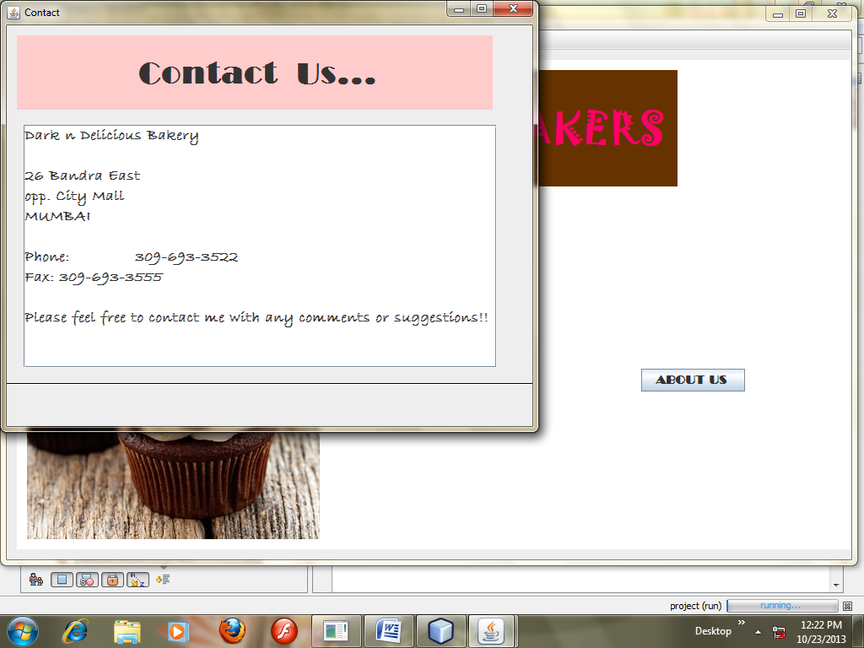

Coding of Cake page(cake.java)
import java.sql.*;
import javax.swing.ImageIcon;
import javax.swing.table.DefaultTableModel;
/*
* To change this template, choose Tools | Templates
* and open the template in the editor.
*/

/*
* cake.java
*
* Created on Oct 23, 2013, 12:24:57 PM
*/

/**
*
* @author lab2
*/
public class cake extends javax.swing.JFrame {

/** Creates new form cake */
public cake() {
initComponents();
}

/** This method is called from within the constructor to
* initialize the form.
* WARNING: Do NOT modify this code. The content of this method is
* always regenerated by the Form Editor.
*/
@SuppressWarnings("unchecked")
// <editor-fold defaultstate="collapsed" desc="Generated Code">
private void initComponents() {

lcpic = new javax.swing.JLabel();
border = new javax.swing.JButton();
jPanel1 = new javax.swing.JPanel();
ccrange = new javax.swing.JComboBox();
tcvalue = new javax.swing.JTextField();
bselcake = new javax.swing.JButton();
BCAKES = new javax.swing.JButton();
bcclear = new javax.swing.JButton();
jButton1 = new javax.swing.JButton();
jScrollPane1 = new javax.swing.JScrollPane();
tcakes = new javax.swing.JTable();
jLabel1 = new javax.swing.JLabel();

setDefaultCloseOperation(javax.swing.WindowConstants.EXIT_ON_CLOSE);

border.setText("ORDER");
border.addActionListener(new java.awt.event.ActionListener() {
public void actionPerformed(java.awt.event.ActionEvent evt) {
borderActionPerformed(evt);
}
});

jPanel1.setBorder(javax.swing.BorderFactory.createTitledBorder("PRICE RANGE"));

ccrange.setModel(new javax.swing.DefaultComboBoxModel(new String[] { "<", ">", "<=", ">=", "=" }));

bselcake.setText("SELECTION");
bselcake.addActionListener(new java.awt.event.ActionListener() {
public void actionPerformed(java.awt.event.ActionEvent evt) {
bselcakeActionPerformed(evt);
}
});

javax.swing.GroupLayout jPanel1Layout = new javax.swing.GroupLayout(jPanel1);
jPanel1.setLayout(jPanel1Layout);
jPanel1Layout.setHorizontalGroup(
jPanel1Layout.createParallelGroup(javax.swing.GroupLayout.Alignment.LEADING)
.addGroup(javax.swing.GroupLayout.Alignment.TRAILING, jPanel1Layout.createSequentialGroup()
.addGroup(jPanel1Layout.createParallelGroup(javax.swing.GroupLayout.Alignment.TRAILING)
.addGroup(jPanel1Layout.createSequentialGroup()
.addContainerGap()
.addComponent(bselcake))
.addGroup(jPanel1Layout.createSequentialGroup()
.addComponent(ccrange, javax.swing.GroupLayout.PREFERRED_SIZE, javax.swing.GroupLayout.DEFAULT_SIZE, javax.swing.GroupLayout.PREFERRED_SIZE)
.addPreferredGap(javax.swing.LayoutStyle.ComponentPlacement.RELATED, 30, Short.MAX_VALUE)
.addComponent(tcvalue, javax.swing.GroupLayout.PREFERRED_SIZE, 69, javax.swing.GroupLayout.PREFERRED_SIZE)))
.addGap(43, 43, 43))
);
jPanel1Layout.setVerticalGroup(
jPanel1Layout.createParallelGroup(javax.swing.GroupLayout.Alignment.LEADING)
.addGroup(jPanel1Layout.createSequentialGroup()
.addGroup(jPanel1Layout.createParallelGroup(javax.swing.GroupLayout.Alignment.BASELINE)
.addComponent(ccrange, javax.swing.GroupLayout.PREFERRED_SIZE, javax.swing.GroupLayout.DEFAULT_SIZE, javax.swing.GroupLayout.PREFERRED_SIZE)
.addComponent(tcvalue, javax.swing.GroupLayout.PREFERRED_SIZE, javax.swing.GroupLayout.DEFAULT_SIZE, javax.swing.GroupLayout.PREFERRED_SIZE))
.addPreferredGap(javax.swing.LayoutStyle.ComponentPlacement.RELATED, 18, Short.MAX_VALUE)
.addComponent(bselcake)
.addContainerGap())
);

BCAKES.setText("SHOW ALL CAKES");
BCAKES.addActionListener(new java.awt.event.ActionListener() {
public void actionPerformed(java.awt.event.ActionEvent evt) {
BCAKESActionPerformed(evt);
}
});

bcclear.setText("CLear");
bcclear.addActionListener(new java.awt.event.ActionListener() {
public void actionPerformed(java.awt.event.ActionEvent evt) {
bcclearActionPerformed(evt);
}
});

jButton1.setText("show pic");
jButton1.addActionListener(new java.awt.event.ActionListener() {
public void actionPerformed(java.awt.event.ActionEvent evt) {
jButton1ActionPerformed(evt);
}
});

tcakes.setModel(new javax.swing.table.DefaultTableModel(
new Object [][] {

},
new String [] {
"CID", "TYPE", "PRICE PER PIECE"
}
) {
boolean[] canEdit = new boolean [] {
false, false, false
};

public boolean isCellEditable(int rowIndex, int columnIndex) {
return canEdit [columnIndex];
}
});
jScrollPane1.setViewportView(tcakes);

jLabel1.setFont(new java.awt.Font("Tahoma", 1, 16));
jLabel1.setText("cake menu..");

javax.swing.GroupLayout layout = new javax.swing.GroupLayout(getContentPane());
getContentPane().setLayout(layout);
layout.setHorizontalGroup(
layout.createParallelGroup(javax.swing.GroupLayout.Alignment.LEADING)
.addGap(0, 498, Short.MAX_VALUE)
.addGroup(layout.createSequentialGroup()
.addContainerGap()
.addGroup(layout.createParallelGroup(javax.swing.GroupLayout.Alignment.LEADING)
.addGroup(layout.createSequentialGroup()
.addGroup(layout.createParallelGroup(javax.swing.GroupLayout.Alignment.LEADING)
.addComponent(BCAKES)
.addComponent(bcclear)
.addComponent(jButton1)
.addComponent(lcpic, javax.swing.GroupLayout.PREFERRED_SIZE, 272, javax.swing.GroupLayout.PREFERRED_SIZE))
.addGroup(layout.createParallelGroup(javax.swing.GroupLayout.Alignment.LEADING)
.addGroup(layout.createSequentialGroup()
.addGap(77, 77, 77)
.addComponent(border))
.addGroup(layout.createSequentialGroup()
.addGap(11, 11, 11)
.addComponent(jPanel1, javax.swing.GroupLayout.PREFERRED_SIZE, javax.swing.GroupLayout.DEFAULT_SIZE, javax.swing.GroupLayout.PREFERRED_SIZE)))
.addContainerGap())
.addGroup(layout.createSequentialGroup()
.addComponent(jScrollPane1, javax.swing.GroupLayout.PREFERRED_SIZE, 375, javax.swing.GroupLayout.PREFERRED_SIZE)
.addContainerGap(113, Short.MAX_VALUE))
.addGroup(javax.swing.GroupLayout.Alignment.TRAILING, layout.createSequentialGroup()
.addComponent(jLabel1, javax.swing.GroupLayout.PREFERRED_SIZE, 177, javax.swing.GroupLayout.PREFERRED_SIZE)
.addGap(210, 210, 210))))
);
layout.setVerticalGroup(
layout.createParallelGroup(javax.swing.GroupLayout.Alignment.LEADING)
.addGap(0, 454, Short.MAX_VALUE)
.addGroup(layout.createSequentialGroup()
.addComponent(jLabel1)
.addGap(13, 13, 13)
.addComponent(jScrollPane1, javax.swing.GroupLayout.PREFERRED_SIZE, 77, javax.swing.GroupLayout.PREFERRED_SIZE)
.addPreferredGap(javax.swing.LayoutStyle.ComponentPlacement.UNRELATED)
.addGroup(layout.createParallelGroup(javax.swing.GroupLayout.Alignment.LEADING)
.addGroup(layout.createSequentialGroup()
.addComponent(BCAKES)
.addPreferredGap(javax.swing.LayoutStyle.ComponentPlacement.UNRELATED)
.addComponent(bcclear)
.addGap(18, 18, 18)
.addComponent(jButton1))
.addComponent(jPanel1, javax.swing.GroupLayout.PREFERRED_SIZE, javax.swing.GroupLayout.DEFAULT_SIZE, javax.swing.GroupLayout.PREFERRED_SIZE))
.addPreferredGap(javax.swing.LayoutStyle.ComponentPlacement.RELATED)
.addGroup(layout.createParallelGroup(javax.swing.GroupLayout.Alignment.LEADING)
.addGroup(layout.createSequentialGroup()
.addGap(53, 53, 53)
.addComponent(border))
.addGroup(layout.createSequentialGroup()
.addGap(23, 23, 23)
.addComponent(lcpic, javax.swing.GroupLayout.PREFERRED_SIZE, 191, javax.swing.GroupLayout.PREFERRED_SIZE)))
.addGap(20, 20, 20))
);

pack();
}// </editor-fold>

private void borderActionPerformed(java.awt.event.ActionEvent evt) {
DefaultTableModel dm1= (DefaultTableModel)tcakes.getModel();
int i=tcakes.getSelectedRow();
System.out.print(" "+i);
String name=(String) dm1.getValueAt(i, 1);
Object pr=dm1.getValueAt(i,2);
new bill(name,pr).setVisible(true);
}

private void bselcakeActionPerformed(java.awt.event.ActionEvent evt) {
bcclear.doClick();
DefaultTableModel dm=(DefaultTableModel)tcakes.getModel();
try{
Class.forName("java.sql.Driver");
Connection con=DriverManager.getConnection("jdbc:mysql://localhost/project","root","tiger");
System.out.println("connected");
Statement s1=con.createStatement();
String sym=(String)ccrange.getSelectedItem();

int Val=Integer.parseInt(tcvalue.getText());
String sql="Select * from cake where price_per_piece"+sym+Val+";";
ResultSet r1=s1.executeQuery(sql);
String id=null,name=null;
int price=0;
while(r1.next()) {
id=r1.getString(1);
name =r1.getString(2);
price=r1.getInt(3);
dm.addRow(new Object[]{id,name,price});
}

} catch(Exception ex) {
System.out.println(ex);
} // TODO add your handling code here:
}

private void BCAKESActionPerformed(java.awt.event.ActionEvent evt) {
bcclear.doClick();
DefaultTableModel dm=(DefaultTableModel)tcakes.getModel();
try{
Class.forName("java.sql.Driver");
Connection con=DriverManager.getConnection("jdbc:mysql://localhost/project","root","tiger");
System.out.println("connected");
Statement s1=con.createStatement();
String sql="Select * from Cake;";
ResultSet r1=s1.executeQuery(sql);
String id=null,name=null;
int price=0;
while(r1.next()) {
id=r1.getString(1);
name =r1.getString(2);
price=r1.getInt(3);
dm.addRow(new Object[]{id,name,price});
}

} catch(Exception ex) {
System.out.println(ex);
}
// TODO add your handling code here:
}

private void bcclearActionPerformed(java.awt.event.ActionEvent evt) {
//tcvalue.setText("");
DefaultTableModel dm=(DefaultTableModel)tcakes.getModel();
int rc=dm.getRowCount();
for(int i=rc-1;i>=0;i--)
dm.removeRow(i);

// TODO add your handling code here:
}

private void jButton1ActionPerformed(java.awt.event.ActionEvent evt) {
DefaultTableModel dm1= (DefaultTableModel)tcakes.getModel();
int j=tcakes.getSelectedRow();
System.out.print(" "+j);
String pic=(String) dm1.getValueAt(j, 0);
if(pic.equals("CB1"))
lcpic.setIcon(new ImageIcon(getClass().getResource("/special.jpg")));
if(pic.equals("CC1"))
lcpic.setIcon(new ImageIcon(getClass().getResource("/choclatecookie.jpg")));
if(pic.equals("CC2"))
lcpic.setIcon(new ImageIcon(getClass().getResource("/choco.jpg")));
if(pic.equals("CP1"))
lcpic.setIcon(new ImageIcon(getClass().getResource("/coffee.jpg")));
if(pic.equals("CS1"))
lcpic.setIcon(new ImageIcon(getClass().getResource("/tumbler.jpg")));
if(pic.equals("CV1"))
lcpic.setIcon(new ImageIcon(getClass().getResource("/almond.jpg")));
if(pic.equals("CV2"))
lcpic.setIcon(new ImageIcon(getClass().getResource("/walnut.jpg")));
if(pic.equals("C2"))
lcpic.setIcon(new ImageIcon(getClass().getResource("/cash.jpg")));
}

/**
* @param args the command line arguments
*/
public static void main(String args[]) {
java.awt.EventQueue.invokeLater(new Runnable() {
public void run() {
new cake().setVisible(true);
}
});
}

// Variables declaration - do not modify
private javax.swing.JButton BCAKES;
private javax.swing.JButton bcclear;
private javax.swing.JButton border;
private javax.swing.JButton bselcake;
private javax.swing.JComboBox ccrange;
private javax.swing.JButton jButton1;
private javax.swing.JLabel jLabel1;
private javax.swing.JPanel jPanel1;
private javax.swing.JScrollPane jScrollPane1;
private javax.swing.JLabel lcpic;
private javax.swing.JTable tcakes;
private javax.swing.JTextField tcvalue;
// End of variables declaration

}

PASTRY PAGE

Coding of pastry page(pastry.java)
import java.sql.*;
import javax.swing.ImageIcon;
import javax.swing.table.DefaultTableModel;/*
* To change this template, choose Tools | Templates
* and open the template in the editor.
*/

/*
* Pastry.java
*
* Created on Oct 23, 2013, 12:37:47 PM
*/

/**
*
* @author lab2
*/
public class Pastry extends javax.swing.JFrame {

/** Creates new form Pastry */
public Pastry() {
initComponents();
}

/** This method is called from within the constructor to
* initialize the form.
* WARNING: Do NOT modify this code. The content of this method is
* always regenerated by the Form Editor.
*/
@SuppressWarnings("unchecked")
// <editor-fold defaultstate="collapsed" desc="Generated Code">
private void initComponents() {

bpastry = new javax.swing.JButton();
bcclear = new javax.swing.JButton();
jButton1 = new javax.swing.JButton();
lcpic = new javax.swing.JLabel();
border = new javax.swing.JButton();
jPanel1 = new javax.swing.JPanel();
ccrange = new javax.swing.JComboBox();
tcvalue = new javax.swing.JTextField();
bselpastry = new javax.swing.JButton();
jScrollPane1 = new javax.swing.JScrollPane();
tpastry = new javax.swing.JTable();
jLabel1 = new javax.swing.JLabel();

setDefaultCloseOperation(javax.swing.WindowConstants.EXIT_ON_CLOSE);

bpastry.setText("SHOW ALL PASTRY");
bpastry.addActionListener(new java.awt.event.ActionListener() {
public void actionPerformed(java.awt.event.ActionEvent evt) {
bpastryActionPerformed(evt);
}
});

bcclear.setText("CLear");
bcclear.addActionListener(new java.awt.event.ActionListener() {
public void actionPerformed(java.awt.event.ActionEvent evt) {
bcclearActionPerformed(evt);
}
});

jButton1.setText("show pic");
jButton1.addActionListener(new java.awt.event.ActionListener() {
public void actionPerformed(java.awt.event.ActionEvent evt) {
jButton1ActionPerformed(evt);
}
});

border.setText("ORDER");
border.addActionListener(new java.awt.event.ActionListener() {
public void actionPerformed(java.awt.event.ActionEvent evt) {
borderActionPerformed(evt);
}
});

jPanel1.setBorder(javax.swing.BorderFactory.createTitledBorder("PRICE RANGE"));

ccrange.setModel(new javax.swing.DefaultComboBoxModel(new String[] { "<", ">", "<=", ">=", "=" }));

bselpastry.setText("SELECTION");
bselpastry.addActionListener(new java.awt.event.ActionListener() {
public void actionPerformed(java.awt.event.ActionEvent evt) {
bselpastryActionPerformed(evt);
}
});

javax.swing.GroupLayout jPanel1Layout = new javax.swing.GroupLayout(jPanel1);
jPanel1.setLayout(jPanel1Layout);
jPanel1Layout.setHorizontalGroup(
jPanel1Layout.createParallelGroup(javax.swing.GroupLayout.Alignment.LEADING)
.addGroup(javax.swing.GroupLayout.Alignment.TRAILING, jPanel1Layout.createSequentialGroup()
.addGroup(jPanel1Layout.createParallelGroup(javax.swing.GroupLayout.Alignment.TRAILING)
.addGroup(jPanel1Layout.createSequentialGroup()
.addContainerGap()
.addComponent(bselpastry))
.addGroup(jPanel1Layout.createSequentialGroup()
.addComponent(ccrange, javax.swing.GroupLayout.PREFERRED_SIZE, javax.swing.GroupLayout.DEFAULT_SIZE, javax.swing.GroupLayout.PREFERRED_SIZE)
.addPreferredGap(javax.swing.LayoutStyle.ComponentPlacement.RELATED, 30, Short.MAX_VALUE)
.addComponent(tcvalue, javax.swing.GroupLayout.PREFERRED_SIZE, 69, javax.swing.GroupLayout.PREFERRED_SIZE)))
.addGap(43, 43, 43))
);
jPanel1Layout.setVerticalGroup(
jPanel1Layout.createParallelGroup(javax.swing.GroupLayout.Alignment.LEADING)
.addGroup(jPanel1Layout.createSequentialGroup()
.addGroup(jPanel1Layout.createParallelGroup(javax.swing.GroupLayout.Alignment.BASELINE)
.addComponent(ccrange, javax.swing.GroupLayout.PREFERRED_SIZE, javax.swing.GroupLayout.DEFAULT_SIZE, javax.swing.GroupLayout.PREFERRED_SIZE)
.addComponent(tcvalue, javax.swing.GroupLayout.PREFERRED_SIZE, javax.swing.GroupLayout.DEFAULT_SIZE, javax.swing.GroupLayout.PREFERRED_SIZE))
.addPreferredGap(javax.swing.LayoutStyle.ComponentPlacement.RELATED, 18, Short.MAX_VALUE)
.addComponent(bselpastry)
.addContainerGap())
);

tpastry.setModel(new javax.swing.table.DefaultTableModel(
new Object [][] {

},
new String [] {
"CID", "TYPE", "PRICE PER PIECE"
}
) {
boolean[] canEdit = new boolean [] {
false, false, false
};

public boolean isCellEditable(int rowIndex, int columnIndex) {
return canEdit [columnIndex];
}
});
jScrollPane1.setViewportView(tpastry);

jLabel1.setFont(new java.awt.Font("Tahoma", 1, 16));
jLabel1.setText("Pastry menu..");

javax.swing.GroupLayout layout = new javax.swing.GroupLayout(getContentPane());
getContentPane().setLayout(layout);
layout.setHorizontalGroup(
layout.createParallelGroup(javax.swing.GroupLayout.Alignment.LEADING)
.addGroup(layout.createSequentialGroup()
.addGroup(layout.createParallelGroup(javax.swing.GroupLayout.Alignment.LEADING)
.addGroup(layout.createSequentialGroup()
.addGap(138, 138, 138)
.addComponent(jLabel1, javax.swing.GroupLayout.PREFERRED_SIZE, 177, javax.swing.GroupLayout.PREFERRED_SIZE))
.addGroup(layout.createSequentialGroup()
.addGap(21, 21, 21)
.addComponent(jScrollPane1, javax.swing.GroupLayout.PREFERRED_SIZE, 375, javax.swing.GroupLayout.PREFERRED_SIZE)))
.addContainerGap(104, Short.MAX_VALUE))
.addGroup(layout.createSequentialGroup()
.addGroup(layout.createParallelGroup(javax.swing.GroupLayout.Alignment.TRAILING)
.addGroup(layout.createSequentialGroup()
.addContainerGap()
.addGroup(layout.createParallelGroup(javax.swing.GroupLayout.Alignment.LEADING)
.addComponent(bpastry)
.addGroup(layout.createSequentialGroup()
.addGap(10, 10, 10)
.addGroup(layout.createParallelGroup(javax.swing.GroupLayout.Alignment.LEADING)
.addComponent(jButton1)
.addComponent(bcclear))))
.addPreferredGap(javax.swing.LayoutStyle.ComponentPlacement.RELATED, 151, Short.MAX_VALUE))
.addGroup(layout.createSequentialGroup()
.addContainerGap()
.addComponent(lcpic, javax.swing.GroupLayout.PREFERRED_SIZE, 272, javax.swing.GroupLayout.PREFERRED_SIZE)
.addPreferredGap(javax.swing.LayoutStyle.ComponentPlacement.RELATED)))
.addGroup(layout.createParallelGroup(javax.swing.GroupLayout.Alignment.LEADING)
.addGroup(javax.swing.GroupLayout.Alignment.TRAILING, layout.createSequentialGroup()
.addComponent(jPanel1, javax.swing.GroupLayout.PREFERRED_SIZE, javax.swing.GroupLayout.DEFAULT_SIZE, javax.swing.GroupLayout.PREFERRED_SIZE)
.addGap(19, 19, 19))
.addGroup(javax.swing.GroupLayout.Alignment.TRAILING, layout.createSequentialGroup()
.addComponent(border)
.addGap(72, 72, 72))))
);
layout.setVerticalGroup(
layout.createParallelGroup(javax.swing.GroupLayout.Alignment.LEADING)
.addGroup(layout.createSequentialGroup()
.addComponent(jLabel1)
.addGap(36, 36, 36)
.addComponent(jScrollPane1, javax.swing.GroupLayout.PREFERRED_SIZE, 77, javax.swing.GroupLayout.PREFERRED_SIZE)
.addGroup(layout.createParallelGroup(javax.swing.GroupLayout.Alignment.LEADING)
.addGroup(layout.createSequentialGroup()
.addGap(29, 29, 29)
.addComponent(jPanel1, javax.swing.GroupLayout.PREFERRED_SIZE, javax.swing.GroupLayout.DEFAULT_SIZE, javax.swing.GroupLayout.PREFERRED_SIZE)
.addGap(34, 34, 34)
.addComponent(border))
.addGroup(layout.createSequentialGroup()
.addGap(18, 18, 18)
.addComponent(bpastry)
.addPreferredGap(javax.swing.LayoutStyle.ComponentPlacement.RELATED)
.addComponent(bcclear)
.addPreferredGap(javax.swing.LayoutStyle.ComponentPlacement.UNRELATED)
.addComponent(jButton1)
.addPreferredGap(javax.swing.LayoutStyle.ComponentPlacement.UNRELATED)
.addComponent(lcpic, javax.swing.GroupLayout.PREFERRED_SIZE, 191, javax.swing.GroupLayout.PREFERRED_SIZE)))
.addContainerGap(javax.swing.GroupLayout.DEFAULT_SIZE, Short.MAX_VALUE))
);

pack();
}// </editor-fold>

private void bpastryActionPerformed(java.awt.event.ActionEvent evt) {
bcclear.doClick();
DefaultTableModel dm=(DefaultTableModel)tpastry.getModel();
try{
Class.forName("java.sql.Driver");
Connection con=DriverManager.getConnection("jdbc:mysql://localhost/project","root","tiger");
System.out.println("connected");
Statement s1=con.createStatement();
String sql="Select * from pastry;";
ResultSet r1=s1.executeQuery(sql);
String id=null,name=null;
int price=0;
while(r1.next()) {
id=r1.getString(1);
name =r1.getString(2);
price=r1.getInt(3);
dm.addRow(new Object[]{id,name,price});
}

} catch(Exception ex) {
System.out.println(ex);
}
// TODO add your handling code here:
}

private void bcclearActionPerformed(java.awt.event.ActionEvent evt) {
//tcvalue.setText("");
DefaultTableModel dm=(DefaultTableModel)tpastry.getModel();
int rc=dm.getRowCount();
for(int i=rc-1;i>=0;i--)
dm.removeRow(i);

// TODO add your handling code here:
}

private void jButton1ActionPerformed(java.awt.event.ActionEvent evt) {
DefaultTableModel dm1= (DefaultTableModel)tpastry.getModel();
int j=tpastry.getSelectedRow();
System.out.print(" "+j);
String pic=(String) dm1.getValueAt(j, 0);
if(pic.equals("P1"))
lcpic.setIcon(new ImageIcon(getClass().getResource("/special.jpg")));
if(pic.equals("P2"))
lcpic.setIcon(new ImageIcon(getClass().getResource("/choclatecookie.jpg")));
if(pic.equals("P3"))
lcpic.setIcon(new ImageIcon(getClass().getResource("/choco.jpg")));
if(pic.equals("P4"))
lcpic.setIcon(new ImageIcon(getClass().getResource("/coffee.jpg")));
if(pic.equals("P5"))
lcpic.setIcon(new ImageIcon(getClass().getResource("/tumbler.jpg")));

}

private void borderActionPerformed(java.awt.event.ActionEvent evt) {
DefaultTableModel dm1= (DefaultTableModel)tpastry.getModel();
int i=tpastry.getSelectedRow();
System.out.print(" "+i);
String name=(String) dm1.getValueAt(i, 1);
Object pr=dm1.getValueAt(i,2);
new bill(name,pr).setVisible(true);
}

private void bselpastryActionPerformed(java.awt.event.ActionEvent evt) {
bcclear.doClick();
DefaultTableModel dm=(DefaultTableModel)tpastry.getModel();
try{
Class.forName("java.sql.Driver");
Connection con=DriverManager.getConnection("jdbc:mysql://localhost/project","root","tiger");
System.out.println("connected");
Statement s1=con.createStatement();
String sym=(String)ccrange.getSelectedItem();

int Val=Integer.parseInt(tcvalue.getText());
String sql="Select * from cake where price_per_piece"+sym+Val+";";
ResultSet r1=s1.executeQuery(sql);
String id=null,name=null;
int price=0;
while(r1.next()) {
id=r1.getString(1);
name =r1.getString(2);
price=r1.getInt(3);
dm.addRow(new Object[]{id,name,price});
}

} catch(Exception ex) {
System.out.println(ex);
} // TODO add your handling code here:
}

/**
* @param args the command line arguments
*/
public static void main(String args[]) {
java.awt.EventQueue.invokeLater(new Runnable() {
public void run() {
new Pastry().setVisible(true);
}
});
}

// Variables declaration - do not modify
private javax.swing.JButton bcclear;
private javax.swing.JButton border;
private javax.swing.JButton bpastry;
private javax.swing.JButton bselpastry;
private javax.swing.JComboBox ccrange;
private javax.swing.JButton jButton1;
private javax.swing.JLabel jLabel1;
private javax.swing.JPanel jPanel1;
private javax.swing.JScrollPane jScrollPane1;
private javax.swing.JLabel lcpic;
private javax.swing.JTextField tcvalue;
private javax.swing.JTable tpastry;
// End of variables declaration

}

