A+ Computer Science STARFIGHTER III

Lab Goal : This lab was designed to teach you more about OOP and using Abstract Classes and Interfaces.

Lab Description : Write a first person shooter game. You are the StarFighter and your job is to destroy all of the enemies that enter your space. The StarFighter ship and enemy ships will share lots of the same properties. This lab provides the perfect opportunity to use inheritance, abstract classes, and interfaces. You will also review ifs, loops, and ArrayList / Matrices.

Task Six – Make your Ship shoot some type of Ammo. You must make an Ammo class that extends MovingThing. Start with just a single Ammo. An group of Ammo will be added once the single Ammo has been tested thoroughly.
Task Seven – Make your Ship shoot and destroy the Alien.

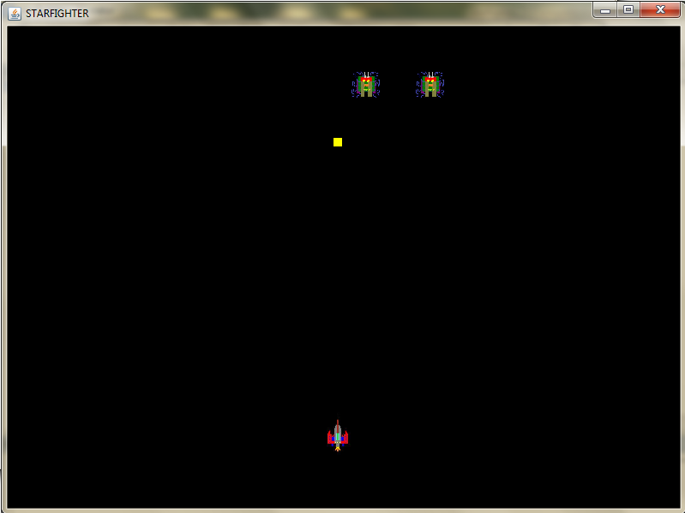
KEYS TO CONTROL THE SHIP

h - left
j - right
u - up
n - down

