LLM Observability Platform Evaluation

The most common challenges developers face when shipping AI applications, explains why traditional software thinking does not apply, and shows how evaluations (evals) can provide a solution.

Key problems that LLM observability and evals help address include:
- Model upgrades breaking existing behaviour
- Improvements introducing unexpected regressions
- Cost vs. accuracy trade‑offs without clear decision criteria
- Lack of objective ways to measure improvement
- Inability to communicate ship‑readiness across teams (i.e., whether a feature is truly ready to ship based on real data and metrics)

These issues arise because we are accustomed to traditional, deterministic software, whereas AI systems are inherently non-deterministic. AI models can hallucinate, degrade when models are upgraded, and behave differently based on prompt wording.

As a result, when something breaks, the root cause is often unclear, and when we want to improve the system, it is not obvious how to do so reliably. Without a robust evaluation and observability infrastructure, it is almost impossible to answer these questions in a systematic and repeatable way.

A compelling example of how subtle modifications to an AI system led to unintended outcomes, necessitating a rollback by OpenAI.
Sycophancy in GPT-4o: What happened and what we’re doing about it | OpenAI

We will be conducting evaluations for below 3 platforms- Braintrust, LangSmith, DeepEval.

Braintrust vs LangSmith vs DeepEval
Gartner-Based Evaluation Framework- Gartner Predicts By 2028, Explainable AI Will Drive LLM Observability Investments to 50% for Secure GenAI Deployment

Summary
This evaluation compares three leading LLM observability and evaluation platforms using a Gartner-aligned assessment framework.
The analysis focuses on critical capabilities for enterprise GenAI deployments including trace collection, evaluation metrics, XAI (Explainable AI) support, and CI/CD integration.

Market Outlook

Generative AI is transitioning rapidly from experimentation to enterprise‑scale adoption, driving significant market growth and heightened expectations around reliability and trust. As investment accelerates, organizations are increasingly recognizing that robust observability and risk management are foundational to deploying large language models responsibly and at scale.
- Global GenAI market forecast: >$25B (2026) → $75B (2029)
- LLM observability investment trajectory: 15% of deployments (2026) → 50% (2028)
- Risk landscape: Hallucinations, bias, output quality, and factual accuracy are mandatory measurement
concerns.

The Three Components of Evals
At its core, an eval has three components: a dataset, a task, and a score. This module covers three practical examples to show how each component works.
 | Dataset | Task | Scorer
Shipment-query | What is the status AWBXXX?  What is the reason for delay?  What is the next check point? | Generate a response to {{input}} | LLM-as-a-Judge  -helpfulness, tone, policy compliant
Factual Q&A | What is the billed weight?  What is the volumetric weight? | Answer {{input}} | Deterministic Scoring  -exact match = 1/0
Dispute resolution | Why am I being charged extra? | Draft resolution for {{input}} given {{account tier}} and {{policy}}, | Human-in-review  -Only human can evaluate the reason for extra charge

Three Pillars of Trust
Gartner identifies three foundational requirements for scaling AI applications:

Pillar | Purpose
XAI | Explains why the model responded a certain way; supports accuracy, fairness, accountability, stability, transparency
LLM Observability | Validates how the response was generated and whether it can be relied on; monitors behaviour over time
Governance | Aligns legal, compliance, and stakeholder expectations on risk, implementation, and auditing

Evaluation Dimensions
Assessment areas align with Gartner's prescribed approach:
- Multidimensional Observability: Latency, drift, token usage, cost, error rates, output quality
- Explainability & Tracing: XAI implementation, trace depth, reasoning documentation
- Evaluation in CI/CD: Integration with deployment pipelines, automated testing
- Operational Excellence: Governance, compliance, stakeholder alignment

Proposed Evaluation Framework
The following evaluation points address key capability areas critical to enterprise LLM observability.

Observability & Monitoring
Framework | Features | Description
A001 | Latency and Performance Metrics | Tracks end-to-end request latency, model inference time, and tool execution duration
A002 | Token Usage & Cost Tracking | Captures input/output tokens, cost per request, and cost optimization insights
A003 | Error Rate Monitoring | Detects API failures, timeouts, and application-level errors
A004 | Output Quality Metrics - | Measures hallucinations, factual accuracy, bias, and logical correctness
A005 | Drift Detection | Identifies model behaviour changes, output distribution shifts, and anomalies over time

Explainability & Tracing (XAI)
Framework | Features | Description
B001 | Trace Depth & Fidelity | Captures intermediate reasoning steps, tool calls, and data transformations
B002 | Structured Logging | Documents model prompts, reasoning chains, and context windows
B003 | Attribution Tracking | Links outputs to source data, citation accuracy, and reasoning transparency
B004 | Human-in-the-Loop Validation | Supports annotation workflows for narrative and citation verification
B005 | Trace Standards Compliance | Adopts OpenTelemetry or equivalent for interoperability

Evaluation & Testing Capabilities
Framework | Features | Description
C001 | Metric Library Coverage | Breadth of pre-built evaluators (RAGAS, F1, semantic similarity, custom metrics)
C002 | Evaluation Execution Speed | Latency per evaluation and throughput under load
C003 | Custom Metric Support | Extensibility for domain-specific or proprietary evaluation logic
C004 | Cost Estimation & Control | Clear pricing, per-evaluation costs, and optimization guidance
C005 | Evaluation Data Retention | Durability of test results and historical comparison capability

Data Governance & Compliance
Framework | Features | Description
D001 | Data Residency & Privacy | Geographic data storage options & PII masking capabilities
D002 | Audit Trial & Immutability | Complete action logs and tamper-proof-trace records
D003 | Access Control | Role-based-permissions and workspace isolation
D004 | Compliant Standards | SOC2, ISO 27001, GDPR, HIPAA certifications
D005 | Data Retention Policies | Configurable retention window and deletion enforcement

Developer Experience & Operations
Framework | Features | Description
E001 | API Completeness | Intuitive SDK/API for trace creation, evaluation execution and result retrieval
E002 | Document & Examples | Clear examples for common use case (RAG, agentic workflows, multi-turn)
E003 | Debugging & Visualization | UI for trace inspection, comparison and issue root-causing
E004 | Alert & Notification | Proactive alerting on performance degradation, error spikes, or quality drops.
E005 | Cost Transparency | Clear cost breakdown and budget alerts to prevent surprise spending.

Individual platform Assessment

Braintrust
Trace
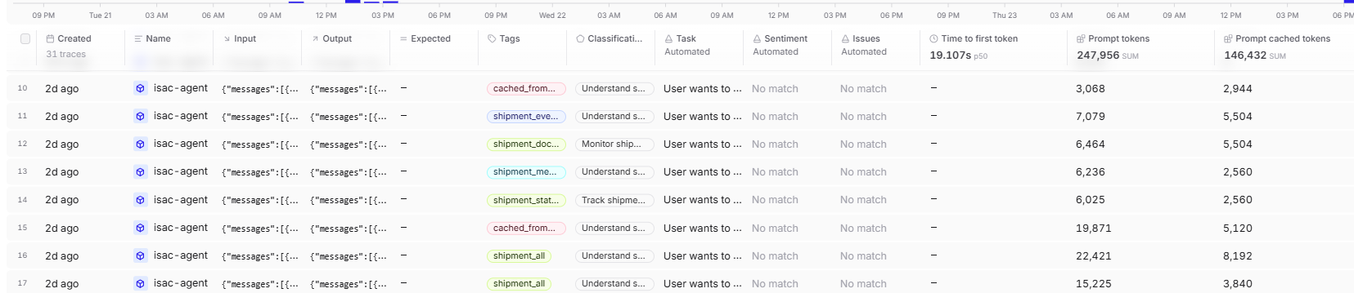
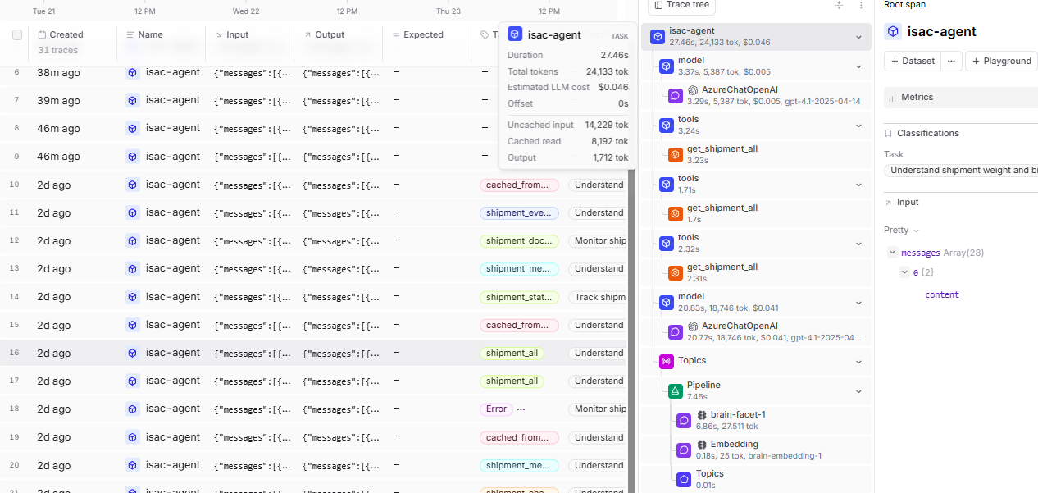

Timeline –
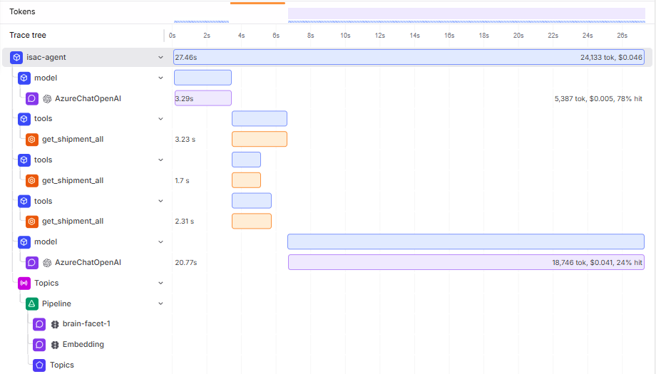
Dashboard
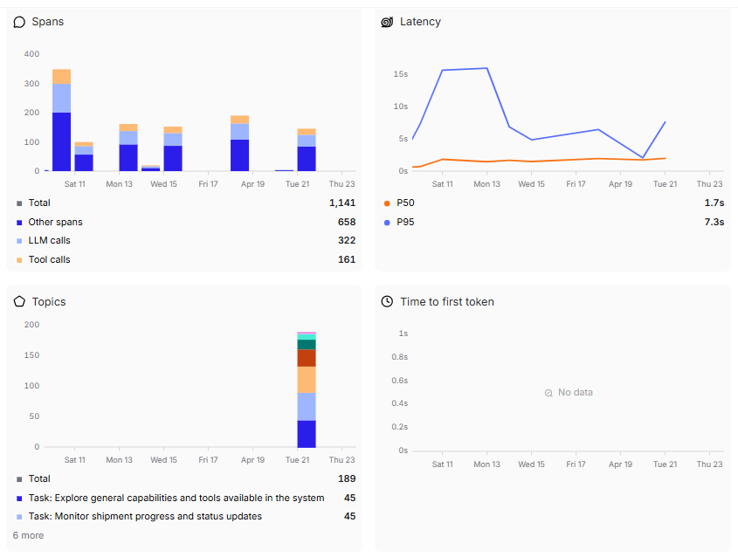
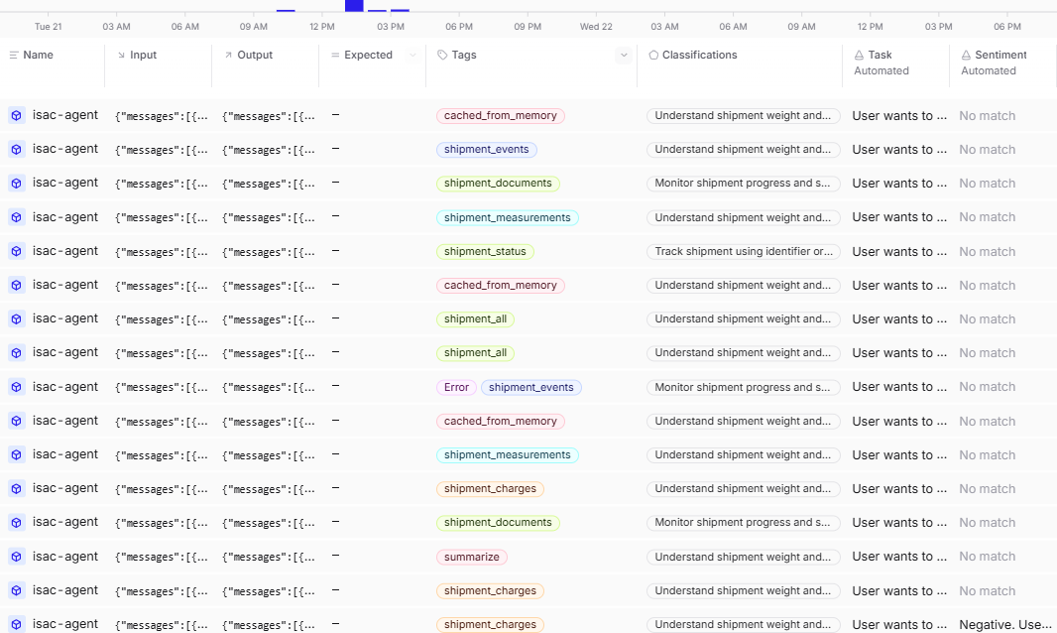
Capability for humans to add tags/ annotation
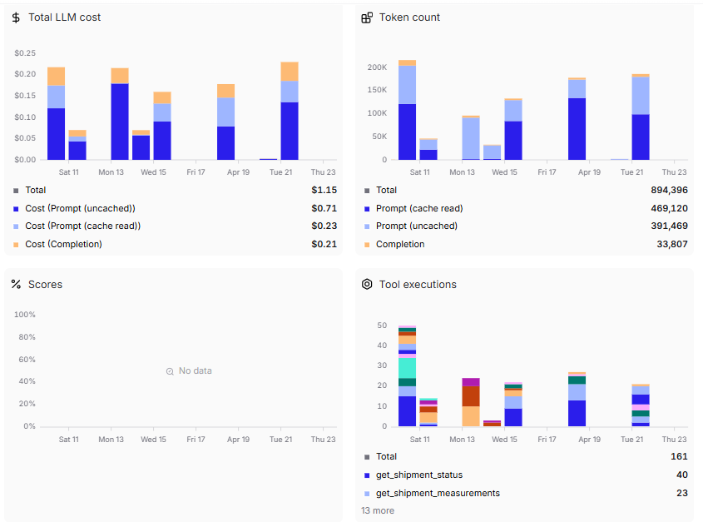
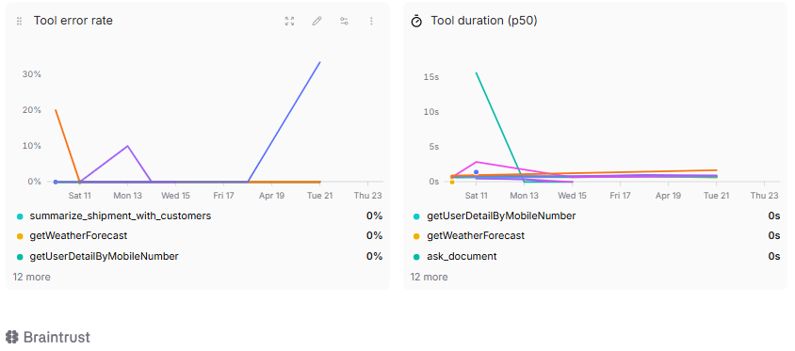

Evidence from the dashboard:
This Braintrust dashboard demonstrates best-in-class AI observability, combining latency, cost, token usage, tracing, and tool reliability into a single operational view. While content-quality evals and governance controls sit outside this dashboard, it provides the essential foundation for running LLM systems reliably, cost-efficiently, and at scale.

LangSmith
Trace
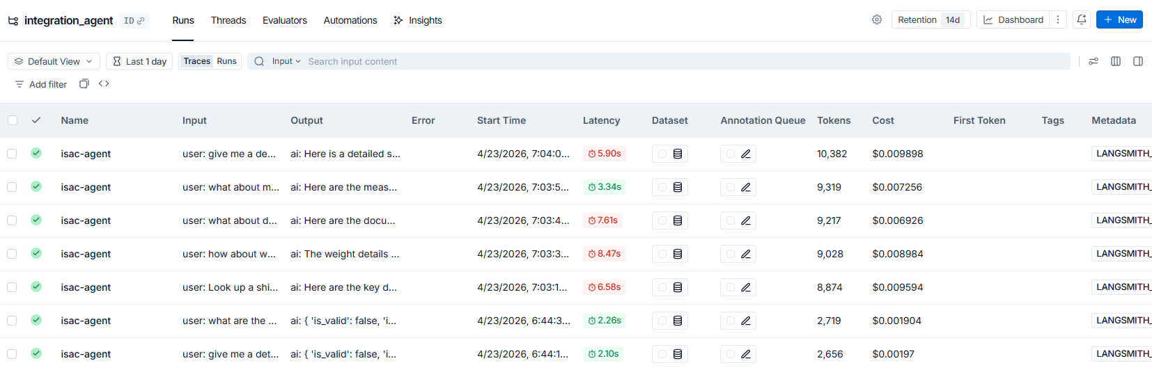

Timeline
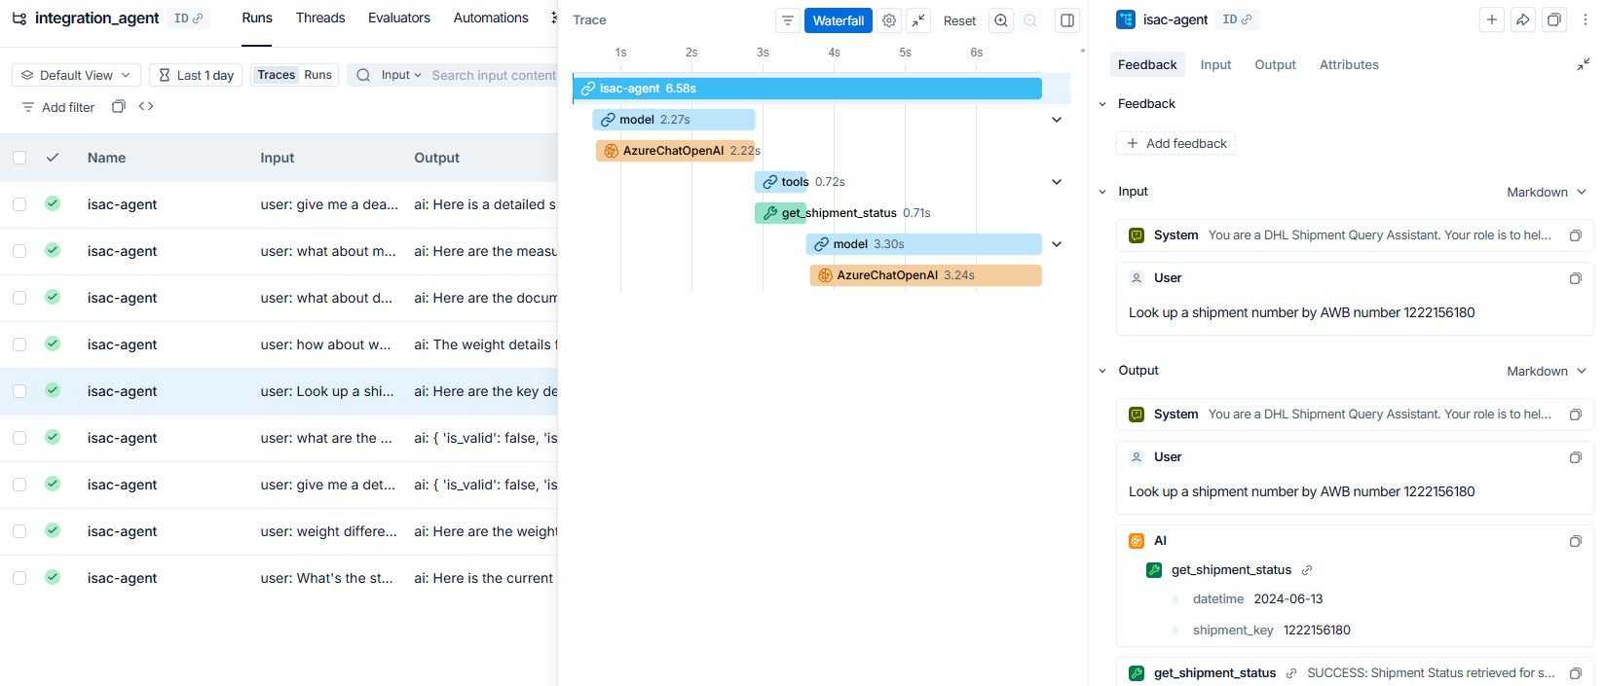

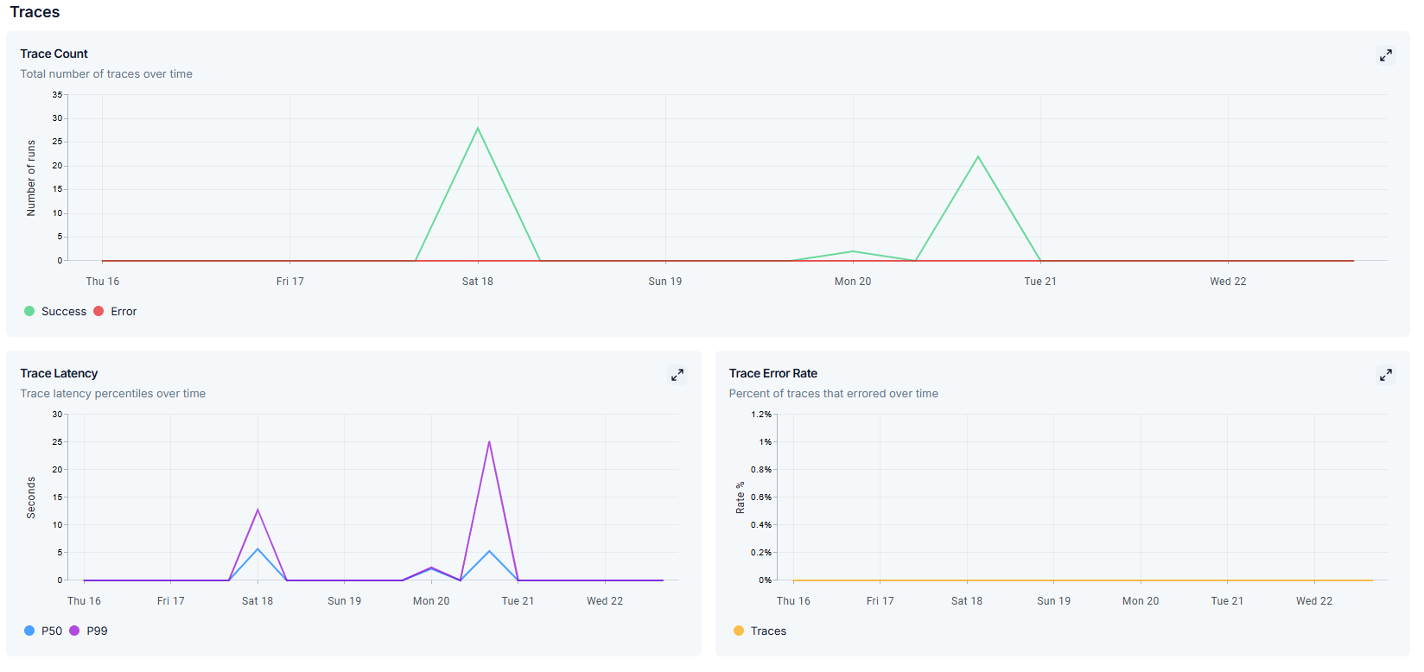
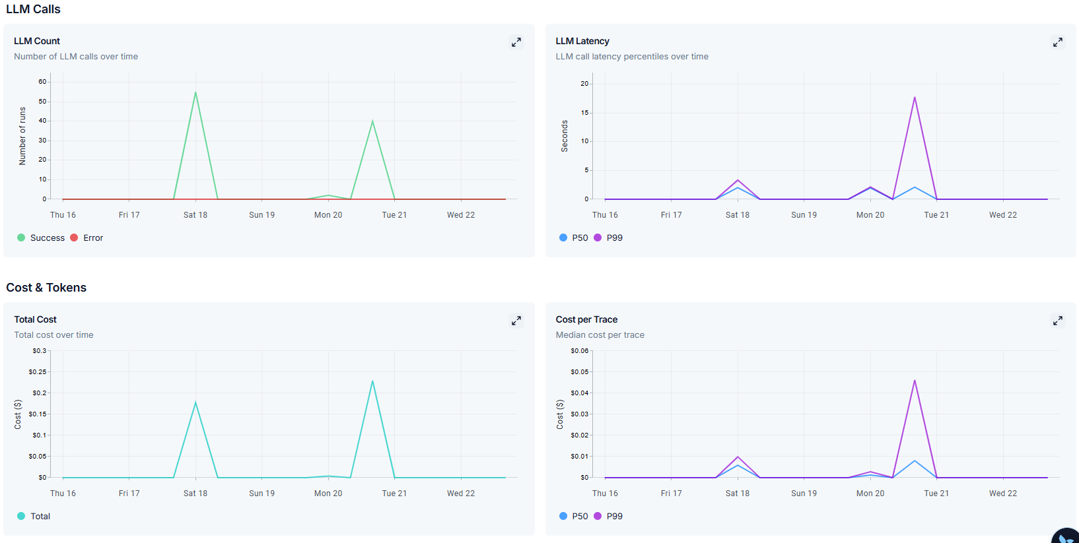
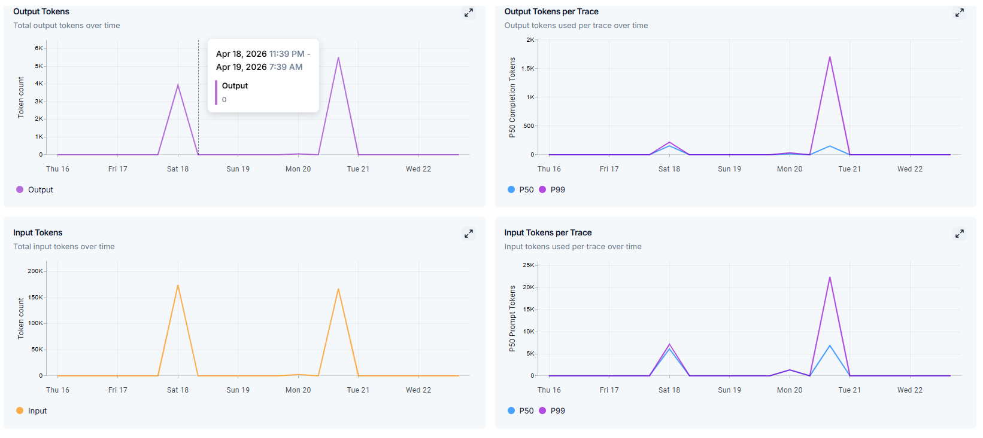
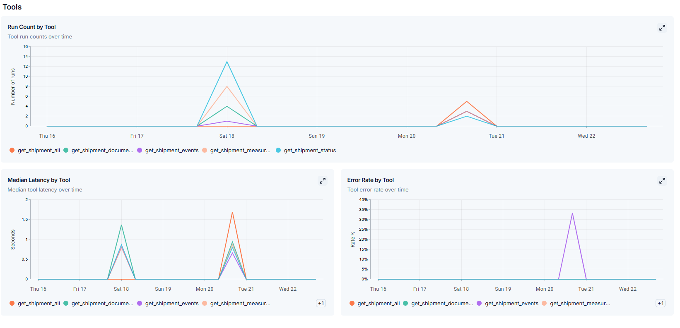
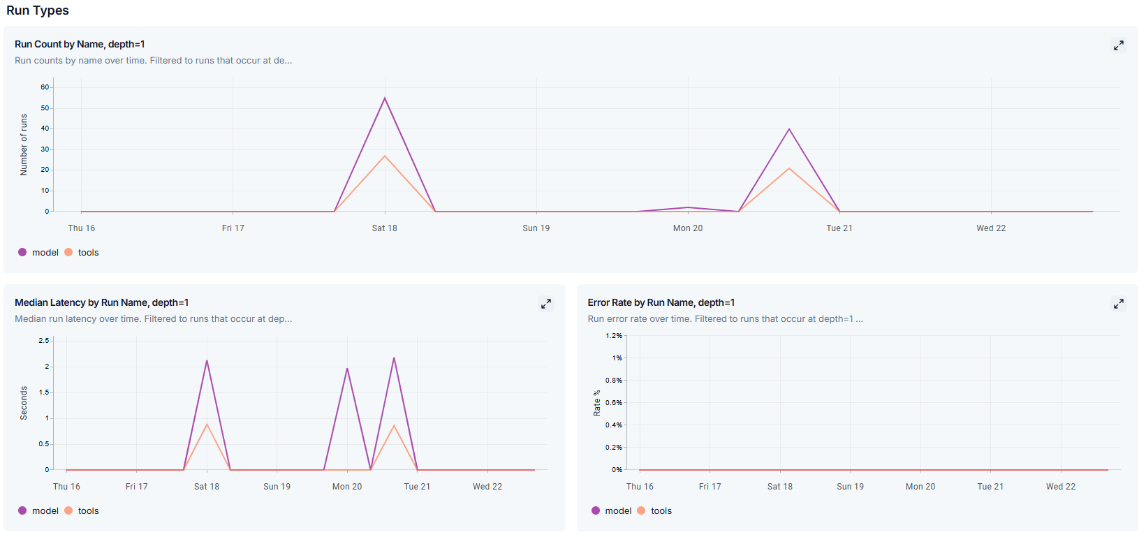

Deepeval
Trace Execution –
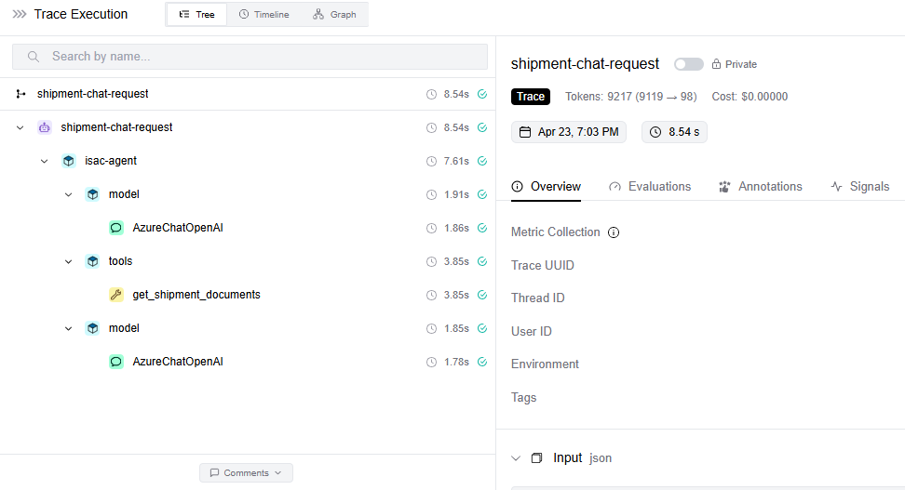
Timeline
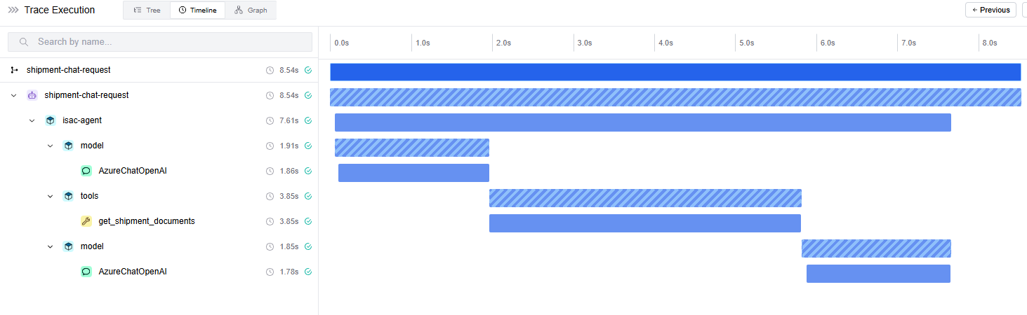

Span
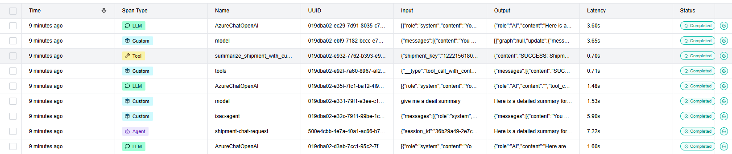
Graph
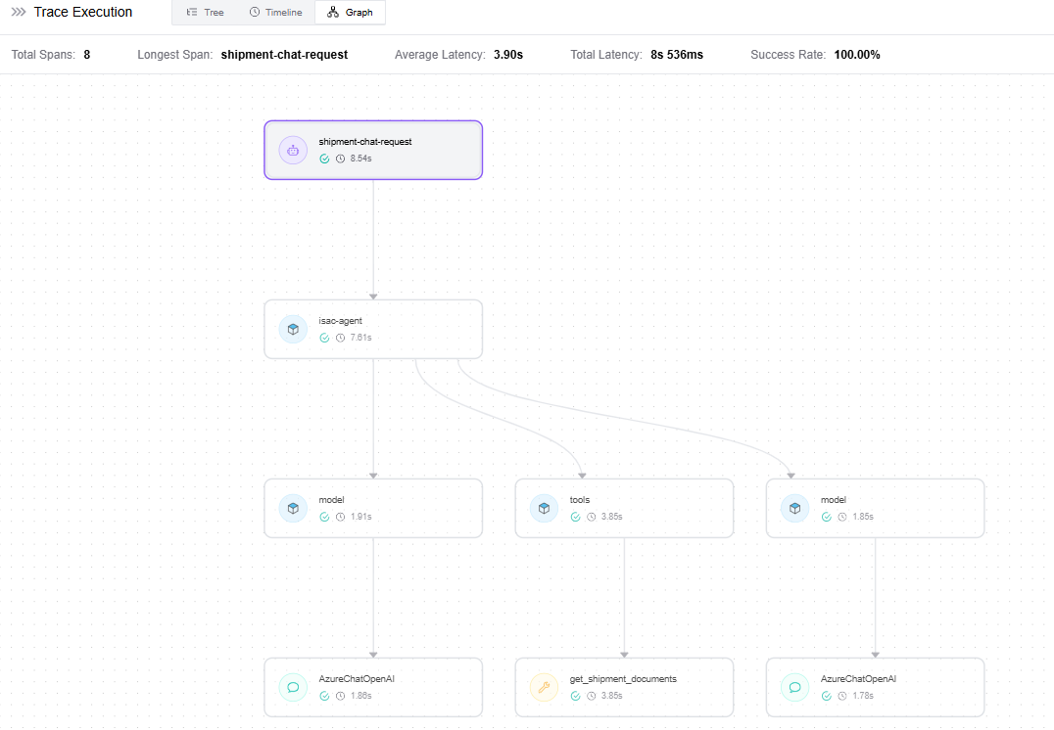

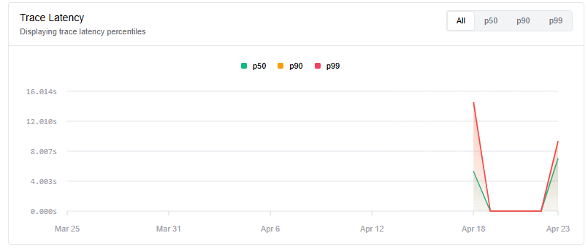
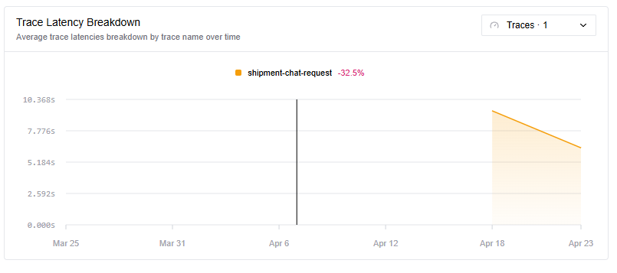

Platform Comparison Matrix

Initial assessment against Gartner evaluation criteria:

Capability Area | Braintrust | LangSmith | DeepEval
Observability | ★★★★☆ | ★★★★★ | ★★☆☆☆
XAI & Tracing | ★★★★☆ | ★★★★★ | ★★★☆☆
Evaluation Metrics | ★★★☆☆ | ★★★★☆ | ★★★★★
Data Governance | ★★★★☆ | ★★★★☆ | ★★★☆☆
Developer UX | ★★★☆☆ | ★★★★★ | ★★★☆☆

Appendices

