Name= Anshul Nitnaware.

Roll.No= 14

1. Find airports that are listed as both a source and distination in the routes table.

Ans= select src_airport_iata,dest_airport_iata from routes limit 10;

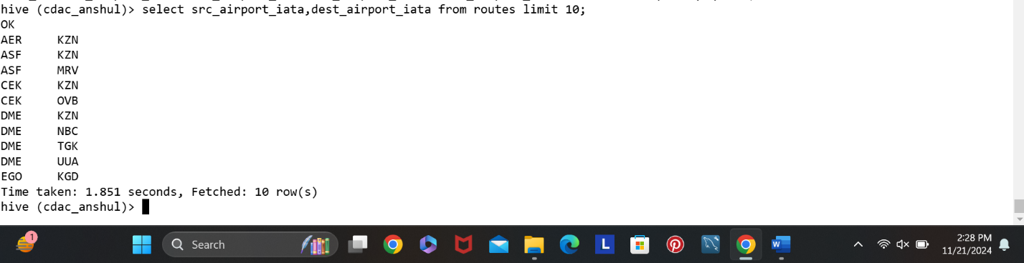

QUESTION 2)=

1. Create a partitioned table to store the routes data by the source_Airport. Write the SQL Query to create this table and insert into it.

Ans= CREATE TABLE routesby (airline string, airline_id int, src_airport_id int, dest_airport_iata string, dest_airport_id int, codeshare string, stops int, equipment string) PARTITIONED BY (src_airport_iata string) ROW FORMAT DELIMITED FIELDS TERMINATED BY ',' STORED AS TEXTFILE;

Insert overwrite table routesby partition(src_airport_iata) select airline, airline_id,src_airport_iata, src_airport_id,dest_airport_iata, dest_airport_id, codeshare, stops, equipment from routes;

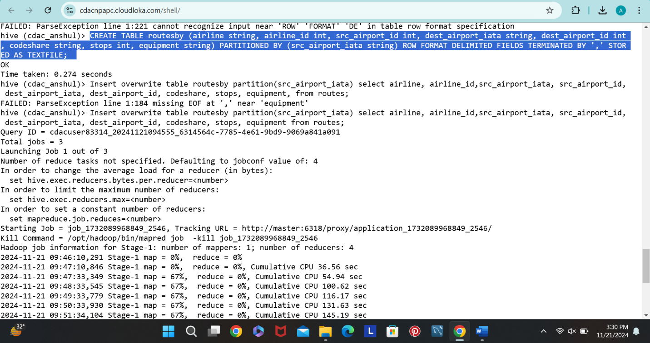

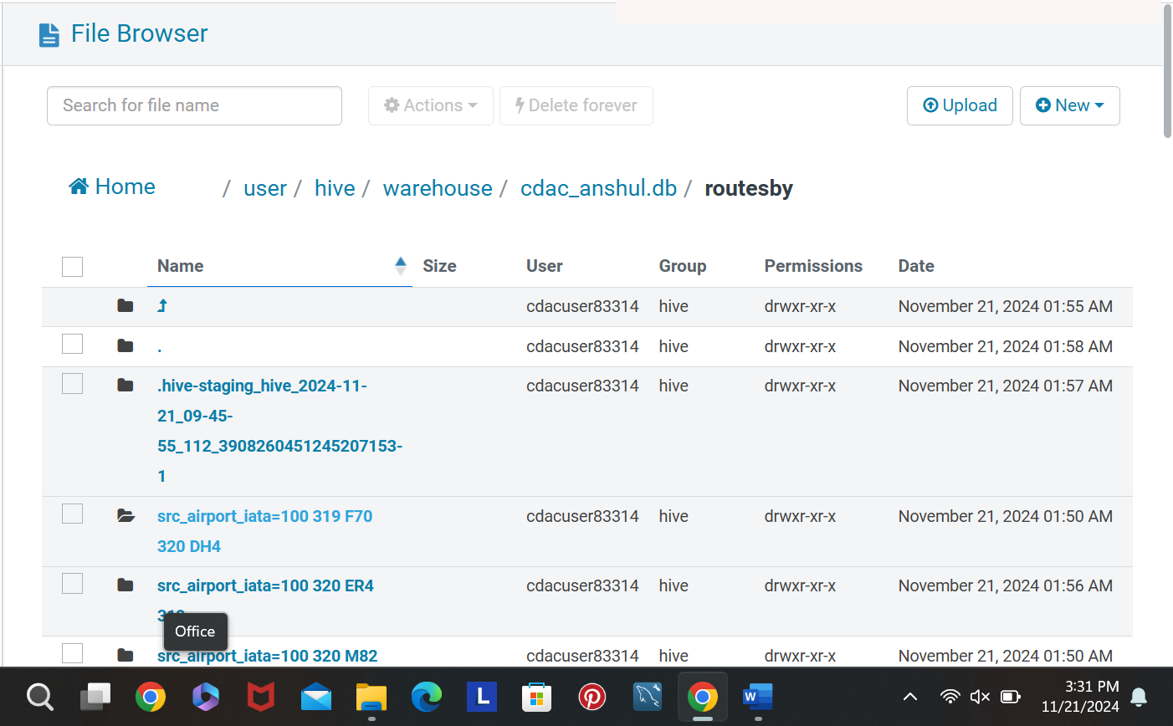

Q.2) insert data into portioned routes_partitioned table for the source airport =”JFK” partiotioned.

ANS= CREATE TABLE routesb (airline string, airline_id int, src_airport_id int, dest_airport_iata string, dest_airport_id int, codeshare string, stops int, equipment string) PARTITIONED BY (src_airport_iata string) ROW FORMAT DELIMITED FIELDS TERMINATED BY ',' STORED AS TEXTFILE;

Insert overwrite table routesby partition(LAX) select airline, airline_id,src_airport_iata, src_airport_id,dest_airport_iata, dest_airport_id, codeshare, stops, equipment from routes;