Slide 1: Title & Authors
- Title: PE-GPT: A New Paradigm for Power Electronics Design
- Authors: Fanfan Lin, Xinze Li, Weihao Lei, Juan J. Rodriguez-Andina, J. Guerrero, Changyun Wen, Xin Zhang, Hao Ma
- Repository: GitHub – XinzeLee/PolygonObjectDetection

Slide 2: What is PE-GPT?
- Customized LLM specifically for power electronics design
- Overcomes limitations of general-purpose LLMs
- Applied to:
  - Modulation optimization for Dual-Active-Bridge (DAB) converters
  - Circuit parameter design for Buck converters
- Core is a hybrid design framework:
  - Power-electronics-tailored LLM agent
  - Model Zoo
  - Simulation Repository
  - Optimizers

Slide 3: Key Capabilities
- Expert-Level Insights (RAG): Answers based on verified PE knowledge base
- Adaptive Semantic Understanding: Interprets technical queries accurately
- Optimizing Design Parameters: Uses metaheuristic algorithms + model zoo
- Simulation Integration: PLECS, PSIM, Simulink, COMSOL, Ansys
- Fine-Tuning with User Data: Improves accuracy for real-world use cases
- Iterative Customization: Incorporates user feedback for refinements
- Consistency & Reliability: 98.8% consistency, 22.2% more correct than experts

Slide 4: Advantages & Impact
- Reduced Hallucinations: Context-aware answers grounded in verified data
- Multimodal Processing: Handles text + time-series waveform data
- Scalable & Generalizable: Works for many PE design problems
- Improved Accuracy & Reliability: Validated through hardware experiments
- Paradigm Shift: Faster design cycles, improved reliability, lower errors
- Ethical & Social Considerations: Focuses on transparency & privacy

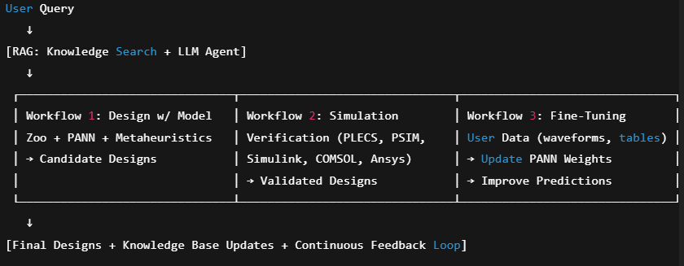

Slide 1: How Large Language Models Think
🔹 Imagine a Smart Engineer Reading Your Question
- When you ask:
"The inverter converts DC power into ___?"
- The model looks at all previous words (“The”, “inverter”, “converts”, “DC power”)
- It decides which words matter most (DC power + converts)
- Then it picks the most probable word: “AC”.
This process is called “attention” — like a good student deciding which words in a sentence are most important.

Slide 2: Why Transformers Were a Big Deal
Before 2017, models could only read text left to right — they forgot things quickly (like a short memory).
Transformers (2017) allowed them to look at the whole sentence at once, so:
- They don’t forget words that appeared earlier.
- They understand technical terms better (like “soft-switching” or “PWM”).

Slide 3: Making GPT Useful for Power Electronics
We use 3 main tricks to make a general GPT work for PE:
- Prompt Engineering
  - Like asking a junior engineer a clear question:
  - Instead of: “Explain buck converter”
  - We say: “Explain buck converter working step-by-step with equations.”
- RAG (Retrieval-Augmented Generation)
  - GPT doesn’t know your textbook → so we “hand it the right pages.”
  - It searches in our PE knowledge base, finds relevant sections, then answers.
- Fine-Tuning
  - If we have many lab results or simulation data → we can “train” GPT on them.
  - This makes it give more accurate answers for our use case (e.g., DAB converter optimization).
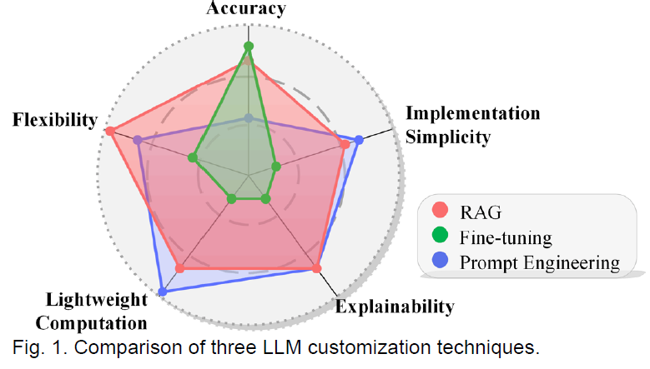

Slide: Hybrid Framework of PE-GPT – Intuitive Explanation

1. Two Types of Inputs
- Textual Queries: Like asking a smart assistant – “What modulation is best for DAB converter at 10 kW?”
- Fine-Tuning Data: Like giving it your own lab results – measured waveforms, tabular efficiency data – so it learns from your experiments.

2. Retrieval-Augmented Generation (RAG) – The Knowledge Booster
- Think of RAG as giving GPT a personal PE library.
- First, we prepare a PE Knowledge Base (collecting papers, datasheets, standards).
- When you ask a question:
  - The system converts your question into numbers (embeddings)
  - It finds the most relevant pages/snippets from the knowledge base
  - Combines them with your question
  - Sends both to GPT → GPT gives grounded, context-aware answer
This prevents hallucinations (random wrong answers) because GPT is forced to “read before answering.”

3. Three Workflows (Brains of PE-GPT)
Workflow 1 – Design with Model Zoo (Optimization Brain)
- You ask: “Design a DAB converter for 5 kW, 400 V → 48 V.”
- PE-GPT runs a metaheuristic optimization loop:
  - Function Evaluation: Tries many candidate designs using the Model Zoo (simulation models of converters)
  - Selection: Keeps only the better-performing ones
  - Evolution: Tweaks parameters (like duty cycle, transformer ratio) to improve results
- Repeats this until it finds an optimal solution (e.g., minimum losses, best efficiency).
- Advantage: Metaheuristics can find global solutions without getting stuck in bad designs.

Workflow 2 – Simulation Verification (Testing Brain)
- Once a design is found → PE-GPT can automatically pass it to tools like Simulink, PLECS, PSIM
- One-click run → Simulates current waveforms, voltages, efficiency, THD
- This is like validating your design before building hardware

Workflow 3 – Fine-Tuning (Learning Brain)
- Suppose the simulation gave 96% efficiency, but real lab measurement is 94% → there’s a gap.
- You feed your experimental data back → PE-GPT updates its internal models
- This makes future designs more realistic and closer to your actual hardware performance

Summary of Intuition
PE-GPT = Ask (Query) → Search Knowledge (RAG) → Design (Model Zoo) → Verify (Simulation) → Improve (Fine-tuning).
It’s like having a virtual PE engineer that learns from you over time.

Retrieval-Augmented Generation (RAG) – Intuition
Why RAG?
- The Problem:
Large Language Models (LLMs) like GPT-4 or Llama are trained on huge amounts of data from books, websites, and articles. This gives them good general knowledge but not very deep expertise in niche areas like power electronics (PE).
Think of them as a smart engineering graduate – they know a bit about every subject, but they might not know the exact equations or design details for, say, a dual-active-bridge (DAB) converter.
- The Solution:
RAG acts like a smart library assistant for the LLM. When you ask a question:
  - It first searches a specialized PE knowledge base (collection of papers, datasheets, and design notes).
  - It picks the most relevant pieces (like quoting exact paragraphs from those papers).
  - Then, it gives those to the LLM along with your question.
This makes the LLM’s answer much more accurate and technical, because it’s now using the exact same references an engineer would use.
- Benefits:
  - Accuracy & Relevancy: If you ask for modulation strategies, RAG can pull exact equations or simulation results from IEEE papers, so the answer is grounded in real engineering literature.
  - Customizability: You can have different knowledge bases for different projects.
Example:
    - Project A: Converter design → Knowledge base full of topology papers.
    - Project B: Thermal management → Knowledge base full of cooling and loss modeling papers.
The same PE-GPT can adapt by just switching databases — no retraining needed.

How RAG Works (Workflow)
Think of RAG like a three-step process before the LLM even starts answering:
- Chunking (Splitting):
  - Imagine you have a 200-page textbook. RAG first splits it into smaller sections (like 1–2 paragraphs each).
  - This makes searching faster and more precise (we don’t want to feed the entire textbook for every query).
- Embedding (Turning Text into Math):
  - Each chunk and your question are converted into vectors — basically lists of numbers that capture their meaning.
  - If your query is "best modulation for DAB converter at light load", RAG finds chunks whose meaning is mathematically "close" to your question.
- Retrieval (Finding the Best Match):
  - RAG compares your query vector with all chunk vectors and finds the closest ones.
  - Example: If there are 1000 chunks, it might pick the top 5 most similar ones.
  - Those 5 chunks + your question are then sent to the LLM so it can generate a context-aware, PE-specific answer.

Hyperparameters (Important Settings to Tune)
- Chunk Size:
  - Bigger chunks = fewer searches, but might include irrelevant text.
  - Smaller chunks = more precise, but slower and may lose context.
  - Choosing the right size is like deciding how big each "note card" should be when summarizing a textbook.
- Top-k (Number of Results to Retrieve):
  - If you retrieve too few chunks (say top-1), you risk missing key info.
  - If you retrieve too many (say top-50), the LLM gets overloaded with irrelevant info.
  - Usually a small number like 3–5 works well.

Model Zoo & PANN – Intuition
1. Model Zoo – The “Evaluation Engine”
- Purpose:
The Model Zoo is like a toolbox of models that PE-GPT uses to evaluate candidate designs during optimization.
Imagine you are designing a DAB converter — you try different modulation parameters (phase shifts, duty cycles) and then check performance metrics (current stress, ZVS/ZCS conditions, efficiency).
The Model Zoo automates this evaluation step.
- Types of Models in the Zoo:
  - White-Box Models:
    - These are pure equations — like using classical converter equations you’d find in textbooks.
    - Example:
iL(t)=Vp−nVsLti_L(t) = \frac{V_p - nV_s}{L}tiL​(t)=LVp​−nVs​​t (basic inductor equation).
    - Advantage: Exact and interpretable, but may be oversimplified for real-world designs.
  - Black-Box Models:
    - These are pure ML models trained on data (no physics explicitly included).
    - Example: Train a neural network to predict converter efficiency given input parameters.
    - Advantage: Can capture complex behavior but may fail outside training data range.
  - Gray-Box Models:
    - Best of both worlds — partly physics-based, partly ML.
    - Example: Physics-Informed Neural Networks (PINNs) that enforce Kirchhoff’s laws while still learning unknown nonlinearities from data.
    - Advantage: Good generalization, physically meaningful results.
- Key Idea:
The Model Zoo allows PE-GPT to mix and match models depending on accuracy needs and available data.
  - Quick analytic models for fast prototyping.
  - Data-driven models for detailed performance prediction.

2. PANN Model – The Star of the Show
- What is PANN?
PANN = Physics-Aware Neural Network.
It is a special neural network designed for power electronic circuits, where physics (like inductor current equations) is embedded into the model.
- Why PANN is Powerful:
  - Traditional neural networks learn “black box” patterns, which might not respect circuit laws.
  - PANN forces the network to obey differential equations of circuits.
  - Think of it as “teaching the neural network Ohm’s law, Kirchhoff’s law, and inductor equations” before it starts learning.
- How It Works (Intuitive Flow):
  - Input: Candidate modulation parameters (phase shifts D0,D1,D2D_0, D_1, D_2D0​,D1​,D2​, duty cycles ϕ1,ϕ2\phi_1, \phi_2ϕ1​,ϕ2​).
  - Step 1 – Generate Inputs: Convert those parameters into primary/secondary voltages vp,vsv_p, v_svp​,vs​.
  - Step 2 – Predict Current:
    - PANN uses a recurrent neural architecture (like memory) to predict iL(t)i_L(t)iL​(t) step by step over a switching period TsT_sTs​.
    - The update rule uses an implicit Euler method (numerical technique for solving differential equations).
      - This means instead of just guessing, it solves iL(tk+1)i_L(t_{k+1})iL​(tk+1​) considering circuit physics.
  - Step 3 – Performance Evaluation:
    - Current stress: ipp=iL,max−iL,mini_{pp} = i_{L,\text{max}} - i_{L,\text{min}}ipp​=iL,max​−iL,min​.
    - Soft switching check: Looks at whether iLi_LiL​ is in the right direction at switching instants (ZVS, ZCS).
    - These outputs are then used as the objective function for the metaheuristic algorithm.

3. Metaheuristic Algorithm (Search for Best Design)
- Once PANN evaluates a candidate, the metaheuristic algorithm decides whether to:
  - Keep it (if it’s better than previous designs).
  - Evolve it (change parameters slightly).
- This repeats until the algorithm finds an optimal or near-optimal solution.
- Think of it as a genetic algorithm or swarm optimization where PANN is the “fitness function.”

4. Fine-Tuning with Real Data
- Problem: Simulated models may not always match real lab results.
- Solution: PE-GPT allows users to feed measured time-series data (like oscilloscope waveforms).
- This data is used to fine-tune PANN by:
  - Calculating the Mean Squared Error (MSE) between predicted iLi_LiL​ and measured iL∗i_L^*iL∗​.
  - Backpropagating the error to adjust parameters θ={L,RL,n,… }\theta = \{L, R_L, n, \dots\}θ={L,RL​,n,…}.
- Result: The model becomes more accurate for the specific converter you are working on.

Summary Intuition
- Model Zoo = Toolbox of models (from equations to AI models).
- PANN = Physics-guided neural network that predicts inductor current & performance metrics.
- Metaheuristics = Smart search algorithm to find the best design.
- Fine-tuning = Makes the models more accurate using real lab data.

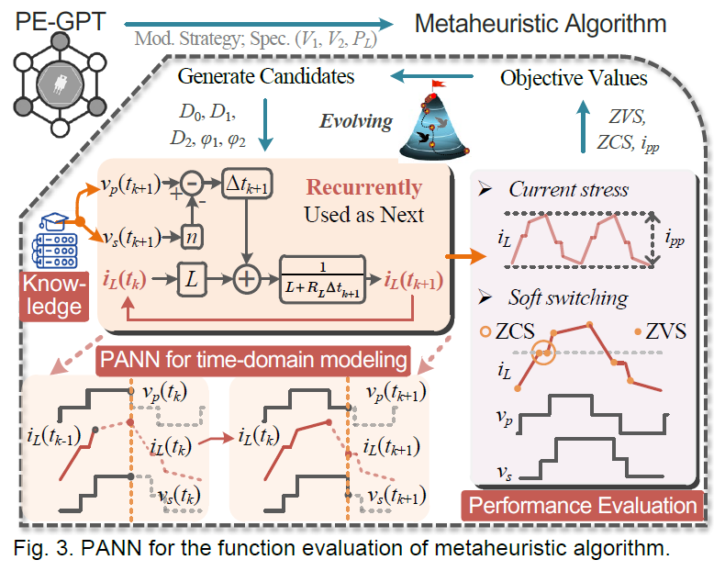

The workflow for the Physics-in-Architecture Neural Network (PANN) for a metaheuristic algorithm is as follows:
- PANN for Time-Domain Modelling:
  - The PANN takes input parameters like modulation strategy specifications (V1​, V2​, PL​) and a set of candidate variables (D0​, D1​, D2​, ϕ1​, ϕ2​) for the model.
  - This network is designed for time-domain modeling. It uses a recurrent structure, where the output at one time step, iL​(tk+1​), is fed back as an input for the next time step. This allows it to simulate the converter's behavior over time. The equations shown within the PANN block define the relationships between voltage (vp​, vs​), current (iL​), inductance (L), and resistance (RL​).
  - The PANN's internal structure and parameters are informed by both the physical knowledge of the circuit and the neural network's learning capabilities.
- Performance Evaluation:
  - The PANN's output, a simulated current waveform iL​(t), is used to evaluate the converter's performance.
  - Specific objective values are extracted from this waveform, such as Zero Voltage Switching (ZVS), Zero Current Switching (ZCS), and peak-to-peak inductor current (ipp​).
  - These values represent key performance metrics, including soft switching conditions (ZVS, ZCS) and current stress (ipp​).
- Metaheuristic Algorithm:
  - The extracted objective values (ZVS, ZCS, ipp​) are fed back to the metaheuristic algorithm.
  - The algorithm uses these performance metrics to evaluate the quality of the current set of candidate variables.
  - Based on this evaluation, the algorithm evolves the candidate variables to generate a new set that is likely to produce better performance, repeating the entire loop. This iterative process continues until the design objectives are met or a certain number of iterations are completed.

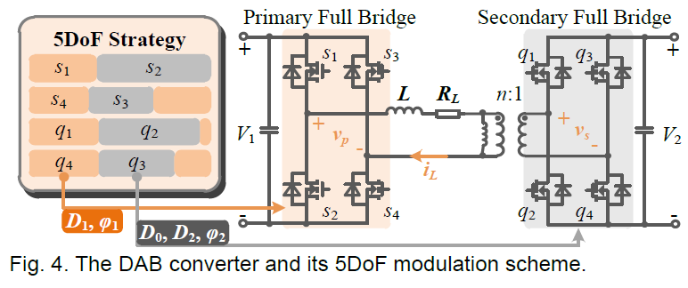
Diagram illustrating a 5-Degree-of-Freedom (5-DOF) modulation scheme for a Dual-Active-Bridge (DAB) converter.
What's Happening in the Image
The diagram shows a control scheme for a Dual-Active-Bridge (DAB) DC-DC converter. A DAB converter is used to transfer power between two DC voltage sources using two H-bridges and a high-frequency transformer.
The key information presented in the image is:
- Variables (5-DOF): The control scheme uses five independent variables to manipulate the power flow and performance of the converter. These variables are:
  - V1​: Input voltage on the primary side.
  - V2​: Output voltage on the secondary side.
  - D0​: A duty cycle or phase shift variable.
  - D1​: A duty cycle or phase shift variable.
  - D2​: A duty cycle or phase shift variable.
- Modulation Waveforms: The diagram shows how these variables influence the voltage waveforms on the primary (V1​) and secondary (V2​) sides of the converter. The waveforms are multi-level, not simple square waves, indicating a more advanced modulation strategy than the basic single-phase-shift (SPS) control. This complexity provides greater flexibility to optimize the converter's performance.
- Performance Metrics: The output of the modulation scheme is a current waveform (iL​) which is then used to evaluate the converter's performance. The diagram highlights three key performance indicators:
  - ipp​ (Peak-to-Peak Inductor Current): This value relates to the current stress on the components, which affects the efficiency and thermal performance of the converter. Minimizing this value is a common optimization goal.
  - ZVS (Zero Voltage Switching): This indicates that the switches (like MOSFETs) in the converter are turned on when the voltage across them is zero. Achieving ZVS is crucial for high efficiency, as it drastically reduces switching losses.
  - ZCS (Zero Current Switching): Similar to ZVS, this indicates that a switch is turned on or off when the current is zero, which also helps to minimize switching losses.
In essence, the image illustrates a complex modulation strategy that uses five variables to precisely control a DAB converter, allowing for the optimization of key performance metrics like efficiency and current stress. This is a more sophisticated approach than simpler modulation schemes, which often have fewer degrees of freedom.

DAB Converter & Modulation Design
1. What is a DAB Converter?
- Full Name: Dual Active Bridge (DAB) Converter.
- Purpose: It is a bidirectional isolated DC-DC converter — meaning it can transfer power both ways (useful for battery charging/discharging, energy storage systems, EVs).
- Where It’s Used:
  - Solid-State Transformers (SSTs)
  - Energy Storage Systems (ESS)
  - Electric Vehicles (EVs)
  - Renewable energy integration
- Key Components:
  - Two full bridges: One on the primary side, one on the secondary.
  - High-frequency transformer: Provides isolation + voltage scaling.
  - Leakage Inductor (L): Acts as the energy transfer element, limits current ripple, shapes power flow.

2. Power Transfer Principle
- DAB uses phase shift control to regulate power flow.
- Idea:
  - Shift the timing (phase) between primary and secondary bridge voltages.
  - This creates a controlled AC waveform across the leakage inductor.
  - The inductor current ramps up/down depending on the phase shift, transferring controlled power.

3. Modulation Strategies
- The “modulation scheme” decides how the switches in both bridges turn ON/OFF.
- Common Strategies:
  - SPS – Single Phase Shift:
    - Shift one bridge voltage relative to the other by a fixed phase.
    - Easiest to implement, but limited flexibility.
  - DPS – Double Phase Shift:
    - Adds a second degree of freedom (inner phase shift).
    - Better current shaping ,reduced reactive power.
  - EPS – Extended Phase Shift:
    - Adds more control to optimize efficiency under light load.
  - TPS – Triple Phase Shift:
    - Three adjustable phase shifts, even more flexibility.
  - 5DoF (Five Degrees of Freedom):
    - Most flexible — uses:
      - D0: Outer phase shift
      - D1, D2: Inner phase shifts (primary & secondary)
      - φ1, φ2: Duty cycles of primary & secondary bridges
    - Can optimize multiple objectives simultaneously — like minimizing current stress and maximizing ZVS range.

4. Why Modulation Design Matters
- Key Performance Metrics to Optimize:
  - Current Stress: High current → higher conduction loss & stress on devices.
  - Zero Voltage Switching (ZVS) Range: Achieve soft switching → reduces switching losses, improves efficiency.
  - Zero Current Switching (ZCS): Avoids current spikes → protects switches.
  - Reactive Power: Reduce circulating current to minimize wasted energy.
  - Efficiency: Overall system efficiency improves with better modulation.
- Trade-off Example:
  - Increasing phase shift might improve power transfer but increase current stress.
  - Adjusting duty cycles φ1, φ2 can improve ZVS but might slightly reduce efficiency.
  - The goal is to find optimal parameters that balance all these metrics.

Summary Intuition
- DAB converter = two bridges + transformer + inductor → controlled power transfer.
- Modulation strategy = how you “time” the switches to get desired power flow.
- 5DoF modulation = most flexible strategy with 5 tuning knobs (D0, D1, D2, φ1, φ2).
- Design Goal = optimize modulation parameters for best efficiency, low stress, and wide soft-switching range.
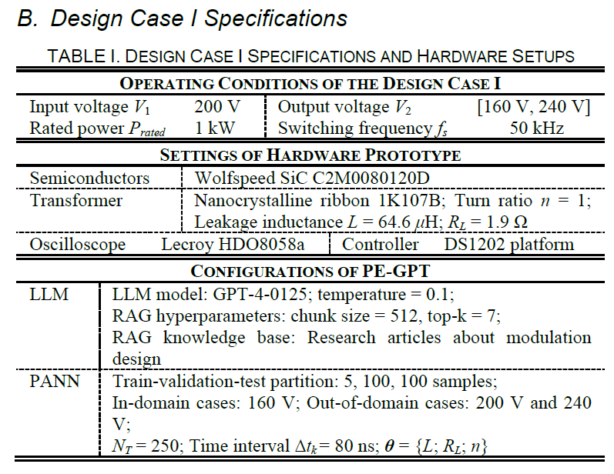
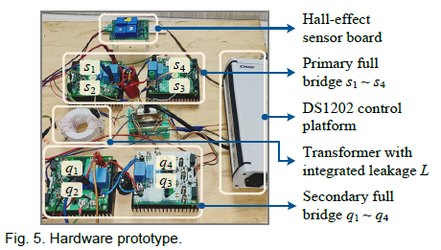
Design Case I – Iterative Design with PE-GPT
1. What This Case Study Shows
This case demonstrates how PE-GPT can actually help design a modulation strategy for a DAB converter, step by step.
The focus is on two key performance requirements:
- Current Stress (keep device current low to avoid losses/stress)
- Soft Switching (achieve ZVS/ZCS for efficiency & reduced losses)

2. Four-Stage Iterative Process
The interaction between the user and PE-GPT unfolds like a real conversation — not a one-shot calculation — and covers Workflow 1 (Design) and Workflow 3 (Fine-Tuning).
1️⃣ Initial Recommendations (ID 1 & 2)
- User asks for a good modulation strategy.
- PE-GPT recommends a suitable approach (e.g., 5DoF strategy) based on given specs and objectives.
2️⃣ Parameter Design + Performance Analysis (ID 3)
- PE-GPT uses its metaheuristic algorithm + Model Zoo (PANN) to search for optimal parameters.
- It analyzes time-domain waveforms (inductor current, switching instances).
- Provides performance metrics like current stress, ZVS range, etc.
3️⃣ Adaptation to Feedback (ID 4 & 5)
- User gives feedback (e.g., "current stress too high" or "want better ZVS").
- PE-GPT adjusts parameters, runs another iteration, and proposes an improved design.
- Shows that PE-GPT is interactive and iterative, just like working with a real engineer.
4️⃣ Fine-Tuning with Real Data (ID 6)
- User uploads experimental data (waveforms).
- PE-GPT fine-tunes PANN inside Model Zoo to match real-world behavior.
- Produces even more accurate results for the next design cycle.

Unique Competencies Demonstrated
a) Adaptive Semantic Understanding (ASU)
- PE-GPT doesn’t just answer blindly — it understands what the user really wants, interprets specs and feedback, and updates its recommendations.
- Example: If the user asks for “low current stress,” it knows to adjust modulation parameters like D1, D2, φ1, φ2.
b) PE-Specific Knowledge & Reasoning (PE-KR)
- Goes beyond generic LLM capabilities — uses power electronics expertise to select strategies and justify choices.
- Can explain why a certain modulation gives better ZVS or lower stress.
c) Multimodal Processing (MMP)
- Uses time-series data (currents, voltages) to evaluate performance, not just text.
- Can learn from user-provided experimental data and make the model smarter over time.

Key Intuition
This case proves that PE-GPT is not just a "chatbot," but a design assistant that:
- Understands the problem
- Suggests strategies
- Runs optimization
- Iterates with user feedback
- Improves itself with real-world data
This mirrors how real engineers work, but automates much of the heavy-lifting (simulation + parameter search).
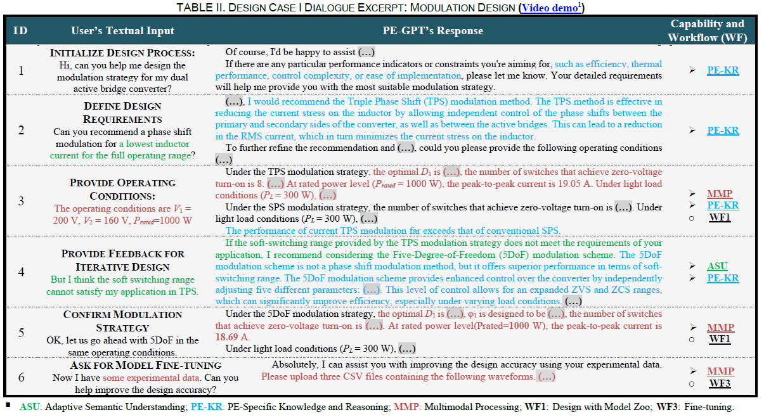
Fine-Tuning the PANN Model
- Bridging the Gap: The core purpose of this step is to make our simulated model behave exactly like a real-world prototype. We take actual measurements from hardware and use them to teach our simulation model to be more accurate.
- A Major Accuracy Boost: After this fine-tuning process, the model's accuracy is dramatically improved. We can see this in the results: the difference between our model's predictions and the real-world measurements is reduced by 84%.
- Seeing the Improvement: The visual evidence shows how effective this is. Before fine-tuning, the simulated waveform has some small errors. But after the process, it aligns almost perfectly with the actual waveform from the hardware, with its accuracy (R2) improving by nearly 5%. This is crucial for trusting the simulation results.
- Learning and Stabilizing: As the model fine-tunes, its internal parameters (like resistance and inductance values) initially fluctuate but then quickly stabilize to find the best possible values. This shows the model's ability to learn and converge on a reliable solution.
- Outperforming Other Models: Our PANN model is not only accurate but also robust. It consistently outperforms other leading AI models, proving its superior ability to handle both familiar and new scenarios with minimal errors. This gives us confidence in its predictions for a wide range of power electronics designs.
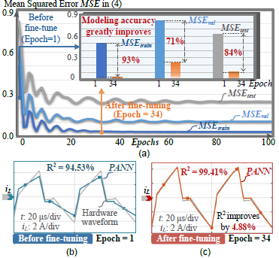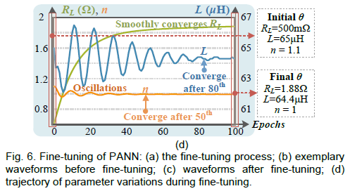
PANN stands for Physics-in-Architecture Neural Network. It is a specialized type of neural network designed to be more accurate and efficient for power electronics applications. Unlike a standard AI model that learns everything from scratch by looking at data, a PANN is built with the fundamental laws of physics already programmed into its structure.
How PANN is Different
- Physics-Informed: A typical AI model (a "black box") learns the relationship between inputs and outputs purely from data, like a student memorizing a textbook without understanding the concepts. In contrast, a PANN's architecture is explicitly designed to follow the physical equations that govern a power converter's behavior. This is like giving the student the textbook and the underlying principles of physics.
- Hybrid Approach: PANN combines a traditional neural network's ability to learn from data (the "Data-Driven" part) with the fundamental equations of the circuit itself (the "Physical Parts"). This hybrid approach makes it highly effective. The physical parts ensure the model's predictions are always physically plausible, while the data-driven parts allow it to fine-tune its accuracy based on real-world measurements.
- Analogy: Think of it this way: a regular AI model learning to simulate a circuit is like a blindfolded artist trying to draw a car by only feeling its shape. A PANN, on the other hand, is like an artist who has studied engineering blueprints; they know the exact relationships between the parts, which guides their drawing and makes it far more accurate.
In the context of the PE-GPT project, PANN is the core component used for time-domain modeling and function evaluation. It can accurately simulate a converter's behavior over time, and these simulations are then used by the metaheuristic algorithm to optimize the design.

E. Hyperparameters of RAG – Simple Explanation
- Chunk Size: Decides how big each “knowledge piece” is when PE-GPT searches its database.
• Too small = loses context
• Too big = slower and less focused
• Chosen value: 512 (best balance)
- Top-k: Number of best-matching pieces retrieved for each query.
• Too low = may miss info
• Too high = adds noise + slows down
• Chosen value: 7 (best mix of accuracy & speed)
- Performance Metrics Used:
HR (Hit Rate) – correctness,
MRR – rank of correct answer,
RS – speed,
FF – faithfulness to PE knowledge,
Rel – relevancy to query.
- Result: After tuning → almost perfect HR, FF, Rel + high MRR + fast responses.

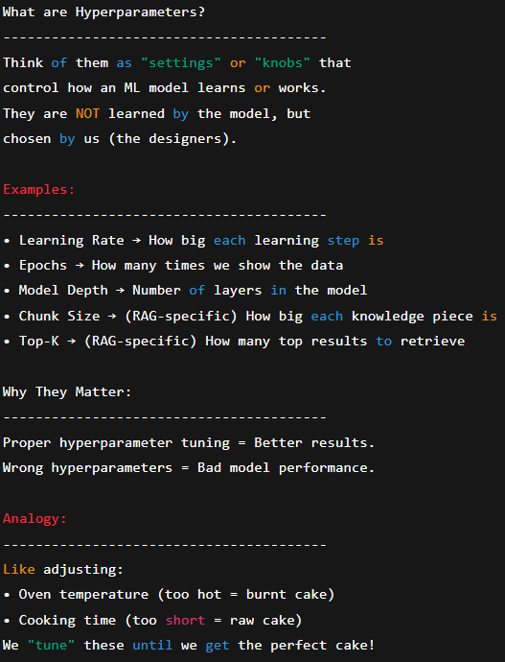
Design Case II: Circuit Parameter Design
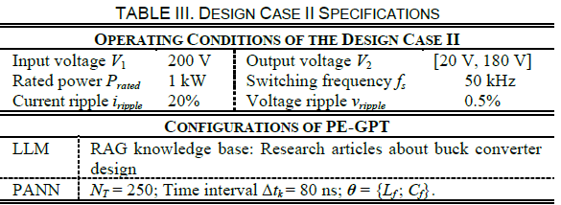
A. Specifications (Buck Converter Example)
- Input Voltage: 200 V
- Output Voltage Range: 20–180 V
- Rated Power: 1 kW
- Switching Frequency: 50 kHz
- Ripple Constraints:
• Current ripple ≤ 20%
• Voltage ripple ≤ 0.5%
- PE-GPT Setup:
• Knowledge base = research articles on buck converter design
• PANN configured with: NT = 250, Δtk = 80 ns, parameters = {Lf, Cf}

B. Design Case II Breakdown (Workflows 1 & 2)
- Circuit Parameter Design (ID 1–3):
PE-GPT interprets the request → guides user to set design requirements → finds optimal Lf and Cf.
- Rationale Analysis (ID 4–5):
PE-GPT explains why those parameters work, using PE knowledge.
- Simulation Verification (ID 6):
PE-GPT launches simulation (PLECS) → verifies results automatically.

Key Competencies Demonstrated
- ASU: Understands and clarifies design requirements
- MMP: Automates parameter search + simulation process
- PE-KR: Provides expert reasoning for recommended design
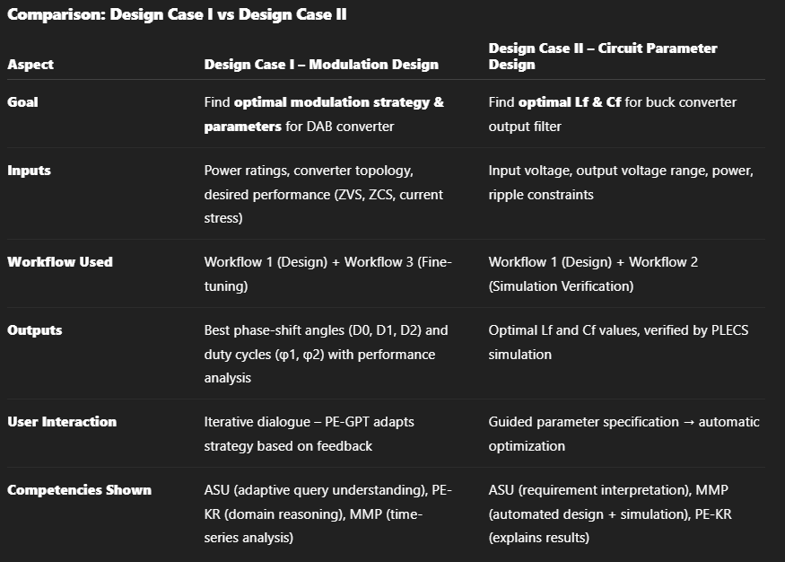
- Once PE-GPT finds the optimal circuit parameters (say Lf = 1.2 mH, Cf = 50 µF),
- It automatically passes those parameters to a simulation model (like PLECS)
- The simulation tool then runs a virtual experiment of the circuit and generates waveforms (output voltage, current ripple, etc.).
- Those waveforms are compared against the design requirements (e.g., current ripple ≤ 20%, voltage ripple ≤ 0.5%).
So, verification = checking if simulation results match the design goals.
If they don’t, the user can ask PE-GPT to re-optimize or tweak parameters.
- Without PE-GPT, an engineer would calculate Lf and Cf manually, then open PLECS, enter values, run simulation, and see if it works.
- With PE-GPT, it’s a one-click process — the tool calculates, runs simulation, and gives you “Yes, your ripple is within limits” or “No, it’s too high.”
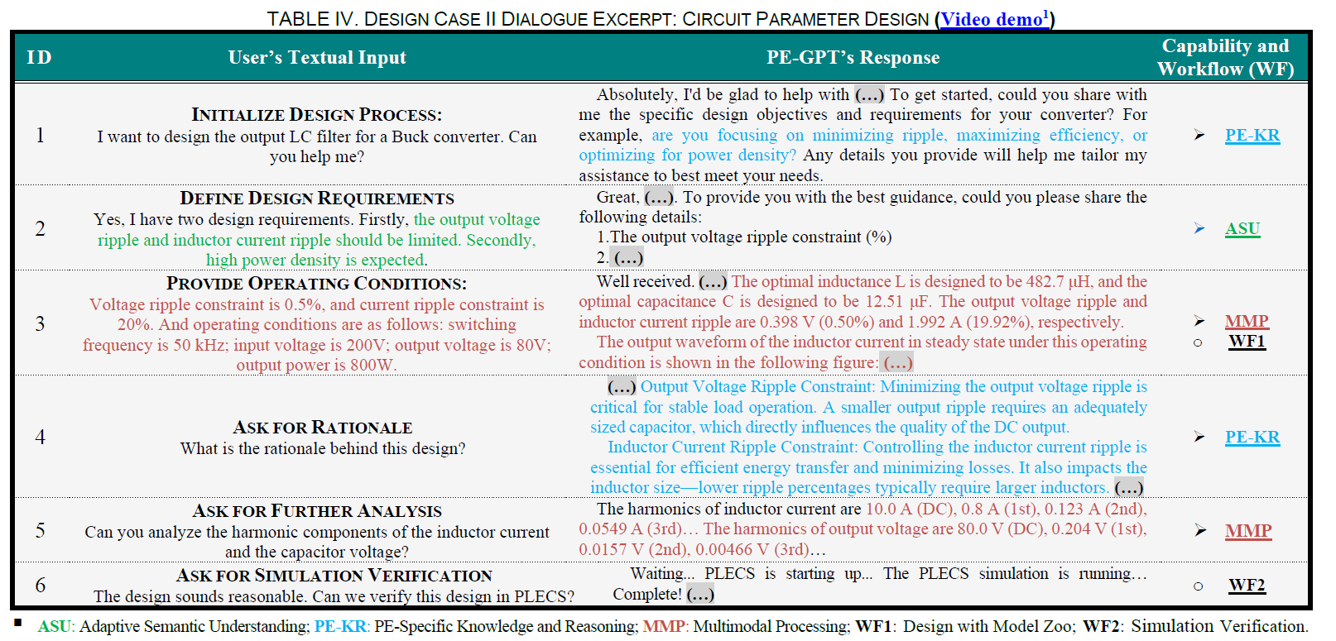
Design Outcomes & Analysis (Buck Converter)
Key Points to Present:
- Designed Values:
  - Inductance (Lf) = 482.7 μH
  - Capacitance (Cf) = 12.5 μF
- Performance Verification (via PLECS):
  - Output Voltage Ripple (Δvo): 0.49% ✅ (within 0.5% limit)
  - Inductor Current Ripple (ΔiL): 20% ✅ (exactly at the 20% limit)
- Model Accuracy:
  - PANN predictions very close to simulation
  - Mean Squared Error (MSE) between PANN & PLECS:
    - vo: 3.02 × 10⁻⁴
    - iL: 2.9 × 10⁻³
- Trade-Off Understanding:
  - Larger Lf & Cf → Lower ripple but lower power density
  - PE-GPT selected balanced values → satisfies ripple constraints without oversizing filter
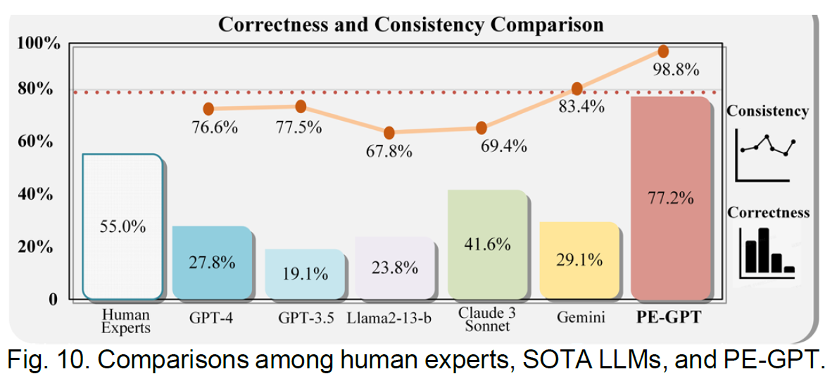
CONCLUSION
- Current Scope: Demonstrated on two cases – DAB converter modulation design and buck converter parameter design – as proof of concept.
- Framework Nature: PE-GPT is designed as a general and flexible hybrid framework, not limited to these two cases.
- Extensibility: By adding relevant knowledge bases (for RAG) and models (to the Model Zoo), it can support other PE design tasks (topology, component selection, EMI/EMC, thermal design, etc.).
- Key Message: The paper shows that the approach works, and it can be scaled to cover the entire PE design workflow with further customization.

