Kubernetes (K8)

It’s like docker-compose for multiple machines

Components of Kubernetes

Pod
Smallest unit in kubernetes. Used to run a single container. It can contain multiple container, but a smallest unit can contain a single one. It also holds surrounding resources like volumes. By default, a pod in a cluster has internal IP address.
Multiple containers inside a pod can communicate with localhost.

Worker Node
They run the applications in your container. We can equate worker node to a machine/virtual instance (EC2 for example).
A worked node contains pod and proxy/config. Again, a WN can contain either 1 pod, or multiple. The configs specify whether the network traffic can reach the internet and vice versa.
In a basic kubernetes setup, you need atleast 1 worker node.
But while working in k8, typically you don’t directly interact with worker nods/pods (though you can do that), but there’s something else.

Master Node
Master node contains something called as Control Plane which interacts with worker node. So it decides whether to start a new worker node, stop existing one, distribute workload evenly.
So basically, a WN is managed by MN.
Theoretically, you can have MN and WN both on the same machine, but in big applications they are on 2 different machines.

Cluster
All together, the above 3 things forms a cluster (of MN and WN) and they share one common network.
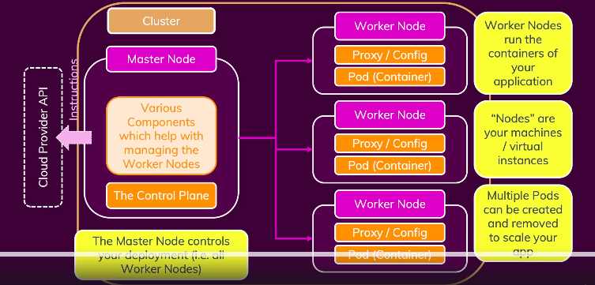
Worker Node
As specified above, it can contain either 1 pod, or multiple. And these pods could be running same type of container or different also. At the end, a WN is equivalent to a machine, and we can have 1 machine running multiple applications.
Every worker node must contain these 2 pieces of software:
1. Docker – since we are running docker containers on them.
2. Kubelet – which enables communication between MN and WN.
3. Kube-proxy – network communication between pod and managed node.

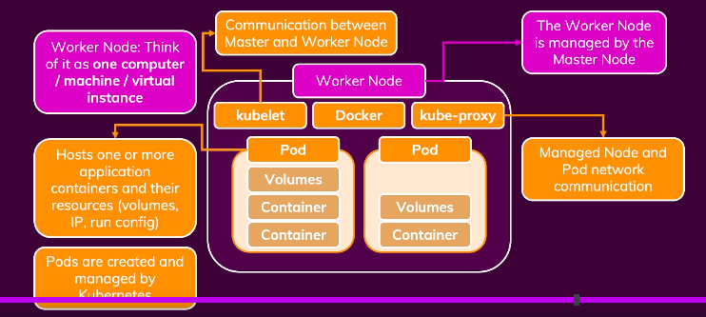
Master Node
The softwares running on a MN are:
API Server – API for kubelet to communicate
Scheduler – Watch for new pods, select worker nodes to run them on. So basically this tells the API Server what to tell worker nodes.
Kube-controller-manager – It works closely with API Server and Scheduler to make sure we have correct number of pods running.
Cloud-controller-manager – It’s a cloud specific kube-controller-manager. So it knows how to interact with Cloud Provider resources.
So for big cloud providers, we need to just provide our configuration and they do all the heavy lifting.
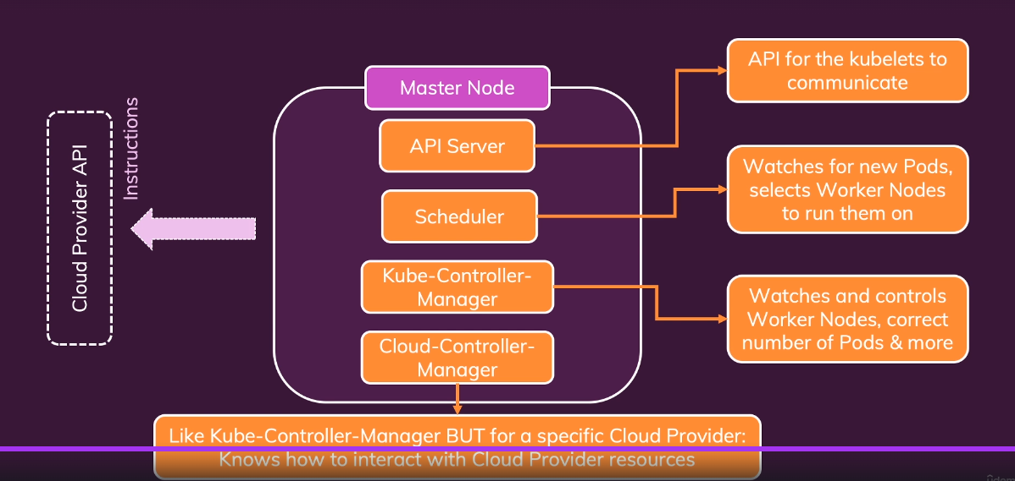
Kubectl (Kube Control)
It is a tool used to send instructions to the cluster, therefore must be installed on our local machine.

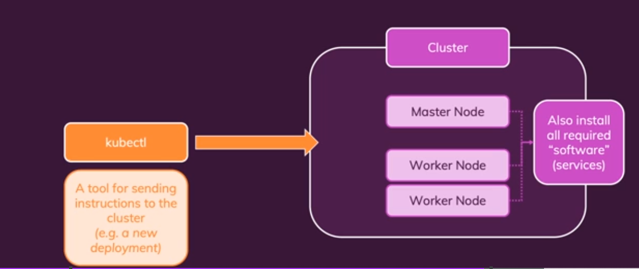
Kubernetes Objects
When a cluster is ready, we can start sending commands to this cluster.
But in order to do that, we need to understand what kind of commands/language k8 understands.
K8 knows objects (pods, service, deployments). So in k8, we just give command on these objects, and based on configurations these are created.
Objects can be created in 2 different ways, Imperatively & Declaratively.

Pod Object
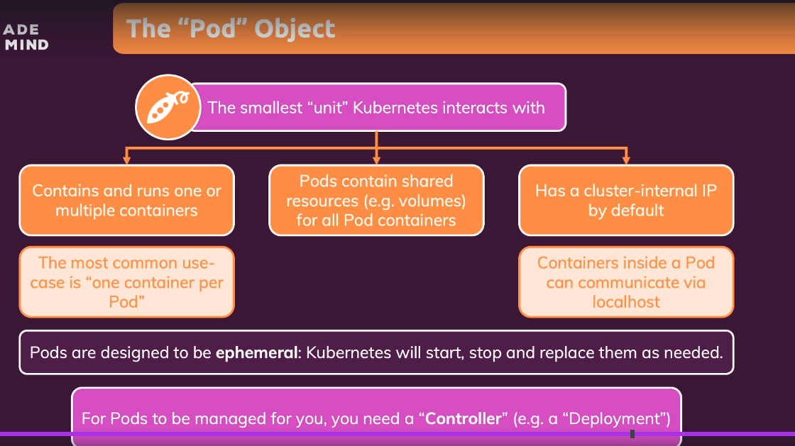
Deployment Object
Typically, we don’t create pods and assign them to WN directly. Infact, we use something called deployment object.
So, a deployment object controls multiple pods. We can do following things:
- Can set a desired end state, k8 then changes the actual state. We define which pods and containers to run and the number of instances. K8 figures out which WN has enough memory and cpu resources to handle that.
- Deployment can be paused, deleted and rolled back. So if there’s any bug, we immediately roll back and debug the issue later on.
- Deployments can be scaled dynamically and automatically.

Create first Kubernetes deployment
- Take a basic node app, expose some endpoints.
- create its dockerfile, build image (sudo docker build -t node-basic .)
- run minikube (sudo minikube start --driver=docker --force)
- Some commands
Get the pods: sudo kubectl get pods
Get deployments: sudo kubectl get deployments
Delete deployment: sudo kubectl delete deployment <deployment-name>
- Create a deployment (sudo kubectl create deployment --image=node-basic)
You may think the above statement will work, but it will not. This is the output you’ll see on kubectl get deployments command (0/1 ready):
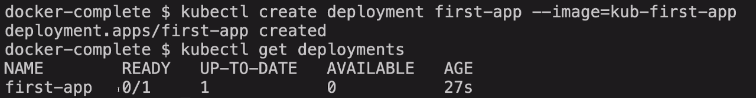
To understand what was the issue, run “sudo kubectl get pods”:
It will have trouble in getting the image “PullError”. This is because the cluster is a virtual environment in itself, it does not have access to the images in your local machine. So just push this image to docker hub and fetch it from there.
- I created an image on docker-hub account with this name – anshulrts/node-basic
- To run a kubernetes cluster based on this: sudo kubectl create deployment first-app –image=anshulrts/node-basic first-app
The above command will create a deployment object and automatically sends it to the MN (control plane). This MN is responsible for creating what we need. So, like we discussed earlier, the scheduler on MN analyse the currently running pods, finds the relevant WN to start the new pod. WN has the kubelet which manages the pod, start the container in the pod, monitor it, check its health.

Right now, there’s one big problem with our setup. Pods have internal/private IP address only, which means they are not accessible from the outside world.
We can assign a public IP to pods, but that wouldn’t make sense because pods spin up and down all the time. The solution is to use a “Service” object.

Service Object
It is used to expose pods to the cluster or externally.
Pods have internal IP address by default (can see it in dashboard). But it changes when a pod is replaced & is not accessible outside the cluster.
Service group the pods and assign them a sharable IP address. Services also allow external access to the pods.
So, to summarize, without services, pods are hard to reach and communication is difficult.
And reaching a pod from outside the cluster is not possible at all without services.

We create a service using expose command:
sudo kubectl expose deployment first-app --type=LoadBalancer –port=8080
--type: can have different values, LoadBalancer must be supported. Minikube and AWS both support this.
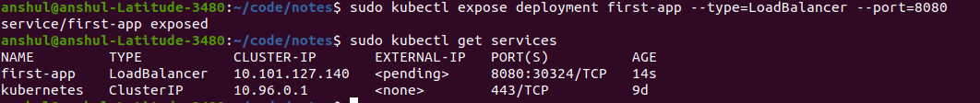
As you may note, external IP is not assigned here in minikube setup for first-app. But when running on a cloud provider, it’ll be assigned.
So the question is how to access this service running in minikube on local virtual machine?
Ans – There’s a command which can give such access. It’ll map a special port to an IP which we can access from our local machine and which identified this virtual machine. The command is : sudo minikube service first-app
The above command is not required if we exposed this on a cloud provider, where external IP would be enough to access the service. This is needed only when we do local development. Here’s what happens when we enter this:
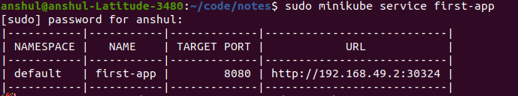
Now you can open http://192.168.49.2:30324 to see this:
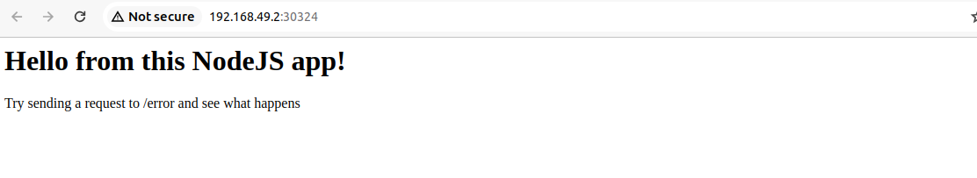
Now, if you visit /error url, you’ll see that the application crashes, as we have set process.exit(1) on that URL in the code.
But you’ll see that the application still works, because the pod will be restarted again.

Scale
We can scale out using following command:
kubectl scale deployment/first-app –replicas=3
This will instantly create 2 more pods. You may view this dashboard.
Since we have LoadBalancer, traffic is evenly distributed.

Update
You can update the image which is running in a pod using the following command:
sudo kubectl set image deployment/first-app <old-container-image>:<new-container-image>
One point to note here is that the new image should have different name or tag in order to be pulled.

Rollbacks
Some command to check rollout status:
- get the status of rollout: sudo kubectl rollout status deployment/first-app
- rollback: sudo kubectl rollout undo deployment/first-app
- check the history: sudo kubectl rollout history deployment/first-app
- get more details about a particular version in history: sudo kubectl rollout history deployment/first-app –revision=3
- rollback to a specific version: sudo kubectl rollout undo deployment/first-app –to-revision=1

delete a service: sudo kubectl delete service first-app

Networking
- For communication between multiple containers in the same pod, use localhost:<port-number>. Tip – in docker-compose, we use service name in order to do the same thing. A network is created by default if not specified explicitly.
- Changing/updating the deployment does not update the IP address exposed by the service.
- It’s true the a deployment control multiple pod, but of the same type. So 1 deployment object will create 1 pod (and it can have multiple containers).
- It’s not ideal to have a pod inside a cluster without a service. This is because even though it will be exposed to other pods within the cluster, but its IP adress will be dynamic if new pod is created. So if you want to create a pod which must be accessible only within the cluster, create a service of type “ClusterIP”, this will assign a stable IP for this pod. If you need to expose it outside the cluster, use “LoadBalancer” type
- In above scenario, how will you connect 2 different pods? 3 ways: 1) Get the IP address of the service and put it in as the environment variable 2) directly use the environment variable with service name in caps, - replaced by _, and append “_SERVICE_HOST” in the service name 3) Cluster internal domain names can be created using CoreDNS service. It creates the domain in this format <service-name>.<namespace>, by default the services are created in the “default” namespace.

