### **Assignment: PHP Developer – Automatic Sequence Correction & Visualization**

### **Objective:**

Develop a **PHP-based application** that automatically detects missing numbers in a sequence, corrects the sequence, and visually represents it using a **JavaScript-based charting library** (e.g., Google Charts, Chart.js, or Highcharts).

### **Project Requirements:**

### **1. Sequence Correction**

* Implement a PHP program that:
  + Takes an input list of numbers with hierarchical sublevels.
  + Identifies missing numbers within the sequence.
  + Generates a corrected sequence, filling in missing values logically.
* The correction should follow the hierarchical pattern.
* Example input and corrected sequence are provided below.

### **2. Data Processing & Algorithm**

* Parse the given sequence correctly and **detect missing sub-levels** dynamically.
* Maintain proper **parent-child relationships** while filling in missing values.
* Ensure that the generated sequence is **logically structured** and formatted.

### **3. Visualization Using JavaScript Chart Library**

* Use **Google Charts, Chart.js, or Highcharts** to visually represent the corrected sequence.
* The sequence should be displayed in a **bar chart format** with appropriate labeling.

### **4. Project Structure & Best Practices**

* Use a **modular PHP structure** (avoid writing all logic in a single file).
* Separate the **PHP logic** from the **frontend (HTML & JavaScript)**.
* Ensure **code readability** with proper comments and variable naming conventions.

### **5. Error Handling & Optimization**

* Validate input data before processing.
* Implement **error handling** for invalid sequences or incorrect input formats.
* Optimize the program for handling large datasets efficiently.

### **Example Input & Expected Output:**

### **Input Sequence:**

1.1   
1.2   
1.3.1   
1.3.1.1   
1.3.1.3   
1.3.2   
1.3.2.1   
1.3.2.2   
2.1   
2.2   
2.3.1   
2.3.2   
2.3.3

### **Expected Corrected Sequence:**

1.1   
1.2   
1.2.1   
1.2.1.1   
1.2.1.2   
1.2.2   
1.2.2.1   
1.2.2.2   
1.3   
1.4   
1.4.1   
1.4.2

1.4.3

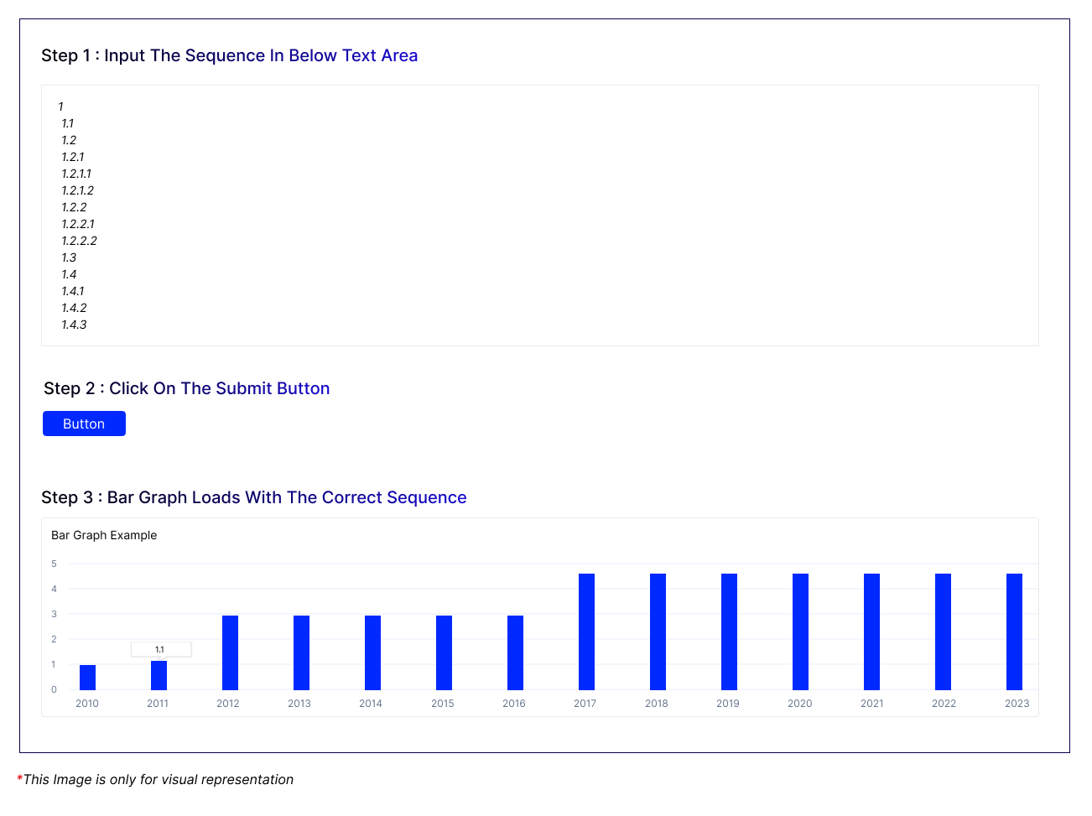

### **Bonus (Optional for Extra Credit):**

Allow **dynamic input** where users can enter a custom sequence through a form.  
 Implement a **downloadable CSV** of the corrected sequence.  
 Provide **search functionality** within the visualization.

### **Deliverables:**

1. **GitHub Repository** with structured PHP, JavaScript, and HTML files.
2. **A working web page** where users can input data and see corrected results in a chart.
3. **Code documentation** explaining logic and function usage.