Here are the Steps I have followed to create the assignment.

1. I have used the Magento 2 Environment to create the Project.
2. Create the Module “Ansh_BirthdayReminder”.
3. Created the Admin menu’s to access the Birthday Reminder.

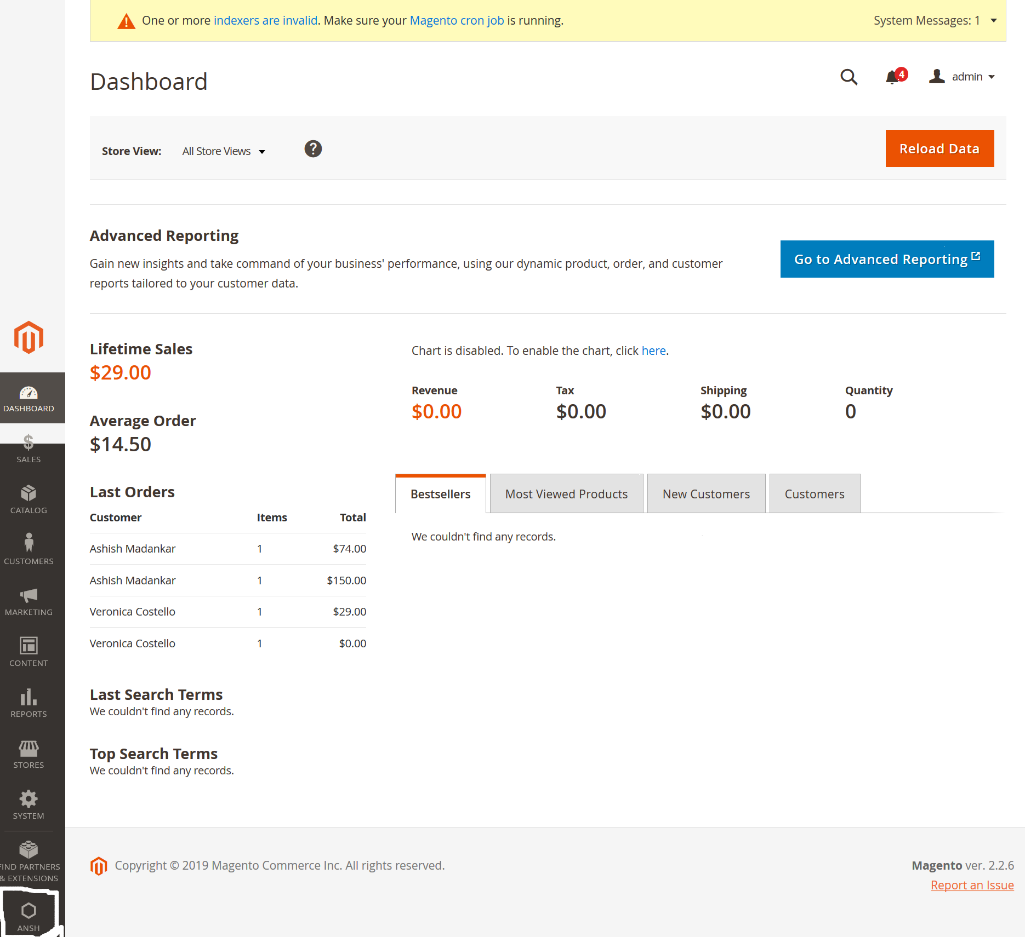

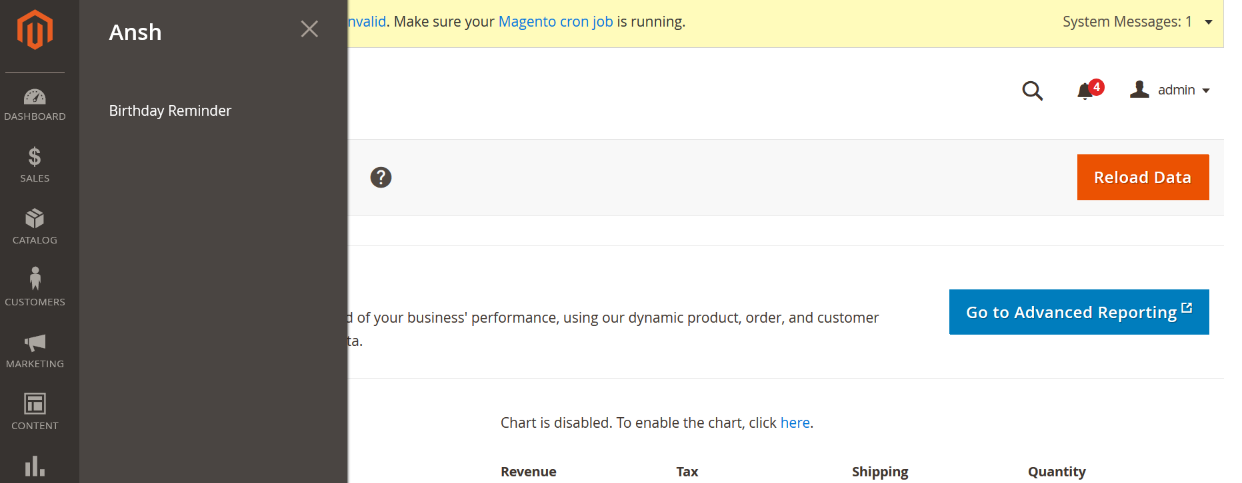

1. Check the Customer Birthday programmatically, if Customer Birthday matches with today’s date then it first delete the record from custom Table “**ansh_birthdayreminder_birthdayreminder**” and insert the matching record like “*Customer Id, Customer Email and Date of birth*”.

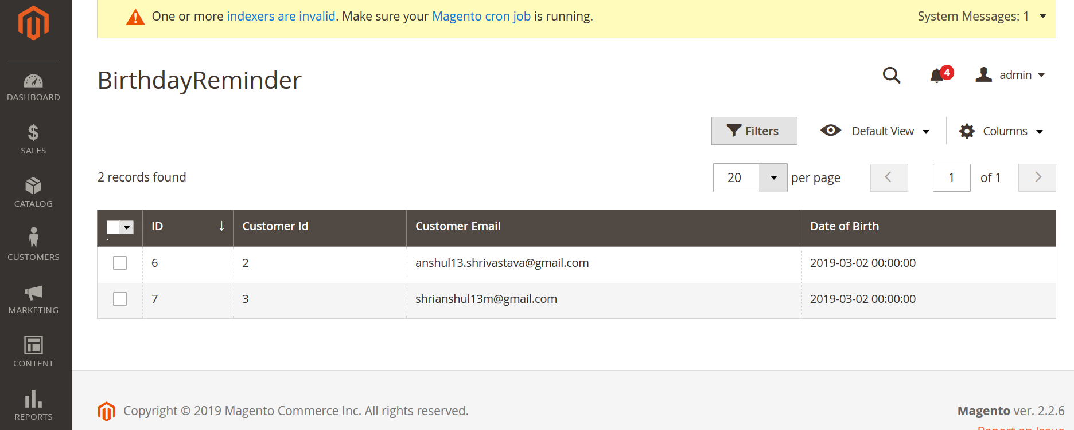

1. Created the Configuration setting where we can manage the Enable/Disable to send the Reminder Email, Sender’s Name and Sender’s mail.

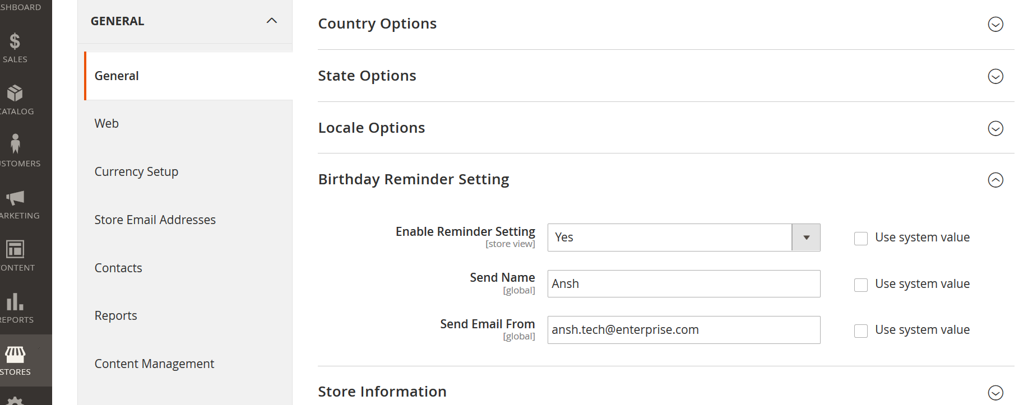

1. Create the Cron configuration setting to send the Birthday Reminder E-mail through code. At 6 AM reminder E-mail will send and every after 24 hrs.

