1. What is MySQL dB in python?

These days, storing our data into databases has become very beneficial for everyone in such a way that it can be easily accessed, managed and updated anytime and anywhere around the world.

MySQL dB – where SQL stands for **Structured Query Language database**, is an **interface** to link and access a database for either **retrieving** or **storing** data from the user, using python commands like execute (), fetch (), etc., on any kind of notebooks like the Jupyter-notebook, google-colab, command line, by following certain procedures. It was developed by Oracle Corporation.

We can access the MySQL dB, by First, importing the MySQL Connector files in python command line after **installing** it in a virtual environment; then eventually connecting it to the specific databases using **host**, **user**, **password** and in the very end, writing Python and SQL commands altogether, to access and manage the data stored inside our personal databases.

MySQL dB is frequently used in the open-source community and upon that it is well known for its fast speed and quick processing.

Down below is my code for connecting a database – “dummy” in jupyter notebook and creating a table within it with id as primary key and name, subject as columns in the table.

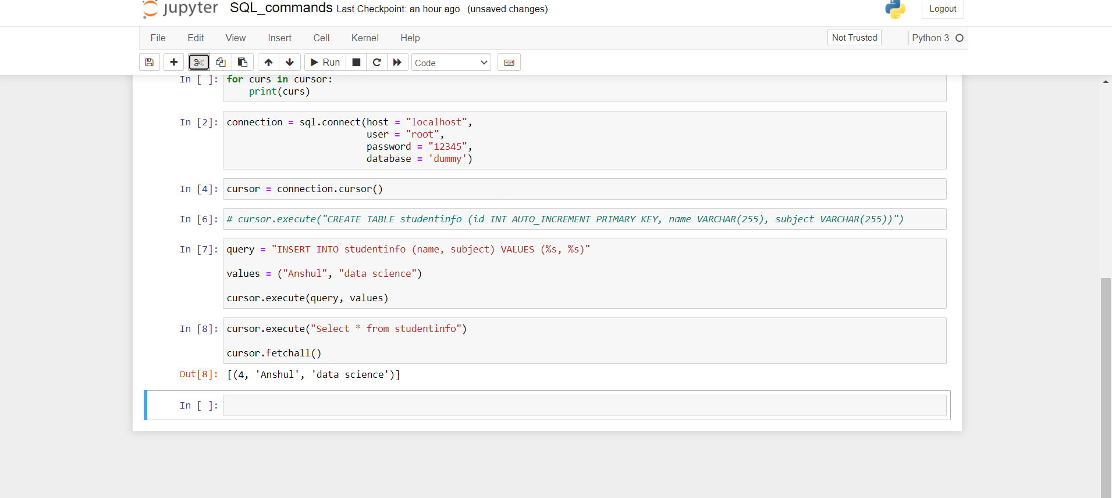

The major **issue** with these databases is that it **can’t handle very large database** much efficiently and also doesn’t support **SQL check constraints**.

My SQl dB is used in many web applications like WordPress, etc., and websites like, Facebook, Twitter, YouTube and many other and also will be used in the future too because of its quick processing capabilities and marvellous speeds.

2. What is CGI in python with examples?

CGI – stands for Command Gateway Interface, which are a **set of standards**, that define in what way the information can be exchanged between the **custom-scripts** (like, the python script I have made below) and the **web server**.

First of all, I **created** a python-scripts file and saved it as .py file, in such a place (CGI bin) where the HTTP server can access it and execute it eventually, when I run on a certain port number.

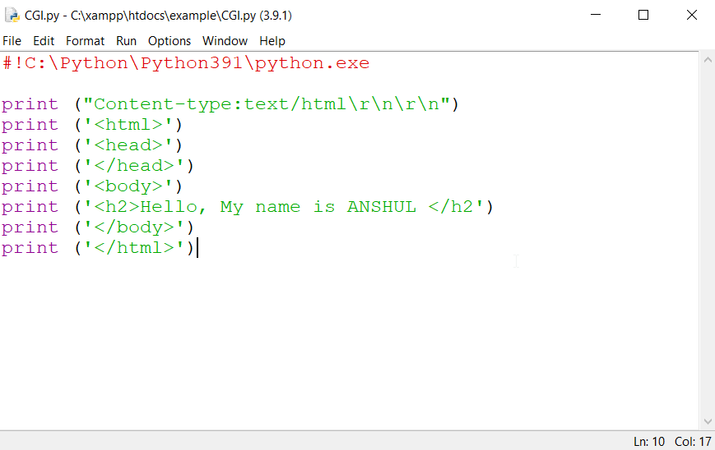

Then through my **Apache Server** - running on a certain port number from XAMPP control centre, I have made it to **run**, the localhost path of the python scripts file. Down below is the output:

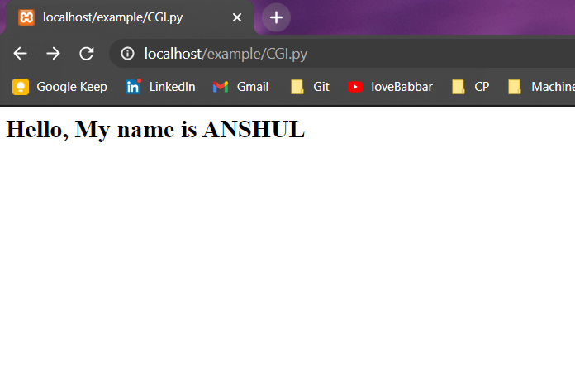

So, when the server is able to access the .py file that I created, then it gives an **output** accordingly. If the file would have been absent, we would have received an error of file missing from the server on the web browser.

There are several advantages of using these CGI scripts which include the **portability** and the **language-independency** as they can be written in any language preferred by us like here, we have used python. Upon that, we even don’t need any special API’s or libraries to make any easy scripts like these.

The main disadvantage is that the security of the information that we enter into the scripts are very **vulnerable** to online threats.

These days web applications have grown to a large extent but CGI has not evolved much, and therefore even today many **embedded-devices** still are using CGI these days.