**Convert Gradle Project to Maven Project in Eclipse**

1. Right Click Project.
2. Go to Configure >> Convert to Maven Project
3. In the next window, set the package for the project as Group Id i.e. groupId will identify your project uniquely across all projects e.g. com.arsoft.projects.arcommon
4. Set the name for the jar as Artifact Id e.g. arcommon
5. Set the version for the jar as Version e.g. 1.0
6. Click Ok.

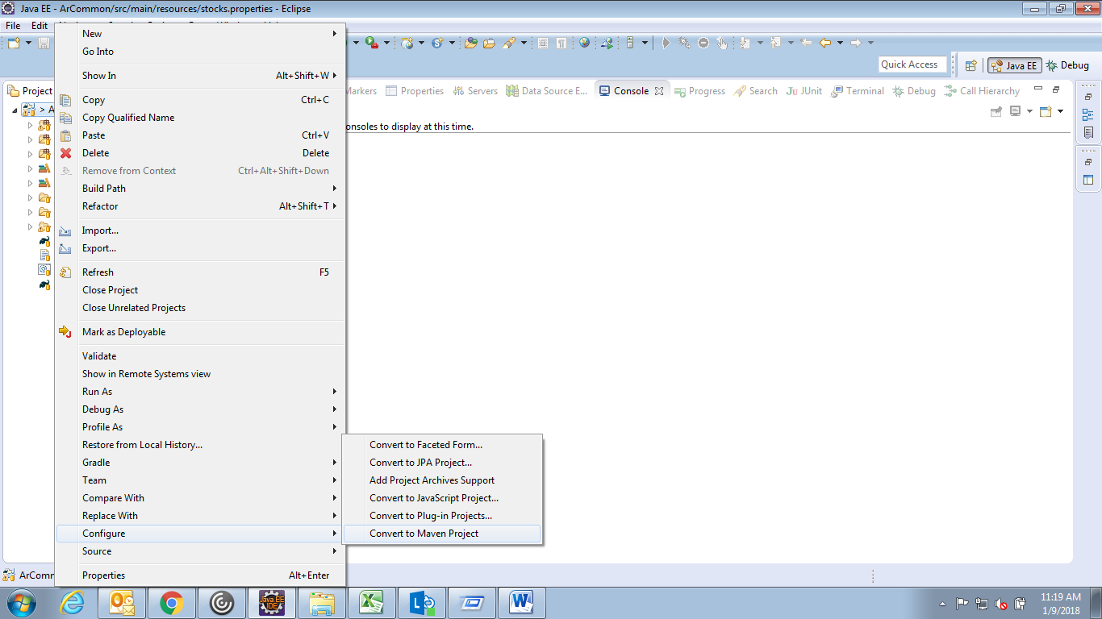

1. Remove entry <classpathentry kind="con" path="org.eclipse.buildship.core.gradleclasspathcontainer"/> from the file .classpath for the project.

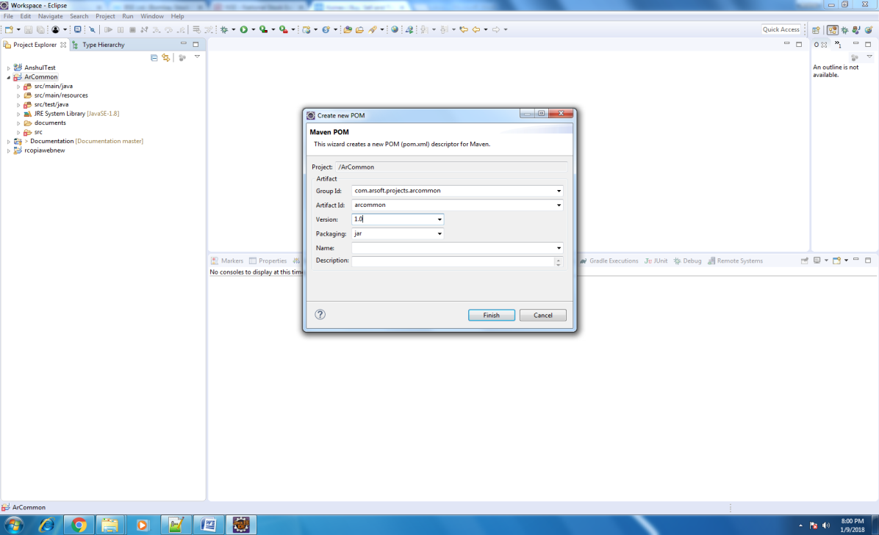

1. Click Finish.
2. This creates file pom.xml inside the root of the project.

**How to fix the errors in maven**

**Error Description:**

Error in pom.xml Failure to transfer org.apache.maven.plugins:maven-surefire-plugin:pom:2.12.4 from https://repo.maven.apache.org/maven2 was cached in the local repository, resolution will not be reattempted until the update interval of central has elapsed or updates are forced. Original error: Could not transfer artifact org.apache.maven.plugins:maven-surefire-plugin:pom:2.12.4 from/to central (https:// repo.maven.apache.org/maven2): The operation was cancelled.

**Solution:**

1. Right Click the project.
2. Click Maven >> Update Projects

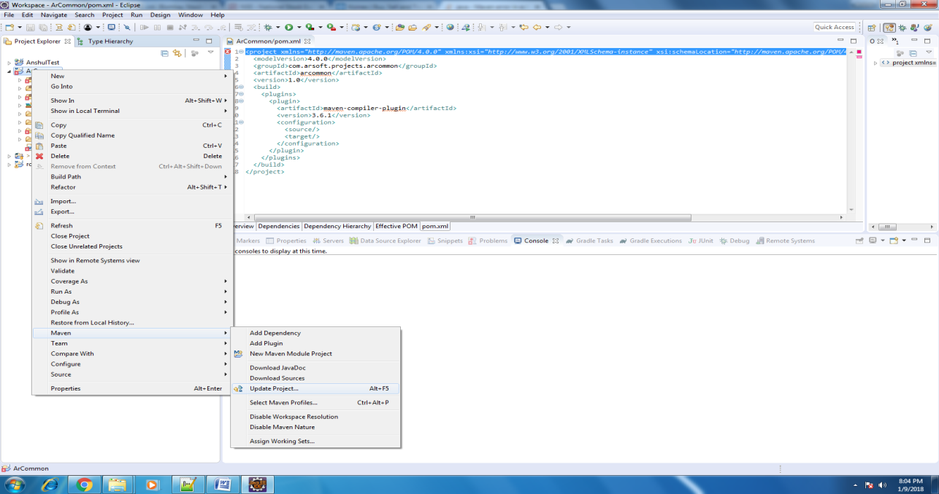

1. In the next window, select the project.
2. Check the option "Force Update of Snapshots/Releases"
3. Click "Ok"

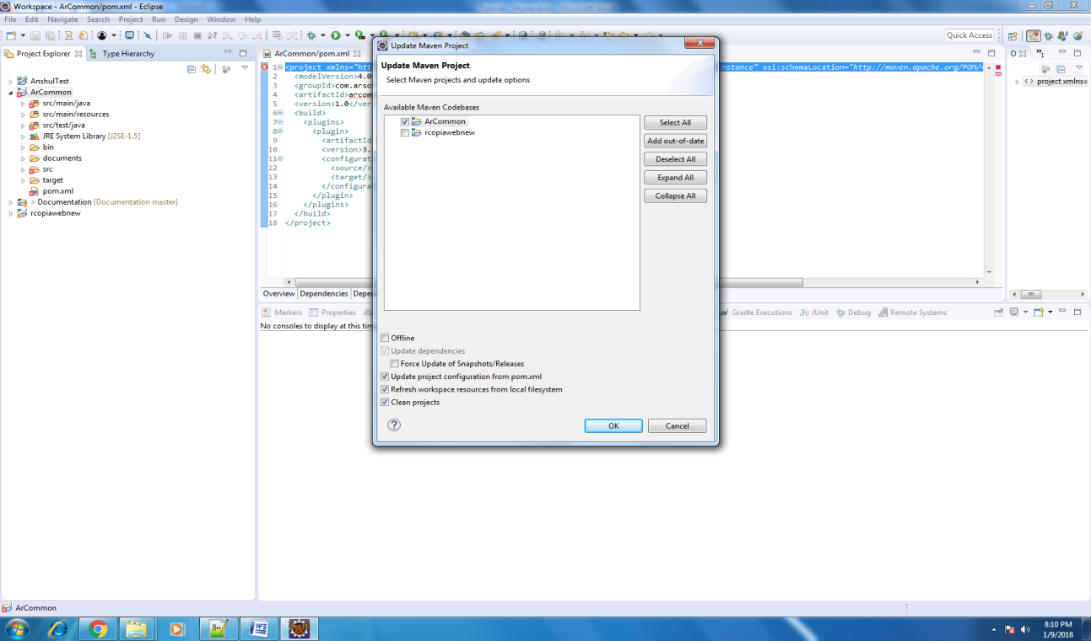

1. Right click the Project
2. Click Run As >> Maven clean
3. Click Run As >> Maven install

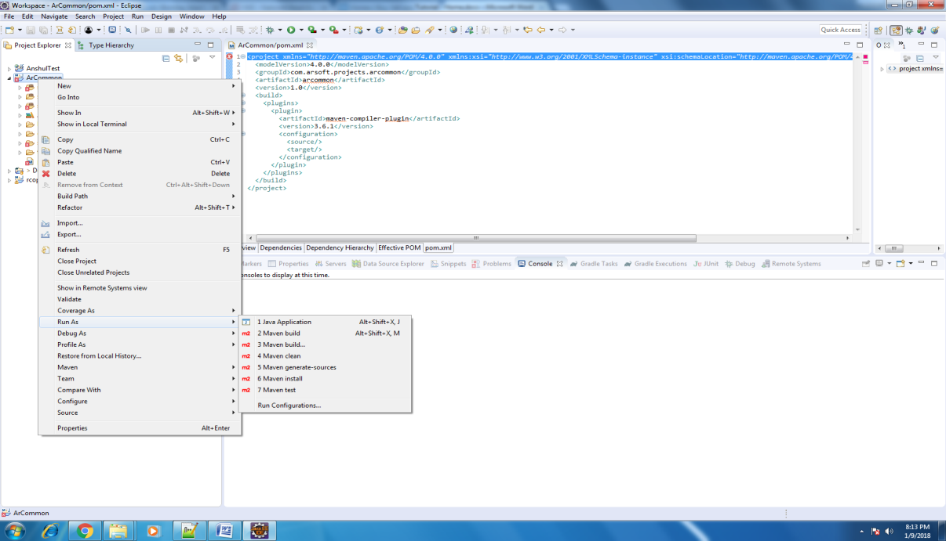

**Error Description:**

Could not find or load main class org.codehaus.plexus.classworlds.launcher.Launcher

**Solution:**

Update the m2e plug-in of the eclipse.

Update maven project using command line

mvn clean install -U

**Error Description:**

Source option 1.5 is no longer supported. Use 1.6 or later

**Solution:**

Change the compiler version of maven project

Add the below plug in to pom.xml

<plugin>

<groupId>org.apache.maven.plugins</groupId>

<artifactId>maven-compiler-plugin</artifactId>

<version>3.6.1</version>

<configuration>

<source>1.8</source>

<target>1.8</target>

</configuration>

</plugin>

or

Open pom.xml and add the below properties inside the properties tag.

<properties>

<maven.compiler.source>1.8</maven.compiler.source> <maven.compiler.target>1.8</maven.compiler.target>

</properties>