1. Write a JavaScript to get the choice from user to

a. Convert Age to Days using form.

b. Convert the Fahrenheit to Celsius

c. Calculate the area of the triangle.

Consider the user input from the form.

<!DOCTYPE html>

<html>

<head>

<title>AGE TO DAYS</title>

</head>

<script type="text/javascript">

function meth()

{

var x=document.myform.choice.value;

switch(x)

{

case 'a':

var r=parseInt(prompt("Enter Area of Triangle "));

var r=parseInt(r);

var ff=3.14\*r\*r;

document.write("Area of Triangle is "+ff);

break;

case 'b':

var c=prompt("Enter Degree Value:");

var c=parseInt(c);

var f=(c \* 1.8) + 32;

document.write("Fahraniet value is"+f);

break;

case 'c':

var a =prompt("Enter Age:");

var a=parseInt(a);

var Days = a\*100;

document.write("No of days: "+Days);

break;

default:

document.write("ENTER PROPER VALUE");

break;

}

}

</script>

<body>

<p>a)AREA OF TRIANGLE</p>

<p>b)F to C</p>

<p>c)Age to Days</p>

<form name="myform" method="post" action= "" onsubmit="meth();">

Enter Choice:<input type=text name=choice>

<input type="submit" name="submit">

</form>

</body>

</html>

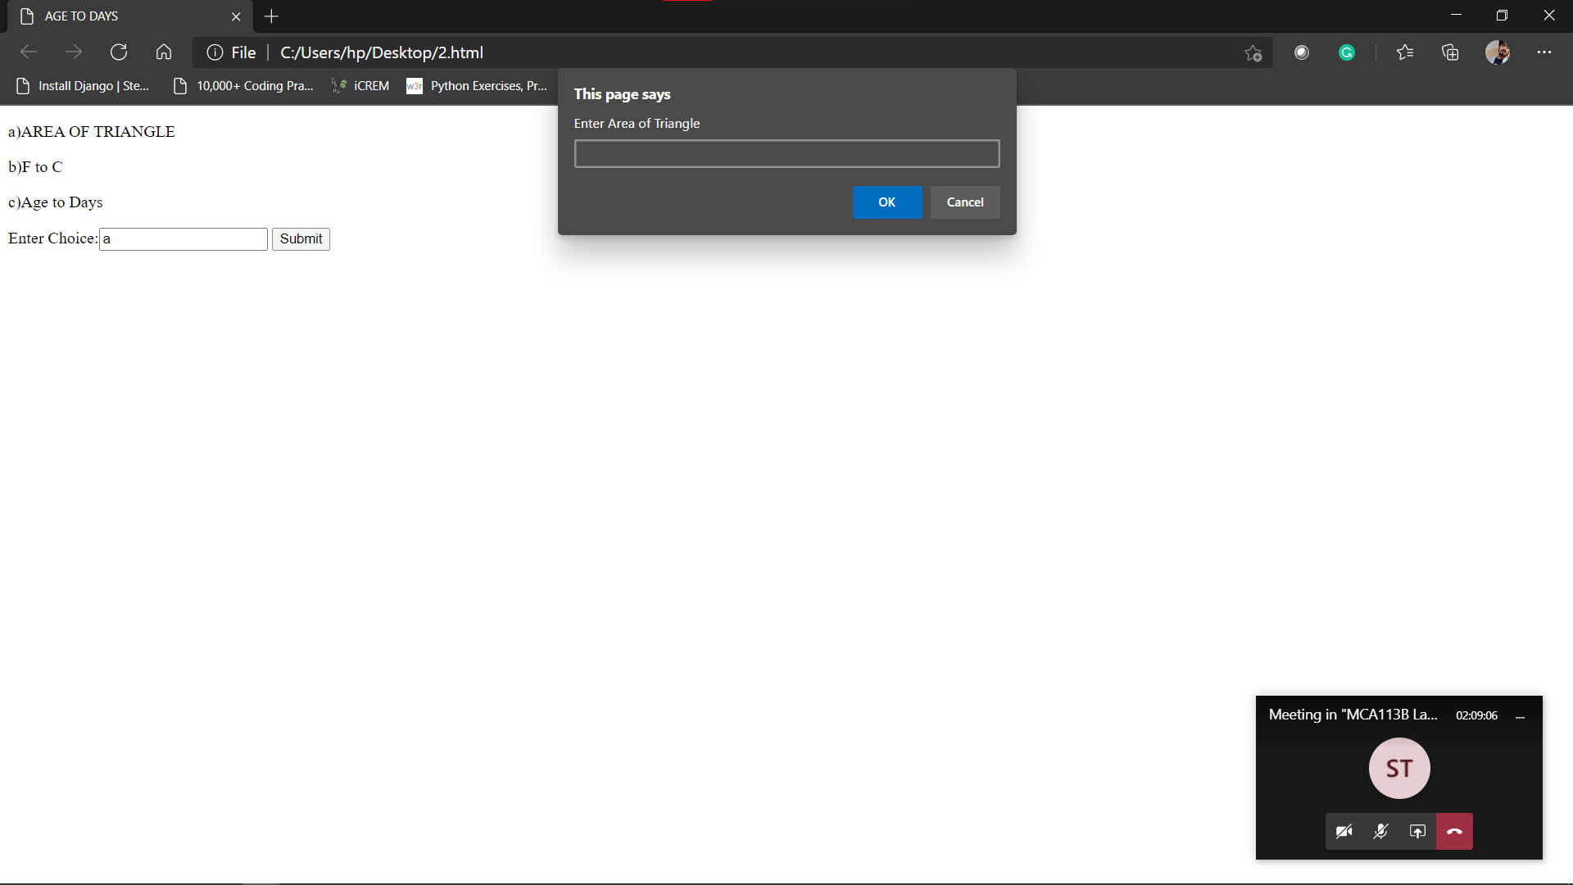

2. Design the registration form to collect the student's personal information and elective subject choice using form and validate the fields using JavaScript and display the submitted valid data.

<html>

<head>

<script>

function validate()

{

var fname=document.form.fname.value;

var lname=document.form.lname.value;

var addr=document.form.addr.value;

if(fname== null || fname=="")

{

alert("First Name Can't be blank");

return false;

}

else if(lname== null || lname=="")

{

alert("Last Name Can't be blank");

return false;

}

else if(document.form.es.selectedIndex=="")

{

alert("Please select subject");

return false;

}

else

{

var sel=document.getElementById("id");

var selectedText=sel.options[sel.selectedIndex].text;

alert("You Have selected "+selectedText);

return true;

}

}

</script>

</head>

<body align="center">

<form name="form" action="" method="post" onsubmit="validate()">

<br><br>

Enter First Name:<input type="text" name="fname"><br><br>

Enter Last name:<input type="text" name="lname"><br><br>

Address:<input type="text" name="addr"><br><br>

Select The Subject

<select name="electivesubject" id="es">

<option value=''>Select one </option>

<option value="HTML"> HTML </option>

<option value="Ns">NetworkSecurity </option>

<option value="Dbms"> Database </option>

</select><br><br>

<input type="submit" value="Submit">

</form>

</body>

</html>

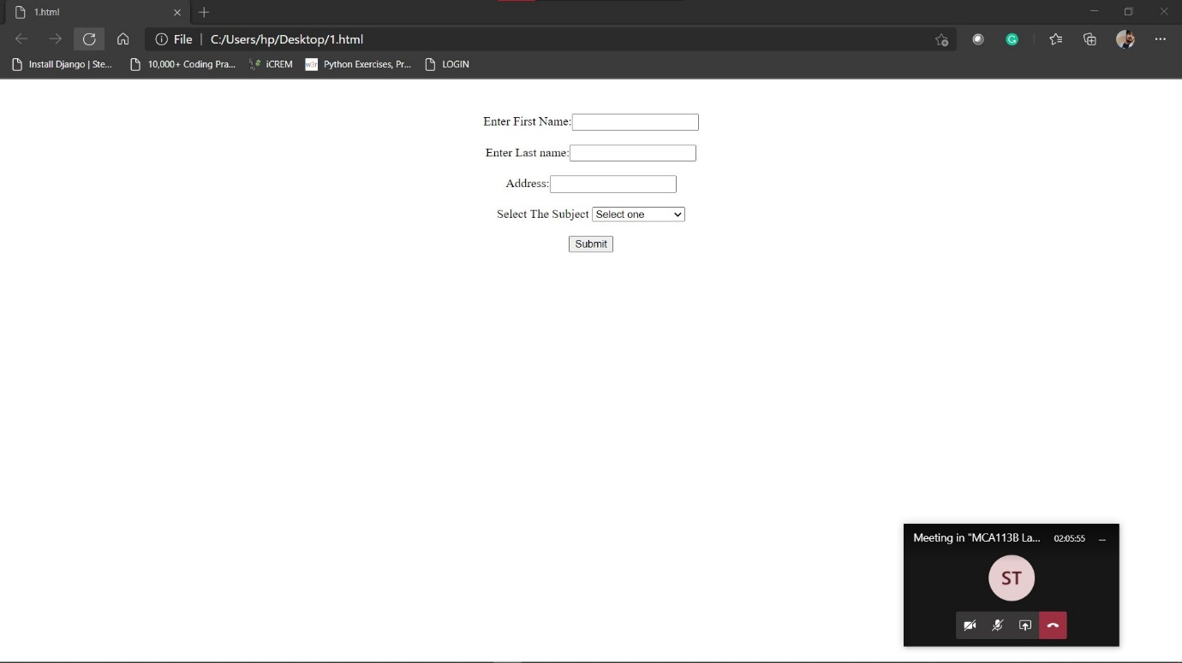

3. Write a program using JQuery to display the result of the students for one trimerster along with grade obtained.

<!DOCTYPE html>

<html lang="en">

<head>

<meta charset="UTF-8">

<meta http-equiv="X-UA-Compatible" content="IE=edge">

<meta name="viewport" content="width=device-width, initial-scale=1.0">

<title>Assignment 3</title>

<script src="https://ajax.googleapis.com/ajax/libs/jquery/3.4.1/jquery.min.js"></script>

</head>

<body>

<div class="container">

<form>

<label for="sub1">Enter the marks of Web Technology</label>

<input type="number" id="sub1">

<label for="sub2">Enter the marks of java</label>

<input type="number" id="sub2">

<label for="sub3">Enter hte marks of UML</label>

<input type="number" id="sub3">

<p id="percentage"></p>

<p id="grade"></p>

<button type="submit">Calculate result</button>

</form>

</div>

<script>

$(document).ready(function () {

$("form").submit(function (e) {

e.preventDefault();

const sub1 = parseInt($("#sub1").val());

const sub2 = parseInt($("#sub2").val());

const sub3 = parseInt($("#sub3").val());

const per = (sub1 + sub2 + sub3) / 3;

$("#percentage").text(per);

if (per >= 90) {

$("#grade").text(`Grade A+`);

} else if (per >= 80 && per < 90) {

$("#grade").text('Grade A');

} else if (per >= 70 && per < 80) {

$("#grade").text('Grade B+');

} else if (per >= 60 && per < 70) {

$("#grade").text('Grade B');

} else {

$("#grade").text('Grade C');

}

})

});

</script>

</body>

</html>

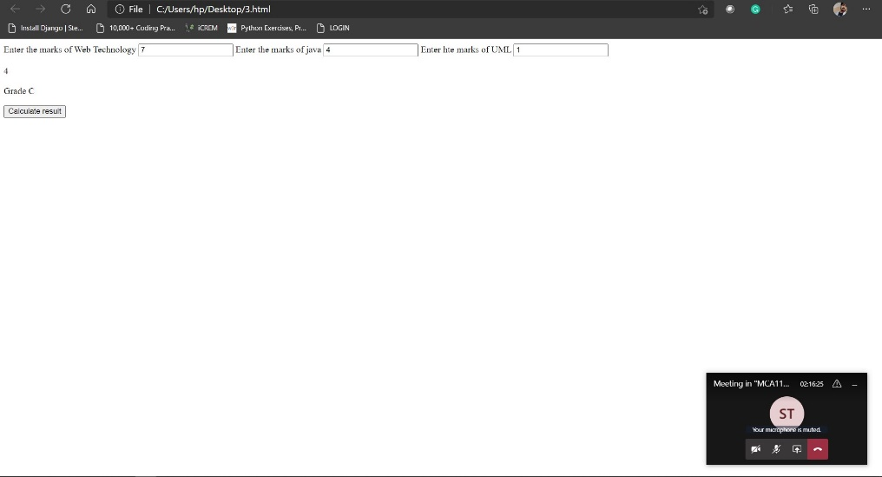

4. Write a program using JavaScript to check whether the given string is palindrome, display the leng of the string find the vowels present in the string.

<!DOCTYPE html>

<html lang="en">

<head>

<meta charset="UTF-8">

<meta http-equiv="X-UA-Compatible" content="IE=edge">

<meta name="viewport" content="width=device-width, initial-scale=1.0">

<title>Document</title>

<script>

function check(){

const string = document.getElementById("name").value;

const len = string.length;

var flag=0;

for (let i = 0; i < len / 2; i++) {

if (string[i] !== string[len - 1 - i]) {

flag=1;

break;

}

}

if(flag==1)

{

document.getElementById('pal').innerText="It is Not palindrome";

}

else{

document.getElementById('pal').innerText="It is palindrome";

}

var n = string.length;

document.getElementById('len').innerText="length of given string is:"+n;

const count = string.match(/[aeiou]/gi).length;

document.getElementById('vow').innerText="number of vowels in string:"+count;

}

</script>

</body>

</html>