Employee Segmentation Report
Employee Workforce Segmentation: K-Means, Hierarchical Clustering and PCA
Student name | Anshuman Gaikwad
Project | Employee Workforce Segmentation
Dataset | data/employee_data.csv (1,470 employees, 16 columns; synthetic, IBM HR-Analytics style schema)
Date | 28 October 2026
Deliverables | This report (includes PCA Summary), Employee_Workforce_Segmentation.ipynb, dashboard/workforce_dashboard.html, GitHub repository

1. Executive summary
The workforce of 1,470 employees was segmented with K-Means and Hierarchical (Ward) clustering after reducing 12 employee features to 7 principal components that keep 86.1% of the variance. Four segments emerged. Company attrition is 16.1%, but it is very unevenly spread: the Overworked & Disengaged segment (21% of staff) loses 43.0% of its people and accounts for 57% of all leavers, while Engaged High Performers lose only 2.6%. Overtime, low job satisfaction and low work-life balance define the high-risk group; 188 employees who combine all three leave at 45.7% versus 11.7% for everyone else. The same segment also loses 23 of its 55 high performers, which makes it the first place to act.

2. Data and method
Twelve features were used for clustering: Age, JobLevel, MonthlyIncome (log-transformed because of skew), YearsAtCompany, YearsSinceLastPromotion, DistanceFromHome, OverTime (0/1), JobSatisfaction, EnvironmentSatisfaction, WorkLifeBalance, PerformanceRating and TrainingTimesLastYear. TotalWorkingYears was dropped because it duplicates Age. Attrition and Department were kept out of the clustering and used only to interpret the segments, so the groups are not shaped by the outcome they are meant to explain. All features were standardised before PCA and clustering.
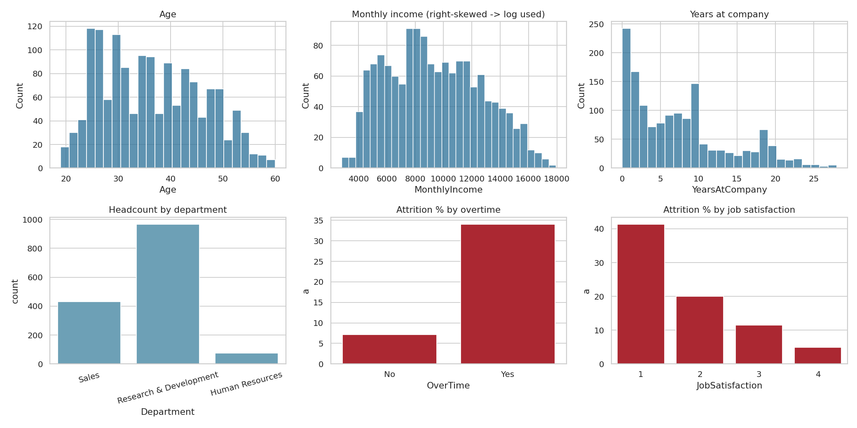
Figure 1. Exploratory analysis: distributions, headcount and attrition by overtime and job satisfaction.

3. PCA summary
PCA was fitted on the 12 standardised features. The first component explains 28.19% of the variance, the second 19.69% and the third 10.48%. Five components keep 73.75% and seven keep 86.08%, so seven components (>= 85% retained) were used as the clustering input, a reduction from 12 to 7 dimensions.
Component | Eigenvalue | Variance % | Cumulative %
PC1 | 3.385 | 28.19 | 28.19
PC2 | 2.365 | 19.69 | 47.89
PC3 | 1.259 | 10.48 | 58.37
PC4 | 0.998 | 8.31 | 66.68
PC5 | 0.849 | 7.07 | 73.75
PC6 | 0.775 | 6.45 | 80.2
PC7 | 0.705 | 5.87 | 86.08
PC8 | 0.628 | 5.23 | 91.31

Interpretation. PC1 is a seniority axis (YearsAtCompany, Age, MonthlyIncome and JobLevel all load about +0.4 to +0.5). PC2 is an engagement and performance axis (PerformanceRating, JobSatisfaction, EnvironmentSatisfaction, WorkLifeBalance). PC3 is a workload axis (OverTime +0.53 against WorkLifeBalance -0.42). Plotting PC1 against PC2 therefore gives a readable map: senior staff to the right, engaged and high-performing staff towards the top.
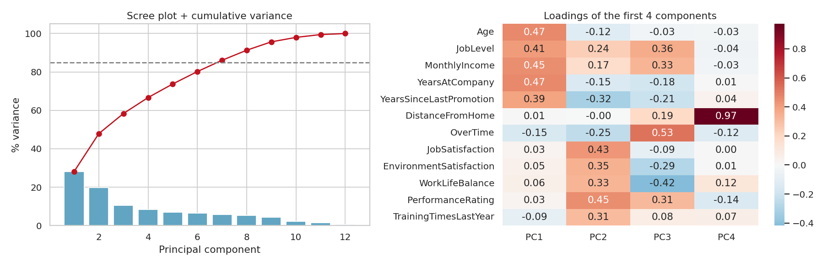
Figure 2. Scree plot with cumulative variance (left) and loadings of the first four components (right).
Clustering on the 7-component space gives practically the same result as clustering on all 12 standardised features (Adjusted Rand Index 0.989), so PCA removes noise and redundancy without changing the structure.

4. Clustering results

4.1 Choosing k for K-Means
K-Means was run for k = 2 to 8 and judged with inertia, silhouette, Calinski-Harabasz and Davies-Bouldin. Within k = 3 to 6, the rule was to take the largest k whose silhouette is within 0.01 of the best. Silhouette is 0.271 at k = 3 and 0.268 at k = 4, with Davies-Bouldin 1.367 and 1.371, so the two are practically tied. k = 4 was chosen because k = 3 merges early-career staff with overworked staff into one group of 48% of employees, which HR would want to treat differently.
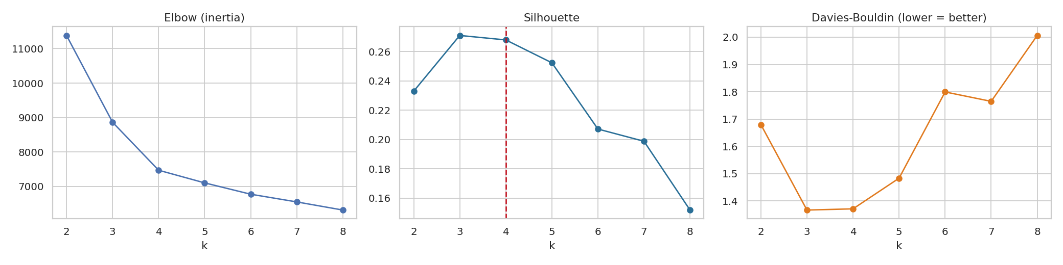
Figure 3. Elbow, silhouette and Davies-Bouldin scores for k = 2 to 8.

4.2 K-Means versus Hierarchical clustering
Method | Silhouette | Calinski-Harabasz | Davies-Bouldin
K-Means (k = 4) | 0.268 | 504.4 | 1.371
Hierarchical, Ward (k = 4) | 0.233 | 434.7 | 1.624

The two methods agree substantially (Adjusted Rand Index 0.738). K-Means is the stronger solution on all three metrics, is stable across 10 random seeds (ARI 1.00) and can assign new employees with predict, so it is the final segmentation. The dendrogram (Figure 4) gives four clusters when cut at the dashed line.
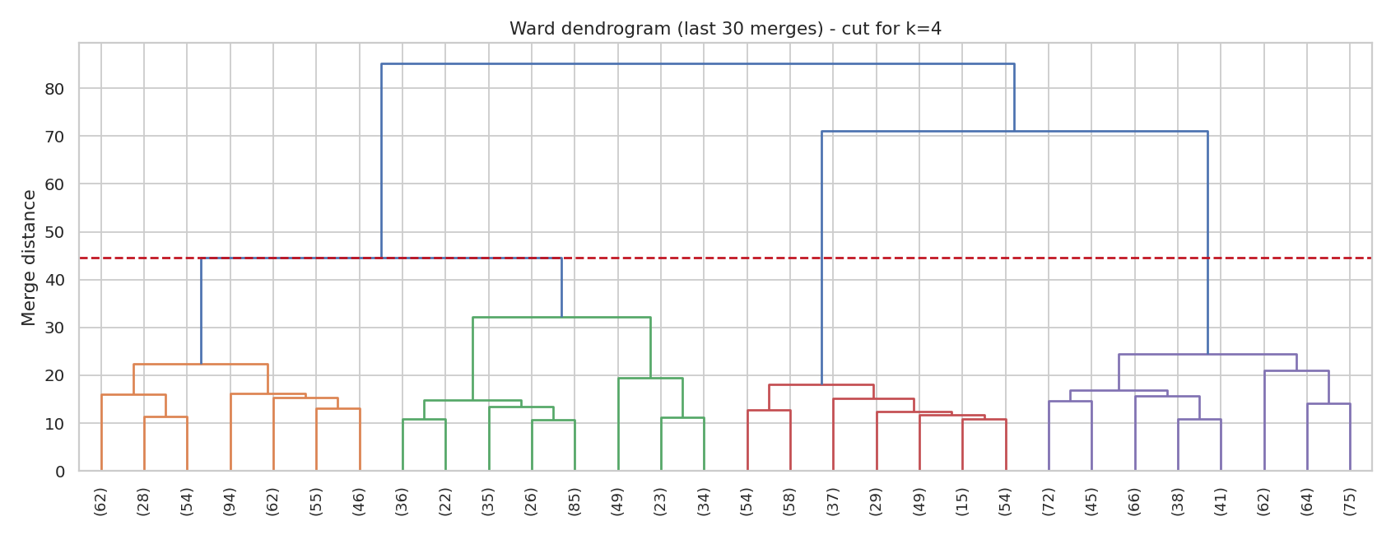
Figure 4. Ward dendrogram (last 30 merges), cut for four clusters.
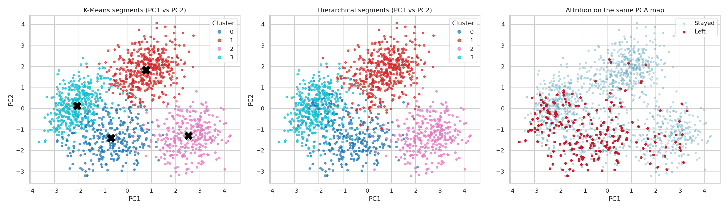
Figure 5. Segments in PCA space for K-Means (left) and Hierarchical clustering (centre); leavers on the same map (right).

5. Segment profiles
Segment | Employees | Attrition % | Overtime % | Job sat. | Work-life | Age | Tenure (yrs) | Yrs since promo
Overworked & Disengaged | 314 | 42.99 | 90.13 | 1.94 | 1.84 | 35.3 | 5.1 | 2.8
Early-Career Starters | 426 | 14.32 | 25.12 | 2.75 | 2.86 | 26.6 | 1.9 | 0.7
Stagnant Veterans | 301 | 9.63 | 10.96 | 2.33 | 2.69 | 49 | 18 | 8.9
Engaged High Performers | 429 | 2.56 | 15.15 | 3.41 | 3.12 | 38.5 | 7.9 | 1.6

- Overworked & Disengaged: mid-career, 90% on overtime, the lowest job satisfaction (1.9 of 4) and work-life balance (1.8), second-lowest average income.
- Engaged High Performers: highest income, satisfaction and performance (79% rated 4 or higher), little overtime, very low attrition.
- Stagnant Veterans: average age 49 and 18 years at the company, almost 9 years since the last promotion, no high performers and 55% rated 2 or lower.
- Early-Career Starters: average age 27, under 2 years of tenure, lowest pay and level, moderate satisfaction.
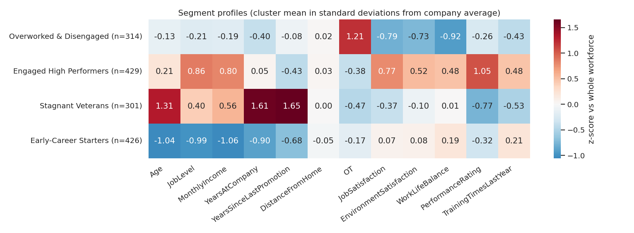
Figure 6. Segment profiles as standard deviations from the company average.

6. Analysis

6.1 High-risk employee clusters
Overworked & Disengaged is the only high-risk cluster: 43.0% attrition, 2.7 times the company rate, and 135 of the 236 leavers (57%). Early-Career Starters are close to the average (14.3%), Stagnant Veterans below it (9.6%), and Engaged High Performers lose only 11 people (2.6%).
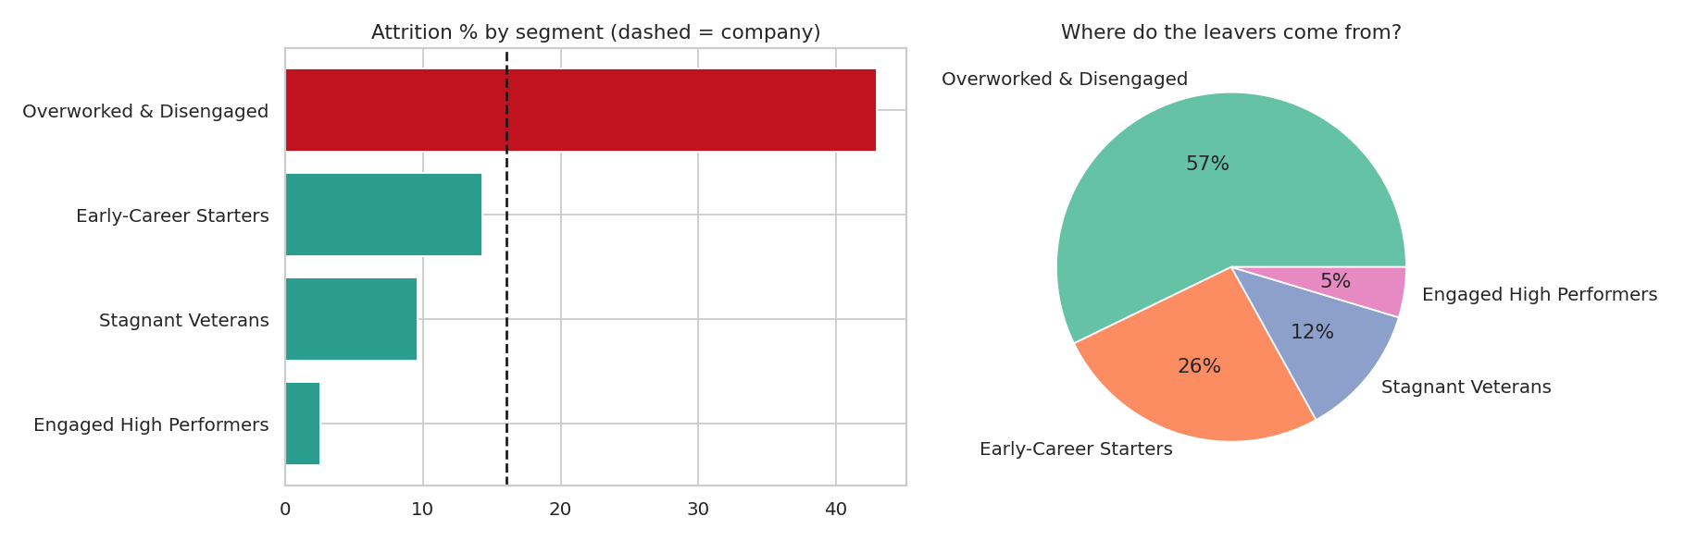
Figure 7. Attrition by segment and the share of all leavers coming from each segment.

6.2 Department-level workforce segments
Department attrition is similar (HR 17.6%, Sales 17.7%, R&D 15.2%), so the department alone does not explain who leaves; the segment does. Sales and R&D have a larger early-career share (30.0% and 29.2%) than HR (20.3%). The Overworked & Disengaged share is 25.7% in HR, 23.3% in Sales and 20.2% in R&D. Inside every department this segment has attrition of roughly 41% to 53% (HR has only 19 people in it, so that figure is indicative).
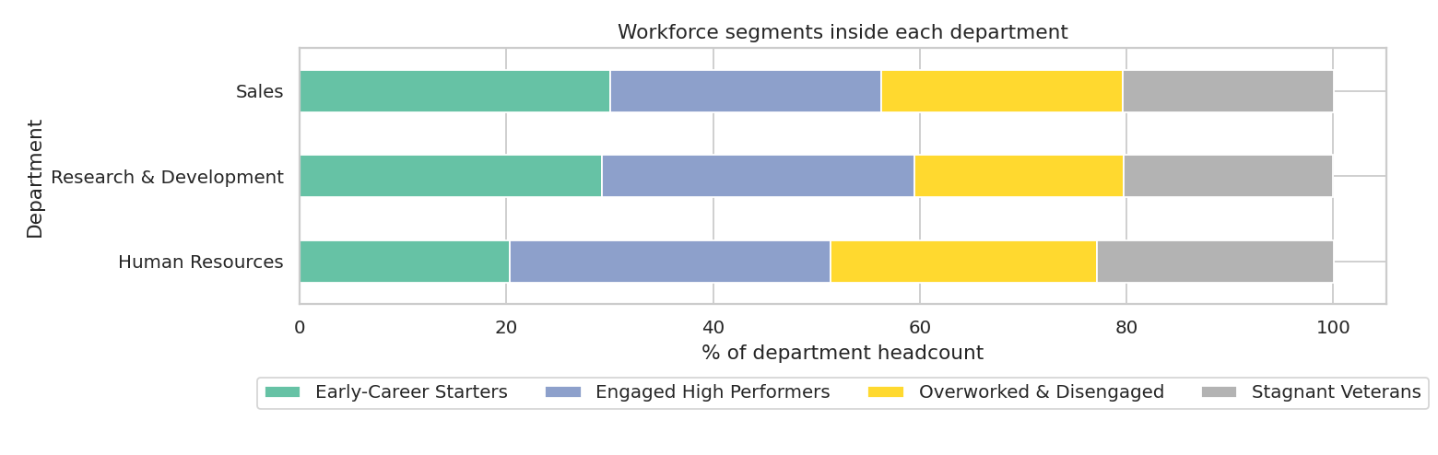
Figure 8. Segment mix inside each department.

6.3 Performance groups
Ratings were grouped as Low (2 or below), Solid (3) and High (4 or above). High performers leave less often overall (8.4%) than Solid (20.7%) or Low (17.1%) performers, but that average hides a problem: 23 of 55 high performers in the Overworked & Disengaged segment (41.8%) left, against 8 of 339 (2.4%) in Engaged High Performers and 6 of 49 (12.2%) in Early-Career Starters. These 37 departures are the costly, regretted attrition.
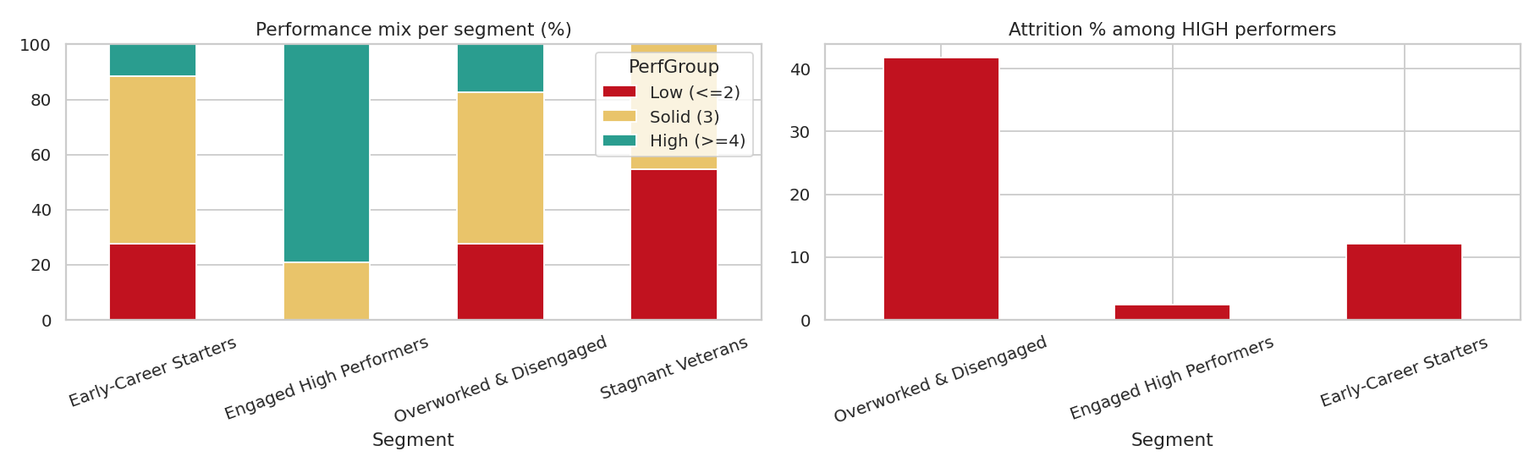
Figure 9. Performance mix per segment and attrition among high performers.

6.4 Retention-risk groups
Segments were tiered by attrition relative to the company rate: High risk (at least 1.25 times), Medium (0.85 to 1.25 times) and Low (below 0.85 times).
Tier | Segments | Employees | Attrition %
High risk | Overworked & Disengaged | 314 | 43
Medium risk | Early-Career Starters | 426 | 14.3
Low risk | Engaged High Performers, Stagnant Veterans | 730 | 5.5

For individual follow-up, an employee-level watch-list (overtime, job satisfaction of 2 or below, work-life balance of 2 or below) flags 188 employees whose attrition is 45.7%, against 11.7% for the other 1,282. Of the 188, 166 sit in the Overworked & Disengaged segment, 10 in Early-Career Starters, 8 in Stagnant Veterans and 4 in Engaged High Performers.

7. Recommendations
- Overworked & Disengaged: review workload and overtime rules for this group first, start manager check-ins for the 188 watch-list employees, and prioritise the 55 high performers in it for retention conversations.
- Early-Career Starters: invest in onboarding, mentoring and a visible pay and level progression, since they are the second-largest source of leavers (26%).
- Stagnant Veterans: attrition is low, but 9 years without promotion and weak ratings point to a disengagement and skills problem; consider reskilling and lateral moves.
- Engaged High Performers: protect what works (low overtime, good work-life balance) and use them as mentors.

8. Limitations
- The dataset is synthetic and was generated for this project with the same column layout as the IBM HR-Analytics data, because no dataset file was supplied. The numbers show how the method works and are not findings about a real company; re-run the notebook on the real file to get real results.
- Segments describe patterns and associations; they do not prove that overtime or low satisfaction causes people to leave.
- Attrition rates are in-sample, historical rates; small cells (for example HR within a segment) are indicative only.
- Segment names come from a rule set applied to each segment profile; they assume four segments and would need adjusting if k changes.

9. Deliverables and reproducibility
Files: Employee_Workforce_Segmentation.ipynb (all code and outputs), data/employee_data.csv and data/generate_employee_data.py, outputs/ (pca_summary.csv, segment_profile.csv, employee_segments.csv, dashboard_data.json), dashboard/workforce_dashboard.html, figures/. All random seeds are fixed (42), so results are reproducible.

