LLD: Low Level Design

**ONLINE BANKING APPLICATION**

mJunction

* **PROJECT NAME – ONLINE BANKING APPLICATION**
* **Date: 21.10.2022**
* **Version: 1.0**
* **PROJECT TEAM – 1. ANSHUMAN DAS (TEAM LEAD)**

**2. ANIKET MUKHERJEE(DEVELOPER)**

**3. ROHIT SAMANTA (LEAD DEVELOPER)**

**4. PUBALI MUKHERJEE (TESTER)**

**5. DIGANTA KUMAR DUTTA (DEVELOPER, DOCUMENT WRITER)**

**6. MADHURIMA DUTTA (PROJECT MANAGER)**

* **Contents :-**
  + Document Control………………………………………………….…..1
  + Technical Overview…………………………………………………….2
  + Commercial benefits and importance ………………………..3
  + Entity Relationship Diagram………………………………………..4
  + Module List…………………………………………………………………5
  + Performance Issues…………………………………………………….6

1. **Document Control :-**

* **Change/update Record**-

|  |  |  |  |
| --- | --- | --- | --- |
| **Date** | **Author** | **Version** | **Change Reference/**  **Patch notes** |
| 21.10.2022 | Team B: Phoenix | **V** 1.0 | This is the first released version |
| 10.11.2022 | Team B: Phoenix | **V** 1.1 | An update is expected, with the added new feature of tracking logs of the transaction history. |

1. **Technical Overview :-** The technical overview will be demonstrated practically, following this document presentation.
2. **Commercial benefits and importance :-** The main approach with a new, smart, seamless, hassle-free, and secure way to Net-banking is Developing an online banking web application.

Banking and financial services are one of the most lucrative sectors of the IT industry. The market size of the BFSI sector is estimated to be currently at $35.3 billion. Online Banking software helps customers complete their transactions and other banking works through multiple mediums like many mobile devices from anywhere.

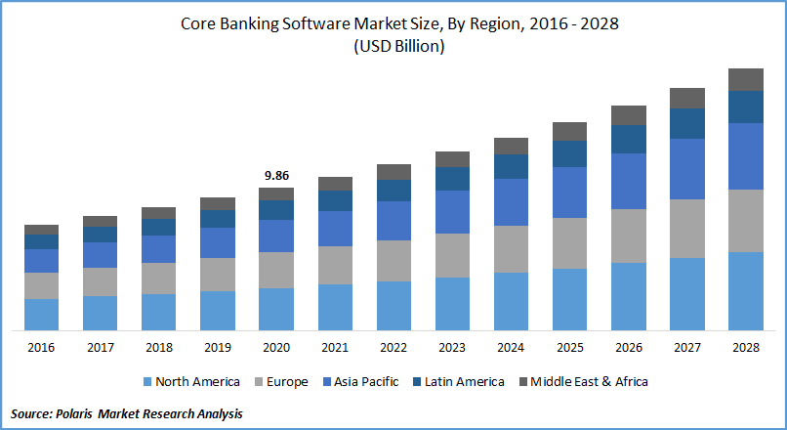

The main features of this online banking application:

* Logging in and out
* Create/Delete account
* Fund transfer
* Check account balance
* View account details

1. **Entity Relationship Diagram:-**

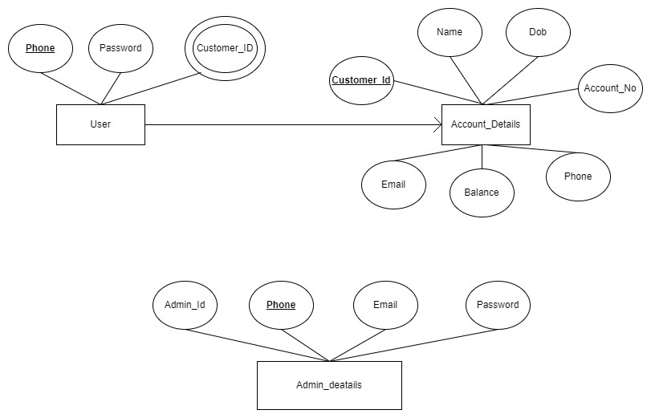

1. **Module List :-**

|  |  |  |
| --- | --- | --- |
| **Front-End** | **Back-End** | **Database** |
| admin-login, admincreateaccount,  admindetails,  adminlogout,  adminupdateuser,  Class (account.spec.ts, accountdetails.spec.ts, accountdetails.ts, admin.spec.ts, admin.ts, userdata.spec.ts, userdata.ts),  Customer,  customer-login,  customer-services,  customer-welcome,  header,  Services,  Successful,  user-logout,  useraccountdetails,  usercreateaccount,  userdetails,  welcome | BankingApplication.java,  HomeController.java,  AccountExecptionController.java,  AccountNotFound.java,  Accountdetails.java,  Admindetails.java,  Userdetails.java,  AccountRepo.java,  AdminRepo.java,  UserRepo.java | Bankapp,  Tables- accountdetails,  userdetails,  Admindetails. |

1. **Performance Issues :- Performance issues will be updated with further testing, patch update or change in the software.**