A
Minor Project-II Report
On
“SMART LOGISTICS DELIVERY SYSTEM”
Submitted in partial fulfillment of
The requirements for the 6thSemester Sessional Examination of
BACHELOR OF TECHNOLOGY
IN
COMPUTER SCIENCE & ENGINEERING
By
ANSHUMAN MOHANTY (22UG010692)
SIBA SANKAR PANDA (22UG010914)
ADITYA KUMAR NAYAK (22UG010666)
Under the Supervision of
DR. BIDUSH KUMAR SAHOO
DEPARTMENT OF COMPUTER SCIENCE & ENGINEERING


GANDHI INSTITUTE OF ENGINEERING AND TECHNOLOGY
UNIVERSITY, ODISHA, GUNUPUR
2024 - 25



GANDHI INSTITUTE OF ENGINEERING AND

TECHNOLOGY

UNIVERSITY, ODISHA, GUNUPUR
Dist. – Rayagada-765022,Visit us:- www.giet.edu

Department of Computer Science & Engineering


CERTIFICATE

This is to certify that the project work entitled “Smart Logistics Delivery System” is done by Anshuman Mohanty, Aditya Kumar Nayak, Siba Sankar Panda, 22UG010692, 22UG010666, 22UG010914 in partial fulfilment of the requirements for the 6th Semester Sessional Examination of Bachelor of Technology in Computer Science and Engineering during the academic year 2025-26. This work is submitted to the department as a part of evaluation of 6th Semester Minor Project-II.

Project supervisor Class Teacher

Project Coordinator, 3rd year HoD, CSE

ACKNOWLEDGEMENT

"We would like to express our deepest gratitude to our esteemed project supervisor, DR. BIDUSH KUMAR SAHOO, Department of Computer Science and Engineering, for providing us with the opportunity to undertake this project. His/her invaluable guidance, expertise, and unwavering support have been instrumental in the successful completion of this project report.

We also extend our sincere thanks to our class teacher Prof. RAJENDRA KUMAR MAHANTA for their constant encouragement and support throughout the project's execution.

Additionally, we would like to thank Mr. Bhavani Sankar Panda, Project Coordinator, Dr. Premanshu Sekhar Rath, Head of the Department of Computer Science and Engineering, and Prof. (Dr.) Kakita Murali Gopal, Deputy Dean, Computational Science, SOET, for their consistent support, guidance, and assistance.

Last but not least, we would like to thank our friends, family members, and everyone else who has provided us with unconditional support and encouragement during the project's execution. Your contributions have been invaluable to us.

ANSHUMAN MOHANTY (22UG010692)
ADITYA KUMAR NAYAK (22UG010666)
SIBA SANKAR PANDA (22UG010914)

TABLE OF CONTENTS
CHAPTER 1. INTRODUCTION 6-9
  - Purpose……………………………………………………………………………7
  - Scope……………………………………………………………………………...8
  - Features…………………………………………………………………………... 9
CHAPTER 2. WORKS DONE IN RELATED AREA 10
CHAPTER 3. SYSTEM ANALYSIS 11-12
  - Hardware Requirement…………………………………………………………..11
3.2 Software Requirements …………………………………………………………12
CHAPTER 4. 13-16
  - Language used…………………………………………………………………..13-14
  - Library Used 15
4.3 Algorithm Used 16
CHAPTER 5. SYSTEM DESIGN & SPECIFICATION 17-27
  - FLOW CHART 17
  - ER DIAGRAM…………………………………………………………………..18
  - UML… 19
  - SCREEN SHOTS 20-27
CHAPTER 6. CODING | 28-40
CHATER 7. TESTING | 41-42
CONCLUSION | 43
LIMITATION | 44
REFERENCE | 45

ABSTRACT

Smart Logistics is a web-based delivery management system designed to calculate distance, shortest route, and estimated time between two locations in India. The platform enables users to register, log in, and enter delivery details, providing accurate route calculations and estimated travel time to improve efficiency.
The system incorporates database connectivity for storing user data and route details, ensuring a seamless experience. It processes input locations to determine normal distance and shortest distance, helping users optimize their delivery planning. Users can check routes, travel distance, and estimated delivery time for shipments across different states and within the same state.
A core feature of Smart Logistics is its real-time notifications, allowing users to stay informed about their delivery schedules. The platform provides cost-effective and optimized solutions for delivery planning, reducing delays and enhancing overall efficiency.
By integrating user-friendly features, real-time tracking, and an efficient distance estimation mechanism, Smart Logistics simplifies logistics operations, making it an ideal solution for delivery management and route planning across India.
The core functionality of this system revolves around calculating the shortest and normal distance between two points using advanced computational models. It provides users with real-time insights into their selected routes, enabling them to make informed decisions about transportation and delivery.
A key feature of our system is the integration of real-time weight calculation for packages, enabling accurate shipping cost estimation based on the weight and distance of the delivery. This ensures transparency and fair pricing for users.
Additionally, our platform incorporates a secure online payment gateway, allowing users to pay for logistics services directly through the system. This simplifies the entire process — from booking a delivery to making payment — making it user-friendly and time-saving.

INTRODUCTION

In today’s fast-paced world, efficient logistics and transportation management play a crucial role in various industries, including e-commerce, supply chain management, and delivery services. With the increasing demand for timely and cost-effective deliveries, businesses require a robust system that provides accurate distance calculations, optimized route planning, and estimated travel time between two locations. Smart Logistics is designed to address these challenges by offering an automated, web-based platform that helps users determine the shortest and normal distance, estimated travel time, and optimized delivery routes across India.
The primary objective of Smart Logistics is to simplify the logistics process by allowing users to register, log in, and input source and destination locations to retrieve detailed route information. The system leverages real-time data processing to calculate the most efficient delivery paths, helping businesses and individuals save time and reduce transportation costs. Users can easily access information such as:
Total distance (in Km) between locations.
Shortest route available for faster delivery.
Estimated travel time based on selected routes.
This system is useful for both interstate and intrastate logistics operations, making it highly adaptable to different business needs. Whether it is a long-distance delivery across multiple states or a local transportation requirement within a city.
It allows users to register, log in, and enter their delivery details easily through the platform. In addition to route optimization, the system enables users to input the weight of their goods for accurate cost estimation. It also provides a secure online payment facility, allowing customers to complete their transactions quickly and safely within the platform.
he Smart Logistics platform is integrated with a secure online payment system to provide users with a fast and convenient payment experience. After calculating the transportation cost based on distance and weight parameters, users can directly make payments through the website.

PURPOSE

Logistics and transportation are essential components of modern commerce, ensuring the timely and efficient movement of goods and services. Smart Logistics is developed to provide a web-based solution for distance calculation, shortest route identification, and estimated travel time prediction between two locations. The purpose of this system is to enhance logistics efficiency by automating route planning and optimizing delivery management.
The platform offers a seamless interface where users can log in, register, and enter source and destination locations. Once the locations are provided, the system calculates the total distance, the shortest available route, and the estimated travel time. This information is crucial for logistics companies, e-commerce platforms, and transport agencies that need accurate distance measurements for delivery planning.
One of the primary objectives of Smart Logistics is to improve accuracy in distance and time estimation. Traditional methods of route planning often lead to delays and inefficiencies due to reliance on static data. In contrast, this system integrates real-time route calculations to ensure that users receive the most relevant and optimized distance results.
Furthermore, the system incorporates a weight parameter feature that allows users to input the weight of their goods. This enables the platform to calculate transportation costs more accurately based on distance and package weight, ensuring fair pricing and better resource management for logistics providers.
In addition, Smart Logistics provides a secure online payment gateway, allowing users to complete transactions directly through the platform after cost estimation. This integrated payment system simplifies the process for both customers and service providers, promoting a faster, cashless, and more reliable logistics experience.
1. To calculate distance, find the shortest route, and estimate travel time between two locations for efficient delivery management.
2. To calculate transportation cost based on distance and weight parameters provided by the user.
3. To provide a secure online payment system for easy and direct transaction of logistics services.

SCOPE

The scope of Smart Logistics extends to various aspects of logistics, transportation, and delivery management by providing an efficient, automated, and user-friendly system for distance calculation, shortest route identification, and estimated travel time prediction. The platform is designed to support both individuals and businesses involved in logistics operations, ensuring improved efficiency and cost-effectiveness.
The system covers a wide range of functionalities, including user registration, database management, real-time distance calculation, and optimized route planning. By integrating advanced route computation methods, the platform helps in minimizing travel costs and delivery time while ensuring the most effective transport solutions.
1)Interstate Deliveries: Logistics companies can use the platform to determine the most efficient routes between different states.
2)Intrastate Deliveries: Businesses and transport services can calculate distances within the same state to optimize local deliveries.
3)Urban and Rural Areas: The system covers both urban road networks and rural routes, making it applicable for diverse geographical locations.
The system also includes database connectivity using MongoDB and Firebase, which enables secure data storage and retrieval. The ability to store and manage past route searches, user preferences, and delivery history makes it useful for logistics companies that require frequent route calculations.
The platform is designed to assist logistics companies, transport agencies, and e-commerce businesses in improving their delivery operations. Additionally, the system enables users to enter the weight of their goods, allowing for accurate cost estimation based on both distance and weight parameters. To further enhance user convenience, a secure online payment gateway is integrated within the platform, enabling customers to complete transactions quickly and safely.

FEATURES

Smart Logistics is designed to offer an efficient and user-friendly platform for calculating distance, shortest routes, and estimated travel times between two locations. The system incorporates multiple features to ensure seamless delivery planning, route optimization, and real-time tracking. These features make the platform suitable for logistics companies, transportation agencies, and e-commerce businesses that rely on accurate route data for their operations.
One of the key features of Smart Logistics is user registration and authentication. The system allows users to create accounts, log in securely, and store their preferences in a connected database. Another essential feature of the platform is distance calculation and shortest route detection. The system computes both the normal distance and the shortest possible distance between two entered locations. By utilizing advanced route computation techniques, the platform ensures that users receive accurate and reliable distance estimates. The system is capable of handling both long-distance interstate deliveries and local intrastate transportation, making it highly adaptable for various business needs.
Features:
1. User Registration & Authentication
2. Distance Calculation & Shortest Route Finder
3. Estimated Travel Time Calculation.
4. interstate and intrastate route planning.
5. Estimated weight input By users
6. Calculative value showing with Cost calculation and Payment gateway.
This feature helps logistics companies and e-commerce businesses plan deliveries more efficiently. Additionally, users can input the weight of their goods, allowing the system to accurately estimate transportation costs based on both distance and weight parameters. After receiving the cost estimate, users can complete the transaction through a secure online payment gateway, ensuring a quick and hassle-free payment experience. With its user-friendly interface, real-time tracking, and optimized delivery management tools, Smart Logistics streamlines the entire logistics process, making it more efficient for businesses and customers alike.
CHAPTER -2
WORK DONE IN RELATED AREA
Here are the key points for the work done in related areas:
(1) Distance Calculation Methods Implemented:
- Implemented algorithms to compute the shortest distance between two locations.
- Calculated normal (road) distance between locations to provide alternative routes.
- Used geographical coordinates (latitude & longitude) for precise distance measurement.
(2) Time Estimation Based on Distance:
- Developed a formula to estimate time required for travel based on predefined speed limits or average travel speed.
- Ensured scalability for different transportation modes (e.g., bike, car, truck).
- Converted raw distance data into standard metric units (kilometers) for easy interpretation.
- Ensured accuracy in calculations using Haversine Formula or Google Maps API (if external tools were used).
(3) User Input & Output System:
- Developed a simple interface where users can enter source and destination locations.
The logistics and transportation industry has seen significant advancements in recent years, with various companies implementing digital solutions to enhance delivery efficiency. Technologies like Geographic Information Systems (GIS) have been widely adopted for route optimization and distance calculation, helping logistics companies find the shortest and most cost-effective routes. Several platforms have also integrated real-time tracking systems to provide customers with accurate delivery updates. Additionally, e-commerce platforms have increasingly adopted automated cost estimation tools based on weight and distance, streamlining their shipping processes. However, many of these solutions remain fragmented or lack seamless integration with payment systems. Smart Logistics seeks to build upon this existing work by combining distance and route optimization, weight-based cost calculation, and secure online payment functionality into one cohesive platform.

CHAPTER –3

SYSTEM ANALYSIS

HARDWARE REQUIREMENT:
Server-Side Hardware Requirements (For Hosting & Backend Processing)
Processor: Intel Core i3 (or AMD equivalent) – 2.0 GHz or higher
RAM: 4GB
Storage: 20GB SSD (For faster data retrieval)
Internet Speed: Minimum 10 Mbps (For API calls and real-time updates)
Graphics Card: Not required (since this is a backend system)

Recommended Requirements:
Processor: Intel Core i5/i7 (or AMD Ryzen 5+) – 3.0 GHz or higher
RAM: 8GB or more (For handling multiple user requests efficiently)
Storage: 50GB SSD or NVMe (For optimal performance)
Internet Speed: 50 Mbps or higher (For real-time data fetching & notifications)
GPU (Optional): NVIDIA GTX 1650 or higher (For future scalability & additional
processing)

2. Client-Side Hardware Requirements (For End-Users & Developers)

Device Compatibility: Any modern laptop, desktop, tablet, or smartphone
Operating System: Windows 10+, macOS, Linux, Android, iOS
Processor: Intel Core i3 (or equivalent).
RAM: 2GB or more.
Storage: At least 500MB free space for cache & browser data.
Internet Connection: Minimum 5 Mbps for smooth access to route calculations.

SOFTWARE REQUIREMENT:

Smart Logistics is designed to offer an efficient and user-friendly platform for calculating distance, shortest routes, and estimated travel times between two locations. The system incorporates multiple features to ensure seamless delivery planning, route optimization, and real-time tracking.
1. Operating System (OS) Compatibility
-The system can be developed and deployed on the following platforms.
-Windows 10/11 (For development & deployment).
-Linux (Ubuntu, CentOS, Debian, etc.) (For server hosting & database).
-macOS (M1/M2 or later) (For development & testing).
-Android & iOS (For mobile accessibility via browser or app).
2. Backend Development Tools
-Programming Language: Python (For distance computation), ML model.
-Frameworks: Flask, Node.js (For API handling & backend logic)
-Package Manager: npm (For JavaScript dependencies)
-API Integration: Google Maps API (For location-based data retrieval).
3. Frontend Development Tools
The frontend ensures an interactive and responsive user experience.
-Programming Languages: HTML5, CSS3, JavaScript (ES6+)
-Frameworks & Libraries: React.js (For UI design & user interaction)
-Styling: Material-UI, Styled Components (For consistent design)
-Browser Compatibility: Chrome, Firefox (for android), Edge, Safari

Python:

CHAPTER – 3

4.1 LANGUAGE USED

Python programming offers a dynamic, beginner-friendly environment for creating software solutions. Its extensive library ecosystem and succinct syntax enable quick development in a variety of fields, including scientific computing and web development. Python's interpreted nature allows for rapid development and iteration, and its readability encourages collaboration and understanding among developers. There is a lot of documentation, a thriving community, and easy access to learning materials and assistance. Python is a great option for jobs ranging from automation to machine learning because of its adaptability.

Programming with Python is like to assembling adaptable Lego pieces. It is powerful, accessible, and intuitive, making it appropriate for both novices and specialists. Python makes hard jobs easier with its rich libraries and straightforward syntax, ranging from data analysis to web development. Because of its dynamic nature, creativity is fostered through experimentation and quick prototyping. The community-driven nature of Python guarantees a wealth of resources for education and problem-solving. With Python's flexibility, users may create websites, automate processes, and explore artificial intelligence with ease. Python also helps users to develop smart ideas. Its growing popularity means that everyone interested in programming should understand it as soon as possible.
FRONTEND TECHNOLOGIES:
For the Smart Logistics project, the frontend is developed using a combination of the following technologies:
HTML: The structure of the web pages is built using HTML5, ensuring semantic markup and accessibility. HTML forms are used for input fields like the source, destination, and weight parameters, allowing users to interact with the platform easily.CSS: Custom styles are applied using CSS3 to ensure a clean and modern design. The use of CSS includes layout designs, font styles, and color schemes that align with the project’s branding and user experience goals.
Advanced CSS: To improve the user interface and responsiveness, advanced CSS techniques such as Flexbox and CSS Grid are used for layout management. This ensures that the website is both mobile-friendly and responsive across various screen sizes.
Bootstrap: The project incorporates Bootstrap 4/5, a popular front-end framework that helps with the rapid development of responsive and mobile-first websites. It is used for predefined grid systems, responsive containers, buttons, navigation menus, and other UI components, reducing development time and ensuring a uniform look across different devices.
JavaScript: JavaScript is employed for dynamic functionality, including real-time route calculation, distance estimation, and interactive user inputs. It is also used for form validation, as well as to handle asynchronous requests (AJAX) for fetching data such as real-time shipping information or cost estimates.
Kotlin: For any mobile applications developed as part of the Smart Logistics platform (e.g., an Android app). Kotlin is used as the primary language. Kotlin's concise syntax and full compatibility with Java allow for the development of a high-performance, user-friendly mobile app. It handles functionalities such as location tracking, real-time updates, and payment integration, ensuring that the logistics platform is accessible on both web and mobile devices.

LIBRARIES USED

Import pickle :
The pickle library in Python is used for serializing and deserializing Python object structures. It's a way to convert a Python object into a byte stream, and vice versa, allowing you to save complex data structures like lists, dictionaries, and even custom objects to a file and load them back into memory.
Person class and create an instance of it. We then use pickle.dump() to serialize and save the object to a file, and pickle.load() to deserialize and load it back into memory. It's a powerful tool for saving and loading Python objects, but remember to use it carefully due to potential security risks when deserializing data from untrusted sources.

Import streamlit as st :
Streamlit is an open-source Python library that makes it easy to create custom web apps for machine learning, data science, and other interactive applications. With Streamlit, you can create web apps using only Python scripts, without needing to write any HTML, CSS, or JavaScript. It's a powerful and user- friendly tool for creating interactive web apps with Python, particularly well- suited for data science and machine learning applications.

Running the App:
To run the Streamlit app, save the above code in a file (e.g., app.py) and run the following command in your terminal:

streamlit run app.py:
This will start a local web server and open the app in your default web browser.

ALGORITHM USED

- Principal Component Analysis (PCA) Algorithm for Smart Logistics:
Principal Component Analysis (PCA) is a widely used dimensionality reduction technique in machine learning that helps simplify large datasets while retaining essential information. In the Smart Logistics System, PCA plays a significant role in route optimization, distance calculation, and delivery time estimation by reducing redundant data and improving computational efficiency. The logistics system processes multiple parameters such as distance, traffic conditions, route availability, road types, and estimated delivery time. Handling such high-dimensional data can slow down computations, making the system inefficient.
- Implementation of Intelligent System for Transportation Management:
An Intelligent System for Transportation Management (ISTM) is a technology-driven approach designed to optimize route planning, distance calculation, and delivery time estimation. In the Smart Logistics System, ISTM ensures that deliveries are handled efficiently by leveraging real-time data processing, predictive analytics, and route optimization techniques. This system enables logistics providers to improve efficiency, reduce costs, and enhance delivery reliability.
- Random Forest Algorithm in Smart Logistics System:
The Random Forest algorithm is a powerful ensemble learning technique used in machine learning-based logistics systems. It improves the accuracy of route optimization, estimated delivery time prediction, and traffic pattern analysis by making multiple decision trees work together.
- XGBOOST:
An optimized version of Gradient Boosting that improves both the speed and accuracy of the algorithm. It is widely used in data science competitions due to its efficiency and effectiveness in handling large datasets.

CHAPTER 4

SYSTEM DESIGN AND SPECIFICATION
5.1 FLOW CHART
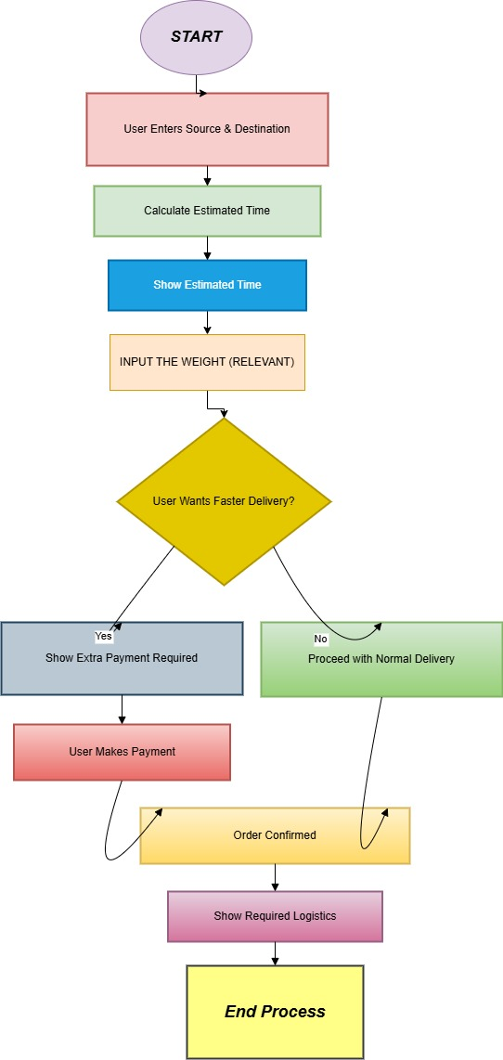

4.2 ER DIAGRAM

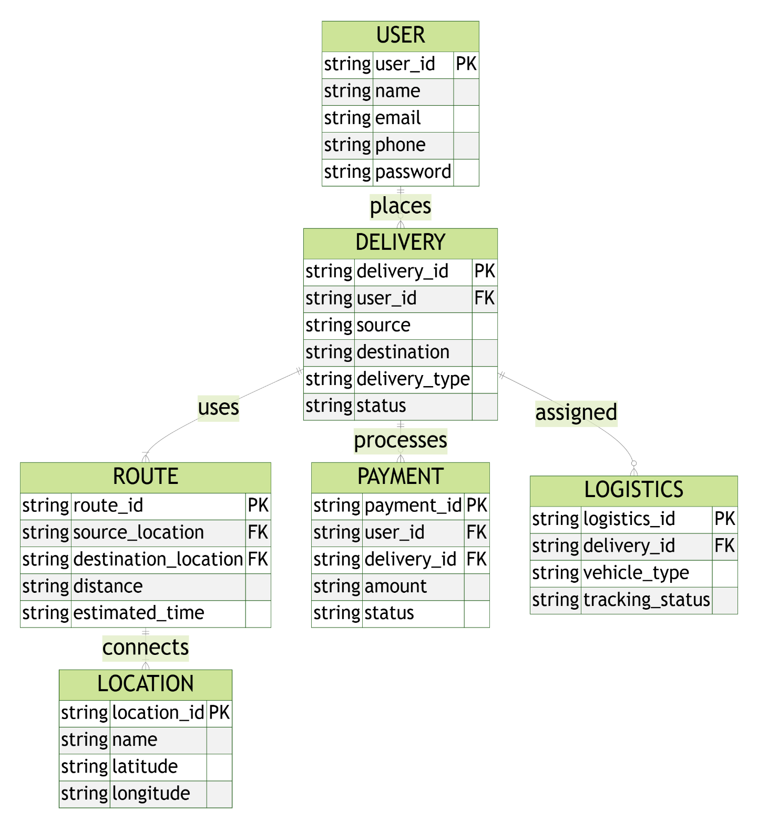

4.3 PROPOSED MODEL:(UML DIAGRAM)
DATA SET COLLECTION
TRAINING AND

DATA STORE
LOGISTIC REGRESSION
DATA SPLITING
ACCURACY OF TRAINING ACCURACY OF TESTING
PCA ALGORITHM
RANDOM FOREST
ISTM ALGORITHM

CALCULATING OF DATA
FIND DISTANCE AND TIME.

4.4 SCREENSHOT

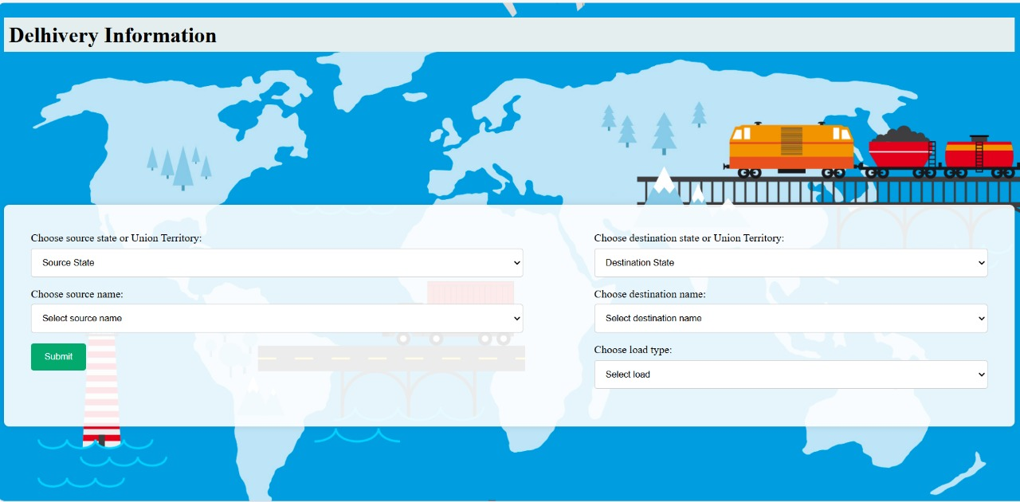
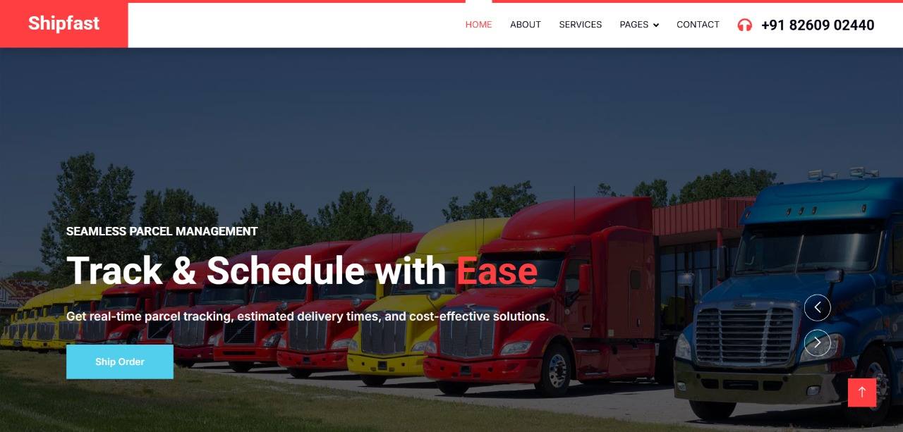
- DELIVERY SYSTEM FRONTEND

4.4 SCREENSHOT
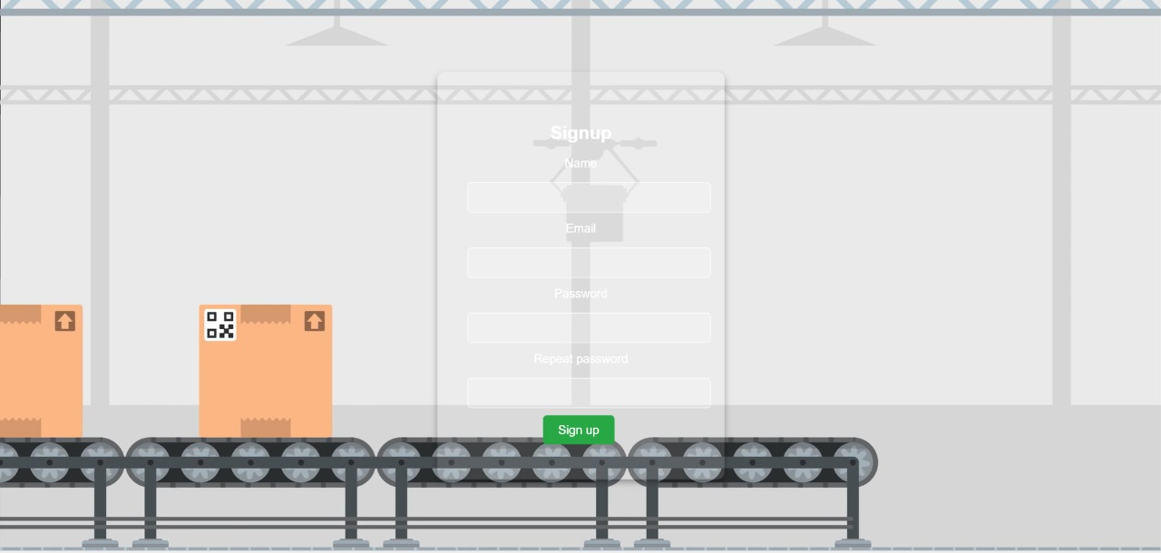
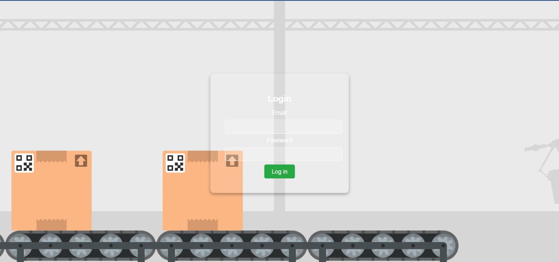
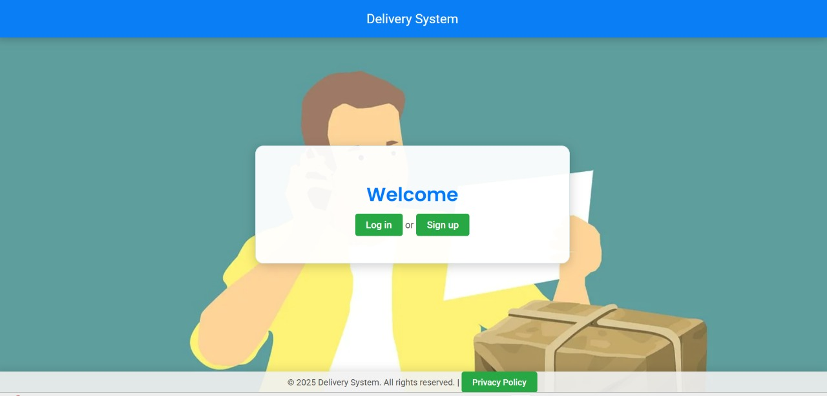
2. DELIVERY SYSTEM DATABASE( LOGIN AND SIGN UP )

4.4 SCREENSHOT
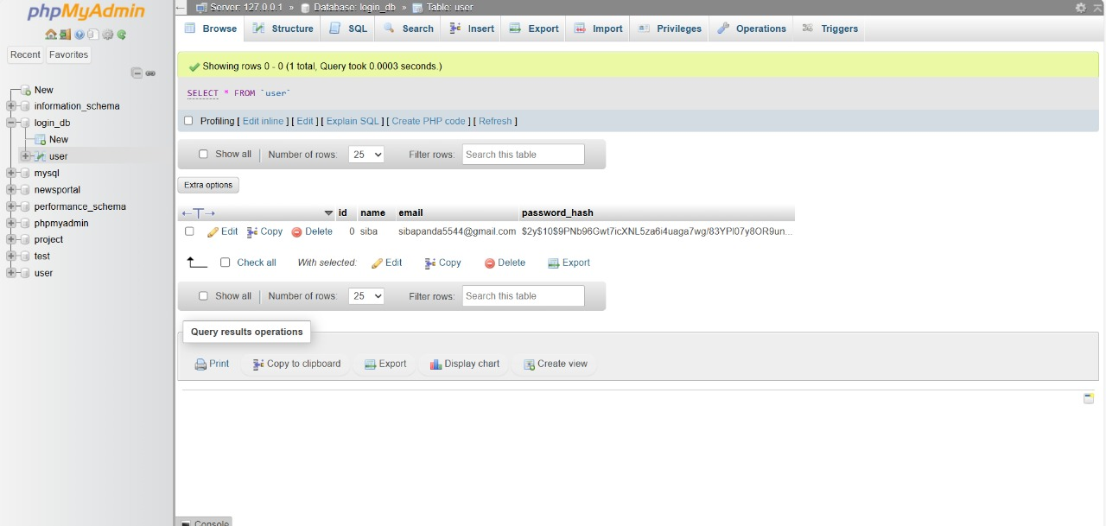
3. DELIVERY SYSTEM DATABASE
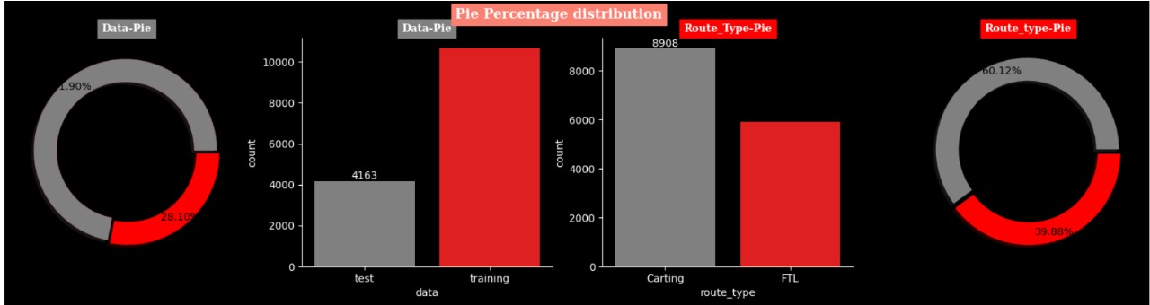

4.4 SCREENSHOT

- DELIVERY WEBSITE DATASET
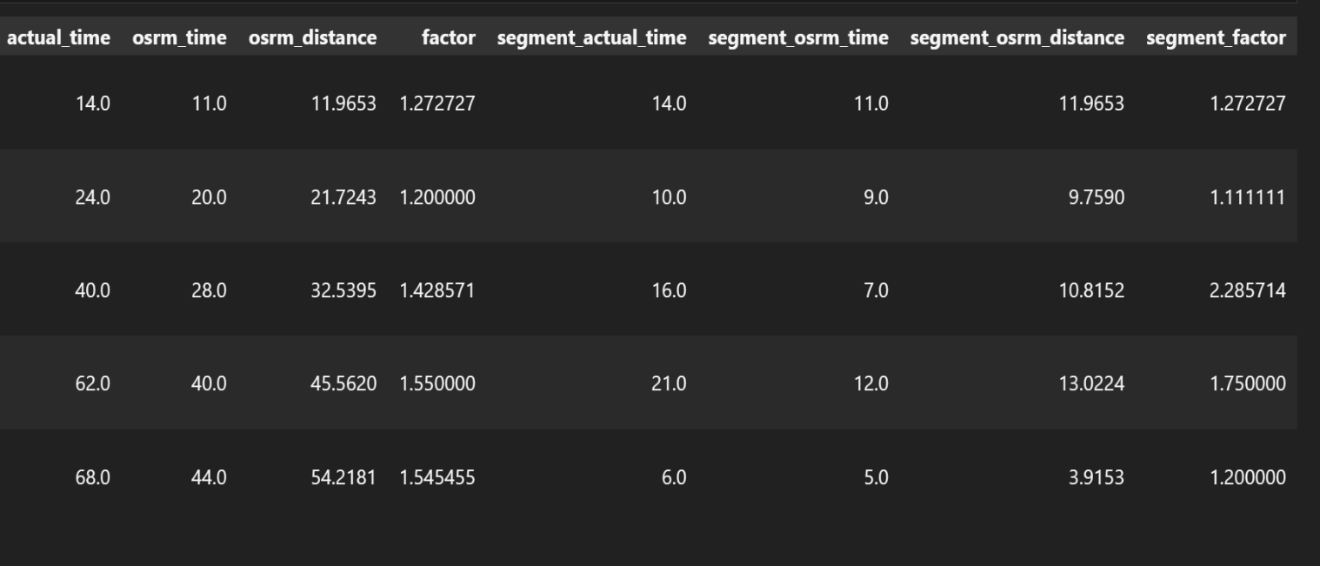
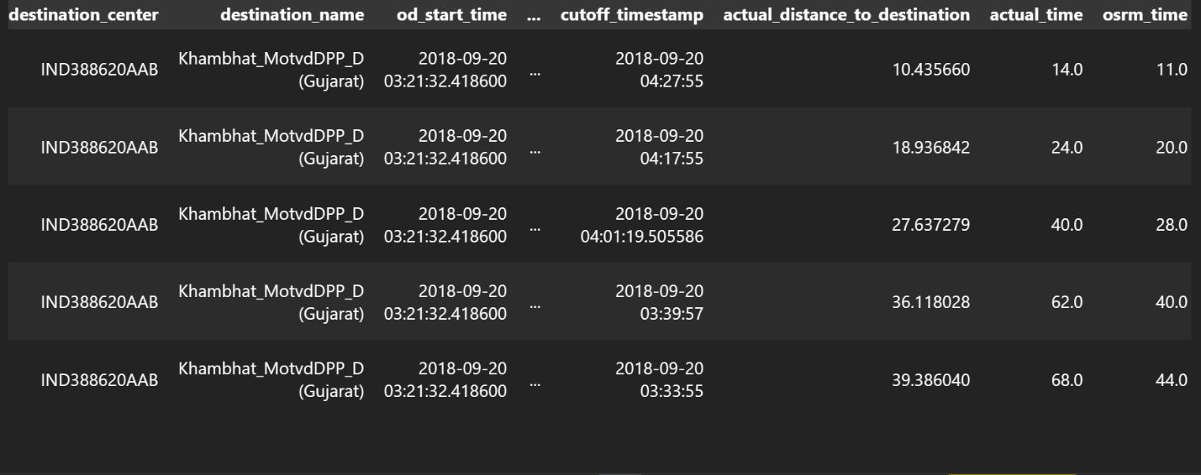
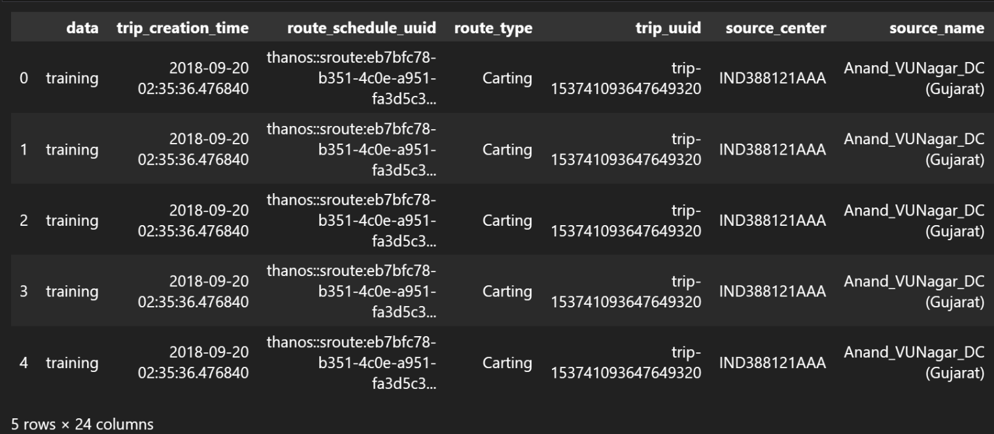

4.4 SCREENSHOT

- IMPLEMENTING CLEANED AND TRAINED DATA SET

4.4 SCREENSHOT

ANDROID DEVELOPED FOR DELIVERY PURPOSES
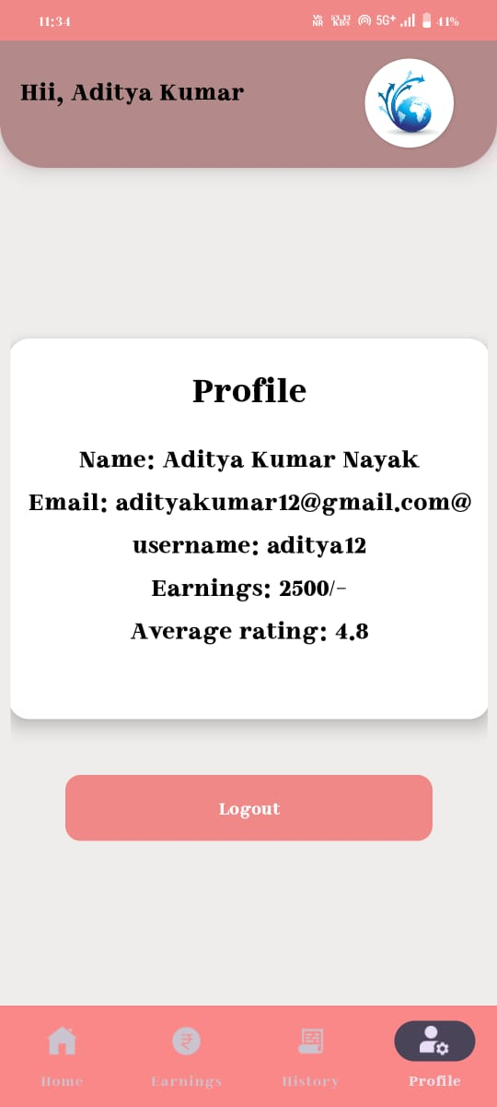
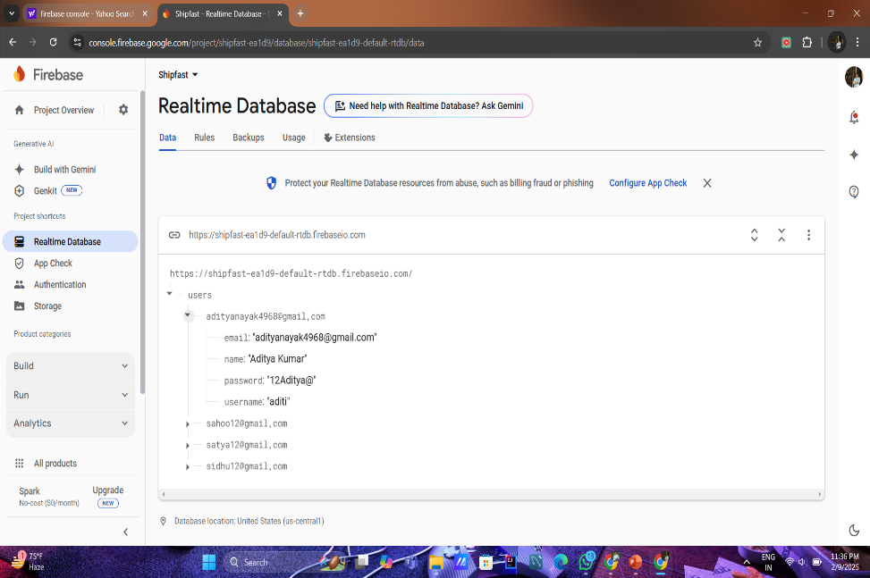
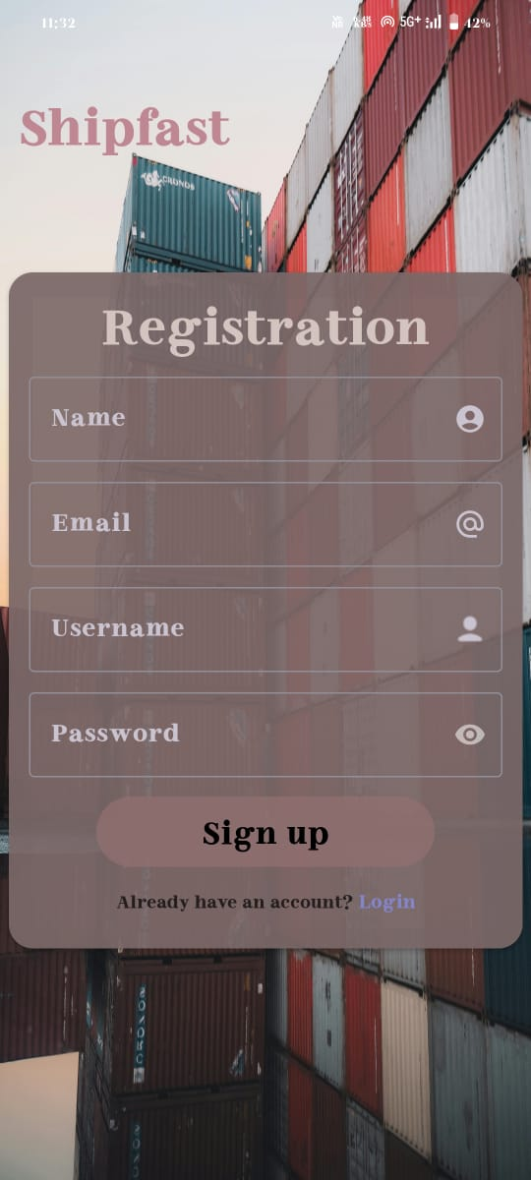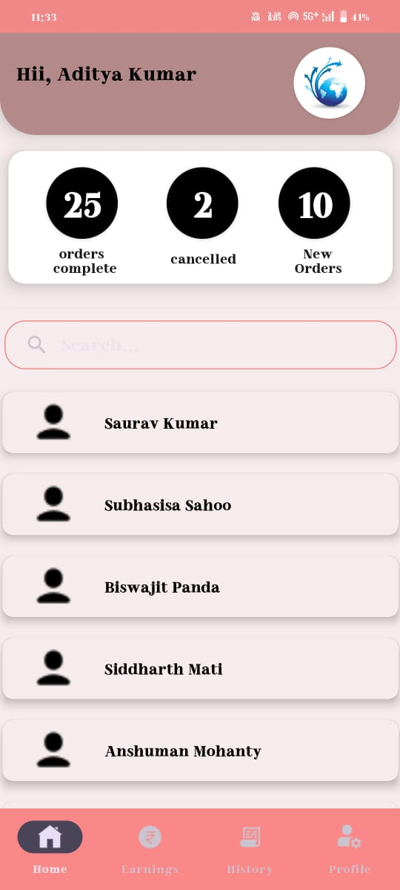
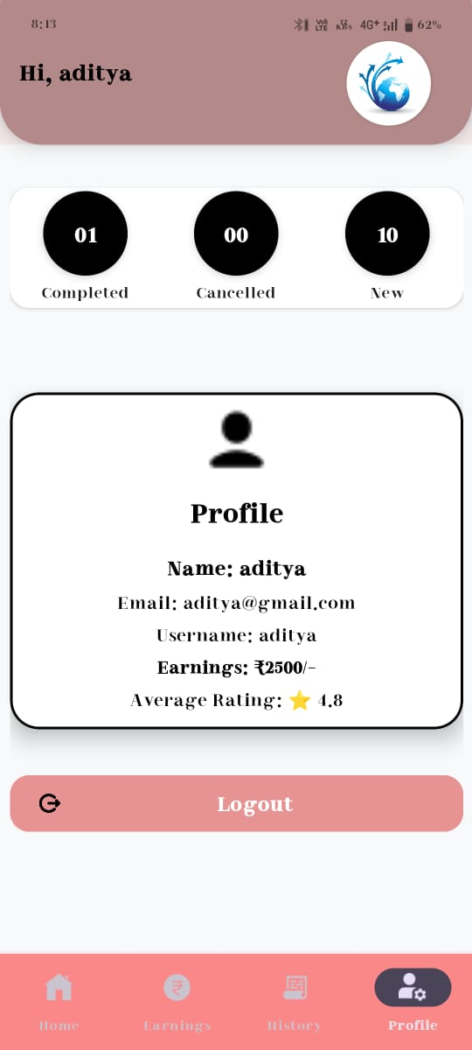
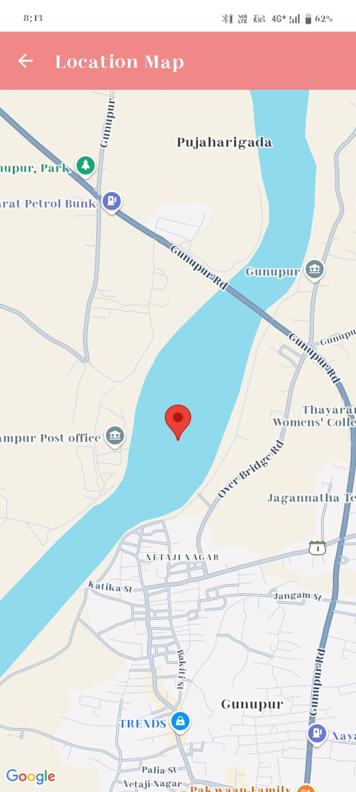
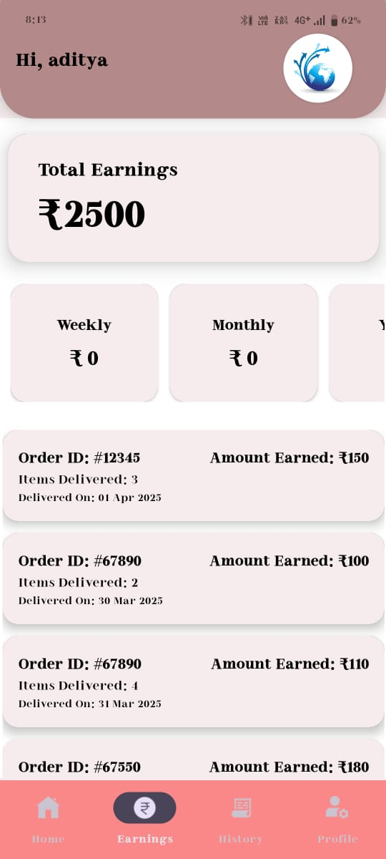


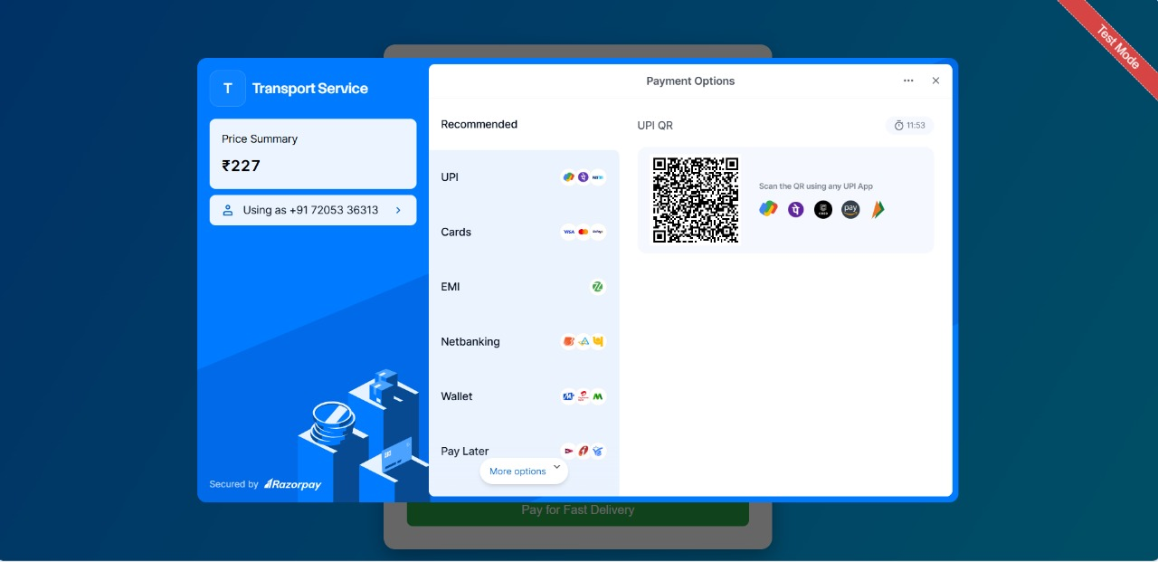
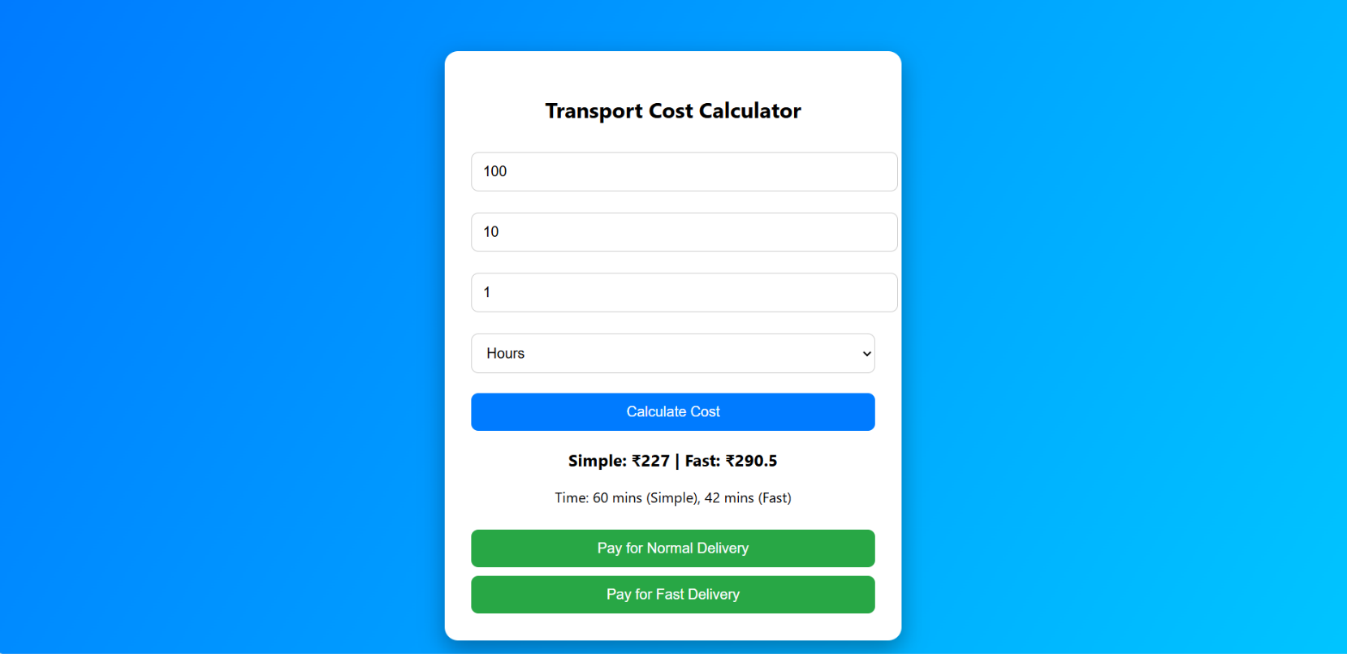

5.1 new_delivery.py

CHAPTER - 5 PROJECT CODING

import pandas as pd
import numpy as np
import matplotlib as mpl
import matplotlib.pyplot as plt
%matplotlib inline
import scipy.stats as spy
import seaborn as sns
import re

delhivery = pd.read_csv('/content/delhivery_data.csv')

delhivery.head()

# setting the option of displaying all the columns
pd.set_option('display.max_columns', 50)

delhivery.head()

delhivery.info

delhivery.shape

delhivery.column

Index(['data', 'trip_creation_time', 'route_schedule_uuid', 'route_type',
'trip_uuid', 'source_center', 'source_name', 'destination_center',
'destination_name', 'od_start_time', 'od_end_time',
'start_scan_to_end_scan', 'is_cutoff', 'cutoff_factor',
'cutoff_timestamp', 'actual_distance_to_destination', 'actual_time',
'osrm_time', 'osrm_distance', 'factor', 'segment_actual_time',
'segment_osrm_time', 'segment_osrm_distance', 'segment_factor'],
dtype='object

delhivery.isnull().sum()

delhivery.describe().T

delhivery.describe(include=object).T

delhivery[delhivery.duplicated()]

delhivery.isna().any()

delhivery.isnull().sum()

def missing_data(df):
total_missing_df = df.isnull().sum().sort_values(ascending =False)
percent_missing_(df.isnull().sum()/df.isna().count()*100).sort_values(ascending=False) # ----> /len(dd)
missing_data_df = pd.concat([total_missing_df, percent_missing_df], axis=1, keys=['Total', 'Percent'])
return missing_data_df

missing_pct = missing_data(delhivery)
missing_pct[missing_pct['Total']>0]

plt.show()

plt.figure(figsize=(25,8))
plt.style.use('dark_background')
sns.heatmap(delhivery.isnull().T,cmap='Greys')
plt.title('Visual Check of Nulls',fontsize=20,color='r')
plt.show()
unknown_fields = ['is_cutoff', 'cutoff_factor', 'cutoff_timestamp', 'factor', 'segment_factor']
delhivery = delhivery.drop(columns = unknown_fields)

#checking the unique values for columns
for col in delhivery.columns:
print(col,':',delhivery[col].unique())

delhivery.sample()

# Converting the datatypes to category for columns like data and route_type as they only have 2 values.
delhivery['data'] = delhivery['data'].astype('category')
delhivery['route_type'] = delhivery['route_type'].astype('category')

# Converting time columns to datetime format
datetime_cols = ['trip_creation_time', 'od_start_time', 'od_end_time']
for _ in datetime_cols:
delhivery[_] = pd.to_datetime(delhivery[_])

float_cols = []
for _ in delhivery.columns:
if delhivery[_].dtype=='float64':
float_cols.append(_)
float_cols

# reducing the float64 to float32 to save memory
for _ in float_cols:
delhivery[_] = delhivery[_].astype('float32')

delhivery.info()

# Time period of data

delhivery['trip_creation_time'].max(), delhivery['trip_creation_time'].min() , delhivery['trip_creation_time'].max()-delhivery['trip_creation_time'].min()

# Time period of data
delhivery['od_start_time'].max(), delhivery['od_start_time'].min(), delhivery['od_start_time'].max() - delhivery['od_start_time'].min()

# Time period of data
delhivery['od_end_time'].max(), delhivery['od_end_time'].min(), delhivery['od_end_time'].max() - delhivery['od_end_time'].min()

data_time_frame = delhivery['od_end_time'].max() - delhivery['trip_creation_time'].min()
data_time_frame

delhivery[(delhivery.source_name.isna())&(delhivery.destination_name.isna())]

delhivery[delhivery.source_name.isna()]

delhivery[delhivery.destination_name.isna()]
missing_source_name = delhivery.loc[delhivery['source_name'].isnull(), 'source_center'].unique()
missing_source_name

missing_destination_name = delhivery.loc[delhivery['destination_name'].isnull(), 'destination_center'].unique()
missing_destination_name

for _ in missing_source_name:
unique_source_name = delhivery.loc[delhivery['source_center'] == _, 'source_name'].unique()
if pd.isna(unique_source_name):
print("Source Center :", _, "-" * 5, "Source Name :", 'NA')
else :
print("Source Center :", _, "-" * 5, "Source Name :", unique_source_name)

for _ in missing_destination_name:
unique_destination_name = delhivery.loc[delhivery['destination_center'] == _, 'destination_name'].unique()
if pd.isna(unique_destination_name):
print("Destination Center :", _, "-" * 5, "Destination Name :", 'NA')
else :
print("Destination Center :", _, "-" * 5, "Destination Name :", unique_destination_name)

count = 1
for i in missing_destination_name:
delhivery.loc[delhivery['destination_center'] == i, 'destination_name'] = delhivery.loc[delhivery['destination_center'] == i,
'destination_name'].replace(np.nan, f'location_{count}')
count += 1

d = {}
for i in missing_source_name:
d[i] = delhivery.loc[delhivery['destination_center'] == i, 'destination_name'].unique()
for idx, val in d.items():
if len(val) == 0:
d[idx] = [f'location_{count}']
count += 1
d2 = {}
for idx, val in d.items():
d2[idx] = val[0]
for i, v in d2.items():
print(i, v)

for i in missing_source_name:
delhivery.loc[delhivery['source_center'] == i, 'source_name'] = delhivery.loc[delhivery['source_center'] == i, 'source_name'].replace(np.nan, d2[i])

len(delhivery)

df = delhivery.dropna()

df.isna().sum().any()

df.info()

delhivery.head()

def location_name_to_state(x):
l = x.split('(')
if len(l) == 1:
return l[0]
else:
return l[1].replace(')', "")

def location_name_to_city(x):
if 'location' in x:
return 'unknown_city'
else:
l = x.split()[0].split('_')
if 'CCU' in x:
return 'Kolkata'
elif 'MAA' in x.upper():
return 'Chennai'
elif ('HBR' in x.upper()) or ('BLR' in x.upper()):
return 'Bengaluru'
elif 'FBD' in x.upper():
return 'Faridabad'
elif 'BOM' in x.upper():
return 'Mumbai'
elif 'DEL' in x.upper():
return 'Delhi'
elif 'OK' in x.upper():
return 'Delhi'
elif 'GZB' in x.upper():
return 'Ghaziabad'
elif 'GGN' in x.upper():
return 'Gurgaon'
elif 'AMD' in x.upper():
return 'Ahmedabad'
elif 'CJB' in x.upper():
return 'Coimbatore'
elif 'HYD' in x.upper():
return 'Hyderabad'
return l[0]

def location_name_to_place(x):
if 'location' in x:
return x
elif 'HBR' in x:
return 'HBR Layout PC'
else:
l = x.split()[0].split('_', 1)
if len(l) == 1:
return 'unknown_place'
else:
return l[1]

delhivery['source_state'] = delhivery['source_name'].apply(location_name_to_state)
delhivery['source_state'].unique()

delhivery['source_city'] = delhivery['source_name'].apply(location_name_to_city)
print('No of source cities :', delhivery['source_city'].nunique())
delhivery['source_city'].unique()[:100]

delhivery['source_place'] = delhivery['source_name'].apply(location_name_to_place)
delhivery['source_place'].unique()[:100]

delhivery.shape

delhivery.info()

delhivery.sample()

segment_cols = ['segment_actual_time', 'segment_osrm_distance', 'segment_osrm_time']

df['segment_key'] = df['trip_uuid'] + '+' + delhivery['source_center'] + '+' + delhivery['destination_center']

for col in segment_cols:
df[col + '_sum'] = df.groupby('segment_key')[col].cumsum()

df[['segment_key', 'segment_actual_time', 'segment_actual_time_sum','segment_osrm_distance', 'segment_osrm_distance_sum','segment_osrm_time', 'segment_osrm_time_sum']]

df=delhivery

df_merge=df.groupby(['trip_uuid','source_center','destination_center']).agg({'data':'first',
'trip_creation_time':'first',
'route_schedule_uuid':'first',
'route_type':'first',
'source_name':'first',
'destination_name':'last',
'od_start_time':'first',
'od_end_time':'last',
'start_scan_to_end_scan':'max',
'actual_distance_to_destination':'max',
'actual_time':'max',
'osrm_time':'max',
'osrm_distance':'max',
'segment_actual_time':'sum',
'segment_osrm_time':'sum',
'segment_osrm_distance':'sum'}).reset_index()
df_merge

df_merge=df.groupby(['trip_uuid','source_center','destination_center']).agg({'data':'first',
'trip_creation_time':'first',
'route_schedule_uuid':'first',
'route_type':'first',
'source_name':'first',
'destination_name':'last',
'od_start_time':'first',
'od_end_time':'last',
'start_scan_to_end_scan':'max',
'actual_distance_to_destination':'max',
'actual_time':'max',
'osrm_time':'max',
'osrm_distance':'max',
'segment_actual_time':'sum',
'segment_osrm_time':'sum',
'segment_osrm_distance':'sum'}).reset_index()
df_merge

df=df_merge.groupby('trip_uuid').agg({'data':'first',
'trip_creation_time':'first',
'route_schedule_uuid':'first',
'route_type':'first','source_center':'first',
'source_name':'first',
'destination_center':'last',
'destination_name':'last',
'od_start_time':'first',
'od_end_time':'last',
'start_scan_to_end_scan':'sum',
'actual_distance_to_destination':'sum',
'actual_time':'sum',
'osrm_time':'sum',
'osrm_distance':'sum',
'segment_actual_time':'sum',
'segment_osrm_time':'sum',
'segment_osrm_distance':'sum'}).reset_index()
df

df.describe(include=['object'])
cat_columns=df.dtypes=='object'
category=list(cat_columns[cat_columns].index)
num_columns=df.dtypes!='object'
numerical=list(num_columns[num_columns].index)

category_data=df[category]
category_data

for col in category_data.columns:
print(col,':',category_data[col].nunique())

numerical_data=df[numerical]

for col in numerical_data.columns:
print(col,':',numerical_data[col].nunique())

df['trip_creation_time']=pd.to_datetime(df['trip_creation_time'])
df['od_start_time']=pd.to_datetime(df['od_start_time'])
df['od_end_time']=pd.to_datetime(df['od_end_time'])

df.info()

for col in df.columns:
print(col,':',df[col].nunique())

df[['destination','dest_state']] = df['destination_name'].str.split('(', n=1, expand=True)
df['dest_state'] = df['dest_state'].str.rstrip(')')
df[['dest_City','dest_place','dest_code']] = df['destination'].str.split('_', n=2, expand=True)
df[['source','source_state']] = df['source_name'].str.split('(', n=1, expand=True)
df['source_state'] = df['source_state'].str.rstrip(')')
df[['source_City','source_place','source_code']] = df['source'].str.split('_', n=2, expand=True)

df['trip_creation_year'] =df['trip_creation_time'].dt.year
df['trip_creation_month'] =df['trip_creation_time'].dt.month_name()
df['trip_creation_day'] =df['trip_creation_time'].dt.day
df

df.dtypes

cp = ['gray','red','dimgrey','tomato','dimgray','orangered','k','salmon','gray','red','dimgrey','tomato','dimgray','orangered','k','salmon']

plt.figure(figsize=(20,4))
plt.suptitle('Pie Percentage distribution',fontsize=13,fontfamily='serif',fontweight='bold',backgroundcolor=cp[-1],color='w')

plt.subplot(141)
plt.pie(df['data'].value_counts(), labels=df['data'].value_counts().index, colors=cp,counterclock=True , explode=(0.02,0.02) , autopct='%.2f%%', pctdistance=0.905,
textprops={'color':'k','fontsize':10} , shadow=True, radius=1,wedgeprops=dict(edgecolor='r',linewidth=0.1,width=0.25))
plt.title('Data-Pie',fontsize=10,fontfamily='serif',fontweight='bold',backgroundcolor=cp[0],color='w')

plt.subplot(142)
a = sns.barplot(x=df['data'].value_counts().index, y=df['data'].value_counts(), palette=cp)
a.bar_label(a.containers[0], label_type='edge',fmt='%d')

CHAPTER – 6

TESTING
Testing for a Smart Logistics System
Testing is a crucial phase in the development of a smart logistics system, ensuring that all components function efficiently and reliably.
Unit Testing:
Unit testing is conducted to verify the functionality of individual components of the system. Each module, such as user authentication (sign-up and login), distance calculation algorithms, and route optimization techniques, is tested separately to confirm that it performs as expected. This testing ensures that the core functionalities, such as computing normal and shortest distances between locations, operate correctly in isolation before integrating them into the complete system.
Integration Testing:
Integration testing is performed to validate the interaction between different components of the system. Since the logistics platform relies on multiple interconnected parts, such as user input, backend processing, API calls to Google Maps, and database interactions, it is essential to ensure that data flows smoothly between these elements. This testing phase verifies that location input from users correctly triggers distance calculations, routes are fetched accurately, and results are displayed without errors.
Functional Testing:
Functional testing is carried out to determine whether the system meets its defined functional requirements. This involves verifying that the system accurately calculates distances, identifies the shortest possible routes, and provides estimated travel times for deliveries.
Performance Testing:
Performance testing evaluates the efficiency of the system under various conditions. The system is tested to measure its response time, processing speed, and computational efficiency when handling multiple route calculations.
Scalability Testing:
Scalability testing is conducted to assess how well the system handles an increasing number of users and route requests. This testing ensures that the system performs optimally even when multiple users request route calculations, delivery tracking, or distance estimation at the same time.
Robustness Testing:
Robustness testing evaluates how the system handles unexpected or incorrect inputs. The system is tested for its ability to manage invalid or missing location data, incorrect coordinates, or network failures.
Cross-Validation:
Cross-validation is used to test the generalization capability of the route optimization models. The system is validated using multiple datasets to ensure that the distance and time predictions remain accurate regardless of location variations. This testing helps confirm that the system’s route optimization model can effectively work for different regions across India.

CONCLUSION

The Smart Logistics System is designed to provide an efficient and reliable solution for distance calculation, shortest route identification, and estimated delivery time prediction. The system successfully integrates user authentication, database connectivity, and machine learning-based route optimization to enhance the logistics process. By supporting both interstate and intrastate deliveries, the platform ensures seamless operation across urban and rural areas, making it highly adaptable to various logistics needs.

Through rigorous testing and validation, the system has been optimized for accuracy, performance, and scalability.

The platform’s ability to handle multiple user requests simultaneously, process large datasets efficiently, and provide optimized delivery solutions makes it a valuable tool for logistics companies, e-commerce businesses, and transport service providers. By leveraging advanced computational models and cloud-based infrastructure, the system is built for scalability and future expansion, enabling the addition of new features and improvements over time.

In conclusion, the Smart Logistics System provides a robust and intelligent approach to logistics management, reducing delivery inefficiencies, optimizing travel time, and improving overall transportation efficiency. With continuous improvements and enhancements, the system has the potential to revolutionize the way logistics operations are planned and executed across India.
.

LIMITATIONS

Limitations of the Smart Logistics System

While the Smart Logistics System offers efficient distance calculation, route optimization, and estimated delivery time prediction, it has certain limitations that may impact its functionality and scalability. Some of these limitations include:
- Dependency on Internet Connectivity.
- Accuracy of Route Predictions.
- Limited to Indian Road Networks.
- Performance Issues with Large Datasets.
-Increased processing time for distance calculations.
-Higher memory usage in handling multiple API requests simultaneously.
-Database queries taking longer due to large volumes of stored delivery data.
5. Scalability Challenges.
6. Handling of Incorrect or Missing Input Data.
7. Dependence on External APIs.
8. Lack of Real-Time Traffic Updates.

REFERENCE

For Tutorials: https://www.youtube.com/
For Project References: https://github.com/

