**Assignment -8**

Classify the test samples by implementing decision trees on the given database.

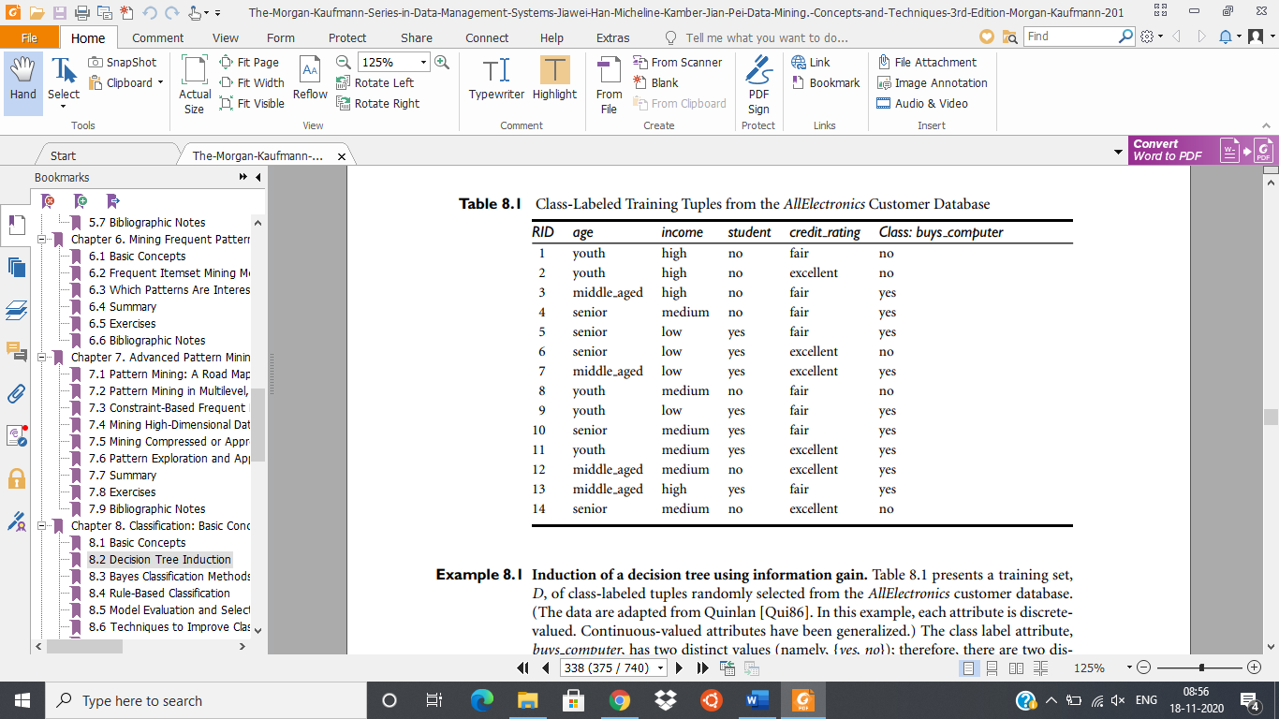

**Testing Samples:**

|  |  |  |  |  |
| --- | --- | --- | --- | --- |
| **age** | **income** | **student** | **credit_rating** | **class** |
| senior | low | no | fair | no |
| youth | low | yes | excellent | yes |
| middle_aged | low | yes | fair | yes |

**Predict Samples:**

|  |  |  |  |
| --- | --- | --- | --- |
| **age** | **income** | **student** | **credit_rating** |
| senior | high | yes | fair |
| youth | high | yes | fair |
| middle_aged | low | no | excellent |