DELIVERY ANALYTICS STUDIO
Turn delayed shipments into a clear, explainable story.
Explore city risk, warehouse friction, and customer sentiment with a more intuitive view of what is causing delivery friction.
Applied filters — City: All Client: All Warehouse: All

Total orders  10,000 | Incidents flagged  5,207 | Failure rate  52.1% | Active warehouses  50

WHAT THE DATA SAYS
A sharper read on the delay story
New Delhi is the highest-risk corridor at 51.8% delay exposure. Unknown Operational Delay is the dominant trigger with 670 visible incidents. Warehouse Warehouse 36 is carrying the loudest bottleneck. Fog / Heavy / Holiday is the clearest environmental signal.
• Prioritize unknown operational delay with proactive dispatch checks and customer notifications.
• Rebalance staffing around Warehouse 36 and tighten pick/pack SLAs.
• Create a city-specific recovery playbook for New Delhi during peak windows.
Delay reason breakdown
The strongest operational triggers behind the selected slice of orders.
TABULAR | GRAPHICAL  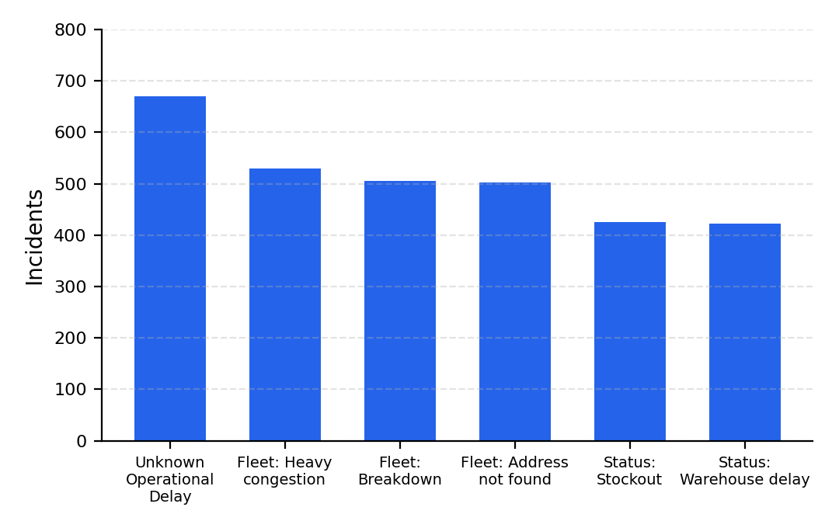
  Reason | Incidents
  Unknown Operational Delay | 670
  Fleet: Heavy congestion | 530
  Fleet: Breakdown | 506
  Fleet: Address not found | 503
  Status: Stockout | 425
  Status: Warehouse delay | 422
City disruption hotspots
The cities with the most concentrated delivery exposure.
TABULAR | GRAPHICAL  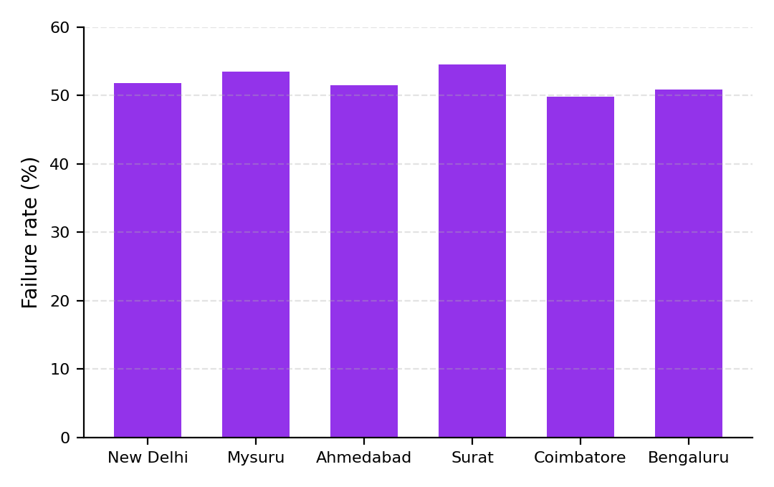
  City | Failure rate
  New Delhi | 51.8%
  Mysuru | 53.5%
  Ahmedabad | 51.5%
  Surat | 54.6%
  Coimbatore | 49.8%
  Bengaluru | 50.9%
Warehouse friction
The warehouses that are most tied to visible incidents.
TABULAR | GRAPHICAL  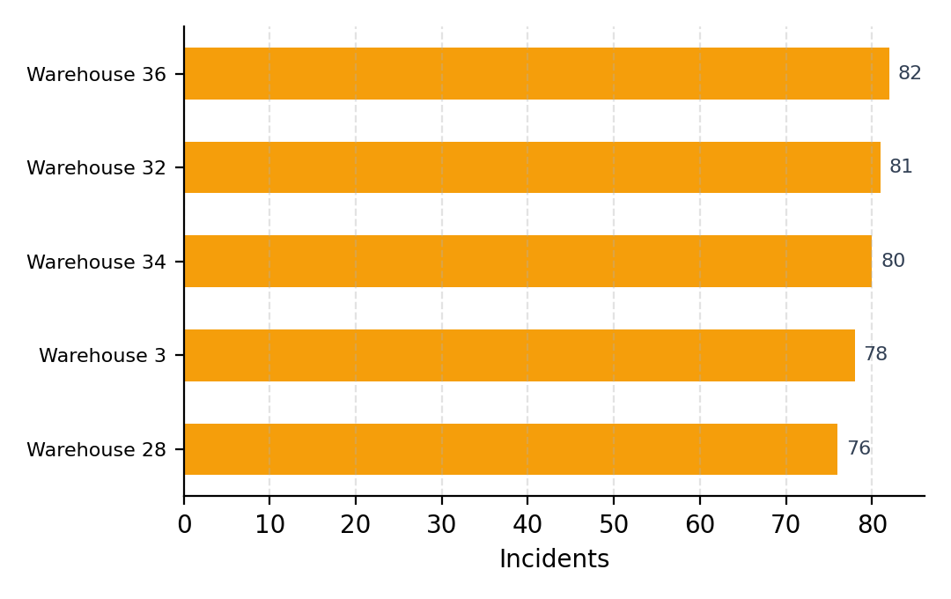
  Warehouse | Incidents
  Warehouse 36 | 82
  Warehouse 32 | 81
  Warehouse 34 | 80
  Warehouse 3 | 78
  Warehouse 28 | 76
Customer sentiment
The emotional tone of customer feedback connected to the current view.
TABULAR | GRAPHICAL  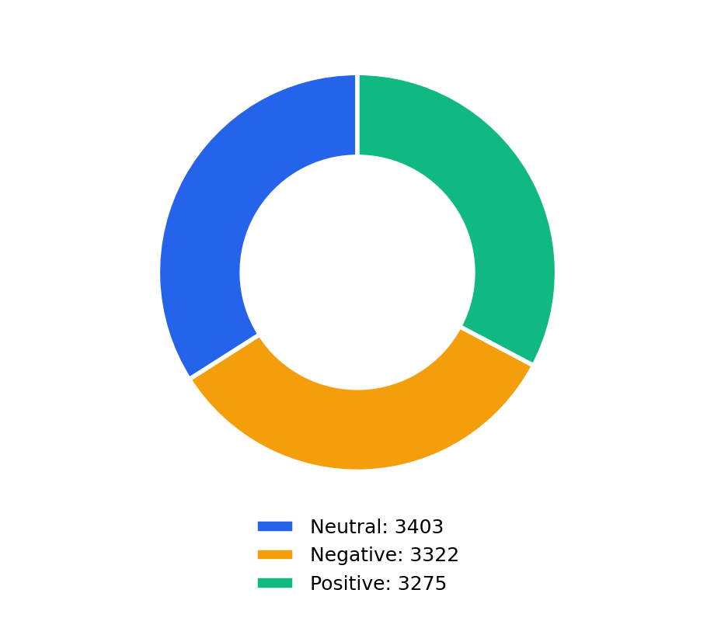
  Sentiment | Count
  Neutral | 3403
  Negative | 3322
  Positive | 3275

