Screen shots

Initial page load with one entry in Db

Initial page load when one entry is there in the db


Add Customer

Customer Addition Success

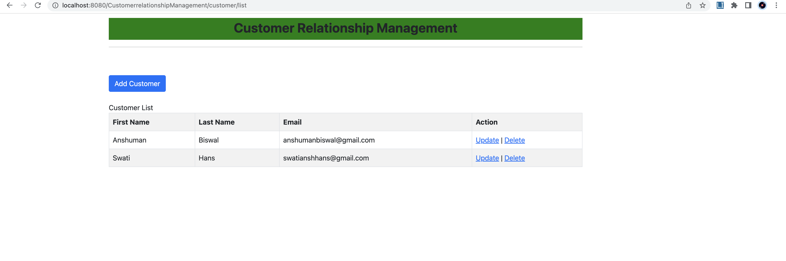

Added few more customers

Updating a customer

UPDATE Successful

Deleting a customer

Delete Successful

